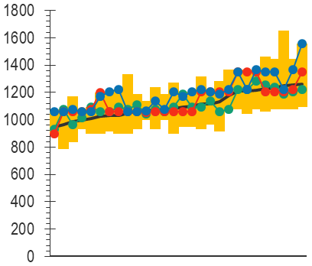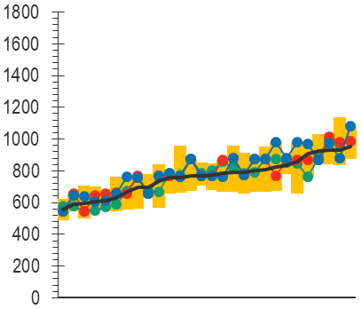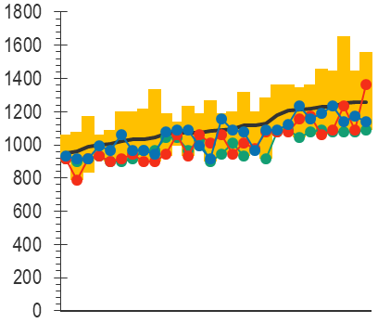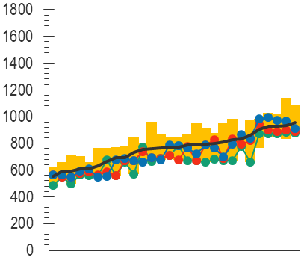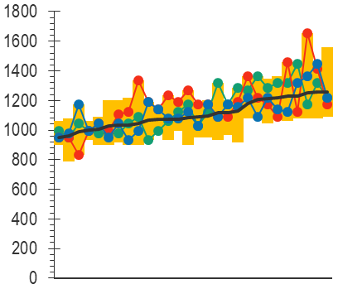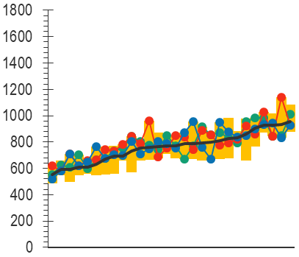

Measure #1

Measure #2

Measure #3

Mean

**TUNEL**

**Cleaved Dcp‑1**

**Experimenter 1**

**Experimenter 2**

**Experimenter 3**

Images

Images

Images

Images

Images

Images

**Supplementary** **Figure S1.** Individual experimenters' choice of threshold values.

Results of each experimenter manual determination of threshold in triplicate for the 28 images of the *vg > rbf1* genotype are presented for TUNEL (on the left) and anti‑cleaved Dcp‑1 (on the right). For every experimenter, the first measure is in green, the second in red and the third in blue. In order to facilitate comparison between experimenters, the mean of those 9 measures have been added (in black) and yellow bars correspond to experimenters' range of values for each image.

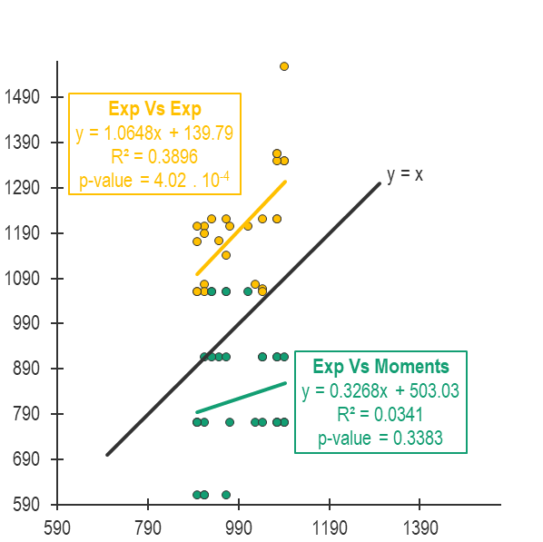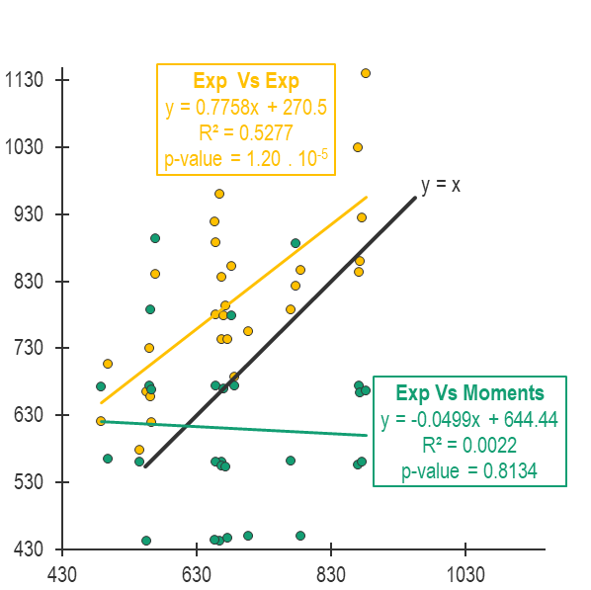

**Experimenter 1, measure 3**

**Moments**

**Experimenter 2, measure 1**

**Experimenter 3, measure 2**

**Moments**

**A: TUNEL**

**B: cleaved Dcp‑1**

**Experimenter 2, measure 1**

**Supplementary Figure S2**: Statistical analysis of threshold values consistency

Statistical analysis by linear regression of the threshold values obtained by experimenters or Moments for TUNEL (A) or anti‑cleaved Dcp‑1 (B) stainings. In yellow, relationship between the two furthest experimenters datasets. In green, relationship between the values obtained with Moments and its closest experimenter dataset.

**Supplementary Figure 3**: Pairwise comparison of thresholding methods

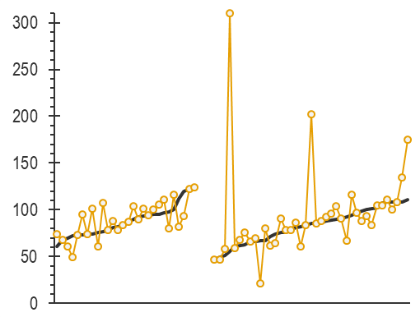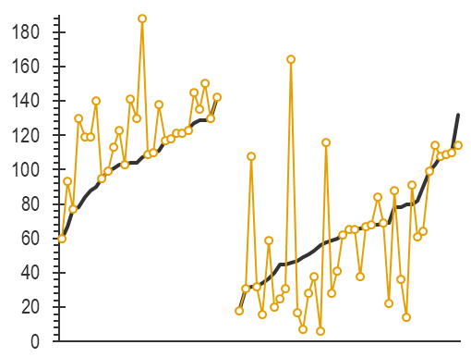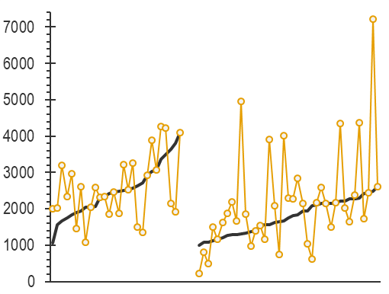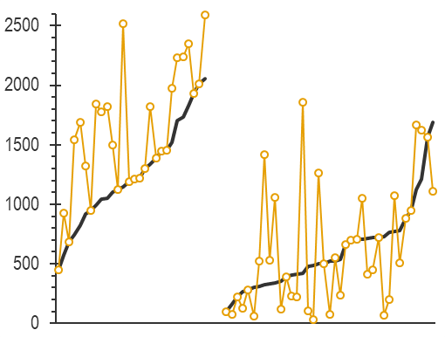

*vg > rbf1*

*vg > rbf1, debclE26*

*vg > rbf1*

*vg > rbf1, debclE26*

*vg > rbf1*

*vg > rbf1, debclE26*

*vg > rbf1*

*vg > rbf1, debclE26*

Manual

Total

**TUNEL**

**Cleaved Dcp‑1**

**Count**

**Area**

Results presented here are the same as the one presented Figure 5 (e‑h) but in a pairwise organization. Upper panel presents the number of object counted for TUNEL (on the left) and anti‑cleaved Dcp‑1 (on the right) for both *vg > rbf1* and *vg > rbf1, debclE26* after applying different thresholding methods (Manual in black, Total in yellow). Bottom panel similarly presents the total number of white pixels after applying different thresholding methods. Images order have been reorganized for each panel in ascending order of results according to Manual method.