Appendix A

Table A1. Clinical features and basal levels of IL-1β cytokine in migraine patients (n = 64).
Patient | Gender | Age | Age of onset | Duration of Disease | Type of migraine | Hearing Loss | IL-1ß  levels
1 | woman | 25 | 20 | 5 | with aura | No | 2.65
2 | woman | 26 | 12 | 14 | without aura | No | 1.24
3 | man | 21 | 15 | 6 | with aura | No | 4.21
4 | man | 17 | 12 | 5 | without aura | No | 4.40
5 | man | 53 | 12 | 40 | with aura | No | 4.78
6 | man | 55 | 15 | 40 | without aura | No | 0
7 | man | 33 | 12 | 11 | without aura | No | 5.02
8 | man | 39 | 32 | 7 | with aura | No | 5.77
9 | woman | 24 | 10 | 14 | without aura | No | 0.43
10 | man | 20 | 13 | 7 | with aura | No | 0
11 | man | 30 | 12 | 18 | with aura | No | 0
12 | man | 39 | 13 | 26 | without aura | No | 0
13 | woman | 47 | 20 | 27 | without aura | No | 0.02
14 | woman | 15 | 13 | 2 | with aura | No | 0
15 | woman | 34 | 33 | 1 | without aura | No | 26.31
16 | woman | 38 | 33 | 5 | with aura | No | 6.88
17 | woman | 40 | 29 | 11 | with aura | Yes | 474.76
18 | woman | 32 | 15 | 17 | without aura | No | 7.40
19 | woman | 34 | 20 | 13 | with aura | No | 1.34
20 | woman | 25 | 22 | 3 | with aura | No | 2.53
21 | woman | 20 | 14 | 6 | without aura | No | 6.03
22 | woman | 41 | 38 | 3 | without aura | No | 3.49
23 | woman | 59 | 14 | 45 | with aura | No | 29.77
24 | woman | 27 | 25 | 2 | with aura | No | 69.34
25 | woman | 37 | 31 | 6 | without aura | No | 1149.73
26 | woman | 34 | 31 | 3 | with aura | Yes | 155.70
27 | woman | 25 | 18 | 7 | without aura | No | 1.13
28 | man | 25 | 8 | 17 | with aura | No | 1.74
29 | man | 35 | 15 | 20 | without aura | No | 1.54
30 | woman | 45 | 20 | 25 | without aura | No | 1.74
31 | man | 43 | 35 | 8 | with aura | No | 2.92
32 | woman | 51 | 47 | 4 | without aura | No | 8.58
33 | woman | 24 | 8 | 16 | without aura | No | 2.14
34 | woman | 14 | 14 | 1 | with aura | No | 1.34
35 | man | 16 | 7 | 9 | without aura | No | 2.14
36 | man | 28 | 25 | 3 | without aura | No | 1.54
37 | woman | 38 | 22 | 16 | with aura | No | 1.34
38 | woman | 42 | 20 | 22 | without aura | No | 1.74
39 | woman | 61 | 30 | 31 | without aura | No | 2.53
40 | woman | 38 | 18 | 20 | with aura | No | 1.13
41 | woman | 37 | 16 | 21 | without aura | No | 0.72
42 | woman | 57 | 30 | 27 | with aura | No | 6.30
43 | woman | 43 | 38 | 5 | without aura | No | 0.93
44 | man | 68 | 31 | 37 | without aura | No | 0.72
45 | woman | 43 | 27 | 16 | without aura | No | 1.54
46 | woman | 63 | 45 | 18 | without aura | No | 15.71
47 | woman | 31 | 27 | 4 | without aura | No | 0.72
48 | man | 57 | 40 | 17 | without aura | No | 0.93
49 | woman | 20 | 18 | 2 | without aura | No | 0
50 | woman | 31 | 27 | 4 | with aura | No | 4.82
51 | woman | 50 | 30 | 20 | without aura | No | 1.34
52 | woman | 41 | 40 | 1 | with aura | No | 6.85
53 | woman | 50 | 46 | 4 | with aura | No | 1.74
54 | woman | 29 | 24 | 5 | without aura | No | 0.72
55 | woman | 54 | 48 | 6 | without aura | No | 1.34
56 | woman | 54 | 34 | 20 | without aura | No | 1.24
57 | woman | 60 | 20 | 40 | with aura | No | 2.73
58 | woman | 42 | 22 | 20 | without aura | No | 4.26
59 | man | 32 | 24 | 8 | with aura | No | 3.30
60 | woman | 67 | 45 | 22 | without aura | No | 2.53
61 | man | 52 | 37 | 15 | without aura | No | 0.0
62 | woman | 39 | 34 | 5 | without aura | No | 5.75
63 | woman | 52 | 32 | 20 | without aura | Yes | 3.69
64 | woman | 55 | 36 | 19 | without aura | No | 0.93

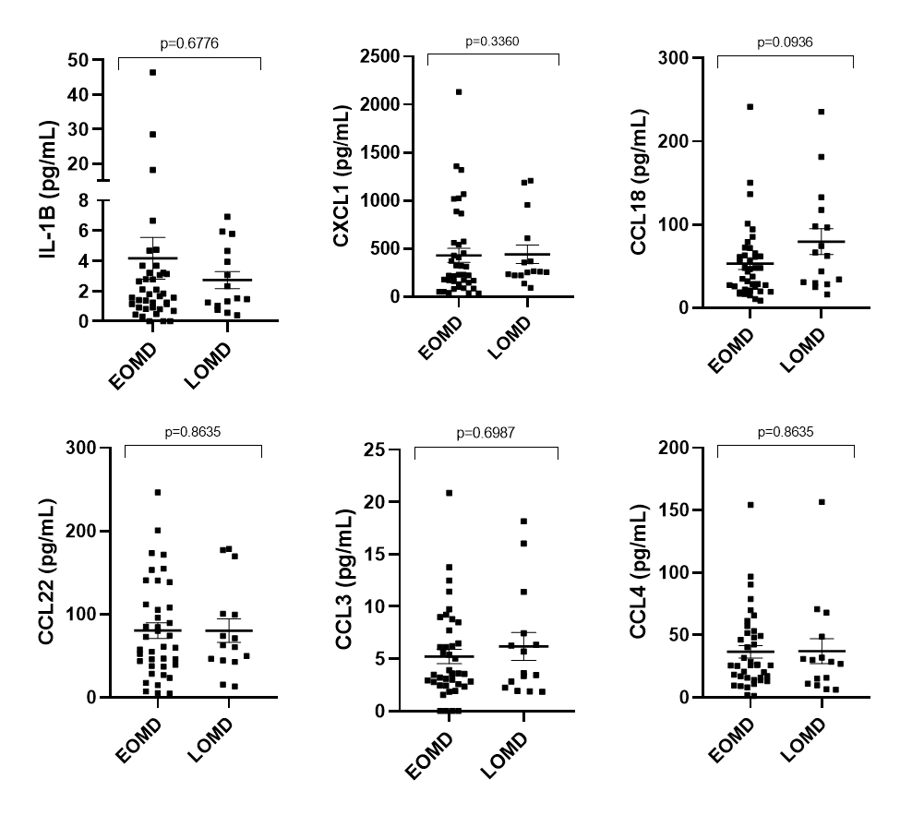
Figure A1. Scattered plot showing cytokines levels in the supernatant of PBMCs from patients with EOMD and LOMD.

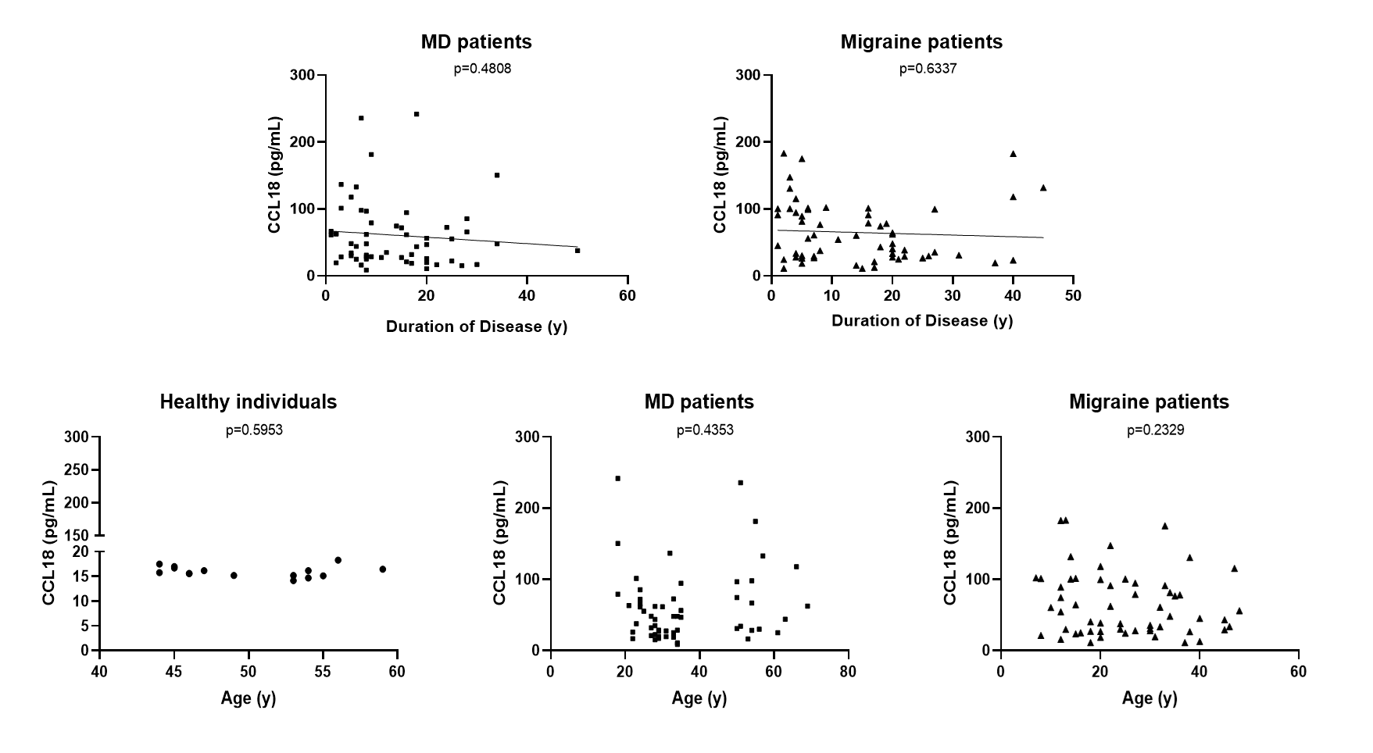
Figure A2. Scattered plots showing CCL18 levels as a function of age of patients and years of disease evolution in healthy controls, patients with MD and migraine. No association was found between CCL18 levels and duration of disease or age of individuals.

