Supporting information

Dissecting the innate immunological effect of mild hyperthermia in U87 human glioblastoma cells

Stefano Persano^{1,*}, Francesco Vicini¹, Alessandro Poggi², Maria L Guevara³, Leonardo Jordi Castrillo Fernandez², Giusy Maria Rita Rizzo¹, Helena Gavilán¹, Niccolo Silvestri¹, and Teresa Pellegrino^{1,*}
¹ Nanomaterials for Biomedical Applications Department, Istituto Italiano di Tecnologia (IIT), via Morego 30, 16163 Genoa, Italy.
² Molecular Oncology and Angiogenesis Unit, IRCCS Ospedale Policlinico San Martino, 16132 Genoa, Italy.
³ Department of Experimental Medicine (DIMES), University of Genoa, 16132 Genoa, Italy.

* Co-corresponding authors: e-mail: stefano.persano@iit.it; e-mail: teresa.pellegrino@iit.it

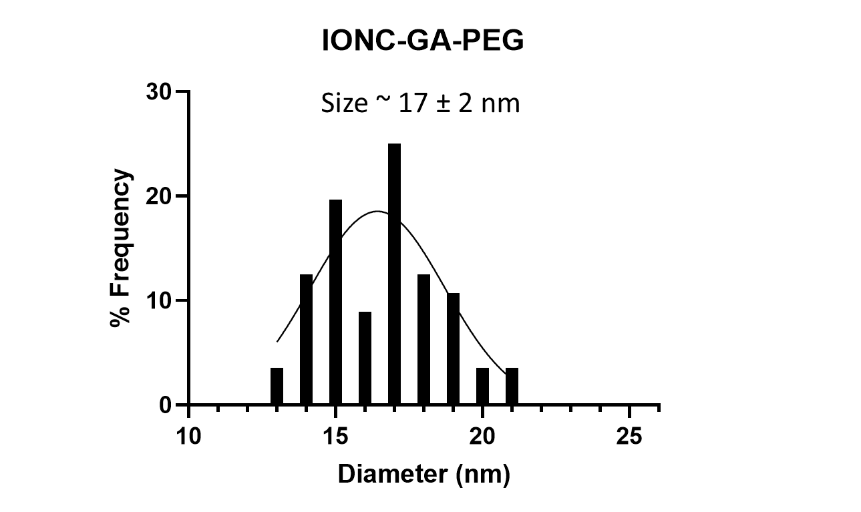
Figure S1. Histogram of size distribution and Gaussian fitting curve of IONC-GA-PEG analyzed by TEM.

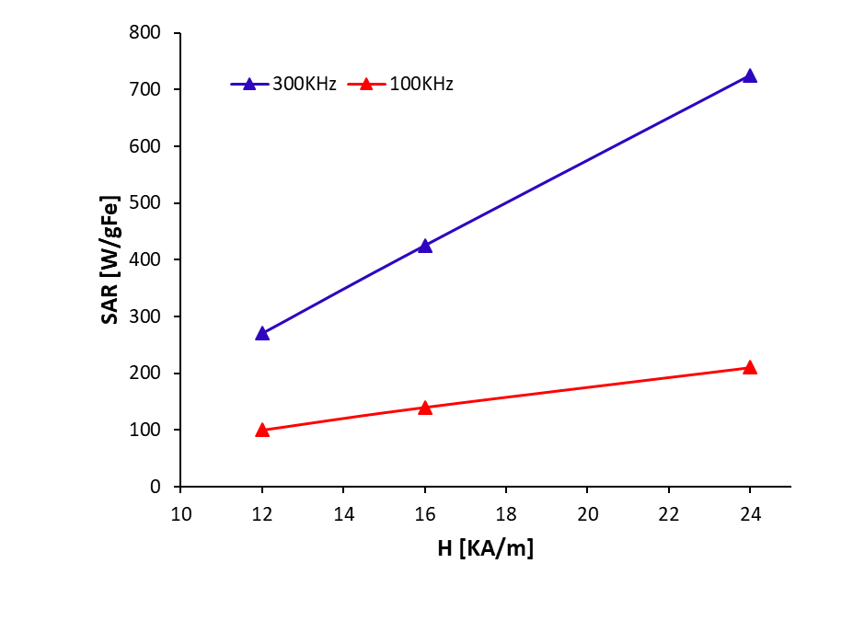
Figure S2. SAR values of IONC-GA-PEG at frequencies of 100 (red triangles) and 300 (blue triangles) kHz, and field amplitudes of 12, 16 and 24 kA/m.
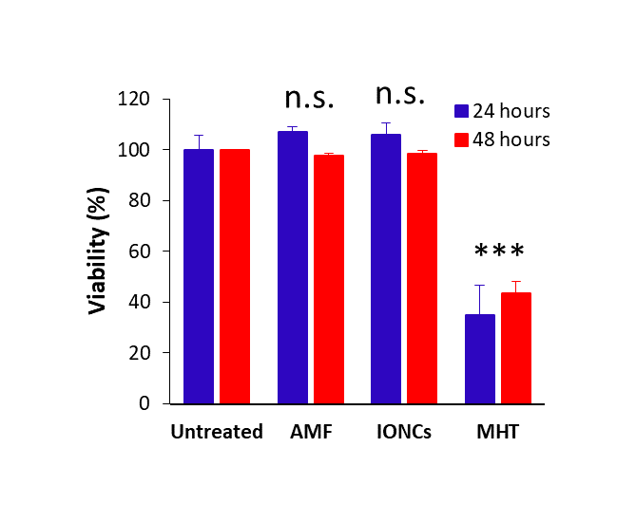
Figure S3. Evaluation of cell viability of U87 cells exposed to various treatment conditions, such as no treatment (untreated group), AMF, IONCs at a concentration of 2 g_{Fe}/L and MHT (2 g_{Fe}/L of IONCs + AMF). Cell viability was determined by CCK-8 assay at 24 and 48 hours post-treatment. Statistical analysis was conducted via two-tailed unpaired student’s t test (*0.01 < P < 0.05; **0.001 < P < 0.01; ***P < 0.001; n.s.= not significant).
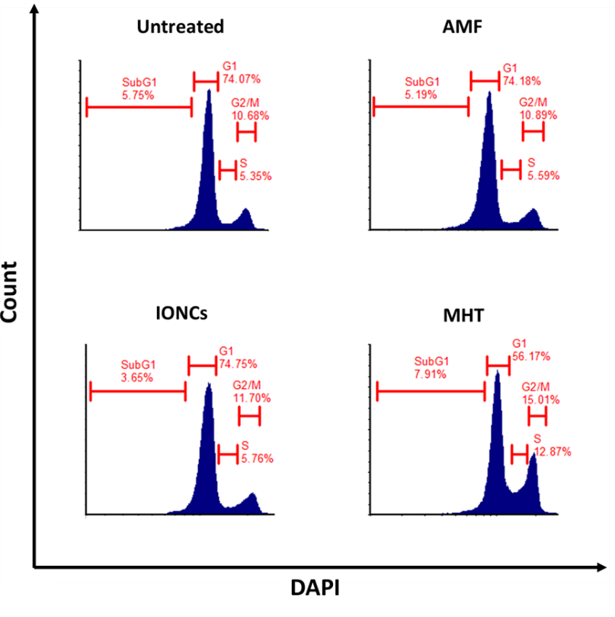
Figure S4. Flow cytometry analysis of cell cycle in U87 cells after 24 hours post-treatment with AMF, IONCs or MHT compared to untreated cells. Representative figures of cell cycle distribution (SubG1. G0/G1, S, and G2/M) showing accumulation of MHT-treated cells in S and G2/M phases.

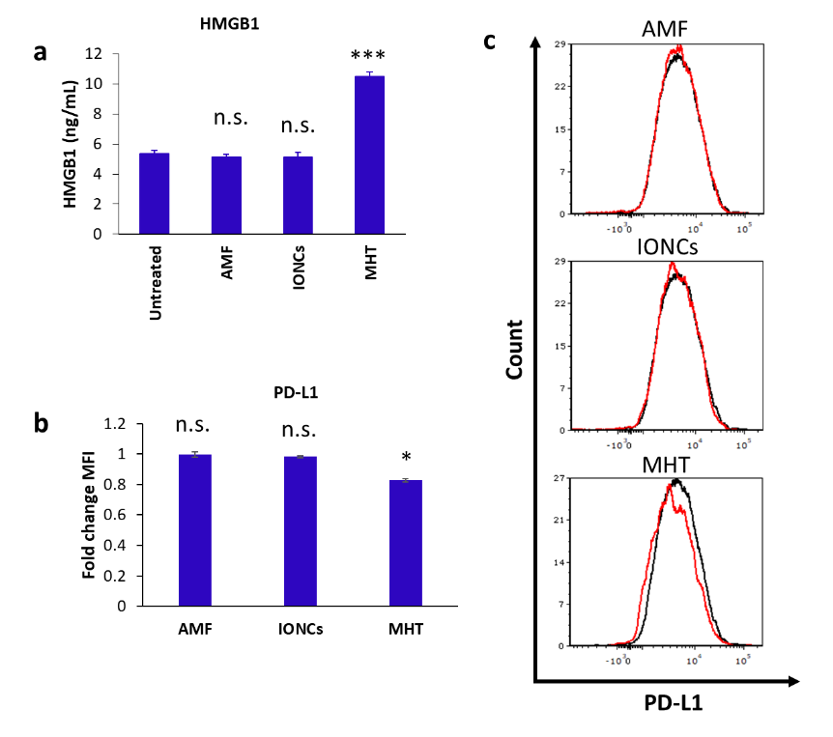
Figure S5. Release of HMGB1 in response to MHT treatment was evaluated by ELISA (a). The expression of PD-L1 on the surface of untreated cells or U87 cells exposed to different treatment (AMF, IONCs and MHT) was evaluated by flow cytometry (b,c). Data are shown as expressed as average fold change (mean ± SD) of the mean fluorescence intensity (MFI) of three independent experiments (n = 3) and as representative histograms. Statistical analysis was conducted via two-tailed unpaired student’s t test (*0.01 < P < 0.05; **0.001 < P < 0.01; ***P < 0.001; n.s.= not significant).

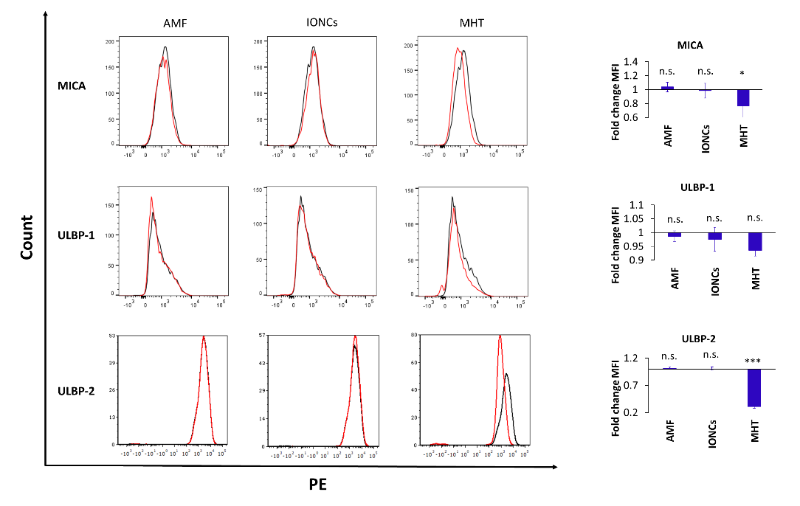
Figure S6. Flow cytometric evaluation of changes in surface expression of MICA, ULBP-1 and B7H6 in U87 cells exposed to different treatments (AMF, IONCs and MHT) compared to untreated cells at 24 hours post-treatment. Data are shown as representative histograms and expressed as average fold change (mean ± SD) of the mean fluorescence intensity (MFI) of three independent experiments (n = 3). Statistical analysis was conducted via two-tailed unpaired student’s t test (*0.01 < P < 0.05; **0.001 < P < 0.01; ***P < 0.001; n.s.= not significant).
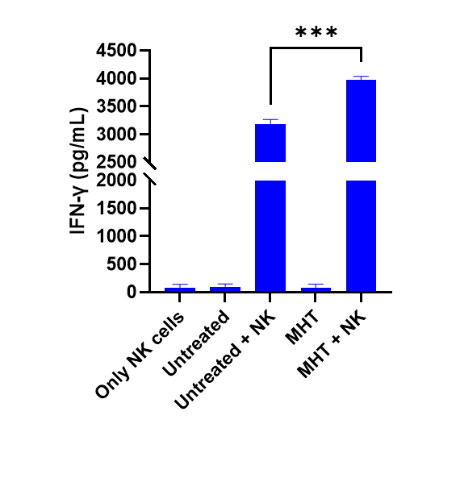
Figure S7. Analysis of IFN-γ secretion by IL-2-activated NK cells co-cultured with untreated or treated U87 GBM cells. Only NK cells and, untreated and MHT-treated U87 (MHT) cells alone were included as control groups. Data are shown as mean ± SEM of three experiments. Statistical analysis was performed using a one-way ANOVA test (*0.01 < p < 0.05; **0.001 < p < 0.01; ***p < 0.001; n.s.= not significant).

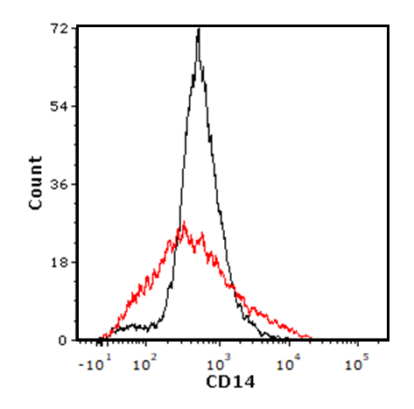

Figure S8. Evaluation of CD14 expression on THP-1 cells before and after macrophage differentiation by flow cytometry.

