SUPPLEMENTAL MATERIAL – FIGURES LEGEND

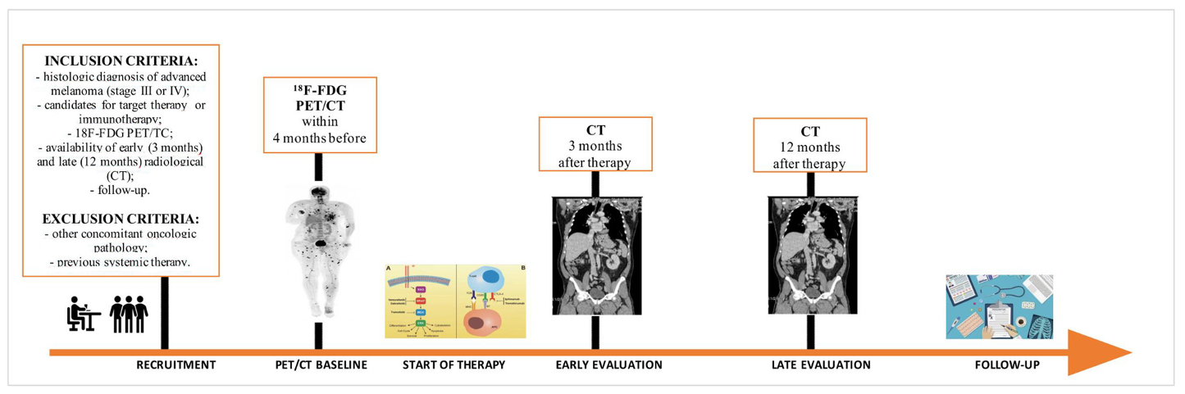
Figure S1. Study workflow.

Figure S2. Optimal cut-offs of semi-quantitative parameters to predict responder vs non-responder patients at 12 months defined using the receiver operating characteristic (ROC) curve.
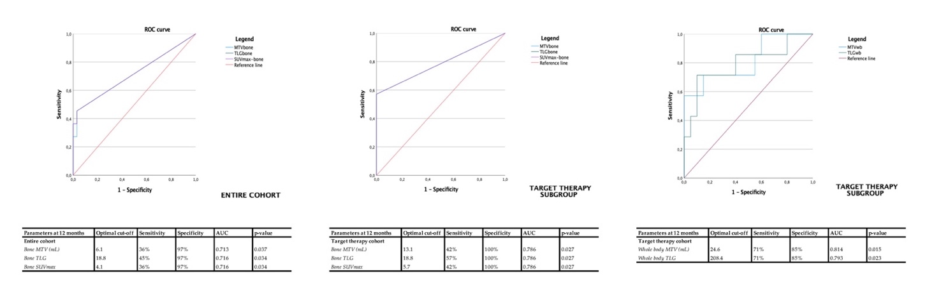

Figure S3. Optimal cut-offs of semi-quantitative parameters to predict PFS and OS defined using the receiver operating characteristic (ROC) curve.

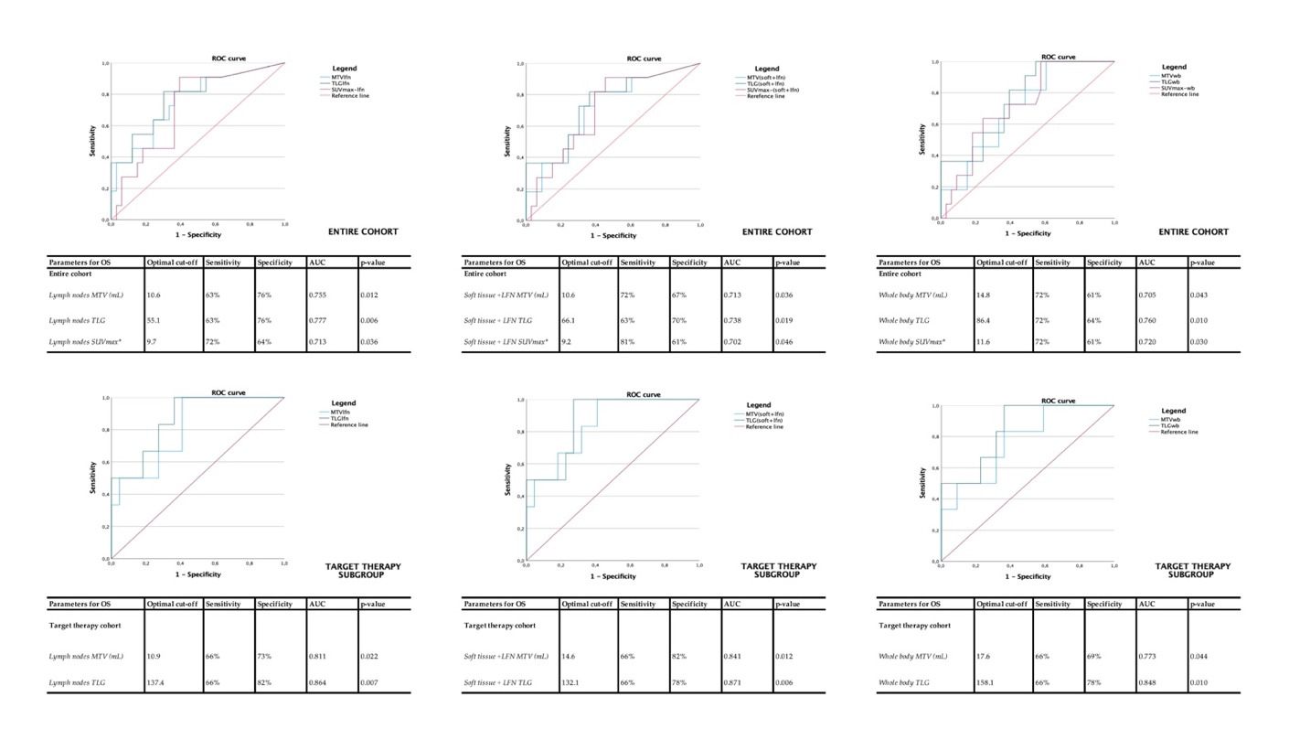

SUPPLEMENTAL MATERIAL – TABLE LEGEND

Table S1. Semi-quantitative parameters extrapolated for each district from the PET images.

Parameters  mean ± SD (range) | Entire cohort  (44/44) | Target therapy cohort (28/44) | Immunotherapy cohort (16/44)
Soft tissue MTV (mL)  Soft tissue TLG  Soft tissue SUVmax* | 5.3 ± 15.3 (0.0 - 77.5)  25.8 ± 75.4 (0.0 – 336.4)  2.9 ± 6.2 (0.0 - 25.6) | 3.0 ± 9.5 (0.0 - 49.4) **  19.1 ± 66.3 (0.0 – 336.4)  3.1 ± 6.0 (0.0 – 25.6) | 9.3 ± 21.9 (0.0 – 77.5) **  37.7 ± 90.3 (0.0 – 269.5)  2.6 ± 6.6 (0.0 – 24.5)
Lymph nodes MTV (mL)  Lymph nodes TLG  Lymph nodes SUVmax* | 19.2 ± 49.9 (0.0 – 304.4)  133.9 ± 289.3 (0.0 – 1634.5)  12.1 ± 17.2 (0.0 – 82.3) | 25.2 ± 61.2 (0.0 – 304.4)  166.8 ± 337.6 (0.0 – 1634.5)  14.2 ± 20.1 (0.0 – 82.3) | 8.8 ± 14.3 (0.0 – 49.7)  76.3 ± 171.1 (0.0 – 682.9)  8.4 ± 9.9 (0.0 – 28.7)
Soft tissue +LFN MTV (mL)  Soft tissue + LFN TLG  Soft tissue + LFN SUVmax* | 24.6 ± 53.8 (0.0 – 304.4)  159.8 ± 308.3 (0.0 – 1634.5)  12.6 ± 17.1 (0.0 – 82.3) | 28.2 ± 64.8 (0.0 – 304.4)  185.9 ± 361.5 (0.0 – 1634.5)  14.8 ± 19.9 (0.0 – 82.3) | 18.2 ± 25.6 (0.0 – 79.0)  114.1 ± 183.8 (0.0 – 682.9)  8.8 ± 10.1 (0.0 – 28.7)
Lung MTV (mL)  Lung TLG  Lung SUVmax* | 2.0 ± 3.7 (0.0 – 16.1)  10.2 ± 25.5 (0.0 – 143.4)  2.9 ± 4.9 (0.0 – 18.4) | 0.7 ± 2.5 (0.0 – 12.4) **  1.9 ± 7.2 (0.0 – 36.2) **  0.7 ± 2.0 (0.0 – 9.5) ** | 4.2 ± 4.3 (0.0 – 16.1) **  24.6 ± 37.8 (0.0 – 143.4) **  6.6 ± 6.2 (0.0 – 18.4) **
Liver MTV (mL)  Liver TLG  Liver SUVmax* | 0.7 ± 2.9 (0.0 – 16.76)  5.0 ± 25.5 (0.0 – 166.0)  1.5 ± 8.9 (0.0 – 59.2) | 0.9 ± 3.6 (0.0 – 16.7)  7.2 ± 31.8 (0.0 – 166.0)  2.2 ± 11.1 (0.0 – 59.2) | 0.2 ± 1.1 (0.0 – 4.6)  1.2 ± 5.1 (0.0 – 20.7)  0.3 ± 1.5 (0.0 – 6.3)
Bone MTV (mL)  Bone TLG  Bone SUVmax* | 3.3 ± 10.4 (0.0 – 49.1)  12.7 ± 40.9 (0.0 – 236.5)  2.2 ± 9.5 (0.0 -61.9) | 4.0 ± 12.1 (0.0 – 49.1)  15.9 ± 49.1 (0.0 – 236.5)  3.0 ± 11.8 (0.0 – 61.9) | 2.2 ± 6.5 (0.0 – 24.4)  7.2 ± 19.9 (0.0 – 66.0)  0.8 ± 2.6 (0.0 – 9.8)
Other MTV (mL)  Other TLG  Other SUVmax* | 1.9 ± 6.9 (0.0 – 42.7)  12.8 ± 45.3 (0.0 – 253.6)  2.2 ± 7.5 (0.0 – 40.3) | 1.4 ± 3.6 (0.0 – 15.1)  10.8 ± 32.2 (0.0 – 131.0)  2.9 ± 9.1 (0.0 – 40.3) | 2.7 ± 10.6 (0.0 – 42.7)  16.1 ± 63.3 (0.0 – 253.6)  1.0 ± 3.0 (0.0 – 253.6)
Whole body MTV (mL)  Whole body TLG  Whole body SUVmax* | 32.7 ± 59.9 (0.8 – 329.5)  198.4 ± 326.2 (1.5 – 1732.9)  15.5 ± 16.0 (1.2 – 82.3) | 35.5 ± 72.0 (0.8 – 329.5)  218.4 ± 384.4 (1.5 – 1732.9)  16.4 ± 19.4 (1.7 – 82.3) | 27.7 ± 30.6 (1.5 – 103.5)  163.4 ± 192.5 (5.2 – 682.9)  14.0 ± 7.3 (1.2 – 28.7)
NOTE: LFN = lymph nodes; MTV = metabolic tumor volume, SUVmax= maximum standardize uptake value, TLG = total lesion glycolysis.
* Corresponds to the highest SUVmax found in each district.
** The only statistically different means to Levine's test (p<0.05), comparing the means of the two sub-cohorts (target therapy vs immunotherapy).

Table S2. Semi-quantitative parameters extrapolated for each district from the PET images associated to early and late response assessment results.

Parameters | Entire cohort  (44/44) |  |  | Target therapy cohort  (28/44) |  |  | Immunotherapy cohort  (16/44)
At 3 months | Responders  (mean) | Non responders (mean) | p value | Responders  (mean) | Non responders (mean) | p value | Responders  (mean) | Non responders (mean) | p value
Soft tissue MTV (mL)  Soft tissue TLG  Soft tissue SUVmax* | 5.2  22.8  2.4 | 5.8  45.2  6.2 | 0.881  0.726  0.628 | 3.2  20.1  2.4 | 0.4  6.6  12.8 | 0.936  0.640  0.476 | 9.6  28.8  2.5 | 8.6  64.6  2.9 | 0.935  0.862  0.862
Lymph nodes MTV (mL)  Lymph nodes TLG  Lymph nodes SUVmax* | 21.9  149.4  11.6 | 2.9  36.0  15.6 | 0.245  0.431  0.777 | 26.9  173.1  12.7 | 3.3  86.1  34.7 | 0.381  0.698  0.894 | 11.0  98.2  9.3 | 2.6  11.0  6.0 | 1.000  0.862  0.862
Soft tissue +LFN MTV (mL)  Soft tissue + LFN TLG  Soft tissue + LFN SUVmax* | 27.1  172.3  12.0 | .87  81.3  16.5 | 0.259  0.514  0.881 | 30.1  193.2  13.3 | 3.7  92.6  34.7 | 0.296  0.582  0.963 | 20.6  127.0  9.4 | 11.2  75.7  7.4 | 1.000  0.953  1.000
Lung MTV (mL)  Lung TLG  Lung SUVmax* | 1.9  9.6  2.5 | 2.8  14.5  5.4 | 0.493  0.451  0.431 | 0.9  2.1  0.8 | 0.0  0.0  0.0 | 0.698  0.698  0.698 | 4.2  25.6  6.2 | 4.2  21.8  8.1 | 0.684  0.684  0.684
Liver MTV (mL)  Liver TLG  Liver SUVmax* | 0.7  5.3  1.7 | 0.8  3.5  1.1 | 0.701  0.701  0.677 | 1.0  7.8  2.4 | 0.0  0.0  0.0 | 0.894  0.894  0.894 | 0.0  0.0  0.0 | 1.2  5.2  1.6 | 0.521  0.521  0.521
Bone MTV (mL)  Bone TLG  Bone SUVmax* | 2.3  6.8  2.0 | 10.1  50.4  3.7 | 0.374  0.356  0.356 | 2.5  8.1  2.8 | 24.6  118.3  6.2 | 0.339  0.339  0.381 | 2.0  4.1  0.4 | 2.8  16.5  2.5 | 0.684  0.599  0.599
Other MTV (mL)  Other TLG  Other SUVmax* | 2.0  14.0  2.4 | 1.2  5.0  1.2 | 1.000  0.987  0.987 | 1.3  10.6  2.9 | 3.6  15.0  3.5 | 0.529  0.476  0.476 | 3.6  21.5  1.4 | 0.0  0.0  0.0 | 0.684  0.684  0.684
Whole body MTV (mL)  Whole body TLG  Whole body SUVmax* | 34.2  205.4  14.6 | 23.6  154.7  22.1 | 0.987  0.582  0.289 | 35.9  217.9  14.6 | 32.0  225.9  40.9 | 0.640  0.296  0.222 | 30.5  178.3  14.5 | 19.4  119.1  12.7 | 0.599  0.684  0.862
Parameters | Entire cohort  (44/44) |  |  | Target therapy cohort  (28/44) |  |  | Immunotherapy cohort  (16/44)
At 12 months | Responders  (mean) | Non responders (mean) | p value | Responders  (mean) | Non responders (mean) | p value | Responders  (mean) | Non responders (mean) | p value
Soft tissue MTV (mL)  Soft tissue TLG  Soft tissue SUVmax* | 4.6  16.8  3.1 | 7.8  54.7  3.0 | 0.945  0.924  0.945 | 1.6  9.6  3.4 | 7.4  49.0  3.0 | 0.935  0.893  0.935 | 9.6  28.8  2.5 | 8.6  64.6  2.9 | 0.953  0.862  0.862
Lymph nodes MTV (mL)  Lymph nodes TLG  Lymph nodes SUVmax* | 9.4  86.3  11.3 | 48.7  279.5  15.0 | 0.433  0.301  0.651 | 8.5  79.2  12.4 | 75.1  432.9  20.1 | 0.179  0.104  0.431 | 11.0  98.2  9.3 | 2.6  11.0  6.0 | 1.000  0.862  0.862
Soft tissue +LFN MTV (mL)  Soft tissue + LFN TLG  Soft tissue + LFN SUVmax* | 14.0  103.1  11.7 | 56.6  334.2  15.5 | 0.501  0.276  0.573 | 10.1  88.8  13.1 | 82.5  481.9  20.2 | 0.240  0.162  0.464 | 20.6  127.0  9.4 | 11.2  75.7  7.4 | 1.000  0.953  1.000
Lung MTV (mL)  Lung TLG  Lung SUVmax* | 1.6  9.7  2.5 | 2.8  9.4  3.6 | 0.450  0.519  0.555 | 0.1  0.2  0.2 | 2.0  2.4  1.0 | 0.431  0.431  0.464 | 4.2  25.6  6.2 | 4.2  21.8  8.1 | 0.684  0.684  0.684
Liver MTV (mL)  Liver TLG  Liver SUVmax* | 0.5  1.1  0.1 | 1.3  17.0  6.0 | 0.483  0.466  0.450 | 0.8  1.8  0.2 | 1.4  23.7  8.5 | 0.766  0.725  0.725 | 0.0  0.0  0.0 | 1.2  5.2  1.6 | 0.521  0.521  0.521
Bone MTV (mL)  Bone TLG  Bone SUVmax* | 0.8  1.5  0.1 | 11.3  46.5  8.7 | 0.037*  0.034*  0.034* | 0.0  0.0  0.0 | 16.2  63.7  12.3 | 0.026*  0.026*  0.026* | 2.0  4.1  0.4 | 2.8  16.5  2.5 | 0.684  0.599  0.599
Other MTV (mL)  Other TLG  Other SUVmax* | 2.3  16.6  2.9 | 0.9  3.0  0.8 | 0.967  0.967  0.967 | 1.5  13.6  3.7 | 1.4  4.8  1.2 | 0.725  0.685  0.685 | 3.6  21.5  1.4 | 0.0  0.0  0.0 | 0.684  0.684  0.684
Whole body MTV (mL)  Whole body TLG  Whole body SUVmax* | 19.3  129.0  14.7 | 73.2  410.2  18.6 | 0.117  0.082  0.433 | 12.6  99.4  14.9 | 104.0  576.5  22.0 | 0.013*  0.022*  0.314 | 30.5  178.3  14.5 | 19.4  119.1  12.7 | 0.599  0.684  0.862
NOTE: LFN = lymph nodes; MTV = metabolic tumor volume, SUVmax= maximum standardize uptake value, TLG = total lesion glycolysis.
* The only statistically different means to Mann-Whitney test (p<0.05).

