The artemiside-artemisox-artemisone-M1 tetrad: efficacies against blood stage *P. falciparum* parasites, DMPK properties, and the case for artemiside.

Liezl Gibhard 1, Dina Coertzen 2, Janette Reader 2, Mariëtte E. van der Watt 2, Lyn-Marie Birkholtz 2, Ho Ning Wong 3, Kevin T. Batty 4, Richard K. Haynes 3* and Lubbe Wiesner 5*

1. H3D, Department of Chemistry, University of Cape Town, Observatory, 7925, Cape Town, South Africa.
2. Malaria Parasite Molecular Laboratory, Department of Biochemistry, Genetics and Microbiology, Institute for Sustainable Malaria Control, University of Pretoria, Pretoria, South Africa.
3. Centre of Excellence for Pharmaceutical Sciences, Faculty of Health Sciences, North-West University, Potchefstroom, 2520, South Africa
4. Curtin Medical School, Curtin University, Bentley, Western Australia, 6102.
5. Division of Clinical Pharmacology, Department of Medicine, University of Cape Town, Observatory, 7925, Cape Town, South Africa

**Supplementary Material**

**S1. Efficacy of artemisox**: Dose-response curves of artemisox **6** against asexual blood stages and gametocytes of *Plasmodium falciparum* (*Pf*).

**Fig. S1a**:Dose response curve of artemisox against the asexual blood stages of *Pf* NF54. The curve represents three independent biological repeats (n=3), ± SEM.



**Fig. S1b**:Dose response curve of artemisox against the asexual blood stages of *Pf* K1. The curve represents three independent biological repeats (n=3), ± SEM.



**Fig. S1c**: Dose response curve of artemisox against the asexual blood stages of *Pf* W2. The curve represents three independent biological repeats (n=3), ± SEM.



**Fig. S1d**:Dose response curve of artemisox against early stage *Pf* NF54 gametocytes determined with the luciferase assay. Dose response was obtained at 48 h incubation. Each curve represents three independent biological repeats (n=3), ± SEM**.**



**Fig. S1e**: Dose response curve of artemisox against late stage *Pf* NF54 gametocytes determined with the luciferase assay. Dose response was obtained at 72 h. Each curve represents three independent biological repeats (n=3), ± SEM.



**S2. Efficacy of M1**: Dose-response curves of M1 **8** against asexual blood stages and gametocytes of *Plasmodium falciparum*.

**Fig. S2a**:Dose response curve of M1 against the asexual blood stages of *Pf* NF54. The curve represents three independent biological repeats (n=3), ± SEM.



**Fig. S2b**:Dose response curve of M1 against the asexual blood stages of *Pf* K1. The curve represents three independent biological repeats (n=3), ± SEM.

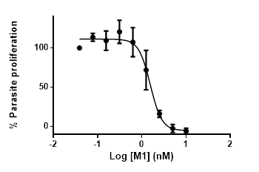

**Fig. S2c**: Dose response curve of M1 against the asexual blood stages of *Pf* W2. The curve represents three independent biological repeats (n=3), ± SEM.



**Fig. S2d**:Dose response curve of M1 against early stage *Pf* NF54 gametocytes determined with the luciferase assay. Dose response was obtained at 48 h incubation. Each curve represents three independent biological repeats (n=3), ± SEM**.**



**S3. Pharmacokinetics and Metabolism**:Circulating concentrations of each of artemiside **5**, artemisox **6** and artemisone **7** and respective metabolites (µM) after iv and po dosing of parent compounds in mice; iv = intravenous, po = oral; sd = standard deviation, blq = below limit of quantitation; n/a not available; n = no. of mice used.

**Dosing of Artemiside****5**

**Table S3a**: Concentrations of artemiside **5**

|  |  |  |  |  |  |  |
| --- | --- | --- | --- | --- | --- | --- |
| Time (h) | Mean iv (µM) | sd | n | Mean po (µM) | sd | n |
| 0.08 | 6.241 | 0.914 | 3 | 0.085 | 0.027 | 3 |
| 0.25 | 3.555 | 1.020 | 3 | 0.109 | 0.004 | 3 |
| 0.5 | 1.711 | 0.348 | 3 | 0.135 | 0.014 | 3 |
| 1 | 0.930 | 0.281 | 3 | 0.119 | 0.008 | 3 |
| 3 | 0.180 | 0.088 | 3 | 0.058 | 0.023 | 3 |
| 5 | 0.086 | 0.036 | 3 | 0.012 | 0.002 | 3 |
| 7 | 0.037 | 0.014 | 3 | 0.006 | 0.001 | 2 |
| 24 | 0.008 | 0.003 | 3 | blq | n/a | n/a |

**Table S3b**: Concentrations of artemisox **6** afterdosing of artemiside **5**

|  |  |  |  |  |  |  |
| --- | --- | --- | --- | --- | --- | --- |
| Time (h) | Mean iv (µM) | sd | n | Mean po (µM) | sd | n |
| 0.08 | 1.926 | 0.400 | 3 | 1.864 | 0.260 | 3 |
| 0.25 | 1.817 | 0.400 | 3 | 2.150 | 0.382 | 3 |
| 0.5 | 1.376 | 0.339 | 3 | 2.510 | 0.282 | 3 |
| 1 | 0.674 | 0.388 | 3 | 2.026 | 0.183 | 3 |
| 3 | 0.066 | 0.017 | 3 | 0.286 | 0.228 | 3 |
| 5 | 0.020 | 0.001 | 3 | 0.007 | 0.001 | 3 |
| 7 | 0.011 | 0.004 | 3 | 0.005 | 0.000 | 1 |
| 24 | 0.005 | 0.000 | 2 | blq | n/a | n/a |

**Table S3c**: Concentrations of artemisone **7** afterdosing of artemiside **5**

|  |  |  |  |  |  |  |
| --- | --- | --- | --- | --- | --- | --- |
| Time (h) | Mean iv (µM) | sd | n | Mean po (µM) | sd | n |
| 0.08 | 0.117 | 0.015 | 3 | 1.003 | 0.051 | 3 |
| 0.25 | 0.247 | 0.068 | 3 | 1.387 | 0.177 | 3 |
| 0.5 | 0.270 | 0.093 | 3 | 1.786 | 0.135 | 3 |
| 1 | 0.160 | 0.102 | 3 | 1.671 | 0.104 | 3 |
| 3 | 0.012 | 0.007 | 3 | 0.179 | 0.137 | 3 |
| 5 | 0.005 | 0.000 | 1 | blq | n/a | n/a |
| 7 | blq | n/a | n/a | blq | n/a | n/a |
| 24 | blq | n/a | n/a | blq | n/a | n/a |

**Fig. S3a**:LC-MS/MS chromatogram indicating presence of M1 following dosing of artemiside.a



**a**As determined by LC-MS/MS analysis with an AB SCIEX 5500 QTRAP instrument coupled with an Agilent 1260 HPLC detection system measured on mass of molecular ion [M+ H]+ (Transition 400.2/163.1) (ref. S[1]).

**Dosing of Artemisox** **6**

**Table S3d**: Concentrations of artemisox **6**

|  |  |  |  |  |  |  |
| --- | --- | --- | --- | --- | --- | --- |
| Time (h) | Mean iv (µM) | sd | n | Mean po (µM) | sd | n |
| 0.08 | 1.897 | 1.181 | 3 | 3.043 | 0.512 | 3 |
| 0.25 | 2.420 | 0.537 | 3 | 4.207 | 2.670 | 3 |
| 0.5 | 1.920 | 0.608 | 3 | 2.153 | 0.344 | 3 |
| 1 | 0.663 | 0.266 | 3 | 2.013 | 1.616 | 3 |
| 3 | 0.007 | 0.003 | 3 | 0.013 | 0.006 | 3 |
| 5 | 0.007 | 0.003 | 2 | 0.005 | 0.004 | 3 |
| 7 | blq | n/a | n/a | 0.004 | 0.001 | 2 |
| 24 | blq | n/a | n/a | blq | n/a | n/a |

**Table S3e**: Concentrations of artemisone **7** after dosing of artemisox **6**

|  |  |  |  |  |  |  |
| --- | --- | --- | --- | --- | --- | --- |
| Time (h) | Mean iv (µM) | sd | n | Mean po (µM) | sd | n |
| 0.08 | 1.112 | 0.716 | 3 | 3.643 | 0.328 | 3 |
| 0.25 | 1.404 | 0.138 | 3 | 3.534 | 0.997 | 3 |
| 0.5 | 1.250 | 0.181 | 3 | 3.686 | 0.792 | 3 |
| 1 | 0.659 | 0.164 | 3 | 3.202 | 0.156 | 3 |
| 3 | 0.007 | 0.000 | 1 | 0.048 | 0.018 | 3 |
| 5 | blq | n/a | n/a | 0.007 | 0.000 | 1 |
| 7 | blq | n/a | n/a | blq | n/a | n/a |
| 24 | blq | n/a | n/a | blq | n/a | n/a |

**Fig. S3b**:LC-MS/MS chromatogram indicating presence of M1 following dosing of artemisox.a

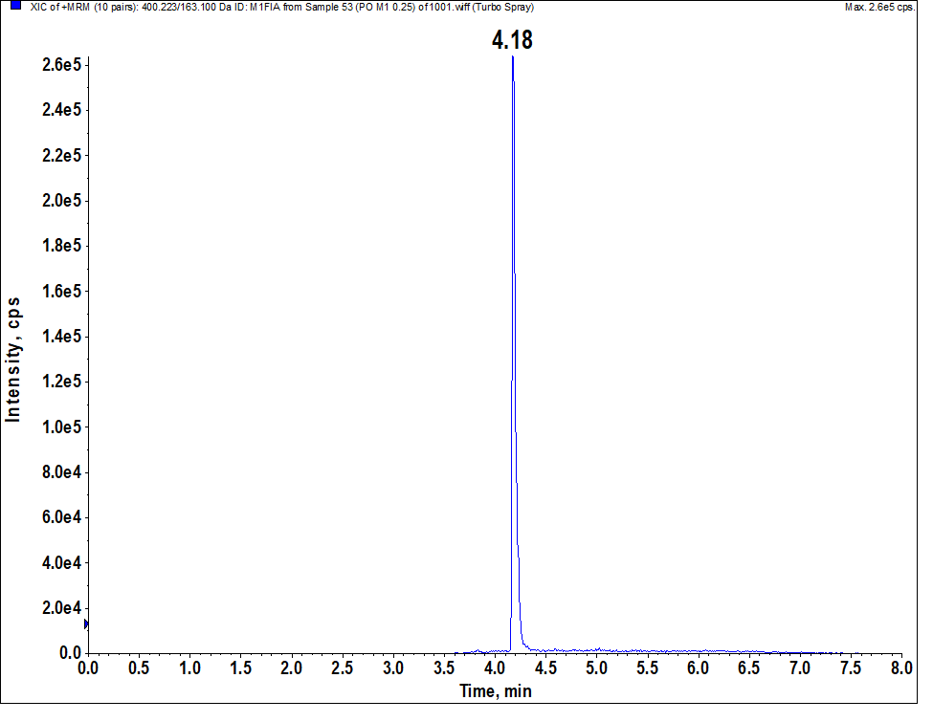

**a** As determined by LC-MS/MS analysis with an AB SCIEX 5500 QTRAP instrument coupled with an Agilent 1260 HPLC detection system measured on mass of molecular ion [M+ H]+ (transition 400.2/163.1) (ref.S1).

**Dosing of artemisone 7**

**Table S3f**: Concentration of artemisone **7**

|  |  |  |  |  |  |  |
| --- | --- | --- | --- | --- | --- | --- |
| Time (h) | Mean iv (µM) | sd | n | Mean po (µM) | sd | n |
| 0.08 | 3.864 | 0.854 | 3 | 1.626 | 0.466 | 3 |
| 0.25 | 2.506 | 0.691 | 3 | 1.523 | 0.163 | 3 |
| 0.5 | 1.715 | 0.389 | 3 | 1.135 | 0.249 | 3 |
| 1 | 0.831 | 0.374 | 3 | 0.357 | 0.096 | 3 |
| 3 | 0.028 | 0.021 | 3 | 0.012 | 0.010 | 3 |
| 5 | blq | n/a | n/a | blq | n/a | n/a |
| 7 | blq | n/a | n/a | blq | n/a | n/a |
| 24 | blq | n/a | n/a | blq | n/a | n/a |

**Fig. S3c**:LC-MS/MS chromatogram indicating presence of M1 following dosing of artemisone.a



**a** As determined by LC-MS/MS analysis with an AB SCIEX 5500 QTRAP instrument coupled with an Agilent 1260 HPLC detection system measured on mass of molecular ion [M+ H]+ (transition 400.2/163.1) (ref. S1).

**S4. *In vitro* efficacy data (references** **S[2],****S[3])**

**Table S4a:** *In vitro* antimalarial activities for chloroquine, mefloquine, atovaquone, DHA **2**, artesunate **3**, artemisone **6**, metabolite M1 **12** determined with the [3H]-hypoxanthine drug susceptibility assay (ref. S2).a

|  |  |  |  |  |  |  |
| --- | --- | --- | --- | --- | --- | --- |
| Compound | Antimalarial activities IC50 nM ± SEM | | | | | |
| D6 | W2 | 7G8 | TM93-C1088 | TM91-C235 | TM-C2B |
| Chloroquine CQ | 16 ± 2 | 195 ± 70 | 84 ± 18 | 360 ± 38 | 70 ± 12 | 95 ± 23 |
| Mefloquine MFQ | ND | ND | 5.4 ± 1.7 | 16 ± 5.0 | 107 ± 41 | 130 ± 51 |
| Atovaquone | ND | ND | 3.1±0.9 | 18,830 ± 5,102 | 2.2 ± 0.7 | 31,850 ± 6,833 |
| DHA **2** | 1.7 ± 0.4 | 2.2 ± 0.8 | 1.3 ± 0.2 | 1.4 ± 0.4 | 2.3 ± 0.7 | 2.0 ± 0.7 |
| Artesunate **4** | ND | 3.0 ± 1.6 | 1.5 ± 0.2 | 1.4 ± 0.1 | 2.9 ± 1.4 | 2.5 ± 0.5 |
| Artemisone **7** | 1.0 ± 0.4 | 1.3 ± 0.5 | 0.8 ± 0.1 | 0.7 ± 0.2 | 1.1 ± 0.5 | 1.1 ± 0.4 |
| Metabolite M1 **8** | 4.7 ± 0.2 | 6.6 ± 0.4 | 2.6 ± 0.8 | 2.5 ± 0.4 | 5.0 ± 0.6 | 8.6 ± 8.2 |

a D6 CQ sensitive; W2 and 7G8 CQ resistant; TM90-C2B and TM93-C1088 atovaquone and CQ resistant; TM91-C235 CQ and MFQ resistant; values represent the mean ± SD from three independent experiments carried out in triplicate

**Table S4b***: In vitro* antimalarial activities of amino-artemisinins against *P. falciparum* asexual blood stage artemisinin-resistant clones carrying the *Pf*KI3 C580Y mutation as determined with the [3H]-hypoxanthine drug susceptibility assay (ref. S3).

|  |  |  |  |  |  |  |  |  |
| --- | --- | --- | --- | --- | --- | --- | --- | --- |
| Compound a | W2 | | ARC08-22 (4G) (48 h lc)b | | | PL08-009 (5C) (36 h lc)b | | |
| IC50 nM | IC90 nM | IC50 nM | IC90 nM | RIb | IC50 nM | IC90 nM | RIc |
| DHA **2** | 4.58±2.54 | 10.30±5.76 | 6.68±0.61 | 15.40±1.39 | 1.5 | 6.41±1.54 | 10.73±3.81 | 1.4 |
| Artemiside **5** | 2.21±0.42 | 4.28±0.25 | 2.43±0.13 | 4.85±0.09 | 1.1 | 0.29±0.03 | 0.43±0.03 | 0.1 |
| Artemisone **7** | 1.69±0.36 | 3.42±0.45 | 1.62±0.19 | 3.38±0.28 | 1.0 | 0.27±0.05 | 0.43±0.07 | 0.2 |

a Structures in Fig. 1; b lc = life cycle (h); c RI = IC50 for ARC08-22(4G)/IC50 forW2; d RI = IC50 for PL08-09 (5C)/IC50 forW2; Results are the mean of three independent biological replicates, performed as technical triplicates, ± SEM.

**Table S4c**: *In vitro* activities of selected amino-artemisinins against liver stage *P. berghei* sporozoites and cytotoxicities (ref. S3)a

|  |  |  |  |  |
| --- | --- | --- | --- | --- |
| Compound | IC50 nM | Maximum inhibition %  (Conc. µM) | Cytotoxicity EC50b | |
| *P. berghei* sporozoites | | HepG2 µM | SI |
| Atovaquone | 2.515±0.997 | 94.85±2.76 (0.5) | > 0.25 | > 100 |
| Puromycin | 22.7±4.525 | 110±4.24 (5) | 0.117 | 5.15 |
| Artemether **3** | >104 | 49.4 (10) | nd | nd |
| Artemiside **5** | 81.3±9.616 | 99.05±1.34 (5) | > 25.0 | > 308 |
| Artemisone **7** | 28.3±01.273 | 93.35±1.76 (10) | > 50.0 | > 1767 |

a Structures in Fig. 1; luciferase-expressing *P. berghei* ANKA GFP-Luc-SMcon sporozoites were allowed to invade HepG2 cells and luciferase activity was measured after 48 h; data ± SD from biological duplicate and technical quadruplicate measurements. SI = EC50 HepG2/IC50 *P. berghei* sporozoites

**S5. *In vivo* efficacy data from reference** **S[4]**

**Table S5:** *In vivo* activities against CQ-sensitive *P. berghei* N strain and CQ-resistant *P. yoelii* NS strain(ref. S4).

|  |  |  |  |  |  |  |  |
| --- | --- | --- | --- | --- | --- | --- | --- |
| Compound | *P. berghei* ED90 mg/kg | | *P. berghei* artesunate index | | *P. yoelii* ED90 mg/kg | | *P. yoelii* artesunate index |
| *sc* | *po* | *sc* | *po* | *sc* | *po* | *sc* |
| Artesunate **4** | 7.2 | 7.1 | 1.0 | 1.0 | 22.0 | - | 1.0 |
| Artemiside **5** | 0.51 | 1.9 | 14.1 | 4.9 | 0.61 | 2.0 | 36.0 |
| Artemisone **7** | 1.5 | 3.1 | 3.2 | 2.3 | 3.9 | 5.0 | 5.6 |

aPeters four-day test with mice treated daily subcutaneously (sc) or orally (po) from the day of infection (day 0) through day 3; ED90 values are evaluated from parasite counts in peripheral blood on day 4; bED90 artesunate/ ED90 compound.

**S6. *In vitro* neurotoxicity data from reference S4 according to methods from refs.** **S[5],** **S[6]**

**Table S6:** Effects of the test compounds on viability and neurofilaments in rat primary neuronal brain stem cell cultures.a

|  |  |  |  |  |  |  |
| --- | --- | --- | --- | --- | --- | --- |
| Compound | Viability µg/mLb | | ATP µg/mLc | | Neurofilaments µg/mLd | |
| NOECe | IC50 | NOECe | IC50 | NOECe | IC50 |
| DHA **2** | 0.1 | 5.0 | 0.01 | 0.08 | <0.001 | 0.01 |
| Artesunate **4** | 0.1 | >10 | - | - | 0.1 | 5.0 |
| Artemiside **5** | 1.0 | >10 | 1.0 | 8.5 | 0.001 | >10 |
| Artemisone **7** | 10 | >10 | >10 | >10 | >10 | >10 |

aDetermined on fetal rat brain stem cells (E18–E19) cultured to generate a permanent neuronal network during days 1–8; compounds in dimethyl sulfoxide were applied at 0.001, 0.01, 0.1, 1, and 10 mg/mL for 7 days starting on day 9 according to refs. S5,S6. bCytotoxicity was measured by viability based on the activity of neuron-specific enolases. cATP (adenosine triphosphate) levels measured at 1 day after initial administration (refs 5,6); dNeurotoxicity was assessed by the effect on the cytoskeleton on day 7; eNo observable effect concentration.

**References**

1. S Watson, D.J., Laing, L., Gibhard, L., Wong, H.N., Haynes, R.K., Wiesner, L. Towards new transmission-blocking combination therapies - pharmacokinetics of 10-amino-artemisinins and 11-aza-artemisinin, and comparison with DHA and artemether. *Antimicrob. Agents Chemother*, **2021**, *65*, e00990-21, doi.10.1128/AAC.00990-21.
2. S Grobler, L., Chavchich, M., Haynes, R.K., Edstein, M.D., Grobler, A.F. Assessment of the induction of dormant ring stages in *Plasmodium falciparum* parasites by artemisone and artemisone entrapped in Pheroid vesicles *in vitro*. *Antimicrob. Agents Chemother.* **2014**, *58*,7579-7582, doi: 10.1128/AAC.02707-14.
3. S Wong, H.N., Padín-Irizarry, V., van der Watt, M.E., Reader, J., Liebenberg, W., Wiesner, L. et al. Optimal 10-aminoartemisinins with potent transmission-blocking capabilities for new artemisinin combination therapies – activities against blood stage *P. falciparum* Including *Pf*KI3 C580Y mutants and liver stage *P. berghei* parasites. *Front. Chem.* **2020**, *7*, 901,doi: 10.3389/fchem.2019.00901.
4. S Haynes, R.K., Fugmann, B., Stetter, J., Rieckmann, K., Heilmann, H.- D., Chan, H.-W. et al. Artemisone - a highly active antimalarial drug of the artemisinin class. *Angew. Chem. Internat. Edit.* **2006**,*45*, 2082-2088, doi: 10.1002/anie.200503071.
5. S Schmuck, G., Haynes, R.K. Establishment of an in vitro screening model for neuro­degeneration induced by antimalarial drugs of the artemisinin-type *Neurotoxic. Res.* **2000**, *2*, 37-49. doi: 10.1007/BF03033326.
6. S Schmuck, G., Roehrdanz, E., Haynes, R.K., Kahl, R. Neurotoxic mode of action of artemisinin. *Antimicrob. Agents Chemother.* **2002,** *46*, 821 – 827, doi: 10.1128/aac.46.3.821-827.2002.