Supplementary Information for “Escape from the heat: Thermal stratification in a well-mixed estuary and implications for fish species facing a changing climate”
Brian Mahardja*¹, Samuel M. Bashevkin², Catarina Pien³, Michelle Nelson³, Brittany Davis³, Rosemary Hartman³
¹United States Bureau of Reclamation, 801 I Street, Suite 140, Sacramento, CA, 95814, USA
² Delta Science Program, Delta Stewardship Council, Sacramento, CA, 95814, USA
³California Department of Water Resources, 3500 Industrial Blvd, West Sacramento, CA, 95691, USA
*Corresponding author. E-mail: bmahardja@usbr.gov

Figure S1. Results from Generalized Additive Models (GAM) constructed to select the best basis dimension (k) value for spatial coordinates. All GAMs from this particular analysis had surface-bottom temperature difference as the response variable with x and y coordinates as predictors. Top plot shows adjusted R² by k value and bottom plot shows Akaike information criterion for limited sample size (AICc) by k value.
Figure S2. Results from GAMs constructed to select the best basis dimension (k) value for temperature anomaly covariate. All GAMs from this particular analysis had surface-bottom temperature difference as the response variable, x and y coordinates, as well as temperature anomaly for predictors. Only k for temperature anomaly was allowed to vary; k was set at 20 for the spatial component covariates. Top plot shows adjusted R² by k value and bottom plot shows AICc by k value.

Figure S3. Boundaries (black outline) and locations of knots (red points) for the GAM soap-film smoother used to interpolate the discrete dataset.
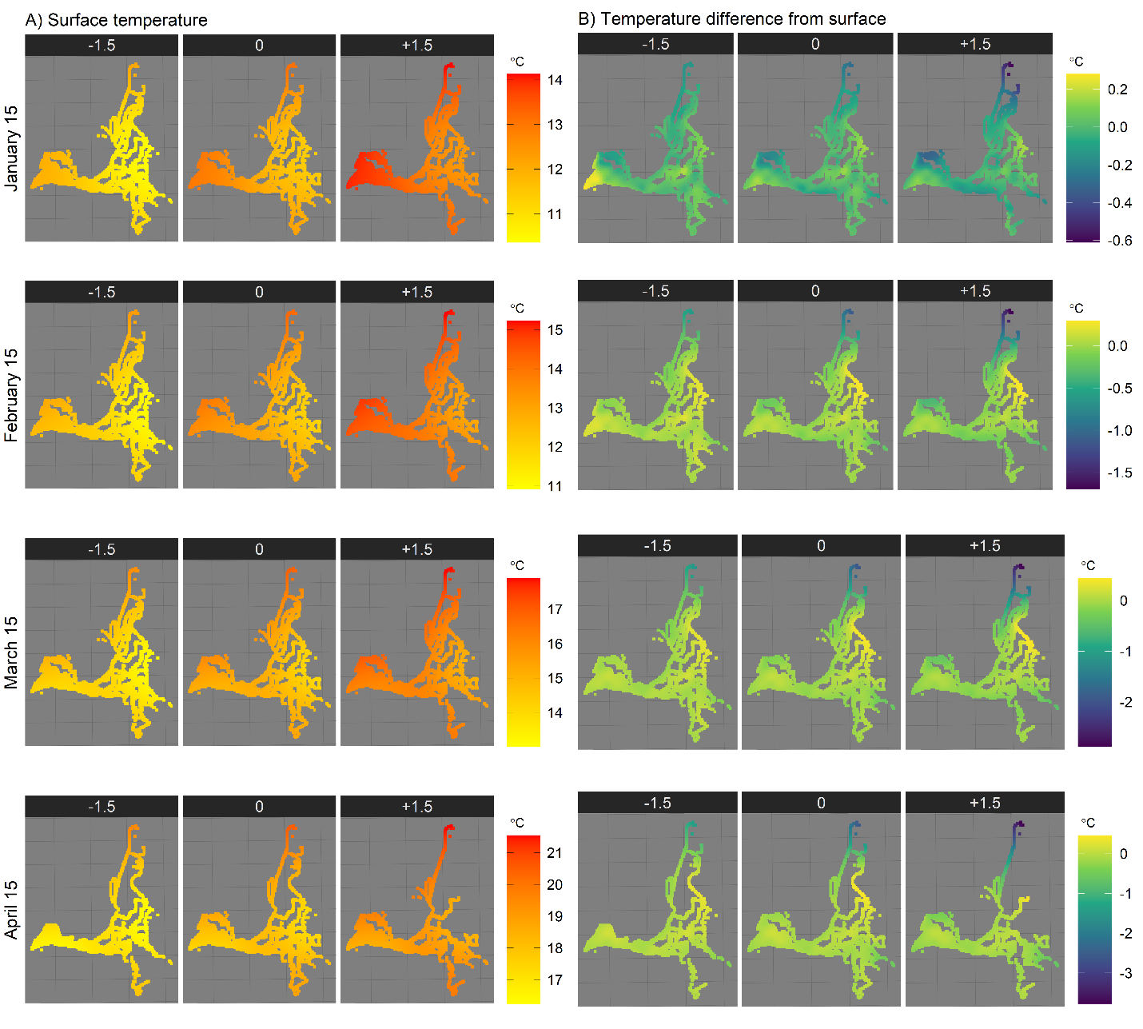
Figure S4. Model predictions of surface temperature and surface-bottom temperature differences over the waterways of the SFE for the 15th of each month in the January-April period, per Figure 3 of main text. The surface temperature model outputs used to calculate the temperature anomaly are shown on the left panel, while the final soap-film smooth model results (model 4 in Table 1) are shown on the right panel. Columns within each panel represent three different scenarios: cool conditions (-1.5 °C from expected surface temperatures), average conditions (0 temperature anomaly, predicted surface temperatures), and warm conditions (+1.5 °C from expected surface temperatures). To avoid extrapolation, only regions with data that match the categories (season and temperature anomaly group) are shown for each plot. Note that the color-temperature scale changes between months.
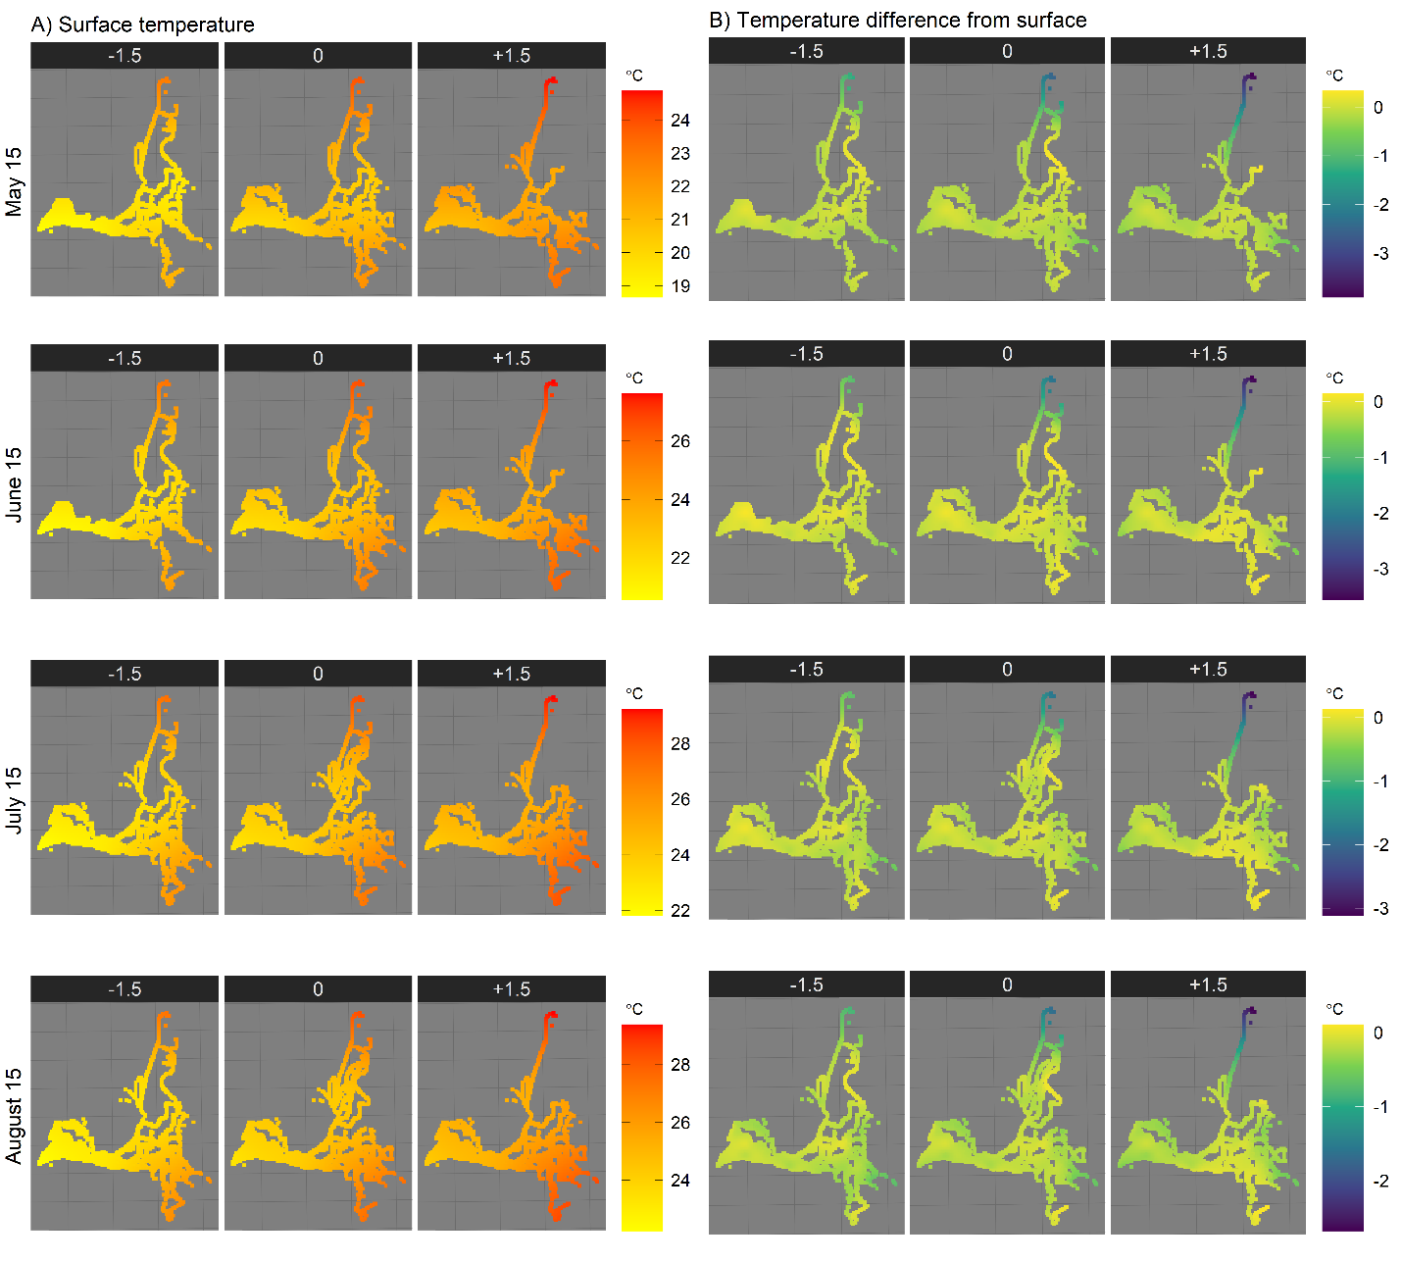
Figure S5. Model predictions of surface temperature and surface-bottom temperature differences over the waterways of the SFE for the 15th of each month in the May-August period, per Figure 3 of main text. The surface temperature model outputs used to calculate the temperature anomaly are shown on the left panel, while the final soap-film smooth model results (model 4 in Table 1) are shown on the right panel. Columns within each panel represent three different scenarios: cool conditions (-1.5 °C from expected surface temperatures), average conditions (0 temperature anomaly, predicted surface temperatures), and warm conditions (+1.5 °C from expected surface temperatures). To avoid extrapolation, only regions with data that match the categories (season and temperature anomaly group) are shown for each plot. Note that the color-temperature scale changes between months.
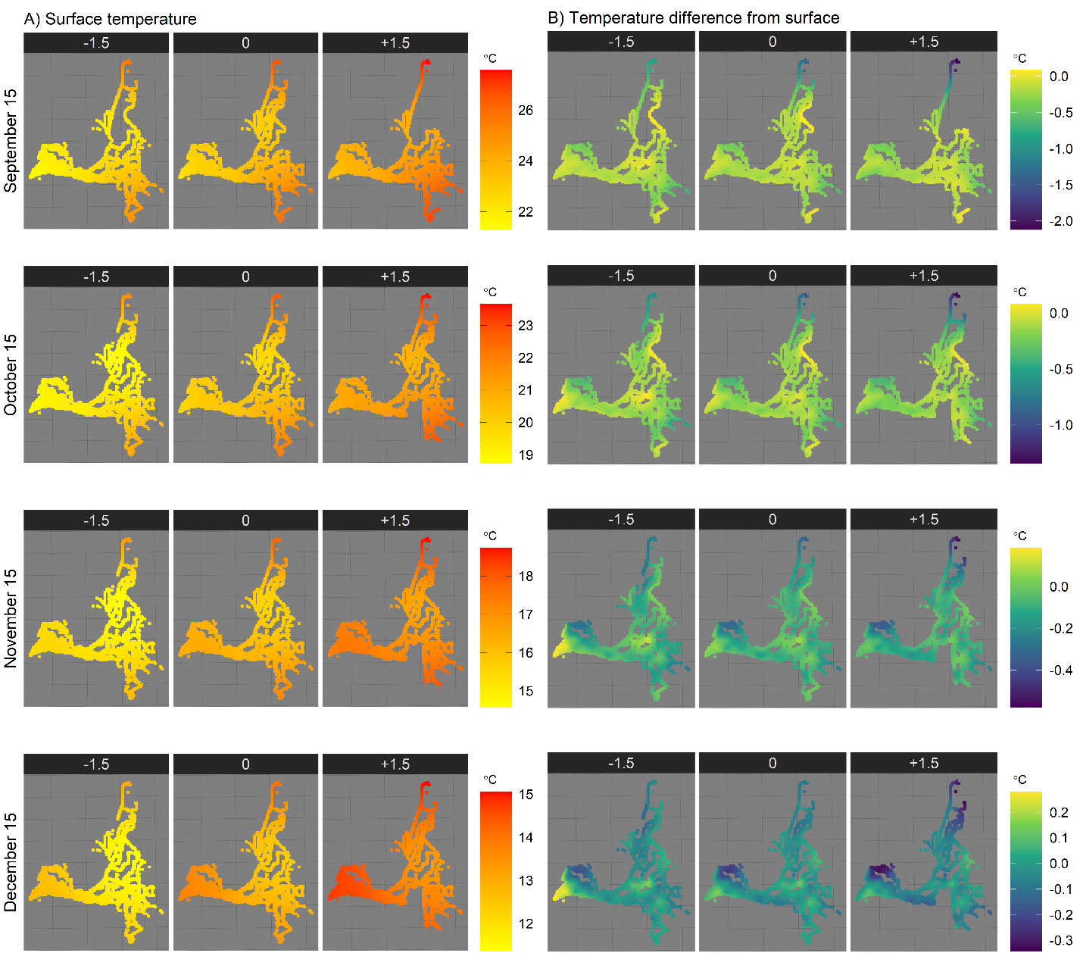
Figure S6. Model predictions of surface temperature and surface-bottom temperature differences over the waterways of the SFE for the 15th of each month in the September-December period, per Figure 3 of main text. The surface temperature model outputs used to calculate the temperature anomaly are shown on the left panel, while the final soap-film smooth model results (model 4 in Table 1) are shown on the right panel. Columns within each panel represent three different scenarios: cool conditions (-1.5 °C from expected surface temperatures), average conditions (0 temperature anomaly, predicted surface temperatures), and warm conditions (+1.5 °C from expected surface temperatures). To avoid extrapolation, only regions with data that match the categories (season and temperature anomaly group) are shown for each plot. Note that the color-temperature scale changes between months.
Figure S7. Spatiotemporal variogram (gamma) of model 4 residuals for various number of days within a two-week span (see Table 1 in main text for model description).
Figure S8. Spatiotemporal variogram (gamma) of model 4 residuals for one to seven-week gaps (see Table 1 in main text for model description).
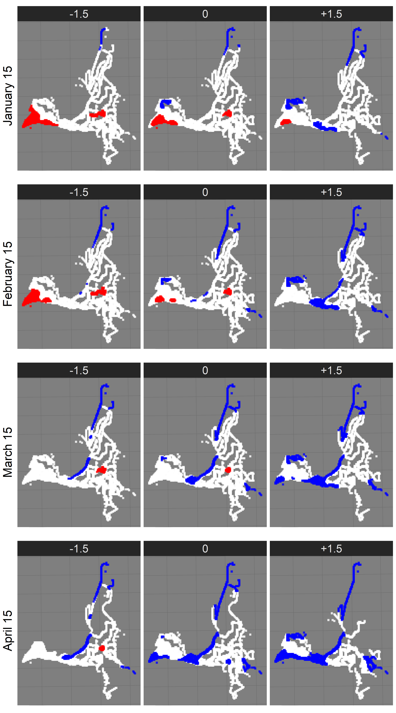
Figure S9. Model results for the discrete dataset showing areas with significant difference in temperature between surface and bottom (p < 0.01) for January-April period. Red areas indicate warmer temperature in the bottom relative to surface, while blue areas indicate cooler temperature in the bottom relative to surface. Rows are the dates used to create predictions. Columns within each panel represent three different scenarios: cool conditions (-1.5 °C from expected surface temperatures), average conditions (0 temperature anomaly, predicted surface temperatures), and warm conditions (+1.5 °C from expected surface temperatures). Only regions with data that match the categories (month and temperature anomaly group) are shown for each plot.
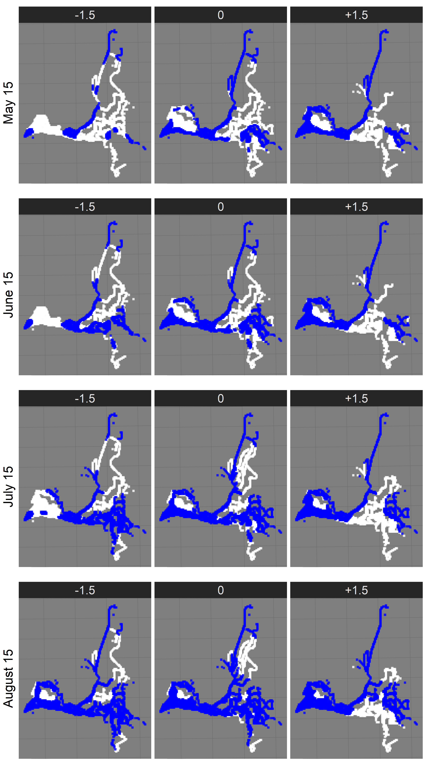
Figure S10. Model results for the discrete dataset showing areas with significant difference in temperature between surface and bottom (p < 0.01) for May-August period. Red areas indicate warmer temperature in the bottom relative to surface, while blue areas indicate cooler temperature in the bottom relative to surface. Rows are the dates used to create predictions. Columns within each panel represent three different scenarios: cool conditions (-1.5 °C from expected surface temperatures), average conditions (0 temperature anomaly, predicted surface temperatures), and warm conditions (+1.5 °C from expected surface temperatures). Only regions with data that match the categories (month and temperature anomaly group) are shown for each plot.
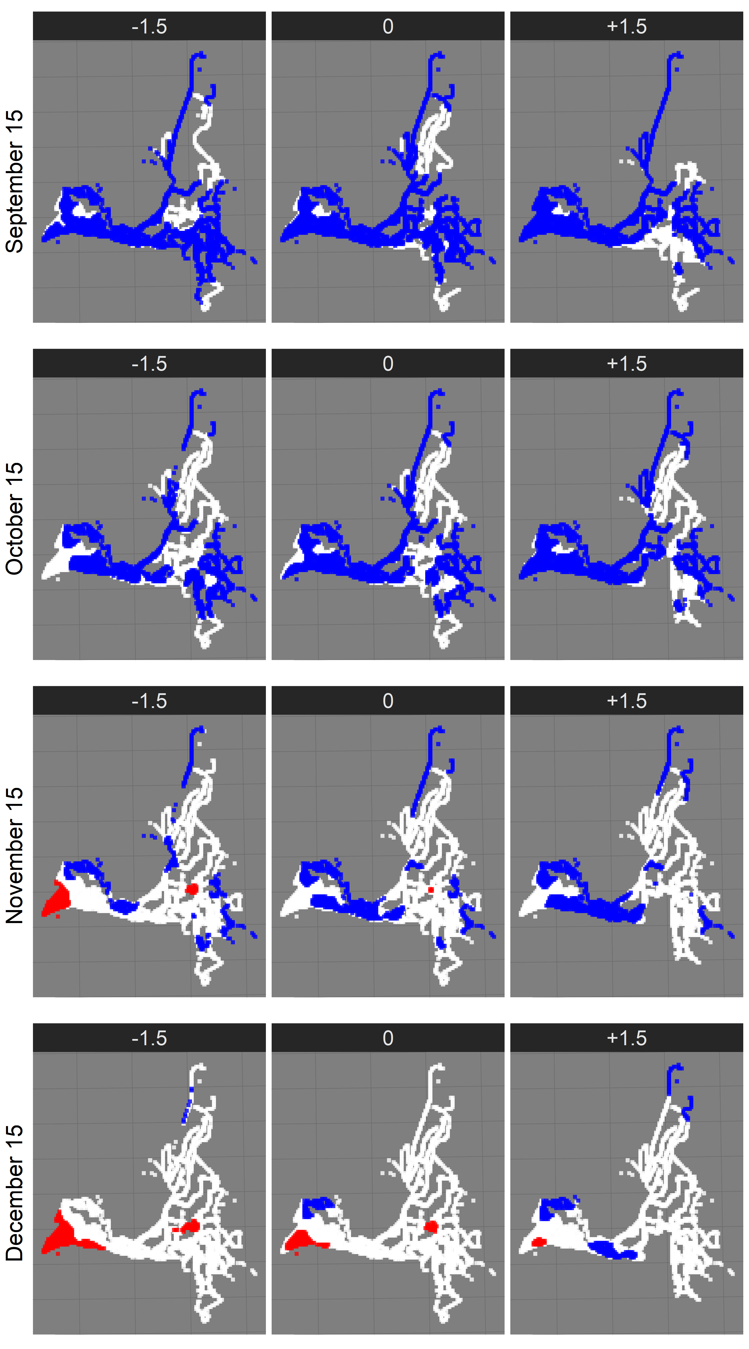
Figure S11. Model results for the discrete dataset showing areas with significant difference in temperature between surface and bottom (p < 0.01) for September-December period. Red areas indicate warmer temperature in the bottom relative to surface, while blue areas indicate cooler temperature in the bottom relative to surface. Rows are the dates used to create predictions. Columns within each panel represent three different scenarios: cool conditions (-1.5 °C from expected surface temperatures), average conditions (0 temperature anomaly, predicted surface temperatures), and warm conditions (+1.5 °C from expected surface temperatures). Only regions with data that match the categories (month and temperature anomaly group) are shown for each plot.

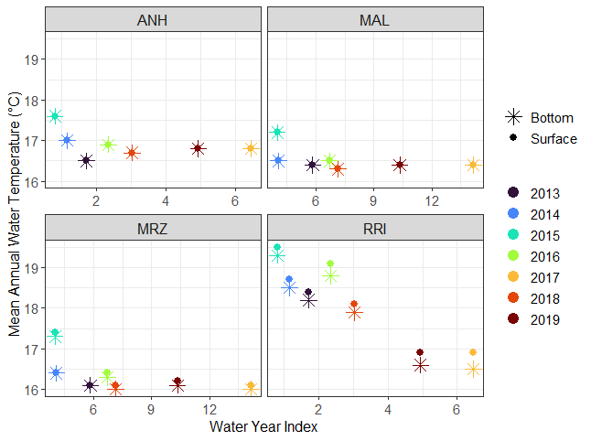
Figure S12. Relationship between mean annual water temperature and water year index. Circles represent mean annual surface temperature, and stars represent mean annual bottom temperature. Water year index comes from DWR Water Year Hydrologic Classification Indices (https://cdec.water.ca.gov/reportapp/javareports?name=WSIHIST). Antioch (ANH) and Rough and Ready Island (RRI) are located on the San Joaquin River, so San Joaquin Valley Indices were used. Mallard Island (MAL) and Martinez (MRZ) are located at or past the confluence of the rivers, so Sacramento Valley indices were used.
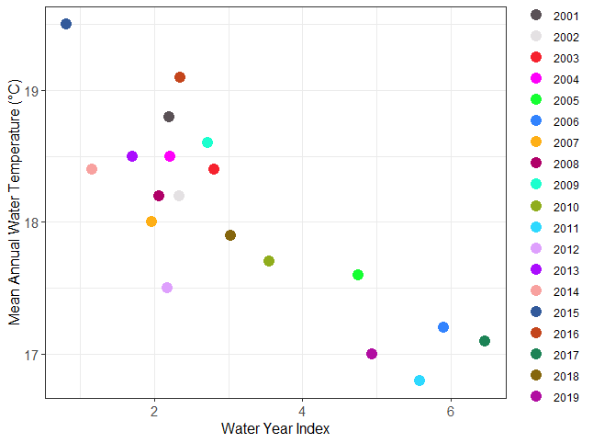

Figure S13. Relationship between mean annual water temperature and water year index at Rough and Ready Island (RRI) from 2001-2019. Water year index comes from DWR Water Year Hydrologic Classification Indices (https://cdec.water.ca.gov/reportapp/javareports?name=WSIHIST). Years 2006, 2011, 2017, and 2019 are classified as wet years.

