Supplementary Information

Mitochondrial ROS produced in human colon carcinoma HCT116 cells reduces cell survival via autophagy

Eunji Gwak, Dasol Kim, Hui-Yun Hwang, and Ho Jeong Kwon*
¹Chemical Genomics Laboratory, Department of Biotechnology, College of Life Science and Biotechnology, Yonsei University, Seoul 03722, Republic of Korea
*Correspondence: kwonhj@yonsei.ac.kr (H.J.K); Tel.: +82-2-2123-5883 (H.J.K.)

Ho Jeong Kwon, Ph.D.
Professor, Department of Biotechnology, College of Life Science and Biotechnology,
Yonsei University, Engineering Hall B, B410, 50 Yonsei-ro, Seodaemun-gu,
Seoul 03722, Republic of Korea
Phone: 82-2-2123-5883
Fax: 82-2-362-7265
E-mail: kwonhj@yonsei.ac.kr. Tel: +82-2-2123-5883

Materials and Methods
mROS measurement
Mitochondria ROS levels were assessed using red fluorescence mitochondrial superoxide indicator MitoSOX (Invitrogen, Grand Island, NY). Cells were incubated with 5 μM MitoSOX and Hoechst 33342 (Life Technologies, Grand Island, NY) for 10 min, washed with media or 1X PBS three times and fixed with 4% formaldehyde. MitoSOX and Hoechst staining results were analyzed using a Zeiss LSM 980 confocal microscope (Carl Zeiss MicroImaging, Thornwood, NY), and the fluorescence intensity of MitoSOX was measured by using ImageJ software.
Acridine orange staining
HEK293 and MT cells were grown on 15 mm coverslips at a density of 1.3x10⁵ cells/well in 6-well plates The cells were then treated with drugs for 24 h, and then treated 5 μg/mL AO (Sigma-Aldrich). Nuclei were stained with Hoechst. Then the cells were incubated for 20 min, fixed with 4% PFA, and washed three times with media PBS. Images were obtained using an LSM880 confocal microscope at 400x magnification. Red fluorescence intensity was quantified using Image J2 software.
In Vivo Mouse Tumor Xenograft Assay
Mice were housed in a pathogen-free facility at the Laboratory Animal Research Center of Yonsei University (Seoul, Korea). These mice were handled in accordance with the Institutional Animal Care and Use Committee (permission number: IACUC-A-201901-859-01) and International Guidelines for the Ethical Use of Animals. For intracranial tumor models, 2 × 10⁵ HCT116 cells were implanted into the right hemispheres of 8–10-wk-old male experimental mice via stereotaxic injection. After 1 week, mice were randomly selected and separated into four groups (four mice per group) and intraperitoneally treated with vehicle or A1938 (10 mg/kg) every two days for 16 days. Tumor volume was calculated according to the formula 0.5 × A × B2, where A is the longest diameter of a tumor, and B is its perpendicular diameter. Vehicle and drugs were dissolved in a saline:Ethanol:Tween 80 solution at a ratio of 88:2:18. The tumor volume and mouse body weight were measured daily using the following formula: π/6 × length × width × height. After 8 times of drug treatment, mice were sacrificed, and tissue samples were obtained. The tumors were surgically removed and slowly frozen with dry ice (−70 °C).

Statistical analysis
All data are expressed as the means ± SEM with GraphPad Prism (ver. 5.00 for Windows; GraphPad Software, Inc., San Diego, CA). Data were obtained from at least three independent experiments. Statistical analyses were performed using an unpaired, two-tailed Student’s t-test. P-values less than 0.05 were considered statistically significant (* indicates p < 0.05, ** indicates p < 0.01, *** indicates p < 0.001).

Supplementary information
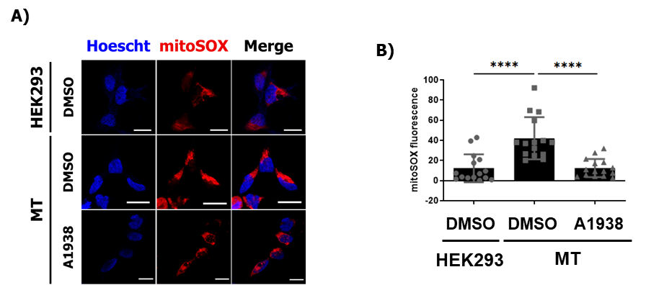
Supplementary Figure S1. The effect of A1938 on mROS generation. (A) Confocal microscopy images of the MitoSOX Red fluorescence of mROS generated in HEK293 and MT cells. A1938, 30 µM. 4 h treatment. Scale bar, 20 μm. (B) Graph shows mean ± SEM of cells (n = 15). ns, ****p < 0.001.

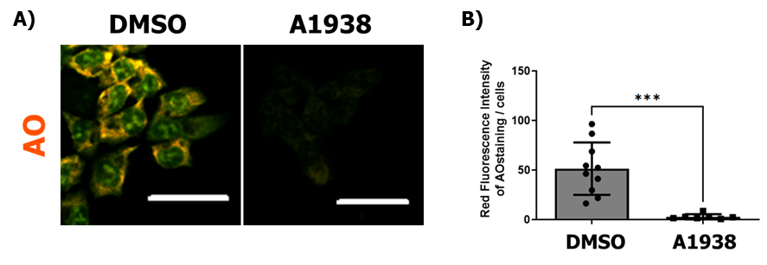
Supplementary Figure S2: A1938 treatment on lysosomal activity in HCT116 cells. (A) HCT116 cells were treated with DMSO control or A1938 30 µM for 24 h. Live cells were stained with AO 2 μg/mL for 25 min, fixed, and examined by confocal fluorescence microscopy. Confocal fluorescence microscopy images of HCT116 cells treated with A1938 in serum free RPMI media. (B) Average AO intensity per cell of HCT116 cells treated with A1938 in serum free RPMI media (n > 10). Scale bar, 20 μm. ***P < 0.001.

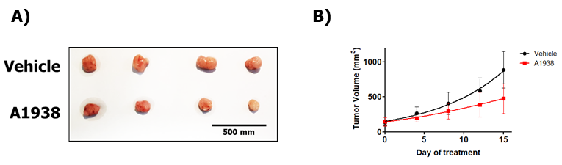
Supplementary Figure S3: UQCRB inhibitor A1938 attenuated HCT116 xenograft tumor growth. (A) Representative images of tumors extracted from nude mice bearing HCT116 cells in different groups. (B) Mouse tumor volumes (n = 4/group).

