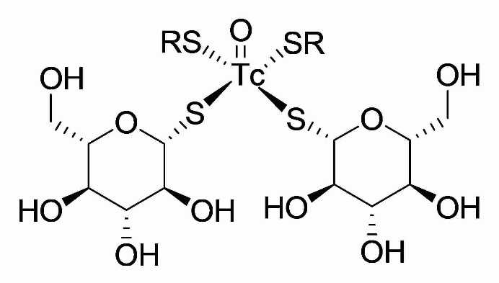

Figure S1. Structure of ^{99m}Tc-1-thio-D-glucose

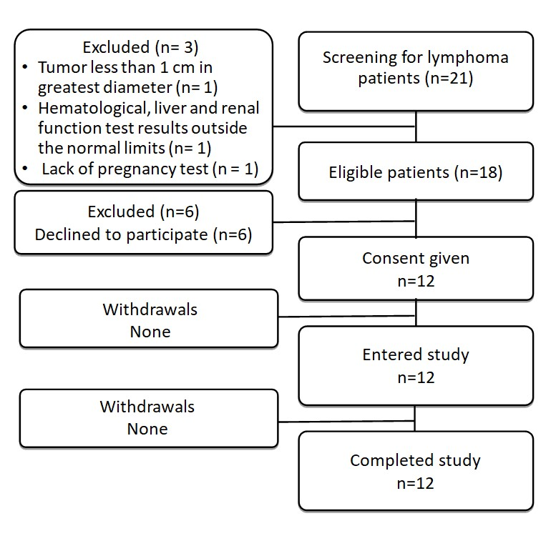

Figure S2. Standards for Reporting of Diagnostic Accuracy Studies (STARD) flow diagram.

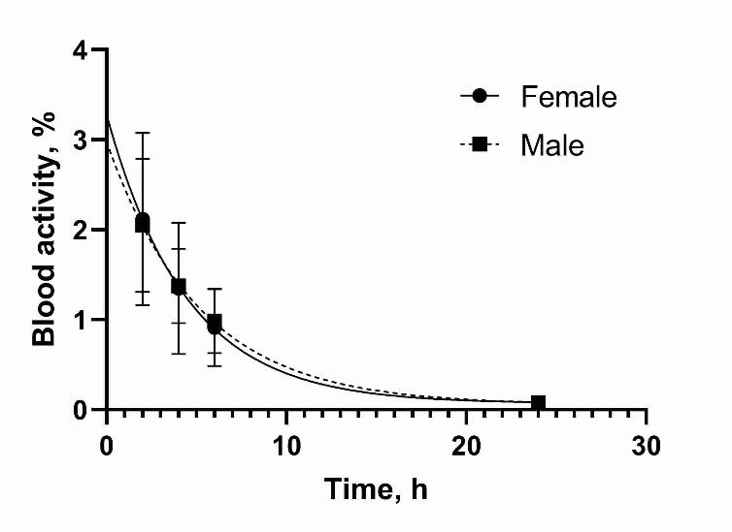
Figure S3. Kinetics of elimination of ^{99m}Tc-TG from blood. Data are based on count rates in regions of interest placed over hearts. %ID = percentage injected dose.

