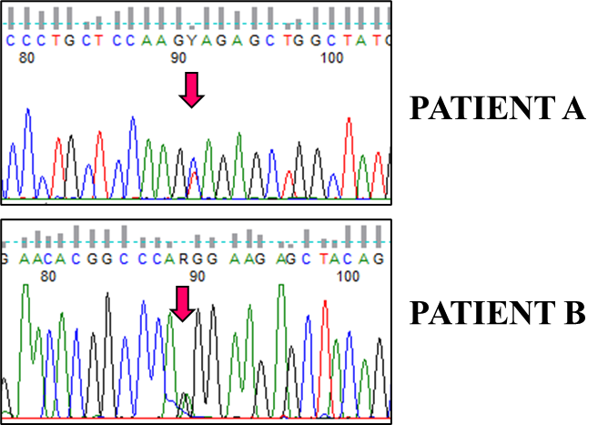
Supplemental Figure 1: TREX1 electropherograms of patients A and B. The chromatograms show the presence of c.407C>T (p.A136V) (upper panel) and c.520A>G (p.R174G) (lower panel) variants in patient A and B, respectively.

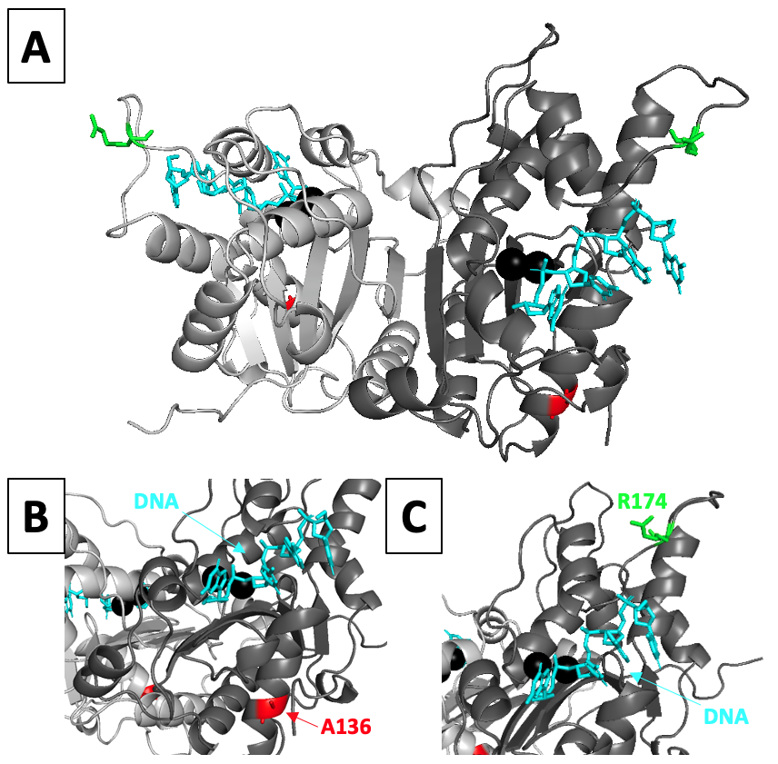

Supplemental Figure 2: Structural context of hTREX1’s mutated residues. A structure of mTREX1₁₋₂₄₂ bound to ssDNA (PDB = ‘2IOC’) was used as a template with MODELLER v9.22 to model the hTREX1₁₋₂₄₂ structure with the originally disordered loops resolved. The respective protomers of the hTREX1 homodimer are shown as dark and light grey cartoons, 4-mer oligos (‘DNA’) are shown as blue sticks, divalent metal ions are shown as black spheres, A136 residues are shown as red sticks, and R174 residues are shown as green sticks. Graphics were generated with PyMOL v2.3.2 (The PyMOL Molecular Graphics System, Version 2.0 Schrödinger, LLC), and figure was prepared in PowerPoint.

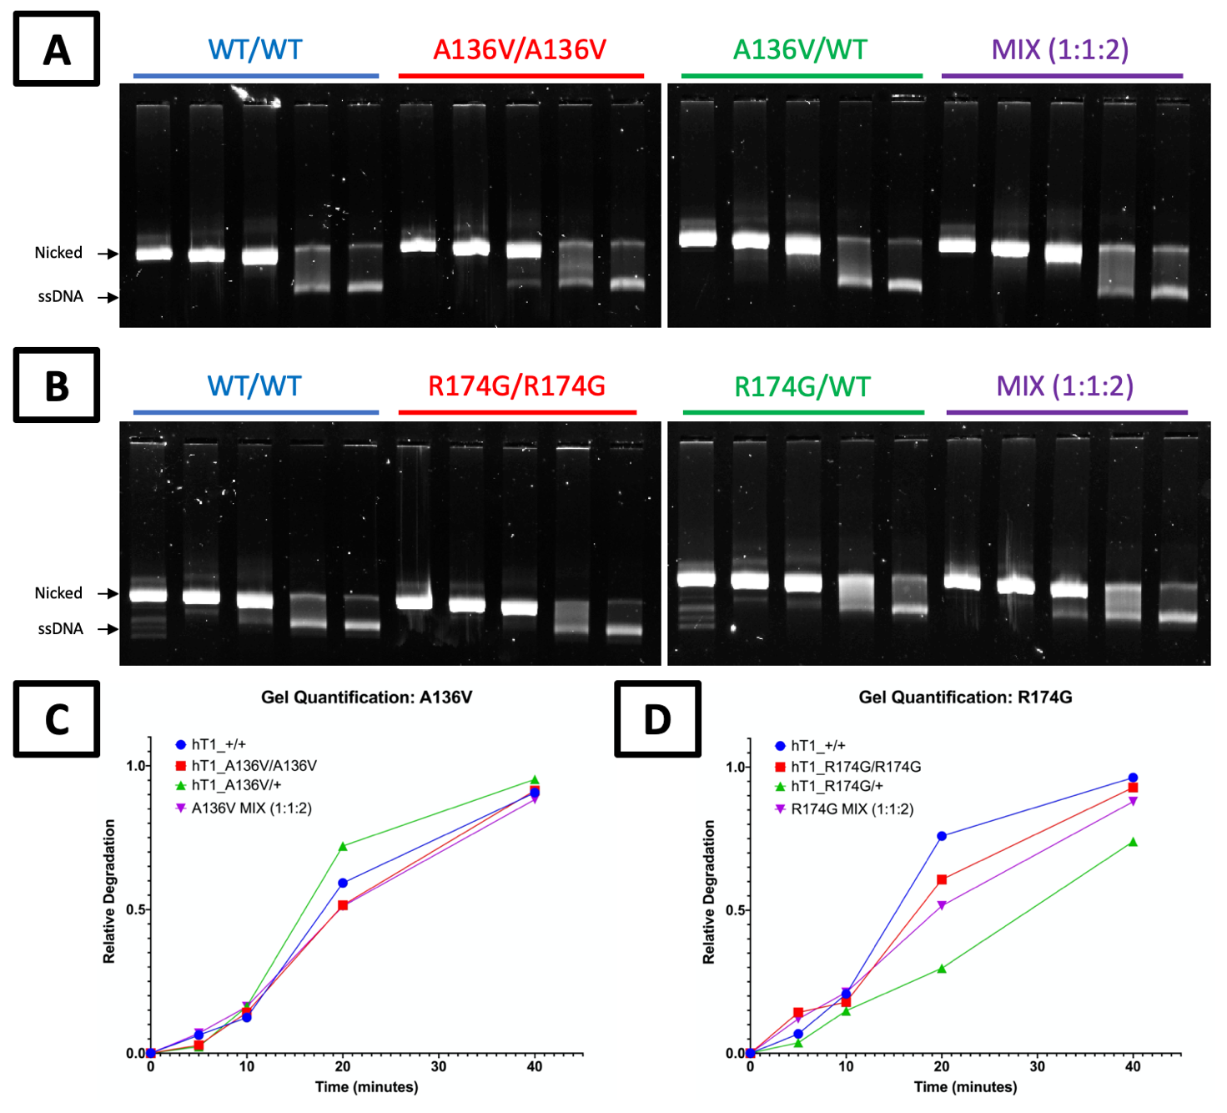

Supplemental Figure 3: dsDNA degradation by A136V and R174G variants. [a,b] Agarose Gel Visualization of TREX1 Exonuclease Activity. Standard exonuclease reactions were prepared with equimolar concentrations of the indicated enzymes, incubated at room temperature for 0, 5, 10, 20, or 40 minutes, quenched in ethanol, then visualized on 0.8% agarose gels. Supercoiled dsDNA plasmid is nicked to generate initial substrate (‘Nicked), and TREX1 degrades one strand of the substrate over time to generate ssDNA plasmid (‘ssDNA’). [c,d] Quantification of Agarose Gels. Band intensity for each of the 0-minute lanes on the gels in panels a-b was quantified by densitometry, along with band intensity on the corresponding region of the associated lanes. Differences in band intensity were normalized to the 0-minute lanes’ band, and these values (‘Relative Degradation’) were plotted as a function of time. Gels and plots are representative of two separate experiments.

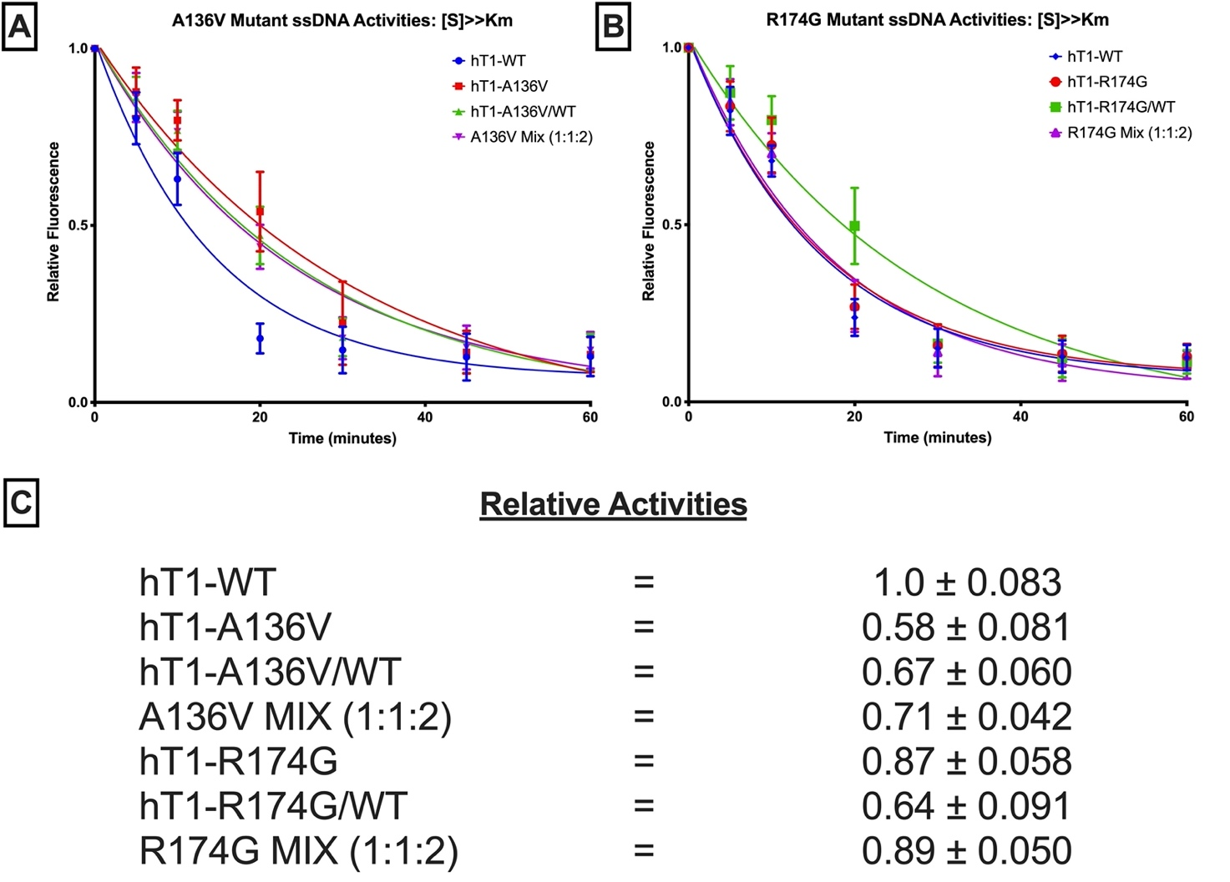

Supplemental Figure 4: ssDNA degradation by A136V and R174G variants. [a,b] Fluorescence-Based Quantification of TREX1 dsDNA Degradation. Standard exonuclease reactions were prepared with equimolar concentrations of the indicated enzymes, incubated at room temperature for the indicated times, quenched in QuantiFluor ssDNA dye, and ssDNA content measured by fluorescence. Plots of fluorescence vs time were generated and fit with one-phase decay nonlinear regression in Prism 7.0 (GraphPad). Plots are composites of 18 different reactions from 3 different experiments. Data points indicate mean, and error bars represent standard deviation. [c] Activity Rates of TREX1 Variants. Initial velocities were quantified from the respective regression lines in panels a-b and normalized to wild-type initial velocity to calculate relative activity. Values are mean and standard deviation. ‘[S] >> K_{m}’ refers to ~5 µM of a 30-mer oligo.

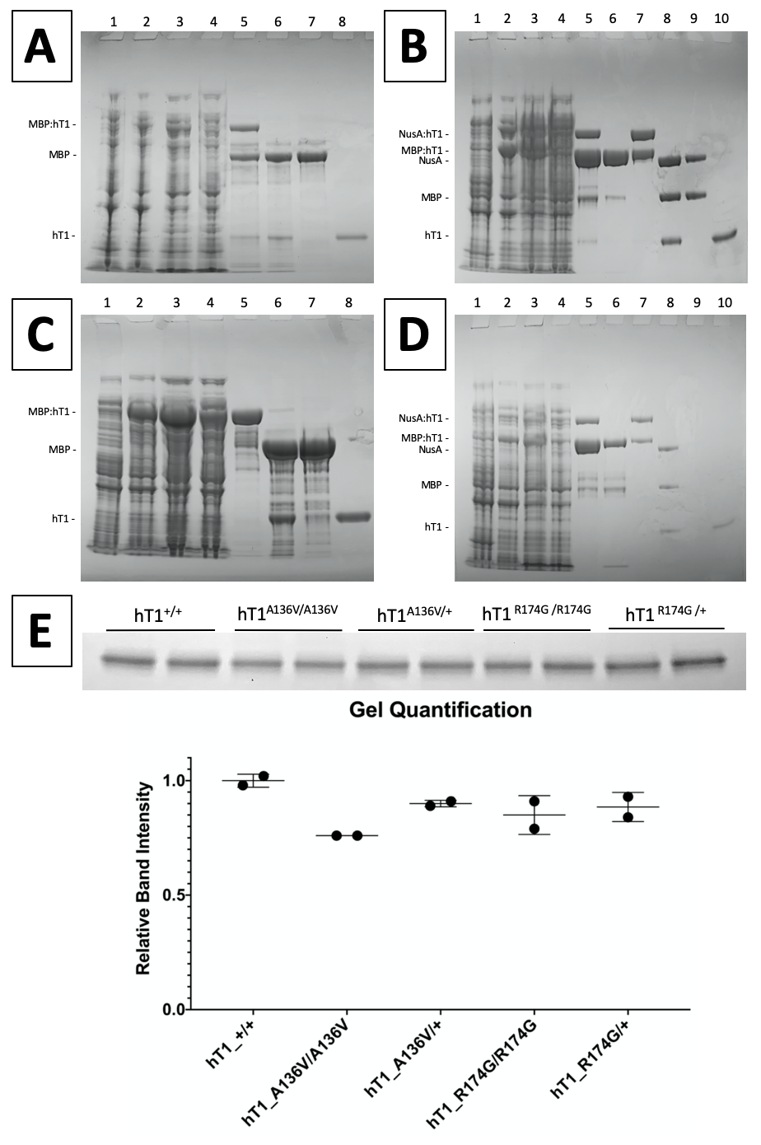
Supplemental Figure 5: Quality control data from A136V and R174G preps. [a,c] Chromatography Purification of hT1^{A136V/A136V} (panel a) & hT1^{R174G/R174G} (panel c). Samples were taken at the indicated steps of chromatography purification and visualized by SDS-PAGE with Coomassie staining. (1) pre-induction culture sample, (2) post-induction culture sample, (3) nickel column applicant, (4) nickel column wash, (5) nickel column eluent, (6) post-cleavage p-cell column applicant, (7) p-cell column wash, & (8) p-cell column eluent. [b,d] Chromatography Purification of hT1^{A136V/+} (panel b) & hT1^{R174G /+} (panel d). (1) pre-induction culture sample, (2) post-induction culture sample, (3) amylose column applicant, (4) amylose column wash, (5) amylose column eluent / nickel column applicant, (6) nickel column wash, (7) nickel column eluent, (8) post-cleavage p-cell column applicant, (9) p-cell column wash, & (10) p-cell column eluent. [e] Validation of Enzyme Purities and Concentrations. Protein content of preps was visualized via SDS-PAGE with Coomassie staining. Enzyme preps were used to load 0.75 µg each, as measured by A₂₈₀, onto a 12% gel. Band intensities were quantified using GelAnalyzer 19.1, then plotted as mean and range. Graph was prepared with Prism 7.0 (GraphPad), and figure was assembled in PowerPoint.

Supplemental Table 1: genes responsible for Mendelian conditions causing monogenic forms of stroke.

GENE | OMIM# gene | OMIM# disease | inheritance pattern | GenBank ID | coding exons | target submitted (bp) | target designed (bp) | missed (bp) | covered (%) | Reference  (PMID)
ABCA1 | 600046 | 604091  205400 | AD  AR | NM_005502 | 49 | 7276 | 7276 | 0 | 100 | 30278532
ABCC6 | 603234 | 614473  264800  177850 | AR  AR  AD | NM_001171 | 31 | 4903 | 4755 | 148 | 96,98 | 24008425  29709427  29722917
ABCD4 | 603214 | 614857 | AR | NM_005050 | 19 | 2771 | 2771 | 0 | 100 | 20301503
ABCG5 | 605459 | 618666 | AR | NM_022436 | 13 | 2606 | 2606 | 0 | 100 | 11099417
ABCG8 | 605460 | 210250 | AR | NM_022437 | 13 | 2672 | 2672 | 0 | 100 | 11099417
ACP5 | 171640 | 607944 | AR | NM_001111036 | 4 | 1178 | 1178 | 0 | 100 | 26951490
ACTA2 | 102620 | 611788  613834 | AD | NM_001613 | 8 | 1214 | 1214 | 0 | 100 | 19409525  30661495
ACTN1 | 102575 | 615193 | AD | NM_001102 | 22 | 3845 | 3845 | 0 | 100 | 30356112
ACVRL1 | 601284 | 600376 | AD | NM_000020 | 9 | 1602 | 1602 | 0 | 100 | 31637968
ADAMTS13 | 604134 | 274150 | AR | NM_139025 | 29 | 5734 | 5722 | 12 | 99,79 | 30356112
ADAR | 146920 | 615010 | AR | NM_001111 | 15 | 4431 | 4431 | 0 | 100 | 25672750
ALG8 | 608103 | 608104 | AR | NM_024079 | 14 | 2336 | 2231 | 105 | 95,5 | 12480927
ANO6 | 608663 | 262890 | AR | NM_001025356 | 23 | 4226 | 4226 | 0 | 100 | 30356112
APP | 104760 | 605714 | AD | NM_201413 | 19 | 2545 | 2545 | 0 | 100 | 7131028
ATP7A | 300011 | 309400 | XLR | NM_000052.7 | 22 | 4723 | 4723 | 0 | 100 | 11118799
BGN | 301870 | 300989 | XL | NM_001711.6 | 7 | 1457 | 1457 | 0 | 100 | 27632686
BRAF | 164757 | 115150  613707  613706 | AD | NM_001374258.1 | 18 | 2481 | 2481 | 0 | 100 | 12187019
BRCC3 | 300617 | 300845 | XLR | NM_001018055.3 | 11 | 1504 | 1504 | 0 | 100 | 25733922
C1R | 613785 | 130080 | AD | NM_001733.7 | 9 | 2336 | 2336 | 0 | 100 | 25485215
CBS | 613381 | 236800 | AR | NM_000071.3 | 15 | 1806 | 1806 | 0 | 100 | 26689889
CCER2 | 617634 | - | - | NM_001243212 | 5 | 851 | 851 | 0 | 100 | 27717682
CCM1 | 604214 | 116860 | AD | NM_004912 | 16 | 2851 | 2851 | 0 | 100 | 9811928
CCM2 | 607929 | 603284 | AD | NM_031443.4 | 11 | 1868 | 1868 | 0 | 100 | 9811928
CD59 | 107271 | 612300 | AR | NM_000611 | 3 | 537 | 537 | 0 | 100 | 25716358
CECR1 | 607575 | 182410  615688 | AR | NM_001282225.2 | 10 | 2066 | 2066 | 0 | 100 | 24552284
COG6 | 606977 | 614576 | AR | NM_020751.3 | 20 | 2996 | 2996 | 0 | 100 | 20605848
COL1A1 | 120150 | 130060 | AD | NM_000088.4 | 51 | 4905 | 4905 | 0 | 100 | 28089253  12695216
COL1A2 | 120160 | 617821  225320 | AD  AR | NM_000089.4 | 52 | 4621 | 4621 | 0 | 100 | 28089253  12695216
COL3A1 | 120180 | 130050  618343 | AD  AR | NM_000090.4 | 51 | 4911 | 4911 | 0 | 100 | 12786757
COL4A1 | 120130 | 611773  175780  618564 | AD | NM_001845.6 | 53 | 5564 | 5564 | 0 | 100 | 30413629
COL4A2 | 120090 | 614483 | AD | NM_001846.4 | 47 | 7489 | 7489 | 0 | 100 | 30413629
COL4A3 | 120070 | 203780  104200 | AR  AD | NM_000091 | 52 | 5533 | 5533 | 0 | 100 | 10893738
COL4A4 | 120131 | 203780 | AD | NM_000092 | 47 | 7423 | 7423 | 0 | 100 | 10893738
COL4A5 | 303630 | 301050 | XLD | NM_000495 | 51 | 5573 | 5573 | 0 | 100 | 30045277
COL4A6 | 303631 | - | - | NM_001847 | 47 | 7488 | 7488 | 0 | 100 | 30045277
COL5A1 | 120215 | 130000 | AD | NM_000093 | 67 | 6256 | 6256 | 0 | 100 | 17053184
COL5A2 | 120190 | 130010 | AD | NM_000393 | 54 | 7200 | 7200 | 0 | 100 | 17053184
CST3 | 604312 | 105150 | AD | NM_000099 | 3 | 591 | 591 | 0 | 100 | 3472718
CTSA | 613111 | - | AD | NM_000308 | 15 | 2247 | 2247 | 0 | 100 | 27664989
CYP11B1 | 610613 | 202010  103900 | AR  AD | NM_000497 | 9 | 1602 | 1602 | 0 | 100 | 10852446
DPM1 | 603503 | 608799 | AR | NM_003859 | 10 | 1388 | 1321 | 67 | 95,1 | 15669674
DYRK1B | 604556 | 615812 | AD | NM_004714 | 10 | 2390 | 2390 | 0 | 100 | 24827035
ELN | 130160 | 123700  185500 | AD | NM_001278939 | 34 | 4094 | 4094 | 0 | 100 | 18348261
ENG | 131195 | 187300 | AD | NM_000118 | 15 | 2753 | 2753 | 0 | 100 | 27352867  31637968
ENPP1 | 173335 | 208000  615522  613312 | AR  AD  AR | NM_006208 | 25 | 4028 | 4028 | 0 | 100 | 19206175
EPAS1 | 603349 | 611783 | AD | NM_001430 | 16 | 3413 | 3413 | 0 | 100 | 18184961
EPHB4 | 600011 | 618196 | AD | NM_004444 | 17 | 3134 | 3134 | 0 | 100 | 28687708
EPOR | 133171 | 133100 | AD | NM_000121 | 8 | 1927 | 1927 | 0 | 100 | 3371213
ESCO2 | 609353 | - | - | NM_001017420 | 10 | 2306 | 2306 | 0 | 100 | 1642282
F10 | 613872 | 227600 | AR | NM_000504 | 8 | 1867 | 1867 | 0 | 100 | 3732313
F13A1 | 134570 | 613225 | AR | NM_000129 | 14 | 2899 | 2899 | 0 | 100 | 9550516
F13B | 134580 | 613235 | AR | NM_001994 | 12 | 2586 | 2586 | 0 | 100 | 30356112
F2 | 176930 | 613679  188050 | AR  AD | NM_000506 | 14 | 2009 | 2009 | 0 | 100 | 28160964
F5 | 612309 | 227400  188055 | AR  AD | NM_000130 | 25 | 6925 | 6925 | 0 | 100 | 30635457
F7 | 613878 | 227500 | AR | NM_000131 | 9 | 1761 | 1761 | 0 | 100 | 30356112
F8 | 300841 | 306700 | XLR | NM_000132 | 27 | 7350 | 7350 | 0 | 100 | 30356112
F9 | 300746 | 306900  300807 | XLR | NM_000133 | 8 | 1466 | 1466 | 0 | 100 | 19846852
FBLN4 | 604633 | 614437 | AR | NM_016938 | 10 | 1432 | 1432 | 0 | 100 | 8985490
FBLN5 | 604580 | 614434  219100  608895 | AD  AR  AD | NM_006329 | 11 | 1897 | 1897 | 0 | 100 | 8985490
FBN1 | 134797 | 604308  154700 | AD | NM_000138 | 65 | 9266 | 9266 | 0 | 100 | 29030048
FGA | 134820 | 202400  616004 | AR  AD/AR | NM_021871 | 6 | 2705 | 2705 | 0 | 100 | 19598064
FGB | 134830 | 202400  616400 | AR  AD/AR | NM_005141 | 8 | 1876 | 1876 | 0 | 100 | 19598064
FGG | 134850 | 202400  616400 | AR  AD/AR | NM_000509 | 10 | 1877 | 1877 | 0 | 100 | 19598064
FLI1 | 193067 | 617443 | AD  AR | NM_001271010 | 10 | 1491 | 1491 | 0 | 100 | 30356112
FLNA | 300017 | 300049  314400 | XLD  XL | NM_001110556 | 47 | 10294 | 10294 | 0 | 100 | 9883725
FOXC1 | 601090 | 602482 | AD | NM_001453 | 1 | 1672 | 1672 | 0 | 100 | 25250569
GAA | 606800 | 232300 | AR | NM_001079803 | 19 | 3049 | 3049 | 0 | 100 | 3322184
GCDH | 608801 | 231670 | AR | NM_000159 | 12 | 1481 | 1484 | 0 | 100 | 28411331
GDF2 | 605120 | 615506 | AD | NM_016204 | 2 | 1390 | 1390 | 0 | 100 | 31637968
GFI1B | 604383 | 187900 | AD  AR | NM_004188 | 6 | 1293 | 1293 | 0 | 100 | 30356112
GGCX | 137167 | 610842  277450 | digenic  AR | NM_000821 | 15 | 3053 | 3053 | 0 | 100 | 12384421
GLA | 300644 | 301500 | XL | NM_000169 | 7 | 1360 | 1360 | 0 | 100 | 33835733
GP1BA | 606672 | 231200  153670  177820 | AR  AD  AD | NM_000173 | 1 | 2009 | 2009 | 0 | 100 | 30356112
GP1BB | 138720 | 231200 | AR | NM_000407 | 2 | 641 | 641 | 0 | 100 | 30356112
GP6 | 605546 | 614201 | AR | NM_016363 | 8 | 2263 | 2263 | 0 | 100 | 30356112
GP9 | 173515 | 231200 | AR | NM_000174 | 1 | 584 | 584 | 0 | 100 | 30356112
GUCY1A3 | 139396 | 615750 | AR | NM_000856 | 8 | 2157 | 2157 | 0 | 100 | 25733922
HBB | 141900 | 603903 | AR | NM_000518 | 3 | 474 | 474 | 0 | 100 | 7782612
HRG | 142640 | 613116 | AD | NM_000412 | 7 | 1928 | 1928 | 0 | 100 | 29108964  8475479
HTRA1 | 602194 | 600142  616779 | AR  AD | NM_002775 | 9 | 1893 | 1893 | 0 | 100 | 32719647
IFIH1 | 606951 | 615846 | AD | NM_022168 | 16 | 3878 | 3878 | 0 | 100 | 175395
ITGA2 | 192974 | - | - | NM_002203 | 30 | 5046 | 5046 | 0 | 100 | 30356112
ITGA2B | 607759 | 187800 | AD | NM_000419 | 30 | 4620 | 4620 | 0 | 100 | 30356112
ITGB3 | 173470 | 619271 | AD | NM_000212 | 15 | 2517 | 2517 | 0 | 100 | 30356112
ITM2B | 603904 | 176500  117300 | AD | NM_021999 | 6 | 1101 | 1101 | 0 | 100 | 10391242
IVD | 607036 | 243500 | AR | NM_002225 | 12 | 1401 | 1401 | 0 | 100 | 20142522
JAG1 | 601920 | 118450 | AD | NM_000214 | 26 | 3917 | 3917 | 0 | 100 | 14993126
JAK2 | 147796 | 614521 | AD | NM_004972 | 23 | 3629 | 3629 | 0 | 100 | 22397670
JAM3 | 606871 | 613730 | AR | NM_032801 | 9 | 1383 | 1383 | 0 | 100 | 21109224
KNG1 | 612358 | 228960 | AR | NM_000893 | 11 | 2566 | 2566 | 0 | 100 | 12576314
KRAS | 190070 | 609942 | AD | NM_004985 | 5 | 737 | 737 | 0 | 100 | 12187019
LDLR | 606945 | 143890 | AD/AR | NM_001195799 | 18 | 2763 | 2763 | 0 | 100 | 1301956
LDLRAP1 | 605747 | 603813 | AR | NM_015627 | 9 | 1377 | 1377 | 0 | 100 | 9626156
LMAN1 | 601567 | 227300 | AR | NM_005570 | 13 | 2183 | 2183 | 0 | 100 | 30356112
LMBRD1 | 612625 | 277380 | AR | NM_018368 | 16 | 2423 | 2423 | 0 | 100 | 20301503
LMNA | 150330 | 115200 | AD | NM_170707 | 15 | 2369 | 2369 | 0 | 100 | 19095983
LOX | 153455 | 617168 | AD | NM_001178102 | 7 | 1604 | 1604 | 0 | 100 | 27432961
LZTR1 | 600574 | 616564  605275 | AD  AR | NM_006767 | 21 | 2733 | 2733 | 0 | 100 | 12187019
MCFD2 | 607788 | 613625 | AR | NM_001171507 | 4 | 733 | 733 | 0 | 100 | 30356112
MFAP5 | 601103 | 616166 | AD | NM_003480 | 9 | 972 | 972 | 0 | 100 | 25434006
MGAT2 | 602616 | 212066 | AR | NM_002408 | 1 | 1394 | 1394 | 0 | 100 | 19419693  1159665
MMACHC | 609831 | 277400 | AR | NM_015506 | 4 | 889 | 889 | 0 | 100 | 18986243
MMADHC | 611935 | 277410 | AR | NM_015702 | 7 | 961 | 961 | 0 | 100 | 20301409
MPI | 154550 | 602579 | AR | NM_002435 | 8 | 1672 | 1672 | 0 | 100 | 10484808
MPL | 159530 | 601977  604498 | AD  AR | NM_005373 | 12 | 2028 | 2028 | 0 | 100 | 15269348
MTHFR | 607093 | 236250 | AR | NM_005957 | 11 | 2081 | 2081 | 0 | 100 | 26839351  29849257
MTRR | 602568 | 236270 | AR | NM_002454 | 15 | 2328 | 2279 | 49 | 97,9 | 29849257
MTR | 156570 | 250940 | AR | NM_000254 | 33 | 4128 | 4128 | 0 | 100 | 29849257
MYH11 | 160745 | 132900 | AD | NM_002474 | 42 | 6391 | 6391 | 0 | 100 | 30661495
MYLK | 600922 | 613780 | AD | NM_053025 | 31 | 6055 | 6055 | 0 | 100 | 29544503  26147384
NBEAL2 | 614169 | 139090 | AR | NM_015175 | 54 | 10965 | 10965 | 0 | 100 | 30356112
NF1 | 613113 | 162200  601321 | AD | NM_001042492 | 58 | 9161 | 9161 | 0 | 100 | 30661495
NOTCH1 | 190198 | 616028  109730 | AD | NM_017617 | 34 | 8008 | 7987 | 21 | 99,7 | 25132448  9631276
NOTCH3 | 600276 | 125310 | AD | NM_000435 | 33 | 7296 | 7296 | 0 | 100 | 19539236
NRAS | 164790 | 613224 | AD | NM_002524 | 4 | 610 | 610 | 0 | 100 | 12187019
P2RY12 | 600515 | 609821 | AR | NM_022788 | 1 | 1079 | 1079 | 0 | 100 | 30356112
PCCA | 232000 | 606054 | AR | NM_000282 | 24 | 2427 | 2427 | 0 | 100 | 18986243
PCCB | 232050 | 606054 | AR | NM_000532 | 16 | 2480 | 2480 | 0 | 100 | 18986243
PCNT | 605925 | 210720 | AR | NM_006031 | 47 | 12361 | 12361 | 0 | 100 | 34016138
PDCD10 | 609118 | 603285 | AD | NM_007217 | 7 | 989 | 989 | 0 | 100 | 17041941
PDE3A | 123805 | 112410 | AD | NM_000921 | 17 | 4321 | 4293 | 28 | 99,3 | 25961942
PDE4D | 600129 | 614613 | AD | NM_001104631 | 22 | 4450 | 4450 | 0 | 100 | 22464250
PGM1 | 171900 | 614921 | AR | NM_002633 | 12 | 2589 | 2589 | 0 | 100 | 10484808
PITX2 | 601542 | 180500 | AD | NM_153426 | 5 | 1209 | 1209 | 0 | 100 | 25250569
PKD1 | 601313 | 173900 | AD | NM_001009944 | 46 | 13372 | 13278 | 94 | 99,3 | 8130364  27567292
PKD2 | 173910 | 613095 | AD | NM_000297 | 15 | 3057 | 3057 | 0 | 100 | 27567292
PLAU | 191840 | 601709 | AD | NM_002658 | 11 | 1880 | 1880 | 0 | 100 | 30356112
PLG | 173350 | 217090 | AR | NM_000301 | 19 | 2627 | 2627 | 0 | 100 | 8392398
PLOD1 | 153454 | 225400 | AR | NM_000302 | 20 | 3325 | 3325 | 0 | 100 | 9617436
PLOD3 | 603066 | 612394 | AR | NM_001084 | 19 | 3167 | 3167 | 0 | 100 | 18834968
PMM2 | 601785 | 212065 | AR | NM_000303 | 8 | 1141 | 1141 | 0 | 100 | 29470411
POLR3F | 617455 | - | AD | NM_006466 | 9 | 1041 | 1041 | 0 | 100 | 30115567
PRDX1 | 176763 | 277400 | AR | NM_181697 | 5 | 650 | 650 | 0 | 100 | 29302025
PRKACG | 176893 | 616176 | AR | NM_002732 | 1 | 1066 | 1066 | 0 | 100 | 30356112
PRKG1 | 176894 | 615436 | AD | NM_001098512 | 19 | 3087 | 3087 | 0 | 100 | 23910461
PROC | 612283 | 176860  612304 | AD  AR | NM_000312 | 8 | 1466 | 1466 | 0 | 100 | 20187890  1511989
PROCR | 600646 | - | AD | NM_006404 | 4 | 757 | 757 | 0 | 100 | 11552992
PROS1 | 176880 | 612336  614514 | AD  AR | NM_000313 | 16 | 2287 | 2287 | 0 | 100 | 20484936
PTPN11 | 176876 | 163950 | AD | NM_002834 | 15 | 1936 | 1936 | 0 | 100 | 12187019
RAF1 | 164760 | 611553 | AD | NM_002880 | 16 | 2107 | 2107 | 0 | 100 | 12187019
RANBP2 | 602752 | - | - | NM_006267 | 29 | 9965 | 8963 | 1002 | 89,9 | 29593631
RASA1 | 139150 | 608354 | AD | NM_002890 | 26 | 3412 | 3411 | 1 | 99,9 | 24038909
RASGRP2 | 605577 | 615888 | AR | NM_001098671 | 15 | 2580 | 2580 | 0 | 100 | 30356112
RIT1 | 609591 | 615355 | AD | NM_001256821 | 6 | 771 | 771 | 0 | 100 | 12187019
RNASEH2A | 606034 | 610333 | AR | NM_006397 | 8 | 1300 | 1300 | 0 | 100 | 32642802
RNASEH2B | 610326 | 610181 | AR | NM_024570 | 12 | 1572 | 1572 | 0 | 100 | 32642802
RNASEH2C | 610330 | 610329 | AR | NM_032193 | 4 | 695 | 695 | 0 | 100 | 32642802
RNF213 | 613768 | 607151 | AD  AR | NM_001256071 | 67 | 16462 | 16439 | 23 | 99,8 | 31650369  26147384
SAG | 181031 | 258100 | AR | NM_000541 | 15 | 1968 | 1968 | 0 | 100 | 22665972
SAMHD1 | 606754 | 612952 | AR | NM_015474 | 16 | 2681 | 2681 | 0 | 100 | 20842748
SCN5A | 600163 | 614022 | AD | NM_001099404 | 28 | 6423 | 6423 | 0 | 100 | 16684018
SERPINC1 | 107300 | 613118 | AD  AR | NM_000488 | 7 | 1465 | 1465 | 0 | 100 | 14347873
SERPIND1 | 142360 | 612356 | AD | NM_000185 | 4 | 1540 | 1540 | 0 | 100 | 14347873
SERPINE1 | 173360 | 613329 | AD  AR | NM_000602 | 8 | 1609 | 1609 | 0 | 100 | 1435917
SKI | 164780 | 182212 | AD | NM_003036 | 7 | 2257 | 2217 | 40 | 98,2 | 24357594
SLC19A2 | 603941 | 249270 | AR | NM_006996 | 6 | 1794 | 1794 | 0 | 100 | 10720020
SLC20A2 | 158378 | 213600 | AD | NM_006749 | 10 | 2459 | 2459 | 0 | 100 | 30637044
SLC2A10 | 606145 | 208050 | AR | NM_030777 | 5 | 1876 | 1876 | 0 | 100 | 17485657
SLFN14 | 614958 | 616913 | AD | NM_001129820 | 4 | 2779 | 2779 | 0 | 100 | 30356112
SMAD3 | 603109 | 613795 | AD | NM_005902 | 10 | 1452 | 1452 | 0 | 100 | 21778426
SMAD4 | 600993 | 175050 | AD | NM_005359 | 11 | 1769 | 1769 | 0 | 100 | 31637968
SMARCAL1 | 606622 | 242900 | AR | NM_014140 | 16 | 3665 | 3665 | 0 | 100 | 16840568
SOS1 | 182530 | 610733 | AD | NM_005633 | 23 | 4232 | 4232 | 0 | 100 | 12187019
SOS2 | 601247 | 616559 | AD | NM_006939 | 23 | 4919 | 4919 | 0 | 100 | 12187019
SPARC | 182120 | 616507 | AR | NM_003118 | 9 | 1478 | 1478 | 0 | 100 | 26027498
STAT1 | 600555 | 614162 | AD | NM_007315 | 23 | 2487 | 2487 | 0 | 100 | 28161409
TBXA2R | 188070 | 614009 | AD | NM_001060 | 3 | 1423 | 1245 | 178 | 87,5 | 30356112
TBXAS1 | 274180 | 614158 | AD | NM_001130966 | 14 | 2472 | 2472 | 0 | 100 | 30356112
TEK | 600221 | 600195 | AD | NM_000459 | 23 | 4525 | 4525 | 0 | 100 | 19888299
TGFB2 | 190220 | 614816 | AD | NM_003238 | 8 | 1409 | 1409 | 0 | 100 | 25835445
TGFB3 | 190230 | 615582 | AD | NM_003239 | 7 | 1589 | 1589 | 0 | 100 | 25835445
TGFBR1 | 190181 | 609192 | AD | NM_004612 | 9 | 1614 | 1614 | 0 | 100 | 15731757
TGFBR2 | 190182 | 600168 | AD | NM_003242 | 8 | 1859 | 1859 | 0 | 100 | 22772368
THBD | 188040 | 614486 | AD | NM_000361 | 1 | 1738 | 1738 | 0 | 100 | 26354877
THPO | 600044 | 187950 | AD | NM_000460 | 6 | 1782 | 1782 | 0 | 100 | 9425899
TREX1 | 606609 | 225750  192315 | AD/AR  AD | NM_033629 | 1 | 1160 | 1160 | 0 | 100 | 11438888
VHL | 608537 | 263400 | AR | NM_000551 | 3 | 672 | 672 | 0 | 100 | 14726398
VKORC1 | 608547 | 607473 | AR | NM_024006 | 4 | 776 | 776 | 0 | 100 | 30356112
VWF | 613160 | 193400  277480  613554 | AD  AR  AD/AR | NM_000552.5 | 51 | 8952 | 08952 | 0 | 100 | 30356112
XYLT1 | 608124 | 264800 | AR | NM_022166.4 | 12 | 3480 | 3477 | 3 | 99,9 | 16571645
XYLT2 | 608125 | 264800 | AR | NM_022167.4 | 11 | 3148 | 3148 | 0 | 100 | 16571645
YY1AP1 | 607860 | 602531 | AR | NM_001198903 | 11 | 2844 | 2844 | 0 | 100 | 27939641

Legend: AD=autosomal dominant; AR=autosomal recessive; XL=X-linked; bp=base pairs

REFERENCES
1. Perrino, F. W., Miller, H. & Ealey, K. A. Identification of a 3’-->5’-exonuclease that removes cytosine arabinoside monophosphate from 3’ termini of DNA. J. Biol. Chem. 269, 16357–16363 (1994).
2. Mazur, D. J. & Perrino, F. W. Excision of 3′ Termini by the Trex1 and TREX2 3′→5′ Exonucleases CHARACTERIZATION OF THE RECOMBINANT PROTEINS. J. Biol. Chem. 276, 17022–17029 (2001).
3. Belyakova, N. V. et al. Proof-reading 3’-->5’ exonucleases isolated from rat liver nuclei. Eur. J. Biochem. 217, 493–500 (1993).
4. Mazur, D. J. & Perrino, F. W. Identification and Expression of the TREX1 and TREX2 cDNA Sequences Encoding Mammalian 3′→5′ Exonucleases. J. Biol. Chem. 274, 19655–19660 (1999).
5. Silva, U. de et al. The Crystal Structure of TREX1 Explains the 3′ Nucleotide Specificity and Reveals a Polyproline II Helix for Protein Partnering. J. Biol. Chem. 282, 10537–10543 (2007).
6. Orebaugh, C. D. et al. The TREX1 C-terminal Region Controls Cellular Localization through Ubiquitination. J. Biol. Chem. 288, 28881–28892 (2013).
7. Hasan, M. et al. Cytosolic nuclease TREX1 regulates oligosaccharyltransferase activity independent of nuclease activity to suppress immune activation. Immunity 43, 463–474 (2015).
8. Kucej, M., Fermaintt, C. S., Yang, K., Irizarry-Caro, R. A. & Yan, N. Mitotic Phosphorylation of TREX1 C Terminus Disrupts TREX1 Regulation of the Oligosaccharyltransferase Complex. Cell Rep. 18, 2600–2607 (2017).
9. Chowdhury, D. et al. The Exonuclease TREX1 Is in the SET Complex and Acts in Concert with NM23-H1 to Degrade DNA during Granzyme A-Mediated Cell Death. Mol. Cell 23, 133–142 (2006).
10. Morita, M. et al. Gene-Targeted Mice Lacking the Trex1 (DNase III) 3′→5′ DNA Exonuclease Develop Inflammatory Myocarditis. Mol. Cell. Biol. 24, 6719–6727 (2004).
11. Simpson, S. R., Hemphill, W. O., Hudson, T. & Perrino, F. W. TREX1 – Apex predator of cytosolic DNA metabolism. DNA Repair 102894 (2020) doi:10.1016/j.dnarep.2020.102894.
12. Ablasser, A. et al. TREX1 Deficiency Triggers Cell-Autonomous Immunity in a cGAS-Dependent Manner. J. Immunol. 192, 5993–5997 (2014).
13. Simpson, S. R. et al. T Cells Produce IFN-α in the TREX1 D18N Model of Lupus-like Autoimmunity. J. Immunol. (2019) doi:10.4049/jimmunol.1900220.
14. Peschke, K. et al. Loss of Trex1 in Dendritic Cells Is Sufficient To Trigger Systemic Autoimmunity. J. Immunol. Baltim. Md 1950 197, 2157–2166 (2016).
15. Sun, L., Wu, J., Du, F., Chen, X. & Chen, Z. J. Cyclic GMP-AMP Synthase Is a Cytosolic DNA Sensor That Activates the Type I Interferon Pathway. Science 339, 786–791 (2013).
16. Kranzusch, P. J., Lee, A. S.-Y., Berger, J. M. & Doudna, J. A. Structure of human cGAS reveals a conserved family of second-messenger enzymes in innate immunity. Cell Rep. 3, 1362–1368 (2013).
17. Civril, F. et al. Structural mechanism of cytosolic DNA sensing by cGAS. Nature 498, 332–337 (2013).
18. Gao, P. et al. Structure-Function Analysis of STING Activation by c[G(2′,5′)pA(3′,5′)p] and Targeting by Antiviral DMXAA. Cell 154, 748–762 (2013).
19. Zhou, W. et al. Structure of the human cGAS–DNA complex reveals enhanced control of immune surveillance. Cell 174, 300-311.e11 (2018).
20. Yang, Y.-G., Lindahl, T. & Barnes, D. E. Trex1 Exonuclease Degrades ssDNA to Prevent Chronic Checkpoint Activation and Autoimmune Disease. Cell 131, 873–886 (2007).
21. Stetson, D. B., Ko, J. S., Heidmann, T. & Medzhitov, R. Trex1 prevents cell-intrinsic initiation of autoimmunity. Cell 134, 587–598 (2008).
22. Rego, S. L. et al. TREX1 D18N mice fail to process erythroblast DNA resulting in inflammation and dysfunctional erythropoiesis. Autoimmunity 51, 333–344 (2018).
23. Crow, Y. J. Type I interferonopathies: a novel set of inborn errors of immunity. Ann. N. Y. Acad. Sci. 1238, 91–98 (2011).
24. Rice, G. I. et al. Assessment of interferon-related biomarkers in Aicardi-Goutières syndrome associated with mutations in TREX1, RNASEH2A, RNASEH2B, RNASEH2C, SAMHD1, and ADAR: a case-control study. Lancet Neurol. 12, 1159–1169 (2013).
25. Rice, G. I., Rodero, M. P. & Crow, Y. J. Human Disease Phenotypes Associated With Mutations in TREX1. J. Clin. Immunol. 35, 235–243 (2015).
26. Orebaugh, C. D., Fye, J. M., Harvey, S., Hollis, T. & Perrino, F. W. The TREX1 Exonuclease R114H Mutation in Aicardi-Goutières Syndrome and Lupus Reveals Dimeric Structure Requirements for DNA Degradation Activity♦. J. Biol. Chem. 286, 40246–40254 (2011).
27. Rice, G. et al. Heterozygous Mutations in TREX1 Cause Familial Chilblain Lupus and Dominant Aicardi-Goutières Syndrome. Am. J. Hum. Genet. 80, 811–815 (2007).
28. Lehtinen, D. A., Harvey, S., Mulcahy, M. J., Hollis, T. & Perrino, F. W. The TREX1 Double-stranded DNA Degradation Activity Is Defective in Dominant Mutations Associated with Autoimmune Disease. J. Biol. Chem. 283, 31649–31656 (2008).
29. Fye, J. M., Orebaugh, C. D., Coffin, S. R., Hollis, T. & Perrino, F. W. Dominant Mutations of the TREX1 Exonuclease Gene in Lupus and Aicardi-Goutières Syndrome. J. Biol. Chem. 286, 32373–32382 (2011).
30. Richards, A. et al. C-terminal truncations in human 3′-5′ DNA exonuclease TREX1 cause autosomal dominant retinal vasculopathy with cerebral leukodystrophy. Nat. Genet. 39, 1068–1070 (2007).
31. Pelzer, N. et al. Heterozygous TREX1 mutations in early-onset cerebrovascular disease. J. Neurol. 260, 2188–2190 (2013).
32. Tan, R. Y. Y. et al. How common are single gene mutations as a cause for lacunar stroke? Neurology 93, e2007–e2020 (2019).
33. McGlasson, S. et al. Rare variants of the 3’-5’ DNA exonuclease TREX1 in early onset small vessel stroke. Wellcome Open Res. 2, 106 (2017).
34. Hemphill, W. O. & Perrino, F. W. Measuring TREX1 and TREX2 exonuclease activities. Methods Enzymol. 625, 109–133 (2019).
35. Benjamin, P. et al. Spectrum of Neuroradiologic Findings Associated with Monogenic Interferonopathies. Am. J. Neuroradiol. 43, 2–10 (2022).
36. Lazea, C., Sur, L. & Florea, M. ROHHAD (Rapid-onset Obesity with Hypoventilation, Hypothalamic Dysfunction, Autonomic Dysregulation) Syndrome—What Every Pediatrician Should Know About the Etiopathogenesis, Diagnosis and Treatment: A Review. Int. J. Gen. Med. 14, 319–326 (2021).
37. Wardlaw, J. M. et al. Neuroimaging standards for research into small vessel disease and its contribution to ageing and neurodegeneration. Lancet Neurol. 12, 822–838 (2013).
38. Perrino, F. W., Harvey, S., McMillin, S. & Hollis, T. The Human TREX2 3′ → 5′-Exonuclease Structure Suggests a Mechanism for Efficient Nonprocessive DNA Catalysis. J. Biol. Chem. 280, 15212–15218 (2005).
39. Perrino, F. W. et al. Cooperative DNA Binding and Communication across the Dimer Interface in the TREX2 3′ → 5′-Exonuclease. J. Biol. Chem. 283, 21441–21452 (2008).
40. Raraigh, K. S. et al. Functional Assays Are Essential for Interpretation of Missense Variants Associated with Variable Expressivity. Am. J. Hum. Genet. 102, 1062–1077 (2018).
41. Richards, S. et al. Standards and Guidelines for the Interpretation of Sequence Variants: A Joint Consensus Recommendation of the American College of Medical Genetics and Genomics and the Association for Molecular Pathology. Genet. Med. Off. J. Am. Coll. Med. Genet. 17, 405–424 (2015).
42. Matthijs, G. et al. Guidelines for diagnostic next-generation sequencing. Eur. J. Hum. Genet. 24, 1515 (2016).
43. Hamosh, A., Scott, A. F., Amberger, J. S., Bocchini, C. A. & McKusick, V. A. Online Mendelian Inheritance in Man (OMIM), a knowledgebase of human genes and genetic disorders. Nucleic Acids Res. 33, D514–D517 (2005).
44. Rentzsch, P., Witten, D., Cooper, G. M., Shendure, J. & Kircher, M. CADD: predicting the deleteriousness of variants throughout the human genome. Nucleic Acids Res. 47, D886–D894 (2019).
45. Adzhubei, I., Jordan, D. M. & Sunyaev, S. R. Predicting Functional Effect of Human Missense Mutations Using PolyPhen-2. Curr. Protoc. Hum. Genet. Editor. Board Jonathan Haines Al 0 7, Unit7.20 (2013).
46. Ng, P. C. & Henikoff, S. SIFT: predicting amino acid changes that affect protein function. Nucleic Acids Res. 31, 3812–3814 (2003).
47. Kopanos, C. et al. VarSome: the human genomic variant search engine. Bioinformatics 35, 1978–1980 (2019).
48. Landrum, M. J. et al. ClinVar: public archive of interpretations of clinically relevant variants. Nucleic Acids Res. 44, D862–D868 (2016).
49. Rehder, C. et al. Next-generation sequencing for constitutional variants in the clinical laboratory, 2021 revision: a technical standard of the American College of Medical Genetics and Genomics (ACMG). Genet. Med. Off. J. Am. Coll. Med. Genet. 23, 1399–1415 (2021).
50. Volpi, S. et al. Efficacy and Adverse Events During Janus Kinase Inhibitor Treatment of SAVI Syndrome. J. Clin. Immunol. 39, 476–485 (2019).

