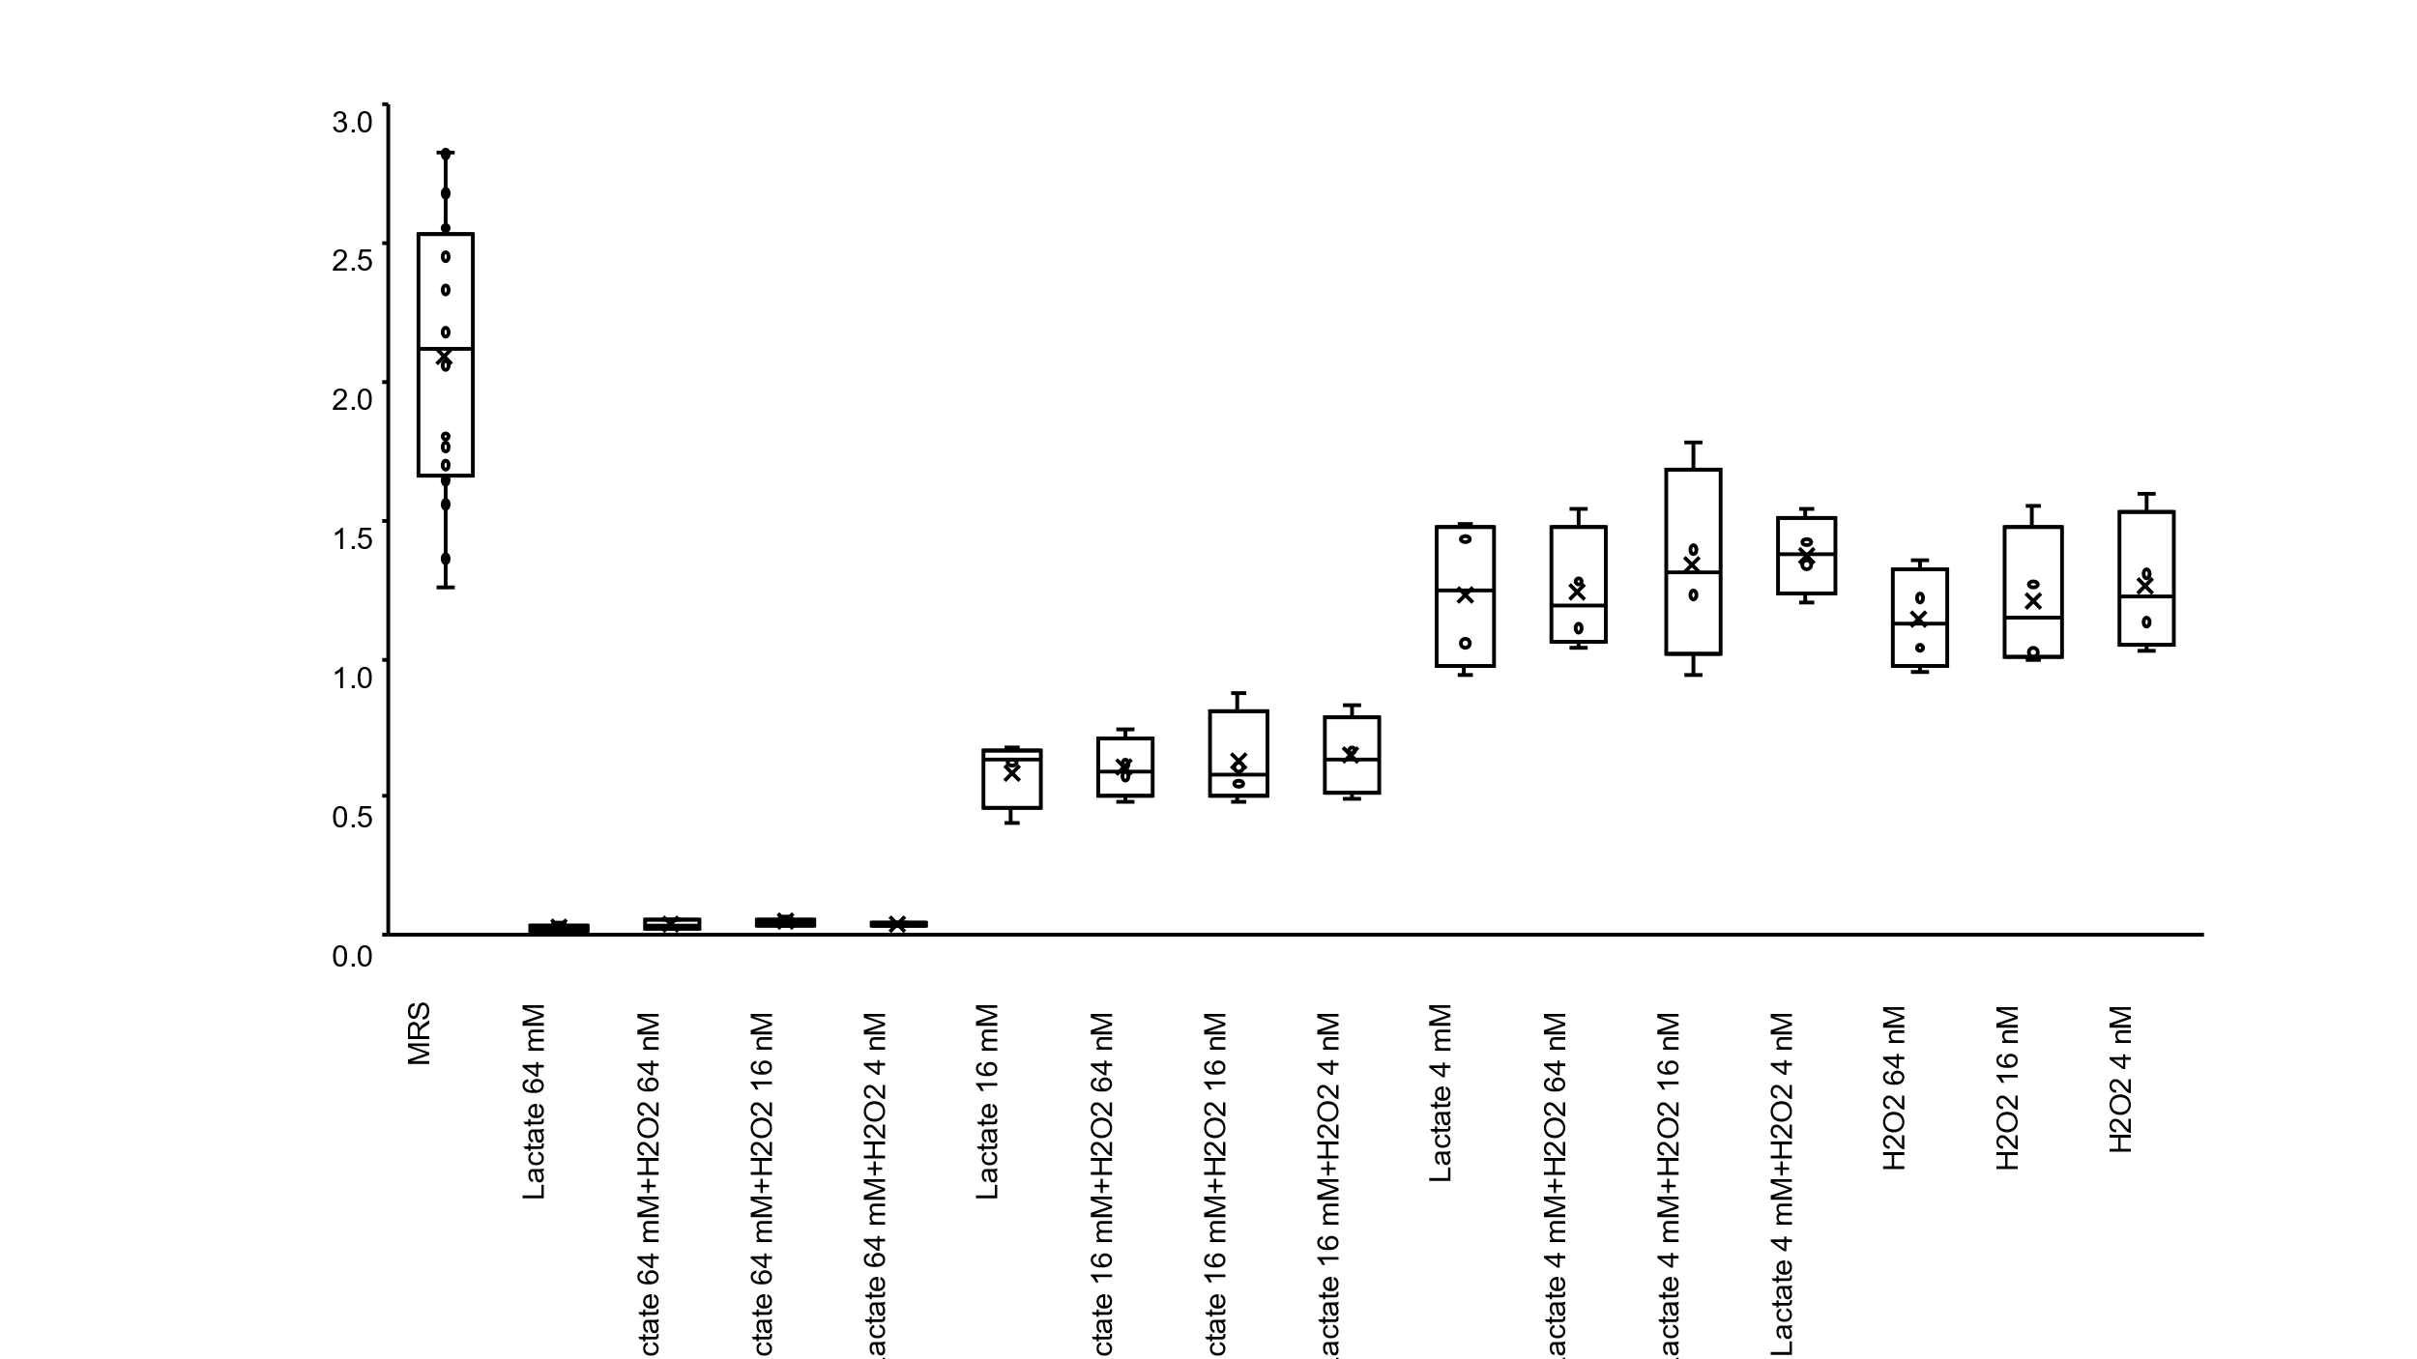
Figure S1. The biofilm formation of C. albicans HB-10 treated with lactate, hydrogen peroxide, or a combination of lactate and hydrogen peroxide
The biofilm formation of C. albicans HB-10 treated with lactate, hydrogen peroxide, or a combination of both, was used to measure WST-1 and was exhibited by the box whisker plots.
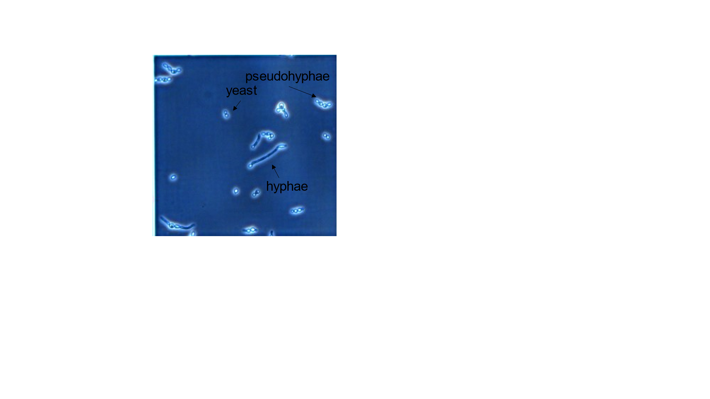
Figure S2. The hyphal formation observed under light microscope.
Under the light microscope, hyphae, pseudohyphal, and yeast forms were distinguished

Table S1. Characteristics of Lactobacillus.
No. | Genus | Species | Strain denomination | Isolation date | Origin
1 | Lactobacillus | crispatus | 3-1-1 | 2014/1/20 | Human vaginal discharge
2 | Lactobacillus | crispatus | 3-1-2 | 2014/1/20 | Human vaginal discharge
3 | Lactobacillus | crispatus | 8-1 | 2014/1/20 | Human vaginal discharge
4 | Limosilactobacillus | vaginalis | 10-1 | 2014/1/20 | Human vaginal discharge
5 | Lacticaseibacillus | rhamnosus | 14-1 | 2014/1/28 | Human vaginal discharge
6 | Lactobacillus | crispatus | 14-2 | 2014/1/28 | Human vaginal discharge
7 | Lactobacillus | gasseri | 16-2-1 | 2014/1/28 | Human vaginal discharge
8 | Lactobacillus | gasseri | 16-2-2 | 2014/1/28 | Human vaginal discharge
9 | Lactobacillus | crispatus | 20-2 | 2014/1/28 | Human vaginal discharge
10 | Lactobacillus | crispatus | 23-1 | 2014/1/28 | Human vaginal discharge
11 | Lactobacillus | jensenii | 27-1 | 2014/4/28 | Human vaginal discharge
12 | Lactobacillus | jensenii | 28-3 | 2014/4/28 | Human vaginal discharge
13 | Lactobacillus | jensenii | 29-1 | 2014/4/28 | Human vaginal discharge
14 | Lactobacillus | gasseri | 30-1 | 2014/4/28 | Human vaginal discharge
15 | Limosilactobacillus | vaginalis | 30-2 | 2014/4/28 | Human vaginal discharge
16 | Lactobacillus | gasseri | 31-1 | 2014/4/28 | Human vaginal discharge
17 | Lactobacillus | gasseri | 32-2 | 2014/7/28 | Human vaginal discharge
18 | Lactobacillus | gasseri | 33-1 | 2014/7/28 | Human vaginal discharge
19 | Lactobacillus | crispatus | 34-1-1 | 2014/7/28 | Human vaginal discharge
20 | Lactobacillus | crispatus | 34-1-2 | 2014/7/28 | Human vaginal discharge
21 | Lactobacillus | crispatus | 35-1 | 2014/7/28 | Human vaginal discharge
22 | Limosilactobacillus | vaginalis | 41-1 | 2014/7/28 | Human vaginal discharge
23 | Lactobacillus | gasseri | 45-3-1 | 2014/7/28 | Human vaginal discharge
24 | Lactobacillus | gasseri | 45-3-2 | 2014/7/28 | Human vaginal discharge
25 | Lactobacillus | gasseri | 49-1 | 2014/7/28 | Human vaginal discharge
26 | Lactobacillus | gasseri | 52-2 | 2014/7/28 | Human vaginal discharge
27 | Lactobacillus | crispatus | 53-1 | 2014/9/8 | Human vaginal discharge

Table S2. Primers used in this study.

Target | Sequence (5'-3') | Tm (°C) | Length (bp) | Reference
ECE1 | Forward: CCAGAAATTGTTGCTCGTGTTGCCA | 62 | 140 | Lee et al. [42] [42]
 | Reverse: TCCAGGACGCCATCAAAAACGTTAG | 61
HWP1 | Forward: TTGTTTGCGTCATCAAGACTTTG | 56 | 73
 | Reverse : GTCTTCATCAGCAGTAACACAACCA | 59
YWP1 | Forward: GTTCCATTTTTCCAAGTTCATTTAG | 53 | 170
 | Reverse : TCAAGAGTAGAACCTTCAAGAGCAG | 58
ACT1 | Forward: GTTGGTGATGAAGCCCAATC | 55 | 79 | Gunsaluset al. [43]
 | Reverse: CCCAGTTGGAAACAATACCG | 55

