Supplementary Information: 3D-QSAR and relative binding affinity estimation of focal adhesion kinase inhibitors
Suparna Ghosh¹ and Seung Joo Cho^{1,2,*}

¹Department of Biomedical Sciences, College of Medicine, Chosun University, Gwangju 501-759, Republic of Korea; s.ghosh@chosun.kr (S.G); chosj@chosun.ac.kr (S.J.C)
² Department of Cellular Molecular Medicine, College of Medicine, Chosun University, Gwangju 501-759, Republic of Korea

*Correspondence:
Address: College of Medicine, Chosun University, 375 Seosuk-dong, Dong-gu Gwangju 501-759, Republic of Korea;
E-mail: chosj@chosun.ac.kr;
Telephone: +82-62-230-7482 or +82-11-5479-1010

Table S1. MM-PB/GBSA binding energy terms
Binding energy terms | BE in kcal/mol
VDW | -58.85 ± 2.34
E_{EL} | -16.96 ± 2.78
E_{GB} | 29.54 ± 1.89
E_{SURF} | -6.49 ± 0.16
ΔG_{gas} | -75.81 ± 3.70
ΔG_{solv} | 23.05 ± 1.82
ΔTOTAL | -52.76 ± 2.95
TΔS | 7.51 ± 0.04
ΔG_{bind} | -45.25 ± 2.95

Residues | BE
I428 | -3.25 ± 0.44
V436 | -1.43 ± 0.26
V484 | -0.70 ± 0.15
M499 | -0.69 ± 0.14
L501 | -2.37 ± 0.34
C502 | -1.97 ± 0.53
G505 | -2.25 ± 0.34
L553 | -2.87 ± 0.38
G563 | -1.04 ± 0.42
D564 | -2.61 ± 0.44
L567 | -2.18 ± 0.30
Table S2. Residue-specific MM-PB/GBSA binding energy decomposition in kcal/mol

Table S3. Dataset compounds and their corresponding pIC₅₀ values
#Cpd | Structure | pIC₅₀
01 |  | 6.76
02 |  | 7.22
03 |  | 7.17
04 |  | 7.20
05 |  | 7.23
06 |  | 7.48
07 |  | 6.94
08 |  | 7.71
09 |  | 7.19
10 |  | 7.05
11 |  | 7.26
12 |  | 7.32
13 |  | 7.65
14 |  | 7.23
15 |  | 7.54
16 |  | 7.64
17 |  | 7.64
18 |  | 7.62
19 |  | 7.94
20 |  | 7.36
21 |  | 7.58
22 |  | 7.81
23 |  | 7.42
24 |  | 8.14
25 |  | 7.31
26 |  | 7.98
27 |  | 7.07
28 |  | 7.08
29 |  | 6.96
30 |  | 7.07
31 |  | 7.06
32 |  | 6.95
33 |  | 6.94
34 |  | 6.96
35 |  | 6.62
36 |  | 8.2
37 |  | 6.87
38 |  | 5.96
39 |  | 6.45
40 |  | 6.85
41 |  | 6.48
42 |  | 6.42
43 |  | 6.19
44 |  | 5.97
45 |  | 6.80
46 |  | 6.73
47 |  | 6.49
48 |  | 6.45
49 |  | 7.10
50 |  | 7.41
51 |  | 7.23
52 |  | 6.77
53 |  | 6.70
54 |  | 6.48
55 |  | 7.31
56 |  | 7.57
57 |  | 7.56
58 |  | 6.78
59 |  | 6.14
60 |  | 7.54
61 |  | 7.59
62 |  | 7.41
63 |  | 7.61
64 |  | 6.92
65 |  | 7.31
66 |  | 6.87
67 |  | 7.14
68 |  | 6.92
69 |  | 6.95
70 |  | 6.82
71 |  | 9.55
72 |  | 9.35
73 |  | 7.53
74 |  | 8.88
75 |  | 8.74
76 |  | 9.24
77 |  | 9.95
78 |  | 8.60
79 |  | 9.35
80 |  | 9.46
81 |  | 10.04
82 |  | 8.29
83 |  | 8.49
84 |  | 9.37
85 |  | 6.69
86 |  | 7.74
87 |  | 7.58
88 |  | 7.30
89 |  | 7.25
90 |  | 6.17
91 |  | 7.04
92 |  | 7.82
93 |  | 7.45
94 |  | 7.10
95 |  | 8.15
96 |  | 7.52
97 |  | 7.74
98 |  | 7.16
99 |  | 8.09
100 |  | 7.92
101 |  | 8.15
102 |  | 7.79
103 |  | 7.88
104 |  | 5.39
105 |  | 5.62
106 |  | 6.14
107 |  | NA
108 |  | 8.00
109 |  | 7.92
110 |  | 7.50
111 |  | 6.44
112 |  | 7.67
113 |  | 6.71
114 |  | 7.74
115 |  | 5.78
116 |  | 6.49
117 |  | 7.22
118 |  | 7.44
119 |  | 7.92
120 |  | 7.95
121 |  | 7.67
122 |  | 7.48
123 |  | 6.89
124 |  | 7.53
125 |  | 7.26

Table S4. random draw table for test set compounds
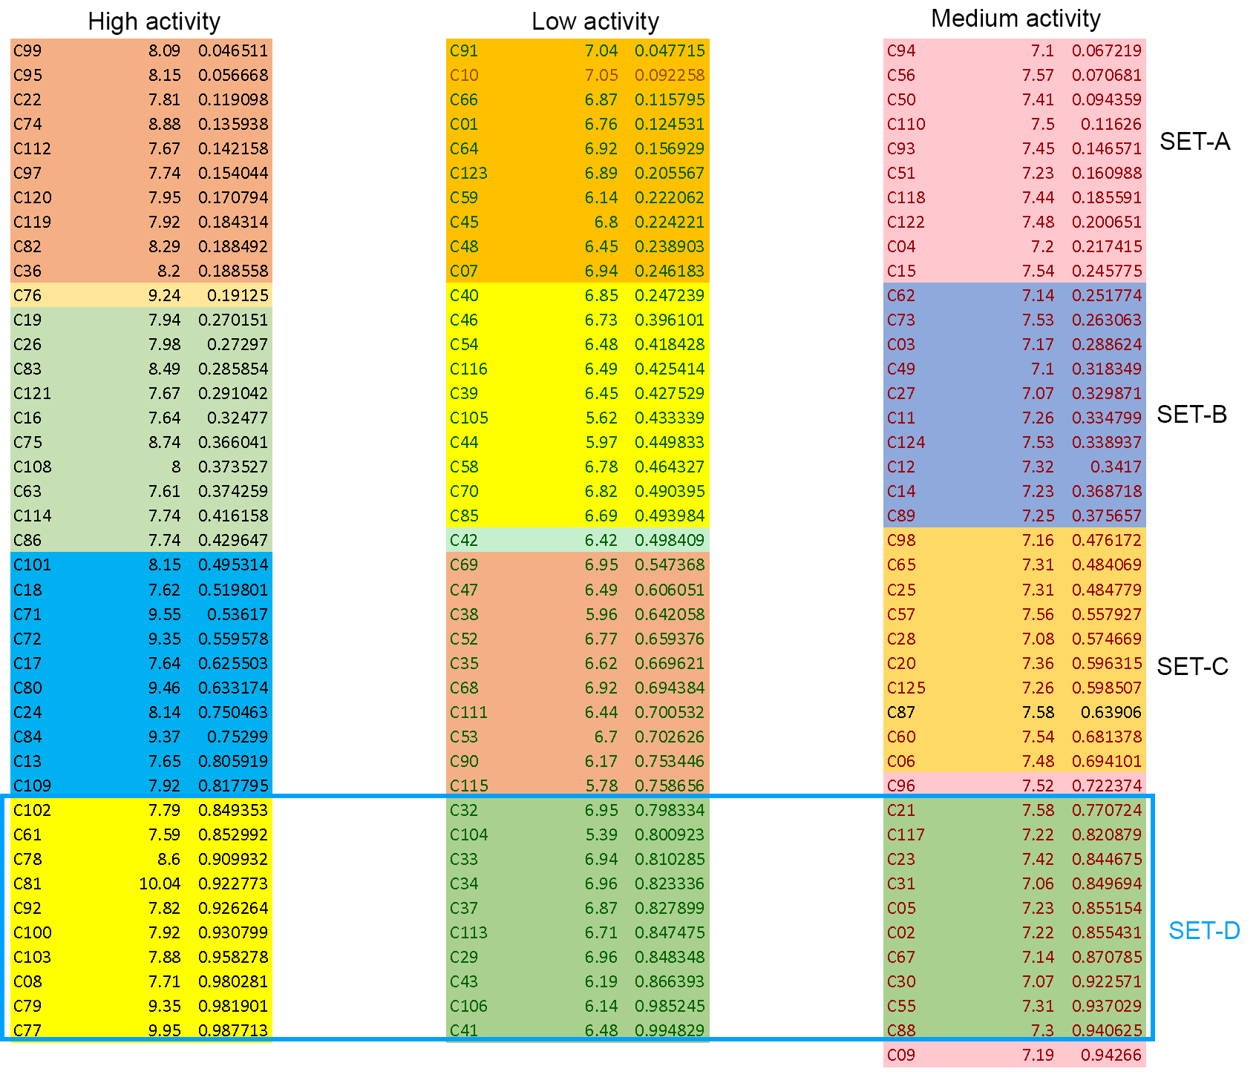
Table S5. Statistics of CoMSIA model development
CoMSIA | q² | ONC | SEP | r² | SEE | F-value | Field Contribution
 |  |  |  |  |  |  | S | E | H | A | D
S | 0.476 | 2 | 0.615 | 0.608 | 0.532 | 69.815 | 100 | - | - | - | -
E | 0.543 | 3 | 0.577 | 0.672 | 0.489 | 60.786 | - | 100 | - | - | -
H | 0.462 | 4 | 0.630 | 0.710 | 0.463 | 53.777 | - | - | 100 | - | -
A | 0.412 | 2 | 0.651 | 0.527 | 0.584 | 50.123 | - | - | - | 100 | -
D | 0.475 | 5 | 0.626 | 0.711 | 0.465 | 42.738 | - | - | - | - | 100
SE | 0.552 | 6 | 0.582 | 0.853 | 0.333 | 82.997 | 31.2 | 68.8 | - | - | -
EH | 0.533 | 6 | 0.594 | 0.854 | 0.332 | 83.767 | - | 62.7 | 37.3 | - | -
EA | 0.531 | 2 | 0.582 | 0.656 | 0.498 | 85.688 | - | 59.1 | - | 40.9 | -
ED | 0.626 | 6 | 0.531 | 0.838 | 0.352 | 73.143 | - | 59.4 | - | - | 40.6
SH | 0.488 | 2 | 0.608 | 0.641 | 0.509 | 80.493 | 49.9 | - | 50.1 | - | -
SA | 0.476 | 5 | 0.626 | 0.786 | 0.400 | 63.954 | 41.1 | - | - | 59.9 | -
SD | 0.544 | 4 | 0.580 | 0.749 | 0.430 | 65.747 | 42.8 | - | - | - | 57.2
HA | 0.426 | 5 | 0.654 | 0.760 | 0.423 | 55.022 | - | - | 46.9 | 53.1 | -
HD | 0.575 | 4 | 0.560 | 0.768 | 0.414 | 72.690 | - | - | 48.1 | - | 51.9
AD | 0.487 | 3 | 0.612 | 0.666 | 0.494 | 59.212 | - | - | - | 54.6 | 45.4
SHE | 0.556 | 6 | 0.579 | 0.877 | 0.305 | 102.032 | 21.2 | 49.9 | 29.3 | - | -
SEA | 0.561 | 6 | 0.576 | 0.864 | 0.320 | 91.420 | 20.4 | 47.0 | - | 32.6 | -
SED | 0.656 | 6 | 0.510 | 0.862 | 0.323 | 89.719 | 18.7 | 46.1 | - | - | 35.2
EHA | 0.543 | 6 | 0.588 | 0.853 | 0.333 | 83.432 | - | 44.6 | 25.0 | 30.3 | -
EHD | 0.631 | 6 | 0.528 | 0.863 | 0.322 | 90.298 | - | 42.7 | 23.2 | - | 34.1
SHA | 0.490 | 5 | 0.617 | 0.811 | 0.376 | 74.442 | 25.6 | - | 33.9 | 40.6 | -
SHD | 0.574 | 4 | 0.561 | 0.783 | 0.400 | 79.243 | 23.9 | - | 34.9 | - | 41.2
EAD | 0.602 | 5 | 0.545 | 0.817 | 0.369 | 77.741 | - | 43.6 | - | 26.5 | 29.9
HAD | 0.540 | 5 | 0.586 | 0.801 | 0.385 | 70.045 | - | - | 32.9 | 32.2 | 34.9
SEHD | 0.639 | 6 | 0.522 | 0.874 | 0.309 | 99.200 | 14.2 | 35.8 | 19.3 | - | 30.6
SEHA | 0.559 | 6 | 0.577 | 0.873 | 0.310 | 98.318 | 15.5 | 37.0 | 20.5 | 27.0 | -
SEAD | 0.639 | 6 | 0.522 | 0.863 | 0.321 | 90.442 | 14.9 | 34.9 | - | 23.9 | 26.3
EHAD | 0.620 | 6 | 0.536 | 0.863 | 0.322 | 90.308 | - | 33.8 | 18.9 | 21.6 | 25.8
SHAD | 0.584 | 5 | 0.557 | 0.827 | 0.359 | 83.193 | 18.0 | - | 25.3 | 27.2 | 29.6
SEHAD | 0.639 | 6 | 0.522 | 0.875 | 0.307 | 100.545 | 12.0 | 28.7 | 15.7 | 19.9 | 23.7
(S: Steric; E: Electrostatic; H: Hydrophobic; A: H-bond acceptor; D: H-bond donor)

Table S6. Actual vs. predicted pIC₅₀ values of CoMFA and CoMSIA (SET-D) models
#Cpd | CoMFA |  |  | CoMSIA (SED)
 | Actual pIC50 | Predicted pIC50 | Residuals | Actual pIC50 | Predicted pIC50 | Residuals
C105 | 5.62 | 5.777 | -0.157 | 5.62 | 5.962 | -0.342
C115 | 5.78 | 6.415 | -0.635 | 5.78 | 6.592 | -0.812
C38 | 5.96 | 6.966 | -1.006 | 5.96 | 6.105 | -0.145
C44 | 5.97 | 7.492 | -1.522 | 5.97 | 6.622 | -0.652
C59 | 6.14 | 7.428 | -1.288 | 6.14 | 7.506 | -1.366
C90 | 6.17 | 6.305 | -0.135 | 6.17 | 6.658 | -0.488
C42 | 6.42 | 6.604 | -0.184 | 6.42 | 6.466 | -0.046
C111 | 6.44 | 6.381 | 0.059 | 6.44 | 6.702 | -0.262
C39 | 6.45 | 6.251 | 0.199 | 6.45 | 6.402 | 0.048
C48 | 6.45 | 6.5 | -0.05 | 6.45 | 6.165 | 0.285
C54 | 6.48 | 6.29 | 0.19 | 6.48 | 6.832 | -0.352
C47 | 6.49 | 6.683 | -0.193 | 6.49 | 6.237 | 0.253
C116 | 6.49 | 6.626 | -0.136 | 6.49 | 7.074 | -0.584
C35 | 6.62 | 6.863 | -0.243 | 6.62 | 6.789 | -0.169
C85 | 6.69 | 7.065 | -0.375 | 6.69 | 7.414 | -0.724
C53 | 6.7 | 6.555 | 0.145 | 6.7 | 6.84 | -0.14
C46 | 6.73 | 6.657 | 0.073 | 6.73 | 6.727 | 0.003
C01 | 6.76 | 7.08 | -0.32 | 6.76 | 6.815 | -0.055
C52 | 6.77 | 6.887 | -0.117 | 6.77 | 6.878 | -0.108
C58 | 6.78 | 7.869 | -1.089 | 6.78 | 8.052 | -1.272
C45 | 6.8 | 6.796 | 0.004 | 6.8 | 6.363 | 0.437
C70 | 6.82 | 7.204 | -0.384 | 6.82 | 7.105 | -0.285
C40 | 6.85 | 6.623 | 0.227 | 6.85 | 6.442 | 0.408
C66 | 6.87 | 7 | -0.13 | 6.87 | 7.131 | -0.261
C123 | 6.89 | 7.283 | -0.393 | 6.89 | 7.339 | -0.449
C64 | 6.92 | 7.152 | -0.232 | 6.92 | 7.001 | -0.081
C68 | 6.92 | 6.898 | 0.022 | 6.92 | 6.846 | 0.074
C07 | 6.94 | 7.044 | -0.104 | 6.94 | 7.192 | -0.252
C69 | 6.95 | 6.904 | 0.046 | 6.95 | 6.706 | 0.244
C91 | 7.04 | 6.999 | 0.041 | 7.04 | 6.954 | 0.086
C10 | 7.05 | 7.255 | -0.205 | 7.05 | 7.154 | -0.104
C27 | 7.07 | 7.168 | -0.098 | 7.07 | 7.123 | -0.053
C28 | 7.08 | 7 | 0.08 | 7.08 | 6.984 | 0.096
C94 | 7.1 | 6.95 | 0.15 | 7.1 | 7.024 | 0.076
C49 | 7.1 | 7.022 | 0.078 | 7.1 | 6.841 | 0.259
C62 | 7.14 | 7.77 | -0.63 | 7.14 | 7.611 | -0.471
C98 | 7.16 | 7.924 | -0.764 | 7.16 | 7.33 | -0.17
C03 | 7.17 | 7.562 | -0.392 | 7.17 | 7.407 | -0.237
C09 | 7.19 | 7.374 | -0.184 | 7.19 | 7.229 | -0.039
C04 | 7.2 | 7.146 | 0.054 | 7.2 | 7.089 | 0.111
C51 | 7.23 | 6.982 | 0.248 | 7.23 | 7.11 | 0.12
C14 | 7.23 | 7.206 | 0.024 | 7.23 | 7.128 | 0.102
C89 | 7.25 | 6.607 | 0.643 | 7.25 | 6.59 | 0.66
C125 | 7.26 | 7.408 | -0.148 | 7.26 | 7.382 | -0.122
C11 | 7.26 | 7.403 | -0.143 | 7.26 | 6.856 | 0.404
C25 | 7.31 | 7.478 | -0.168 | 7.31 | 7.529 | -0.219
C65 | 7.31 | 7.24 | 0.07 | 7.31 | 7.064 | 0.246
C12 | 7.32 | 7.163 | 0.157 | 7.32 | 7.498 | -0.178
C20 | 7.36 | 7.365 | -0.005 | 7.36 | 7.333 | 0.027
C50 | 7.41 | 7.182 | 0.228 | 7.41 | 7.406 | 0.004
C118 | 7.44 | 7.75 | -0.31 | 7.44 | 7.338 | 0.102
C93 | 7.45 | 8.25 | -0.8 | 7.45 | 7.67 | -0.22
C06 | 7.48 | 7.416 | 0.064 | 7.48 | 7.745 | -0.265
C122 | 7.48 | 6.718 | 0.762 | 7.48 | 7.295 | 0.185
C110 | 7.5 | 7.654 | -0.154 | 7.5 | 7.532 | -0.032
C96 | 7.52 | 8.198 | -0.678 | 7.52 | 7.227 | 0.293
C73 | 7.53 | 9.3 | -1.77 | 7.53 | 9.108 | -1.578
C124 | 7.53 | 7.418 | 0.112 | 7.53 | 7.177 | 0.353
C60 | 7.54 | 7.236 | 0.304 | 7.54 | 7.453 | 0.087
C15 | 7.54 | 7.5 | 0.04 | 7.54 | 7.469 | 0.071
C57 | 7.56 | 7.976 | -0.416 | 7.56 | 8.009 | -0.449
C56 | 7.57 | 7.527 | 0.043 | 7.57 | 7.759 | -0.189
C87 | 7.58 | 7.637 | -0.057 | 7.58 | 7.529 | 0.051
C63 | 7.61 | 7.079 | 0.531 | 7.61 | 7.275 | 0.335
C18 | 7.62 | 7.411 | 0.209 | 7.62 | 7.647 | -0.027
C17 | 7.64 | 7.21 | 0.43 | 7.64 | 7.174 | 0.466
C16 | 7.64 | 7.542 | 0.098 | 7.64 | 7.518 | 0.122
C13 | 7.65 | 7.328 | 0.322 | 7.65 | 7.461 | 0.189
C112 | 7.67 | 7.415 | 0.255 | 7.67 | 7.065 | 0.605
C121 | 7.67 | 7.618 | 0.052 | 7.67 | 7.683 | -0.013
C114 | 7.74 | 7.707 | 0.033 | 7.74 | 7.38 | 0.36
C86 | 7.74 | 7.286 | 0.454 | 7.74 | 7.484 | 0.256
C97 | 7.74 | 7.55 | 0.19 | 7.74 | 7.839 | -0.099
C22 | 7.81 | 7.383 | 0.427 | 7.81 | 7.232 | 0.578
C119 | 7.92 | 7.839 | 0.081 | 7.92 | 7.553 | 0.367
C109 | 7.92 | 7.279 | 0.641 | 7.92 | 7.488 | 0.432
C19 | 7.94 | 7.496 | 0.444 | 7.94 | 7.266 | 0.674
C120 | 7.95 | 7.512 | 0.438 | 7.95 | 7.897 | 0.053
C26 | 7.98 | 7.616 | 0.364 | 7.98 | 7.918 | 0.062
C108 | 8 | 7.576 | 0.424 | 8 | 7.355 | 0.645
C99 | 8.09 | 7.995 | 0.095 | 8.09 | 7.817 | 0.273
C24 | 8.14 | 7.249 | 0.891 | 8.14 | 7.425 | 0.715
C101 | 8.15 | 8.236 | -0.086 | 8.15 | 7.869 | 0.281
C95 | 8.15 | 8.35 | -0.2 | 8.15 | 8.458 | -0.308
C36 | 8.2 | 8.332 | -0.132 | 8.2 | 7.951 | 0.249
C82 | 8.29 | 8.845 | -0.555 | 8.29 | 9.14 | -0.85
C83 | 8.49 | 8.409 | 0.081 | 8.49 | 8.613 | -0.123
C75 | 8.74 | 8.846 | -0.106 | 8.74 | 8.593 | 0.147
C74 | 8.88 | 8.911 | -0.031 | 8.88 | 8.989 | -0.109
C76 | 9.24 | 8.916 | 0.324 | 9.24 | 8.836 | 0.404
C72 | 9.35 | 9.362 | -0.012 | 9.35 | 9.248 | 0.102
C84 | 9.37 | 9.363 | 0.007 | 9.37 | 9.237 | 0.133
C80 | 9.46 | 9.475 | -0.015 | 9.46 | 9.262 | 0.198
C71 | 9.55 | 8.86 | 0.69 | 9.55 | 8.774 | 0.776
C104 | 5.39 | 5.672 | -0.282 | 5.39 | 5.403 | -0.013
C106 | 6.14 | 6.452 | -0.312 | 6.14 | 6.272 | -0.132
C43 | 6.19 | 6.276 | -0.086 | 6.19 | 6.416 | -0.226
C41 | 6.48 | 6.752 | -0.272 | 6.48 | 6.434 | 0.046
C113 | 6.71 | 6.471 | 0.239 | 6.71 | 6.641 | 0.069
C37 | 6.87 | 6.544 | 0.326 | 6.87 | 6.402 | 0.468
C33 | 6.94 | 7.027 | -0.087 | 6.94 | 7.089 | -0.149
C32 | 6.95 | 6.848 | 0.102 | 6.95 | 6.932 | 0.018
C34 | 6.96 | 6.948 | 0.012 | 6.96 | 6.828 | 0.132
C29 | 6.96 | 7.258 | -0.298 | 6.96 | 7.068 | -0.108
C31 | 7.06 | 6.936 | 0.124 | 7.06 | 6.859 | 0.201
C30 | 7.07 | 7.164 | -0.094 | 7.07 | 6.921 | 0.149
C67 | 7.14 | 7.198 | -0.058 | 7.14 | 7.195 | -0.055
C117 | 7.22 | 7.115 | 0.105 | 7.22 | 7.435 | -0.215
C02 | 7.22 | 7.164 | 0.056 | 7.22 | 7.208 | 0.012
C05 | 7.23 | 7.36 | -0.13 | 7.23 | 7.685 | -0.455
C88 | 7.3 | 7.427 | -0.127 | 7.3 | 7.081 | 0.219
C55 | 7.31 | 7.241 | 0.069 | 7.31 | 7.549 | -0.239
C23 | 7.42 | 7.379 | 0.041 | 7.42 | 7.376 | 0.044
C21 | 7.58 | 7.716 | -0.136 | 7.58 | 8.157 | -0.577
C61 | 7.59 | 7.487 | 0.103 | 7.59 | 7.747 | -0.157
C08 | 7.71 | 7.798 | -0.088 | 7.71 | 8.06 | -0.35
C102 | 7.79 | 8.102 | -0.312 | 7.79 | 7.827 | -0.037
C92 | 7.82 | 6.909 | 0.911 | 7.82 | 7.033 | 0.787
C103 | 7.88 | 7.74 | 0.14 | 7.88 | 6.659 | 1.221
C100 | 7.92 | 8.022 | -0.102 | 7.92 | 7.808 | 0.112
C78 | 8.6 | 8.596 | 0.004 | 8.6 | 8.673 | -0.073
C79 | 9.35 | 9.123 | 0.227 | 9.35 | 9.132 | 0.218
C77 | 9.95 | 9.02 | 0.93 | 9.95 | 9.152 | 0.798
C81 | 10.04 | 9.695 | 0.345 | 10.04 | 9.277 | 0.763
Test set data are shown in blue
Table S7. λ parameters to gradually change the ligand interaction from State-A to State-B
λ | 1 | 2 | 3 | 4 | 5 | 6 | 7 | 8 | 9 | 10 | 11 | 12
λ ljA | 1.0 | 0.909 | 0.818 | 0.727 | 0.636 | 0.545 | 0.455 | 0.364 | 0.273 | 0.182 | 0.091 | 0.0
λ ljB | 0.0 | 0.091 | 0.182 | 0.273 | 0.364 | 0.455 | 0.545 | 0.636 | 0.727 | 0.818 | 0.909 | 1.0
λ elA | 1.0 | 0.909 | 0.818 | 0.727 | 0.636 | 0.545 | 0.455 | 0.364 | 0.273 | 0.182 | 0.091 | 0.0
λ elB | 0.0 | 0.091 | 0.182 | 0.273 | 0.364 | 0.455 | 0.545 | 0.636 | 0.727 | 0.818 | 0.909 | 1.0
λ bondA | 1.0 | 0.909 | 0.818 | 0.727 | 0.636 | 0.545 | 0.455 | 0.364 | 0.273 | 0.182 | 0.091 | 0.0
λ bondB | 0.0 | 0.091 | 0.182 | 0.273 | 0.364 | 0.455 | 0.545 | 0.636 | 0.727 | 0.818 | 0.909 | 1.0

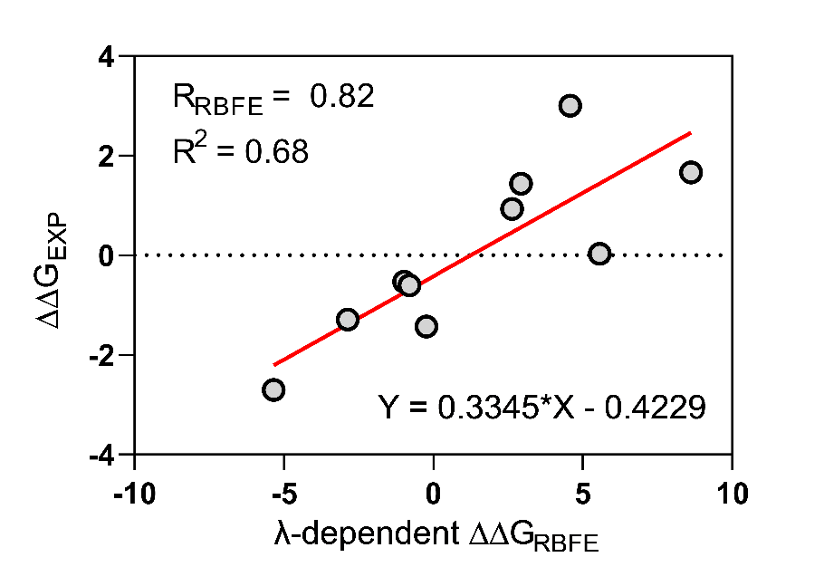
Figure S1. Correlation plot between experimental and computed relative binding free energies.

