Supplementary Data
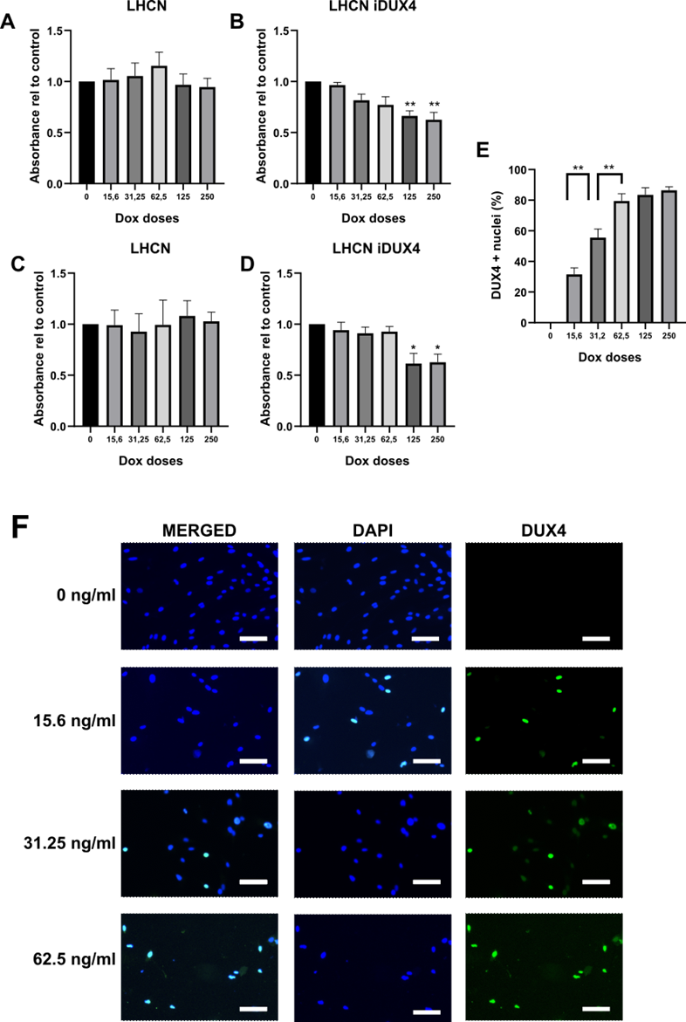
Figure S1. Effect of DUX4 induction on LHCN-M2 and LHCN-M2 iDUX4 cell viability. A-D. MTT (A-B) and CCK8 (C-D) tests were performed 24h after induction of DUX4 expression with increasing doses of doxycycline (DOX, ng/ml). Mean ± SEM, *p<0.05, **p<0.01, One-way ANOVA with Holm Sidak post hoc test vs control (DOX: 0 ng/ml). E. Quantification of DUX4 positive (DUX4⁺) nuclei normalized to the total number of nuclei (DAPI) 24h after induction of DUX4 expression with increasing doses of DOX. Mean ± SEM, *p<0.05, **p<0.01, One-way ANOVA with Holm Sidak post hoc test vs control (DOX: 0 ng/ml). F. Representative field showing DUX4⁺ nuclei detected by immunofluorescence (green) as described in Figure 1. DAPI was used to stain nuclei (blue). Scale = 100µm. Experiments were performed on 3 independent cultures, each in triplicate.
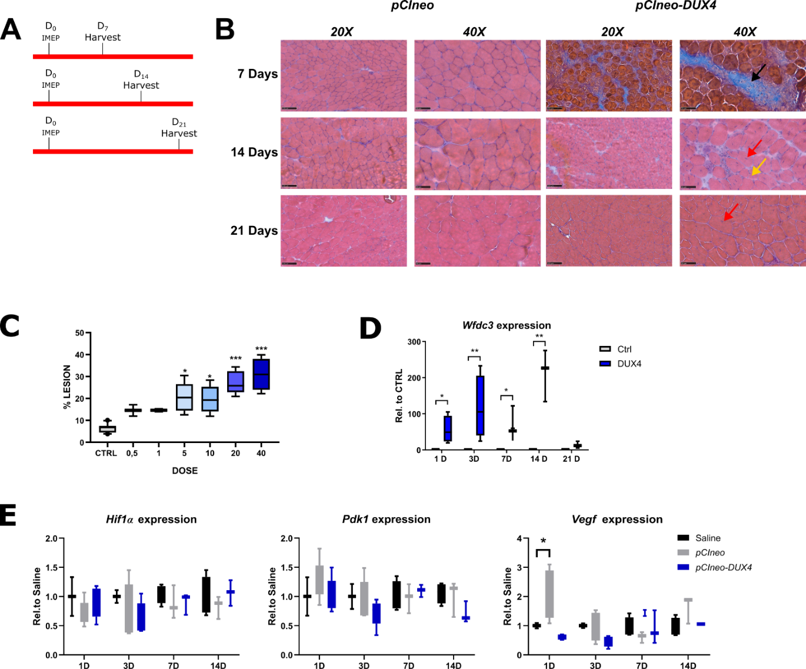
Figure S2. No effect of DUX4 expression on the Hif1α pathway in the DUX4 IMEP murine model with a low dose of DUX4 expression. A. Experiment time courses. B. Representative sections of TA electroporated with 5 µg of pCIneo (left column) or pCIneo-DUX4 (right column) plasmids at 7-, 14- and 21-days post-injection. èFibrosis, èCentral nuclei, èAtrophic fibers. Scale = 100µm for 20-X and 50 µm for 40-X magnification. C. Dose–response of plasmid amount vs muscle lesion area in mouse TA, 1-week post-IMEP procedure. The lesion area percentage was evaluated on total cryosection of medial and proximal part of TA electroporated with different doses of a DUX4 expression plasmid (pCIneo-DUX4). The results obtained from saline solution injected groups and pCIneo group were pooled into a single control group, as no statistical difference could be highlighted between groups at any time point. * p< 0,05, ** p< 0,01, ***p<0,001, Kruskal Wallis followed by Dunn's post hoc test. Control group n=10, 0,5 µg and 1µg n=2, 5µg n=6, 10 µg n=7, 20µg n=8, 40µg n=4. D. Effect of DUX4 expression on Wfdc3 mRNA level in the IMEP model. RT-qPCR quantifications were normalized to Rplp0. * p< 0,05, ** p< 0,01; Kruskal Wallis followed by a Dunn’s post-hoc test. For 1- and 3-day group: pCIneo-DUX4 n=4, pCIneo n=6, saline n=2. For 7- and 14-day groups: pCIneo-DUX4 n=3, pCIneo n=3, saline n=4. For the 21-day group: pCIneo-DUX4 n=3, pCIneo n=4, saline n=4. The results obtained from saline solution injected groups and pCIneo group were pooled into a single control group, as no statistical difference could be highlighted between groups at any time point. E. Effect of DUX4 induction on Hif1α mRNA level in the IMEP model. RT-qPCR normalized to Rplp0 gene. *p< 0,05, **p< 0,01; Kruskal Wallis followed by a Dunn’s post-hoc test. For 1- and 3-day group: pCIneo-DUX4 n=4, pCIneo n=6. For 7- and 14-days group: pCIneo-DUX4 n=3, pCIneo n=4. For the 21-day group: pCIneo-DUX4 n=3, pCIneo n=4. Results obtained from saline solution injected groups from all time points, were pooled together, as no statistical difference could be highlighted between groups at any time point for all tested genes, saline group n=14.

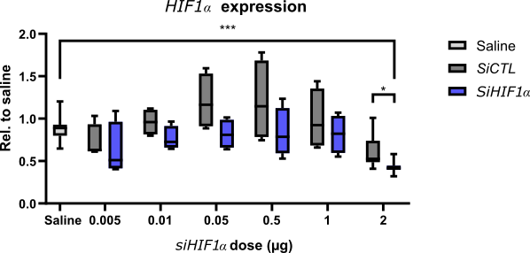
Figure S3. Efficiency of siRNAs directed against Hif1α mRNA (siHIF): dose-response analysis. The TA muscle was electroporated with either saline solution, siCTL or siHIF. The Hif1α mRNA level was quantified by RT-qPCR and normalized to Rplp0. *p<0.05, ***p<0.001, Kruskal Wallis followed by a Dunn’s post-hoc test. Saline : n=10, 0.005 µg, 0.01 µg, 0.05 µg, 0.5 µg and 1 µg : n=4, 2µg : n=10.

