Contents:

Table S1: Search strategy
Table S2: Characteristics of included studies
Table S3: Subgroup analyses of cumulative decline in left ventricular ejection fraction (%) over time in cohorts of cancer patients receiving a cumulative anthracycline dose above 300 mg/m2 versus a cumulative anthracycline dose between 200 to 300 mg/m2.
Table S4: Subgroup analyses of cumulative decline in left ventricular ejection fraction (%) over time in cohorts of cancer patients (A) with a baseline LVEF of 65 to 70% (B) with a baseline LVEF of 60 to 65%.
Table S5: Subgroup analyses of cumulative decline in left ventricular ejection fraction (%) over time in cohorts of cancer patients excluding studies with at least 10% of cancer patients receiving trastuzumab.
Table S6: Cumulative rise in natriuretic peptides (standardised mean) over time.
Figure S1: Risk of bias assessment.
Figure S2: Cumulative rise in natriuretic peptides (standardised mean) over time. Whiskers represent 95% confidence intervals.

Table S1: Search strategy
Database | Search terms | Results
PubMed | (anthracycline or anthra* or epirubicin or doxorubicin or daunorubicin or trastuzumab or herceptin) and (cardiac or cardiotox* or cardiac dysfunction or lvef or ejection fraction or troponin or creatine kinase or natriuretic peptide or bnp or nt-bnp or stress or strain or systolic or diastolic) and (rct OR (random* AND (control*))) | 1,440
EMBASE | ('anthracycline'/exp OR anthracycline OR anthra* OR 'epirubicin'/exp OR epirubicin OR 'doxorubicin'/exp OR doxorubicin OR 'daunorubicin'/exp OR daunorubicin OR 'trastuzumab'/exp OR trastuzumab OR 'herceptin'/exp OR herceptin) AND ('cardiac'/exp OR cardiac OR cardiotox* OR 'cardiac dysfunction'/exp OR 'cardiac dysfunction' OR (('cardiac'/exp OR cardiac) AND dysfunction) OR lvef OR 'ejection fraction'/exp OR 'ejection fraction' OR (ejection AND fraction) OR 'troponin'/exp OR troponin OR 'creatine kinase'/exp OR 'creatine kinase' OR (('creatine'/exp OR creatine) AND ('kinase'/exp OR kinase)) OR 'natriuretic peptide'/exp OR 'natriuretic peptide' OR (natriuretic AND ('peptide'/exp OR peptide)) OR bnp OR 'nt bnp' OR 'stress'/exp OR stress OR 'strain'/exp OR strain OR systolic OR diastolic) AND (rct OR (random* AND control*)) | 3,514
CENTRAL | In all fields: (anthracycline or anthra* or epirubicin or doxorubicin or daunorubicin or trastuzumab or herceptin) and (cardiac or cardiotox* or cardiac dysfunction or lvef or ejection fraction or troponin or creatine kinase or natriuretic peptide or bnp or nt-bnp or stress or strain or systolic or diastolic) and (rct OR (random* AND (control*))) | 1,072

Table S2: Characteristics of included studies

Study | Year | n, patients | Gender (% male) | Mean age | Cancer | Anthracyclines | Baseline mean LVEF (%) | Duration of follow-up (Days)
Lee | 2021 | 43 | 0 | 48.5 | Breast | Doxorubicin | 64 | 480
Kaya | 2013 | 18 | 0 | 50.5 | Breast | Epirubicin | 66.6 | 480
Avila | 2018 | 13 | 0 | 52.9 | Breast | NR | 65.2 | 180
Bosch | 2013 | 37 | NR | 50 | Haematological cancers | NR | 62.59 | 630
Boekhout | 2016 | 206 | 0 | 49 | Breast | NR | NR | 630
Elitok | 2014 | 40 | 0 | 52.9 | Breast | NR | 65 | 180
Nabati | 2017 | 40 | 0 | 47.1 | Breast | Doxorubicin | 61.13 | 180
Acar | 2011 | 20 | 45 | 52.6 | Non-Hodgkin's lymphoma, multiple myeloma, leukemia | Doxorubicin or idarubicin | 62.9 | 180
Kalay | 2006 | 25 | 16 | 49 | Breast, lymphomas | Doxorubicin or epirubicin | 69.7 | 180
Georgakopoulos | 2010 | 40 | 53 | 49.1 | Lymphomas | Doxorubicin | 67.6 | 360
Jhorawat | 2016 | 27 | 66.7 | 38.74 | Haematological cancers | Doxorubicin | 67.56 | 180
Salehi | 2011 | 22 | 36.4 | 43.5 | Breast, lymphomas | Doxorubicin or epirubicin | 58.56 | 120
Dessi | 2013 | 24 | 33.3 | 53 | Various | Epirubicin | 66 | 540
Livi | 2021 | 42 | 0 | 48 | Breast | NR | 64.1 | 360
Janbabai | 2016 | 35 | 11.4 | 47.06 | Various | Doxorubicin | 59.61 | 180
Cardinale | 2006 | 58 | 33 | 44 | Breast, haematological cancers | NR | 61.8 | 270
Abuosa | 2018 | 38 | 24 | 40.4 | Breast, lymphomas | Doxorubicin | 62 | 180
Cochera | 2018 | 30 | 0 | 52 | Breast | Doxorubicin | 61 | 126
Sun | 2015 | 40 | 0 | 55.11 | Breast | Epirubicin | 65 | 126
Slowik | 2020 | 48 | 0 | 45 | Breast | NR | NR | 365
Hundley | 2022 | 140 | 8 | 49.4 | Breast, lymphomas | Doxorubicin | 61.7 | 720
Esfandbod | 2021 | 30 | 0 | 46.2 | Breast | Doxorubicin | 54.9 | 360
Wihandono | 2021 | 25 | 0 | 50.8 | Breast | Doxorubicin | 65.64 | 150
Farahani | 2019 | 35 | 0 | 57.4 | Breast | Doxorubicin or idarubicin | 54.93 | 90
Cadeddu | 2010 | 24 | 0.33 | 53 | Various | Epirubicin | 66 | 28

Table S3: Subgroup analyses of cumulative decline in left ventricular ejection fraction (%) over time in cohorts of cancer patients receiving a cumulative anthracycline dose above 300 mg/m2 versus a cumulative anthracycline dose between 200 to 300 mg/m2. Abbreviations: k, number of studies; CI, confidence interval; n, number of patients.
 | Cohorts with CAD >300 mg/m2 |  |  |  |  | Cohorts with CAD 200-300 mg/m2
Time (days) | k | Mean | Lower CI | Upper CI | n | k | Mean | Lower CI | Upper CI | n
30 | 1 | 2 | 0.457 | 3.542 | 21
60 | 1 | 0 | -1.352 | 1.352 | 21 | 2 | -2.378 | -5.578 | 0.8217 | 56
90 | 2 | -3.799 | -11.247 | 3.648 | 79 | 2 | -2.335 | -5.633 | 0.9623 | 56
120 | 5 | -2.691 | -5.628 | 0.246 | 171
150 | 6 | -3.142 | -5.715 | -0.568 | 196
180 | 10 | -6.240 | -9.920 | -2.559 | 326 | 4 | -3.711 | -5.495 | -1.928 | 116
270 | 10 | -6.603 | -10.507 | -2.699 | 324
360 | 10 | -6.504 | -10.487 | -2.521 | 324
480 |  |  |  |  |  | 4 | -3.513 | -5.238 | -1.789 | 116
540 | 10 | -6.708 | -10.542 | -2.874 | 324
630 |  |  |  |  |  | 5 | -3.358 | -4.343 | -2.374 | 153

Table S4: Subgroup analyses of cumulative decline in left ventricular ejection fraction (%) over time in cohorts of cancer patients (A) with a baseline LVEF of 65 to 70% (B) with a baseline LVEF of 60 to 65%. Abbreviations: k, number of studies; CI, confidence interval; n, number of patients.
A: Subgroup analysis of studies with baseline LVEF 65 to 70%
Time (Days) | k | Mean | Lower CI | Upper CI | n
30 | 2 | 0.949404762 | -1.008048981 | 2.906858505 | 45
60 | 3 | -0.250495486 | -0.99088429 | 0.489893319 | 58
90 | 3 | -0.196770938 | -0.954200274 | 0.560658397 | 58
150 | 4 | -1.415413053 | -3.883936479 | 1.053110373 | 83
180 | 6 | -5.052824098 | -10.29468464 | 0.189036445 | 126
360 | 7 | -4.310041025 | -8.959094917 | 0.339012866 | 166
480 | 8 | -4.908847329 | -9.102819917 | -0.714874741 | 184
540 | 8 | -5.161042087 | -9.180409349 | -1.141674825 | 184
B: Subgroup analysis of studies with baseline LVEF 60 to 65%
Time (Days) | k | Mean | Lower CI | Upper CI | n
60 | 1 | -3.96666667 | -4.601371777 | -3.331961563 | 43
90 | 2 | -5.730447567 | -9.289539721 | -2.171355412 | 101
120 | 4 | -3.20508042 | -6.504861931 | 0.09470109 | 171
180 | 9 | -4.297650721 | -6.785509221 | -1.809792221 | 345
270 | 9 | -4.691378247 | -7.678009813 | -1.70474668 | 343
360 | 9 | -4.634908361 | -7.657462954 | -1.612353767 | 343
480 | 9 | -4.566757609 | -7.599097251 | -1.534417966 | 343
630 | 10 | -4.433753982 | -7.151800009 | -1.715707955 | 380
720 | 11 | -4.324949777 | -6.782451741 | -1.867447813 | 520

Table S5: Subgroup analyses of cumulative decline in left ventricular ejection fraction (%) over time in cohorts of cancer patients excluding studies with at least 10% of cancer patients receiving trastuzumab. Abbreviations: k, number of studies; CI, confidence interval; n, number of patients.
Analysis of LVEF excluding studies with >10% patients receiving trastuzumab
Time (Days) | k | Mean | Lower CI | Upper CI | n
30 | 2 | 0.949404762 | -1.008048981 | 2.906858505 | 45
60 | 4 | -1.229147886 | -3.160625386 | 0.702329614 | 101
90 | 7 | -1.687277745 | -3.88180335 | 0.507247859 | 224
120 | 10 | -1.769694434 | -3.437833119 | -0.10155575 | 316
150 | 11 | -2.079387293 | -3.720336488 | -0.438438099 | 341
180 | 18 | -4.720534537 | -7.054574792 | -2.386494282 | 551
270 | 18 | -4.934523054 | -7.398575287 | -2.47047082 | 549
360 | 19 | -4.702005908 | -7.080384254 | -2.323627563 | 589
480 | 20 | -4.890950966 | -7.19181087 | -2.590091062 | 607
540 | 20 | -4.992631175 | -7.248651301 | -2.736611049 | 607
630 | 21 | -4.906991893 | -7.055323215 | -2.758660571 | 644
720 | 22 | -4.829087089 | -6.877905291 | -2.780268887 | 784

Table S6: Cumulative rise in natriuretic peptides (standardised mean) over time. Abbreviations: k, number of studies; CI, confidence interval; n, number of patients.
Time (days) | k | Mean change | Lower CI | Upper CI | n
30 | 1 | 0 | -1.636 | 1.636 | 96
60 | 1 | 2 | -0.114 | 4.114 | 96
90 | 1 | -1 | -2.710 | 0.710 | 96
180 | 1 | -2 | -3.710 | -0.289 | 96
360 | 2 | 8.114 | -14.519 | 30.749 | 144
480 | 3 | 25.299 | -10.014 | 60.613 | 162
630 | 5 | 22.135 | 2.383 | 41.887 | 284

Figure S1: Risk of bias assessment.
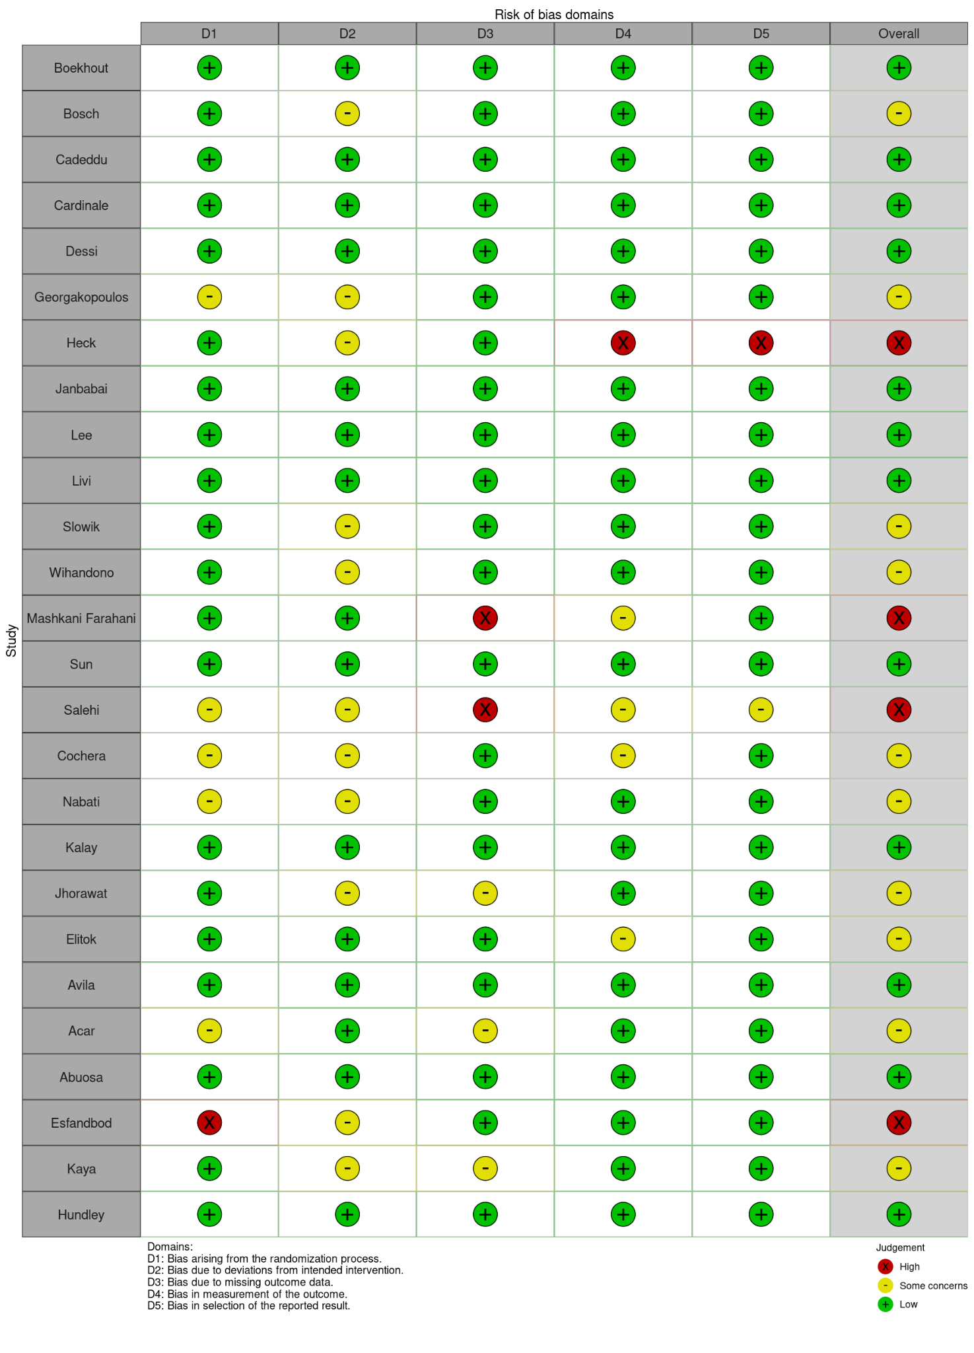
Figure S2: Cumulative rise in natriuretic peptides (standardised mean) over time. Whiskers represent 95% confidence intervals.
