Supplementary file S1: Detailed search formula in various databases

PubMed search strategy:

Search | Query | No. of hits
#1 | Search: (((((((((oral pathogens) OR (oral bacteria)) OR (oral disease))  OR (oral health)) OR (mouth disease)) OR (gum disease)) OR (gum  bacteria)) OR (periodontitis)) OR (gingivitis)) OR (periodontal  gingivalis) | 722027
#2 | Search: (((((((((dementia) OR (peripheral neuroinflammation)) OR  (central neuroinflammation)) OR (neurodegeneration)) OR (cognitive  decline)) OR (memory loss)) OR (Alzheimer's disease)) OR  (Parkinson)) OR (ALS)) OR (Vascular dementia) | 616268
#3 | Search: ((((((((((oral pathogens) OR (oral bacteria)) OR (oral disease))  OR (oral health)) OR (mouth disease)) OR (gum disease)) OR (gum  bacteria)) OR (periodontitis)) OR (gingivitis)) OR (periodontal  gingivalis)) AND ((((((((((dementia) OR (peripheral  neuroinflammation)) OR (central neuroinflammation)) OR  (neurodegeneration)) OR (cognitive decline)) OR (memory loss)) OR  (Alzheimer's disease)) OR (Parkinson)) OR (ALS)) OR (Vascular  dementia)) | 11768
#4 | Search: ((((((((((oral pathogens) OR (oral bacteria)) OR (oral disease)) OR (oral health)) OR (mouth disease)) OR (gum disease)) OR (gum bacteria)) OR (periodontitis)) OR (gingivitis)) OR (periodontal gingivalis)) AND ((((((((((dementia) OR (peripheral neuroinflammation)) OR (central neuroinflammation)) OR (neurodegeneration)) OR (cognitive decline)) OR (memory loss)) OR (Alzheimer's disease)) OR (Parkinson)) OR (ALS)) OR (Vascular dementia)) Filters: Observational Study, Humans, English, Adult: 19+ years | 112
Web of Science search strategy:

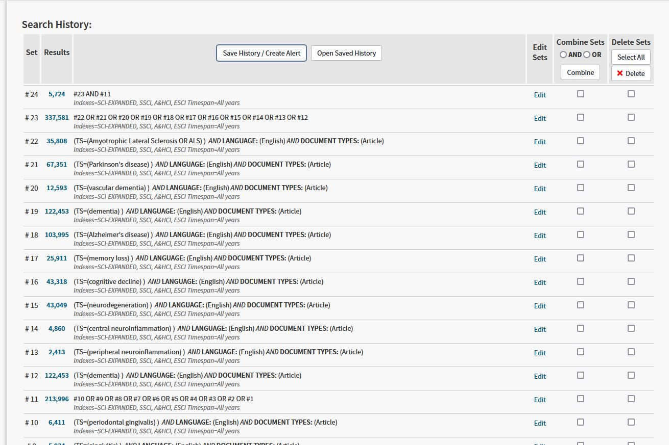
CINAHL search strategy:

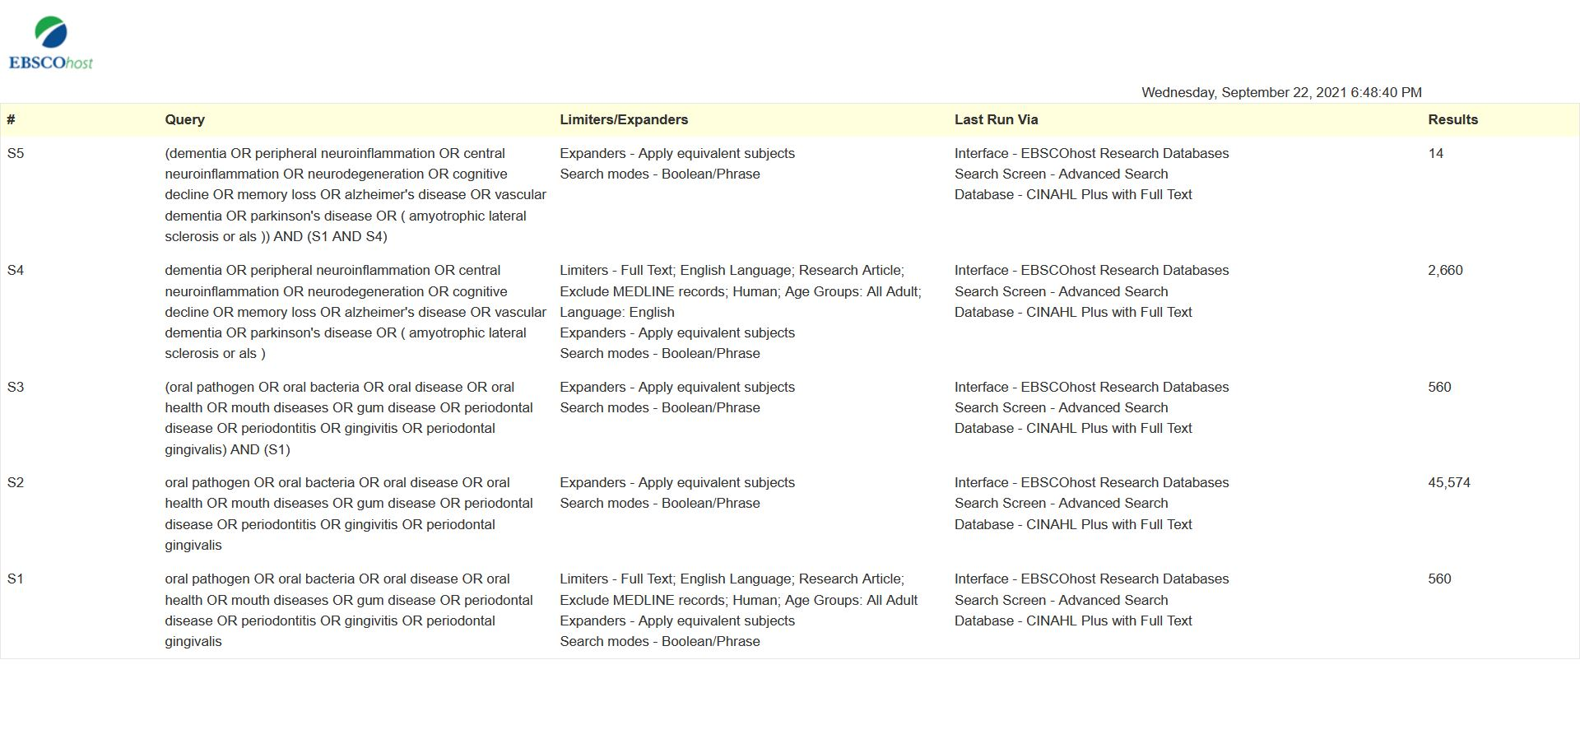

Authors | Outcome |  |  |  | Comparability | selection |  |  | Total
 | Representativeness of the exposed cohort | Selection of the non-exposed cohort | Ascertainment of exposure | Demonstration that outcome of interest was not present at start of study | Comparability of cohorts on the basis of the design or analysis | Assessment of outcome | Was follow-up long enough for outcomes to occur | Adequacy of follow up of cohorts
Choi et al. [27] | * | * | 0 | * | * | 0 | * | * | 6/9
Demmer et al. [28] | * | 0 | * | * | ** | * | * | 0 | 7/9
Chen et al. [26] | * | * | * | * | ** | * | * | * | 9/9
Stewart et al. [30] | * | * | * | * | ** | * | 0 | 0 | 7/9
Tzeng et al. [31] | * | * | * | * | ** | * | * | * | 9/9
Sparks Stein et al.[29] | 0 | * | * | * | ** | * | * | * | 8/9
Supplemantary file S2: Risk of bias assessment of included studies
S2A. Risk of bias in cohort studies

S2B. Risk of bias in case-control studies:
Authors | Selection |  |  |  | Comparability | Outcome |  |  | Total
 | Is the case definition adequate? | Representativeness of the cases | Selection of Controls | Definition of Controls | Comparability of cases and controls on the basis of the design or analysis | Ascertainment of exposure | Same method of ascertainment for cases and controls | Non-Response rate
Montoya et al. [36] | * | * | * | * | ** | * | * | 0 | 8/9
Shin et al. [37] | * | * | * | 0 | * | * | * | 0 | 6/9

total | outcome | comparability | selection |  |  | Authors
 | Ascertainment of outcome |  | Ascertainment of exposure | Selection of non-exposed participants | Representativeness of the sample
4/6 | * | * | * | * | 0 | Hategan et al. [33]
5/6 | * | * | * | * | * | Kamer et al. [34]
5/6 | 0 | ** | * | * | * | Noble et al. [35]
S2C. Risk of bias in cross-sectional stdies:

