Supporting Information
Exploring the biological properties of Zn(II) bisthiosemicarbazone helicates.
Sandra Fernández-Fariña ^{1,*}, Isabel Velo-Heleno ¹, Rocío Carballido ¹, Miguel Martínez-Calvo ¹, Ramiro Barcia ², Òscar Palacios ³, Mercè Capdevila ³, Ana M. González-Noya ^{1,}* and Rosa Pedrido ^{1,}*

Citation: To be added by editorial staff during production.
Academic Editor: Firstname Lastname
Received: date
Accepted: date
Published: date
Publisher’s Note: MDPI stays neutral with regard to jurisdictional claims in published maps and institutional affiliations.

Copyright: © 2022 by the authors. Submitted for possible open access publication under the terms and conditions of the Creative Commons Attribution (CC BY) license (https://creativecommons.org/licenses/by/4.0/).
¹ Departamento de Química Inorgánica, Facultade de Química, Campus Vida, Universidade de Santiago de Compostela, E-15782 Santiago de Compostela, Spain
² Departamento de Bioquímica y Biología Molecular, Facultade de Veterinaria, Campus Terra, Universidade de Santiago de Compostela, E-27002 Lugo, Spain
³ Departament de Química, Universitat Autònoma de Barcelona, 08193 Cerdanyola del Vallès, Spain
* Correspondence: sandra.fernandez.farina@usc.es (S.F.-F); ana.gonzalez.noya@usc.es (A.M.G.-N.); rosa.pedrido@usc.es (R.P.)

- Bisthiosemicarbazone ligands H₂LMe, H₂L^{Ph} and H₂L^{PhNO2}
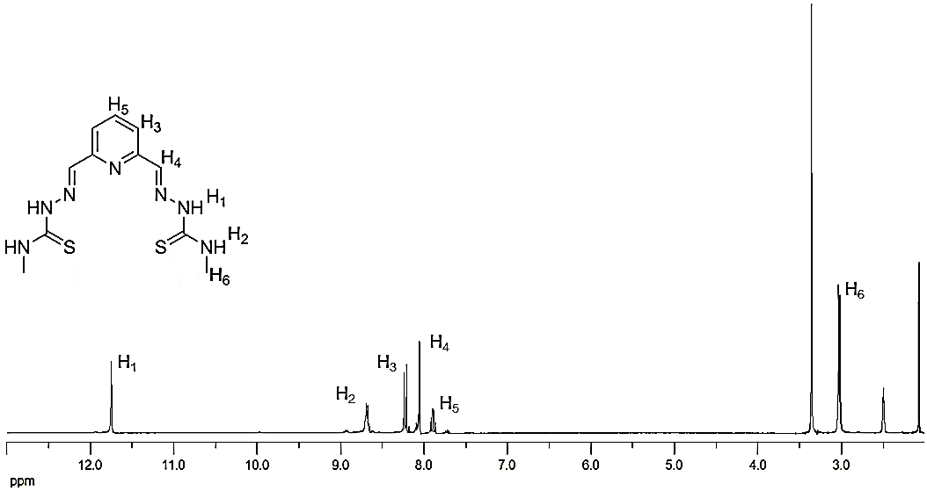
Figure S1. ¹H NMR spectra of H₂LMe·2H₂O (DMSO-d₆, r.t.). ¹H NMR [DMSO-d₆, δ (m, nH, Hx, J)]: 11.76 (s, 2H, H₁), 8.71 (c_{e}, 2H, H₂, J= 4.4 Hz), 8.25 (d, 2H, H₃, J= 7.8 Hz), 8.06 (s, 2H, H₄), 7.90 (t, 1H, H₅, J= 7.8 Hz), 3.04 (d, 6H, H₆, J= 4.1 Hz).
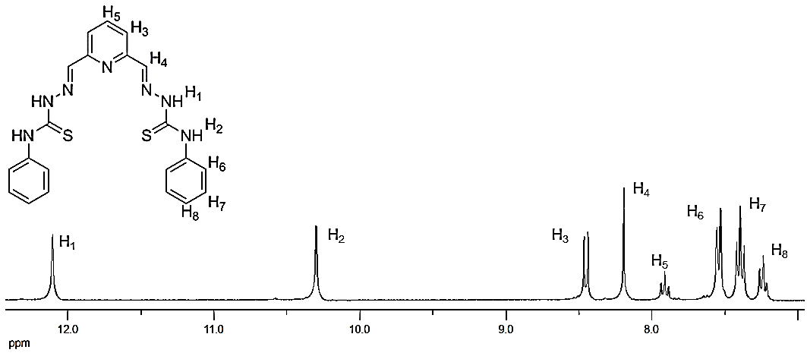
Figure S2. ¹H NMR spectra of H₂L^{Ph}·2H₂O (DMSO-d₆, r.t.). ¹H NMR [DMSO-d₆, δ (m, nH, Hx, J)]: 12.11 (s, 2H, H₁), 10.30 (s, 2H, H₂), 8.46 (d, 2H, H₃, J= 7.8 Hz), 8.19 (s, 2H, H₄), 7.91 (t, 1H, H₅, J= 7.8 Hz), 7.56 (d, 4H, H₆, J= 7.6 Hz), 7.40 (t_{a}, 4H, H₇, J₁= 7.6 Hz, J₂= 8.0 Hz), 7.24 (t, 2H, H₈, J₁= 7.4 Hz, J₂= 7.3 Hz).
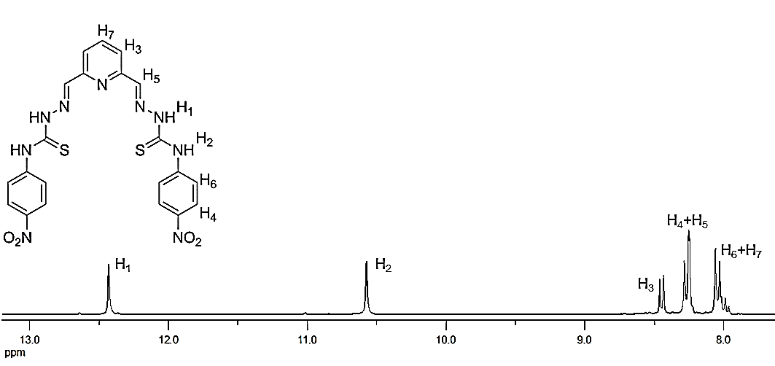
Figure S3. ¹H NMR spectra of H₂L^{PhNO2} (DMSO-d₆, r.t.). ¹H NMR [DMSO-d₆, δ (m, nH, Hx, J)]: 12.43 (s, 2H, H₁), 10.57 (s, 2H, H₂), 8.46 (d, 2H, H₃, J= 7.8 Hz), 8.30-8.20 (m, 6H, H₄+H₅), 8.10-7.90 (m, 1H, H₆+H₇).
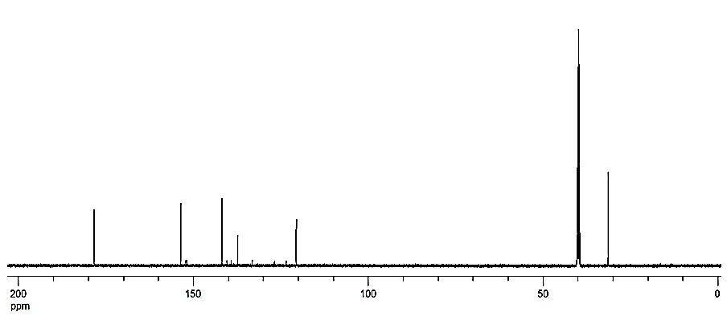
Figure S4. ¹³C NMR spectra of H₂LMe·2H₂O (DMSO-d₆, r.t.). ¹³C NMR (DMSO-d₆, ppm): 178.3 (C=S), 153.3 (C=N), 141.3 (C_{ar}), 137.5 (CH_{ar}), 120.6 (CH_{ar}), 31.26 (CH₃).
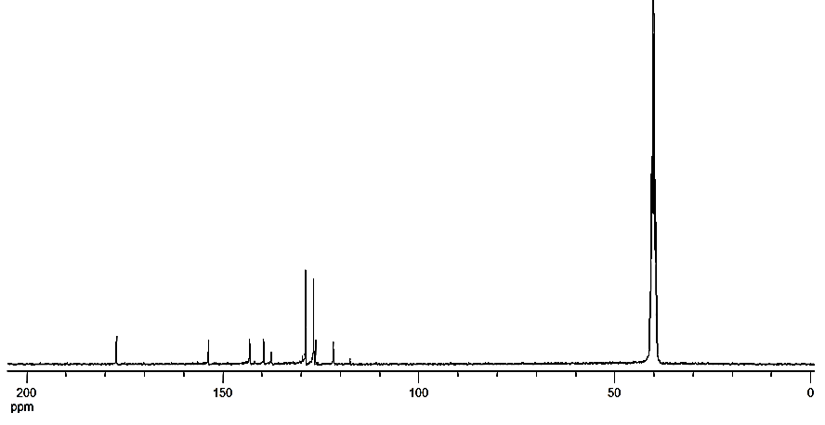
Figure S5. ¹³C NMR spectra of H₂L^{Ph}·2H₂O (DMSO-d₆, r.t.). ¹³C NMR (DMSO-d₆, ppm): 177.1 (C=S), 153.7 (C=N), 143.1 (C_{ar}), 139.6 (C_{ar}), 137.7 (CH_{ar}), 128.8 (CH_{ar}), 126.8 (CH_{ar}), 126.3 (CH_{ar}), 121.8 (CH_{ar}).
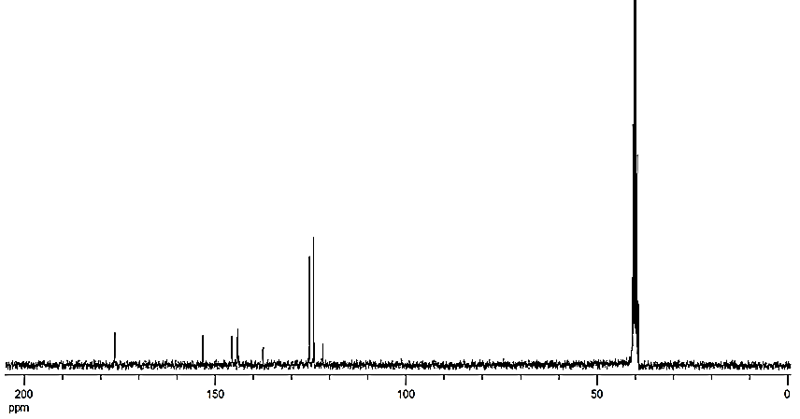
Figure S6. ¹³C NMR spectra of H₂L^{PhNO2} (DMSO-d₆, r.t.). ¹³C NMR (DMSO-d₆, ppm): 176.4 (C=S), 153.3(C=N), 145.7(C_{ar}), 144.2 (C_{ar}), 144.0 (C_{ar}), 137.5 (CH_{ar}), 125.3 (CH_{ar}), 124.2 (CH_{ar}), 121.8 (CH_{ar}).
- Bisthiosemicarbazone derived zinc(II) dihelicates
Figure S7. ¹H NMR spectra of Zn₂(LMe)₂·2H₂O (DMSO-d₆, r.t.). ¹H NMR [DMSO-d₆, δ (m, nH, Hx, J)]: 8.26 (s, 2H, H₄), 7.83 (t, 1H, H₅, J= 7.7 Hz), 7.48 (d, 2H, H₃, J= 7.7 Hz), 7.22 (s_{a}, 1H, H₂), 2.75 (d, 6H, H₆, J= 4.2 Hz).
Figure S8. ¹H NMR spectra of Zn₂(L^{Ph})₂·2H₂O (DMSO-d₆, r.t.). ¹H NMR [DMSO-d₆, δ (m, nH, Hx, J)]: 9.34 (s, 2H, H₂), 8.56 (s, 2H, H₄), 7.99 (d, 1H, H₅, J= 7.8 Hz), 7.84 (d, 4H, H₆, J= 7.8 Hz), 7.70 (d, 2H, H₃, J= 7.8 Hz), 7.30 (t_{a}, 4H, H₇, J₁= 7.8 Hz, J₂= 8.0 Hz), 7.01 (t_{a}, 2H, H₈, J₁= 7.4 Hz, J₂= 6.9 Hz).
Figure S9. ¹H NMR spectra of Zn₂(L^{PhNO2})₂ (DMSO-d₆, r.t.). ¹H NMR [DMSO-d₆, δ (m, nH, Hx, J)]: 10.11 (s, 2H, H₂), 8.80 (s, 2H, H₅), 8.17 (d, 1H, H₄, J= 7.7 Hz), 8.12 (t, 1H, H₇, J= 7.7 Hz), 8.05 (d, 4H, H₆, J= 9.3 Hz), 7.82 (d, 2H, H₃, J= 7.7 Hz).

Table S1. Main crystallographic data for helicates [Zn₂(LMe)₂]·3H₂O 1*, [Zn₂(L^{Ph})₂]·4CH₃CN 2* and [Zn₂(L^{PhNO2})₂] 3*.
 | [Zn₂(L³-Me)₂]·3H₂O | [Zn₂(L³-Ph)₂]·4CH₃CN | [Zn₂(L³-PhNO₂)₂]
Molecular formula | Zn₂C₂₂H₃₂N₁₄S₄ | Zn₂C₅₀H₄₆N₁₈S₄ | Zn₂C₄₂H₃₀N₁₈O₈S₄
Molecular weight | 799.68 | 1158.03 | 1173.82
Spatial group | I2/a | P -1 | C2/c
Crystalline system | Monoclinic | Triclinic | Monoclinic
Crystal size/mm | 0.30 × 0.07 × 0.05 | 0.18 × 0.14 × 0.04 | 0.8 × 0.2 × 0.09
a/Å | 14.424(4) | 10.6496(5) | 21.5284(13)
b/Å | 12.7407(17) | 15.3841(9) | 14.0991(9)
c/Å | 16.748(2) | 18.3830(10) | 15.6869(8)
α/º | 90 | 97.235(2) | 90
β/º | 99.930(7) | 105.836(2) | 94.982(4)
γ/º | 90 | 108.760(3) | 90
Temperature/K | 100 | 373(2) | 100
Volume/Å³ | 3031.6(10) | 2667.0(2) | 4743.5(5)
Z | 4 | 2 | 4
Density/g cm⁻³ | 1.752 | 1.442 | 1.644
Intervale θ/º | 2.5 - 19.1 | 2.4 - 21.6 | 2.9 - 26.2
Measured reflexions | 23453 | 40098 | 24181
Unique reflexions [R_{int}] | 2896 [0.150] | 10094 [0.086] | 3478 [0.054]
μ/mm⁻¹ | 1.91 | 1.110 | 1.262
F(000) | 1640 | 1192 | 2384
Residues/e Å⁻³ | 0.56 and -0.94 | 0.794 and -0.537 | 1.18 and -0.63
R Final Index [I>2sigma(I)] | 0.0612 [0.1383] | 0.0545 [0.1138] | 0.0342 [0.0779]
R Index [all data] | 0.1108 [0.1682] | 0.1038 [0.1298] | 0.0522 [0.0845]

Table S2. Main bond distances and angles for [Zn₂(LMe)₂]·3H₂O 1* zinc helicate.
Bond distances (Å)
N(3)-Zn(1) | 2.114(5) | S(3)-Zn(1) | 2.3865(19) | C(9)-N(5) | 1.263(8)
N(5)-Zn(1) | 2.124(5) | C(3)-N(3) | 1.290(8) | C(10)-S(2) | 1.747(7)
N(4)-Zn(1) | 2.485(5) | C(2)-S(3) | 1.739(6) | S(2)-Zn(1) | 2.3423(19
Bond angles (⁰)
N(3)-Zn(1)-S(3) | 80.53(15) | N(3)-Zn(1)-N(4) | 70.94(18) | C(9)-N(5)-N(6) | 116.0(5)
N(5)-Zn(1)-S(2) | 82.37(15) | N(5)-Zn(1)-N(4) | 102.64(18) | C(10)-N(5)-N(6) | 112.8(5)
S(3)-Zn(1)-S(2) | 112.48(7) | C(3)-N(3)-N(2) | 116.3(5) | N(1)-C(2)-S(3) | 115.7(5)
C(2)-N(2)-N(3) | 113.2(5)

Table S3. Main bond distances and angles for [Zn₂(L^{Ph})₂]·4CH₃CN 2* zinc helicate.
Bond distances (Å)
N(3)-Zn(1) | 2.081(4) | S(1)-Zn(1) | 2.3593(12) | C(14)-N(5) | 1.280(6)
N(4)-Zn(1) | 2.463(3) | S(2)-Zn(2) | 2.3381(13) | C(15)-S(2) | 1.741(5)
N(5)-Zn(2) | 2.081(4) | S(3)-Zn(1) | 2.3384(13) | C(28)-S(3) | 1.741(5)
N(10)-Zn(1) | 2.084(4) | S(4)-Zn(2) | 2.3777(12) | C(29)-N(10) | 1.284(5)
N(11)-Zn(2) | 2.446(3) | C(7)-S(1) | 1.738(5) | C(35)-N(12) | 1.287(5)
N(12)-Zn(2) | 2.080(4) | C(8)-N(3) | 1.278(5)
Bond angles (⁰)
N(10)-Zn(1)-S(3) | 83.30(11) | N(5)-Zn(2)-S(2) | 83.58(11) | N(13)-N(12)-Zn(2) | 123.2(3)
N(3)-Zn(1)-S(1) | 81.96(10) | N(12)-Zn(2)-S(4) | 81.23(10) | C(36)-N(13)-N(12) | 112.7(4)
S(3)-Zn(1)-S(1) | 111.71(5) | S(2)-Zn(2)-S(4) | 110.53(5) | C(35)-N(12)-N(13) | 116.1(4)
N(3)-Zn(1)-N(4) | 72.07(13) | N(12)-Zn(2)-N(11) | 72.20(13) | N(14)-C(36)-S(4) | 114.4(3)
N(10)-Zn(1)-N(4) | 94.92(13) | N(5)-Zn(2)-N(11) | 97.47(13) | C(14)-N(5)-N(6) | 115.4(4)
C(8)-N(3)-N(2) | 116.7(4) | C(29)-N(10)-N(9) | 116.0(4) | C(15)-N(6)-N(7) | 117.3(4)
C(7)-N(2)-N(3) | 112.7(4) | C(28)-N(9)-N(10) | 113.3(4) | N(7)-C(15)-S(2) | 114.3(4)
N(1)-C(7)-S(1) | 94.97(16) | N(8)-C(28)-S(3) | 113.6(3)
Table S4. Main bond distances and angles for [Zn₂(L^{PhNO2})₂] 3* zinc helicate.
Bond distances (Å)
N(4)-Zn(1) | 2.062(2) | S(3)-Zn(2) | 2.3857(7) | C(14)-N(6) | 1.287(3)
S(4)-Zn(1) | 2.3203(7) | C(7)-S(4) | 1.737(3) | C(15)-S(3) | 1.737(3)
N(6)-Zn(2) | 2.116(2) | C(8)-N(4) | 1.279(3)
Bond angles (⁰)
N(4)-Zn(1)-S(4) | 84.14(6) | N(6)-Zn(2)-S(3) | 110.45(6) | C(8)-N(4)-N(3) | 115.1(2)
S(4)-Zn(1)-S(4) | 122.23(4) | S(3)-Zn(2)-S(3) | 118.20(4) | C(14)-N(6)-N(7) | 114.5(2)
N(4)-Zn(1)-N(4) | 145.32(12) | N(6)-Zn(2)-N(6) | 158.14(12) | N(3)-C(7)-S(4) | 127.9(2)
N(7)-C(15)-S(3) | 127.7(2) | N(2)-C(7)-N(3) | 117.3(2) | N(7)-C(15)-N(8) | 116.6(2)

Figure S10. ESI MS-TOF titration of human serum albumin (MW= 66550 Da) with Zn₂(L^{Ph})₂∙2H₂O 2 helicate.
Figure S11. ESI MS-TOF titration of myoglobin (MW= 17567 Da) with Zn₂(L^{Ph})₂∙2H₂O 2 helicate.
Figure S12. ESI MS-TOF titration of cytochrome C (MW= 12359 Da) with Zn₂(L^{Ph})₂∙2H₂O 2 helicate.
Figure S13. ESI MS-TOF titration of transferrin (MW= 78019 Da) with Zn₂(L^{Ph})₂∙2H₂O 2 helicate.

Figure S14. ESI MS-TOF titration of double-stranded oligonucleotides (DS) with Zn₂(L^{Ph})₂∙2H₂O 2 helicate.
Figure S15. ESI MS-TOF titration of human serum albumin (MW= 66550 Da) with Zn₂(L^{PhNO2})₂ 3 helicate.
Figure S16. ESI MS-TOF titration of myoglobin (MW= 17567 Da) with Zn₂(L^{PhNO2})₂ 3 helicate.
Figure S17. ESI MS-TOF titration of cytochrome C (MW= 12359 Da) with Zn₂(L^{PhNO2})₂ 3 helicate.
Figure S18. ESI MS-TOF titration of transferrin (MW= 78019 Da) with Zn₂(L^{PhNO2})₂ 3 helicate.
Figure S19. ESI MS-TOF titration of double-stranded oligonucleotides (DS) with Zn₂(L^{PhNO2})₂ 3 helicate.

