Supplementary Materials
- Supplementary experimental procedures:

Hepatic Secretion of very low-density lipoprotein (VLDL)-TG. To estimate the rate of VLDL-TG secretion from the liver, mice were intraperitoneally injected with 500 mg/kg of tyloxapol (Sigma-Aldrich T0307), an inhibitor of lipoprotein lipase (LPL)[1]. Blood samples were collected from the tail vein 30 min before (time 0) and at 2, 3, and 4 h after injection. The TG concentration was determined with commercial colorimetric kits (Biolabo SAS, Maizy, France, #87656 #87319) based on the CHOD-PAP and GPO-PAP detection methods, coupling enzymatic reaction, and spectrophotometric detection of reaction end products (Dyasis, Grabels France). The TG production rate for individual mice was, therefore, calculated using the linear increment between the baseline value and 4 h and expressed as mg/dL.

1. Duerden, J.M.; Gibbons, G.F. Secretion and storage of newly synthesized hepatic triacylglycerol fatty acids in vivo in different nutritional states and diabetes. Biochem. J. 1988, 255, 929–935.

- Supplementary Tables:

Table S1: List of qPCR primer pair sequences and GeneBank accession numbers specific to each gene.
Gene symbol | Forward primer (5'-3') | Reverse primer (5'-3') | GeneBank
Gapdh | TGCACCACCAACTGCTTAGC | GGCATGGACTGTGGTCATGAG | NM_001289726
Pgc-1α | AAAGGATGCGCTCTCGTTCA | GGAATATGGTGATCGGGAACA | NM_008904
Ucp1 | CCTGCCTCTCTCGGAAACAA | TGTAGGCTGCCCAATGAACA | NM_009463
Prdm16 | CAGCACGGTGAAGCCATTC | GCGTGCATCCGCTTGTG | NM_001291026
Cidea | GCCGTGTTAAGGAATCTGCTG | TGCTCTTCTGTATCGCCCAGT | NM_007702
Cd36 | GCGACATGATTAATGGCACAGACG | TCCGAACACAGCGTAGATAGACC | NM_001159558.1
Acox1 | CTATGGGATCAGCCAGAAAG | AGTCAAAGGCATCCACCAAAG | NM_0015729.4
Cpt1-a | CACCAACGGGCTCATCTTCT | CCTTCTATCGAATTTGCTCTGGTT | NM_013495
Acaca | AGCAACATCACATCAGTCCTGT | CAGTGTAGCTGCATGACTATCTAGG | NM_133360.3
Elovl6 | TCTGATGAACAAGCGAGCCA | TGGTCATCAGAATGTACAGCATGT | NM_130450
Pparα | CCCTGTTTGTGGCTGCTATAATTT | GGGAAGAGGAAGGTGTCATCTG | NM_011144
Ehhadh | TTGGACCATACGGTTAGAGCC | GGATATCAGCACCTGCACAGA | NM_023737.3
Acaa1 | ACATCTCCGTGGGCAATGTT | CTCAGAAATTGGGCGATGCG | NM_001357516.1
Atgl | TCCTTAGGAATGGCCTAC | TCCTCTTCCTGGGGGACAAC | NM_001163689.1
Hsl | GATGCCATGTTGGCCAGAGAC | ACTTCTCGAAAGCCTTCTGGAACA | XM_030242180.1
Srebp1c | CTGGCTTGGTGATGCTATGTTG | GACCATCAAGGCCCCTCAA | NM_001358315
Fas | CGGCTGCGTGGCTATGATTATG | GCAGCTTGCCTTGTTCACCTTC | NM_007988
Scd1 | CGTGGGCGCGGTGAT | CAACACCATGGCGTTCCA | NM_009127.4
Elovl3 | GGACCTGATGCAACCCTATGA | TCCGCGTTCTCATGTAGGTCT | NM_007703
Dgat | GGCGGTCCCCAACCAT | AGACAGGAGTGGAAAAACCAATAGA | NM_010046.3
Mttp | TCAGGAAGCTGTGTCAGAATGAAG | TTTCAAGTCCTCCCAGGATCA | NM_008642
Srebp2 | CTGCAGCCTCAAGTGCAAAG | CAGTGTGCCATTGGCTGTCT | NM_033218
Hmgs1 | TGCATAGTAACACAGCAACAGAGC | TGCAGGGAGTCTTGGCACTTTC | NM_001291439.1
Hmgcr | CCGGCAACAACAAGATCTGTG | ATGTACAGGATGGCGATGCA | NM_001360165
Scarb1/Srb1 | CGCCGACCCTGTGTTGTC | GGATGTCTAGGAACAAGGAATGCT | NM_001205083
Ldlr | GCATCAGCTTGGACAAGGTGT | GGGAACAGCCACCATTGTTG | NM_010700
Vldlr | TCCTGATTGCGAAGACGGTTCTG | ATGCGGCATGTTCTCATATGGC | NM_001347441.1
Abca1 | ATCGTGTCTCGCCTGTTCTCA | GTCCTTAATGCTGGTATCTCTTTGG | NM_013454
Cyp7A1 | CAGGGAGATGCTCTGTGTTCA | AGGCATACATCCCTTCCGTGA | NM_007824
Cyp27A1 | GCCTCACCTATGGGATCTTCA | TCAAAGCCTGACGCAGATG | NM_024264
Abcg5 | GGATCCAACACCTCTATGCTAAA | GGCAGGTTTTCTCGATGAACTG | NM_031884
Abcg8 | ATCCATTGGCCACCCTTGT | GCGTCTGTCGATGCTGGTC | NM_026180

- Supplementary figures:

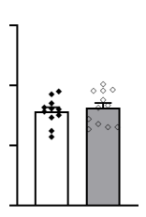  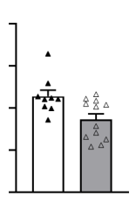  CD  F-IF  F-AL  M-IF  M-AL  0.5  1.0  0  1.5  2.0  0.5  1.0  0  1.5  Metabolic efficiency  (g / MJ)  *  ns  A | 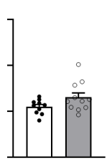  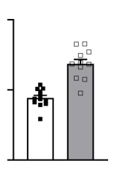  B  HFCD  M-IF  M-AL  F-AL  F-IF  0.5  1.0  0  1.5  0.5  1.0  0  ns  ***  Metabolic efficiency  (g / MJ)
Figure S1. Effect of intermittent fasting in Apoe^{-/-} mice on metabolic efficiency. (A-B) Metabolic efficiency was calculated as g of body weight gained per MJ of food consumed during the 16 weeks of intervention for ad libitum (AL) or intermittent fasting (IF) CD-fed mice (A) and HFCD-fed mice (B). Data are presented as means ± SEM (n = 12–14 per group); ns; not significant, *p < 0.05, **p < 0.01, ***p < 0.001.

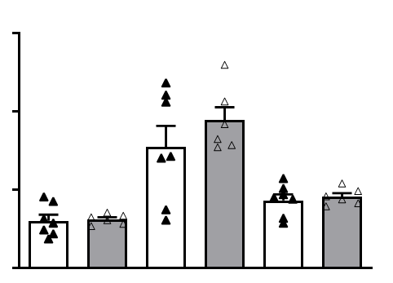  Insulin (pmol / L)  150  100  50  0  30 min  15 min  -30 min  A  ns  ***  **  ns  ns | 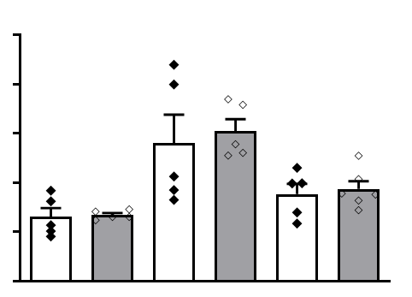  250  150  B  30 min  15 min  -30 min  Insulin (pmol / L)  200  100  50  0  ns  ns  ns  *  **
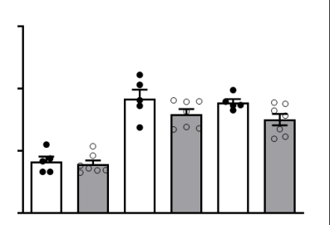  C  30 min  15 min  -30 min  150  100  50  0  Insulin (pmol / L)  ns  *  ***  ns  ns  *  ** | 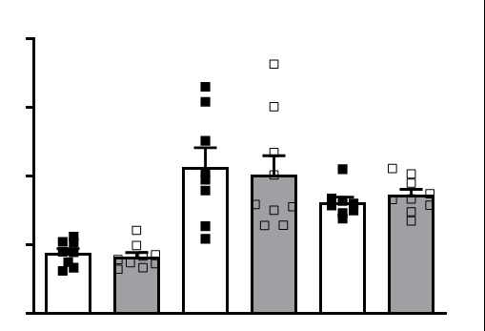  D  30 min  15 min  -30 min  150  200  100  50  0  Insulin (pmol / L)  ns  ***  ***  ns  ns  ***
Figure S2. Effect of intermittent fasting in Apoe^{-/-} mice on the plasma insulin level during glucose tolerance test.
(A-D) Plasma insulin concentration at the indicated times after intraperitoneal bolus injection of glucose to fasted ad libitum (AL, white bars) or intermittent fasting (IF, grey bars) CD-fed males (A), CD-fed females (B), HFCD-fed males (C), and HFCD-fed females (D). Data are presented as means ± SEM (n = 5–9 per group); ns; not significant, *p < 0.05, **p < 0.01, ***p < 0.001.

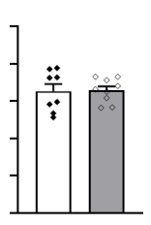  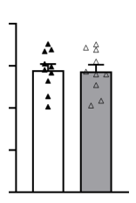  F-IF  F-AL  M-IF  CD  A  SC-WAT weight  (% of BW)  ns  0.0  0.2  0.4  0.6  0.8  0.0  0.2  0.4  0.6  0.8  1.0  ns | 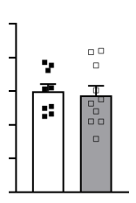  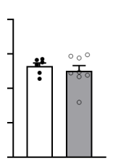  0.0  0.2  0.4  0.1  0.3  0.0  0.2  0.4  0.1  0.3  0.5  B  ns  ns  F-IF  F-AL  M-IF  M-AL  HFCD  SC-WAT weight  (% of BW)
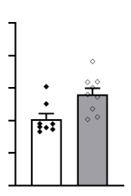  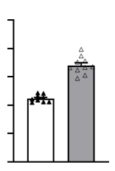  F-AL  M-IF  M-AL  ***  0.0  0.2  0.4  0.1  0.3  0.5  **  0.0  0.2  0.4  0.1  0.3  0.5  C  CD  F-IF  BAT weight  (% of BW) | 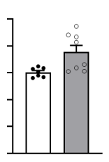  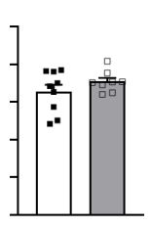  *  0.00  0.10  0.20  0.05  0.15  0.25  0.00  0.10  0.20  0.05  0.15  0.25  D  ns  HFCD  F-IF  F-AL  M-IF  M-AL  BAT weight  (% of BW)
Figure S3. Effect of intermittent fasting in Apoe^{-/-} mice on white and brown adipose tissue weight. (A,B) Subcutaneous white adipose tissue (SC-WAT) weights relative to body weight of ad libitum (AL) or intermittent fasting (IF) CD-fed mice (A) and HFCD-fed mice (B). (C,D) Brown adipose tissue (BAT), weights relative to body weight of ad libitum (AL) or intermittent fasting (IF) CD-fed mice (C) and HFCD-fed mice (D). Data are presented as means ± SEM (n = 6–10 per group); ns; not significant, *p < 0.05, **p < 0.01, ***p < 0.001.

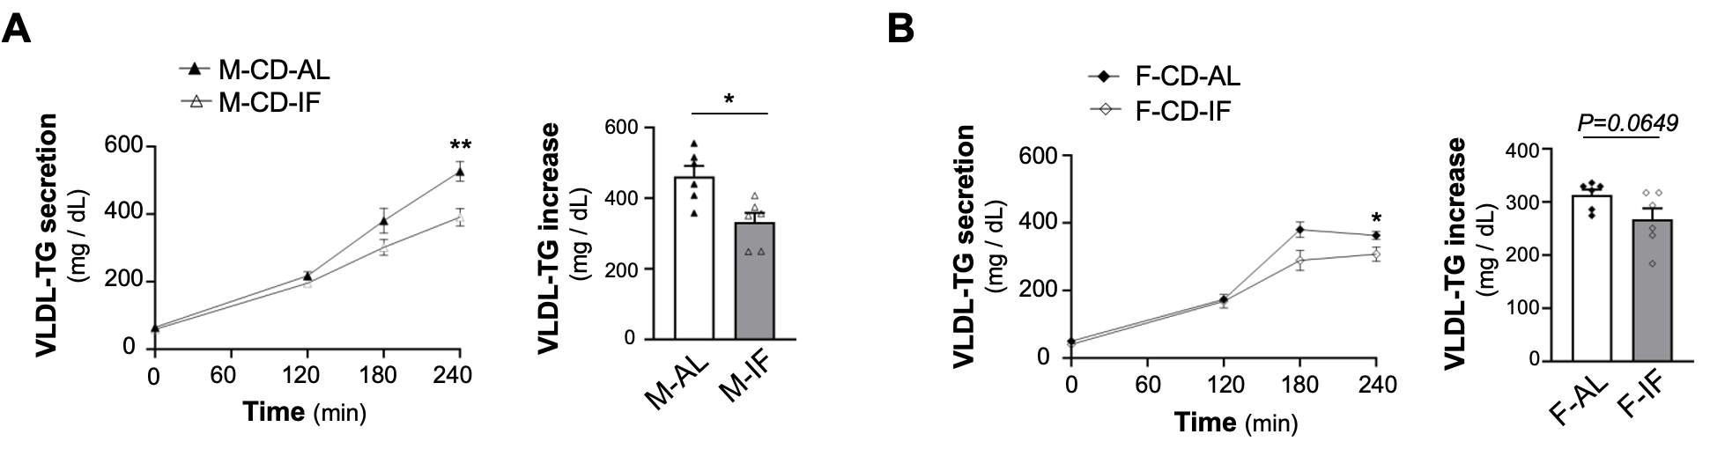

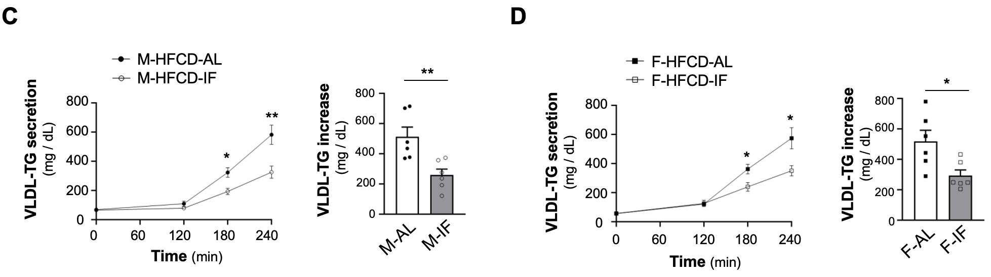

Figure S4. Effect of intermittent fasting in Apoe^{-/-} mice on hepatic very low-density-lipoprotein (VLDL)-TG secretion. (A-D) Hepatic VLDL-TG secretion assessed at the indicated times following lipoprotein lipase inhibition by injecting 500 mg/kg of tyloxapol after a 4 h fast of ad libitum (AL) or intermittent fasting (IF) mice. Left panel: change in plasma VLDL-TG concentration for the indicated times, Right panel: rate of VLDL-TG secretion at 4 h. CD-fed males (A), CD-fed females (B), HFCD-fed males (C), HFCD-fed females (D). Data are means ± SEM (n = 6 per group).; ns; not significant, *p < 0.05, **p < 0.01, ***p < 0.001.

