Supplementary-Table S1. State of the art method specifications

Paper/method | Φ-Net Remedios et al. (2018) [16] | Ayyachamy et al. (2019) [14] | DeepDicomSort  van der Voort et al. (2021) [17] | Qayyum et al. (2017) [13]
Classes type | 5 MR image contrasts | 23 body parts | 8 MR image contrasts | 24 body parts
Scanners and sites | 5 MR scanners and 4 sites | MRI and CT | Experiment 1: 29 scanners from 17 sites  15 scanners from 8 sites  Experiment 2: 23 scanners from 67 sites | MR, CT, PET, PT, OPT
No. of images | Training: 2137  Testing: 1281 | Training: 21632  Validation: 9418  Testing: 5613 | Experiment 1 – Training: 11065, Testing: 2369  Experiment 2 – Training: 7227 scans | Training: 5040  Testing: 2160
Patients | Healthy, traumatic brain injury, hypertension, multiple sclerosis, Alzheimer’s disease | Chest, colon, esophagus, lung, liver, brain, prostate, head and neck | Experiment 1: Glioblastoma, brain neoplasia, other brain tumors  Experiment 2: Alzheimer’s disease | Lung, brain, liver, knee
CNN architecture | Borrows skip connections from 3D ResNet | Pre-trained  ResNet-18 | Inspired by the VGG network | DCNN
Cascaded architecture  For contrast agent enhancement | yes | no | no | no
Preprocessing | Neck removal, resampling (2x2x2), intensity normalization 99th percentile | Resize to 256x256, 0-1 intensity normalized, tumor slice selection + 5 adjacent slices | NIfTI conversion, 3D dimension check, reorientation, resampling (256x256x256), slices extraction, 0-1 intensity normalization, no data augmentation | Resampling (256x256), color images converted to grayscale, no data augmentation
Accuracy | 97.6% | 92% | 98.7% | 99.7%
Deals with the open set recognition problem | No | No | No | No

Supplementary-Table S2. Patient demographics of the data cohorts considered in this study

 | Dataset I | Dataset II | Dataset III
Patients | 320 | 197 | 256
Gender
Male | 196 | 120 | 155
Female | 124 | 77 | 101
Age
<50 | 104 | 84 | 50
50-69 | 167 | 105 | 145
>=70 | 49 | 8 | 61
Tumor grade
III | 73 | 71 | 0
IV | 247 | 126 | 255
Radiation therapy
No | 0 | 0 | 113
Yes | 320 | 197 | 143
Tumor resection
yes | 240 | 25 | 0
No | 10 | 172 | 0
NR | 70 | 0 | 256

Supplementary-Table S3: MR scanner models found in the cohorts

Dataset | Manufacturer | Tesla | Model
I | Siemens | 0.35 | Open
 |  | 1 | Allegra, Harmony
 |  | 1.5 | Aera, Amira, Avanto, Espree, Sonata Symphony, Vision
 |  | 3 | Prisma fit, Skyra, Trio, TrioTim,Verio
 | Philips | 1 | Panorama
 |  | 1.5 | Achieva, Ingenia, Intera,
 |  | 3 | NT
 | GE | 1.5 | Signa, Signa Excite-HDxt
II | Siemens | 1 | Harmony
 |  | 1.5 | Avanto, Aera, Espree, Sonata, Symphony
 |  | 3 | Prisma fit, Skyra, TrioTim,Verio
 | Philips | 1.5 | Achieva, Ingenia, Intera
 | GE | 1.5 | Optima MR450w, Signa HDxt
III | Siemens | 1.5 | Avanto, Espree, Sonata, Symphony
 |  | 3 | Verio, Trio, TrioTrim
 | Philips | 0.5 | T5
 |  | 1.5 | Achieva, Intera
 | GE | 1.5 | Signa, Signa Excite-HDx-HDxt
 | Hitachi | 0.3 | Airis II

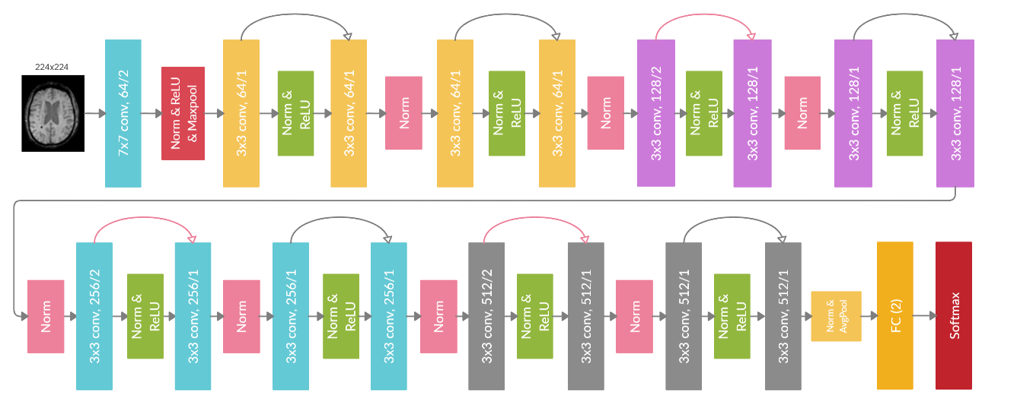
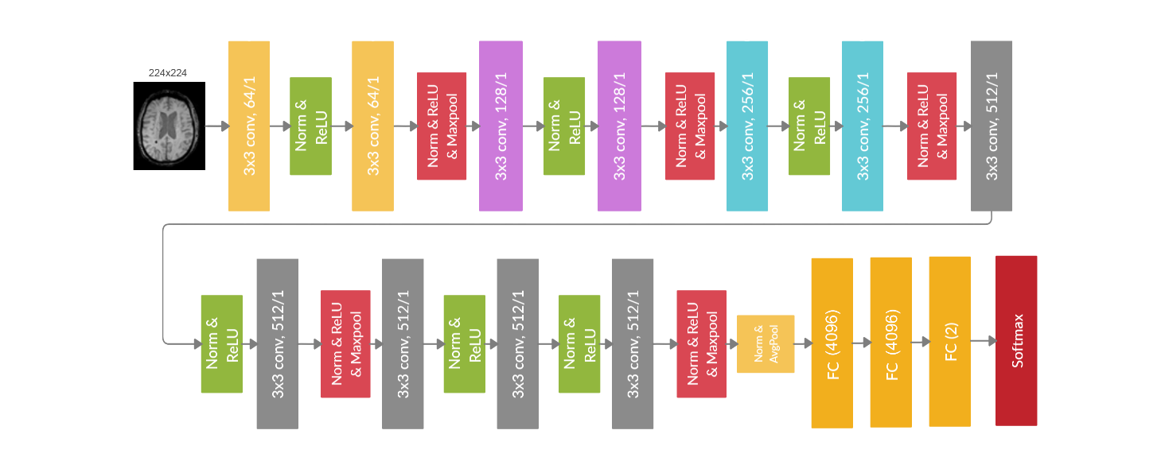
a)
b)

Supplementary-Figure S1: An example of ResNet and VGG architectures with 18 and 16 layers, and two output neurons. FC (2) represents a fully-connected layer with the two output neurons. a) ResNet-18 architecture. Stack of 3x3 convolutional layers, activations layers, and pooling layers. The skip connections, represented with arrows, fit the unmodified input from the previous layer to the next layer, preserving the original image signal. A softmax layer is appended to the FC layer to produce probabilistic predictions of the classes. b) VGG-16 architecture. Stack of 3x3 convolutional layers, activations layers, and pooling layers, followed by FC output layers

Supplementary-Table S4: Nr. of series descriptions (SD) found for each class

 | n |  |  | Nr of series description
 | I | II | III | I | II | III
Pre-CA T1w | 2023 | 1189 | 433 | 1105 | 184 | 120
Post-CA T1w | 1917 | 4315 | 1096 | 1060 | 464 | 158
T2w | 1970 | 630 | 347 | 383 | 126 | 88
T2w-FLAIR | 1919 | 811 | 389 | 223 | 122 | 63
ADC | 1938 | 895 | 122 | 125 | 78 | 23
SWI | 1479 | 486 | - | 61 | 8 | -
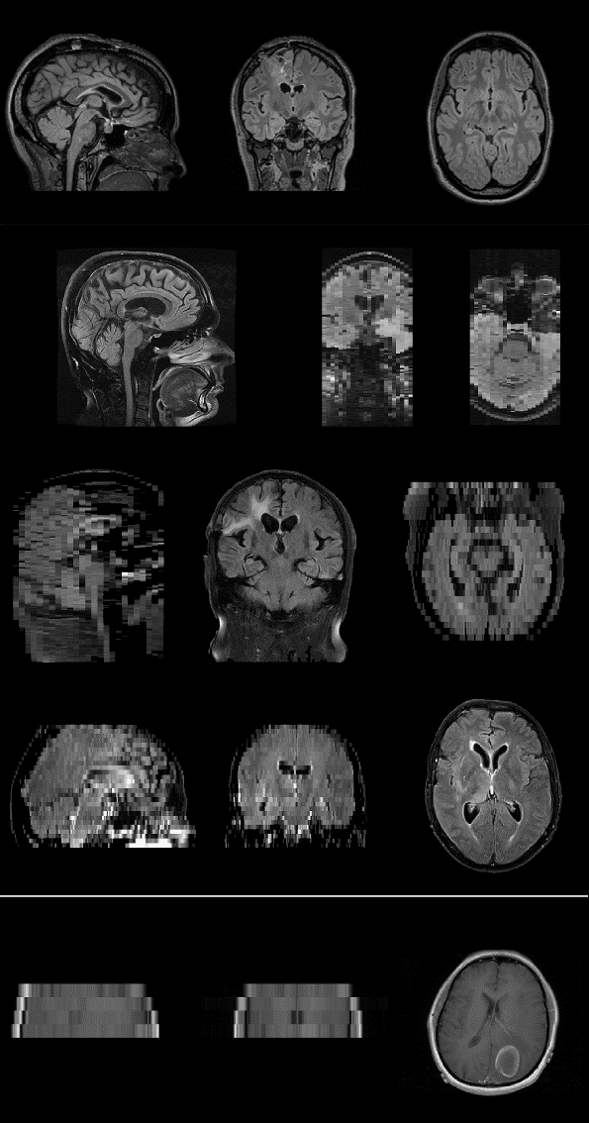

a)

b)

c)

d)

e)

Supplementary-Figure S2: (a) a 3D reconstructed MR scan correctly classified by both the 2D and 3D CNNs. The remaining images are samples correctly classified by the 2D CNNs but misclassified by the 3D CNNs, specifically conventional 2D (b) axial, (c) sagittal (d) coronal acquired scans or (e) scans with field of views that only encompassed the tumor area

