Structural modeling of nanobodies: A benchmark of state-of-the-art artificial intelligence programs
Mario S. Valdés-Tresanco†§*, Mario E. Valdés-Tresanco‡§, Daiver Jiménez† and Ernesto Moreno†*
† Faculty of Basic Sciences, University of Medellin, Medellin, Colombia.
‡ Centre for Molecular Simulations and Department of Biological Sciences, University of Calgary, Alberta T2N 1N4, Canada.
§ These authors contributed equally to this work
* To whom correspondence should be addressed:
Ernesto Moreno: emoreno@udemedellin.edu.co
Mario S. Valdés-Tresanco: mariosergiovaldes145@gmail.com

Table S1. Nbs included in the dataset. All PDB files can be found at: https://github.com/Valdes-Tresanco-MS/NbModelingBenchmark
PDB | PDB | PDB | PDB | PDB
7d8b_B | 7p5y_G | 7ndf_C | 7lzp_B | 7rby_B
7anq_B | 7czd_A | 7d6y_B | 7apj_B | 7e53_B
7r4r_D | 7rnn_C | 7fat_B | 7nfr_B | 7djy_A
7f5g_B | 7vfa_D | 6zwk_A | 7nqa_C | 7p5w_G
7r98_D | 7s2r_B | 7o06_A | 7r74_B | 7omn_A
7fau_B | 7p5v_G | 7r4q_D | 7nft_C | 7t5f_B
7m1h_F | 7z1a_E | 7r20_B | 7lzp_C | 7vfb_B
7nfq_C | 7pqg_B | 7qbg_E | 7lzp_G | 7olz_B
7p6k_G | 7kd0_C | 7oan_F | 7na9_D | 7ocy_C
7e6u_B | 7p60_G | 7r63_A | 7djx_A | 7z1c_E
7qiv_C | 7l6v_B | 7sl9_B | 7b2p_D | 7tpr_F
7qbe_E | 7t5f_C | 7php_N | 7d4b_B | 7r4i_D
7m1h_E | 7te8_A | 7ooi_A | 7zfb_M | 7l6v_D
7n9c_D | 7nqk_B | 7s7r_B | 7l6v_C | 7ar0_B
7ngh_D | 7tpr_D | 7cz0_E | 7z1b_E | 7te8_C
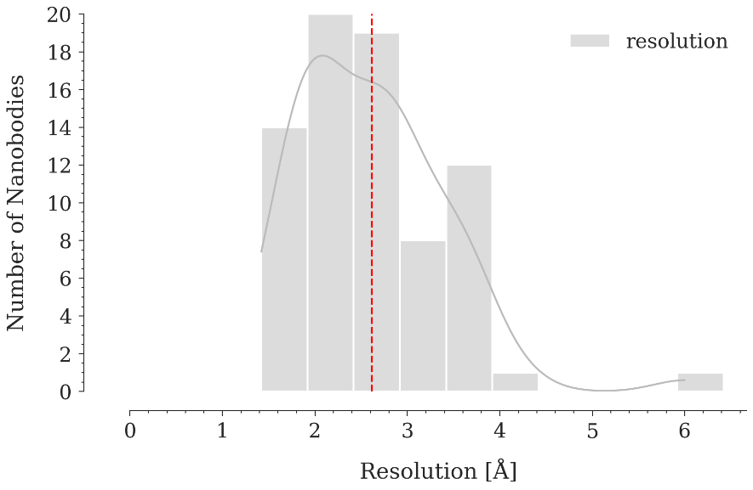
Figure S1. Resolution distribution of crystallographic structures of Nbs in the dataset. The vertical red dashed line represents the median resolution value.

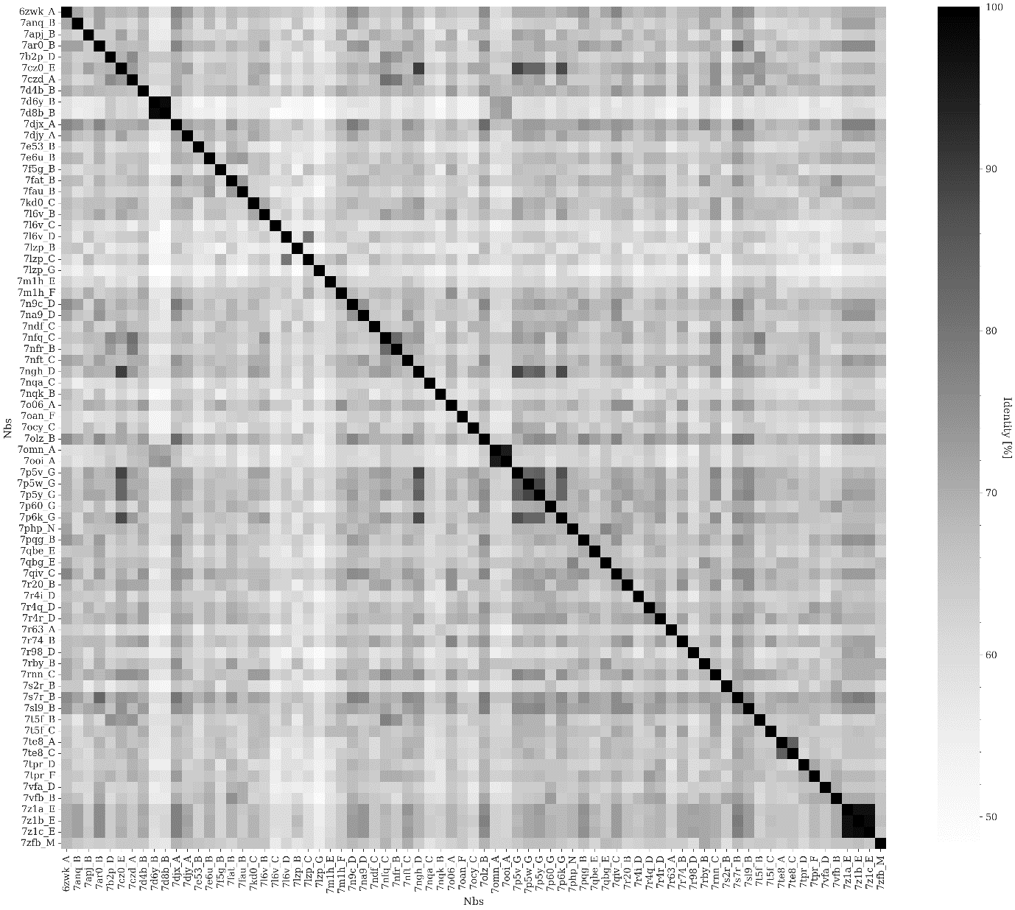
Figure S2. Sequence identity among Nbs in the dataset. Only 4 Nbs have sequence identities greater than 95%.

Table S2. Results from Dunn’s test nonparametric pairwise multiple comparison procedure.
Method1 | Method2 | TM-score | GDT_TS | GDT_HA | Fw | CDR1 | CDR2 | CDR3 | Global
OF | AF2 | ns | ns | ns | ns | ns | ns | ns | ns
OF | IF | * | * | * | ns | ns | ns | * | ns
OF | NN | ** | ** | ** | ns | ns | ns | *** | **
OF | ESM | ns | ns | ns | ns | ns | ns | ns | ns
OF | YS | **** | **** | **** | **** | *** | **** | **** | ****
AF2 | OF | ns | ns | ns | ns | ns | ns | ns | ns
AF2 | IF | ns | ns | ns | ns | ns | ns | ns | ns
AF2 | NN | * | * | * | ns | ns | ns | * | ns
AF2 | ESM | ns | ns | ns | ns | ns | ns | ns | ns
AF2 | YS | **** | **** | **** | **** | *** | **** | *** | ****
IF | OF | * | * | * | ns | ns | ns | * | ns
IF | AF2 | ns | ns | ns | ns | ns | ns | ns | ns
IF | NN | ns | ns | ns | ns | ns | ns | ns | ns
IF | ESM | ns | ns | ns | ns | ns | ns | ns | ns
IF | YS | **** | **** | **** | **** | * | *** | * | ****
NN | OF | ** | ** | ** | ns | ns | ns | *** | **
NN | AF2 | * | * | * | ns | ns | ns | * | ns
NN | IF | ns | ns | ns | ns | ns | ns | ns | ns
NN | ESM | * | * | * | ns | ns | ns | ns | ns
NN | YS | **** | **** | **** | **** | ns | *** | ns | ****
ESM | OF | ns | ns | ns | ns | ns | ns | ns | ns
ESM | AF2 | ns | ns | ns | ns | ns | ns | ns | ns
ESM | IF | ns | ns | ns | ns | ns | ns | ns | ns
ESM | NN | * | * | * | ns | ns | ns | ns | ns
ESM | YS | **** | **** | **** | **** | *** | **** | *** | ****
YS | OF | **** | **** | **** | **** | *** | **** | **** | ****
YS | AF2 | **** | **** | **** | **** | *** | **** | *** | ****
YS | IF | **** | **** | **** | **** | * | *** | * | ****
YS | NN | **** | **** | **** | **** | ns | *** | ns | ****
YS | ESM | **** | **** | **** | **** | *** | **** | *** | ****

Table S3. Number of occurrences of predicted structures with RMSD above 2.5 Å.
Model | CDR1 | CDR2 | CDR3 | Fw | Global
OF | 18 | 4 | 36 |  | 8
AF2 | 18 | 4 | 42 |  | 10
IF | 18 | 6 | 53 |  | 9
NN | 20 | 3 | 56 |  | 14
ESM | 20 | 3 | 49 |  | 11
YS | 28 | 7 | 64 | 1 | 28

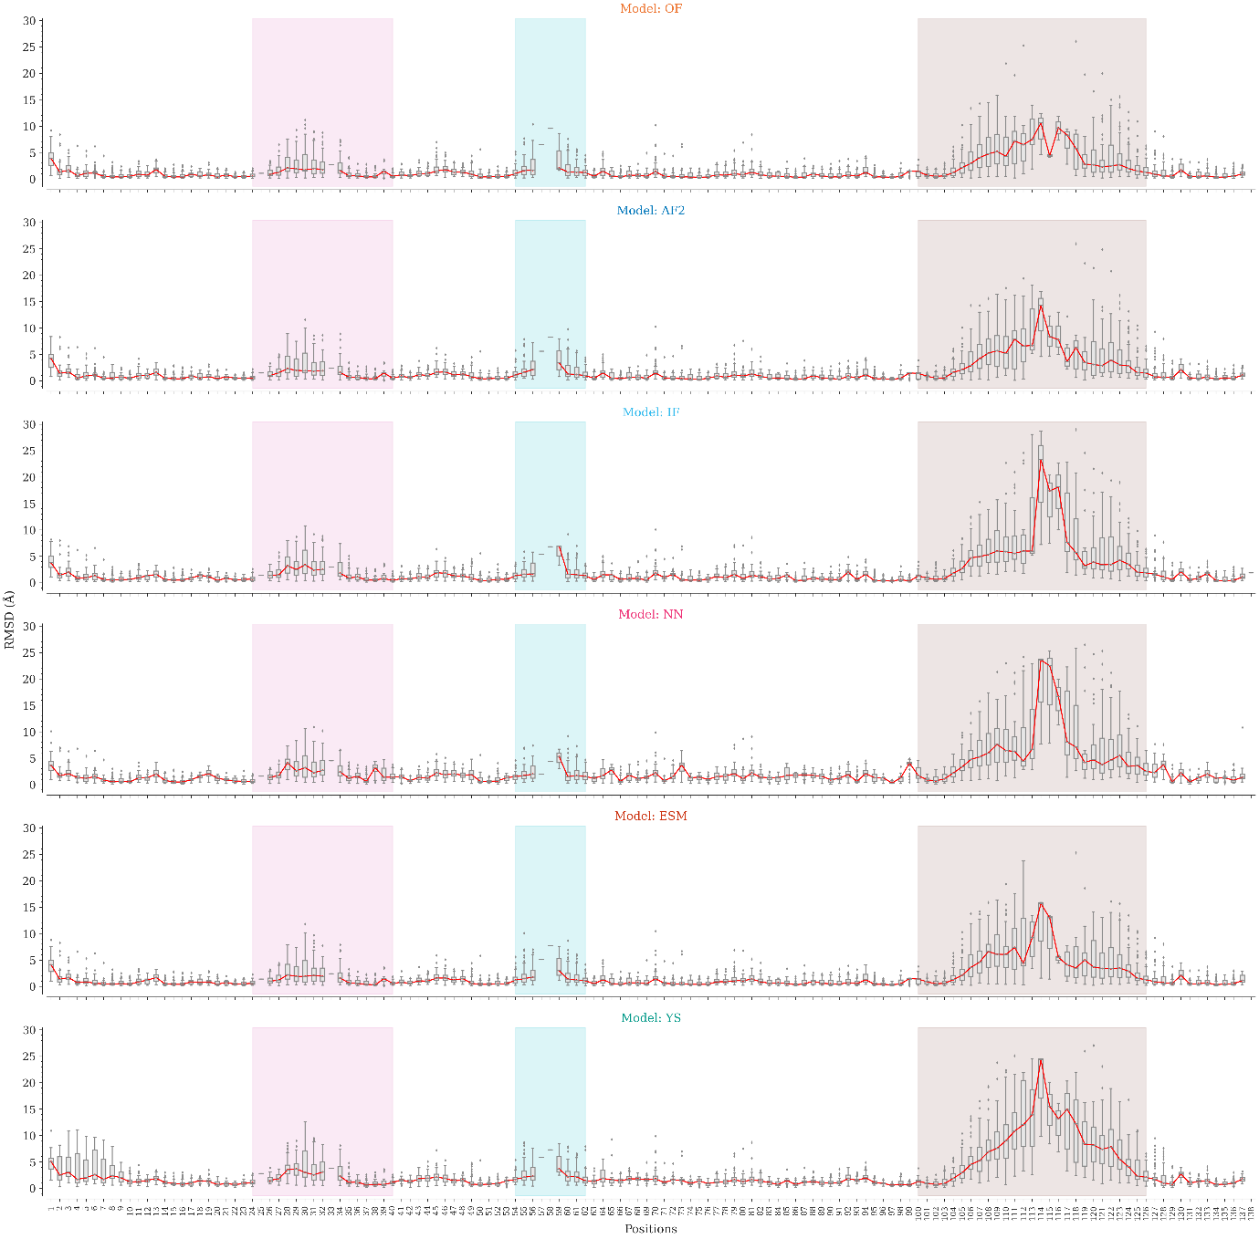
Figure S3. Distribution of heavy atoms RMSD values by position for the OmegaFold, AlphaFold2, IgFold, and Nanonet models. CDR1, CDR2, and CDR3 regions are colored pink, cyan, and brown, respectively. The RMSD distributions are represented by a boxplot. The lower and upper edges of the box represent the first (Q1) and third quartile (Q3), respectively. The difference Q3 - Q1 is known as the interquartile range (IQR). Whiskers extend to the minimum and maximum points within ±1.5 × IQR, respectively. The red line indicates the median value by position.

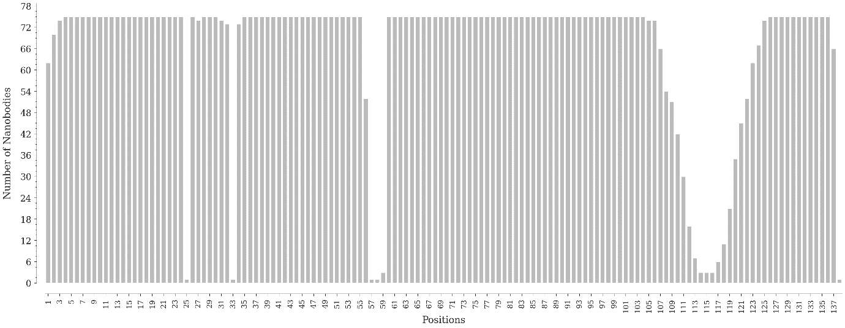
Figure S4. Representation by positions of the Nbs in the dataset using the Aho numbering scheme.

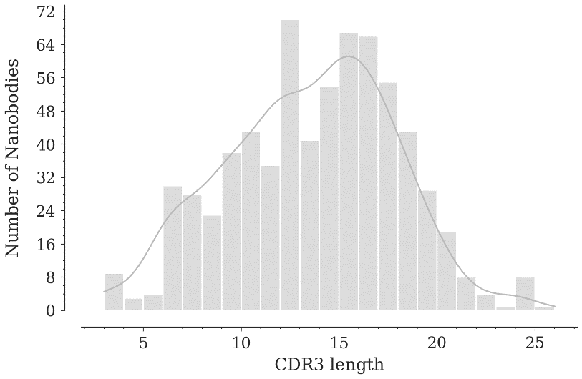
Figure S5. CDR3 length distribution of non-redundant Nbs structures in the Protein Data Bank.

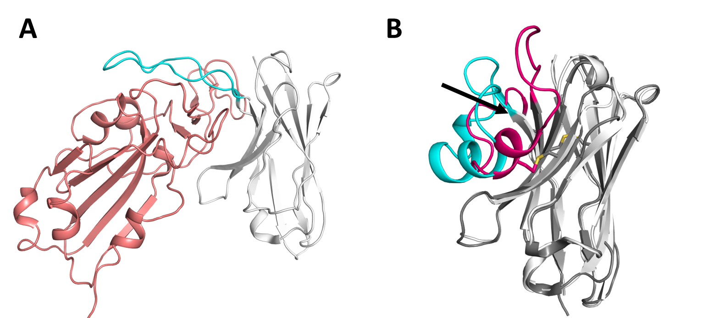
Figure S6. Particular cases of structural variations in the crystallographic structures are used as references. A) PDB: 7tpr. Nb (white) in complex with the antigen (deep salmon), which sits below CDR3 (cyan) stretching it away from the framework. B) Comparison between the engineered human heavy chain variable domain (PDB: 7db8) without canonical disulfide bridge (framework in white and CDR3 in cyan) and a Nb of equal length (PDB: 5lhn) with canonical disulfide bridge (framework in dark gray and CDR3 in hot pink). The arrow indicates the displacement of the N-terminal portion of the VH CDR3 with respect to the Nb.

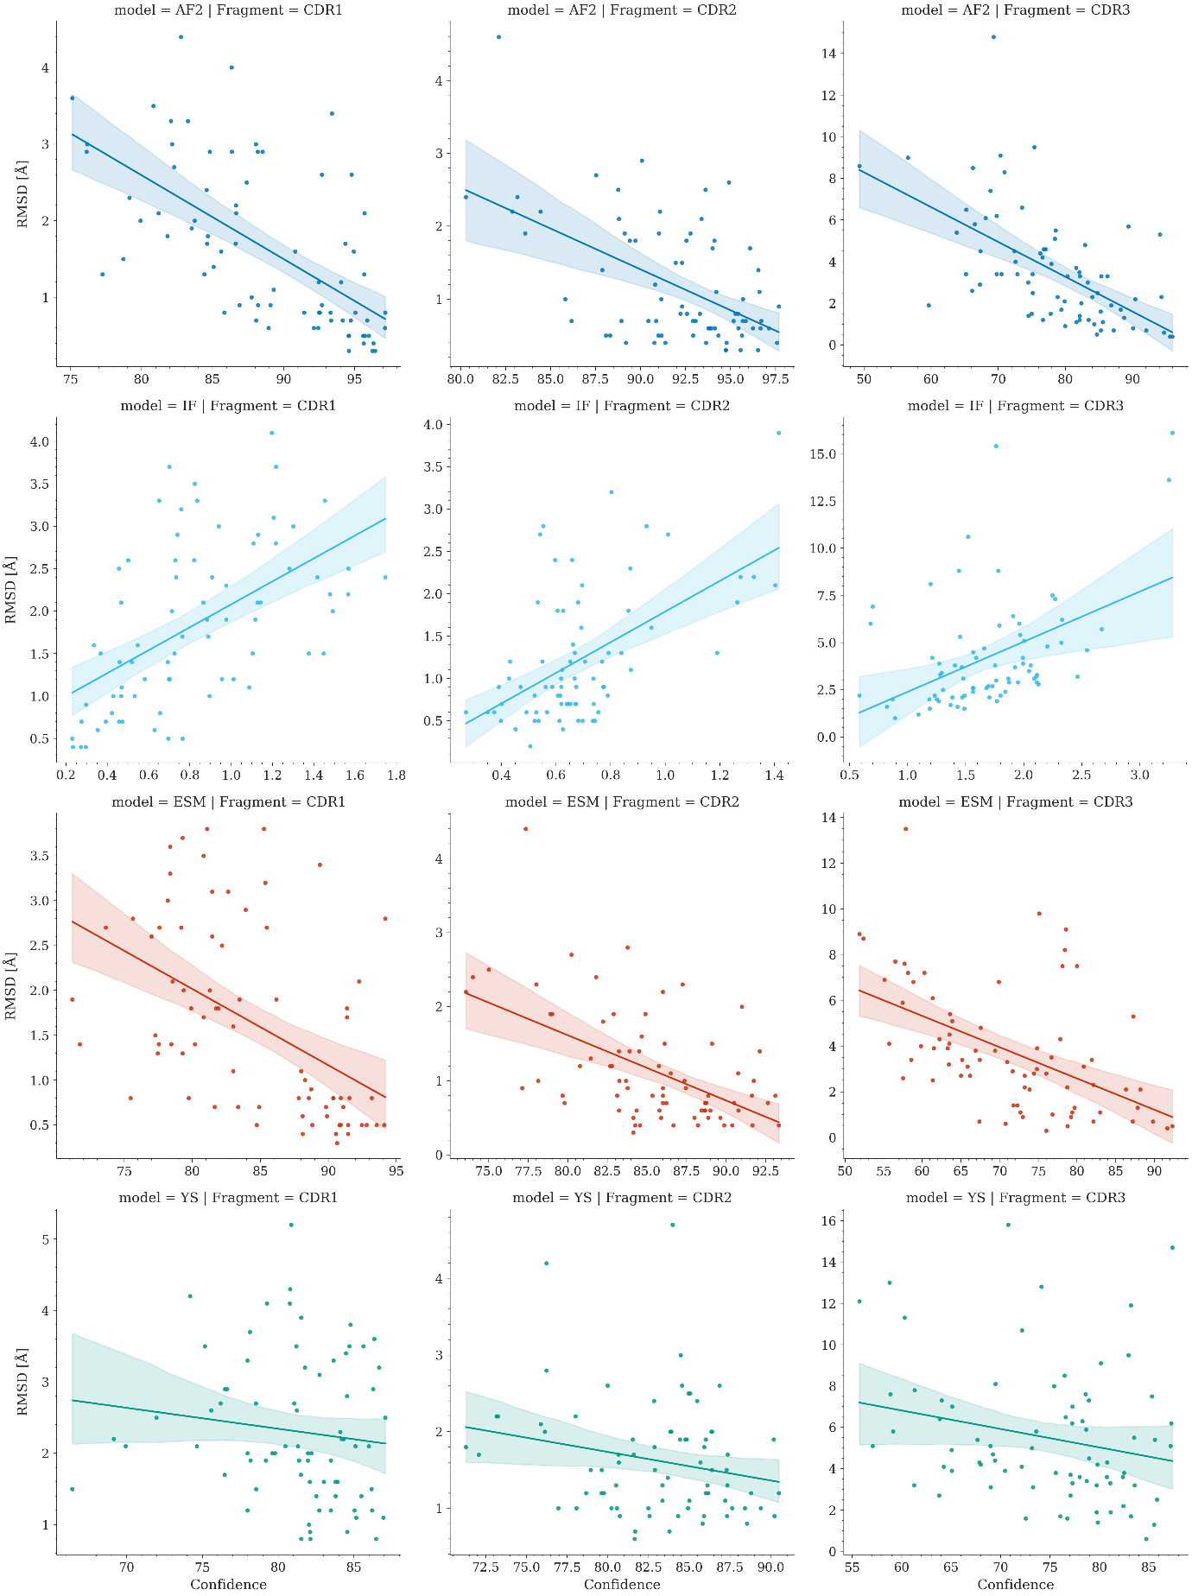
Figure S7. Correlation between the RMSD values and the average predicted confidences by AI models for the CDR regions in the 75 Nbs conforming the dataset. Regression lines relating the RMSD and the average predicted confidence variables are shown in different colors depending on the AI model used. Translucent bands around the regression lines indicate the 95% confidence interval for the regression estimates.

Table S4. Correlation between the RMSD values and the average predicted confidences by AI models for the CDR regions in the 75 Nbs conforming the dataset.
Model | Region | Pearson | Pearson p-value | Spearman | Spearman p-value | Slope | Intercept
AF2 | CDR1 | -0.62 | 2.10E-09 | -0.68 | 1.49E-11 | -0.11 | 11.34
AF2 | CDR2 | -0.54 | 7.46E-07 | -0.42 | 2.12E-04 | -0.11 | 11.50
AF2 | CDR3 | -0.59 | 3.02E-08 | -0.63 | 1.14E-09 | -0.17 | 16.65
OF | CDR1 | -0.59 | 2.57E-08 | -0.62 | 3.55E-09 | -0.08 | 8.68
OF | CDR2 | -0.44 | 6.55E-05 | -0.47 | 2.08E-05 | -0.07 | 7.44
OF | CDR3 | -0.62 | 4.01E-09 | -0.71 | 7.02E-13 | -0.13 | 12.87
IF | CDR1 | 0.54 | 5.91E-07 | 0.60 | 1.42E-08 | 1.35 | 0.73
IF | CDR2 | 0.55 | 3.13E-07 | 0.47 | 2.21E-05 | 1.81 | -0.02
IF | CDR3 | 0.46 | 3.61E-05 | 0.45 | 4.86E-05 | 2.65 | -0.26
ESM | CDR1 | -0.48 | 1.05E-05 | -0.54 | 7.34E-07 | -0.08 | 8.81
ESM | CDR2 | -0.54 | 6.66E-07 | -0.49 | 7.73E-06 | -0.09 | 8.66
ESM | CDR3 | -0.51 | 2.45E-06 | -0.56 | 2.23E-07 | -0.14 | 13.52
YS | CDR1 | -0.13 | 2.81E-01 | -0.21 | 7.02E-02 | -0.03 | 4.69
YS | CDR2 | -0.22 | 5.91E-02 | -0.20 | 8.72E-02 | -0.04 | 4.72
YS | CDR3 | -0.23 | 5.01E-02 | -0.24 | 3.55E-02 | -0.09 | 12.18

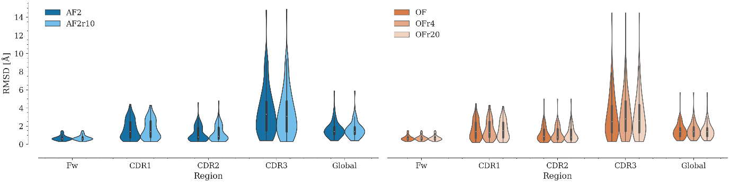
Figure S8. Comparison of the RMSD distribution for the models obtained varying the number of recycles of AlphaFold2 and OmegaFold. The RMSD distributions are represented by a violin plot. It combines the kernel density plot (outer) to show the distribution of values and a boxplot (inner) that summarizes the distribution statistics. The boxplot is composed of the white dot representing the median, the thick gray bar in the center representing the interquartile range, and the thin gray line representing the rest of the distribution. No statistically significant differences were found between the models obtained with the default parameters and those obtained with varying the number of recycles of AlphaFold2 and OmegaFold.

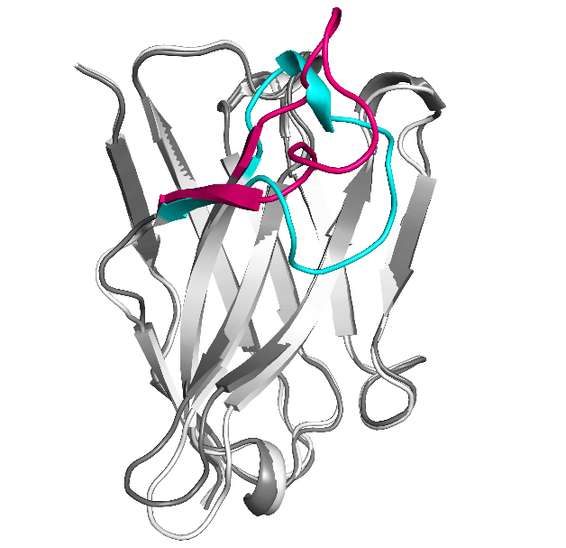
Figure S9. Structural variation of CDR3 of the same Nb in the asymmetric unit. Both CDR3 are highlighted in cyan and hotpink, respectively. PDB ID: 7omn

Table S5. Nanobodies selected for modeling Nb-antigen complexes. All PDB files can be found at https://github.com/Valdes-Tresanco-MS/NbModelingBenchmark
PDB | PDB | PDB | PDB | PDB
7d8b_B | 7l6v_D | 7ocy_C | 7m1h_F | 7z1b_E
7nft_C | 7rby_B | 7d4b_B | 7vfa_D | 7fau_B
7nfr_B | 7lzp_C | 7l6v_B | 7php_N | 7anq_B
7m1h_E | 7z1c_E | 7olz_B | 7d6y_B | 7fat_B
7sl9_B | 7o06_A | 7ar0_B | 7qbg_E | 7qbe_E
7t5f_B | 7lzp_B | 7na9_D | 7s2r_B | 7r74_B
7r98_D | 7e53_B | 7f5g_B | 7zfb_M | 7ndf_C
7t5f_C | 7ngh_D | 7rnn_C | 7lzp_G | 7nfq_C
7pqg_B

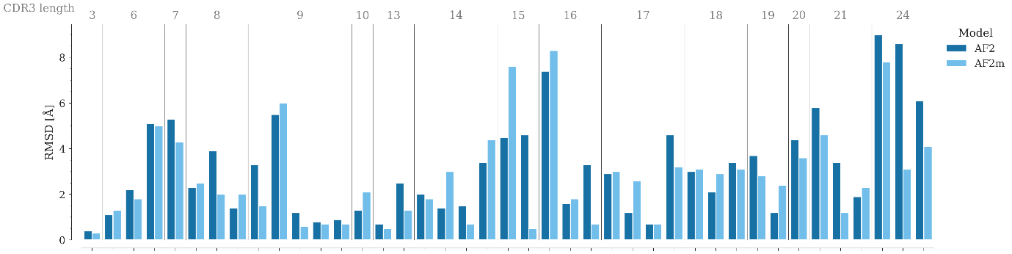
Figure S10. Comparison between the RMSD of models generated with AlphaFold2 (AF2) and AlphaFold-multimer (AF2m) clustered by CDR3 length.
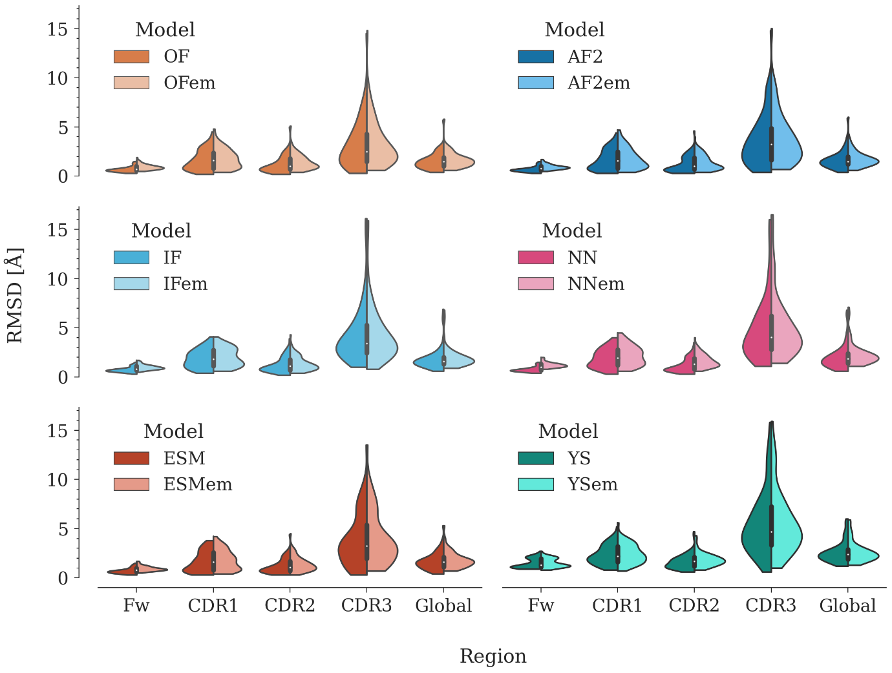
Figure S11. Comparison of the RMSD distribution between the default generated model and its minimized version for OmegaFold, AlphaFold2, IgFold, Nanonet, ESMFold and Yang-server. The RMSD distributions are represented by a violin plot. It combines the kernel density plot (outer) to show the distribution of values and a boxplot (inner) that summarizes the distribution statistics. The boxplot is composed of the white dot representing the median, the thick gray bar in the center representing the interquartile range, and the thin gray line representing the rest of the distribution. No statistically significant differences were found between the models obtained with the default parameters and their minimized version.

