Supplementary Materials
Self-assembled CNF/rGO/Tannin composite: Study of the Physicochemical and Wound Healing Properties
Katherina Fernández ^{1,}*, Ayleen Llanquileo ¹, Montserrat Bustos ¹, Valentina Aedo ¹, Isleidy Ruiz ¹, Sebastián Carrasco ¹, Mauricio Tapia ¹, Miguel Pereira ², Manuel F. Meléndrez ³, Claudio Aguayo ⁴, Leonard I. Atanase ^{5,6}

¹ Laboratorio de Biomateriales, Departamento de Ingeniería Química, Facultad de Ingeniería, Universidad de
Concepción, Box 160-C, Concepción, Chile
² Laboratorio de Productos Forestales, Departamento de Ingeniería Química, Facultad de Ingeniería, Universidad de Concepción. Box 160-C, Concepción, Chile
³ Grupo Interdisciplinario de Nanotecnología Aplicada (GINA). Laboratorio de Materiales Híbridos (HML). Departamento de Ingeniería de Materiales (DIMAT), Facultad de Ingeniería, Universidad de Concepción, Edmundo Larenas 270, Box 160-C, Concepción, Chile
⁴ Departmento de Inmunología y Bioquímica Clínica, Facultad de Farmacia, Universidad de Concepción, Concepción, Chile
⁵ Faculty of Medical Dentistry, Apollonia University of Iasi, 700511, Iasi, Romania
⁶ Academy of Romanian Scientists, 050045 Bucharest, Romania
* Correspondence: kfernandeze@udec.cl;

1. Materials and Methods
1.1 Materials
Graphite powder (flakes; mesh 325) was purchased from Asbury Online (Asbury Carbons, New Jersey, USA). Dopamine hydrochloride (𝐷𝐴 − 𝐻𝐶𝑙, ≥ 98.0%) was purchased from Sigma-Aldrich Company (St. Louis, MO). The other chemicals and solvents, such as tris(hydroxymethyl)aminomethane (buffer Tris), sulfuric acid (H2SO4, 98%), phosphoric acid (H2PO3, 85%), oxygenated water (H2O2, 60 vol), silver nitrate (AgNO3, 0.1 N), potassium permanganate powder (KMnO4, 99.9%) and hydrochloric acid (HCl, 37% v/v), were purchased from Merck (Darmstadt, Germany). These chemicals were used as received, without further purification. Milli-Q® water and distilled water were used throughout the study. Cellulases Quimizime B was provided by CHT group (Santiago, Chile).
1.2. Material characterization
X-ray diffraction (XRD). The X-ray diffraction (XRD) was used to determine the oxidation degree of GO and the crystallinity of rGO/NCF and rGO/CNF/TA composites. The measurements were carried out on the X-ray diffractometer (Bruke Axs, D4 Endeavor, USA) with reference target: Cu Kα radiation (λ=1,541841 Å; 2,2 kW), voltage: 40 kV, and current: 20mA. The samples were measured from 2 to 50° during 141 s with steps of 0.02°.
Fourier Transform Infrared Spectroscopy (FTIR). The FTIR was used to investigate the chemical nature of interaction of rGO/NCF and rGO/CNF/TA composites. The spectra were recorded in the Perkin Elmer UATR Two FTIR Spectrometer. The wavenumber range analyzed was 4000-500 cm-1 and a total of 40 accumulated scans were acquired.
Raman analysis. The Raman was used to identify the spectra features and structural properties of GO and rGO/NCF and rGO/CNF/TA composites. The data were acquired by high-resolution confocal (LabRamHR Evolution Horiba Jobin Yvon microscope, Japan) at 633 nm of wavenumber in the excitation laser line, a power of 13.3 mW and 1.96 eV. The laser spot was focused on the samples using an optic Objective Olympus 100x VIS and a NUV camera (B/S UV 50/50 + Lens F125 D25). The measurements were carried out in quadruplicate at room temperature, and with a laser intensity constant to avoid damaging on the samples. In addition, for the calculation of either the intensity and the area of the D and G bands were applied a Lorentzian function in the spectral region 1000-1800 cm⁻¹.
X-ray photoelectron spectroscopy (XPS). XPS technique was used to quantitatively identify the surface chemistry of rGO/NCF and rGO/CNF/TA composites, also the raw components NCF, TA and rGO were analyzed. The measurements were carried out in a Surface Analysis Station 1 (STAIB model RQ300/2, USA) at ultravacuum conditions (< 10-9 bar) equipped with a hemispherical electron analyzer (SPEC PHOIBOS 100, Germany). The photoelectrons were excited with non-monochromatic radiation Mg Kα (1486.6 eV) and analyzed with a constant energy step of 1 eV. The X-ray source was used with a strength of 300 W.
Thermogravimetric analysis (TGA). TGA technique was used to evaluate the thermal stability of gelatin, GO and rGO/NCF and rGO/CNF/TA composites. The measurements were carried out in a Cahn-Versatherm thermogravimetric analyzer with sensitivity of 0.1 μg, heating rate of 10°C/min under nitrogen atmosphere (100 mL/min) and a temperature range from 30°C to 800°C.
Scanning electron microscopy (SEM). The SEM analysis was used to investigate the micromorphology of rGO/NCF and rGO/CNF/TA composites. SEM images were recorded using a JEOL JSM-6380LV, Japan model microscope at 10 kV. The aerogels were coated using a gold sputter coater and their surfaces were observed at different resolutions. In addition, the SEM images were processed using ImageJ® software to determinate the average pore sizes.
Surface charge measurements. The surface charge was determined through ζ-potential measurements using the Dynamic Light Scattering principle (SZ-100 Nano particle analyzer, Horiba Scientific, Japan). The measurements were carried out for the GO and gelatin-GO aerogels. Samples 1.0 cm3 in volume were dissolved in Milli-Q® water pH 6.5, shaken and sonicated for 20 min to achieve homogeneity. Finally, the samples were measured in triplicate.

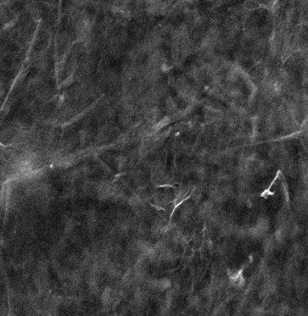
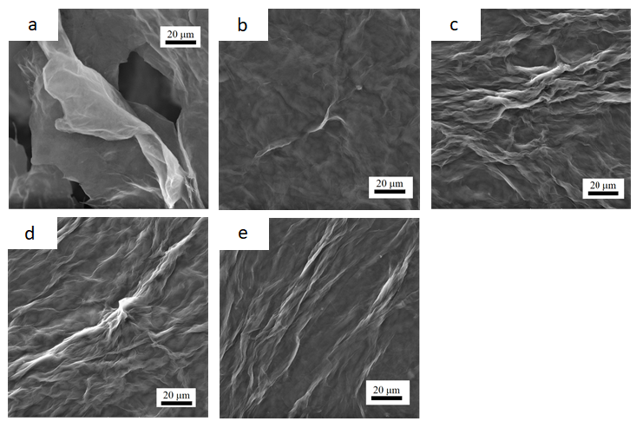
f
20 μm

Figure S1. SEM images a) GO, b) rGO/CNF₅, c) rGO/CNF₁₅, d) rGO/CNF₂₅, e) rGO/CNF₅₀ f) rGO/CNF₂₅/TA.

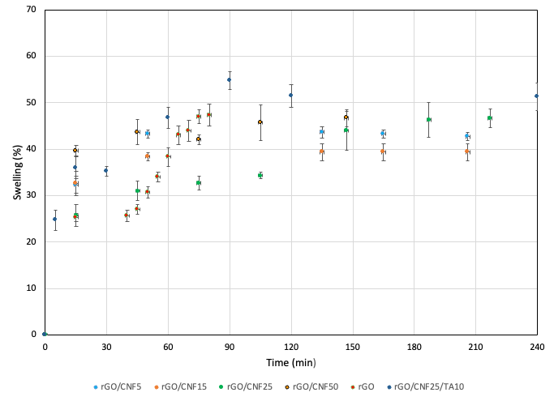
Figure S2. Swelling behavior of neat materials and composite samples on PBS fluid on time.

Table S1. Phenol composition and content of the Pinus Radiata bark extract
Compounds | Content (mg per gram of extract)
(-)-Catechin | 13.8
Taxifolin | 13.9
p-Hydroxybenzoic acid | 7.6
Homovanillic acid a | 6.7
Quercetin | 4.3
Proanthocyanidin B-2 | 3.3
(+)-Epicatechin | 2.8
Dihydroxybenzoic acid b | 2.7
Dihydroxybenzoic acid b | 1.8
Syringic acid a | 1.1
3,4-dihydroxyphenyl acetic acid | 0.9
Dihydroxybenzoic acid b | 0.2
Epigallocatechin | n.d.
n.d.: not detected, a: tentatively identified compounds, b: not recognized isomers.

Table S2. Average molecular weight number (Mn) of pine extracts at different percentages of sample development, determinate by GPC.
% sample development | Mn
10 | 438
25 | 749
50 | 1355
100 | 63277

