Supporting Information

Design, synthesis and anticancer activity of novel 3,6-diunsaturated 2,5-diketopiperazines

Xiaolin Li ^{1,5,†}, Tianrong Xun ^{3,†}, Huayan Xu ², Xiaoyan Pang ¹, Bin Yang ^{1,5}, Junfeng Wang ^{1,5}, Xuefeng Zhou ^{1,5}, Xiuping Liu ¹, Suiyi Tan ^{4,}*, Yonghong Liu^{1,2,5,}* and Shengrong Liao ^{1,5,}*

¹ CAS Key Laboratory of Tropical Marine Bio-Resources and Ecology, Guangdong Key Laboratory of Marine Materia Medica, Research Center for Marine Microbes, South China Sea Institute of Oceanology, Chinese Academy of Sciences, Guangzhou 510301, China
² Wuya College of Innovation, Shenyang Pharmaceutical University, Shenyang 110016, China
³ Department of Pharmacy, Southern Medical University, Shenzhen 518100, China.
⁴ Guangdong Provincial Key Laboratory of New Drug Screening, School of Pharmaceutical Sciences, Southern Medical University, Guangzhou 510515, China
⁵ University of Chinese Academy of Sciences, Beijing 100049, China
* Correspondence: suiyitan@smu.edu.cn (S.T.), yonghongliu@scsio.ac.cn (Y.L.), srliao@scsio.ac.cn (S.L.)
† These authors contributed equally to this work

Copies of NMR spectra for the derivatives
Note: 3 and 7 are known compounds¹⁻²

Figure S1 ¹H NMR of 1
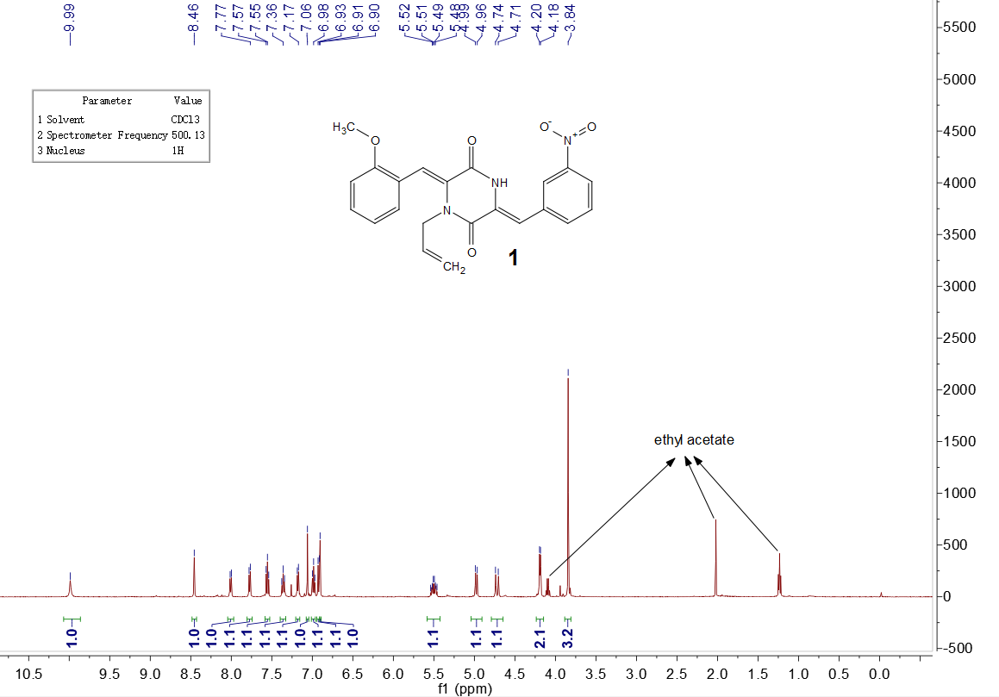

Figure S2 ¹³C NMR of 1
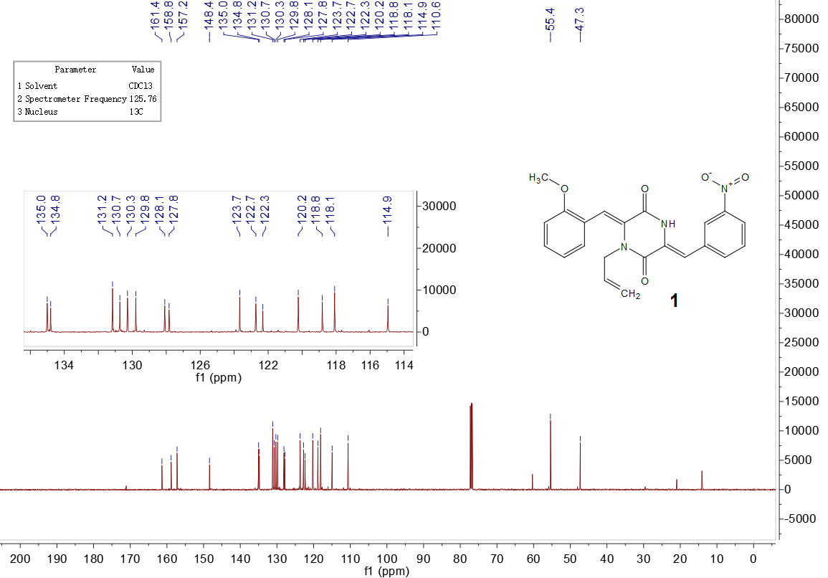
Figure S3 ¹H NMR of 2
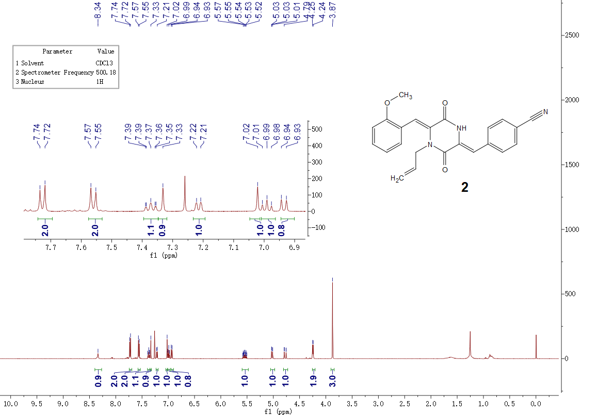

Figure S4 ¹³C NMR of 2 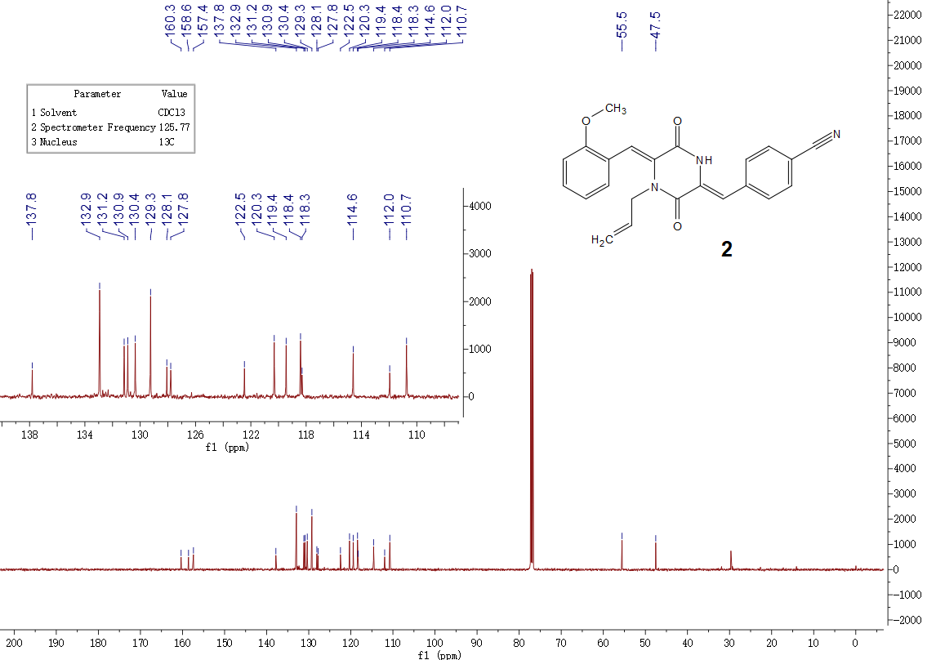

Figure S5 ¹H NMR of 4
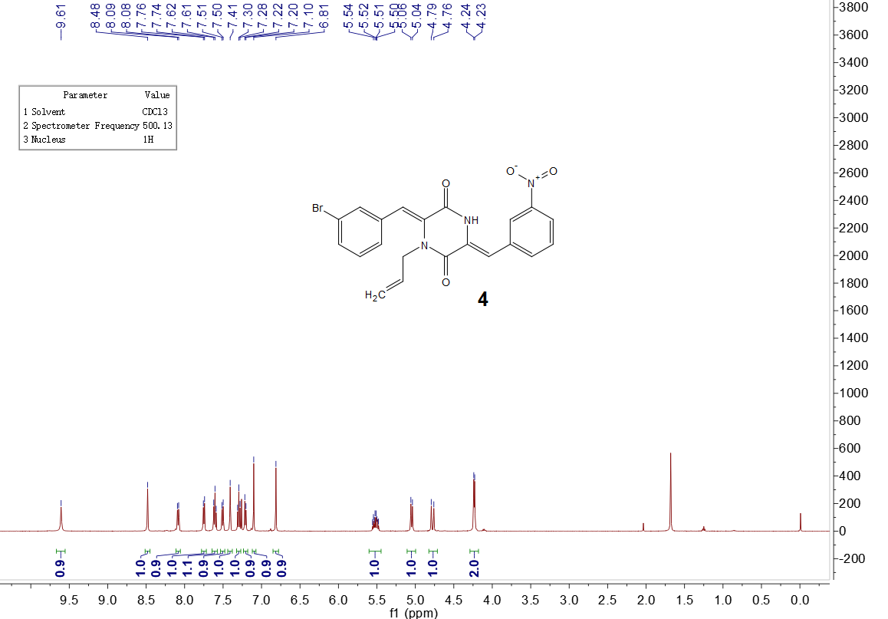

Figure S6 ¹³C NMR of 4
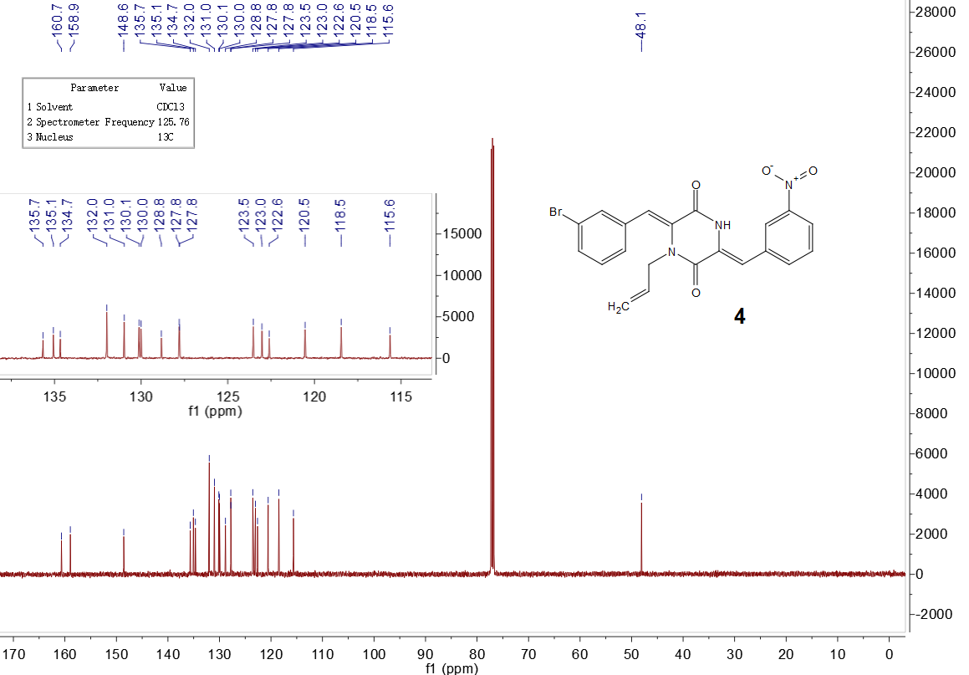

Figure S7 ¹H NMR of 5
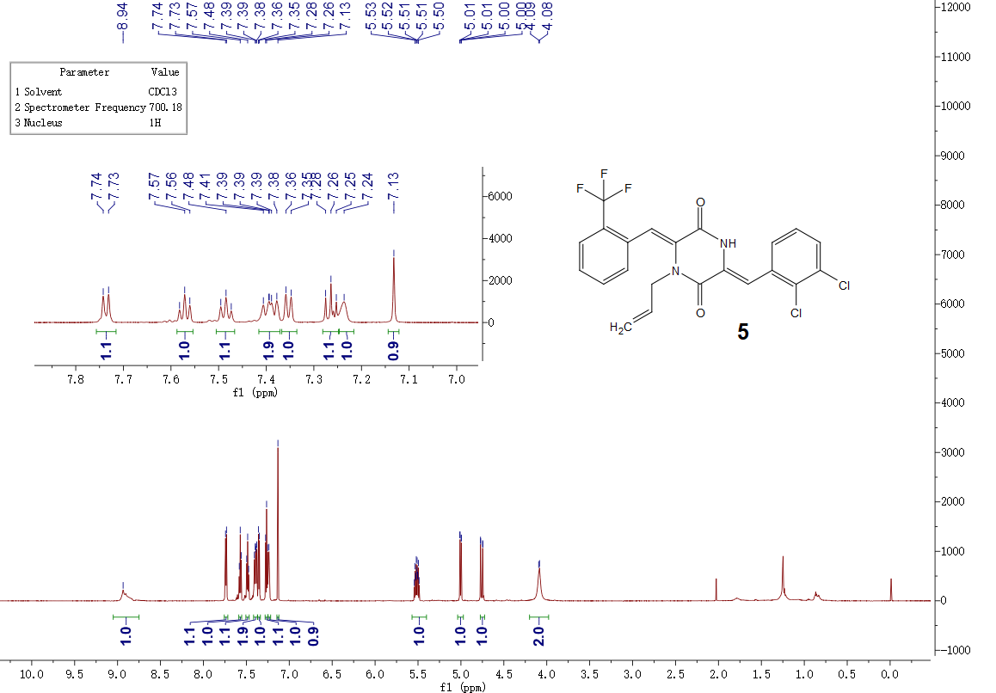

Figure S8 ¹³C NMR of 5
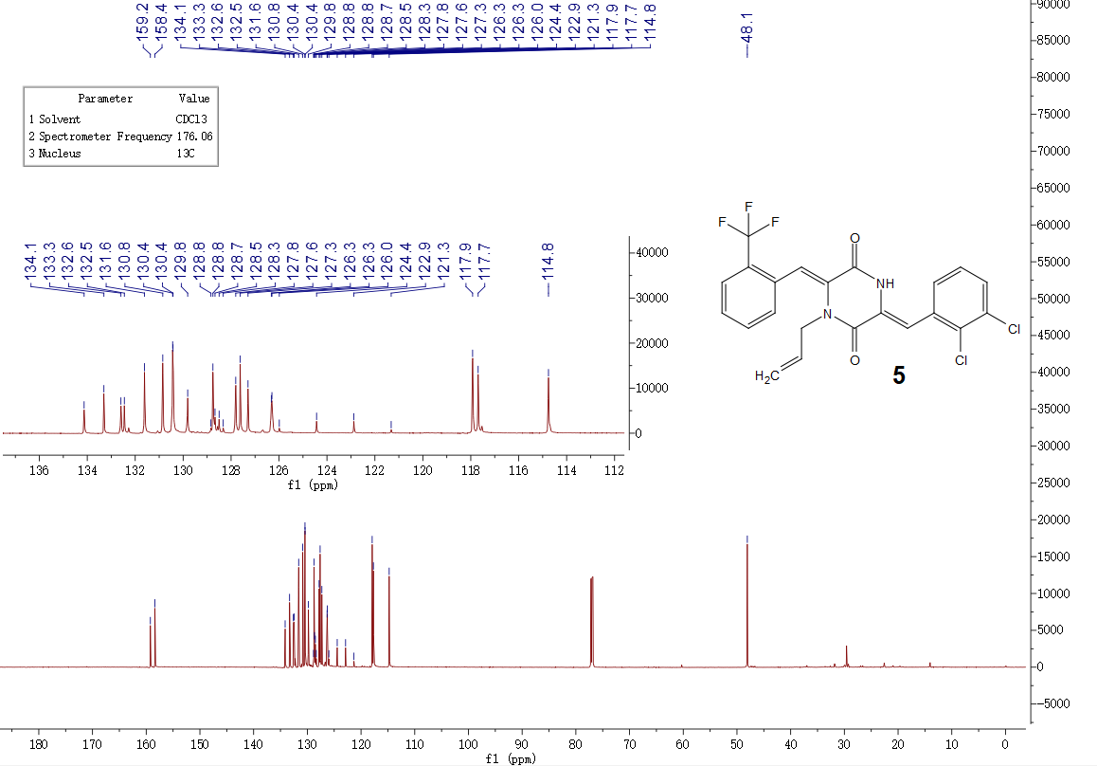

Figure S9 ¹H NMR of 6
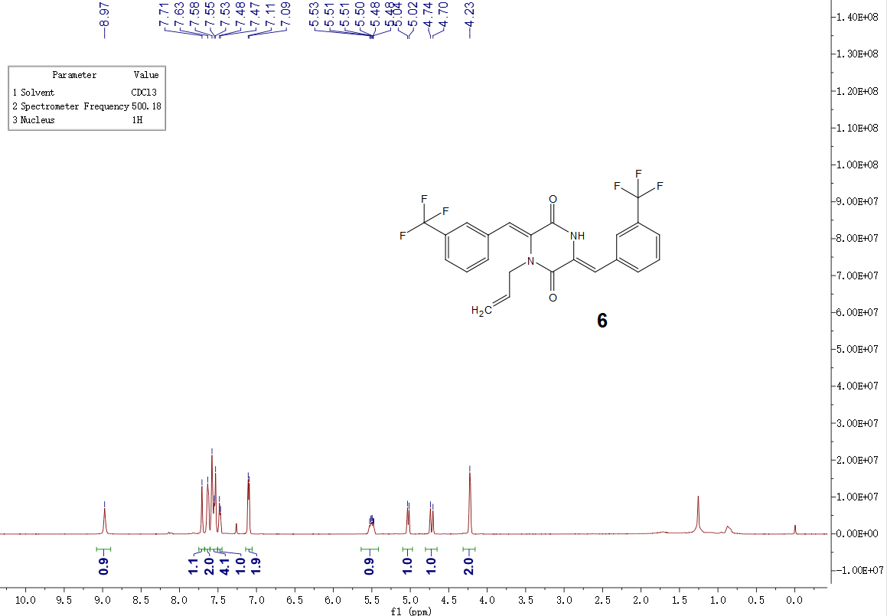

Figure S10 ¹³C NMR of 6
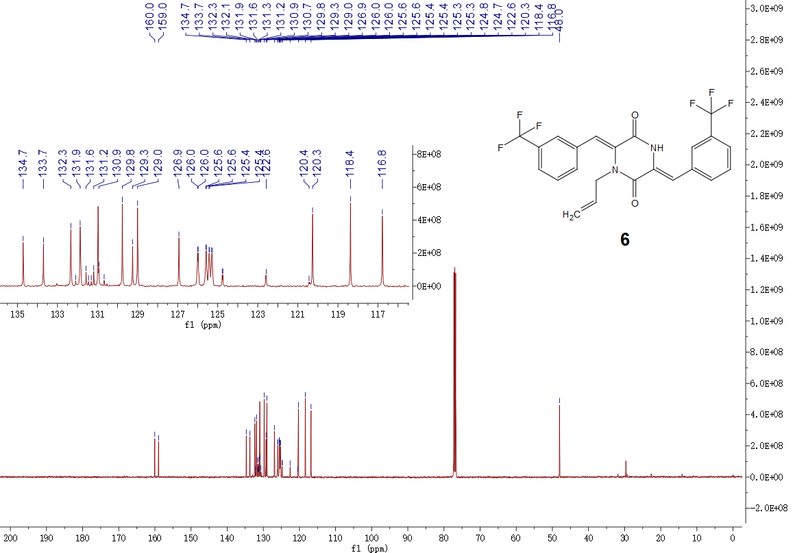

Figure S11 ¹H NMR of 8
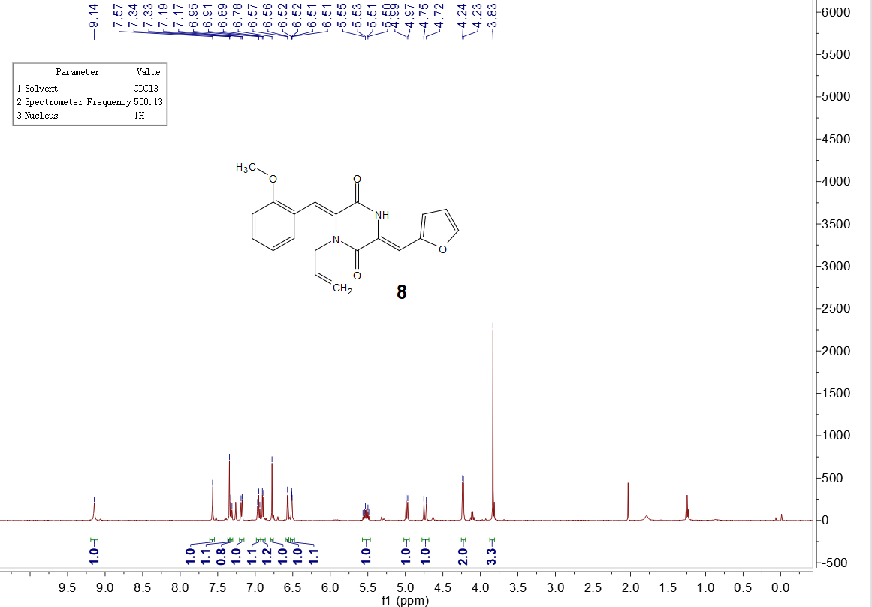

Figure S12 ¹³C NMR of 8
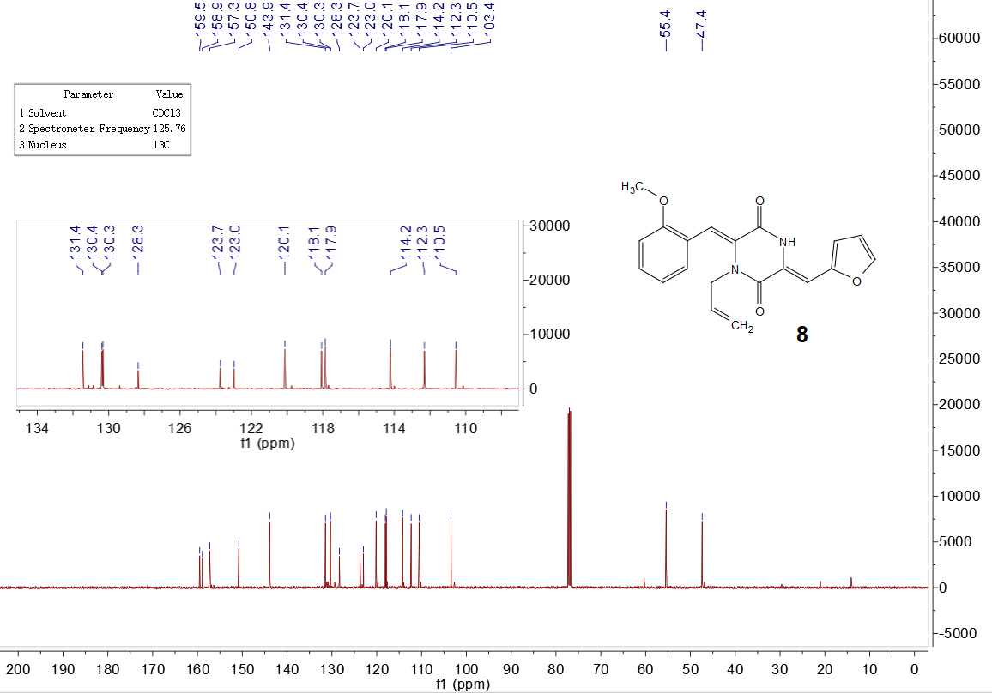

Figure S13 ¹H NMR of 9
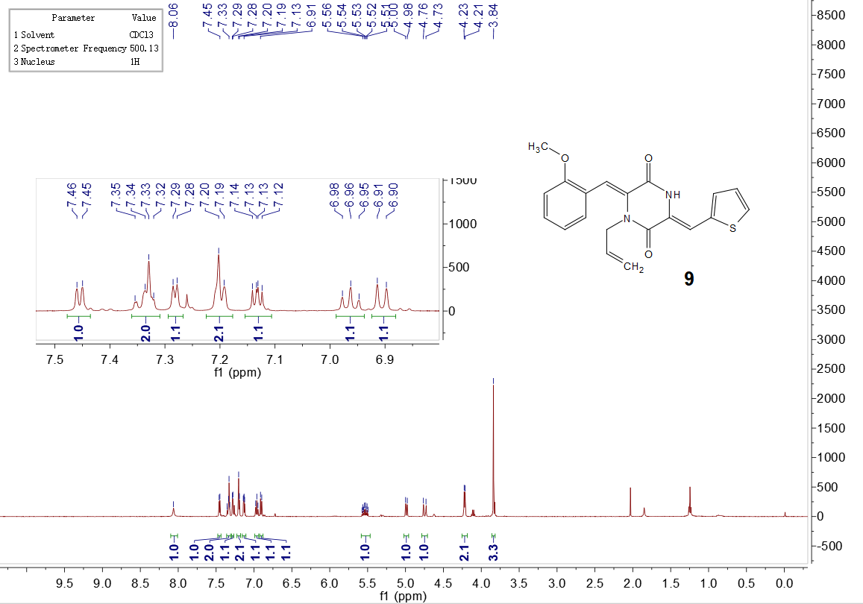

Figure S14 ¹³C NMR of 9
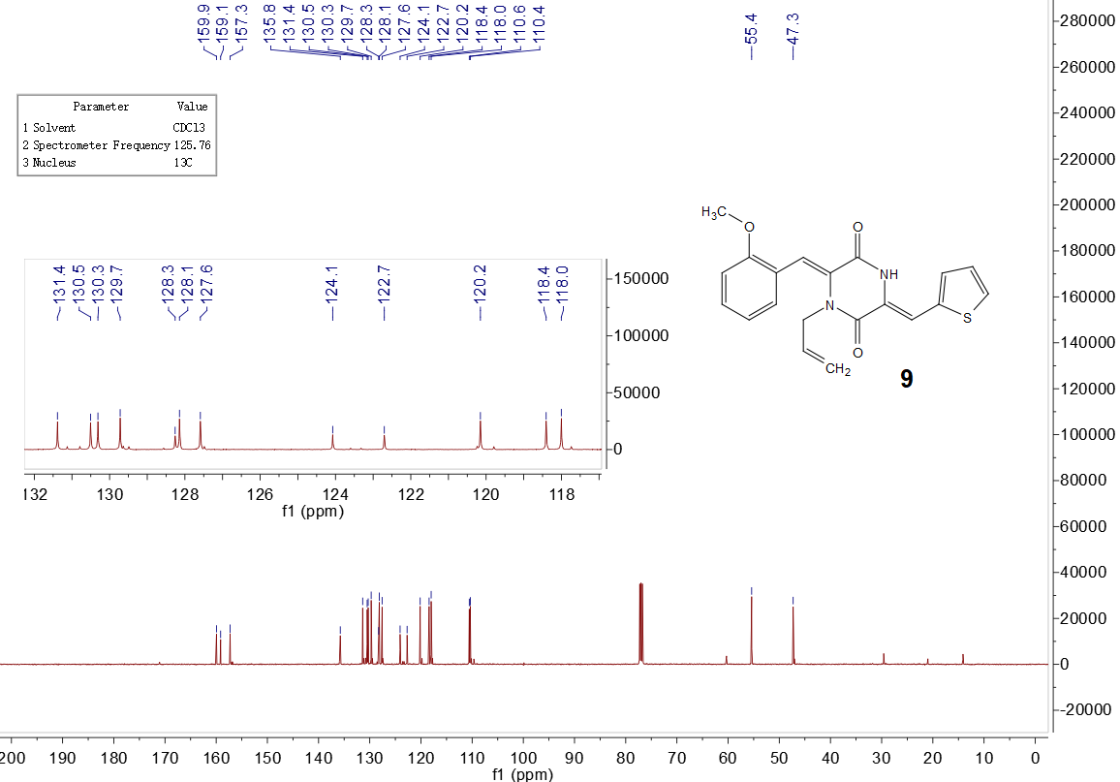

Figure S15 ¹H NMR of 10
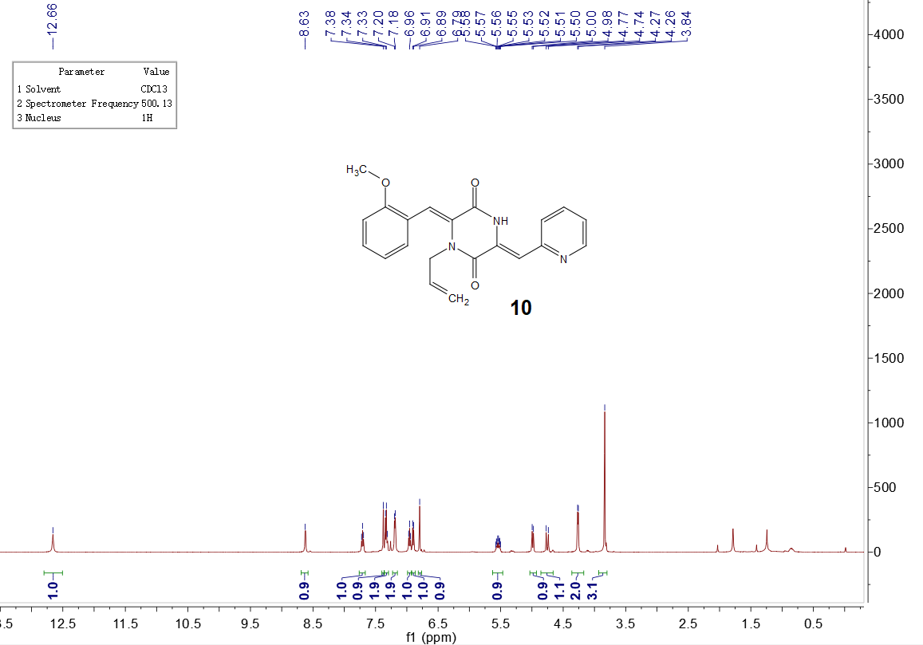

Figure S16 ¹³C NMR of 10 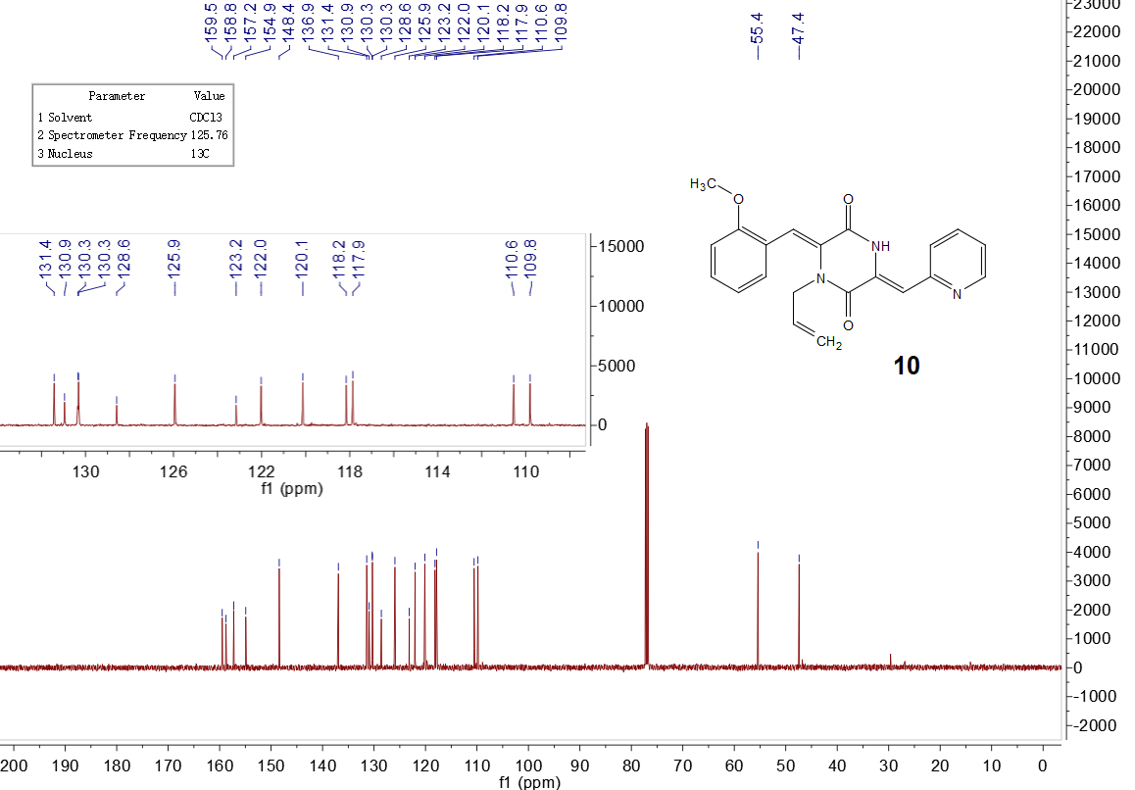

Figure S17 ¹H NMR of 11
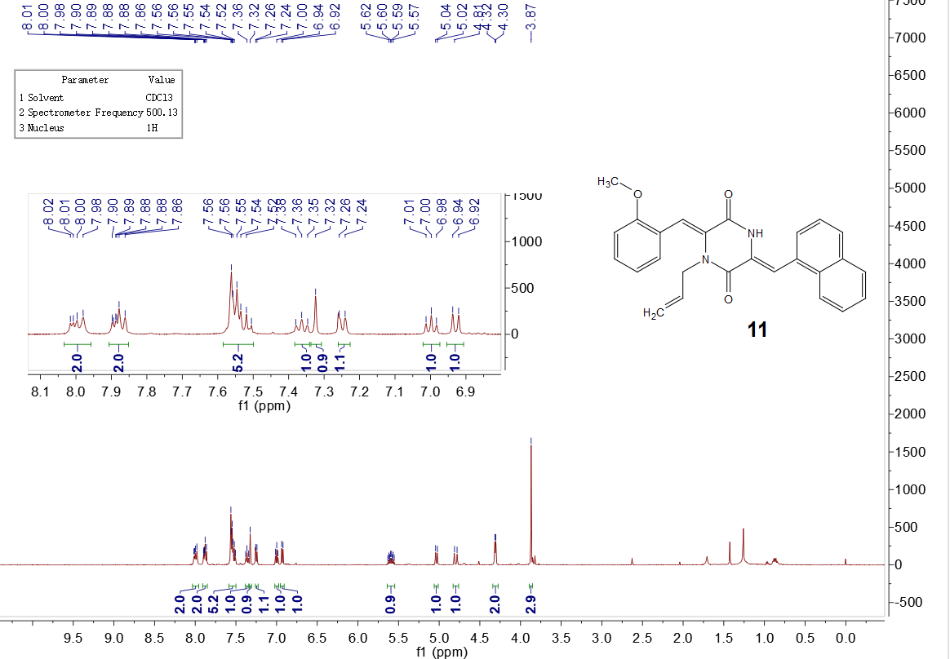

Figure S18 ¹³C NMR of 11 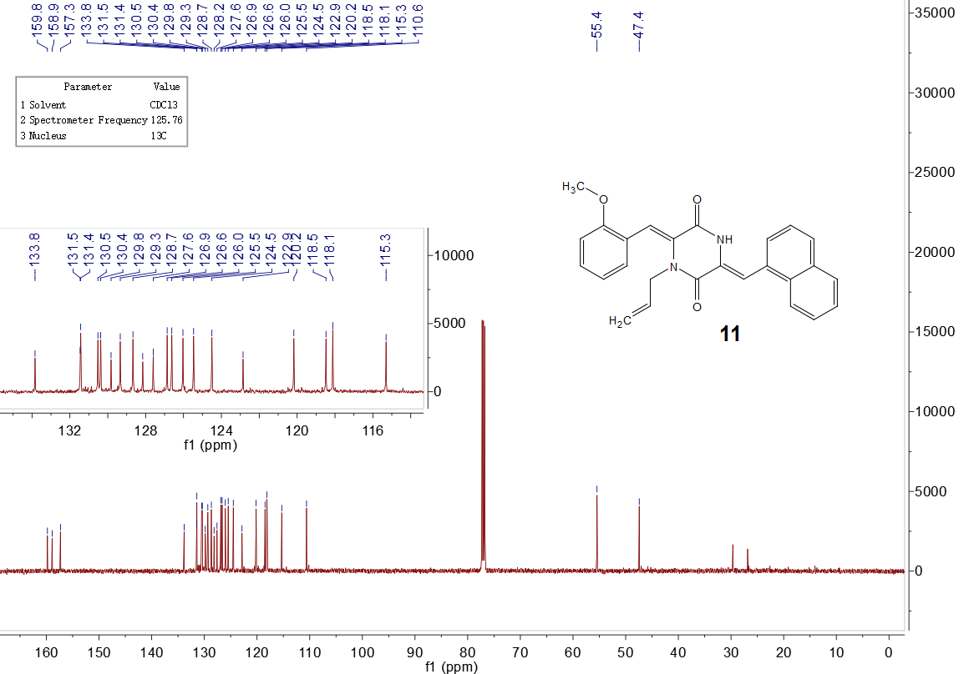

Figure S19 ¹H NMR of 12
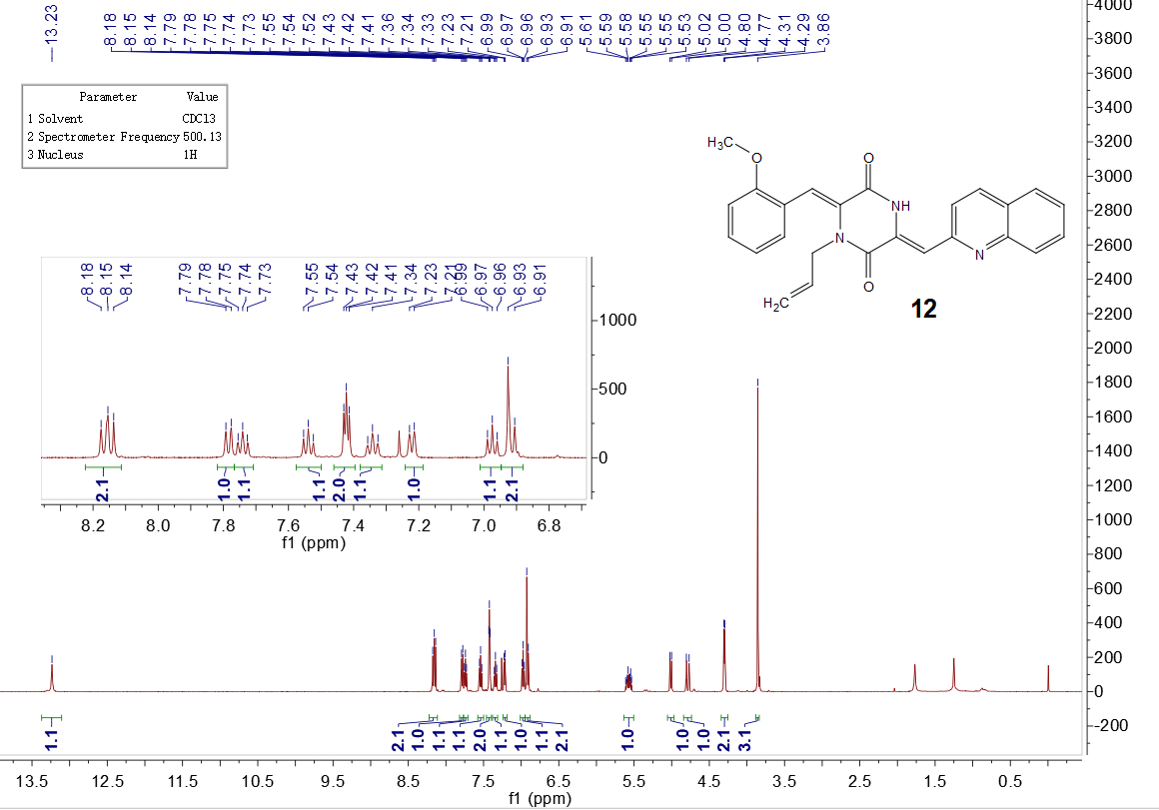

Figure S20 ¹³C NMR of 12 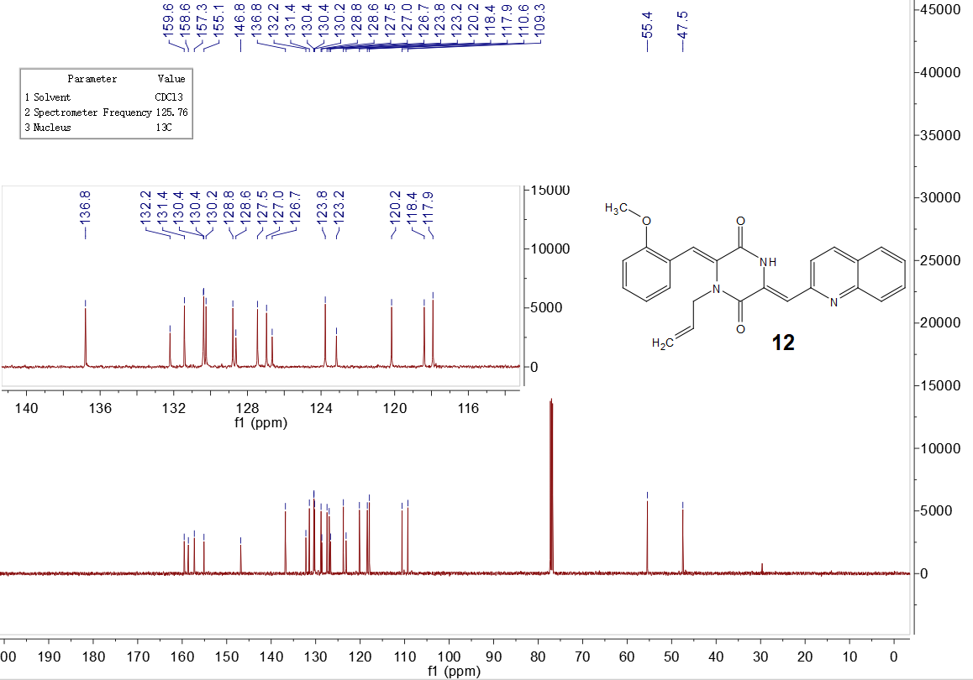

Figure S21 ¹H NMR of 13
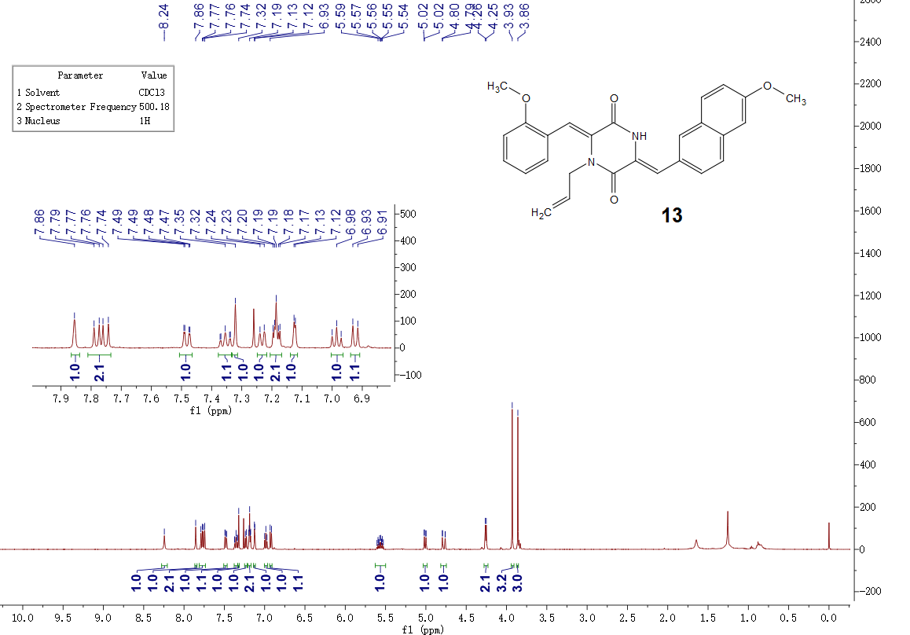

Figure S22 ¹³C NMR of 13
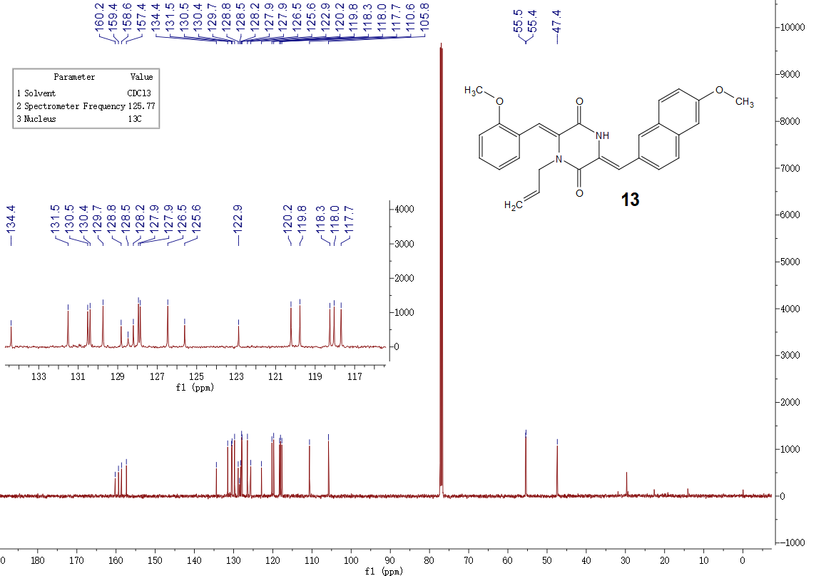

Figure S23 ¹H NMR of 14
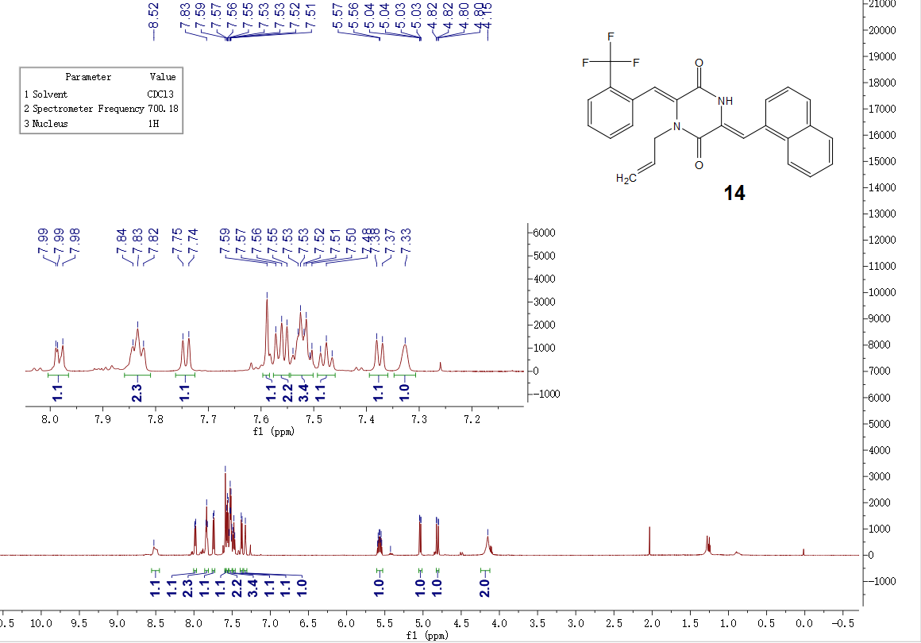

Figure S24 ¹³C NMR of 14
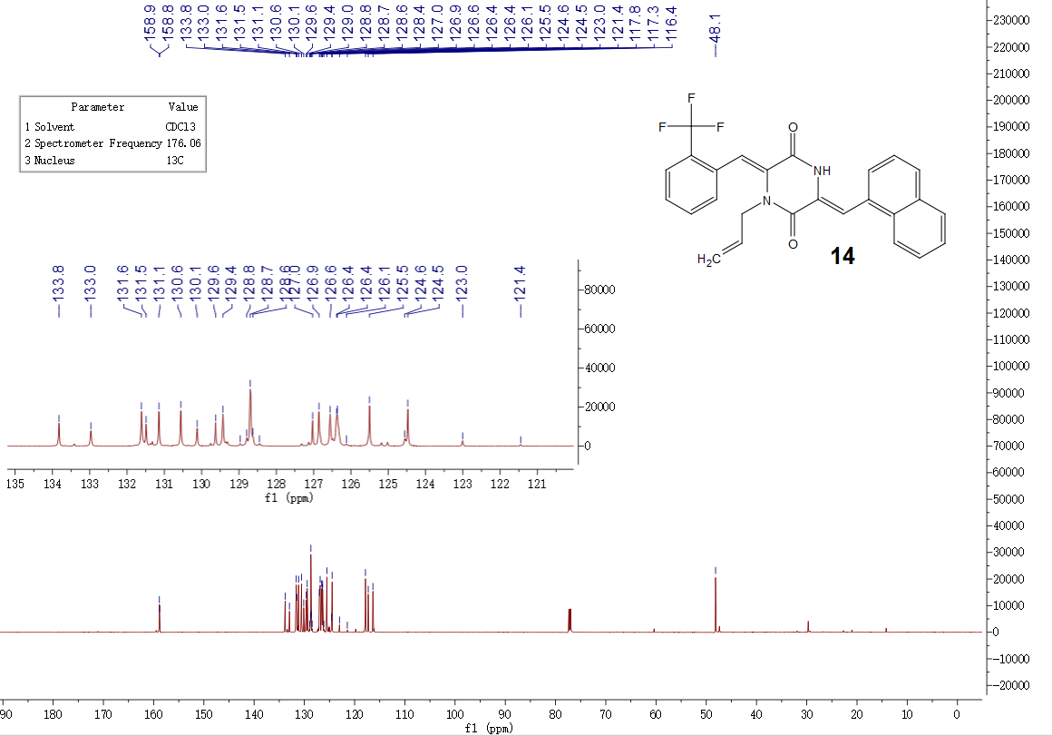

Figure S25 ¹H NMR of 15
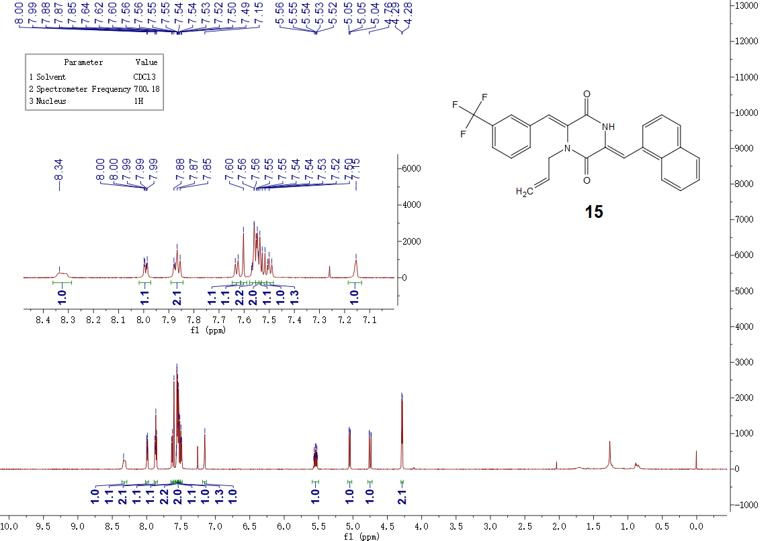

Figure S26 ¹³C NMR of 15
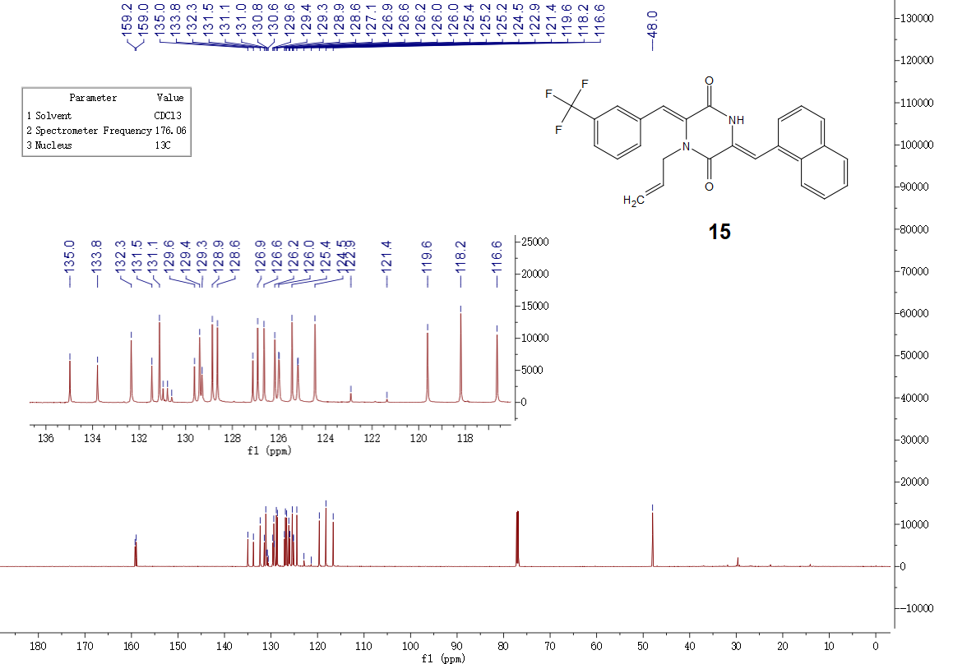

Figure S27 ¹H NMR of 16
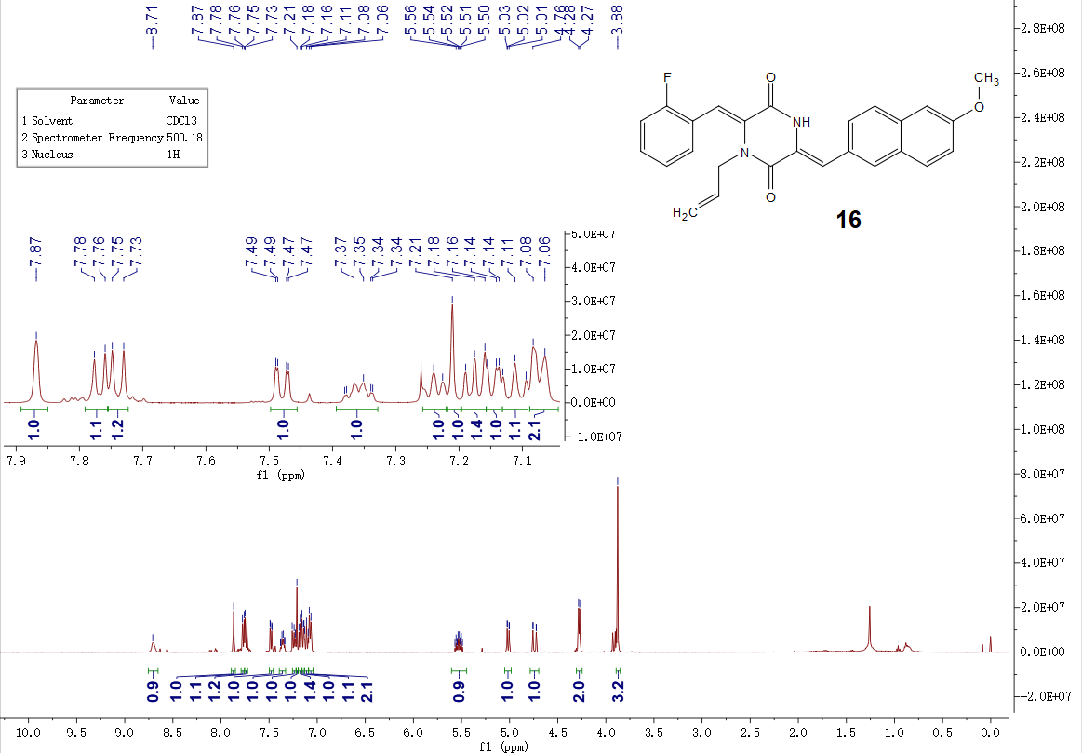

Figure S28 ¹³C NMR of 16
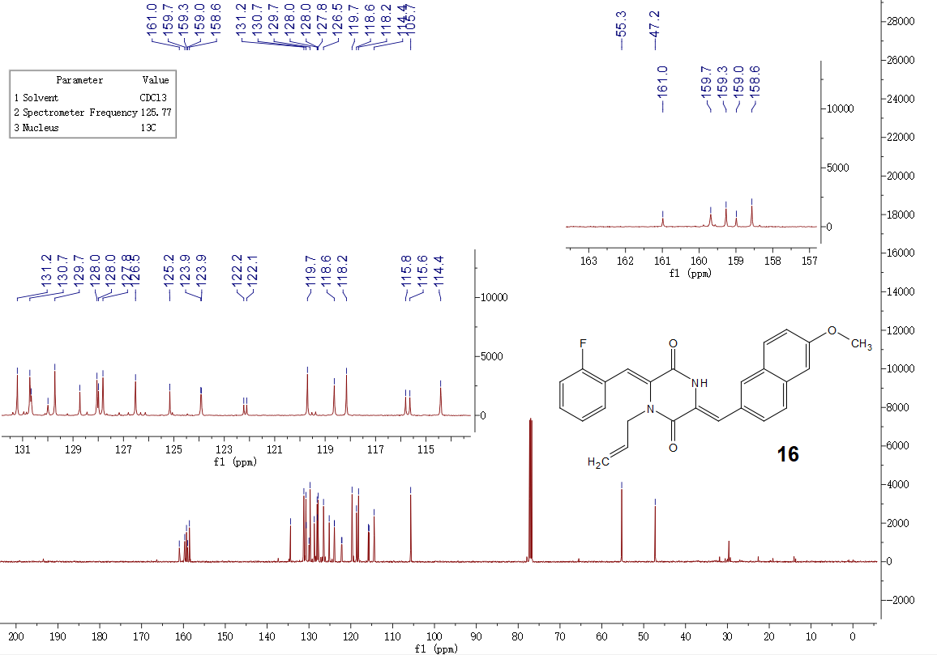

Ref:
1 Liao, S. R.; Du, L. J.; Qin, X. C.; Xu, L.; Wang, J. F.; Zhou, X. F.; Tu, Z. C.; Li, J.; Liu, Y. H., Tetrahedron 2016, 72, (8), 1051-1057.
2 Liao, S. R.; Xu, Y.; Tang, Y.; Wang, J. F.; Zhou, X. F.; Xu, L.; Liu, Y. H., Rsc Adv 2015, 5, (63), 51020-51026.

