SUPPLEMENTARY MATERIALS
General Methods
2,3,5,6-Tetrafluorophenyl 6-(3-(4-(tert-butoxycarbonyl)piperazin-1-yl)propoxy)quinoline-4-carboxylate (1), (R)-(1-glycylpyrrolidin-2-yl)boronic acid (1S,2S,3R,5S)-pinanediol ester, hydrochloride (2), (R)-(1-(D-alanyl)pyrrolidin-2-yl)boronic acid (1S,2S,3R,5S)-pinanediol ester, hydrochloride (5) and PNT6555 were prepared following literature procedures [1–4]. All other chemicals were procured from commercial sources and used without further purification. Flash column chromatography was carried out on a Teledyne ISCO CombiFlash NextGen 100 (Lincoln, NE) using RediSep gold silica gel flash columns (24 or 40 g silica pre-packed, 20-40 µm particle size, 60 Å pore size). Purification and quality control of radiolabeling precursors, ^{nat}Ga-complexed standards and ⁶⁸Ga-labeled tracers were performed on (1) Agilent (Santa Clara, CA) high performance liquid chromatography (HPLC) systems equipped with a model 1200 quaternary pump, a model 1200 UV absorbance detector (set at 220 nm), and a Bioscan (Washington, DC) NaI scintillation detector, and (2) Agilent 1260 Infinity II preparative system equipped with a model 1260 Infinity II preparative binary pump, a model 1260 Infinity variable wavelength detector (set at 220 nm), and a 1290 Infinity II preparative open-bed fraction collector. The operation of Agilent HPLC systems was controlled using the Agilent ChemStation software. HPLC columns used were a semi-preparative column (Luna C18, 5 µm particle size, 100 Å pore size, 250 × 10 mm), an analytical column (Luna C18, 5 µm particle size, 100 Å pore size, 250 × 4.6 mm) from Phenomenex (Torrance, CA), and a preparative column (Gemini, NX-C18, 5 μm particle size, 110 Å pore size 50 mm × 30 mm). The collected HPLC eluates containing the desired products were lyophilized using a Labconco (Kansas City, MO) FreeZone 4.5 Plus freeze drier. Mass analyses were performed using a Waters (Milford, MA) Acquity QDa mass spectrometer with the equipped 2489 UV/Vis detector and e2695 Separations module. C18 Sep-Pak cartridges (1 cm³, 50 mg) were obtained from Waters (Milford, MA). ⁶⁸Ga was eluted from an ITM Medical Isotopes GmbH (Munich, Germany) generator and purified according to the previously published procedures using a DGA resin column from Eichrom Technologies LLC (Lisle, IL) [5]. Radiolabeling of precursors was performed using Danby (Guelph, Canada) microwave oven model DMW7700WDB. Radioactivity of radiolabeled ligands was measured using a Capintec (Ramsey, NJ) CRC-25R/W dose calibrator. The radioactivity of mouse tissues collected from biodistribution studies was counted using a PerkinElmer (Waltham, MA) Wizard2 2480 automatic gamma counter
Synthesis of DOTA-conjugated FAP-targeted ligands
Synthesis of (R)-(1-((6-(3-(4-(tert-butoxycarbonyl)piperazin-1-yl)propoxy)quinoline-4-carbonyl)glycyl)pyrrolidin-2-yl)boronic acid (1S,2S,3R,5S)-pinanediol ester (3)
A mixture of compound 2 (215 mg, 0.63 mmol) and triethylamine (127 mg, 1.3 mmol, 175 µL) were dissolved in CH₃CN (5 mL). Compound 1 (311 mg, 0.55 mmol) was dissolved in CH₃CN (10 mL) and added to it. The resulting mixture was stirred at 80 °C for 2 days. After evaporation, the residue was purified by flash column chromatography (CombiFlash; 60 mL/min using 100% ethyl acetate as an eluent over 8 min followed by methanol/ethyl acetate gradient elution 0/100 to 20/80 over the next 12 min, t_{R} = 18.7 min) to obtain 137 mg (0.19 mmol, 35% yield) of compound 3 as a light purple solid. ESI-MS: calculated [M+H]⁺ for C₃₈H₅₄BN₅O₇ 704.4; found 704.3. ¹H NMR (300 MHz, MeOD) δ 8.74 (s, 1H), 7.97 (d, J = 9.2 Hz, 1H), 7.76 (d, J = 2.7 Hz, 1H), 7.63 (d, J = 4.3 Hz, 1H), 7.46 (dd, J = 9.2, 2.7 Hz, 1H), 4.40 – 4.08 (m, 5H), 3.77 – 3.63 (m, 1H), 3.63 – 3.52 (m, 1H), 3.45 (t, J = 5.1 Hz, 5H), 3.31 – 3.11 (m, 1H), 2.63 (t, J = 7.6 Hz, 3H), 2.49 (q, J = 4.0 Hz, 5H), 2.44 – 2.27 (m, 1H), 2.23 – 2.01 (m, 5H), 2.05 – 1.91 (m, 1H), 1.91 – 1.81 (m, 1H), 1.86 – 1.69 (m, 1H), 1.46 (s, 9H), 1.41 – 1.36 (m, 2H), 1.33 (s, 1H), 1.26 (s, 2H), 0.98 – 0.82 (m, 1H), 0.84 (s, 2H).
Synthesis of (1S,2S,3R,5S)-pinanediol ester of SB02055 (4)
Boc-removal of compound 3 (12 mg, 17 µmol) was accomplished in 20 mL 1:1 (v/v) ether:4M HCl/dioxane by stirring overnight at room temperature. The reaction was evaporated in vacuo and redissolved in 3 mL H₂O. The resulting solution was neutralized by dropwise addition of triethylamine (~40 µL). DOTA-NHS (35 mg, 46 µmol) was added and the reaction was stirred overnight at 55 °C. The crude mixture was purified with HPLC (C18 prep column, 30 mL/min, 0-80% CH₃CN in H₂O (containing 0.1% formic acid), t_{R} = 5.2 min). The elution fractions containing the desired product were collected and lyophilized to give 1.9 mg (1.9 µmol, 11% yield) of compound 4 a white powder. ESI-MS: calculated [M+H]⁺ C₄₉H₇₂BN₉O₁₂ 990.5; found 990.3.

Synthesis of DOTA-conjugated precursor SB02055
The pinanediol protecting group of compound 4 (1.9 mg, 1.9 µmol) was removed by treating it with a cleavage cocktail (4 mL) consisting of 95% TFA, 2.5% H₂O and 2.5% TIS for 4 h at room temperature. The reaction mixture was diluted with ether and evaporated to obtain a crude residue which was purified with HPLC (C18 semi-prep column, 4.5 mL/min, 3% CH₃CN in H₂O (containing 0.1% formic acid), t_{R =} 12.6 min). The elution fractions containing the desired product were collected and lyophilized to afford 0.9 mg, (1.1 µmol, 55% yield) of SB02055 as a white powder. ESI-MS: calculated [M+H–H₂O]⁺ and [M+Na–H₂O]⁺ for SB02055 (C₃₉H₅₈BN₉O₁₂) 838.4 and 860.4; found 838.2 and 860.5, respectively.

Synthesis of ((R)-1-((6-(3-(4-(tert-butoxycarbonyl)piperazin-1-yl)propoxy)quinoline-4-carbonyl)-D-alanyl)pyrrolidin-2-yl)boronic acid (1S,2S,3R,5S)-pinanediol ester (6)
A mixture of compound 5 (101 mg, 0.28 mmol) and triethylamine (86 mg, 0.85 mmol, 118 µL) was dissolved in CH₃CN (5 mL). Compound 1 (123 mg, 0.22 mmol) was dissolved in CH₃CN (10 mL) and added to it. The resulting mixture was stirred at 80 °C for 2 days. After evaporation, the residue was purified by flash column chromatography (CombiFlash, 60 mL/min using 100% ethyl acetate as an eluent over 5 min followed by methanol/ethyl acetate gradient elution 0/100 to 15/85 over next 10 min, t_{R} = 12.1 min) to obtain 73 mg (0.10 mmol, 47% yield) of compound 6 as a light purple solid. ESI-MS: calculated [M+H]⁺ for C₃₉H₅₆BN₅O₇ 718.4; found 718.4. ¹H NMR (300 MHz, MeOD) δ 8.75 (br, 1H), 7.99 (d, J = 9.2 Hz, 1H), 7.67 (d, J = 2.7 Hz, 1H), 7.59 (d, J = 4.3 Hz, 1H), 7.48 (dd, J = 9.2, 2.8 Hz, 1H), 5.01 (q, J = 7.0 Hz, 1H), 4.34 – 4.12 (m, 3H), 3.88 (dt, J = 10.6, 7.6 Hz, 1H), 3.69 (ddd, J = 10.2, 7.9, 3.6 Hz, 1H), 3.46 (t, J = 5.1 Hz, 4H), 3.08 (dd, J = 9.8, 6.9 Hz, 1H), 2.63 (t, J = 7.5 Hz, 3H), 2.53 – 2.44 (m, 4H), 2.37 – 2.14 (m, 1H), 2.14 – 1.99 (m, 4H), 1.98 – 1.84 (m, 1H), 1.84 – 1.72 (m, 2H), 1.48 (d, J = 7.0 Hz, 3H), 1.46 (s, 9H), 1.35 (s, 3H), 1.34 – 1.21 (m, 2H), 1.19 (s, 3H), 0.91 – 0.83 (m, 1H), 0.81 (s, 3H).
Synthesis of (1S,2S,3R,5S)-pinanediol ester of SB04028 (7)

Boc-removal of compound 6 (24 mg, 33.7 µmol) was accomplished in 20 mL 1:1 (v/v) ether:4M HCl/dioxane by stirring overnight at room temperature. The reaction was evaporated in vacuo and redissolved in 3 mL H₂O. The resulting solution was neutralized by dropwise addition of triethylamine (~35 µL). DOTA-NHS (39 mg, 51 µmol) was added and the reaction was stirred overnight at 55 °C. The crude mixture was purified with HPLC (C18 prep column, 30 mL/min, 0-80% CH₃CN in H₂O (containing 0.1% formic acid), t_{R} = 5.6 min). The elution fractions containing the desired product were collected and lyophilized to give 4.8 mg (4.8 µmol, 14% yield) of compound 7 a white powder. ESI-MS: calculated [M+H]⁺ for C₅₀H₇₄BN₉O₁₂ 1004.6; found 1004.4.

Synthesis of DOTA-conjugated precursor SB04028
The pinanediol protecting group of compound 7 (4.8 mg, 4.8 µmol) was removed by treating it with a cleavage cocktail (4 mL) consisting of 95% TFA, 2.5% H₂O and 2.5% TIS for 4 h at room temperature. The reaction mixture was diluted with ether and evaporated to obtain a crude residue which was purified with HPLC (C18 semi-prep column, 4.5 mL/min, 9% CH₃CN in H₂O (containing 0.1% formic acid), t_{R} = 13.9 min). The elution fractions containing the desired product were collected and lyophilized to afford 2.6 mg (3.0 µmol, 63% yield) of precursor SB04028 as a white powder. ESI-MS: calculated [M+H–H₂O]⁺ and [M+Na–H₂O]⁺ for SB04028 (C₄₀H₆₀BN₉O₁₂) 852.5 and 874.5; found 852.5 and 874.4, respectively.
General procedure for synthesis of ^{nat}Ga-complexed standards
Following our previously published procedures [4], 2 mg of precursor was dissolved in 0.2 mL NaOAc buffer (0.1 N, pH 4.5) and ^{nat}GaCl₃ (~5 eq., 42 µL, 0.27 M) was added. The reaction mixture was incubated at 90 °C for 30 min and then purified using HPLC. The elution fractions containing the desired product were collected and lyophilized to give a white powder.
Synthesis of ^{nat}Ga-PNT6555
HPLC conditions: C18 semi-prep column, 4.5 mL/min, 13% CH₃CN in H₂O (containing 0.1% TFA), t_{R} = 12.1 min. Yield: 98%. ESI-MS: calculated [M–H₂O]⁺ for ^{nat}Ga-PNT6555 C₃₁H₄₅BGaN₇O₁₁ 754.3; found 754.2

Synthesis of ^{nat}Ga-SB02055
HPLC conditions: C18 semi-prep column, 4.5 mL/min, 5% CH₃CN in H₂O (containing 0.1% formic acid), t_{R} = 16.8 min. Yield: 75%. ESI-MS: calculated [M+2H–H₂O]²⁺ for ^{nat}Ga-SB02055 (C₃₉H₅₅BGaN₉O₁₂) 453.2; found 453.2

Synthesis of ^{nat}Ga-SB04028
HPLC conditions: C18 semi-prep column, 4.5 mL/min, 10% CH₃CN in H₂O (containing 0.1% TFA), t_{R} = 11.3 min. Yield: 36%. ESI-MS: calculated [M+2H–H₂O]²⁺ for Ga-SB04028 (C₄₀H₅₇BGaN₉O₁₂) 460.2; found 460.7

General procedure for synthesis of ⁶⁸Ga-complexed tracers
Following our previously published procedures [4], purified [⁶⁸Ga]GaCl₃ (158 to 396 MBq) in 0.55 mL water was added to a solution of 10 nmol precursor in 0.65 mL HEPES buffer (2M, pH 5.0). The reaction mixture was incubated in microwave oven for 1 min at power level 2. After cooling down for 1 min at ambient temperature, the mixture was then purified using HPLC. The eluate fractions containing ⁶⁸Ga-labeled tracer were collected, diluted with DI water (50 mL) and passed through a C18 Sep-Pak cartridge. ⁶⁸Ga-labeled tracer trapped on the cartridge was eluted off with ethanol (containing 100 ppm ascorbic acid) and formulated with PBS (containing 100 ppm ascorbic acid). Quality control by HPLC was conducted before animal studies were performed.
HPLC conditions for preparation of [⁶⁸Ga]Ga-SB02055: C18 semi-prep column, eluted with 5% CH₃CN in H₂O (containing 0.1% formic acid) at a flow rate of 4.5 mL/min (t_{R} = 18.0 min). HPLC conditions for quality control of [⁶⁸Ga]Ga-SB02055: C18 analytical column, eluted with 9% CH₃CN in H₂O (containing 0.1% formic acid) at a flow rate of 2.0 mL/min (t_{R} = 8.2 min).
HPLC conditions for preparation of [⁶⁸Ga]Ga-SB04028: C18 semi-prep column, eluted with 12% CH₃CN in H₂O (containing 0.1% TFA) at a flow rate of 4.5 mL/min (t_{R} = 17.0 min). HPLC conditions for quality control of [⁶⁸Ga]Ga-SB04028: C18 analytical column, eluted with 15% CH₃CN in H₂O (containing 0.1% TFA) at a flow rate of 2.0 mL/min (t_{R} = 8.5 min).
HPLC conditions for preparation of [⁶⁸Ga]Ga-PNT6555: C18 semi-prep column, eluted with 14% CH₃CN in H₂O (containing 0.1% TFA) at a flow rate of 4.5 mL/min (t_{R} = 15.2 min). HPLC conditions for quality control of [⁶⁸Ga]Ga-PNT6555: C18 analytical column, eluted with 17% CH₃CN in H₂O (containing 0.1% TFA) at a flow rate of 2.0 mL/min (t_{R} = 9.2 min).
⁶⁸Ga-labeled SB02055, SB04028 and PNT6555 were obtained in 19-58% decay-corrected radiochemical yield with > 92% radiochemical purity and > 9.1 GBq/µmol molar activity.

Table S1: Biodistribution and tumor/organ uptake ratios of [⁶⁸Ga]Ga-SB02055, [⁶⁸Ga]Ga-SB04028 and [⁶⁸Ga]Ga-PNT6555 in HEK239T:hFAP tumor-bearing mice. For blocking, [⁶⁸Ga]Ga-SB04028 was co-injected with FAPI-04 (0.5 mg per mouse).
Tissue | [⁶⁸Ga]Ga-SB02055 | [⁶⁸Ga]Ga-SB04028 | [⁶⁸Ga]Ga-PNT6555 | [⁶⁸Ga]Ga-SB04028
(%ID/g) | (1h, unblocked)  N=4 | (1h, unblocked)  N=4 | (1h, unblocked)  N=4 | (1h, blocked)  N=4
Blood | 3.13 ± 1.25 | 0.97 ± 0.03 | 0.60 ± 0.04 | 0.49 ± 0.13
Fat | 0.16 ± 0.05 | 0.07 ± 0.01 | 0.06 ± 0.02 | 0.14 ± 0.13
Testes | 0.26 ± 0.10 | 0.18 ± 0.02 | 0.16 ± 0.03 | 0.12 ± 0.01
Small Intestine | 0.80 ± 0.29 | 0.34 ± 0.02 | 0.64 ± 0.10 | 0.34 ± 0.04
Large Intestines | 0.56 ± 0.24 | 0.13 ± 0.03 | 0.11 ± 0.03 | 0.08 ± 0.03
Stomach | 0.53 ± 0.36 | 0.06 ± 0.01 | 0.11 ± 0.05 | 0.03 ± 0.00
Pancreas | 2.07 ± 0.83 | 0.18 ± 0.02 | 0.13 ± 0.02 | 0.09 ± 0.02
Spleen | 0.85 ± 0.27 | 0.25 ± 0.04 | 0.21 ± 0.08 | 0.18 ± 0.02
Adrenal Glands | 1.17 ± 1.13 | 0.14 ± 0.10 | 0.56 ± 0.89 | 0.09 ± 0.06
Kidneys | 1.74 ± 0.95 | 2.10 ± 0.33 | 2.29 ± 0.43 | 2.53 ± 0.57
Liver | 0.94 ± 0.27 | 0.32 ± 0.03 | 1.49 ± 0.11 | 0.30 ± 0.05
Heart | 1.23 ± 0.48 | 0.24 ± 0.02 | 0.17 ± 0.01 | 0.11 ± 0.00
Lungs | 1.20 ± 0.35 | 0.59 ± 0.04 | 0.42 ± 0.04 | 0.78 ± 0.37
Tumor | 1.08 ± 0.37 | 10.1 ± 0.42 | 6.38 ± 0.45 | 0.30 ± 0.04
Muscle | 0.63 ± 0.20 | 0.13 ± 0.01 | 0.12 ± 0.02 | 0.66 ± 0.12
Bone | 1.14 ± 0.37 | 0.24 ± 0.09 | 0.45 ± 0.12 | 0.01 ± 0.00
Brain | 0.05 ± 0.02 | 0.02 ± 0.00 | 0.02 ± 0.00 | 0.02 ± 0.00
Thyroid | 1.49 ± 0.47 | 0.35 ± 0.00 | 0.26 ± 0.02 | 0.14 ± 0.01
Tumor/Muscle | 1.72 ± 0.19 | 79.9 ± 7.50 | 52.6 ± 5.86 | 0.46 ± 0.06
Tumor/Blood | 0.35 ± 0.03 | 10.4 ± 0.70 | 10.7 ± 1.29 | 0.63 ± 0.09
Tumor/Kidney | 0.67 ± 0.15 | 4.89 ± 0.72 | 2.87 ± 0.59 | 0.12 ± 0.03
Tumor/Bone | 0.95 ± 0.06 | 48.1 ± 20.5 | 14.9 ± 3.34 | 33.9 ± 13.3

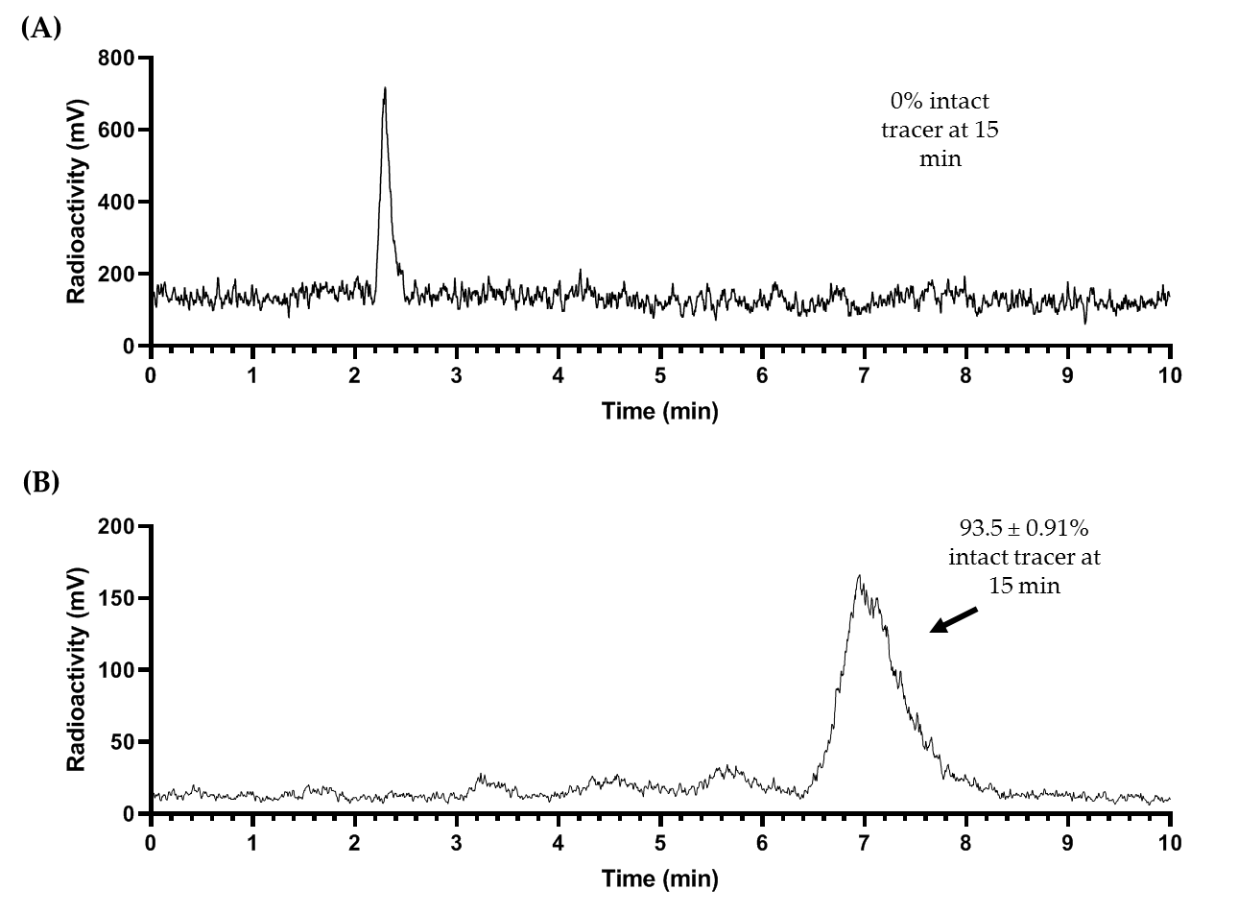

Figure S1: Representative radio-HPLC chromatograms from in vivo stability study performed to determine the percent intact fraction of [⁶⁸Ga]Ga-SB02055 in mouse plasma (A) and urine (B) samples collected at 15 min post-injection. The peak pointed by an arrow is the intact tracer.

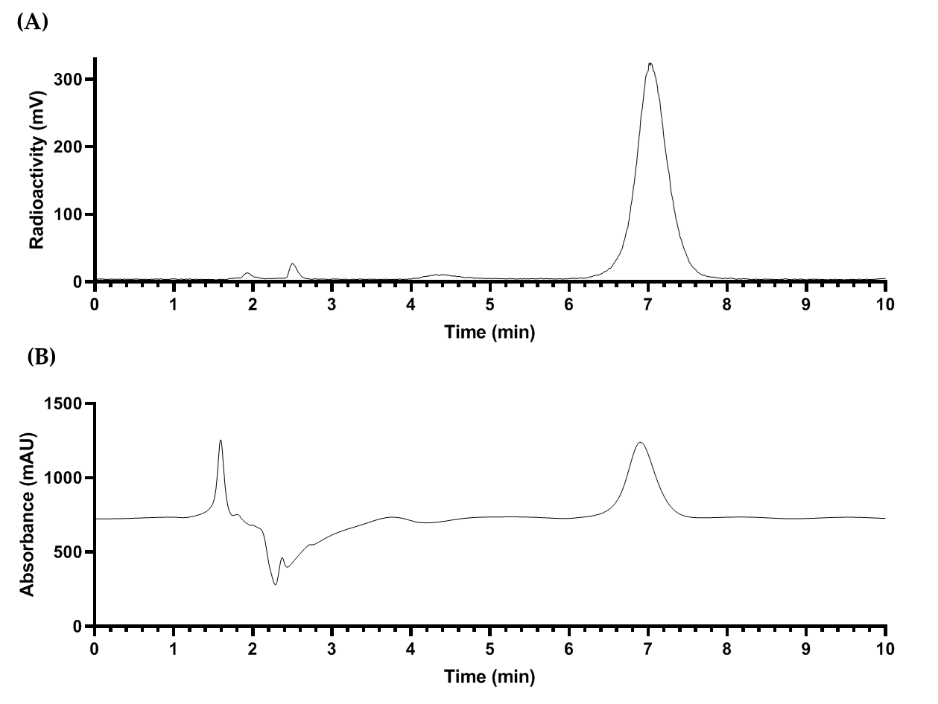

Figure S2: Radio-HPLC analysis of [⁶⁸Ga]Ga-SB02055 (A) QC radio-chromatogram (B) UV- chromatogram upon co-injection of ^{nat}Ga-SB02055.

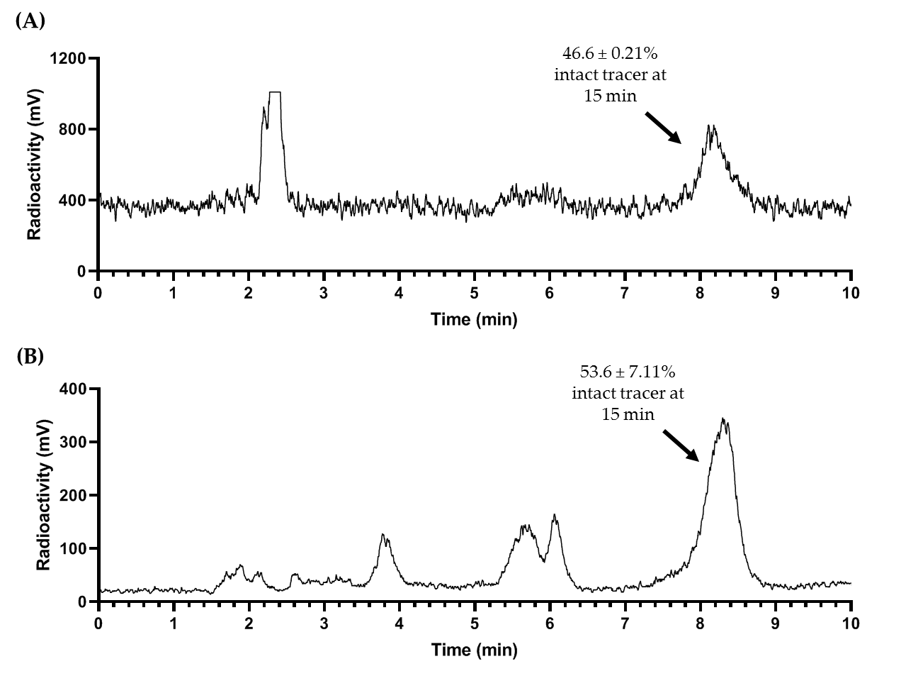
Figure S3: Representative radio-HPLC chromatograms from in vivo stability study performed to determine the percent intact fraction of [⁶⁸Ga]Ga-SB04028 in mouse plasma (A) and urine (B) samples collected at 15 min post-injection. The peak pointed by an arrow is the intact tracer.

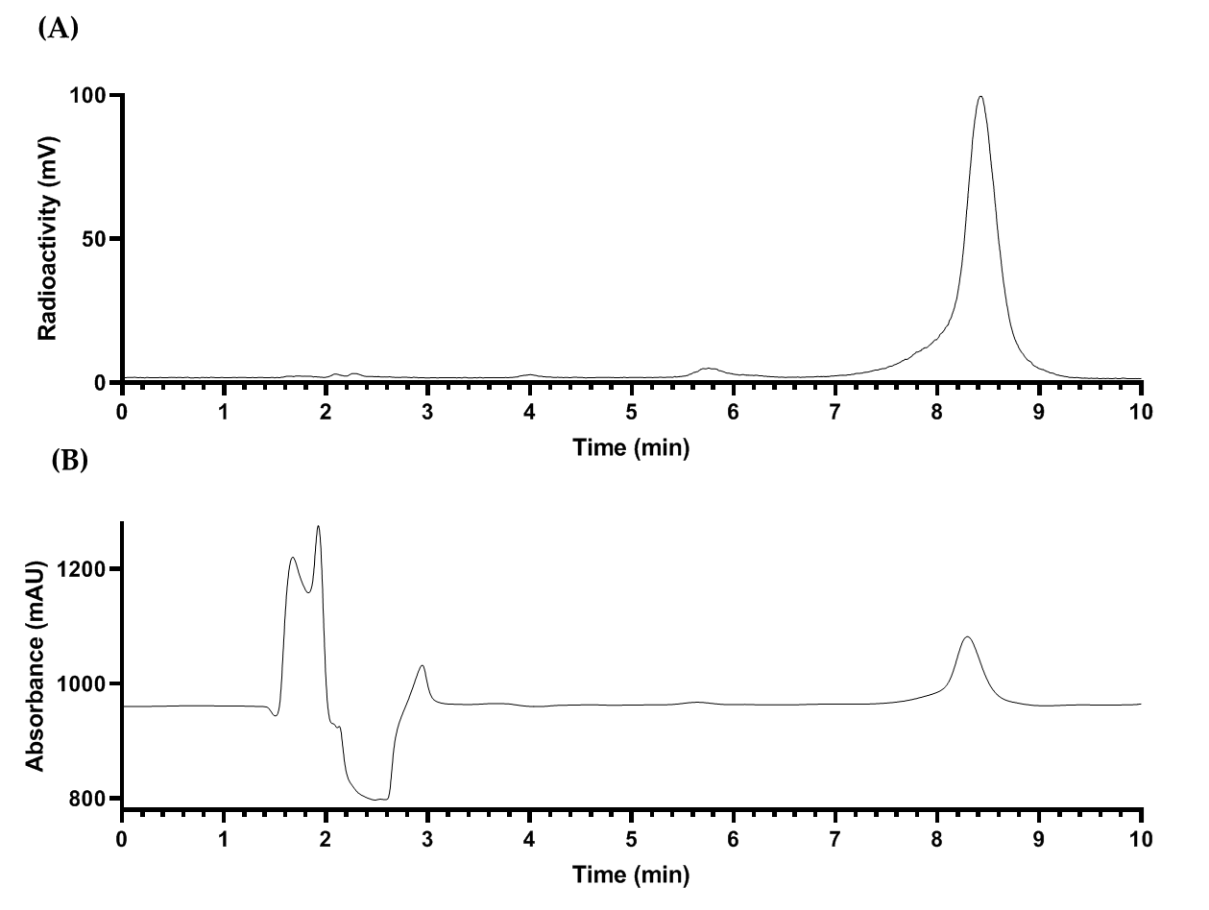
Figure S4: Radio-HPLC analysis of [⁶⁸Ga]Ga-SB04028 (A) QC radio-chromatogram (B) UV- chromatogram upon co-injection of ^{nat}Ga-SB04028.

References:

1. Coutts, S.J.; Kelly, T.A.; Snow, R.J.; Kennedy, C.A.; Barton, R.W.; Adams, J.; Krolikowski, D.A.; Freeman, D.M.; Campbell, S.J.; Ksiazek, J.F.; et al. Structure−Activity Relationships of Boronic Acid Inhibitors of Dipeptidyl Peptidase IV. 1. Variation of the P₂ Position of X_{aa}-BoroPro Dipeptides. J. Med. Chem. 1996, 39, 2087–2094, doi:10.1021/jm950732f.
2. Tran, T.; Quan, C.; Edosada, C.Y.; Mayeda, M.; Wiesmann, C.; Sutherlin, D.; Wolf, B.B. Synthesis and Structure–Activity Relationship of N-Acyl-Gly-, N-Acyl-Sar- and N-Blocked-BoroPro Inhibitors of FAP, DPP4, and POP. Bioorg. Med. Chem. Lett. 2007, 17, 1438–1442, doi:10.1016/j.bmcl.2006.11.072.
3. Trujillo-Benítez, D.; Luna-Gutiérrez, M.; Ferro-Flores, G.; Ocampo-García, B.; Santos-Cuevas, C.; Bravo-Villegas, G.; Morales-Ávila, E.; Cruz-Nova, P.; Díaz-Nieto, L.; García-Quiroz, J.; et al. Design, Synthesis and Preclinical Assessment of 99mTc-IFAP for In Vivo Fibroblast Activation Protein (FAP) Imaging. Molecules 2022, 27, 264, doi:10.3390/molecules27010264.
4. Bendre, S.; Zhang, Z.; Colpo, N.; Zeisler, J.; Wong, A.A.W.L.; Bénard, F.; Lin, K.-S. Synthesis and Evaluation of 68Ga-Labeled (2S,4S)-4-Fluoropyrrolidine-2-Carbonitrile and (4R)-Thiazolidine-4-Carbonitrile Derivatives as Novel Fibroblast Activation Protein-Targeted PET Tracers for Cancer Imaging. Molecules 2023, 28, 3481, doi:10.3390/molecules28083481.
5. Lin, K.-S.; Pan, J.; Amouroux, G.; Turashvili, G.; Mesak, F.; Hundal-Jabal, N.; Pourghiasian, M.; Lau, J.; Jenni, S.; Aparicio, S.; et al. In Vivo Radioimaging of Bradykinin Receptor B1, a Widely Overexpressed Molecule in Human Cancer. Cancer Res. 2015, 75, 387–393, doi:10.1158/0008-5472.CAN-14-1603.

