Supporting Information for:

One-Step Electrochemical Dealloying of 3D bi-continuous Micro-nano Porous Bismuth Electrodes and CO₂RR performance

Wenqin Laiª, Yating Liuª, Mingming Zengª, Dongmei Han^{ab}, Min Xiaoª, Shuanjin Wangª, Yuezhong Mengª*, Shan Renª*
a The Key Laboratory of Low-Carbon Chemistry & Energy Conservation of Guangdong Province, State Key Laboratory of Optoelectronic Materials and Technologies, School of Materials Science and Engineering, Sun Yat-sen University, Guangzhou 510275, P. R. China.
b School of Chemical Engineering and Technology, Sun Yat-sen University, Zhuhai 519000, China
*Corresponding author.
Email-address: stsrs@mail.sysu.edu.cn（S.R）, mengyzh@mail.sysu.edu.cn（Y.Z.M）

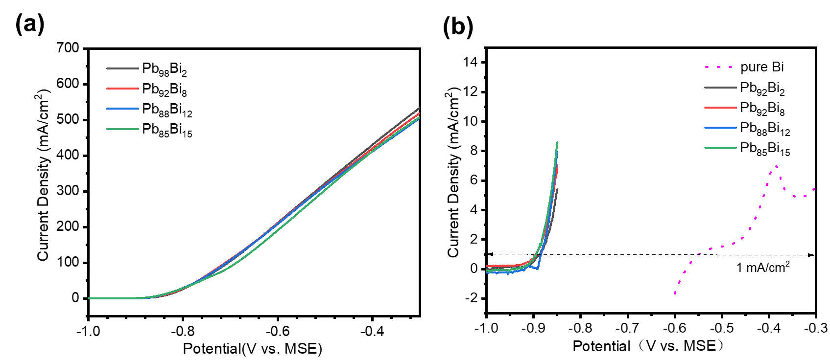
Fig S1 (a) Linear sweep voltammetry curves of Pb₉₈Bi₂、Pb₉₂Bi₈、Pb₈₈Bi₁₂、Pb₈₅Bi₁₅ alloy in 0.5 M HNO₃ aqueous solution at 25℃. The scan rate is 5.0 mV/s. (b) Comparison of details of Pb-Bi alloy and pure Bismuth sample in LSV curves.

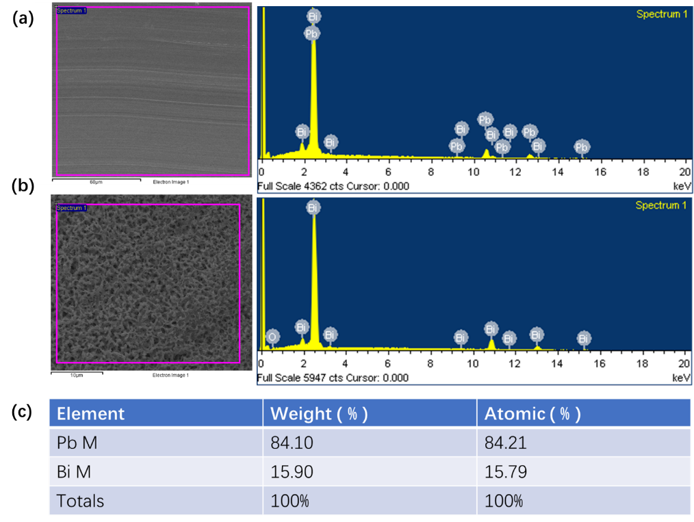
Fig S2 EDS analyses of Pb₉₈Bi₁₅ alloy before (a) and after (b) and (c)element qualitative analysis. the potentiostatic dealloying with electric potential of -0.55 V vs. MSE in 0.5 M HNO₃ aqueous solution at 10℃, 3600s.

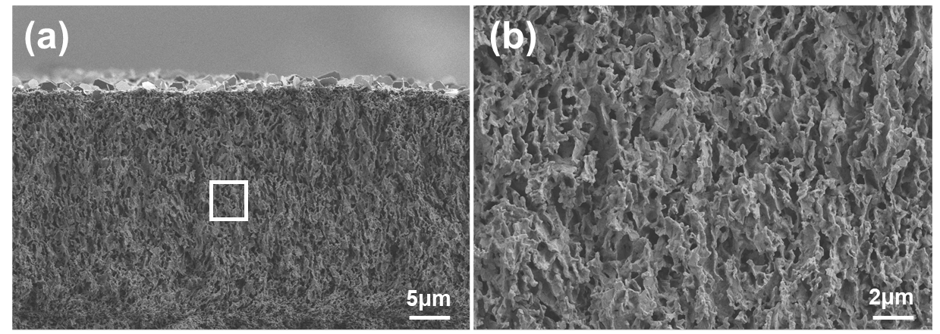
Fig S3 (a,b) cross-section SEM images of np-Bi₁₂ sample. dealloying with electric potential of -0.55 V vs. MSE in 0.5 M HNO₃ aqueous solution at 10℃,1200s.

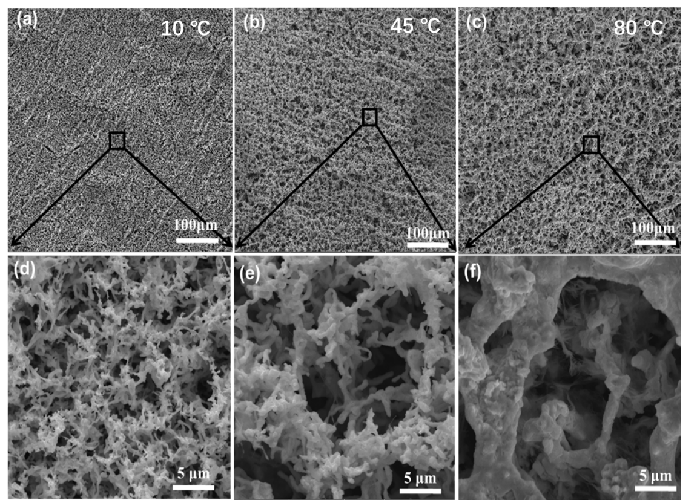
Fig S4 Top-view SEM images of Pb₉₈Bi₂ alloy after the potentiostatic dealloying at 10℃ (a,d)、45℃ (b,e) and 80℃ (c,f).

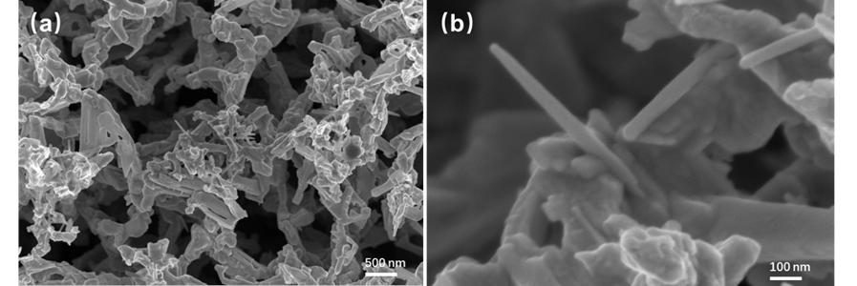
Fig S5 High-resolution scanning electron micrograph of np-Bi₂ sample.

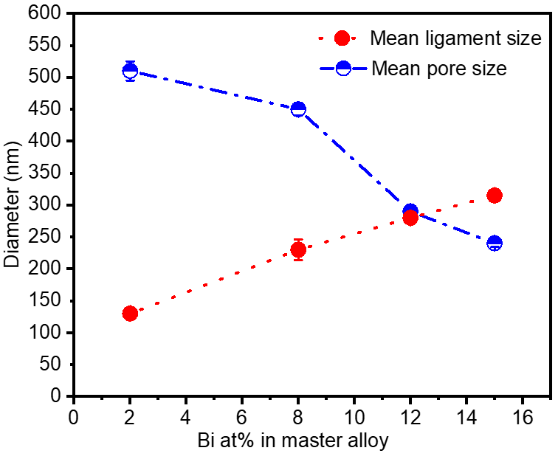
Fig S6 Distribution diagram of the average pore size and ligament size of nano-porous Bi samples as a function of composition. Applied potential is -0.55 V vs. MSE. Electrolyte is 0.5 M HNO3 aqueous solution, dealloying temperature is 10℃.

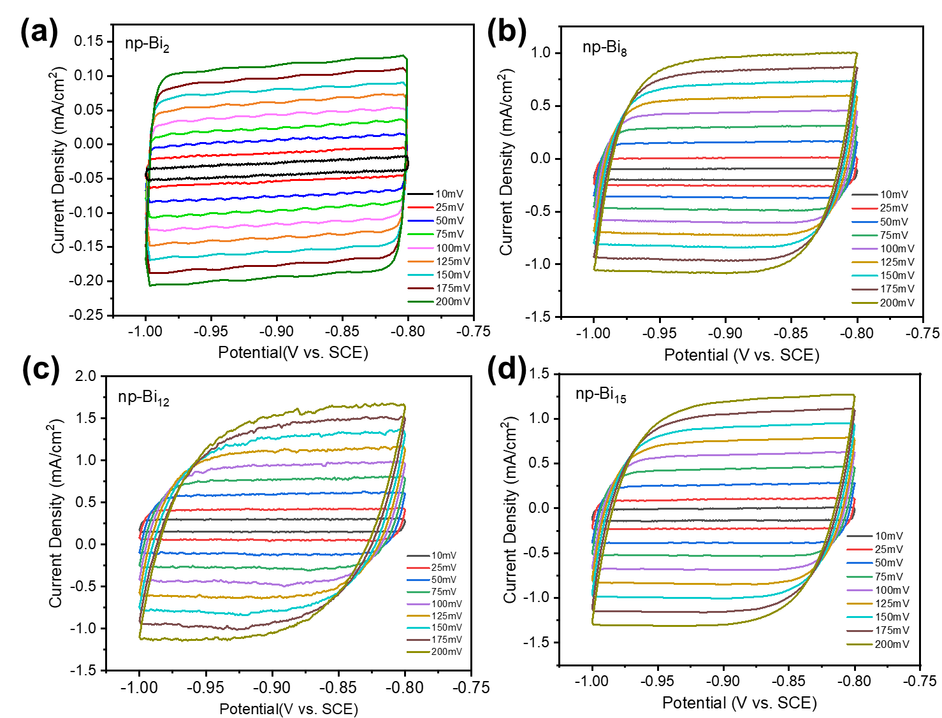
Fig.S7 Cyclic voltammetry (CV) curves of （a）np-Bi₂ , （b）np-Bi₈，（c）np-Bi₁₂,（d）np-Bi₁₅ at different scanning speeds in a 0.1 M KHCO₃ aqueous solution saturated with N₂.

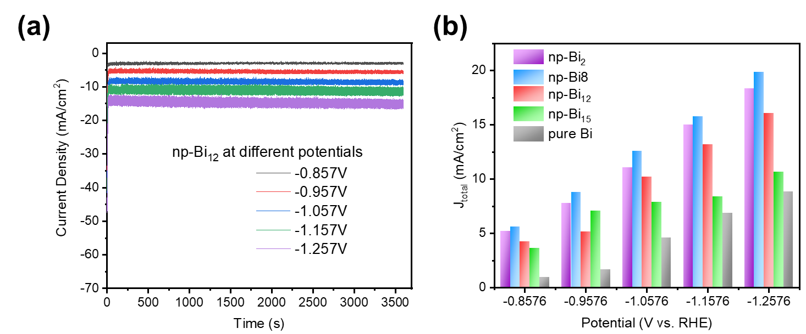
Fig S8 (a) Time-dependent current density curves of np-Bi₁₂ at different potentials. (b) The calculated total current density (J_{total}) values of four nanoporous electrodes under 1hour electrochemical catalysis.

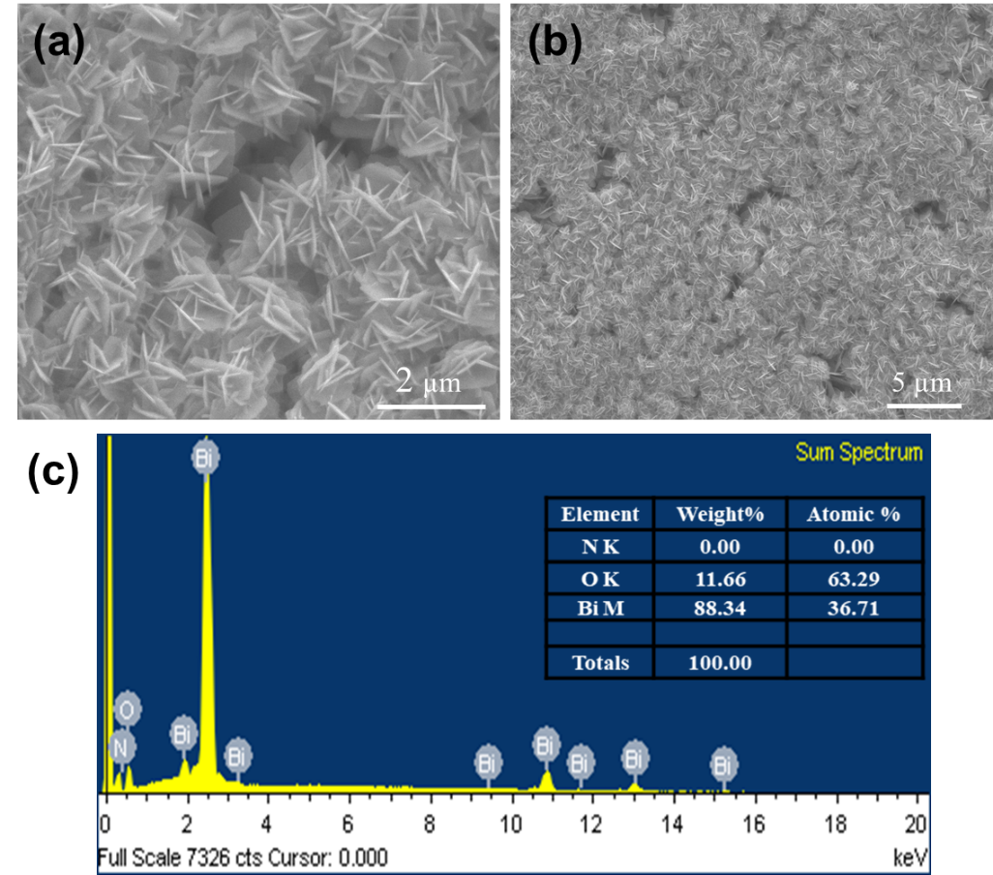

Fig S9 Low (a) and high (b) magnification SEM images of np-Bi₁₂ electrodes after 24h of long-term electrolysis test. (c) EDS analysis of the oxidized np-Bi₁₂ electrodes.

Table S1 The relationship between the size of four nanoporous Bi samples with different morphologies and the Faraday efficiency of formic acid.
Sample Name | Mean pore size（nm） | Mean ligament size（nm） | FE_{HCOOH}（%）
Bi₂-10 | 510 | 130 | 76.7
Bi8-10 | 450 | 230 | 74.5
Bi₁₂-10 | 290 | 280 | 92.2
Bi₁₅-10 | 240 | 315 | 88.8

