Supplementary material

Figure S1. Chronological overview of health care contacts and social events

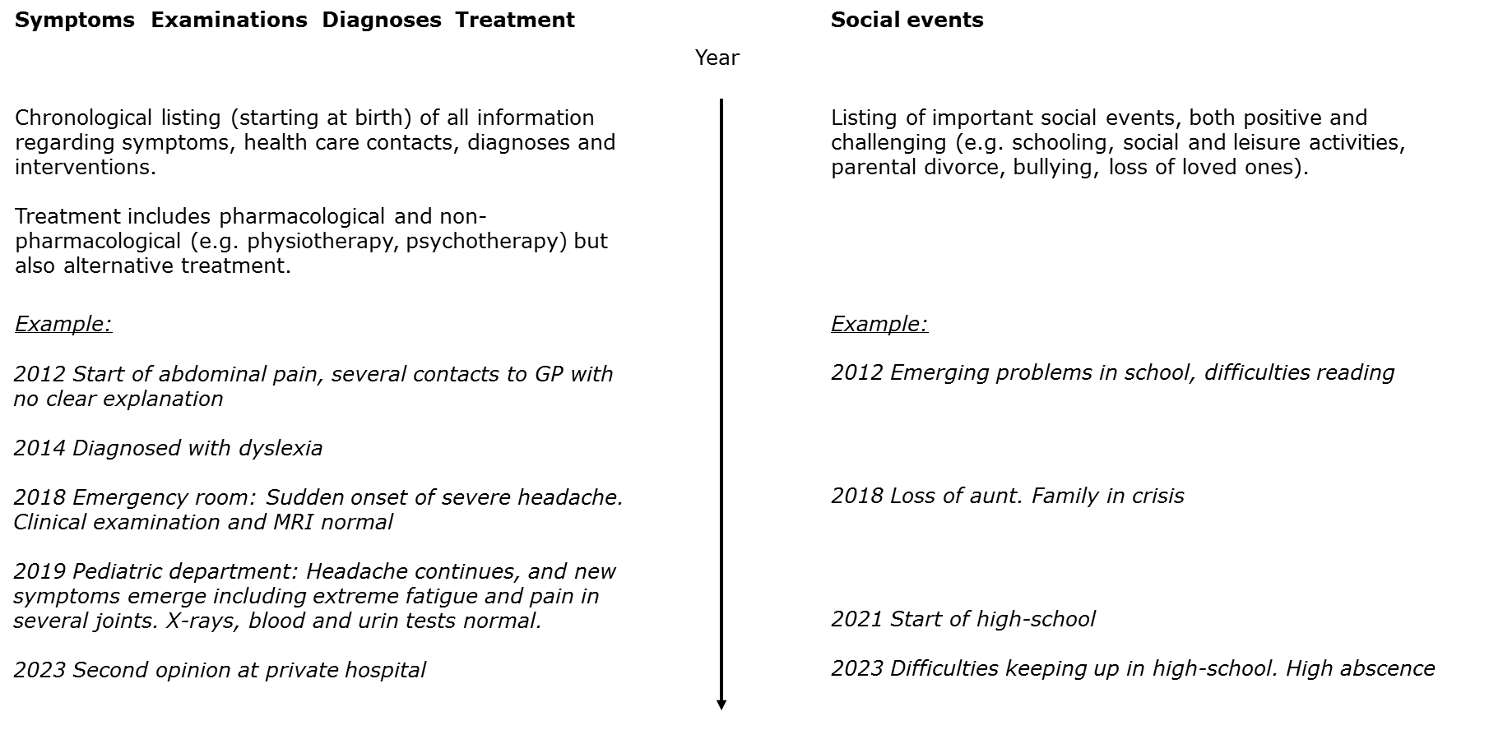GP: general practitioner; MRI: Magnetic Resonance Imaging

Figure S2 Experience of assessment divided by randomization group
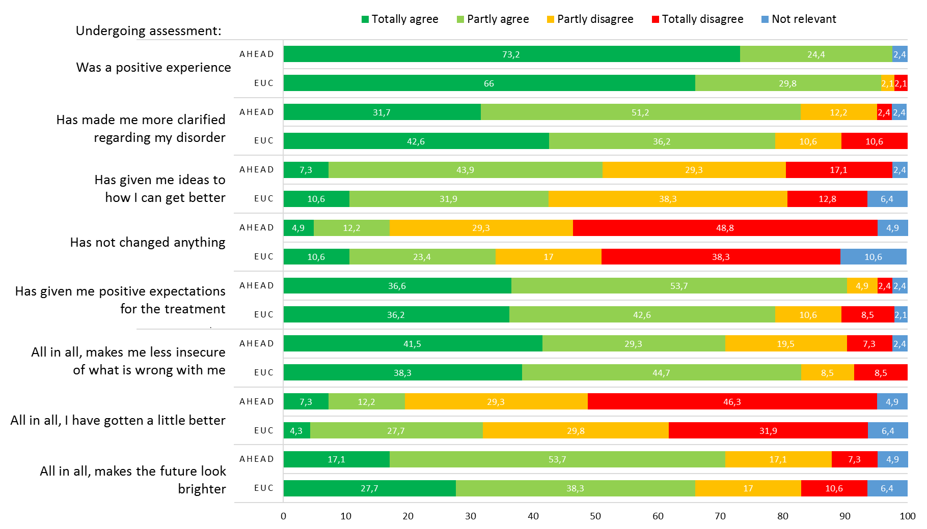
Numbers in figure represent percentage
AHEAD n=41 (missing n=3), EUC n=47 (missing n=0)
Table S1 Mean and SD at T0 and T1

 |  | AHEAD (T0) |  | AHEAD (T1) |  | EUC (T0) |  | EUC (T1)
 |  | Mean | SD | Mean | SD | Mean | SD | Mean | SD
Primary outcome
Physical health | SF-36 (15-65) | 36.58 | 5.83 | 36.43 | 6.71 | 37.10 | 7.79 | 38.48 | 6.82
Secondary outcomes
Symptom severity | SCL-som (0-4) | 2.01 | 0.74 | 1.81 | 0.63 | 1.81 | 0.81 | 1.67 | 0.69
Illness worry | Whiteley-6-R (0-4) | 1.62 | 1.15 | 1.03 | 0.97 | 1.71 | 1.06 | 1.00 | 0.89
Mental health | SF-36 MCS | 35.66 | 16.49 | 37.57 | 15.17 | 35.80 | 11.75 | 36.57 | 10.64
Treatment targets
Illness perception | B-IPQ (0-80) | 52.27 | 7.68 | 49.02 | 10.11 | 51.37 | 8.07 | 45.98 | 9.33
Illness-related behaviour | BRIQ- All or nothing (6-30) | 19.41 | 4.47 | 18.37 | 5.19 | 18.85 | 4.78 | 18.36 | 3.70
 | BRIQ- Limiting (7-35) | 23.50 | 5.19 | 22.26 | 4.93 | 23.64 | 5.48 | 22.04 | 5.17
Psychological inflexibility | AFQ-Y8 (0-32) | 11.57 | 9.20 | 11.38 | 8.46 | 13.34 | 7.36 | 11.97 | 7.01
 | PIPS- Avoidance (8-56) | 35.16 | 9.97 | 31.48 | 10.13 | 34.53 | 10.98 | 32.30 | 10.55
 | PIPS- Fusion (4-28) | 21.93 | 3.88 | 21.33 | 4.84 | 22.06 | 4.96 | 20.77 | 5.01

T0: Questionnaires at baseline prior to assessment
T1: Questionnaires at approximately 2 months prior to specialized treatment

