Advanced electrochemical degradation of organic pollutants from water using Sb-doped SnO₂/Ti anode and assisted by granular activated carbon
Anamaria Baciu ¹, Corina Orha ², Radu Nicolae¹, Mircea Nicolaescu^{1,2}, Sorina Ilies³, and Florica Manea¹*
¹ Department of Applied Chemistry and Engineering of Inorganic Compounds and Environment, Politehnica University of Timisoara, Blv. Vasile Parvan No. 6, 300223, Timisoara, Romania; anamaria.baciu@upt.ro (A.B.); florica.manea@upt.ro (F.M.); radu.nicolae@student.upt.ro (R.N.)
² National Institute for Research and Development in Electrochemistry and Condensed Matter, Timisoara, Condensed Matter Department, 1 P. Andronescu Street, 300254, Timisoara, Romania; orha.corina@gmail.com (C.O.), mircea.nicolaescu@student.upt.ro (M.N.)
³ “Coriolan Drăgulescu” Institute of Chemistry, Romanian Academy, 24 Mihai Viteazu Bvd., 300223 Timisoara, Romania, sorinailies@acad-icht.tm.edu.ro (S.I.)

* Correspondence: florica.manea@upt.ro

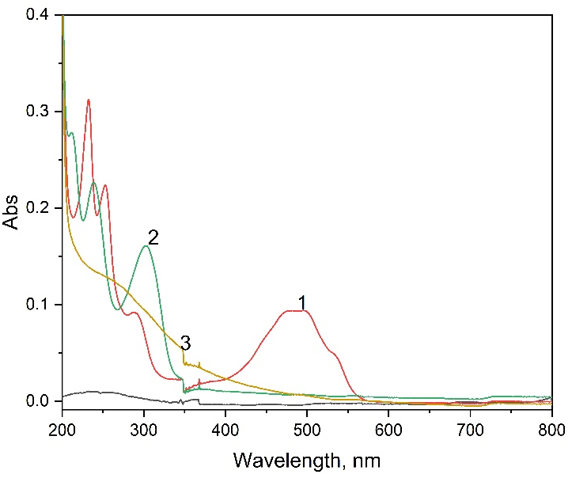
Figure S1. UV-VIS spectra in 0.1 M Na₂SO₄ supporting electrolyte and in the presence of different initial pollutants: 5 mg·L⁻¹ DOX (curve 1), 5 mg·L⁻¹ L CCB (CURVE 2), and 10 mg·L⁻¹ HA (curve 3).

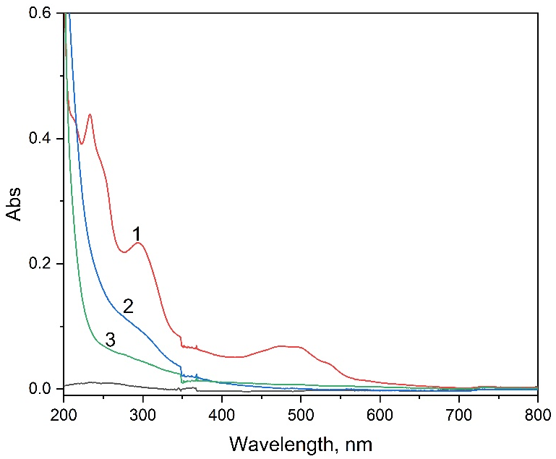
Figure S2. UV-VIS spectra in 0.1 M Na₂SO₄ supporting electrolyte, in the presence of an initial mixture of DOX+CCB+HA pollutants (curve 1) and after treatment by EO (curve 2), and after treatment by EF (curve 3) at an applied potential of 3.00 V vs. SCE.

