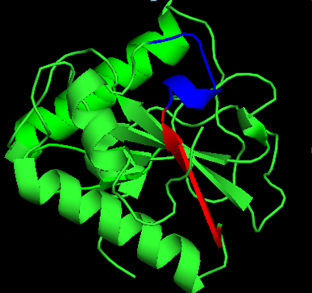
3D-structure of Tag7 (PGLYRP1, PDB-1YCK) protein. 17.1A – red, 17.1В – blue

