Supplementary data
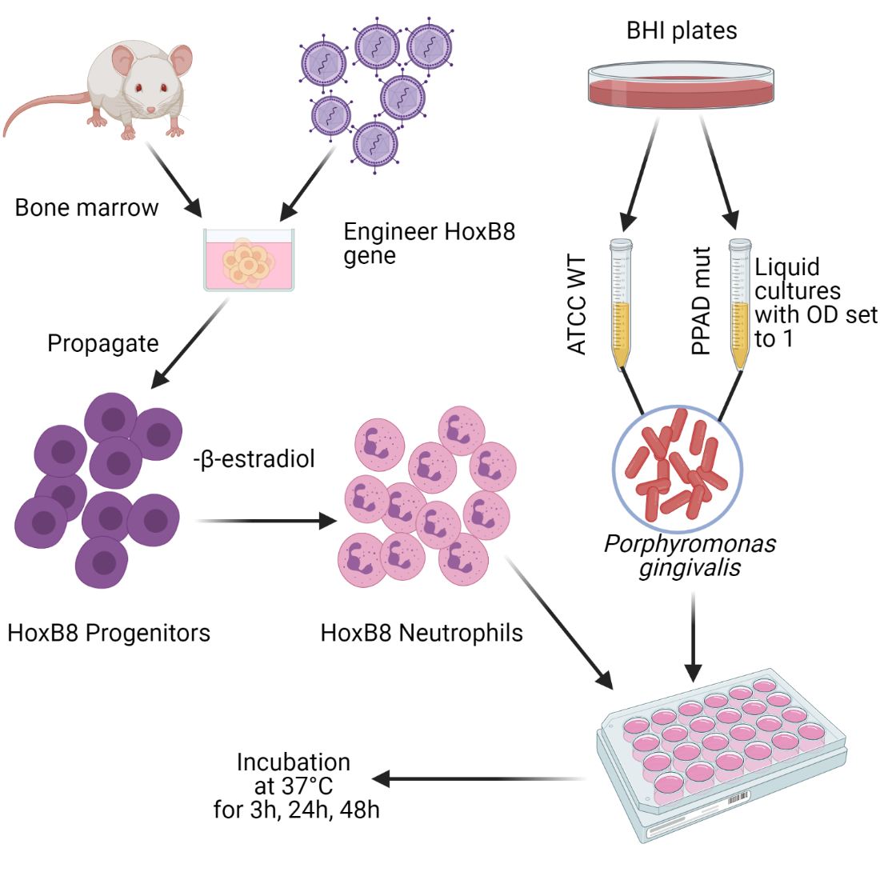
Figure S1. Schematic representation of the experiment protocol (Created with BioRender.com)
(Left panel) Mouse-derived bone marrow cells were transduced with a retrovirus encoding the estradiol-dependent HoxB8 gene. HoxB8 neutrophil progenitor cells were established and expanded in the previously described medium supplemented with β-estradiol. Four days before the planned experiment, HoxB8 progenitors were washed in PBS and 2*10⁴/ml were seeded in differentiation media with no β-estradiol. On the day of the experiment (Day 0), cells were harvested and counted with a Fuchs-Rosenthal Hemocytometer and a Hund Wilovert S inverted microscope. 2.5 * 10⁶ and 0.5 * 10⁶ were seeded in a medium without antibiotics for bacterial challenge. (Right panel) Bacteria were spread on BHI agar plates (PPAD mut C351A on BHI supplemented with tetracycline) and placed into an anaerobic box at 37°C. After 3 days, bacteria were re-spread on new plates that served as a source for inoculation after another 3 days into liquid BHI media without antibiotics. Liquid cultures were placed in an anaerobic chamber. One day before the experiment (Day -1), OD600 was set to 0.1 and on the experiment day (Day 0) to 1.0 in PBS. Bacteria cells were added to the seeded neutrophils at the selected multiplicity of infection (MOI).

