Table 1. DEseq2 analysis of 40 genes with the lowest/highest differential expression
down |  |  |  | up
gene name | log2FoldChange | padj |  | gene name | log2FoldChange | padj
SLITRK3 | -7.045854882 | 2.65248E-42 |  | SLITRK3 | 9.909348963 | 1.37017E-26
CRYGD | -6.771782151 | 3.8109E-64 |  | CRYGD | 9.757223286 | 1.29737E-08
PAEP | -6.708864195 | 1.73502E-29 |  | PAEP | 8.0982045 | 5.60951E-37
C7 | -6.66727242 | 3.52295E-33 |  | C7 | 7.867951817 | 2.74225E-51
WFIKKN2 | -6.607976281 | 4.92632E-06 |  | WFIKKN2 | 7.86526619 | 4.43467E-65
ADH1B | -6.313665892 | 6.84497E-16 |  | ADH1B | 7.791130928 | 1.72672E-35
DPT | -5.914142601 | 2.93564E-13 |  | DPT | 7.783827793 | 7.04687E-57
C1orf141 | -5.886952237 | 1.96561E-27 |  | C1orf141 | 7.62669752 | 3.24032E-23
DAW1 | -5.866866246 | 1.3 1979E-18 |  | DAW1 | 7.603226886 | 2.01716E-43
ADCY8 | -5.792891963 | 2.39409E-07 |  | ADCY8 | 7.600359195 | 1.27994E-14
ADRB3 | -5.760130641 | 1.89031E-08 |  | ADRB3 | 7.487323893 | 1.18912E-55
TCF23 | -5.724501242 | 0.007549198 |  | TCF23 | 7.470150135 | 2.56938E-41
OGN | -5.719919186 | 7.22601E-53 |  | OGN | 7.312150865 | 6.26209E-34
GLRA4 | -5.701737263 | 2.29571E-19 |  | GLRA4 | 7.205117336 | 8.34929E-44
TCEAL6 | -5.672085704 | 1.06702E-13 |  | TCEAL6 | 7.141790863 | 8.01709E-41
CCL14 | -5.656398984 | 1.60974E-08 |  | CCL14 | 6.959937153 | 9.00073E-43
TRDN | -5.499166448 | 0.002729952 |  | TRDN | 6.937399443 | 2.23299E-26
PTGER3 | -5.492071687 | 2.39972E-07 |  | PTGER3 | 6.925024294 | 4.63938E-47
PTGFR | -5.45469131 | 3.2368E-11 |  | PTGFR | 6.818916909 | 9.2898E-43
TMEM196 | -5.425256808 | 5.40886E-11 |  | TMEM196 | 6.81113386 | 5.75724E-20

Table 2. Analysis of GO and KEGG for the differentially expressed genes
ONTOLOGY | ID | Description | GeneRatio | p.adjust
BP | GO:0070268 | cornification | 66/2244 | 1.09e-28
BP | GO:0031424 | keratinization | 80/2244 | 6.34e-17
BP | GO:0008544 | epidermis development | 126/2244 | 4.51e-16
CC | GO:0000786 | nucleosome | 47/2412 | 8.53e-14
CC | GO:0044815 | DNA packaging complex | 49/2412 | 8.53e-14
CC | GO:0062023 | collagen-containing extracellular matrix | 108/2412 | 3.15e-13
MF | GO:0048018 | receptor ligand activity | 131/2240 | 3.06e-15
MF | GO:0005539 | glycosaminoglycan binding | 76/2240 | 1.77e-13
MF | GO:0022803 | passive transmembrane transporter activity | 121/2240 | 1.77e-13
KEGG | hsa04080 | Neuroactive ligand-receptor interaction | 109/1007 | 9.62e-20
KEGG | hsa05322 | Systemic lupus erythematosus | 48/1007 | 6.16e-10
KEGG | hsa05034 | Alcoholism | 57/1007 | 3.76e-09

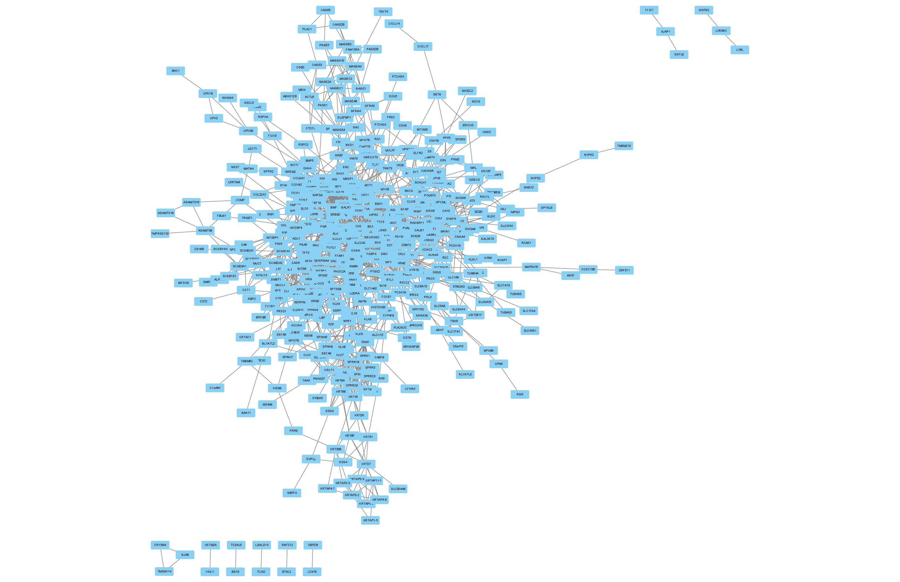Figure 1. Network of protein-protein interactions（PPI）. PPI network included 396 nodes and 955 edges. Nodes represented proteins produced by protein-coding genes. Edges represented associations between proteins
Figure 2. Survival analysis of Hub genes. The X-axis represented the observation time(months). The Y-axis represented the overal survival (OS) rate. Each point on the curve represented the patient's overall survival (OS) rate at that point in time. Genes with higher or lower expression groups in EC were shown in blue and red lines respectively.

