| **MAIDA DIAMOND BISCUIT** | | | | | | |
| --- | --- | --- | --- | --- | --- | --- |
| **Recipe** | **tsp/tbsp/**  **cup** | **g/ml** | **oz/lb** | **Ingredient** | **Cooked Milk protein per**  **100 grams** | **Temperature** |
| *Maida Diamond biscuit* | | | | | 0.006 grams |  |
| **Bakes 40 small finger size biscuits**  **Sugar:1.5 grams/biscuit** | 1 cup | 240 g | 8.46 oz | Flour  (maida/all-purpose flour) |  | Pre-heat the oven to 180c for 10 mins, then bake the biscuits for 15 minutes. |
| ¼ cup | 60 g | 2.11oz | Powdered sugar |
|  | 50 ml | 1.69oz | milk |
| 2 tbsp | 30gms | 1.05oz | ghee/butter |
| 1 big pinch |  |  | Salt and  Baking soda |
| Tip of a knife |  |  | cardamom powder |
| 1. Grind the sugar and the cardamom in a small mixie / grinder to a smooth powder. Set aside. 2. Mix the Maida (All-purpose flour), sugar mixture, a big pinch of salt and a big pinch of baking soda. Add 2 tablespoon of ghee/butter & 50ml milk. Combine well with fingers to make sure the ghee/Butter is evenly mixed. 3. Start adding water, add very little at a time. Make a very stiff dough. Make balls out of the dough. Set aside. Dust the dough ball in maida generously and roll each dough ball into a flat circle. Don’t roll it too thin. Roll it a little thicker than chapati. 4. Cut the circle into little diamonds with the help of a pie cutter or a knife. 5. Heat oil in a pan in medium flame. Gently add the diamond cuts into the oil. Fry the biscuits until golden colour is obtained.   **For baked version** - Pre-heat the oven to 180c for 10 mins, then bake the biscuits for 15 minutes | | | | | | |

**Supplementary Information -1: Detailed Recipes**

|  |  |  |  |  |  |  |  |  |
| --- | --- | --- | --- | --- | --- | --- | --- | --- |
| **MILK COOKIE** | | | | | | | | |
| **Recipe** | **tsp/tbsp/**  **cup** | **g/ml** | **oz/lb** | | **Ingredient** | **Cooked Milk protein per**  **100 grams** | **Temperature** | |
|  | | | | | | 0.36 grams | |  |
| **Bakes 16 milk cookies**  **Sugar: 11.25 grams/cookie** | 1 1/2 cups | 360 g | | 12.69 oz | All-purpose flour |  | | 180-degree Centigrade  Baking time-10-12mins  Tip: Once done, immediately transfer the cookie sheet from the hot oven, to prevent over baking. |
| 3/4cup | 180 | | 6.3oz | Sugar |
| 1 tsp | 5 g | | 0.17oz | Baking powder |
| 2 tbsp | 30 g | | 1.05oz | Dry milk powder |
| 1/2tsp | 2.5gms | |  | Salt |
| 1/2cup | 120ml | | 4.23oz | Butter |
|  |  | |  |  |
| ½ cup | 120ml | | 4.23oz | Water |
| Vanilla essence to taste | | | | |
| **Step -I: To make the dough**   1. Mix all the dry ingredients evenly – flour, baking powder, salt and milk powder 2. Add melted butter, sugar in another bowl, then add water and vanilla extract to the butter sugar mixture and stir it well. 3. Add the wet ingredients mixture slowly to the dry flour mixture to get a crumbly mixture. Knead well. 4. Transfer the bowl with cookie dough to the refrigerator and chill in the refrigerator for about 15 to 20 minutes (do not chill for more time as the dough may harden)   **Step II: To make the cookies**  5.Make small balls out of the dough and then slightly press the balls to form the round cookie shape.  6.Place this cookie in the baking sheet. Similarly shape all round cookies out of the dough and place them all in the cookie sheet.  **Step III. To bake the cookies**   1. Preheat oven to 350-degree Fahrenheit. 2. Place the cookie sheet in the preheated oven and bake for about 10 to 12 minutes. | | | | | | | | |

|  |  |  |  |  |  |  |  |  |
| --- | --- | --- | --- | --- | --- | --- | --- | --- |
| **GAJAR HALWA** | | | | | | | | |
| **Recipe** | **tsp/tbsp/**  **cup** | **g/ml** | **oz/lb** | | **Ingredient** | | **Cooked Milk protein per 100 grams** | **Temperature** |
|  | | | | | | | 0.41 grams |  |
| **Serving size – 20**  **Sugar 6 grams/serving** | 2 cups | 500ml | | 17.6 oz | | Milk |  | Cook in a hot pan until desired consistency is achieved.  (Boiled: 25 minutes) |
| 1/4th cup | 500 g | | 1.76 oz | | Carrot |
| 2 TBSP | 30g | | 1.1 oz | | Ghee |
| 1/2 cup | 120 g | | 4.23 | | Sugar |
| 2 tbsp | 30g | | 1.1 oz | | Nuts &Dry fruits(optional) |
| Tip of knife |  | |  | | Cardamom powder |
|  |  | |  | |  |
| STEPS   1. Add Grated carrot and Milk in a pan. 2. Cook on a low flame by stirring continuously until soft and milk reduces to 75%. 3. Add Ghee and mix well 4. Add required sugar and cardamom powder and cook on low flame. 5. Lastly add nuts and dried fruits (if required) and cook until the mixture looks dry with milk solids appearing in the halwa. 6. It’s fine even if the halwa has some moisture. | | | | | | | | |

|  |  |  |  |  |  |  |  |  |  |  |
| --- | --- | --- | --- | --- | --- | --- | --- | --- | --- | --- |
| **GULAB JAMUN** | | | | | | | | | | |
| **Recipe** | **tsp/tbsp/**  **cup** | | | **g/ml** | | **oz/lb** | | **Ingredient** | Cooked Milk Protein Content per 100 grams | **Temperature** |
|  | | | | | | | | | 1.23 grams |  |
| “Instant Ready mix is available” – (100 gm makes about 20 Gulab jamuns)  Sugar: 20 grams/jamoon | | 7 Tbsp | 100g | | 3.5oz | | Instant Ready-mix ingredient | |  | Fry in a hot pan using oil of choice until golden brown and crispy.  (Boiled+ fry: 20+5 minutes) |
|  |  | |  | | Refined wheat flour | |
|  |  | |  | | Milk solids | |
| 1/4 cup | 50ml | | 1.7oz | | Milk (for kneading) | |
| 1.5 cup  1.5 cup | 400gms  400ml | | 14.1oz  13.5oz | | Sugar  Water (for sugar syrup) | |
|  |  | |  | | Oil (for deep frying) | |
| 1. Add required milk/water gradually to the ready-mix powder and knead to make a smooth dough. Keep aside for 5 min 2. Apply oil/ghee on both palms and shape the dough into small balls 3. Deep fry the balls in oil/ghee over medium flame until golden brown. Remove from oil & keep aside for 1 min 4. Soak fried Gulab jamuns in hot sugar syrup | | | | | | | | | | |

|  |  |  |  |  |  |  |  |
| --- | --- | --- | --- | --- | --- | --- | --- |
| **RASGULLA** | | | | | | | |
| **Recipe** | **tsp/tbsp/**  **cup** | **g/ml** | **oz/lb** | **Ingredient** | **Cooked Milk protein content per 100 grams** | **Temperature** | |
|  | | | | | 2.55 grams | |  |
| 1. **15 medium sized Rasagulla**   **Sugar: 33grams /rasagulla** | 4 cups | 1000ML | 35.2oz | Whole fat pasteurized milk |  | | Boiled: 30 minutes |
| 2cups | 500gms | 17.6oz | Sugar |
| 1tsp | 5gms |  | sooji (semolina) or all-purpose flour or corn starch |
| 2-3 tbsp | 30-45ml | 1.1oz-1.5oz | Lemon juice |
| Tip of knife |  |  | cardamom powder |
|  |  |  |  |
|  |  |  |  |
| 4cup | 1000ml | 35.2oz | Water |
|  | | | |
| **Method**   1. Heat milk in a heavy bottom pan. 2. When the milk comes to a boil, then reduce the flame to its lowest. Add 1 to 3 tbsp lemon juice 3. Add lemon juice till the milk curdles. 4. Now pour the curdled milk in the cheese cloth/muslin lined strainer or bowl. 5. Drain the curdled milk using a muslin cloth. You are now left with what is known as "chena" or "paneer". 6. Squeeze the muslin cloth to remove all the water from the chena. 7. Take the chena in a plate and add cornflour to it. 8. Mash the chena with your hands for 10 minutes to make it soft and smooth. This is an important step to make sure that the rasgullas are soft. 9. Make small balls from the chena after the mashing is done. 10. Meanwhile in a pan mix the sugar and water and let it boil at high temperature. 11. Put the rasgulla balls in the boiling sugar syrup. 12. Cook the rasgullas in sugar syrup for 18-20 minutes on high flame 13. Refrigerate the rasgullas with the syrup and serve chilled. | | | | | | | |

|  |  |  |  |  |  |  |  |  |  |  |
| --- | --- | --- | --- | --- | --- | --- | --- | --- | --- | --- |
| **RAGI SARI/KANJI** | | | | | | | | | | |
| **Recipe** | **tsp/tbsp/**  **cup** | | **g/ml** | | **oz/lb** | **Ingredient** | | **Cooked Milk protein content per 100 grams** | **Temperature** | |
|  | | | | | | | | 2.68 grams | |  |
| **1 Serving - 240ml (30gms ragi sari powder)** | 1.5 to 2 tbsp | 22 to 30 grams | | 1 oz | | | Ragi Powder |  | | Boiled: 30 minutes |
| ¼ tsp | 1.2 ml | | 0.04 oz | | | Ghee |
| ¼ cup | 62.5 ml | | 2.1 oz | | | Milk |
| ½ cup | 125 ml | | 4.4 oz | | | Water |
|  | | | | | | |
| **Ingredients:**   * 2 tbsp ragi flour * 1½ cup water * 1 tsp jaggery / gud * ½ cup milk * ¼ tsp cardamom powder / elachi powde   **Method:**   * Take 2 tbsp ragi flour in a small cup * Dissolve ragi flour in ½ cup water without forming any lumps. keep aside. * Boil 1 cup water in a saucepan * once the water is at boiling point add in dissolved ragi flour. * Stir continuously keeping the flame on medium. * The mixture thickens after 5 minutes * Add 1 tsp jaggery * Stir until the jaggery dissolves completely and turns creamy. * Now add ½ cup milk and mix on low flame. * Further, add ¼ tsp cardamom powder and mix well. | | | | | | | | | | |

|  |  |  |  |  |  |  |  |  |  |
| --- | --- | --- | --- | --- | --- | --- | --- | --- | --- |
| **RICE KHEER** | | | | | | | | | |
| **Recipe** | **tsp/tbsp/**  **cup** | **g/ml** | | **oz/lb** | | **Ingredient** | | **Cooked Milk Protein per 100 grams** | **Temperature** |
|  | | | | | | | | 2.73 grams |  |
| Serves 4  Sugar: 31 grams/serving | 4cups | | 1000ml | | 33.8oz | | Milk |  | Boiled: 30 minutes  Tip: Instead of rice it can also be made with other ingredients like vermicelli, sago |
| 1/2cup | | 125gms | | 4.4oz | | Rice |
| 1/2cup | | 125gms | | 4.4oz | | Sugar |
| 10-12 nos | |  | |  | | Raisins |
| 10-12 nos | |  | |  | | Almonds (blanched) |
|  | | | | | | |
| **Method**   1. Wash and soak the rice for 30 minutes 2. Boil the soaked rice with milk in a deep pan on low flame 3. Keep stirring occasionally till the rice is cooked and milk becomes thick 4. When done add sugar, raisins and cardamoms 5. Stir till sugar gets dissolved properly 6. Transfer into a serving dish and serve | | | | | | | | | |

|  |  |  |  |  |  |  |  |  |  |  |
| --- | --- | --- | --- | --- | --- | --- | --- | --- | --- | --- |
| **RAGI DOSA** | | | | | | | | | | |
| **Recipe** | **tsp/tbsp/**  **cup** | **g/ml** | | **oz/lb** | | **Ingredient** | | **Cooked Milk protein per**  **100 grams** | **Temperature** | |
|  | | | | | | | |  | |  |
| **1serving: 5 dosas** | 1cup | | 250gms | | 8.8oz | | Ragi flour |  | | Fry: 2 to 4 minutes |
| 1/2cup | | 125gms | | 4.4oz | | Rice flour |
| 1/4cup | | 60gms | | 2.1oz | | Curd |
| For preparation  As needed  As needed | |  | |  | | Water  Salt |
| **Method**   1. Add Ragi flour, Rice flour, salt & curd to a bowl 2. Pour water as needed & make a thin batter of pouring consistency. Rest aside for about 15 min 3. The batter must be running and of pouring consistency. If needed add more water to bring it to consistency 4. When the pan is hot enough then pour the batter across the pan 5. Pour a tsp of oil. Allow to cook on a medium heat. Flip and cook on the other side as well | | | | | | | | | | |

|  |  |  |  |  |  |  |  |  |  |  |
| --- | --- | --- | --- | --- | --- | --- | --- | --- | --- | --- |
| **RAVA IDLI** | | | | | | | | | | |
| **Recipe** | **tsp/tbsp/**  **cup** | **g/ml** | | **oz/lb** | | **Ingredient** | | **Cooked Milk protein per 100 grams** | **Temperature** | |
|  | | | | | | | | 3.13 grams | |  |
| **1serving – 5 idlis** | 1 1/4cup | | 300gms | | 10.6oz | | Semolina/sooji |  | | Steam for 15 minutes |
| 1cup | | 240ml | | 8.1oz | | Water |
| 1cup | | 240ml | | 8.1oz | | Curd /yogurt |
| Tip of knife | |  | |  | | Salt |
| For preparation  Oil for greasing idli moulds | |  | |  | | Oil |
| **Method**   1. Take semolina in a bowl (use the same cup to measure semolina, curd and water). 2. Then add water and curd mix it well to make thick batter 3. Cover and let the batter rest for 15 minutes 4. Take oil greased idli mould. Fill the batter till 3/4th of the mould 5. Boil water in an idli pot and keep the idli plate and steam for 15 minutes till rava idli is cooked well 6. Remove the idli and serve hot | | | | | | | | | | |

|  |  |  |  |  |  |  |  |  |
| --- | --- | --- | --- | --- | --- | --- | --- | --- |
| **SRIKHAND** | | | | | | | | |
| **Recipe** | **tsp/tbsp/**  **cup** | **g/ml** | **oz/lb** | | **Ingredient** | **Cooked Milk protein per 100 grams** | **Temperature** | |
|  | | | | | | 8.68 grams | |  |
| **Serves 2nos**  **Sugar: 30 grams/serving** | 3cups  1.5 cup | 720gms  360gms | | 25.3oz  12.6oz | Homemade curd  Or greek yoghurt |  | | No cooking |
| ¼ cup | 60gms | | 2.1oz | Powdered sugar |
| ¼ to ½ spoon | 1.2gms-2.5gms | |  | Cardamom powder/elachi powder |
| 1 pinch |  | |  | Safforn strands/kesari |
| 2Tbsp | 60gms | | 2.1oz | Almonds(optional) |
| 1Tbsp | 30gms | | 1.05 | Pista (optional) |
|  | | | | |
| **Method**   1. Place a strainer over a large bowl to collect the whey 2. Spread a clean muslin or cheese cloth over the strainer 3. Add curd to the cloth. Bring all the edges together 4. Squeeze out the excess whey from the curd 5. Place the curd along with the cloth in between a thick large absorbent cloth 6. Transfer this to a plate and place a heavy object over the curd. 7. Leave this in the fridge for 1 hour 8. Drained thick curd or chakka will be ready after the whey has been drained completely 9. Soak saffron in 1 tbsp hot water or hot milk 10. Powder the sugar and set aside   **How to make shirkhand**   1. Remove chakka from the cloth and transfer to a mixing bowl. Most of the whey would have been drained 2. Add saffron, sugar and cardamom powder 3. Mix everything well either with a spoon or with a whisk until smooth 4. 4.Garnish shrikhand with chopped nuts  Making Shrikhand with Greek Yogurt1.Take ½ to 1 tablespoon milk in a small bowl and warm it on a stove top or in a microwave. Add a pinch of saffron strands – about 12 to 15 strands. Mix and set aside.In a mixing bowl take 1.5 cups chilled Greek yogurt (about 400 grams).Add sugar as per taste.With a wired whisk and with brisk round movements, mix the sugar with the yogurt, as well as beat the yogurt till it becomes smooth and does not have any tiny yogurt granules.Now add the saffron soaked milk and 1/2 teaspoon ground cardamom powderMix again very well.Cover the bowl with a lid and refrigerate for 30 minutes to a couple of hoursNote: Traditional shrikhand is made using hung curd (also known as ‘Chakka‘in Marathi language), a homemade yogurt that is drained of any whey.  Greek yogurt is thick unlike the usual homemade curd as the whey has been already removed during its making. | | | | | | | | |

**Supplementary information-2: Practical guide to use milk ladder**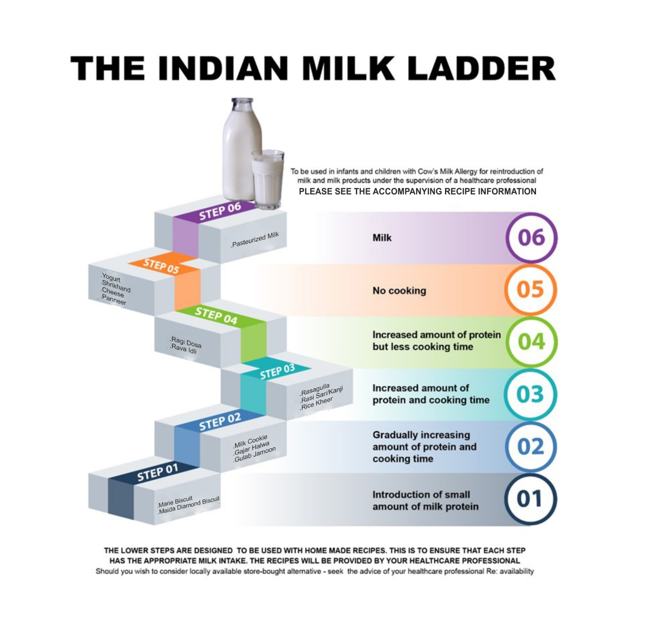

**Practical Points for parents on using Indian Milk ladder at home:**

* Health care practitioner (HCP) will discuss the ladder in detail with parents in detail during the clinic visit.
* Detailed recipe will be provided. (Annexure 2)
* Most children/infants will start at step one of the ladder unless they have eaten some food already; they can then move on to next step of the ladder.
* If foods on any of the steps is tolerated, child should continue to eat this (along the foods in the previous steps) and try food on the next step
* If the child does not tolerate the food in a particular step, it is advised go back to the previous step, until further HCP guidance to step up
* If symptoms recur it is suggested that the challenge is repeated at 6 to 8 weeks interval.
* If the food in particular step of the ladder is tolerated well, the level at which it is tolerated should be continued at, gradually increasing amounts before advancing into the next step.
* If the parents wish to give alternative food listed in the same step its recommended that they can try to increase the variety of the food in the child’s diet.
* The potion details in each step to be introduced are as follows

|  |  |  |
| --- | --- | --- |
| **STEP** | **Food** | **Recommended Portion per serving** |
| **Step 1** | | |
| Step 1 | Marie Biscuit | ½ Biscuit to start with & build up gradually |
| Maida Di**a**mond Biscuit |
| **Step 2** | | |
| Step 2 | Milk Cookie | Start with ½ Cookie & build up |
| Gajar Halwa | Start with ¼ portion & increase gradually |
| Gulab Jamoon | Start with ¼ portion & increase gradually |
| **Step 3** | | |
| Step 3 | Rasgulla | Start with ¼ portion increase gradually |
| Ragi Sari/Kanji |
| Rice Kheer |
| **Step 4** | | |
| Step 4 | Ragi dosa | Start with ¼ portion & increase gradually |
| Rava idli |
| **Step 5** | | |
| Step 5 | Yoghurt | Start with ¼ portion increase gradually |
| Srikhand |
| Cheese |
| Paneer |
| **Step 6** | | |
| Step 6 | Pasteurized Milk | Start with ¼ cup & increase gradually |