Supplementary Materials
Ice core ¹⁷O reveals past changes in surface air temperatures and stratosphere to troposphere mass exchange
Pradeep K. Aggarwal, Frederick J. Longstaffe and Franklin W. Schwartz
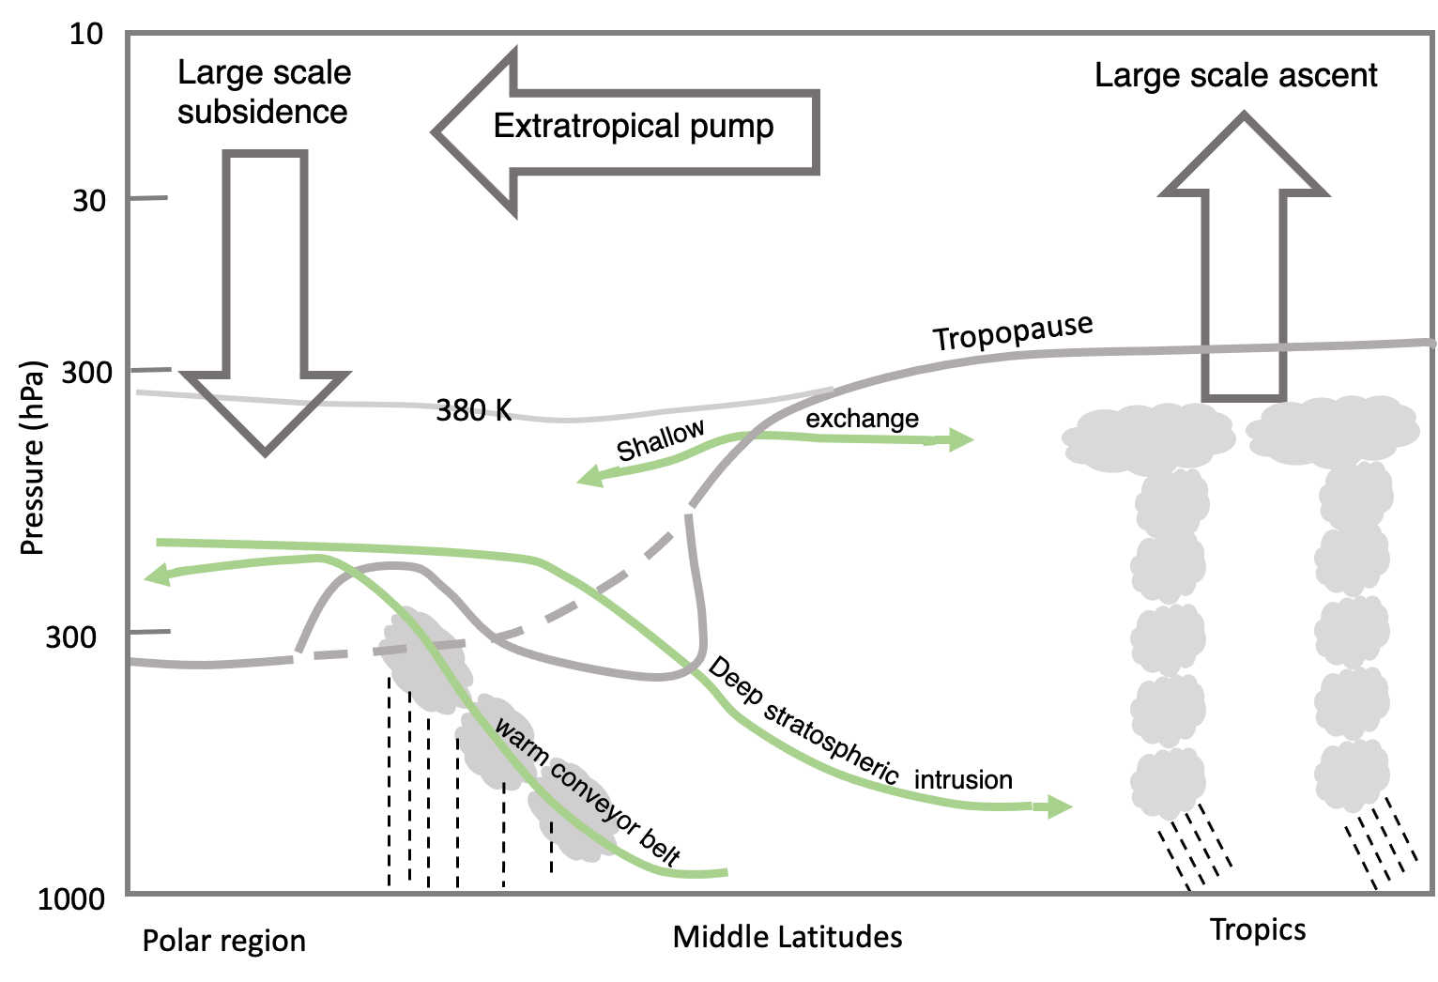
Figure S1. Schematic representation of the Brewer-Dobson Circulation with upwelling in the tropics, poleward transport by the “extratropical pump”, and downwelling in the high latitudes. Re-drawn after Holton et al. (1995) and Stohl et al. (2003).
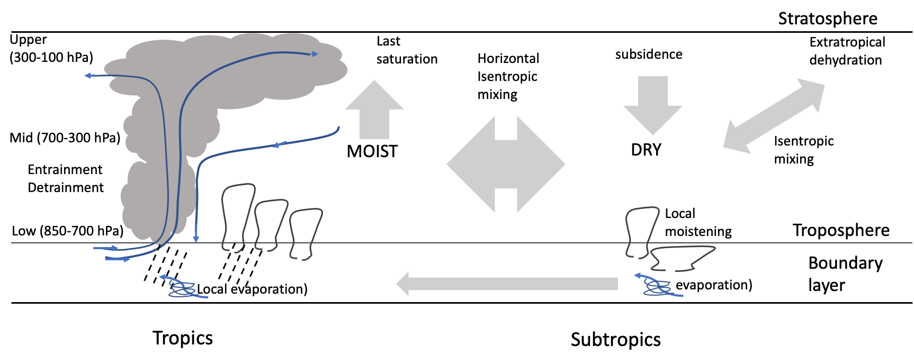
Figure S2. Schematic representation of moisture transport in the troposphere (re-drawn after Stohl et al. (2003). Water vapor from surface evaporation in the tropics and subtropics is transported upwards in convective clouds. Moisture from detrainment of cloud condensate and saturated air mass is transported to other regions by large scale circulation.

A. B.
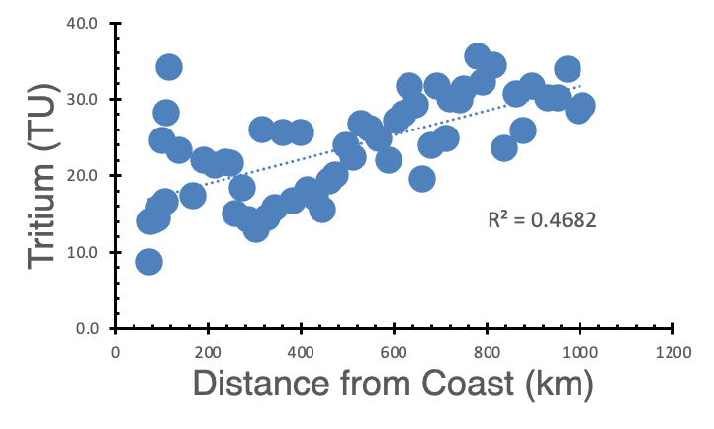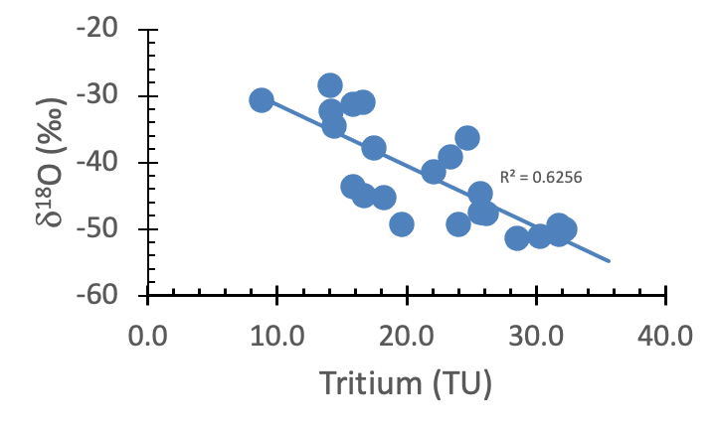

C. D.
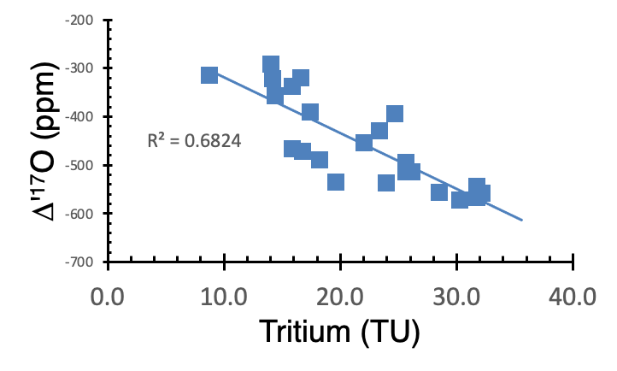

Figure S3. Tritium and oxygen isotopes in Antarctic surface snow from Terra Nova Bay to Dome C. Tritium and distance data are from (55, 56) and δ¹⁸O is from (57). A. Tritium with distance from the coast. B. δ¹⁸O versus tritium. Correlation of δ¹⁸O with tritium suggests that some of the decreasing δ¹⁸O may be attributed to an increasing contribution of upper tropospheric moisture containing stratospheric input. C. Δ'¹⁷O versus tritium with λ = 0.516. D. Δ'¹⁷O versus tritium with λ = 0.528.

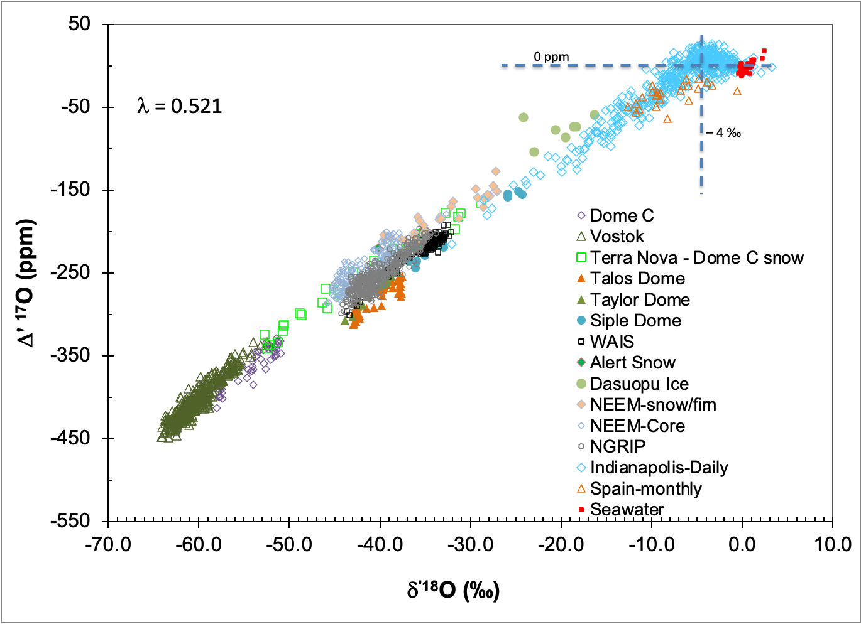

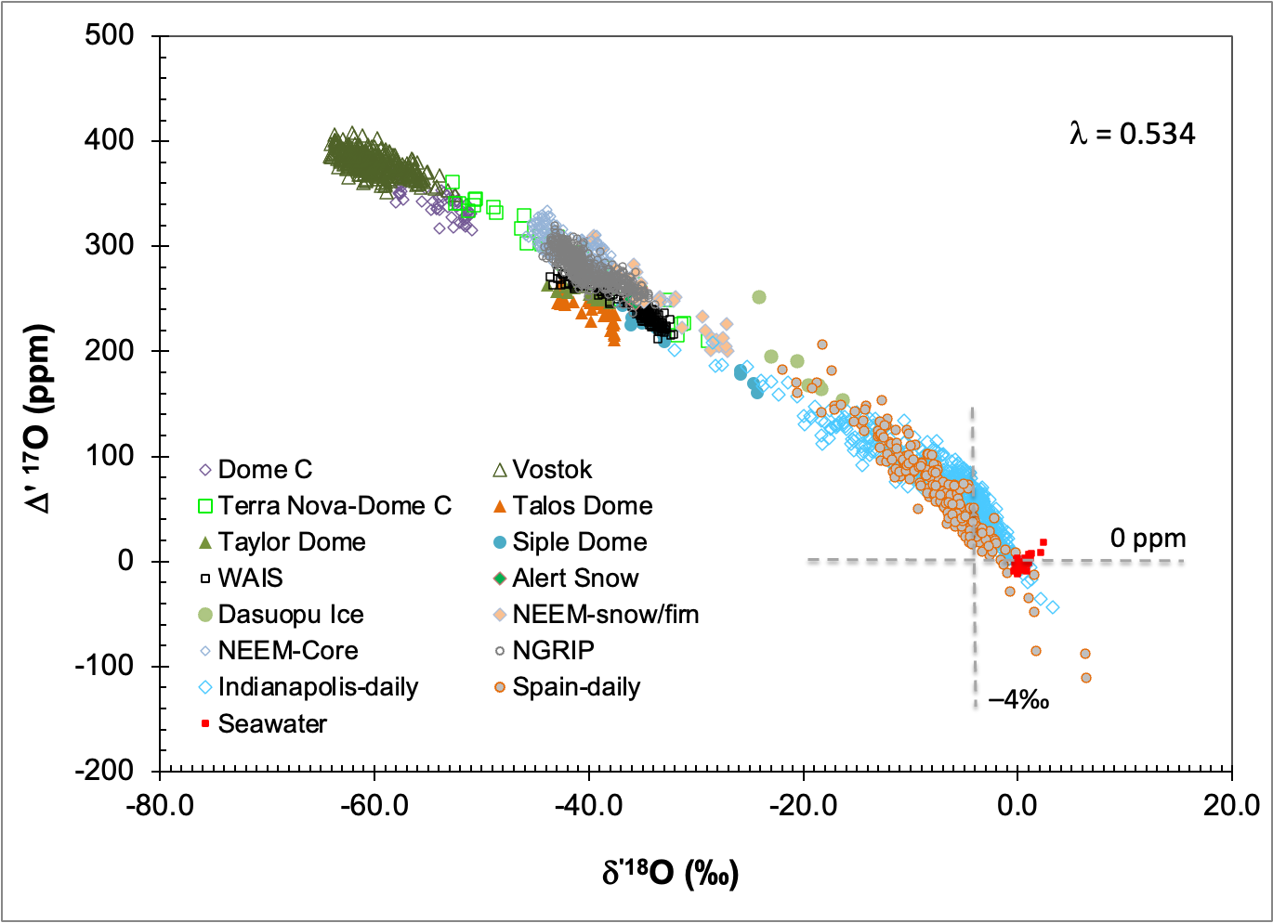
Figure S4. The effect of the value of MDF coefficient on Δ'¹⁷O. For MDF coefficient values less than 0.521, the Δ'¹⁷O and δ'¹⁸O are positively correlated and the magnitude of Δ'¹⁷O has negative values (less than zero) owing to MDF coefficient value being less than the effective δ¹⁷O/δ¹⁸O ratio in stratospheric input. For values of 0.534 or higher, the correlation becomes negative and Δ'¹⁷O values mostly are greater than zero. For intermedite values of MDF, the correlation and Δ'¹⁷O values are variable.
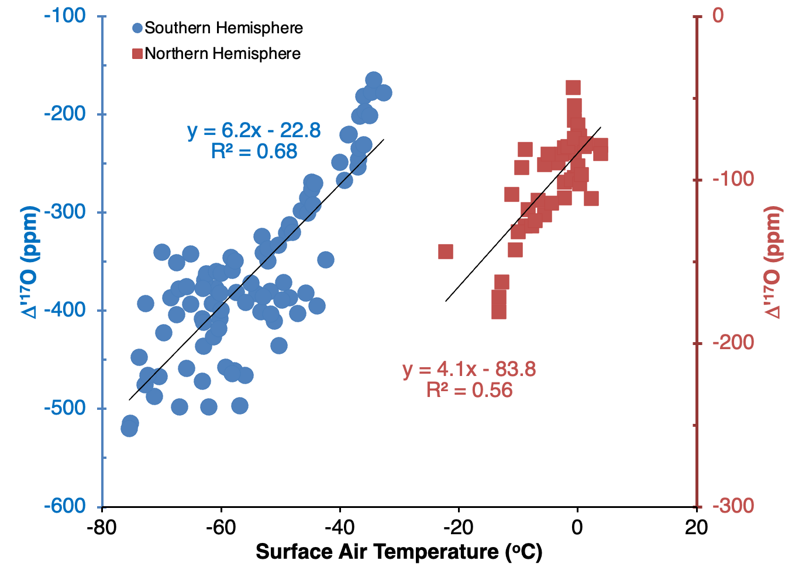
Figure S5. Calibration of the Δ'¹⁷O paleothermometer using an MDF coefficient of 0.521. Compare with Figure 3 in text.
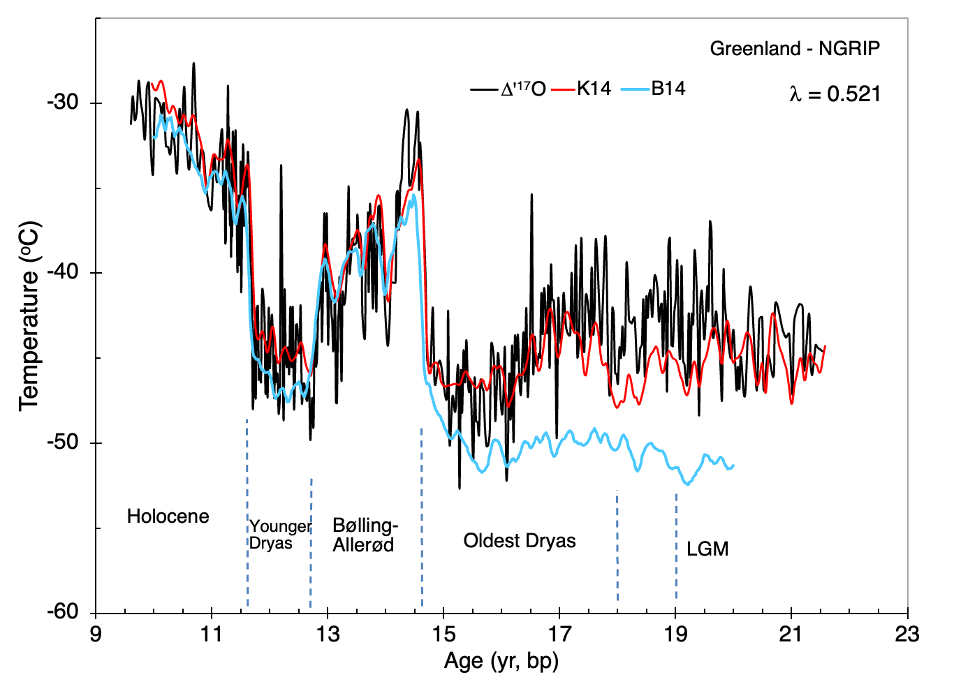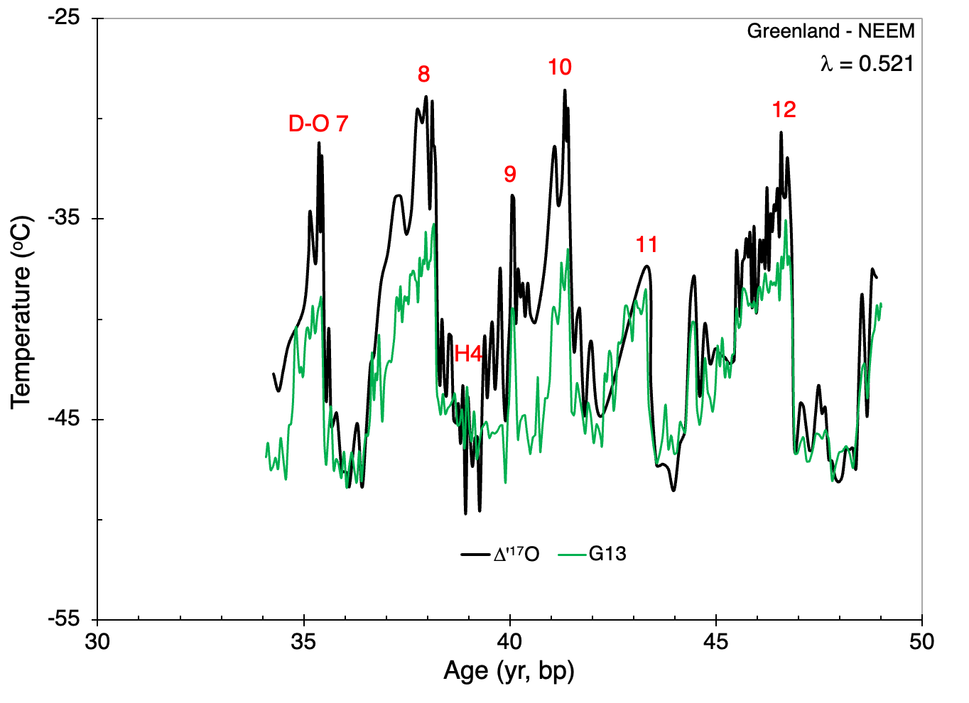

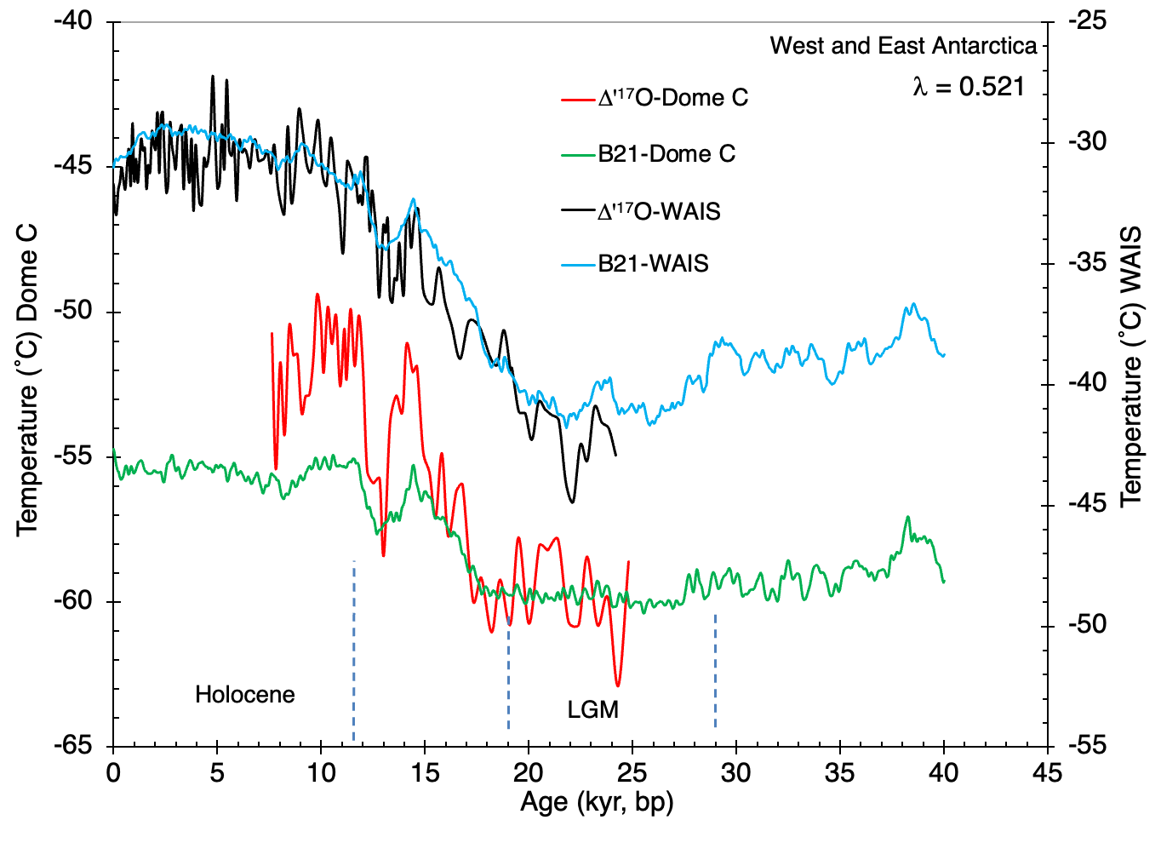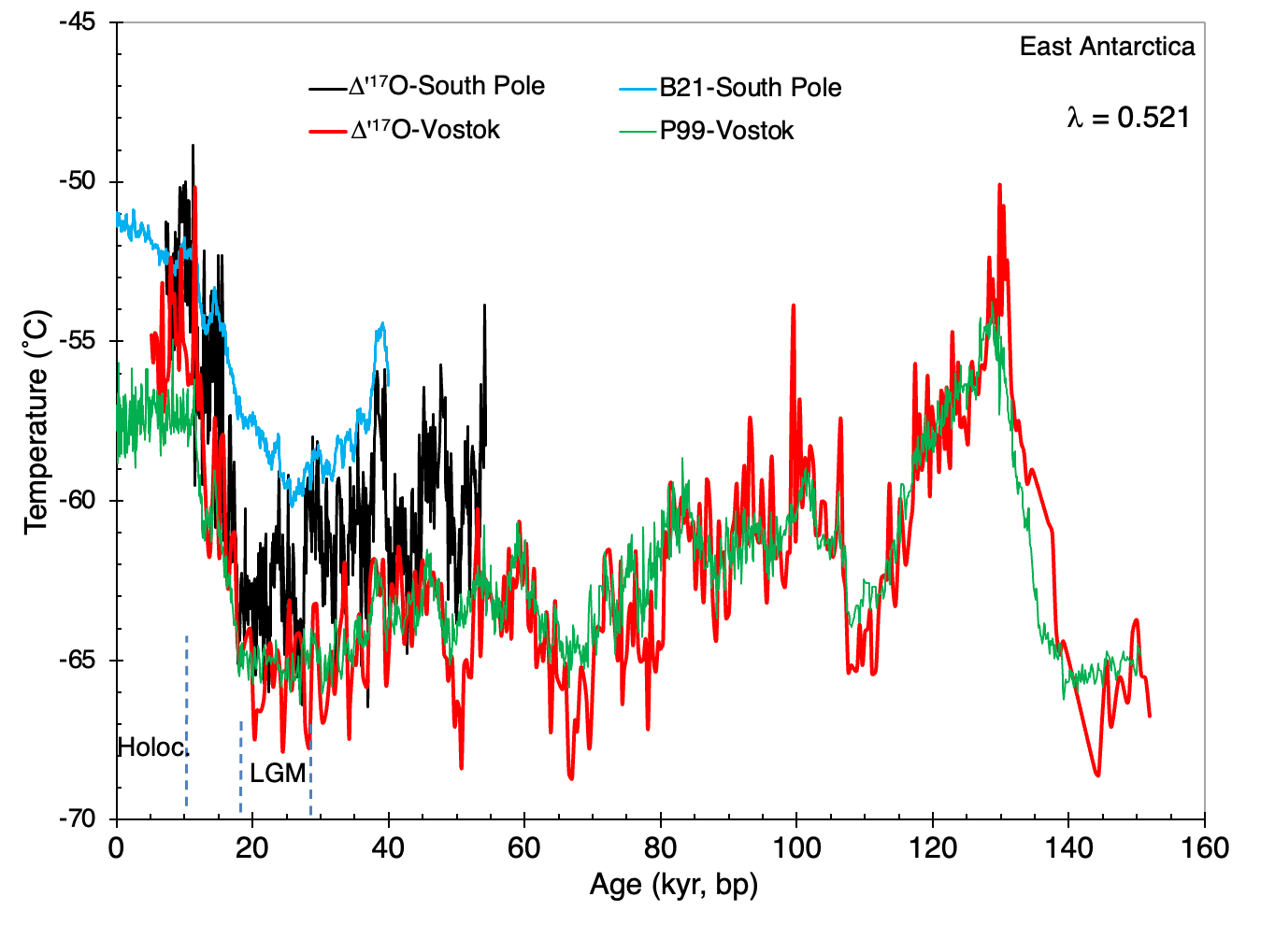

Figure S6. Reconstructed surface air temperatures for multiple ice cores using a value of 0.521 for the MDF coefficient.

