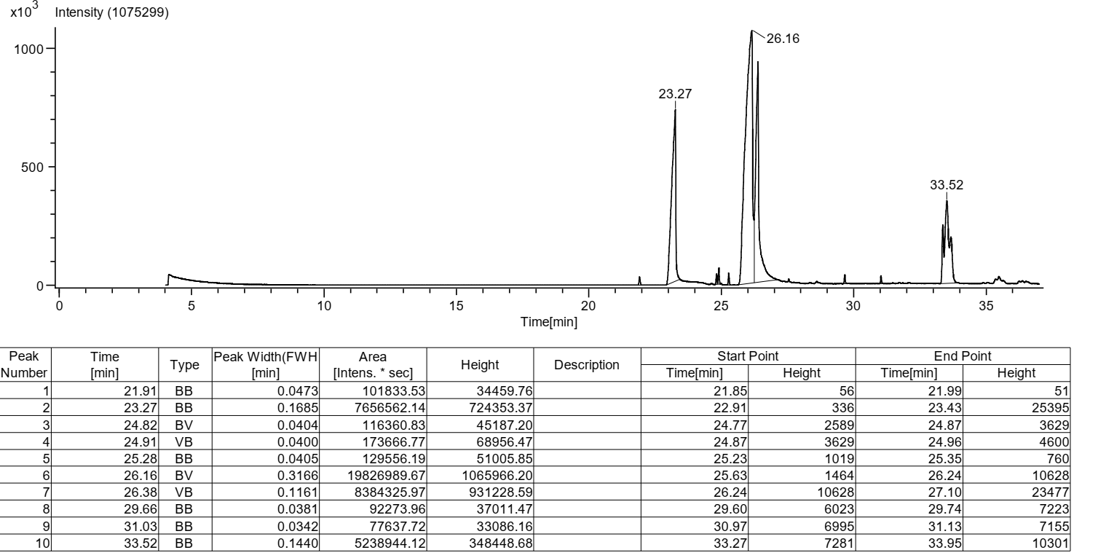
Figure S1: Representative GC chromatogram of tamanu oil components

Figure S2: Graphical representation of % Wound Contraction
Groups | (H& E) | Masson’s trichome (MT)
Control | 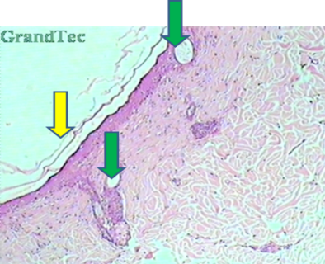 | 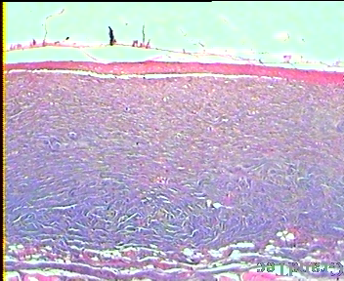
Tamanu oil | 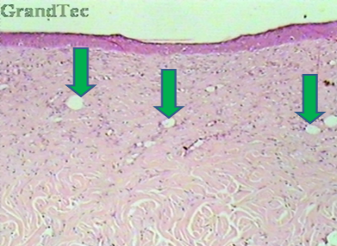 | 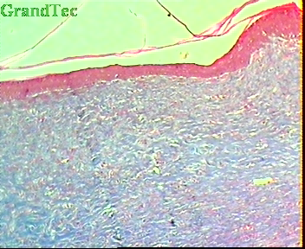
Murivenna® | 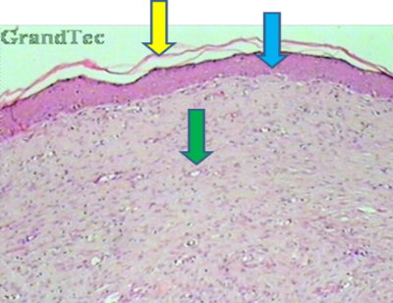 | 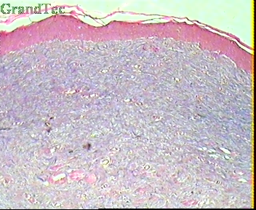  h
BG1 | 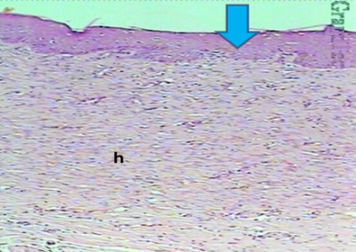 | 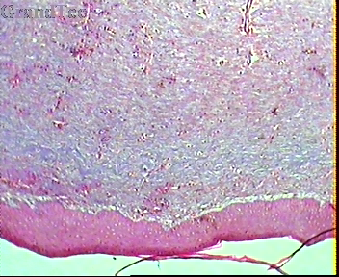  h
BG4 | 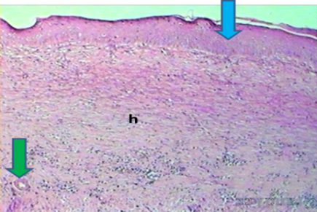 | 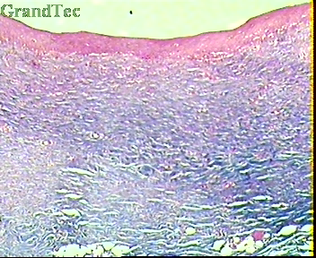
BG8 |  | 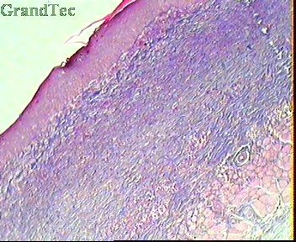  h
Figure S3: Photomicrographs (100x) showing H&E stain and MT stain section of skin tissues at day 15 for control, standard and formulation treated groups
(Yellow- re-epithelialization, Green- irregular connective tissue, Blue- epidermis, Black-collagen formation and h- healed area with multiple layers of fibrous connective tissue)

Table S1: Molecular properties of Ligands (constituents of Tamanu oil)
Properties/ Drugs | Molecular Weight | LogP | No. of Rotatable Bonds | No. of H-Bond Acceptors | No. of H- Bond Donors | Surface Area (m²)
Calophyllolide | 416.473 | 5.8017 | 4 | 5 | 0 | 180.154
Inophyllum C | 402.446 | 5.2439 | 1 | 5 | 0 | 173.473
Calanolide A | 370.445 | 4.3801 | 2 | 5 | 1 | 158.144
4-Norlanosta-17(20),24-diene-11,16-diol-21-oic acid, 3-oxo-16,21-lactone | 454.651 | 5.7834 | 3 | 4 | 1 | 198.78
Bleomycin | 1415.576 | -7.70358 | 35 | 31 | 20 | 558.81
Table S2: Predicted ADMET properties of compounds
Properties | Calophyllolide | Inophyllum C | Calanolide A | 4-Norlanosta-17(20),24-diene-11,16-diol-21-oic acid, 3-oxo-16,21-lactone | Bleomycin
Water solubility (log mol/L) | -5.699 | -4.952 | -4.982 | -5.716 | -2.892
Caco2 permeability (log Papp in 10-6 cm/s) | 1.121 | 1.119 | 0.757 | 0.605 | -2.018
Skin Permeability (log Kp) | -2.702 | -2.729 | -3.013 | -3.253 | -2.735
P-glycoprotein substrate | No | No | Yes | No | Yes
P-glycoprotein I inhibitor | Yes | Yes | Yes | Yes | No
P-glycoprotein II inhibitor | Yes | Yes | Yes | Yes | No
VDss (human)(log L/kg) | 0.47 | 0.169 | 0.371 | -0.124 | -0.159
Fraction unbound (human)(Fu) | 0.147 | 0.165 | 0.103 | 0 | 0.387
BBB permeability (log BB) | -0.823 | -0.453 | -0.322 | -0.56 | -4.5
CNS permeability (log PS) | -1.678 | -1.606 | -1.82 | -1.59 | -7.772
CYP2D6 substrate | No | No | No | No | No
CYP3A4 substrate | Yes | Yes | Yes | Yes | No
CYP1A2 inhibitor | Yes | Yes | Yes | No | No
CYP2C19 inhibitor | Yes | Yes | Yes | No | No
CYP2C9 inhibitor | Yes | Yes | Yes | No | No
CYP2D6 inhibitor | No | No | No | No | No
CYP3A4 inhibitor | Yes | Yes | Yes | No | No
Total Clearance(log ml/min/kg) | 0.757 | 0.589 | 0.506 | 0.331 | 0.649
Renal OCT2 substrate | No | No | No | No | No
AMES toxicity | No | No | No | No | Yes
Max. tolerated dose (human)(log mg/kg/day) | 0.255 | 0.11 | -0.315 | -0.535 | 0.438
hERG I inhibitor | No | No | No | No | No
hERG II inhibitor | Yes | Yes | Yes | No | Yes
Hepatotoxicity | No | Yes | No | No | No
Skin Sensitisation | No | No | No | No | No

Table S3: Period of epithelialization in all groups
Sl. no. | Groups | Period of Epithelialization (days)
1. | Control | 12.83±0.30
2. | Tamanu oil | 10.16 ±0.47**
3. | Murivenna® | 10.00±0.36**
4. | BG1 | 11.50±0.42*
5. | BG4 | 8.16±0.60**
6. | BG8 | 6.66±0.66**
Data are expressed as Mean ± SEM (n=6) and analysed by one-way ANOVA method of variance followed by Dunnett test for multiple comparison. ns p>0.05, * p<0.05, ** p<0.01, in comparison to control. (Where, ns= non-significant, * moderately significant,
Table S4: Formulation of Bigels
 | BG1 | BG2 | BG3 | BG4 | BG5 | BG6 | BG7 | BG8
OLEOGEL PHASE
Tween 20 (mL) | 3 | 3 | 3 | 3 | 3 | 3 | 3 | 3
Tamanu oil (mL) | 5 | 10 | 15 | 20 | 5 | 10 | 15 | 20
HYDROGEL PHASE
Micronized Xanthan gum (g) | 1 | 1 | 1 | 1 | 2 | 2 | 2 | 2
Geogard® ECT (mL) | 1 | 1 | 1 | 1 | 1 | 1 | 1 | 1
Vanilla fragrance oil (mL) | 0.5 | 0.5 | 0.5 | 0.5 | 0.5 | 0.5 | 0.5 | 0.5
Water (mL) | q.s 100mL

