Supplementary Material

In vitro and in silico evaluation of the anti-leishmanial activity of novel synthetic chalcones
Fernando Ferreira Leite ¹, Luis Cezar Rodrigues², Bruno Hanrry Melo de Oliveira¹, Gabrielly Diniz Duarte², Maria Denise Leite Ferreira¹, Natália Ferreira de Sousa ¹, Shayenne Eduarda Ramos Vanderley^{1,3}, Leonardo Lima Cardoso^{1,3}, Tatjana Souza Lima Keesen^{1,3}, Rodrigo Santos Aquino de Araújo^{1,4}, Luciana Scotti¹, Marcus Tullius Scotti¹, and Francisco Jaime Bezerra Mendonça-Junior ^{1,4,}*
¹ Programa de Pós-Graduação em Produtos Bioativos Naturais e Sintéticos, Universidade Federal da Paraíba,
João Pessoa 58051-900, Brasil; fernandoferreira_15@hotmail.com (F.F.L.); hanrygb@hotmail.com (B.H.M.O); denisecaiana@yahoo.com.br (M.D.L.F.); nataliafsousa@ltf.ufpb.br (N.F.d.S.);luciana.scotti@gmail.com (L.S); mtscotti@gmail.com (M.T.S); rodrigosantosbiologojp@gmail.com (R.S.A.A); franciscojaime@servidor.uepb.edu.br (F.J.B.M.-J)
² Programa de Pós-Graduação em Desenvolvimento e Inovação de Fármacos e Medicamentos, Universidade Federal da Paraíba, João Pessoa 58051-900, Brasil; luiscezarodrigues@acedmico.ufpb.br (L.C.R.); gabriellydduarte@hotmail.com (G.D.D.);
³ Laboratório de Imunologia de Doenças Infecciosas do Departamento de Biologia Celular e Molecular; Universidade Federal da Paraíba, João Pessoa 58051-900, PB, Brasil; shayenne.erv@gmail.com (S.E.R.V.); leo_cardoso.l@hotmail.com (L.L.C.); tatkeesen@cbiotec.ufpb.br (T.S.L.K.)
⁴ Laboratório de Síntese e Drug Delivery, Departamento de Ciências Biológicas, Universidade Estadual da Paraíba, João Pessoa 58071-160, Brasil * Correspondência: franciscojaime@servidor.uepb.edu.br (F.J.B.M.-J)
* Correspondence: franciscojaime@servidor.uepb.edu.br

List of Figures
Figure 1: Chalcones synthesized via Claisen condensation. 2
Figure 2: ¹H RMN (CDCl₃, 400 MHz) Compound 1 (CP01). 3
Figure 3: ¹³C RMN (CDCl₃, 100 MHz) Compound 1 (CP01) 4
Figure 4: ¹H RMN (CDCl₃, 400 MHz) Compound 2 (CP02) 5
Figure 5: ¹³C RMN (CDCl₃, 100 MHz) Compound 2 (CP02) 5
Figure 6: Mass spetrum HRMS (ESI-TOF+) Compound CP02. 6
Figure 7: ¹H RMN (CDCl₃, 400 MHz) Compound 3 (CP03) 6
Figure 8: ¹³C RMN (CDCl₃, 100 MHz) Compound 3 (CP03) 7
Figure 9: ¹H RMN (CDCl₃, 400 MHz) Compound 4 (CP04) 8
Figure 10: ¹³C RMN (CDCl₃, 100 MHz) Compound 4 (CP04) 8
Figure 11: Mass spetrum HRMS (ESI-TOF+) Compound CP04. 9
Figure 12: ¹H RMN (CDCl₃, 400 MHz) Compound 5 (CP05) 9
Figure 13: ¹³C RMN (CDCl₃, 100 MHz) Compound 5 (CP05) 10
Figure 14: Mass spetrum HRMS (ESI-TOF+) Compound CP05. 10
Figure 15: ¹H RMN (CDCl₃, 400 MHz) Compound 6 (CP06) 11
Figure 16: ¹³C RMN (CDCl₃, 100 MHz) Compound 6 (CP06) 12
Figure 17: Mass spetrum HRMS (ESI-TOF+) Compound CP06. 12
Figure 18: ¹H RMN (CDCl₃, 400 MHz) Compound 7 (CP07) 13
Figure 19: ¹³C RMN (CDCl₃, 100 MHz) Compound 7 (CP07) 13
Figure 20: Mass spetrum HRMS (ESI-TOF+) Compound CP07. 14
Figure 21: ¹H RMN (CDCl₃, 400 MHz) Compound 8 (CP08) 14
Figure 22: ¹³C RMN (CDCl₃, 100 MHz) Compound 8 (CP08) 15
Figure 23: Mass spetrum HRMS (ESI-TOF+) Compound CP08. 15
Figure 24: ¹H RMN (CDCl₃, 400 MHz) Compound 9 (CP09) 16
Figure 25: ¹³C RMN (CDCl₃, 100 MHz) Compound 9 (CP09) 16
Figure 26: Mass spetrum HRMS (ESI-TOF+) Compound CP09. 17
Figure 27: ¹H RMN (CDCl₃, 400 MHz) Compound 10 (CP10) 17
Figure 28: ¹³C RMN (CDCl₃, 100 MHz) Compound 10 (CP010) 18
Figure 29: Mass spetrum HRMS (ESI-TOF+) Compound CP10. 18
Figure 30: Graph of antileishmanial activity of compounds CP03, CP04 e CP06. 19

Figure 1: Chalcones synthesized via Claisen condensation.
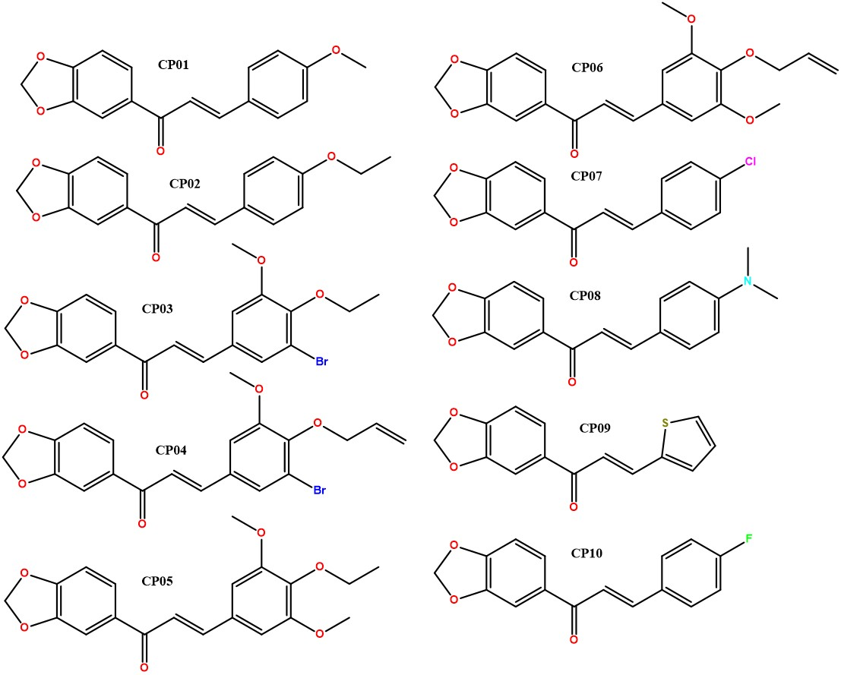

Figure 2: ¹H RMN (CDCl₃, 400 MHz) Compound 1 (CP01).
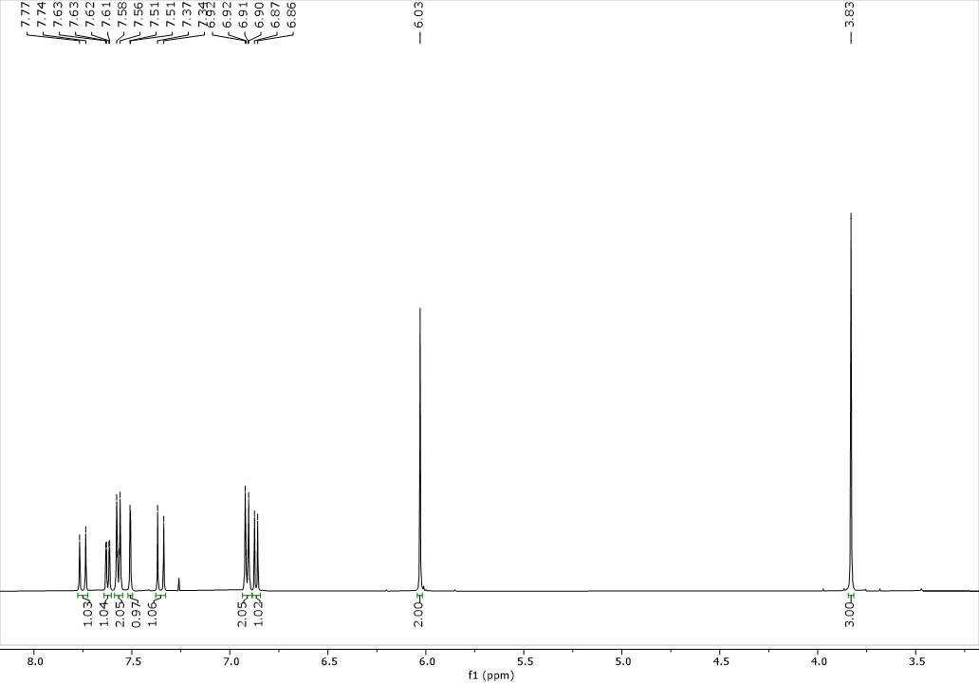

Figure 3: ¹³C RMN (CDCl₃, 100 MHz) Compound 1 (CP01)
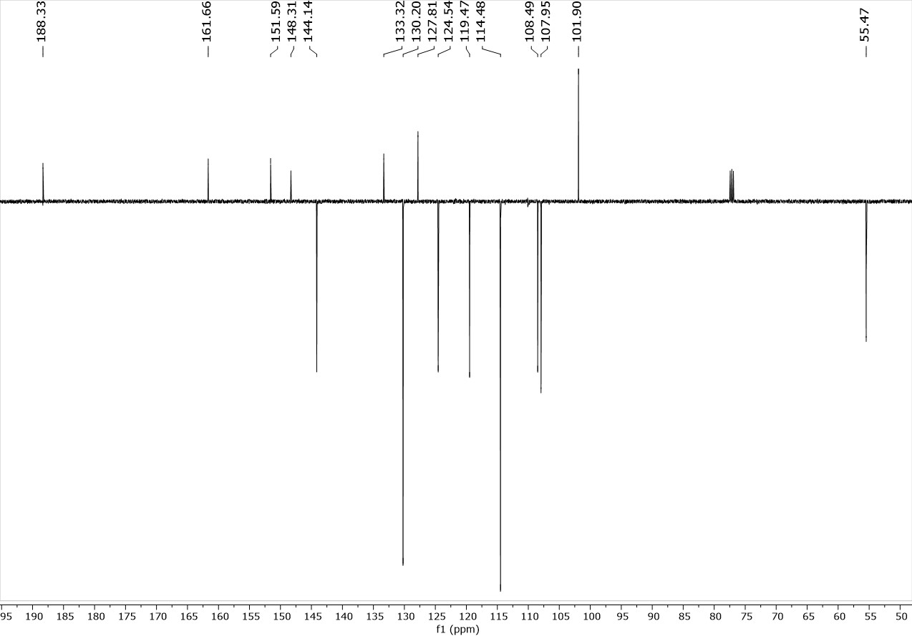

Figure 4: ¹H RMN (CDCl₃, 400 MHz) Compound 2 (CP02)
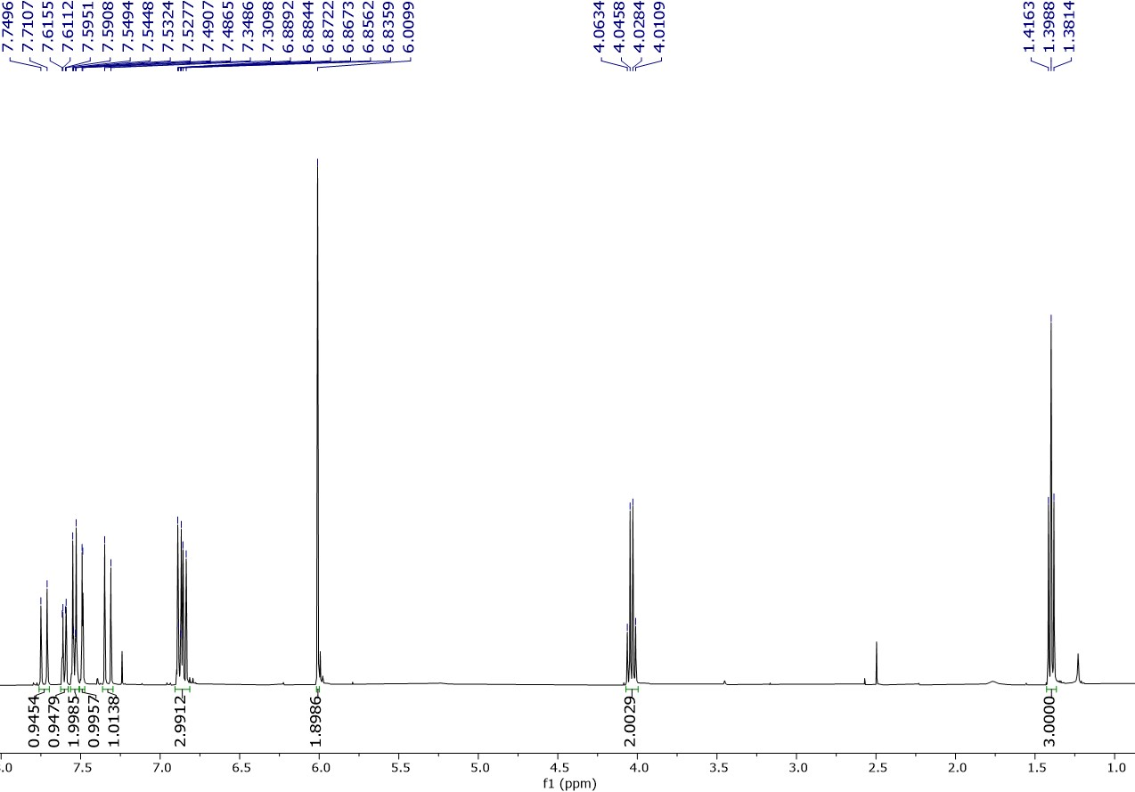

Figure 5: ¹³C RMN (CDCl₃, 100 MHz) Compound 2 (CP02)
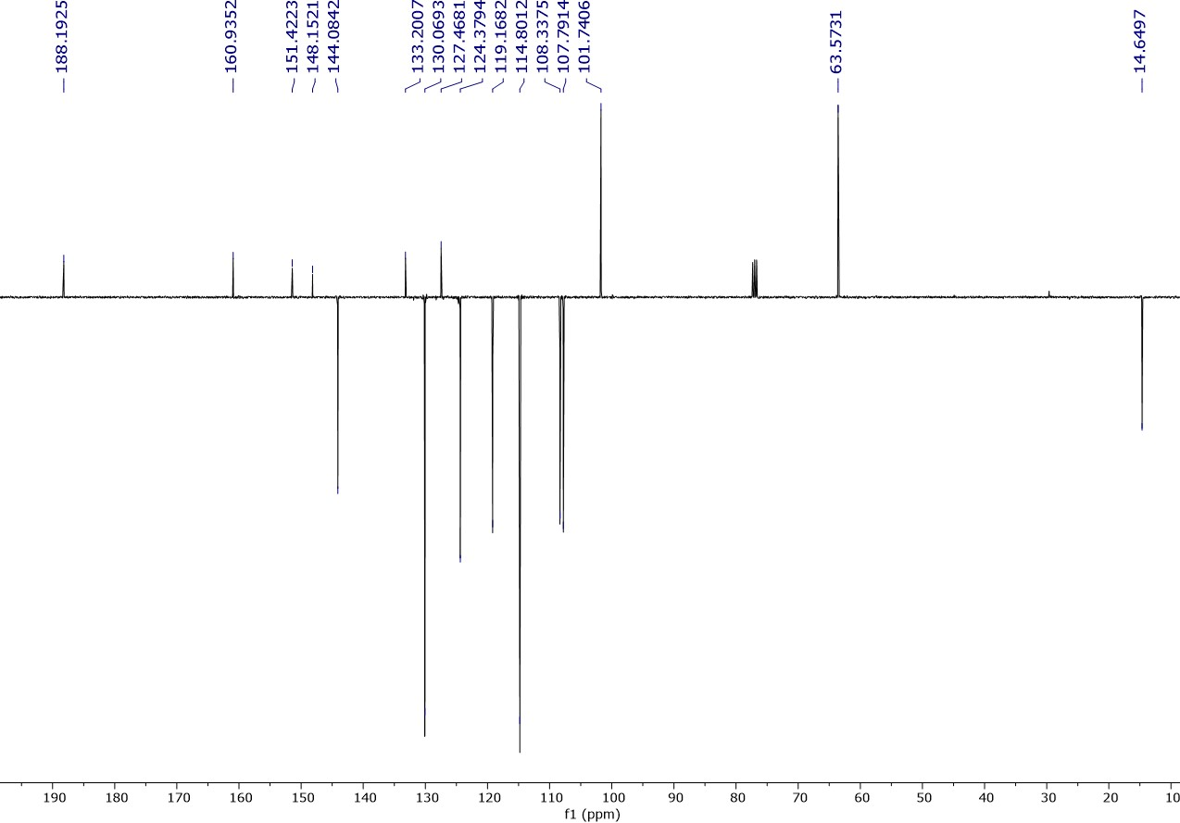
Figure 6: Mass spetrum HRMS (ESI-TOF+) Compound CP02.
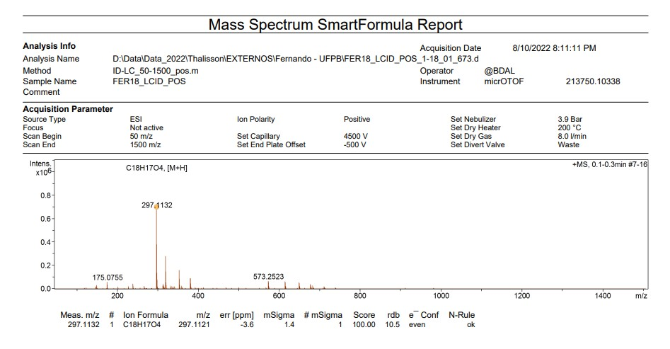

Figure 7: ¹H RMN (CDCl₃, 400 MHz) Compound 3 (CP03)
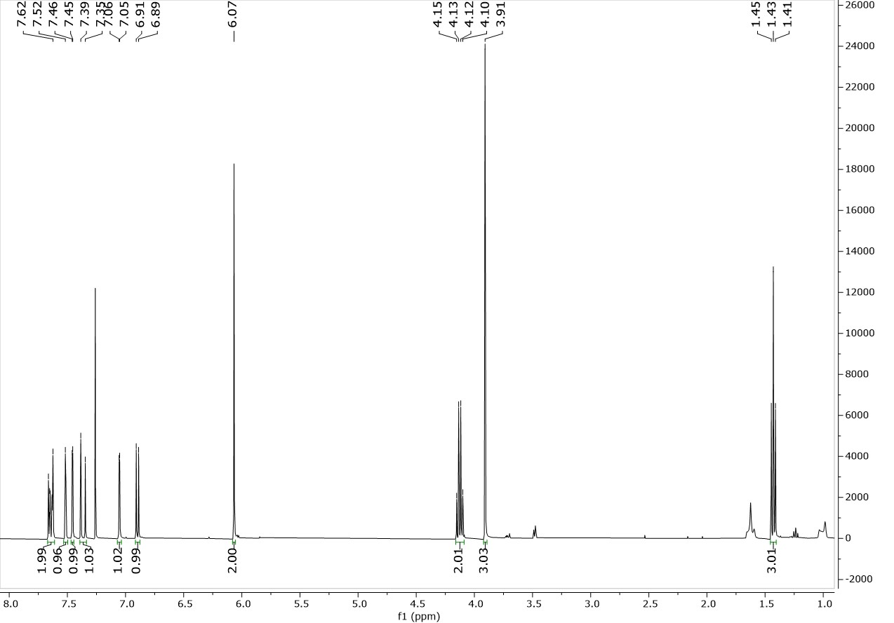
Figure 8: ¹³C RMN (CDCl₃, 100 MHz) Compound 3 (CP03)
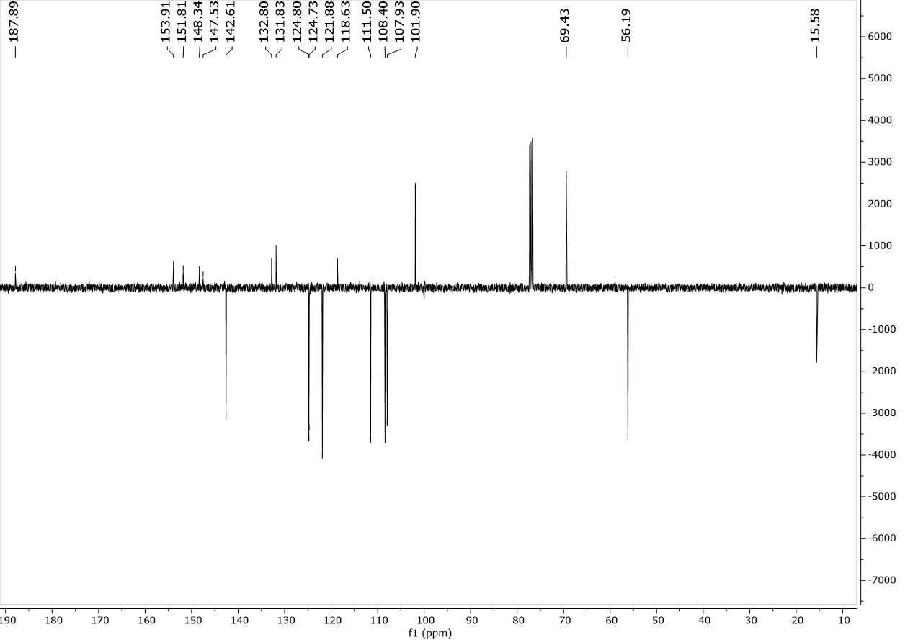

Figure 9: ¹H RMN (CDCl₃, 400 MHz) Compound 4 (CP04)
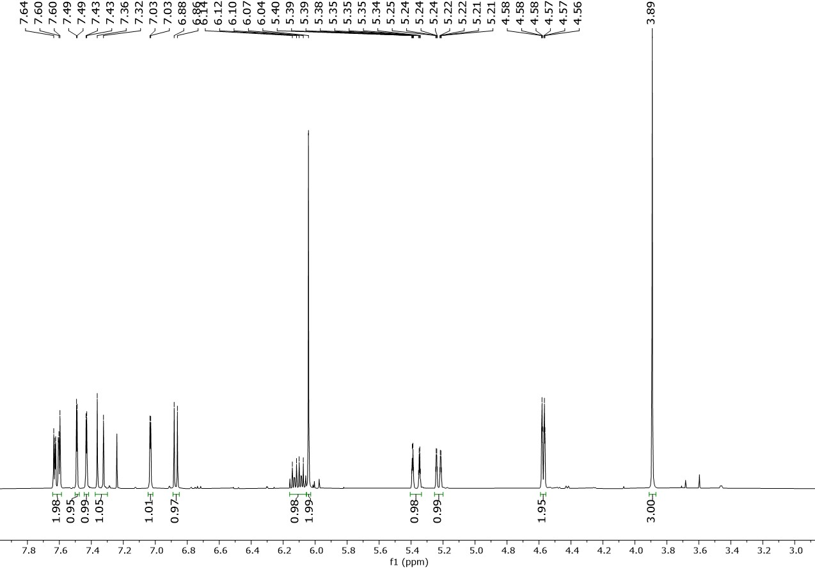
Figure 10: ¹³C RMN (CDCl₃, 100 MHz) Compound 4 (CP04)
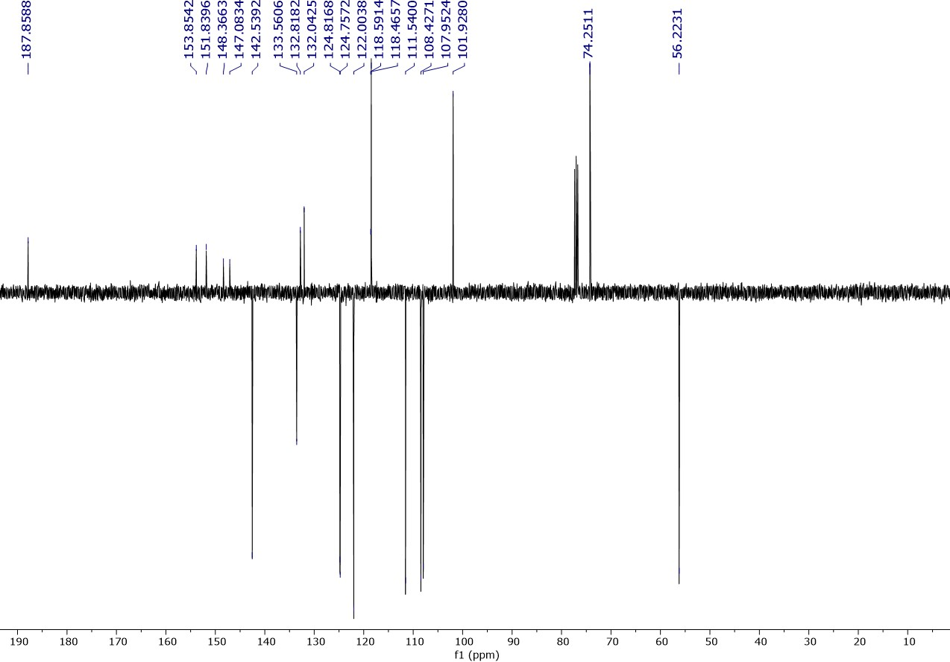
Figure 11: Mass spetrum HRMS (ESI-TOF+) Compound CP04.
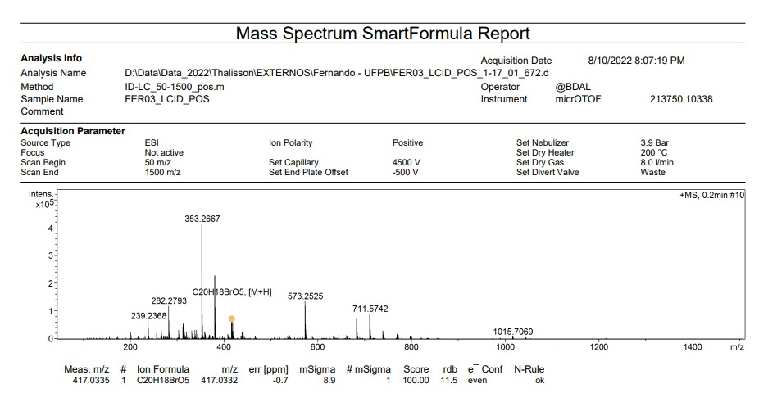

Figure 12: ¹H RMN (CDCl₃, 400 MHz) Compound 5 (CP05)
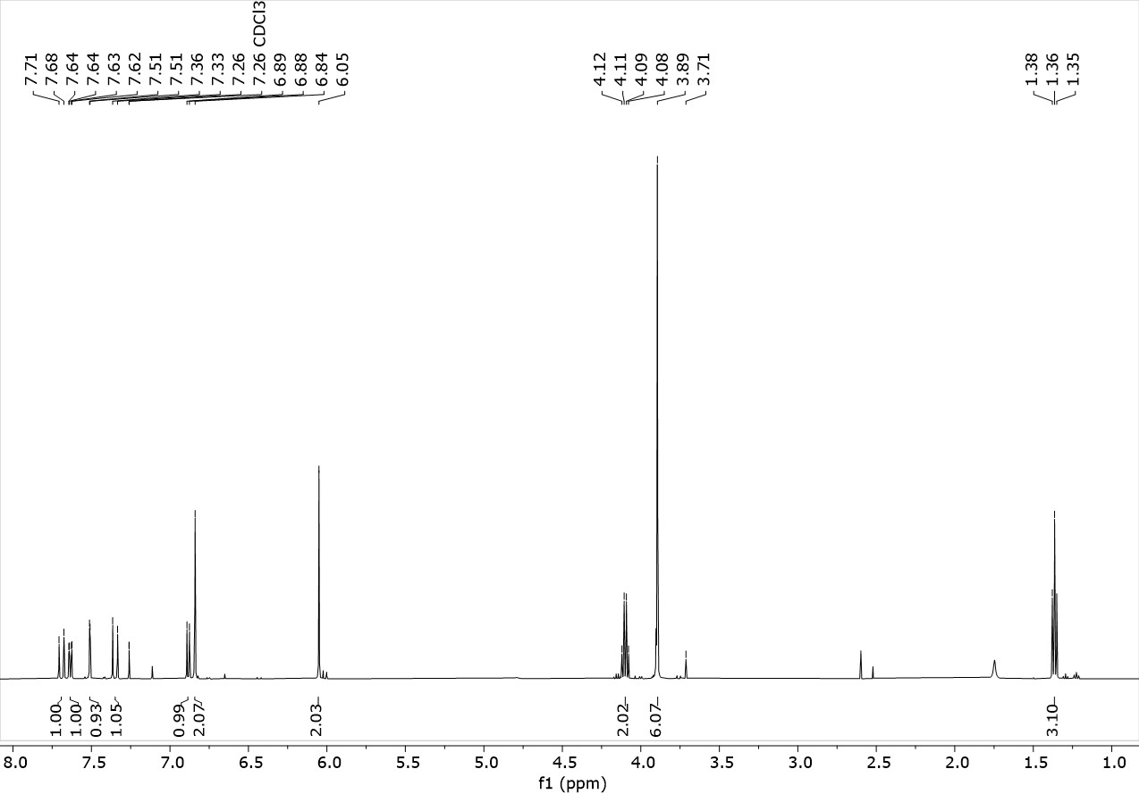
Figure 13: ¹³C RMN (CDCl₃, 100 MHz) Compound 5 (CP05)
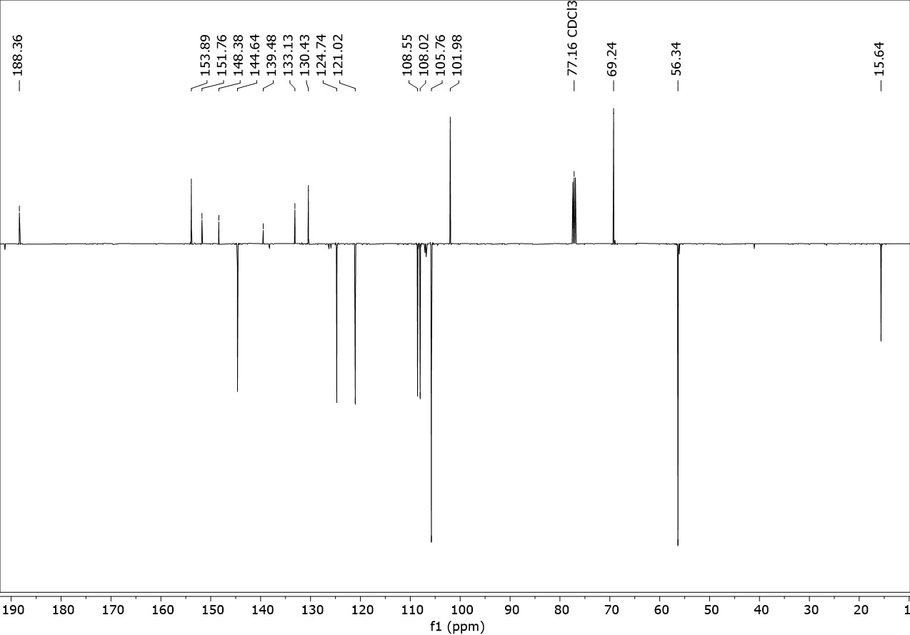
Figure 14: Mass spetrum HRMS (ESI-TOF+) Compound CP05.
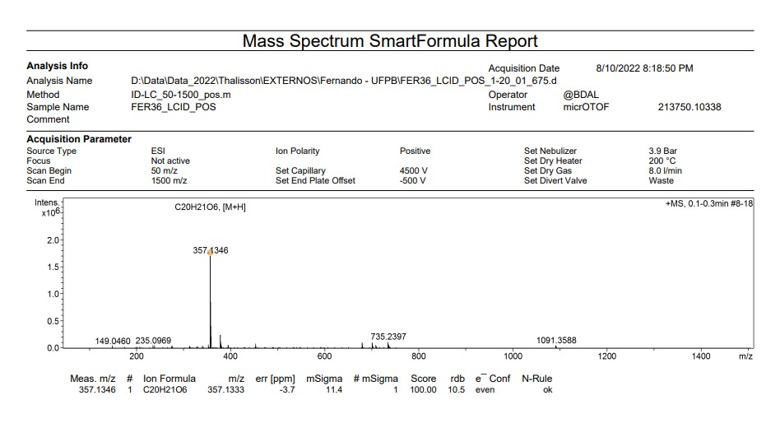

Figure 15: ¹H RMN (CDCl₃, 400 MHz) Compound 6 (CP06)
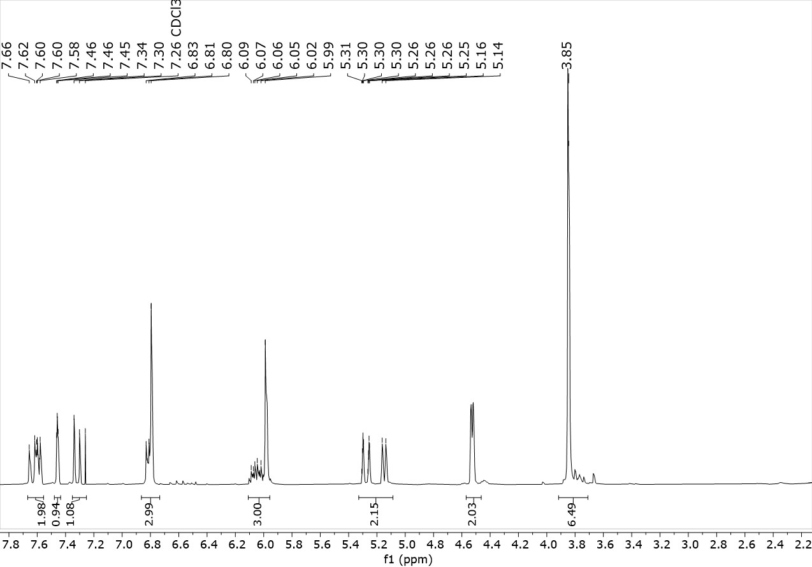

Figure 16: ¹³C RMN (CDCl₃, 100 MHz) Compound 6 (CP06)
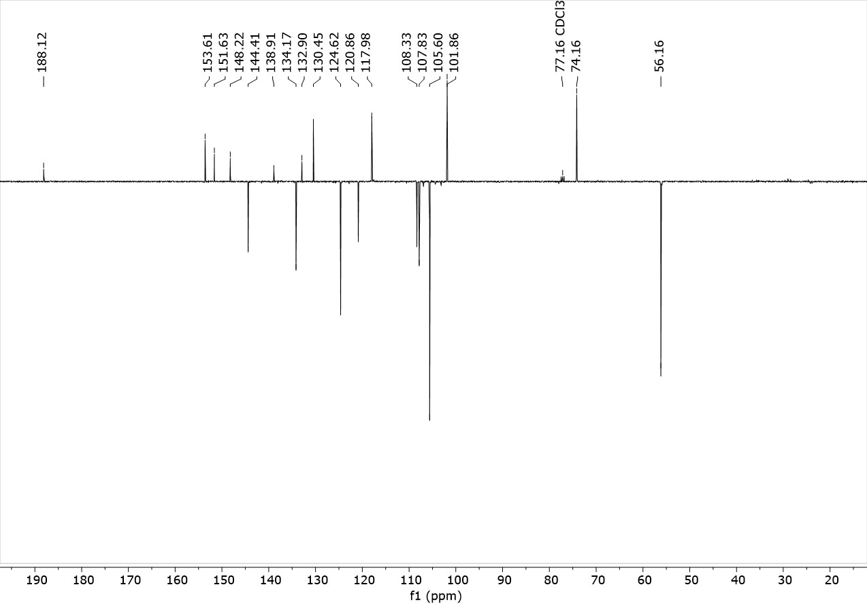
Figure 17: Mass spetrum HRMS (ESI-TOF+) Compound CP06.
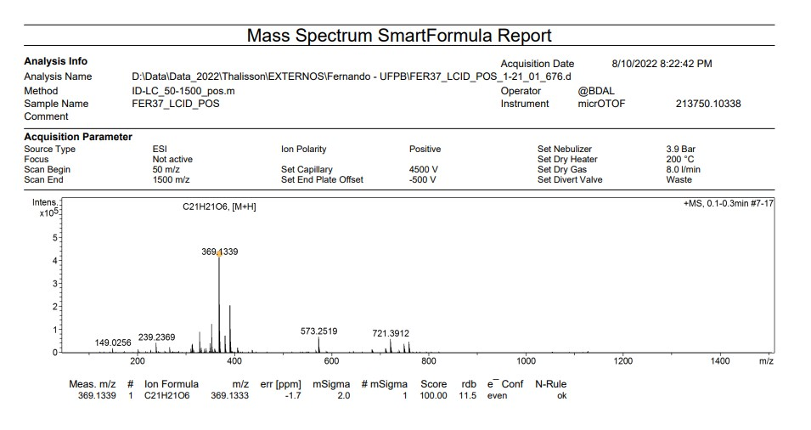

Figure 18: ¹H RMN (CDCl₃, 400 MHz) Compound 7 (CP07)
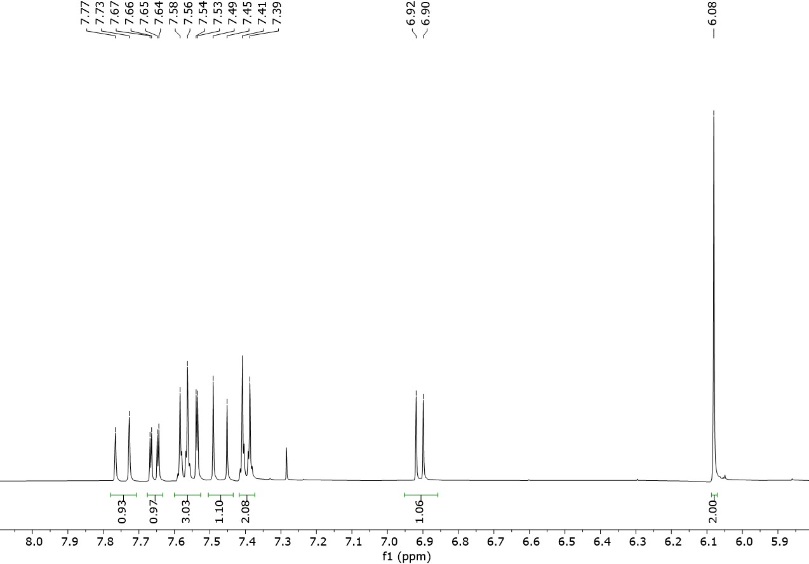
Figure 19: ¹³C RMN (CDCl₃, 100 MHz) Compound 7 (CP07)
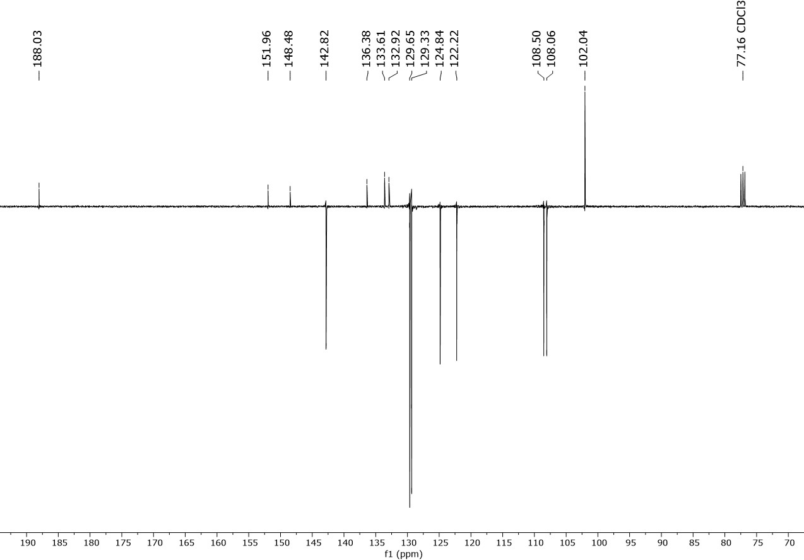
Figure 20: Mass spetrum HRMS (ESI-TOF+) Compound CP07.
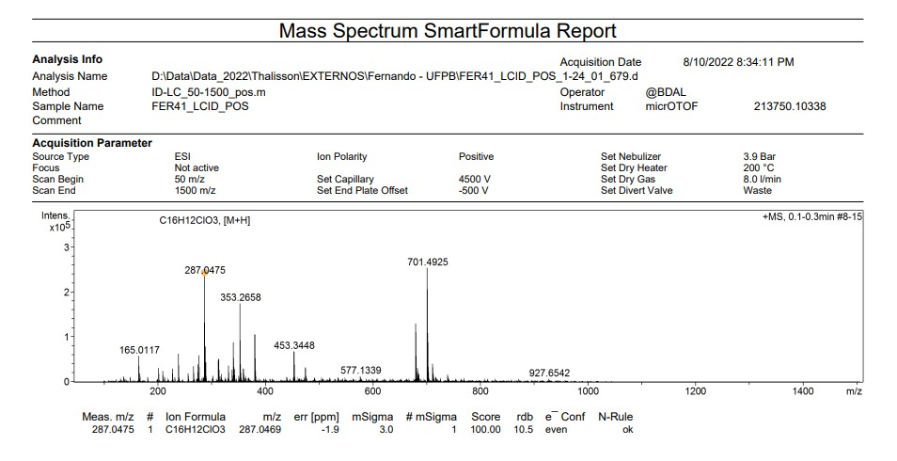

Figure 21: ¹H RMN (CDCl₃, 400 MHz) Compound 8 (CP08)
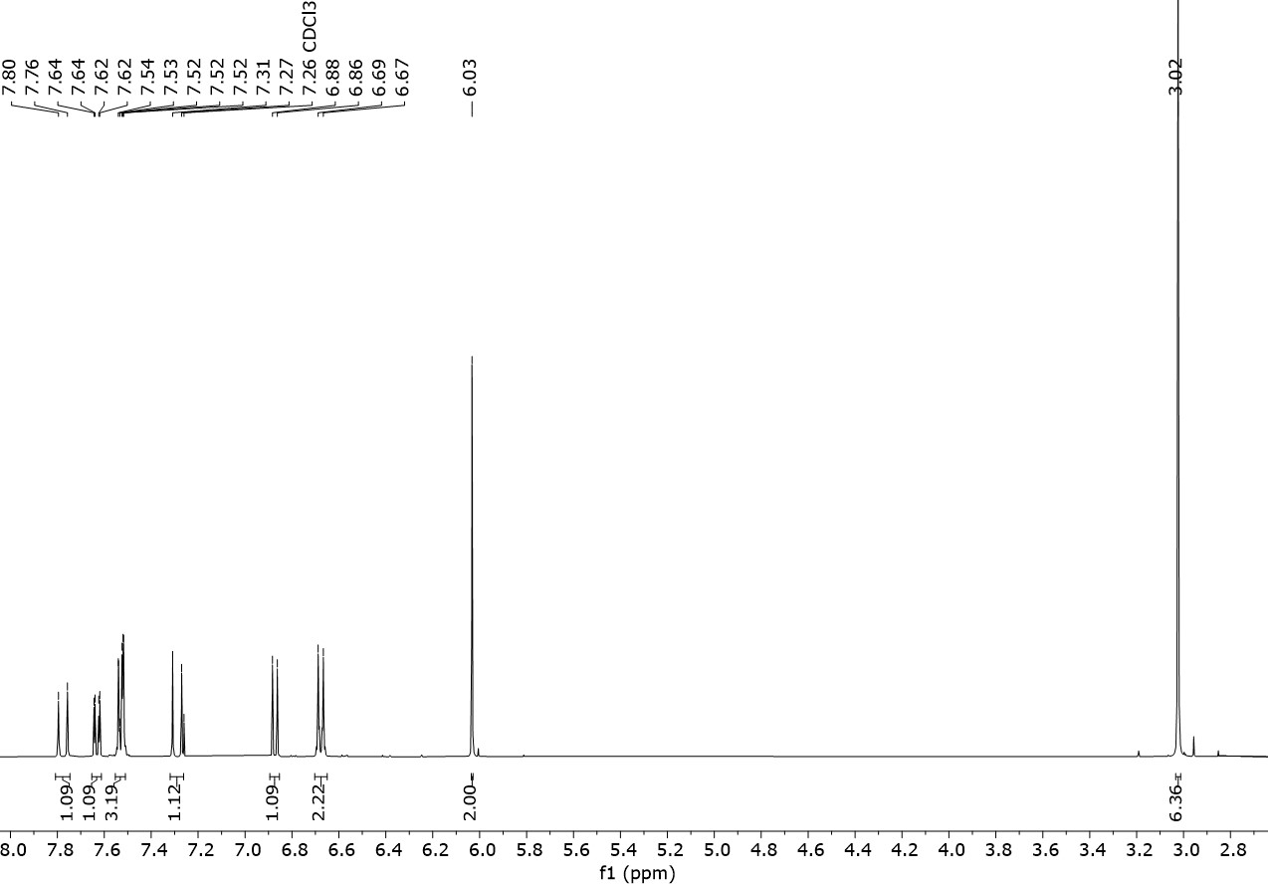

Figure 22: ¹³C RMN (CDCl₃, 100 MHz) Compound 8 (CP08)
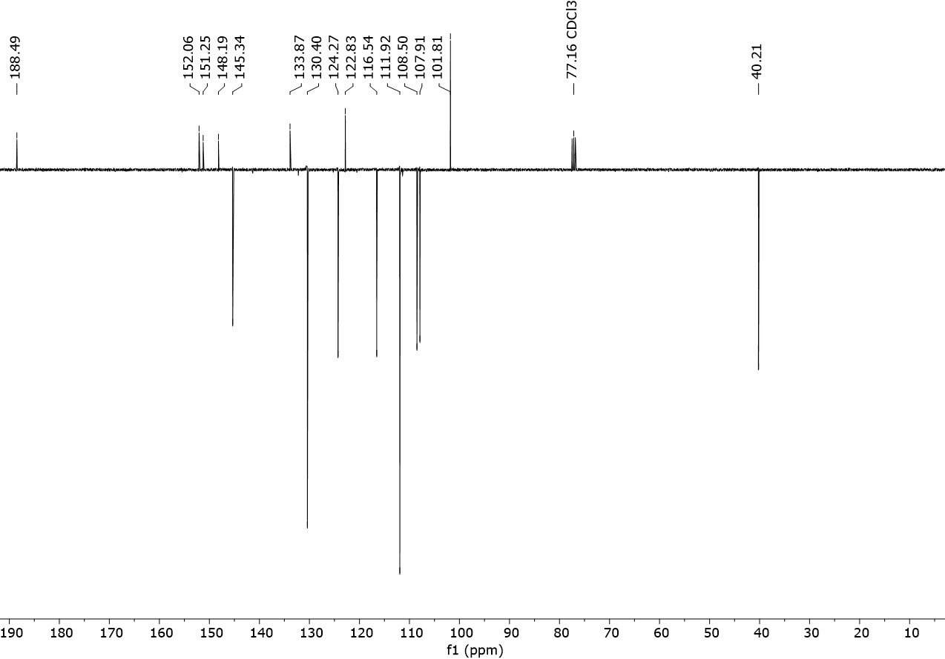

Figure 23: Mass spetrum HRMS (ESI-TOF+) Compound CP08.
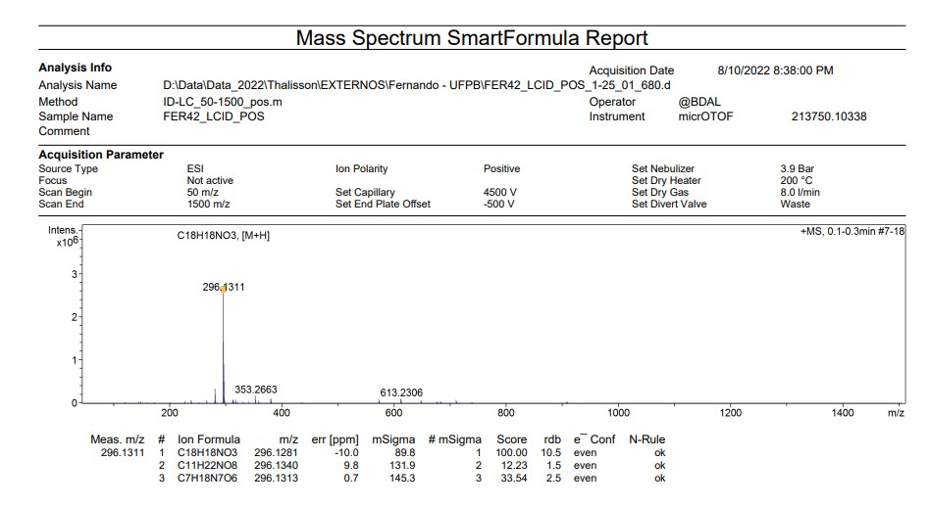

Figure 24: ¹H RMN (CDCl₃, 400 MHz) Compound 9 (CP09)
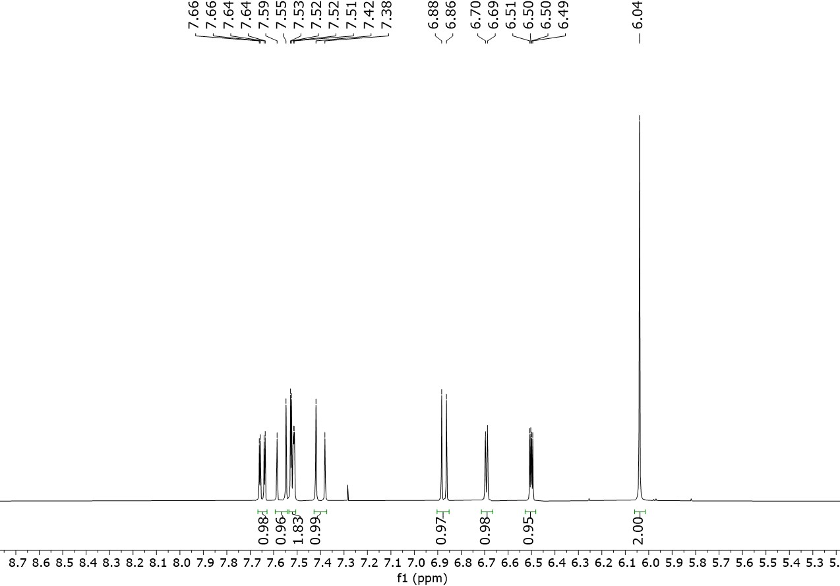
Figure 25: ¹³C RMN (CDCl₃, 100 MHz) Compound 9 (CP09)
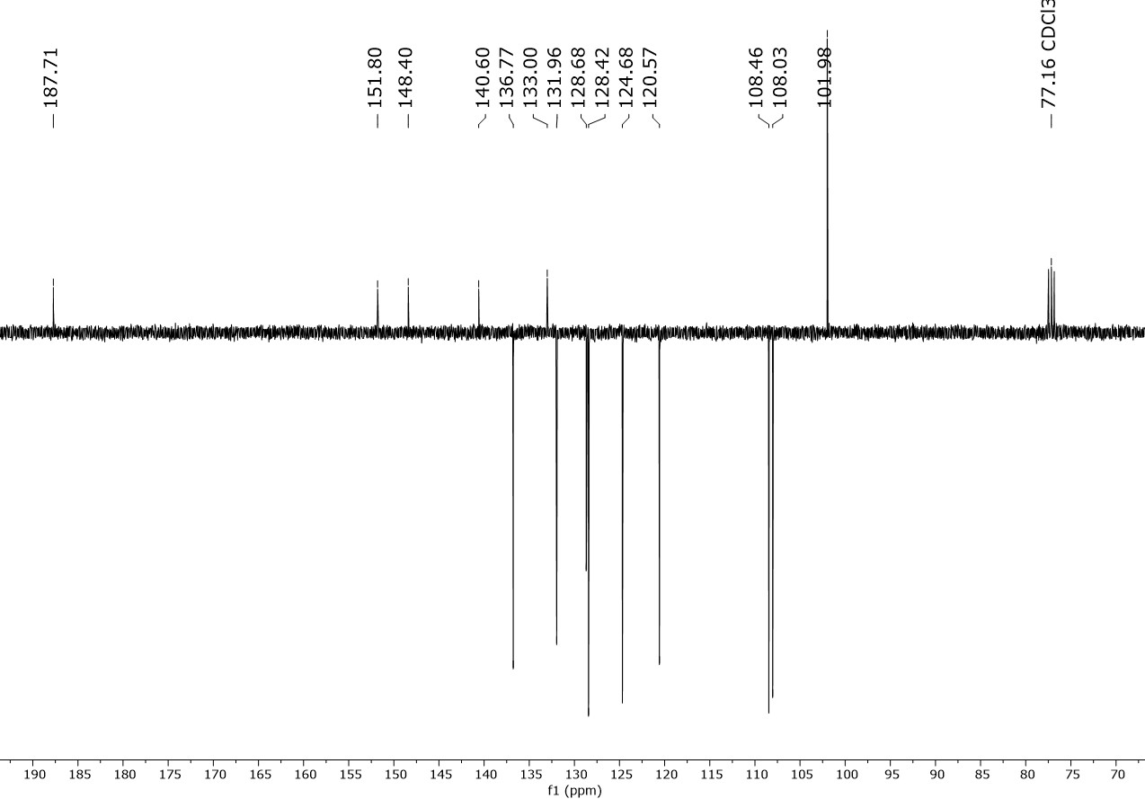
Figure 26: Mass spetrum HRMS (ESI-TOF+) Compound CP09.
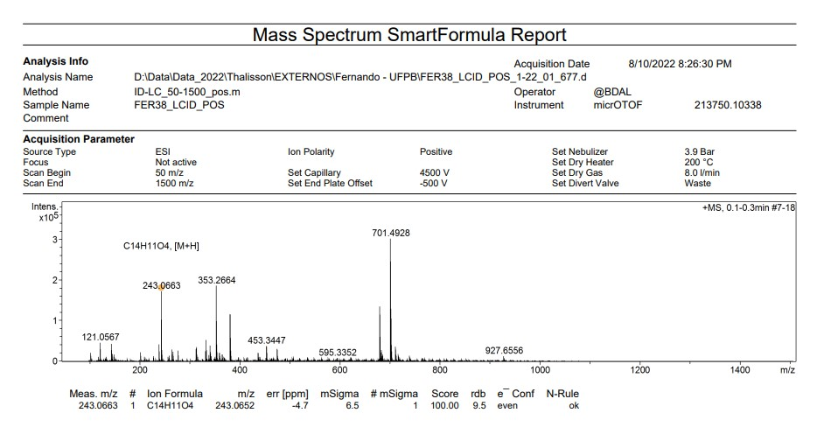

Figure 27: ¹H RMN (CDCl₃, 400 MHz) Compound 10 (CP10)
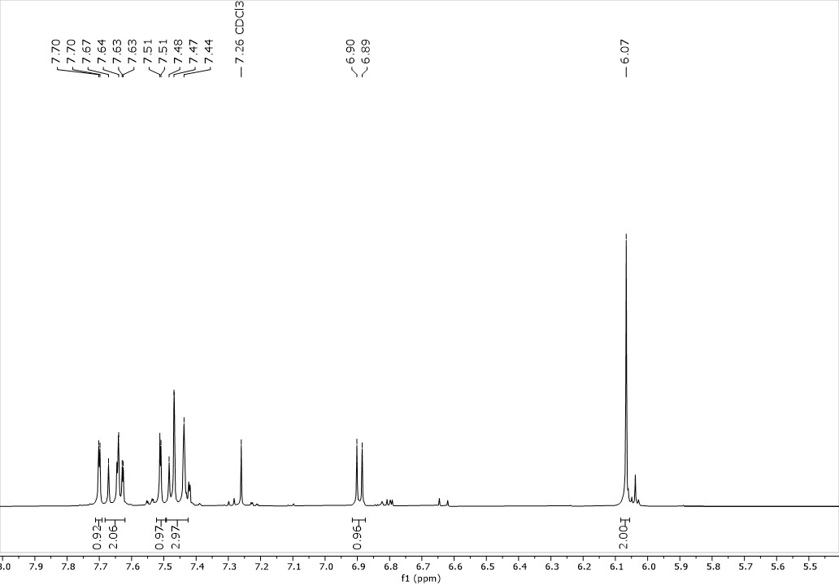
Figure 28: ¹³C RMN (CDCl₃, 100 MHz) Compound 10 (CP010)
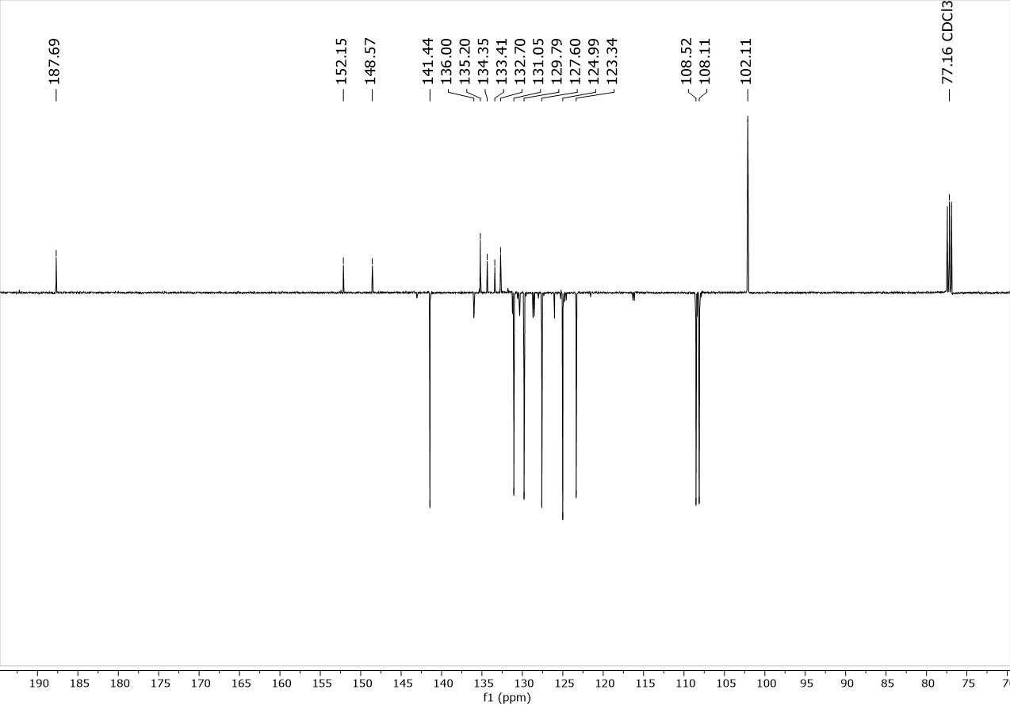
Figure 29: Mass spetrum HRMS (ESI-TOF+) Compound CP10.
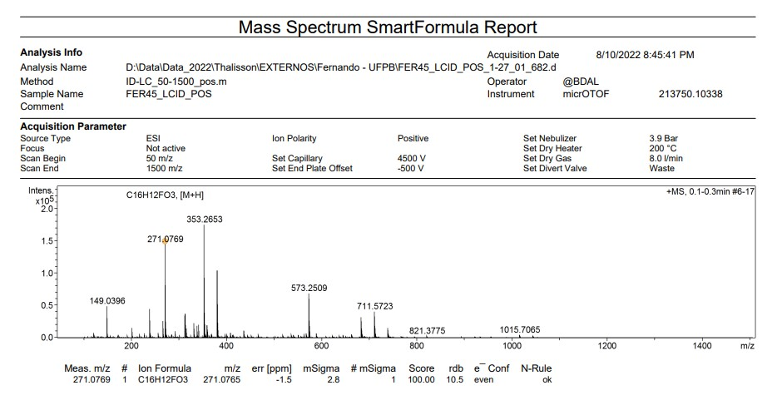

Figure 30: Graph of antileishmanial activity of compounds CP03, CP04 e CP06.
