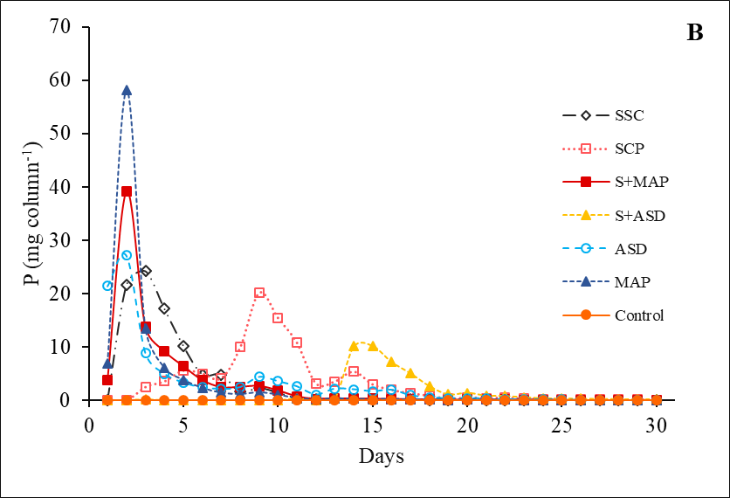
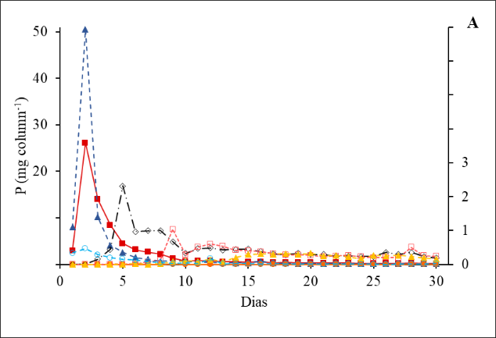
SUPPLEMENTARY MATERIAL

Figure S1. Daily leaching of P from the soil columns, with deionized water (A – left vertical axis for MAP and C+MAP, and right for the others) and citric acid (B). SSC = organic sewage sludge compost; SCP = pelletized organic sewage sludge compost; S+MAP = organic sewage sludge compost + MAP; S+ASD= organic sewage sludge compost + AshDec®; ASD = AshDec®; MAP = monoammonium phosphate

Table S1. Chemical analysis of sewage sludge and organic sewage sludge compost from WWT Bela Vista – Piracicaba, SP.
Determinations | Sewage sludge |  | Organic compost
 | Dry base (65°C) | Wet base | Dry base (65°C) | Wet base
pH (CaCl₂ 0,01 M) | - | 7,1 | - | 6,4
 | ------- % -------
Total organic matter | 72.64 | 11.47 | 67.92 | 65.42
Organic Carbon | 31.22 | 4.93 | 36.52 | 35.18
Total mineral residue | 20.96 | 3.31 | 26.76 | 25.78
Nitrogen (N) | 6.78 | 1.07 | 3.73 | 3.59
Phosphorus (P₂O₅) | 2.41 | 0.38 | 2.46 | 2.37
Potassium K₂O) | 0.19 | 0.03 | 1.10 | 1.06
Calcium (Ca) | 0.82 | 0.13 | 3.08 | 2.97
Magnesium (Mg) | 0.32 | 0.05 | 0.63 | 0.61
Sulfur (S) | 0.13 | 0.02 | 0.52 | 0.50
 | ------- mg/kg -------
Copper (Cu) | 108 | 17 | 94 | 91
Manganese (Mn) | 196 | 31 | 274 | 264
Zinc (Zn) | 469 | 74 | 407 | 392
Iron (Fe) | 12,483 | 1,971 | 13,073 | 12,592
Boron (B) | 25 | 4 | 15 | 14
Sodium (Na) | 969 | 153 | 898 | 865

Table S2. Soil P fractionation of columns leached with deionized water. Fractions separated by lability.
P source | Labile | Mod lalibe | Non labile | Labile | Mod labile | Non labile
 | ------------------------------- mg kg⁻¹ ------------------------------
 |  | 0 - 1 |  |  | 1 – 2
Control | 17.11 e | 40.36 c | 61.76 c | 15.04 d | 39.88 c | 74.79 b
SSC | 180.52 d | 140.36 b | 87.76 b | 157.57 a | 161.50 a | 72.67 b
SCP | 166.82 d | 90.10 b | 74.70 c | 124.43 b | 80.59 b | 60.71 b
S+MAP | 147.71 d | 118.96 b | 116.73 b | 123.95 b | 100.26 b | 61.49 b
S+ASD | 1,165.48 b | 66.69 c | 77.72 c | 58.00 c | 63.36 b | 62.13 b
ASD | 1,732.43 a | 7,774.74 a | 312.90 a | 179.79 a | 193.24 a | 105.19 a
MAP | 306.37 c | 191.87 b | 95.98 b | 138.69 b | 99.94 b | 66.48 b
 |  | 2 - 6 |  |  | 6 – 10
Control | 15.77 d | 40.02 c | 66.10 ^{ns} | 16.56 c | 42.90 c | 78.06 a
SSC | 150.10 a | 103.31 a | 74.15 | 138.34 a | 166.40 a | 75.60 a
SCP | 118.02 b | 88.01 a | 65.55 | 109.14 a | 89.65 b | 64.41 b
S+MAP | 101.83 b | 79.56 a | 63.96 | 146.76 a | 97.38 b | 71.70 b
S+ASD | 50.85 c | 60.45 b | 60.66 | 49.91 c | 58.79 c | 64.55 b
ASD | 54.85 c | 89.46 a | 66.16 | 43.89 c | 88.53 b | 83.98 a
MAP | 76.08 c | 94.53 a | 72.77 | 82.04 b | 87.71 b | 85.01 a
Equal letters do not differ statistically according to the Scott-Knott test at 5% significance level (n=3). SSC = organic sewage sludge compost; SCP = pelletized sludge compost; S+MAP = compost + MAP; S+ASD = compost + AshDec®; ASD = AshDec®; MAP = monoammonium phosphate; and control.
Table S3. Soil P fractionation from columns leached with 2% citric acid. Fractions separated by lability.
P source | Labile | Mod labile | Non-labile | Lábil | Mod lábil | Não lábil
 | ---------------------------- mg kg⁻¹ ----------------------------
 |  | 0-1 |  |  | 1-2
Control | 17.85 b | 33.71 ^{ns} | 56.92 ^{ns} | 28.73 b | 31.53 b | 58.55 ^{ns}
SSC | 24.83 b | 55.54 | 47.75 | 20.40 b | 46.46 a | 44.04
SCP | 38.85 a | 61.22 | 43.47 | 53.27 a | 59.77 a | 52.34
S+MAP | 21.36 b | 46.34 | 44.08 | 27.62 b | 44.05 a | 41.05
S+ASD | 35.70 a | 47.66 | 45.43 | 42.04 a | 50.24 a | 45.83
ASD | 21.89 b | 43.23 | 49.54 | 21.89 b | 46.70 a | 50.66
MAP | 17.46 b | 45.26 | 45.37 | 17.87 b | 46.05 a | 59.13
 |  | 2 – 6 |  |  | 6 - 10
Control | 13.64 d | 41.23 ^{ns} | 59.61 ^{ns} | 12.35 d | 31.30 ^{ns} | 49.92 a
SSC | 21.17 c | 48.69 | 44.95 | 23.34 c | 47.24 | 44.94 b
SCP | 39.54 a | 56.93 | 49.40 | 42.35 b | 48.78 | 44.12 b
S+MAP | 30.58 b | 42.66 | 48.28 | 27.77 c | 38.92 | 53.37 a
S+ASD | 34.64 b | 49.66 | 52.31 | 41.38 b | 49.29 | 55.01 a
ASD | 25.25 c | 47.61 | 49.27 | 72.32 a | 50.41 | 52.40 a
MAP | 26.33 c | 43.37 | 55.09 | 29.04 c | 44.88 | 71.10 a
Equal letters do not differ statistically according to the Scott-Knott test at 5% significance level (n=3). SSC = organic sewage sludge compost; SCP = pelletized sludge compost; S+MAP = compost + MAP; S+ASD = compost + AshDec®; ASD = AshDec®; MAP = monoammonium phosphate; and control.

Table S4. Soil P fractionation of columns leached with deionized water. Fractions separated by extractors.
Tratamento | Lábil |  |  | Moderadamente Lábil |  |  | Não Lábil
 | P (mg kg-1)
 | P-RTA | Pi-Bic | Po-Bic | Pi-Hid 0,1 | Po-Hid 0,1 | P-HCl | Pi-Hid 0,5 | Po-Hid 0,5 | P resid. | Total
 | 0 - 1
Controle | 1.2 | 1.9 | 14.0 | 9.5 | 28.8 | 2.0 | 15.6 | 9.5 | 36.7 | 119.2
CLE | 97.1 | 78.3 | 5.1 | 116.0 | 10.8 | 13.5 | 20.3 | 13.5 | 53.9 | 408.6
CLP | 105.2 | 41.7 | 19.8 | 79.4 | 2.9 | 7.8 | 15.6 | 8.3 | 50.8 | 331.6
C+MAP | 79.8 | 46.2 | 21.7 | 79.4 | 2.9 | 7.8 | 16.6 | 17.2 | 82.9 | 383.4
C+ASD | 63.1 | 12.9 | 1259.0 | 98.1 | 12.4 | 8.5 | 14.5 | 11.4 | 51.8 | 1479.5
ASD | 630.1 | 1017.8 | 84.5 | 142.7 | 133.0 | 7499.0 | 133.6 | 46.1 | 91.0 | 9777.9
MAP | 128.8 | 211.3 | 18.4 | 171.4 | 11.9 | 8.6 | 19.4 | 9.0 | 67.5 | 646.2
 | 1 - 2 cm
Controle | 0.9 | 2.5 | 11.6 | 10.0 | 27.8 | 2.0 | 13.1 | 3.8 | 57.9 | 129.7
CLE | 80.5 | 53.8 | 23.2 | 122.1 | 23.5 | 16.0 | 16.9 | 12.7 | 43.1 | 391.8
CLP | 74.8 | 28.6 | 21.0 | 62.6 | 13.0 | 5.0 | 13.1 | 8.8 | 38.8 | 265.7
C+MAP | 66.5 | 43.4 | 14.0 | 71.5 | 22.9 | 5.8 | 14.2 | 10.3 | 37.0 | 285.7
C+ASD | 34.2 | 5.2 | 18.6 | 46.2 | 13.4 | 3.8 | 12.3 | 8.4 | 41.4 | 183.5
ASD | 87.0 | 75.0 | 17.7 | 80.5 | 1.3 | 111.4 | 33.0 | 19.0 | 53.2 | 478.2
MAP | 69.7 | 51.4 | 17.6 | 77.6 | 17.1 | 5.2 | 16.6 | 8.9 | 41.0 | 305.1
 | 2 - 6 cm
Controle | 1.2 | 2.3 | 12.3 | 10.6 | 27.3 | 2.2 | 12.5 | 6.3 | 47.3 | 121.9
CLE | 72.9 | 66.9 | 10.3 | 85.7 | 7.1 | 10.5 | 16.5 | 13.3 | 44.4 | 327.6
CLP | 72.4 | 34.7 | 10.9 | 74.1 | 7.9 | 6.0 | 14.3 | 7.3 | 43.9 | 271.6
C+MAP | 58.9 | 33.0 | 9.9 | 69.7 | 4.9 | 5.0 | 13.8 | 8.5 | 41.6 | 245.3
C+ASD | 27.8 | 12.8 | 10.2 | 37.6 | 19.1 | 3.8 | 37.6 | 19.1 | 3.8 | 171.8
ASD | 27.8 | 12.8 | 10.2 | 63.2 | 17.9 | 8.4 | 18.7 | 5.8 | 41.6 | 206.5
MAP | 26.5 | 32.5 | 17.1 | 66.1 | 23.5 | 5.0 | 15.6 | 10.2 | 47.0 | 243.4
 | 6 - 10 cm
Controle | 1.2 | 2.4 | 13.0 | 11.6 | 28.8 | 2.5 | 17.8 | 2.4 | 57.9 | 137.5
CLE | 63.3 | 69.7 | 5.3 | 141.5 | 10.7 | 14.2 | 19.5 | 10.1 | 46.1 | 380.3
CLP | 56.8 | 37.4 | 14.9 | 75.1 | 7.6 | 6.9 | 15.1 | 6.8 | 42.5 | 263.2
C+MAP | 57.6 | 42.8 | 46.4 | 79.5 | 11.6 | 6.3 | 15.2 | 8.6 | 37.9 | 305.8
C+ASD | 29.9 | 6.6 | 13.3 | 44.5 | 10.3 | 4.0 | 11.9 | 7.4 | 45.3 | 173.2
ASD | 14.9 | 25.4 | 3.6 | 60.8 | 17.6 | 10.1 | 18.3 | 5.9 | 59.8 | 216.4
MAP | 24.5 | 41.4 | 16.2 | 69.6 | 12.6 | 5.5 | 15.7 | 8.9 | 60.4 | 254.8
SSC = organic sewage sludge compost; SCP = pelletized sludge compost; S+MAP = compost + MAP; S+ASD = compost + AshDec®; ASD = AshDec®; MAP = monoammonium phosphate; and control.

Table S5. Soil P fractionation of the columns leached with 2% citric acid. Fractions separated by extractors.
P source | Labile |  |  | Moderately-labile |  |  | Non-labile
 | P (mg kg⁻¹)
 | Resin | NaHCO₃(i) | NaHCO₃(o) | NaOH 0.1(i) | NaOH 0.1(o) | HCl | NaOH 0.5(i) | NaOH 0.5(o) | Residual | Total
0-1
Control | 7.2 | 4.4 | 6.3 | 7.1 | 25.9 | 0.7 | 15.9 | 4.7 | 36.4 | 108.5
SSC | 9.8 | 7.0 | 8.0 | 15.2 | 38.9 | 1.4 | 6.9 | 3.9 | 37.0 | 128.1
SCP | 11.3 | 14.4 | 13.1 | 20.5 | 37.9 | 2.8 | 8.8 | 4.0 | 30.6 | 143.5
S+MAP | 6.7 | 6.3 | 7.1 | 11.5 | 34.0 | 0.8 | 7.2 | 6.6 | 30.3 | 110.6
S+ASD | 13.5 | 12.5 | 9.7 | 19.7 | 26.4 | 1.6 | 8.7 | 6.3 | 30.5 | 128.8
ASD | 6.6 | 13.6 | 1.7 | 14.7 | 23.7 | 4.8 | 14.1 | 1.2 | 34.3 | 114.7
MAP | 6.7 | 7.1 | 3.7 | 20.4 | 22.3 | 2.6 | 7.4 | 3.9 | 34.1 | 108.1
1-2
Control | 9.9 | 5.8 | 13.1 | 7.4 | 23.1 | 1.0 | 13.8 | 8.0 | 36.7 | 118.8
SSC | 5.9 | 6.3 | 8.2 | 16.1 | 28.7 | 1.6 | 7.8 | 3.4 | 32.9 | 110.9
SCP | 13.8 | 14.1 | 18.9 | 19.8 | 30.4 | 2.5 | 9.1 | 5.2 | 38.0 | 151.8
S+MAP | 6.2 | 6.3 | 15.2 | 12.8 | 30.3 | 0.9 | 6.9 | 5.5 | 28.6 | 112.7
S+ASD | 13.9 | 12.8 | 15.4 | 19.5 | 28.9 | 1.8 | 8.9 | 3.1 | 33.9 | 138.1
ASD | 9.0 | 10.5 | 2.3 | 17.7 | 25.3 | 3.8 | 11.0 | 4.0 | 35.7 | 119.3
MAP | 8.8 | 7.0 | 2.1 | 18.0 | 23.5 | 4.6 | 8.0 | 8.3 | 42.8 | 123.1
2-6
Control | 4.4 | 3.9 | 5.3 | 6.9 | 24.7 | 9.6 | 13.7 | 7.1 | 38.9 | 114.5
SSC | 9.0 | 8.7 | 3.4 | 18.4 | 28.6 | 1.7 | 8.1 | 3.2 | 33.6 | 114.8
SCP | 14.8 | 14.0 | 10.7 | 20.4 | 31.4 | 2.3 | 9.8 | 6.2 | 33.4 | 143.0
S+MAP | 12.9 | 6.8 | 10.9 | 16.4 | 24.9 | 1.4 | 7.6 | 10.1 | 30.6 | 121.5
S+ASD | 16.7 | 14.5 | 3.4 | 20.4 | 26.8 | 2.4 | 13.3 | 8.0 | 31.0 | 136.6
ASD | 9.4 | 13.5 | 2.4 | 19.7 | 25.4 | 2.5 | 10.9 | 1.4 | 37.0 | 122.1
MAP | 13.3 | 9.8 | 3.2 | 19.5 | 21.0 | 2.8 | 9.0 | 6.1 | 40.0 | 124.8
6-10
Control | 4.9 | 4.1 | 3.4 | 6.5 | 23.8 | 1.0 | 11.0 | 7.0 | 31.9 | 93.6
SSC | 10.3 | 9.4 | 3.6 | 20.5 | 25.0 | 1.7 | 8.3 | 3.2 | 33.4 | 115.5
SCP | 18.7 | 14.5 | 6.0 | 22.1 | 18.8 | 2.5 | 10.3 | 3.0 | 27.3 | 123.2
S+MAP | 11.0 | 10.1 | 6.7 | 18.1 | 18.8 | 2.0 | 9.7 | 8.4 | 35.2 | 120.1
S+ASD | 21.8 | 15.4 | 4.2 | 22.9 | 22.1 | 4.2 | 9.5 | 4.6 | 40.9 | 145.7
ASD | 19.4 | 12.5 | 40.4 | 21.8 | 24.0 | 4.6 | 9.0 | 2.8 | 40.6 | 175.1
MAP | 12.8 | 9.3 | 7.0 | 20.9 | 19.6 | 1.7 | 8.8 | 4.5 | 57.8 | 142.4
SSC = organic sewage sludge compost; SCP = pelletized sludge compost; S+MAP = compost + MAP; S+ASD = compost + AshDec®; ASD = AshDec®; MAP = monoammonium phosphate; and control.

