Table S1: Vaccination History of Participants

 | N
mRNA Vaccination preceeding PACVS Onset
Moderna (SpikeVax) | 32
BioNTech (Comirnatry) | 159
Vaccination Cycles before PACVS Onset
1 cycle | 47
2 cycles | 96
3 cycles | 48
Vaccination Regimen before PACVS Onset
1x BioNTech  2x BioNTech  3x BioNTech | 41  72  27
1x Moderna  2x Moderna  3x Moderna | 6  11  6
Moderna/ BioNTech  2x BioNTech/ Moderna  2x Moderna/ BionNTech | 1  8  2
Astra-Zeneca/ BioNTech  Astra-Zeneca/ Moderna  Astra-Zeneca/ 2x BioNTech | 7  1  5
Janssen/ BioNTech  Janssen/ Moderna | 3  1

Table S2: Meta Data and In-/Exclusion Criteria of Controls and PACVS Subjects

Controls  Inclusion:  Exclusion: | N = 89 , Gender: 71 female, 18 male (p<0.001)  Age (years, range/mean/median): 21 - 64, 39/49 (p<0.0001)  Initial dual vaccination with Spikevax (Moderna), spaced six weeks  Monitoring period: six months after second vaccination  Donation of serum sample 48 h before first and 6 months after second vaccination  De novo disease symptoms during monitoring period:  - Immunological/ rheumatological disorders (myalgia, RBV-reactivation, inflammation, arthritis)  - Cardiovascular disorder (pressure crisis, heart insufficiency, arrhythmia, sinus tachycardia, ischemia)  - Neurologic disorder (cognitive impairment, peripheral nerve dysfunction, muscular fibrillation or paresis)  - Other disease or health condition entailing occupational impairment  Increased laboratory markers in post-vaccination serum:  - IL-6 > 7 pg/ml, CRP > 0.5 mg/dl, pBNP > 125 pg/ml, TpT > 11 ng/ml, IgG < 700, >1600 mg/dL  - SARS-CoV-2 nucleocapsid antibodies indicative of passed SARS-CoV-2 infection
Participants.  Inclusion:  Exclusion: | N = 191, Gender: 159 females, 32 males (p<0.001)  Age (years, range, mean/median): 18 - 66, 40/39 years (p<0.0001)  Development of symptoms or disease after SARS-CoV-2 vaccination with mRNA-vaccine (Moderna or Pfizer/BioNTech)  Established or suspected diagnosis of syndrome or ≥3 symptoms thereof¹  Start of symptoms ≥ 1 week after first and/or ≤ 4 weeks after last vaccination  Persistent symptoms for ≥ 5 months  Completion of on-line query  Donation of serum sample at ≥ 5 months after onset of symptoms  Diseases/ syndromes (only included if occurring/diagnosed¹ after SARS-CoV-2 vaccination):  - Myalgic Enzephalomyelitis/Chronic Fatigue Syndrome (ME/CFS)  - Post-Covid-19/long Covid-19 syndrome in the absence of SARS-CoV-2-infection  - Post vaccination syndrome  - Postural Tachycardia Syndrome (POTS)  - Mastcell activation syndrome (MCAS)  - Fibromyalgia/chronic pain syndrome  - Peri-/Myocarditis  - Thrombosis  - Small fiber neuropathy (SFN)  - Bell’s palsy  - Guillain-Barré syndrome (GBS)  - Vaccine-induced hyperinflammation  - Other adverse vaccination reactions including herpes zoster  Included symptoms (≥3):  - Immunological/ rheumatological disorders (e.g. myalgia, joint pain, swollen/painful lymph nodes)  - Cardiovascular disorder (e.g. orthostatic intolerance, arrhythmia, sinus tachycardia, palpitations)  - Neurologic disorder (e.g. cognitive impairment, peripheral nerve dysfunction, sensomotor paresis)  - Other consensus symptoms of ME/CSF [7]  Potentially confounding chronic medication pre- and post-vaccination  - anti-psychotic, anti-depressive  - immunosuppressive, anti-proliferative, anti-inflammatory  - anti-biotic  - immunomodulative treatment after vaccination  Potentially confounding health condition existing before vaccination  - immunological disease (e.g. Post-COVID, Long-COVID, rheumatic disease  - musculoskeletal disease (e.g. ME/CFS, Fibromyalgia, Complex regional pain syndrome)  - neurological disease (e.g. Multiple Sclerosis, Neuromyelitis Optica spectrum disorders, GBS, Chronic inflammatory demyelinating polyneuropathy (CIPD), Polyneuropathy other origin than CIPD)  - Psychiatric disorder (e.g. Depression, Anxiety disorder, Post-traumatic stress disorder, Obsessive compulsive disorder)  - Malignancies, transplantations  Symptoms following other vaccination (incl. non-mRNA SARS-CoV-2 vaccination)
¹By a physician in hospital or general practice
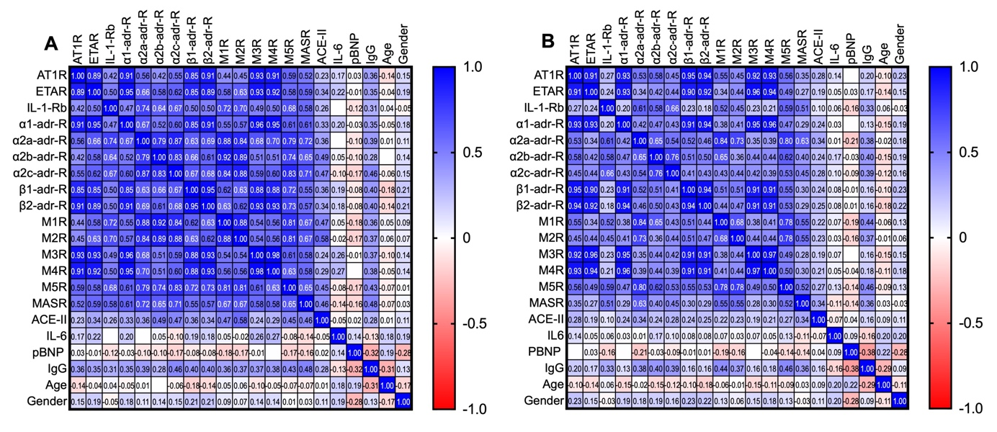

Figure S1. Co-variance of Receptor Antibodies in Serum of healthy Volunteers (n=89): Age, gender and serum values determined 48 h before first (A) and 6 months after second (B) SARS-CoV-2 vaccination (Spikevax, Moderna). Numerical values: Spearmans’s R, values ≥ 0.7 considered significant (p < 0.0001).

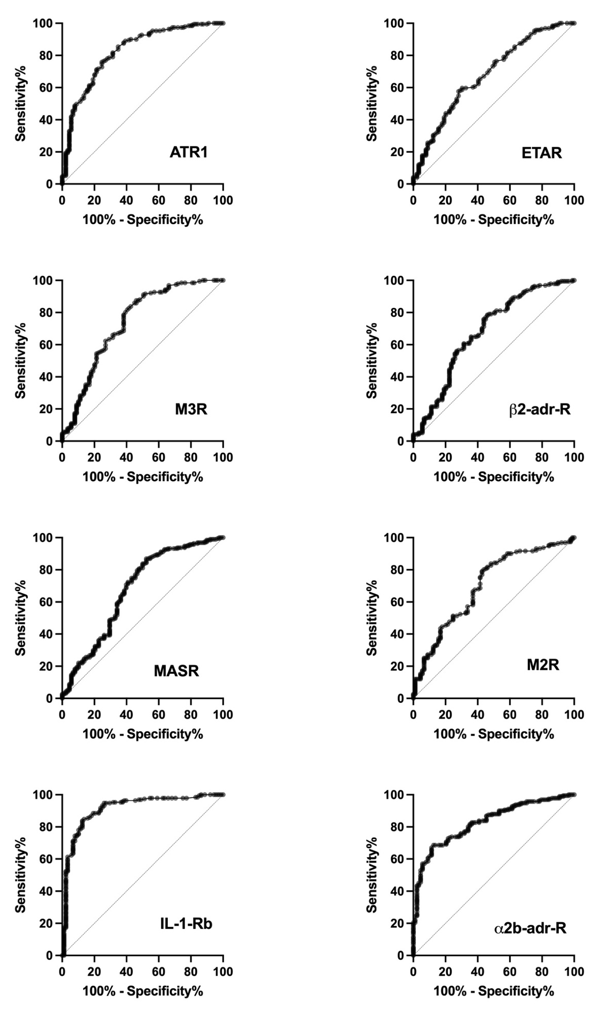

Figure S2. ROC curves of Receptor Antibodies discriminating PACVS Subjects from post-Vaccination Controls

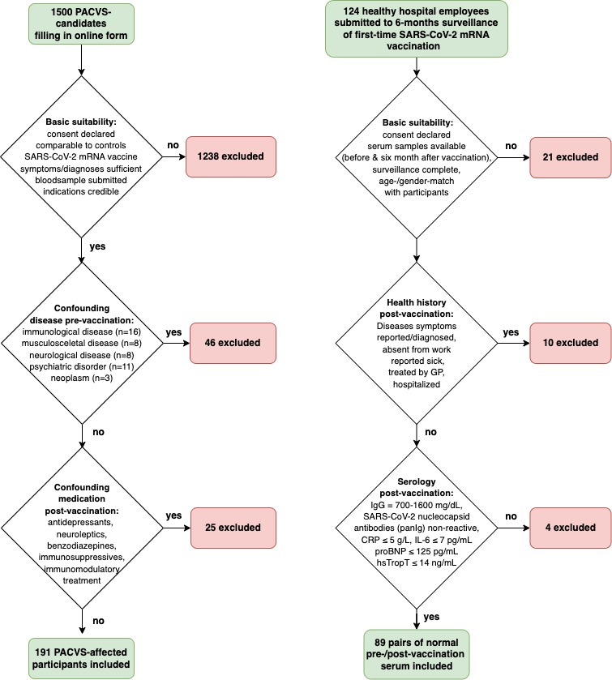

Figure S3. Flow charts of inclusion of study participants (left) and controls (right). In- /exclusion criteria are listed in Suppl. Tab. 1. Serological surveillance of healthy hospital employees used as source for controls as described in [37]

