Cytokine levels in saliva are associated with salivary gland fibrosis and hyposalivation in mice after fractionated radiotherapy of the head and neck

Supplementary figures

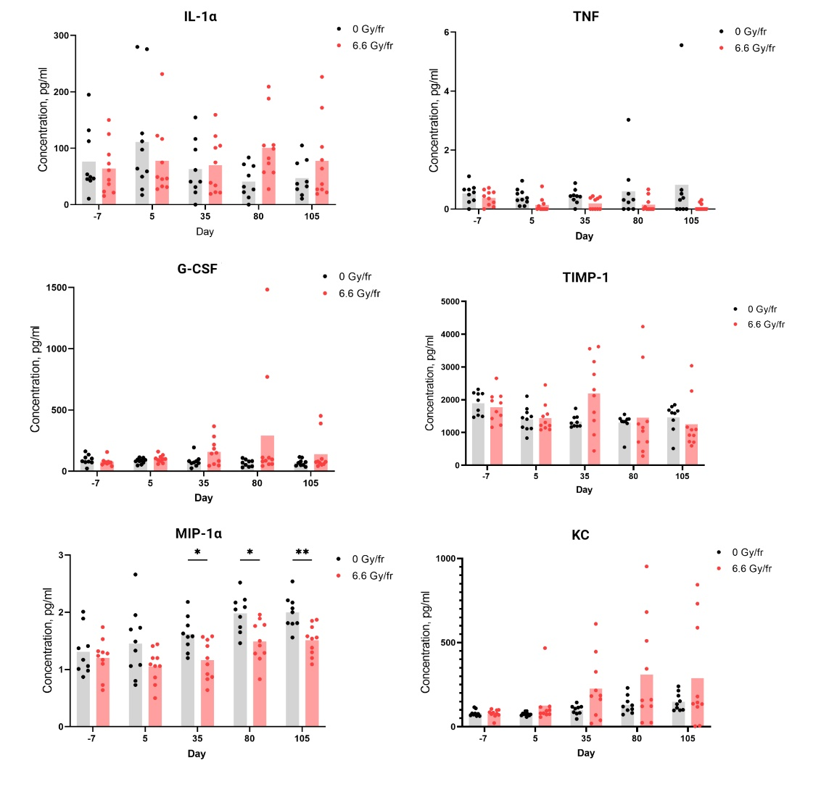
Figure S1. Levels of serum cytokines IL-1α, MIP-1α, KC, G-CSF, TIMP-1 and TNF before and after fractionated irradiation at day -7, 5, 35, 80 and 105 (n = 9 in the control group, n = 10 in the irradiated group). Data are presented as mean pg/ml cytokine (*p<0.05, **p<0.01).
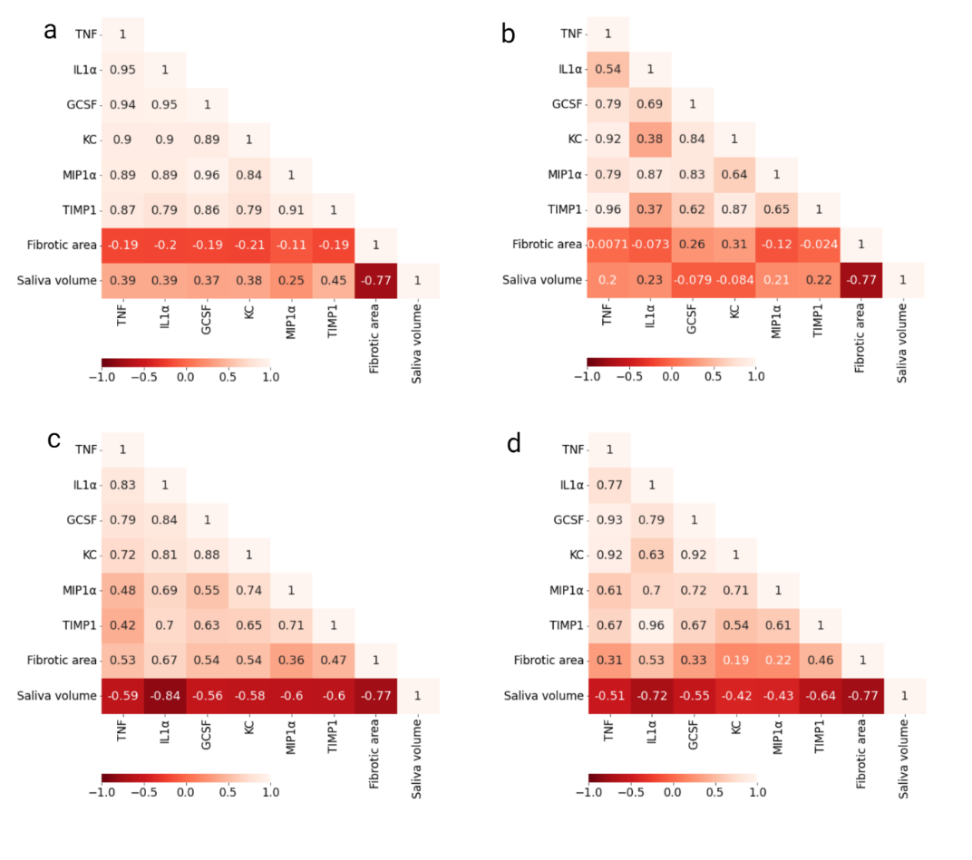
Figure S2. Pearson’s correlation matrix for combined (controls and irradiated) salivary cytokine expression on: (a) baseline, (b) day 5, (c) day 80, (d) day 105.

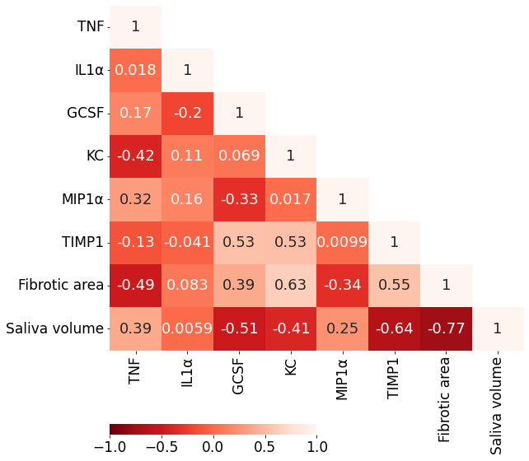
Figure S3. Pearson’s correlation matrix for combined cytokine levels in serum on day 35.

