Supplementary Methods

Cell isolation by collagenase digestion
Following initial aortic dissection and longitudinal incision, collagenase solution (0.25 mg/ml in Medium 199 with Earle’s salts, M199E; sterile filtered; 37°C) was applied to the luminal surface and incubated at room temperature for 10 minutes. The aorta was held in a ‘boat’ made from aluminium foil to ensure the collagenase solution bathed the luminal surface of the vessel and did not come into contact with the cut surfaces. Following incubation, the collagenase solution was gently aspirated and transferred to a sterile 15 ml tube for centrifugation (300 x g, 5 min, 20°C). Resuspended cells were cultured in M199E supplemented with 20% horse serum, 100 U/ml penicillin and 100 U/ml streptomycin.

Optimisation of culture conditions for EAoECs
The compositions of the media used in these studies are detailed in Table 1. Pooled isolates of EAoECs were split and cultured under identical conditions in either M199E or complete EGM2, both supplemented with 20% horse serum and antibiotics. Cells were observed under phase contrast light microscopy for growth characteristics and morphology. Growth rate was quantified by measuring proliferation as described in the main manuscript. Having observed that cells cultured in complete EGM2 had an elongated morphology, separate batches of 3 to 4 pooled isolates of EAoECs were split into tissue culture flasks (25 cm²) and cultured in complete EGM2 or EBM. Morphology was quantified by measuring cell length and width from phase contrast images of confluent cells. Following the observation that culture in EBM led to morphology more consistent with quiescent endothelial cells, culture conditions were further optimised by taking pooled isolates of EAoECs and splitting as above to culture in EBM alone or EBM plus endothelial cell growth supplement (ECGS). Cells cultured in EBM and EBM plus ECGS were then assessed for their behaviour in the tube formation assay. Cells cultured in EBM were also assessed for their proliferation rate in response to different concentrations of equine serum.

Magnetic-activated cell sorting
Confluent EAoECs were detached using trypsin-EDTA (0.05%), centrifuged (300 x g, 5 min, 4°C) and resuspended in 1 ml buffer (Ca²⁺- and Mg²⁺-free phosphate buffered saline (PBS) with 0.1% bovine serum albumin (BSA) and 2 mM EDTA). Conjugated beads (25 μl) were added to the cells in a 15 ml centrifuge tube. The tube was incubated at 4°C on a roller for 20 minutes, then placed in a magnet (DynaMag-15, ThermoFisher) for 2 minutes to allow the magnetic beads and bound cells to migrate to the sides of the tube. The remaining cell suspension was aspirated and either discarded or transferred to a tissue culture flask for continued culture. The tube was removed from the magnet, cells resuspended in buffer (Ca²⁺-and Mg²⁺-free PBS with 0.1% BSA, pH 7.4) and the tube returned to the magnet. This washing process was repeated twice. The cells were resuspended in EGM2 supplemented with 1% horse serum, 1mM CaCl₂, 5 mM MgCl₂ and 2% DNase (pH 7.0-7.4, 37°C, 200 μl) and then incubated on a roller at 20°C for 15 min to detach the beads from the sorted cells (beads were not removed from the suspension following incubation since this process led to loss of cells in preliminary experiments). Following incubation, the cell suspension was diluted in EBM (final volume 12 ml) and transferred to gelatin-coated flasks for continued culture.

Western blotting
EAoECs were plated onto gelatin-coated 6-well plates (300,000 cells/well) and grown to confluence. Cells were serum-deprived in EGM2 + 1% horse serum for 1 hour. The medium was aspirated, replaced with treatments (made up in EGM2 + 1% horse serum) and incubated for the relevant time (as indicated in the figure legends). Treatments were used at concentrations that have been fully optimised in our human EC studies. Cells were lysed in protein lysis buffer (76.5 mM Tris.HCl, 10% Glycerol, 2% SDS, pH 6.8 with 10 µl/ml (v/v) protease and phosphatase inhibitor cocktail + 25 U/ml Basemuncher; Expedeon). Protein contents of lysates were estimated using a bicinchoninic acid (BCA) protein assay detection kit (Pierce; ThermoScientific, UK). Equal amounts of protein were separated by sodium dodecyl sulfate polyacrylamide gel electrophoresis (SDS-PAGE; 10% Mini-PROTEAN TGX Precast Protein Gels) using a Protean® electrophoresis system (Bio-Rad) and resolved proteins transferred to polvinylidine fluoride (PVDF) membrane (0.45 µm) under semi-dry conditions (Bio-Rad) as described previously [1]. PVDF membranes were blocked for 1 hour at room temperature in Tris-buffered saline with Tween (TBST; 50 mM Tris, 150 mM NaCl, 0.02% (v/v) Tween 20, pH 7.4) containing 3% BSA.
For immunodetection membranes were probed with primary antibody overnight (4˚C; supplemental table 2) followed by HRP- or fluorescent-conjugated secondary antibody (1 hour; room temperature). Proteins were detected by enhanced chemiluminescence or directly using an automated imaging instrument (ChemiDoc™ MP, Bio-Rad).
Band densities were semi-quantified by densitometry using Image J. Values were normalised to loading controls and data are expressed as fold change compared to experimental control.

Name | M199E | EBM | EBM + ECGS | EBM + VEGF | Complete EGM2
Base medium | M199 with Earle’s salts | Promocell Endothelial cell Basal Medium 2 | Promocell Endothelial cell Basal Medium 2 | Promocell Endothelial cell Basal Medium 2 | Promocell Endothelial cell Basal Medium 2
Growth supplements | Endothelial Cell Growth Supplement (20 𝛍g/ml) | None | Endothelial Cell Growth Supplement (20 𝛍g/ml) | VEGF-A (0.5 ng/ml) | EGF (5 ng/ml)  FGF-2 (10 ng/ml)  IGF (20 ng/ml)  VEGF-A (0.5 ng/ml)  Ascorbic Acid (1 𝛍g/ml)  Heparin (22.5 𝛍g/ml)  Hydrocortisone (0.2 𝛍g/ml)
Serum | 20% horse serum | 20% horse serum | 20% horse serum | 20% horse serum | 20% horse serum
Antibiotics | 100 U/ml penicillin 100 U/ml streptomycin | 100 U/ml penicillin 100 U/ml streptomycin | 100 U/ml penicillin 100 U/ml streptomycin | 100 U/ml penicillin 100 U/ml streptomycin | 100 U/ml penicillin 100 U/ml streptomycin
Table 1. Media compositions; VEGF-A (vascular endothelial growth factor), EGF (epithelial growth factor), FGF-2 (fibroblast growth factor-2), IGF (insulin-like growth factor).

Application | Primary/ secondary | Target | Clone | Host | Conjugate | Concentration | Diluent | Supplier
Western blotting | Primary | pERK 1/2 | Polyclonal | Rabbit | None | 1:1000 | 5% BSA in TBST | Cell Signalling Technologies
Western blotting | Primary | Total ERK | Polyclonal | Rabbit | None | 1:1000 | 5% BSA in TBST | Santa Cruz Biotechnology
Western blotting | Primary | B-actin | ACTNO5 | Mouse | None | 1:1500 | 5% BSA in TBST | Abcam
Western blotting | Secondary | Rabbit | Polyclonal | Goat | HRP | 1:5000 | 0.2% BSA in TBST | Cell Signalling Technologies
Western blotting | Secondary | Mouse | Polyclonal | Goat | Alexa Fluor 488 | 1:5000 | 0.2% BSA in TBST | Invitrogen
IF | Primary | VWF | Polyclonal | Rabbit | None | 1:1000 | PGAS | Dako
IF | Primary | VE-cadherin | 55-7H1 | Mouse | None | 1:1000 | PGAS | Invitrogen
IF | Primary | Smoothelin | Polyclonal | Rabbit | None | 1:100 | PGAS | Santa Cruz Biotechnology
IF | Secondary | Rabbit | Polyclonal | Goat | Alexa Fluor 488 | 1:500 | PGAS | Invitrogen
IF | Secondary | Rabbit | Polyclonal | Goat | Alexa Fluor 568 | 1:500 | PGAS | Invitrogen
IF | Secondary | Mouse | Polyclonal | Goat | Alexa Fluor 488 | 1:500 | PGAS | Invitrogen
IF | Secondary | Mouse | Polyclonal | Goat | Alexa Fluor 568 | 1:500 | PGAS | Invitrogen
IF | Secondary | Rat | Polyclonal | Goat | Alexa Fluor 488 | 1:500 | PGAS | Invitrogen
En face | Primary | VWF | Polyclonal | Rabbit | None | 1:1000 | 5% BSA in PBST | Dako
En face | Primary | VE-cadherin | 55-7H1 | Mouse | None | 1:50 | 5% BSA in PBST | Invitrogen
En face | Secondary | Rabbit | Polyclonal | Goat | Alexa Fluor 488 | 1:500 | PBST | Invitrogen
En face | Secondary | Mouse | Polyclonal | Goat | Alexa Fluor 568 | 1:500 | PBST | Invitrogen
FACS | Primary | VE-cadherin | 55-7H1 | Mouse | PE | 1:10 | 1% BSA in PBS | BD Biosciences
FACS | Primary | Isotype control | P3.6.2.8.1 | Mouse | PE | 1:25 | 1% BSA in PBS | eBioscience
Endothelial markers with no equine cross reactivity
IF | Primary | Mouse CD31 | MEC13.3 | Rat | None | 1:200 | PGAS | BD Biosciences
En face | Primary | Rat CD31 | TLD3-A12 | Mouse | None | 1:200 | PGAS | Sigma-Aldrich
IF | Primary | Human CD31 | 89C2 | Mouse | None | 1:200 | PGAS | Cell Signalling Technologies
IF | Primary | Human CD31 | JC/70A | Mouse | None | 1:25 | PGAS | Novus Bio
IF | Primary | Human CD31 | Polyclonal | Rabbit | None | 1:100 | PGAS | Abcam
IF | Primary | Human CD31 | Polyclonal | Rabbit | None | 1:200 | PGAS | Biorbyt
IF | Primary | VE-cadherin | Polyclonal | Rabbit | None | 1:500 | PGAS | Unknown
IF | Primary | VEGFR2 | 55B11 | Rabbit | None | 1:500 | PGAS | Cell Signalling Technologies
IF | Primary | Claudin-5 | A-12 | Mouse | None | 1:60 | PGAS | Santa Cruz Biotechnology
IF | Primary | ZO-1 | R40.76 | Rat | None | 1:60 | PGAS | Santa Cruz Biotechnology
IF | Primary | Ang-2 | MM0020-IF29 | Mouse | None | 1:50 | PGAS | Abcam
Table 2. Antibody details: BSA (bovine serum albumin), TBST (tris buffered saline with 0.02% Tween), IF (immunofluorescence), PGAS (phosphate, gelatin and saponin solution; 0.2 % gelatin, 0.02 % saponin, 0.02 % sodium azide in PBS), PBST (phosphate buffered saline with 0.1% triton-X).

cDNA synthesis mastermix (µl per 10 µl) |  | PCR mastermix  (µl per 18 µl)
RT buffer | 2 | Mastermix | 10
dNTP Mix | 0.8 | Primers (F+R) | 2
RT random primers | 2 | Nuclease-free water | 6
Reverse transcriptase | 1
Nuclease-free water | 4.2
Table 3. Mastermix composition for cDNA synthesis and PCR; RT (reverse transcriptase), dNTP (deoxyribonucleotide triphosphate), F + R (forward and reverse).

qPCR cycling conditions
Initial denaturation | 94°C | 2 min | 1 x
Denaturation | 94°C | 15 sec | 40 x
Annealing and extension | 60°C | 1 min | 40 x
Plate read |  |  | 40 x
Melt curve | 60°C - 95°C; 0.5°C increment | 5 sec | 70 x
Plate read | 60°C - 95°C; 0.5°C increment |  | 70 x
Table 4. PCR cycling conditions.

Gene | Sequence (forward, reverse)
Equine β-actin | ATGGATGATGATATCGCCG  CACGTATGAGTCCTTCTGG
Equine FGFR1 | GATGATGCGGGATTGTTGGC  GAGCTTCGGGTGTCAGGAAA
Equine FGFR2 | TCATCTGCCTGGTTGTGGTC  GATCATGGCGGCATCTCTCA
Equine VEGFR1 | CGCTTCACCTGGACTGAGAG  GAGGAGAGCAGCACGAGATC
Equine VEGFR2 | ATCTCTGGTCGTGAATGTC  CAATACCAGTGGATGTGATG
Equine NRP1 | GACCGAAACTGGATGCCTGA  TCTTCCAGTCCGAACCGTTG
Human β-actin | GACAGGATGCAGAAGGAGATTACT  TGATCCACATCTGCTGGAAGGT
Human FGFR1 | CAAACCAAACCGTATGCCCG  AGGTGGCATAACGGACCTTG
Human FGFR2 | CACGACCAAGAAGCCAGACT  GGTGTCTGCCGTTGAAGAGA
Human VEGFR1 | CCATCAGCAGTTCCACCACT  CTTCTGGTTGGTGGCTTTGC
Human VEGFR2 | GCAGGGGACAGAGGGACTTG  GAGGCCATCGCTGCACTCA
Human NRP1 | GCCAGAGGAGTACGATCAGC  TCATCCACAGCAATCCCACC
Table 5. PCR primer sequences.

Supplementary figures

Supplementary fig. S1. Effects of equine serum on EAoEC proliferation rate over 48 hours (*p<0.05; One-way ANOVA with Dunnett’s multiple comparisons test compared to 1%; mean ± S.E.M for n = 2 biological replicates with 3 technical repeats).
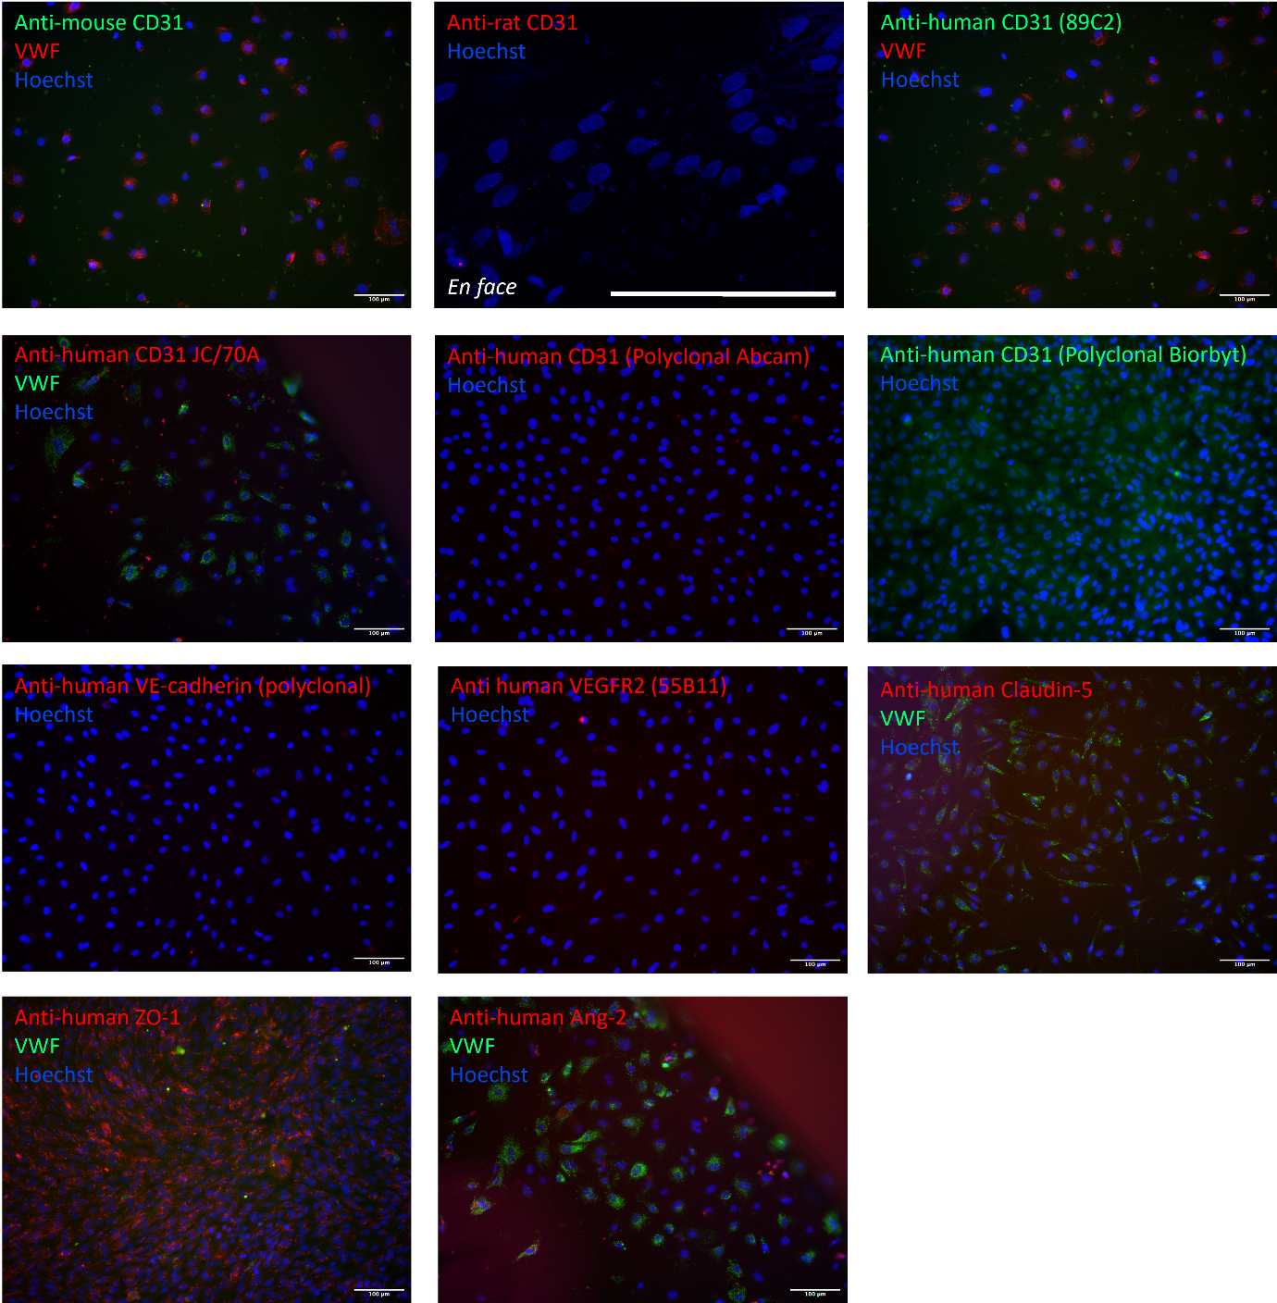

Supplementary fig. S2. Representative immunofluorescent images of cultured EAoECs or en face preparation of equine intercostal artery illustrating lack of cross reactivity, or non-specific staining, when using antibodies targeting specific endothelial cell markers. In some cases, cells were counterstained with VWF to confirm endothelial nature. Scale bars 100 μm.

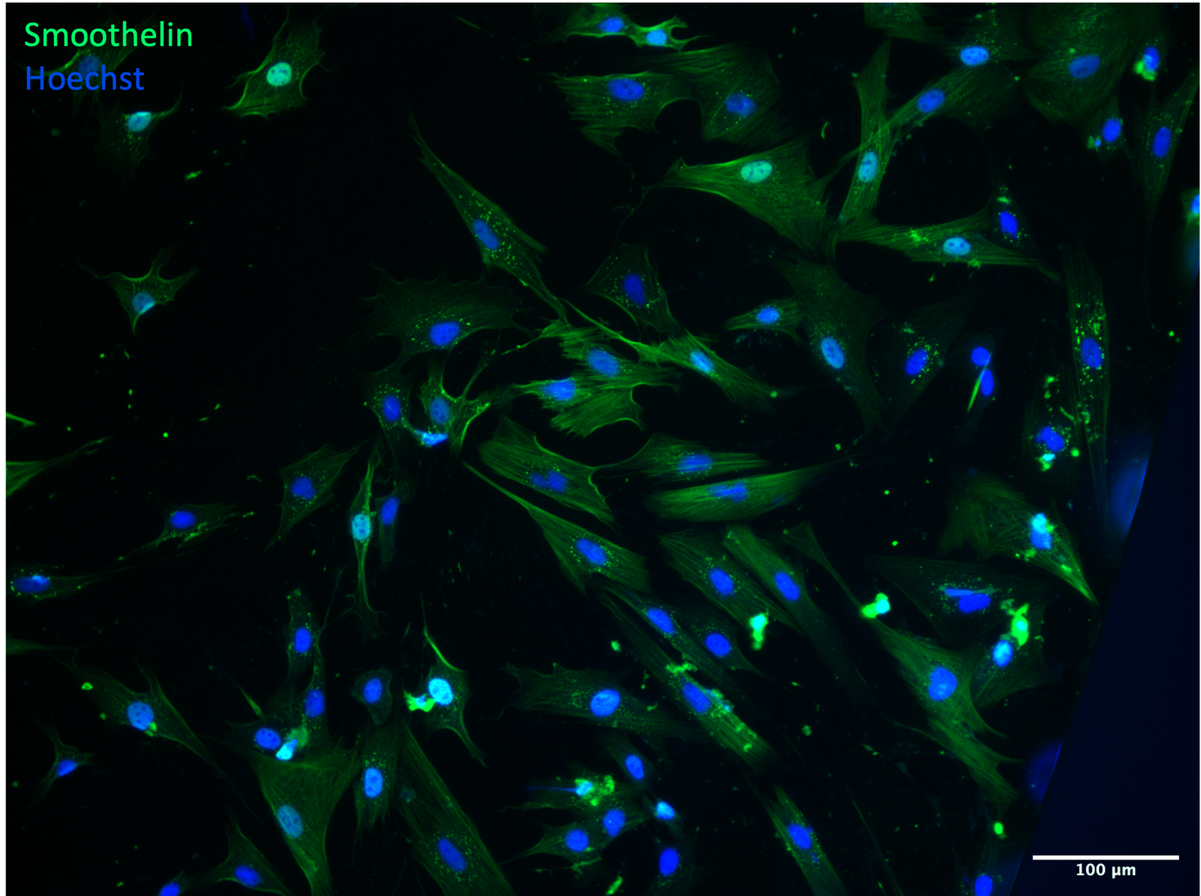

Supplementary fig. S3. Immunofluorescent image of a mixed population of cells (EC-poor) isolated from the equine aorta. Cells were fixed, permeabilised, blocked and stained using an antibody against smoothelin, a specific marker of vascular smooth muscle cells. Scale bar 100 μm.

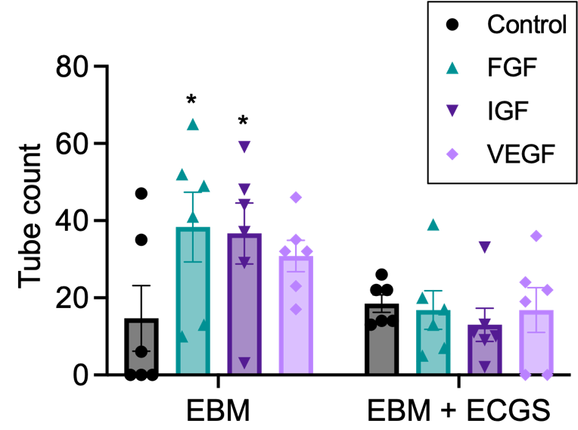

Supplementary fig. S4. EAoECs were exposed to FGF-2 (10 ng/ml), insulin-like growth factor (IGF; 50 ng/ml) or VEGF-A (25 ng/ml) for 16 hours and tube formation analysed. The pro-angiogenic response of ECs to growth factors was only observed with cells cultured in EBM and not those cultured in EBM supplemented with endothelial cell growth supplement (ECGS; *p = 0.03 (FGF-2) and *p = 0.05 (IGF); Two-way ANOVA with Dunnett’s multiple comparisons test compared to control. Data are mean ± S.E.M for n = 6 technical replicates.

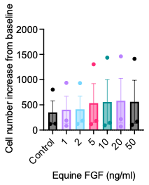
Supplementary fig. S5. EAoECs were exposed to FGF-2 at the indicated concentrations for 18 hours and cell proliferation analysed. No significant increase in cell number from control was identified at this time point. Data are mean ± S.E.M (n = 3 biological replicates) and were analysed by repeated measures one-way ANOVA with Dunnett’s multiple comparisons test.

1. Faulkner, A., et al., Context-dependent regulation of endothelial cell metabolism: differential effects of the PPARβ/δ agonist GW0742 and VEGF-A. Scientific Reports, 2020. 10(1): p. 7849.

