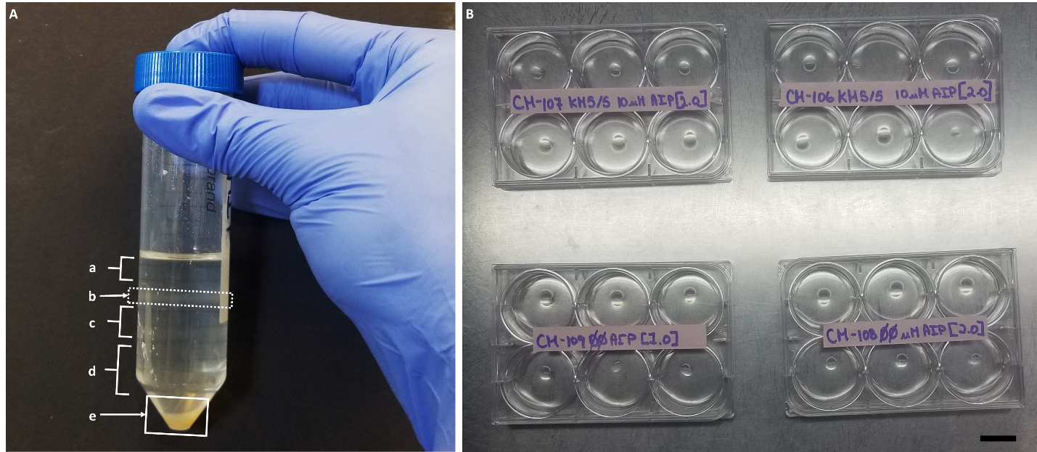
Supplemental Figures
Figure S1. Protoplast purification and culture system. A) OptiPrep density gradient post-centrifugation. a) Top matrix solution layer (0% OptiPrep). b) Protoplast accumulation at the 0%-20% OptiPrep interface (collected for downstream applications and culture). c) The 20% OptiPrep gradient. d) The 40% OptiPrep solution containing initial protoplast suspension post-digestion, with cell debris at the tube bottom (e). B) Protoplasts in low melting point agarose beads in 1.5 mL KM5/5 media with 0 µM and 10 µM AIP.

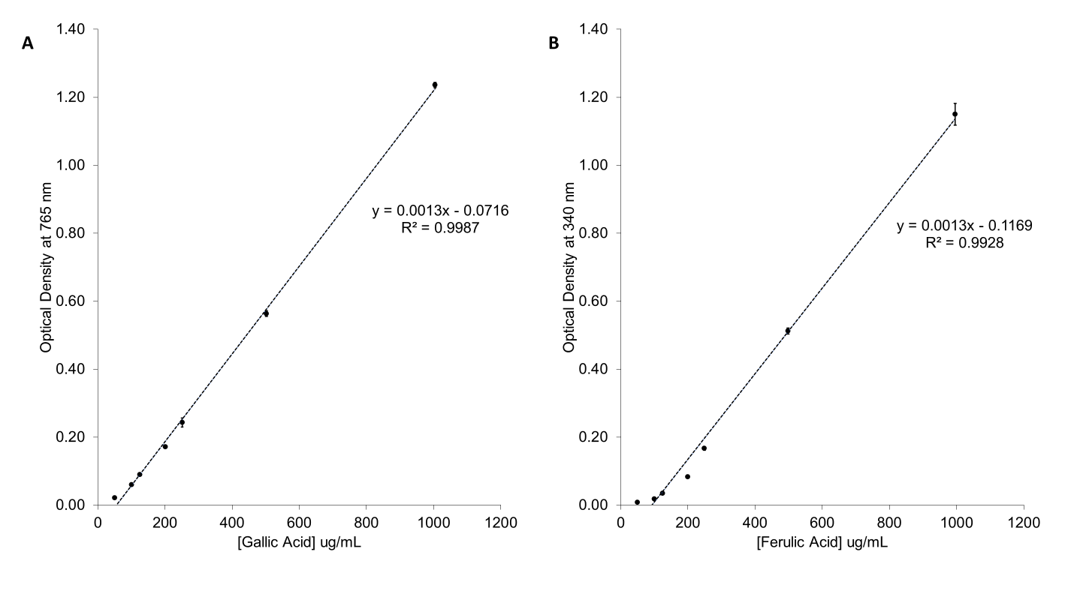
Figure S2. Representative standard curves obtained for the F-C assay (A) and for the browning assay (B). Both curves show strong linearity (R²>0.99). Each data point represents the mean of 3 readings (n=3), error bars indicated standard error of the mean. Data was processed and graphs prepared using Microsoft Excel™.

Supplemental Tables
Table S1. Daily F-C assay calibration curves concentrations, coefficient of variation and linear regression equations. Calculated using Microsoft Excel™. GAE: gallic acid equivalent. Calibration Curves were obtained between May 03, 2021 and May 07, 2021.
Daily Concentration Range  (µg GAE /mL) | R² | Linear Regression Equation
50.2-1004 | 0.9983 | y=0.0014x-0.0409
50.5-1010 | 0.9993 | y=0.0014x-0.0539
50.4-1008 | 0.9982 | y=0.0012x-0.0443
50.2-1004 | 0.9987 | y=0.0013x-0.0716

Table S2. Daily browning assay calibration curves concentrations, coefficient of determination (R²) and linear regression equations. Calculated using Microsoft Excel™. FAE: ferulic acid equivalents. Calibration Curves were obtained between May 03, 2021 and May 07, 2021.
Daily Concentration Range  (µg FAE/mL) | R² | Linear Regression Equation
50.7-1014 | 0.9942 | y=0.0012x-0.1128
50.8-1016 | 0.9953 | y=0.0013x-0.1091
50.5-1010 | 0.9911 | y=0.0013x-0.1270
49.8-996 | 0.9928 | y=0.0013x-0.1169

Table S3. Results of the F-test from the ANOVA of the protoplast yield. Yield (protoplasts/gram fresh weight) obtained from enzymatically digested Cannabis sativa callus. ɑ=0.05.
Fixed Effects | Numerator df | Denominator df | F Value | P-value
Media | 1 | 36 | 5.07 | 0.0305
Subculture Frequency | 1 | 36 | 0.00 | 0.9852
Media×Subculture Frequency | 1 | 36 | 2.31 | 0.1369

Table S4. Results of the F-test from the ANOVA of the F-C assay. Assay quantifies total soluble phenolics (µg GAE/gram fresh weight) obtained from Cannabis sativa callus. ɑ=0.05.
Fixed Effects | Numerator df | Denominator df | F Value | P-value
Media | 1 | 34 | 8.87 | 0.0053
Subculture Frequency | 1 | 34 | 0.14 | 0.7092
Media×Subculture Frequency | 1 | 34 | 0.95 | 0.3375

Table S5. Results of the F-test from the ANOVA of the browning assay. Assay quantifies browning measured as ferulic acid equivalents (µg FAE/gram) obtained from Cannabis sativa callus. ɑ=0.05.
Fixed Effects | Numerator df | Denominator df | F Value | P-value
Media | 1 | 17.69 | 47.88 | <0.0001
Subculture Frequency | 1 | 17.69 | 0.01 | 0.9208
Media×Subculture Frequency | 1 | 17.69 | 0.50 | 0.4887

Table S6. Kendall Tau-b correlation table. This table displays Kendall Tau-b correlation coefficients, significance levels (ɑ=0.05) for the test of null hypothesis (no correlation), and the number of observations used for ranked correlation out of a total of n=40. Some data points were omitted due to limited sample extract availability caused by insufficient callus for extract preparation.
 | Yield | F-C | Browning
Yield | 1.000  -  40 | -0.20827  0.692  38 | -0.24480  0.0322  38
F-C | -0.20827  0.692  38 | 1.000  -  38 | 0.37237  0.0012  37
Browning | -0.24480  0.0322  38 | 0.37237  0.0012  37 | 1.000  -  38

