Supplementaly file

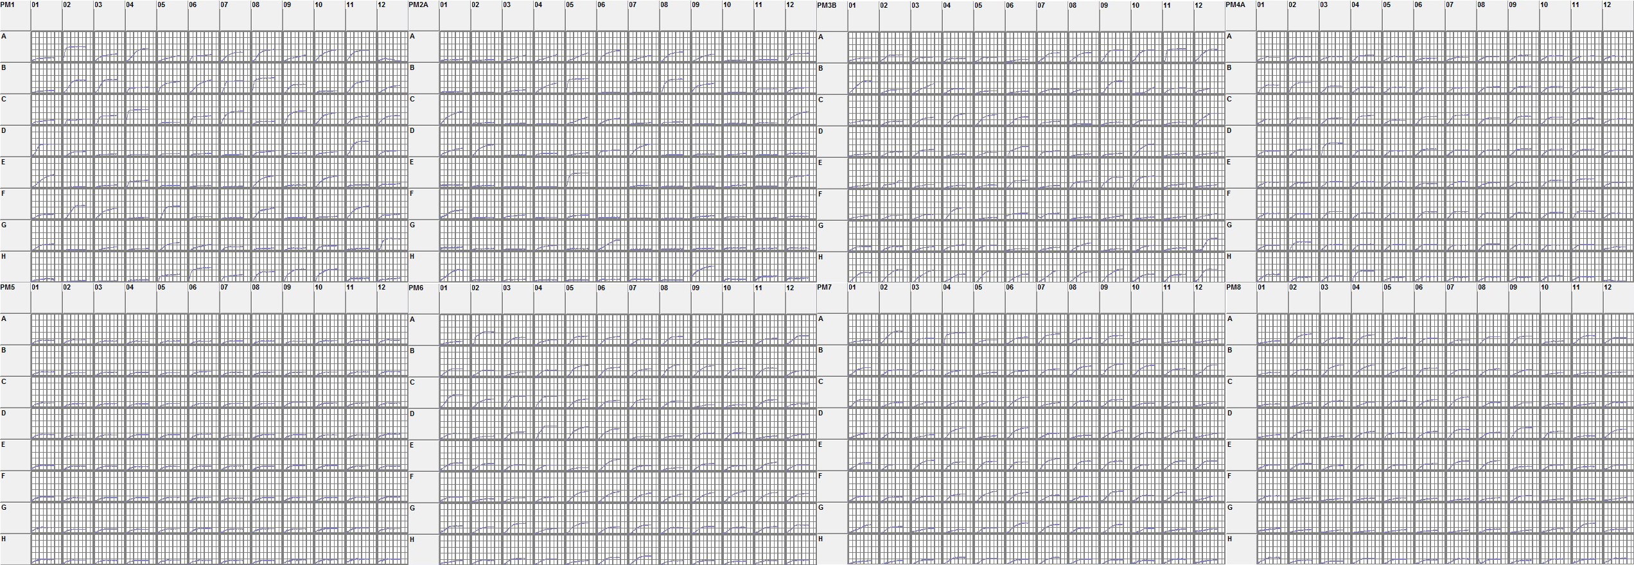
Supplementary Figure 1. Phenotype microarrays analysis of B. subtilis NCD-2. Letters A-H and numbers 01-12 refer to the well co-ordinates on the microarray plates, each square such as A01 displays time on the X-axis and redox signal intensity on the Y-axis.

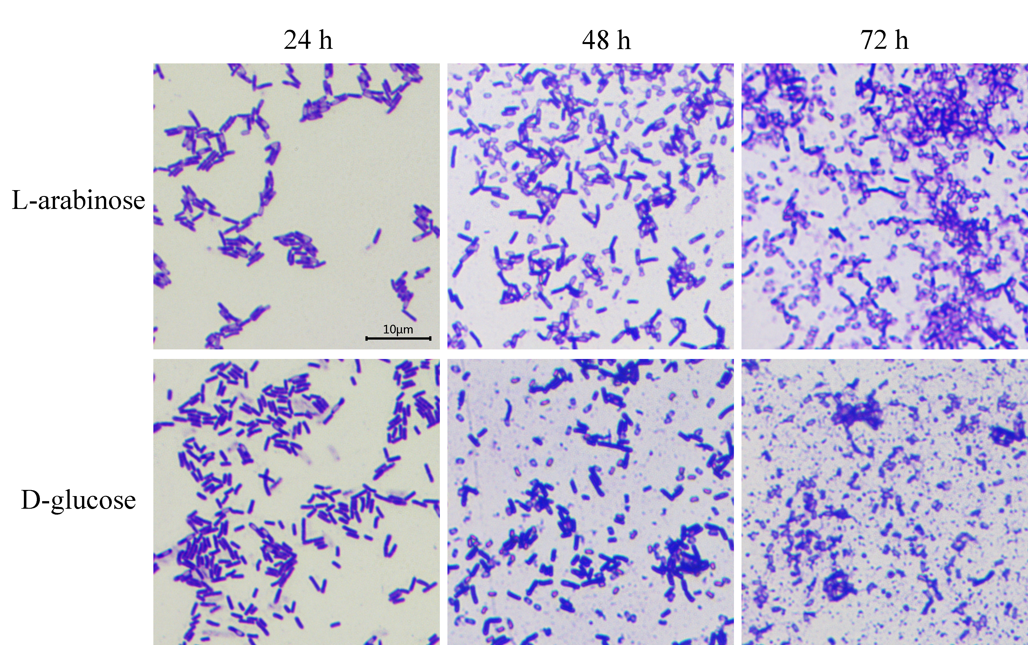
Supplimentary Figure 2. Proportion of spores of strain NCD-2 in M9 medium with L-arabinose and D-glucose as carbon sources, at 24, 48 and 72 h after inoculation.

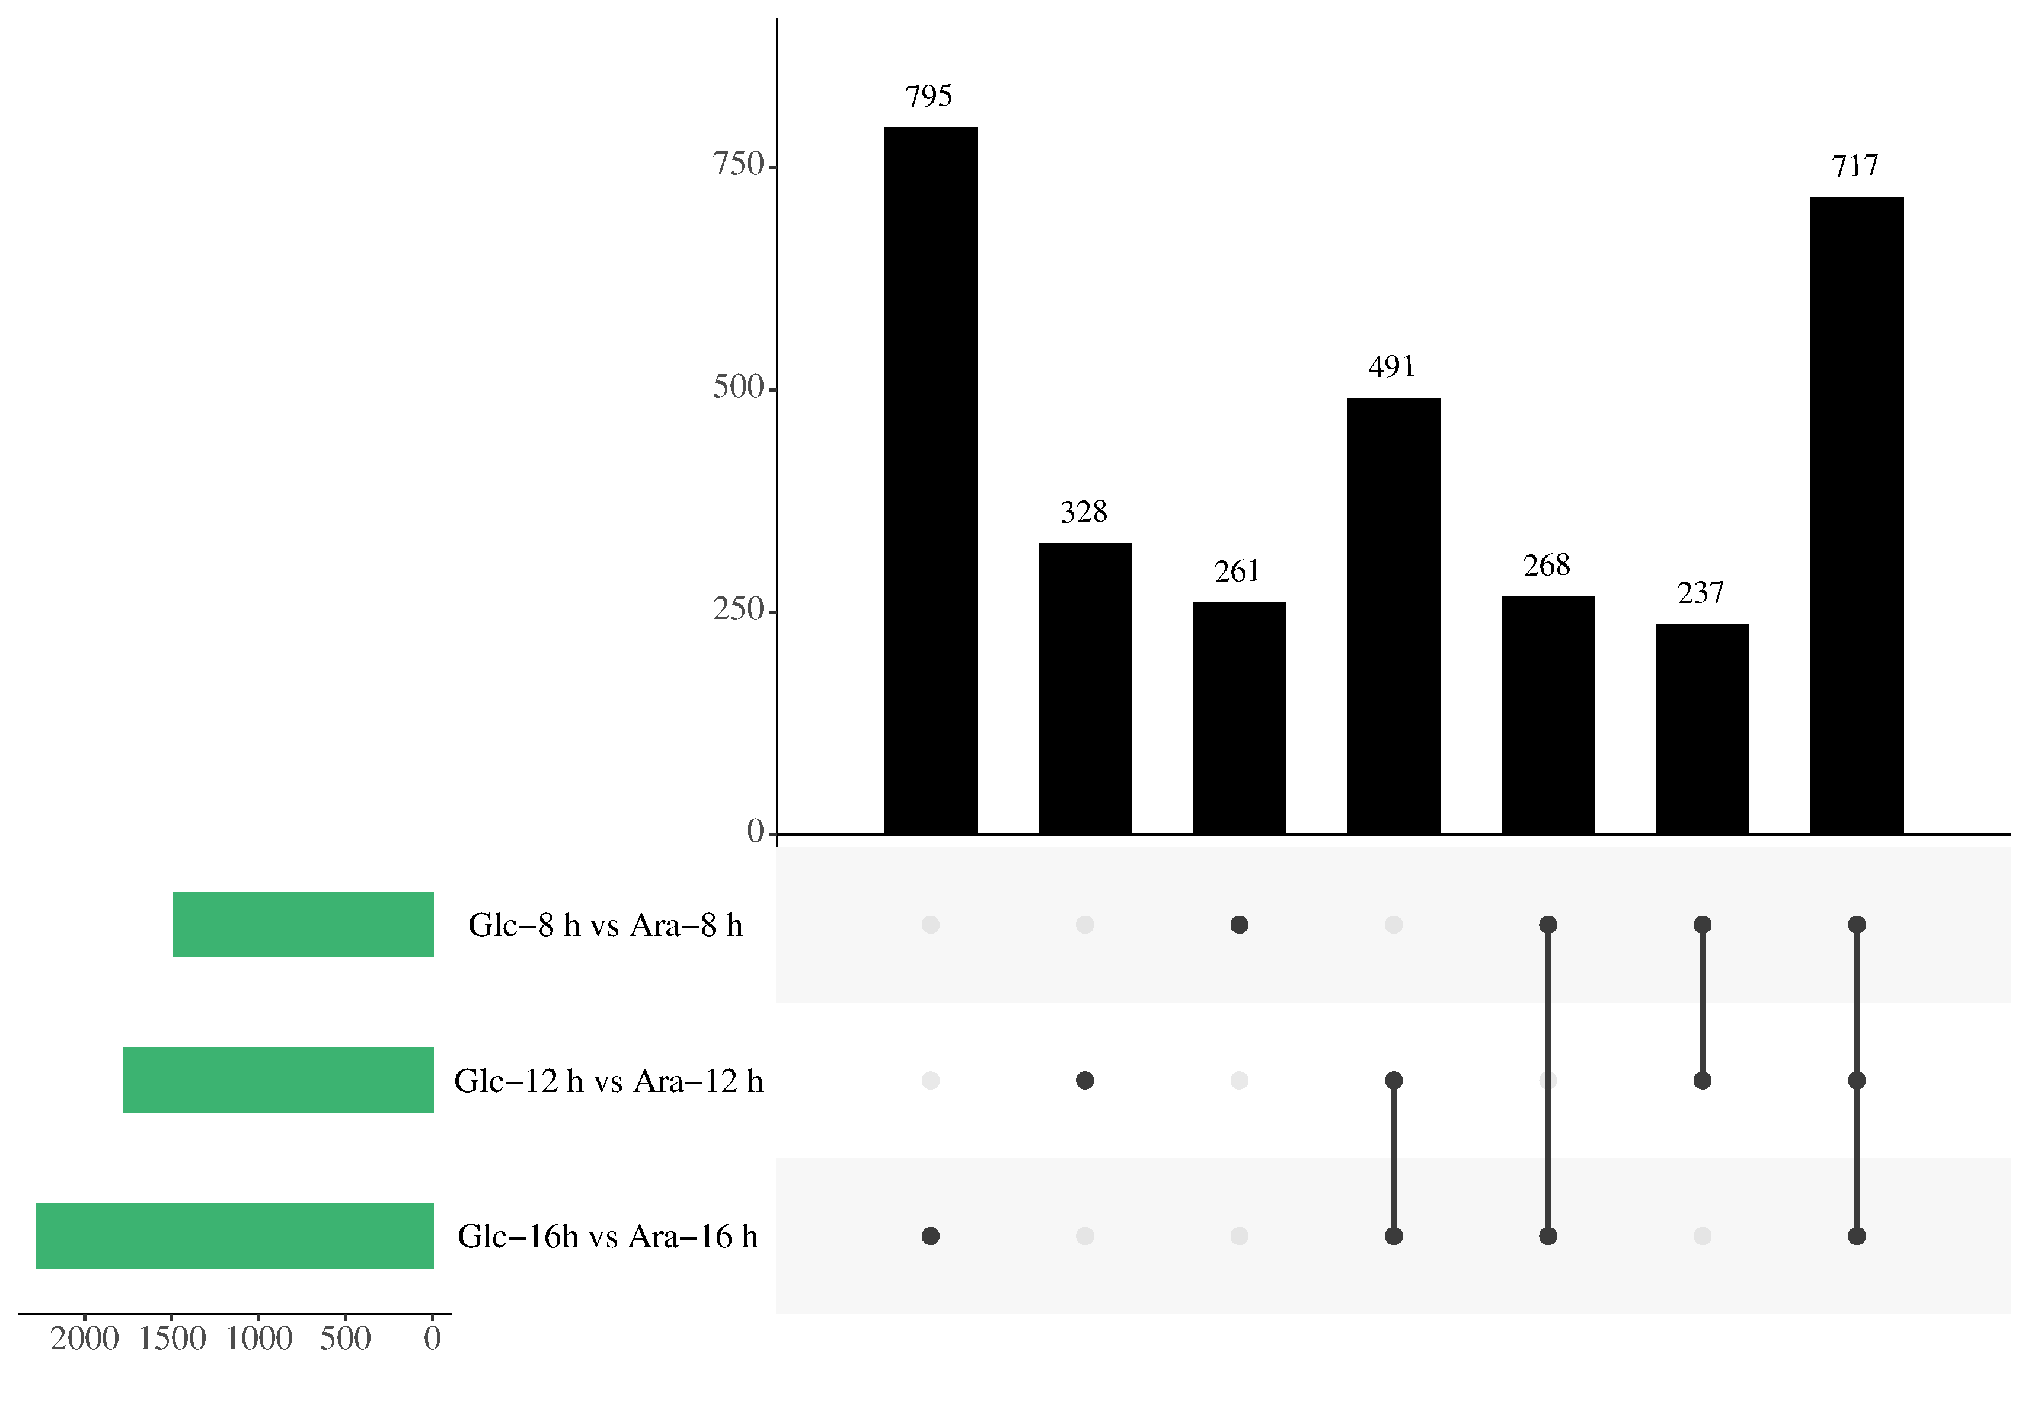
Supplementary Figure 3. Venn diagram analysis of DEGs in different comparisons.

Supplementary Figure 4. Proportion of spores of strain NCD-2 wild type (WT), msmX-null mutant (ΔmsmX) and its complemented strain (CPmsmX) in M9 medium with L-arabinose as carbon sources, at 24, 48 and 72 h after inoculation.

Supplementary table 1 Primers used in this study
Primer | Sequence（5’ to 3’） | Function
cotY-F | AAGGCGGATTGTTCTCCA | qRT-PCR for cotY
cotY-R | TCTGGTGACAGGCACTGAAT
dpaA-F | CAGGAGAAGGTGTCGTATCG | qRT-PCR for dpaA
dpaA-R | TCATCCCGCTCAAACAGT
dpaB-F | CGATTGTAAAGGCAGAACCT | qRT-PCR for dpaB
dpaB-R | GAGATACCCAGAACGACAGG
msmX-F | GACCTCTTTGCCGATGTAGC | qRT-PCR for msmX
msmX-R | GGACGCCGAAGGATGTTTA
sspA-F | ACTCAGGTAACAGCAACAACC | qRT-PCR for sspA
sspA-R | TCCTCCAACAGAACCGTT
sspB-F | TAACCTTGGAGCGGACACT | qRT-PCR for sspB
sspB-R | TGCTGCTGAGCGAAAGAT
tuaC-F | CGTAGGTTCTGCGTCAGTTG | qRT-PCR for tuaC
tuaC-R | GATTTCCTCTTTCGTCTCCTCA
spoIIQ-F | AAGAGAAAGAAGCAGCACTCG | qRT-PCR for spoIIQ
spoIIQ-R | CGCTCAGAGAAGCAGAGACA
Spo0E-F | AAGAGAAAGAAGCAGCACTCG | qRT-PCR for Spo0E
Spo0E-R | CGCTCAGAGAAGCAGAGACA
sdpC-F | CGATTGACAGCAAAGACCC | qRT-PCR for sdpC
sdpC-R | GCATAAAGCCCACAAGATGG
leuA-F | TTCGTGATGGTGAACAGTCC | qRT-PCR for leuA
leuA-R | TCTTGCGATTTCCTGAACAG
ilvC-F | CGGCGGATGTAGATGTATTCT | qRT-PCR for ilvC
ilvC-R | GCTTTGTCTCTTGCTTCTCCA
srfAA-F | CGGCGGATGTAGATGTATTCT | qRT-PCR for srfAA
srfAA-R | GCTTTGTCTCTTGCTTCTCCA
ppsC-F | TGATGCTCTATTGGTTGGACTG | qRT-PCR for ppsC
ppsC-R | TAGCCCGATTCCGAAACA
gyrB-F | GAAGCACGGACAATCACC | referenc gene
gyrB-R | TCCAAAGCACTCTTACGG

Supplementary table 2 Verification of differently express genes by RT-qPCR
Gene | log₂(Ara/Glc) (transcriptome) |  |  |  | log₂(Ara/Glc) (RT-qPCR)
 | 8 h | 12 h | 16 h |  | 8 h | 12 h | 16 h
cotY | 5.16 | 7.90 | 9.47 |  | 5.76 | 8.83 | 9.01
dpaA | 6.30 | 6.84 | 4.81 |  | 5.50 | 6.42 | 5.10
dpaB | 5.76 | 6.12 | 4.21 |  | 5.12 | 5.98 | 4.37
msmX | 2.96 | 1.35 | -ª |  | 3.14 | 1.51 | -
sspA | 7.23 | 3.14 | 1.67 |  | 8.11 | 3.51 | 2.01
sspB | 7.40 | 3.43 | 2.66 |  | 7.71 | 3.25 | 3.05
tuaC | 1.65 | 1.12 | 5.15 |  | 1.78 | 1.35 | 4.82
spoIIQ | 5.69 | 1.78 | -1.82 |  | 5.47 | 1.33 | -2.04
spo0E | - | -1.75 | -1.93 |  | - | -2.21 | -2.34
sdpC | -1.23 | -5.57 | -6.81 |  | -1.77 | -6.08 | -7.71
leuA | -1.34 | -1.03 | -2.98 |  | -1.19 | -1.28 | -3.22
ilvC | -1.45 | -1.36 | -3.80 |  | -1.73 | -1.39 | -3.77
srfAA | -2.46 | -1.88 | -2.41 |  | -2.89 | -1.79 | -2.50
ppsC | -3.00 | -4.75 | -4.66 |  | -3.25 | -4.17 | -4.23
a: “-” means no significant difference in gene expression between L-arabinose (Ara) treatment and D-glucos (Glc) treatment

