Supporting Information

PDB Code : 1HVK
HIV-1 PROTEASE-Crystal Ligand A79 COMPLEX ( N-{1-BENZYL-(2S,3S)-2,3-DIHYDROXY-4-[3-METHYL-2-(3-METHYL-3-PYRIDIN-2-YLMETHYL-UREIDO)-BUTYRYLAMINO]-5-PHENYL-PENTYL}-3-METHYL-2-(3-METHYL-3-PYRIDIN-2-YLMETHYL-UREIDO)-BUTYRAMIDE)

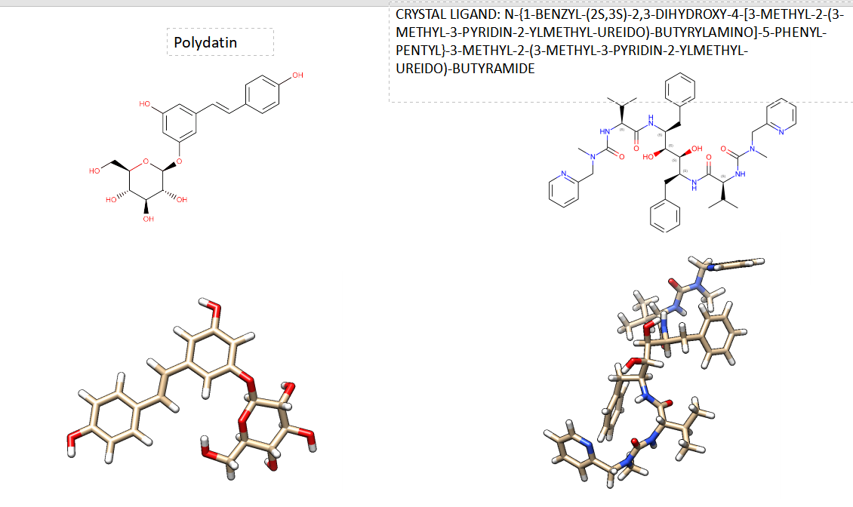

SP Fig.1 Comparison 2D and 3D structures of Polydatin and Crystal Ligand A79 COMPLEX ( N-{1-BENZYL-(2S,3S)-2,3-DIHYDROXY-4-[3-METHYL-2-(3-METHYL-3-PYRIDIN-2-YLMETHYL-UREIDO)-BUTYRYLAMINO]-5-PHENYL-PENTYL}-3-METHYL-2-(3-METHYL-3-PYRIDIN-2-YLMETHYL-UREIDO)-BUTYRAMIDE

PDB Code : 1HII
HIV-2 PROTEASE-Crystal Ligand C20 COMPLEX (ACETYL-NH-VAL-CYCLOHEXYL-CH2[NCH2CHOH]CH2-BENZYL-VAL-NH-ACETYL)

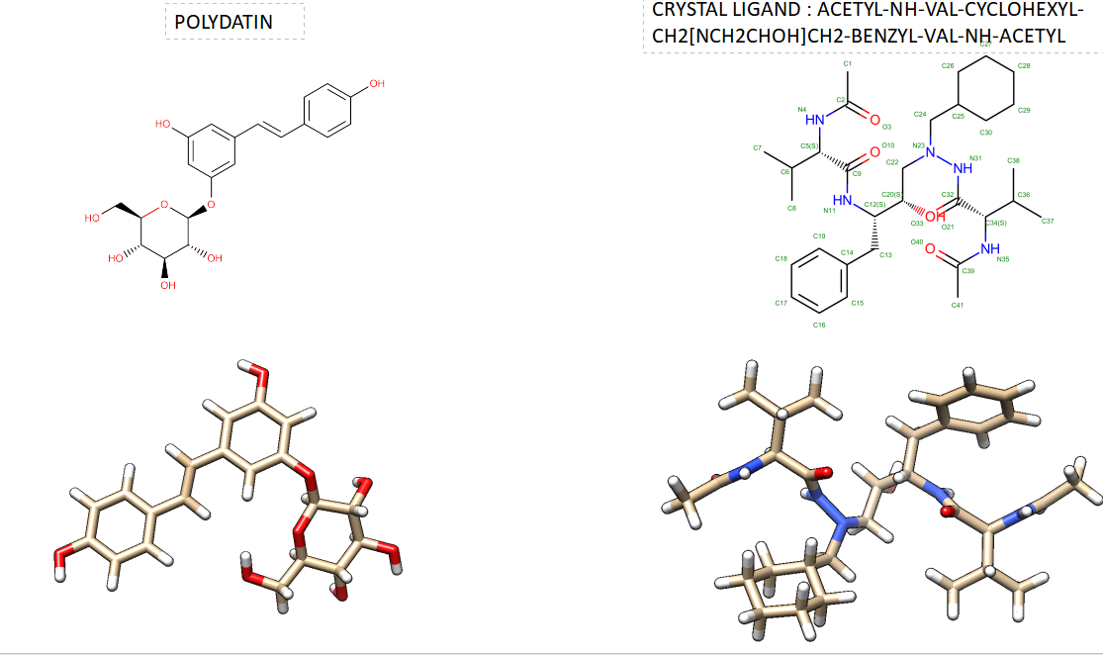

SP Fig.2 Comparison 2D and 3D structures of Polydatin and Crystal Ligand C20 COMPLEX (ACETYL-NH-VAL-CYCLOHEXYL-CH2[NCH2CHOH]CH2-BENZYL-VAL-NH-ACETYL)

SP Fig.3 Comparison Similary Scores performed by SWISS Similary web tool and Drug Bank
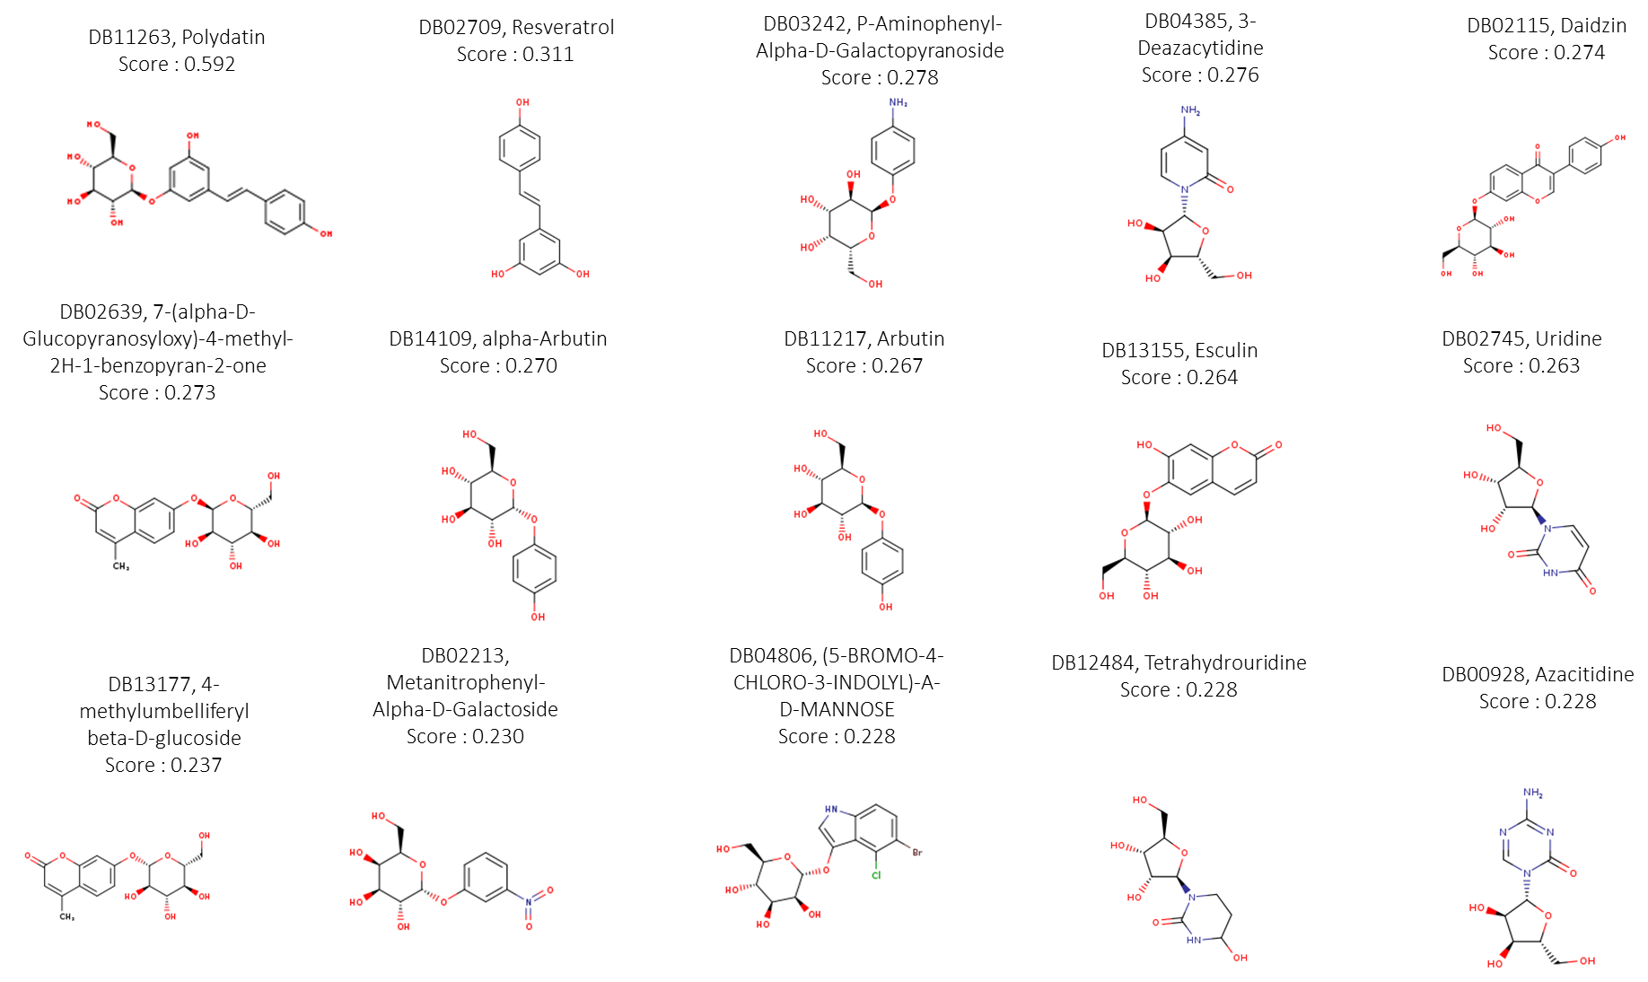

SP Fig.4 Comparison 2D Structures were evaluated by Drug Bank through SWISS Similary web tool

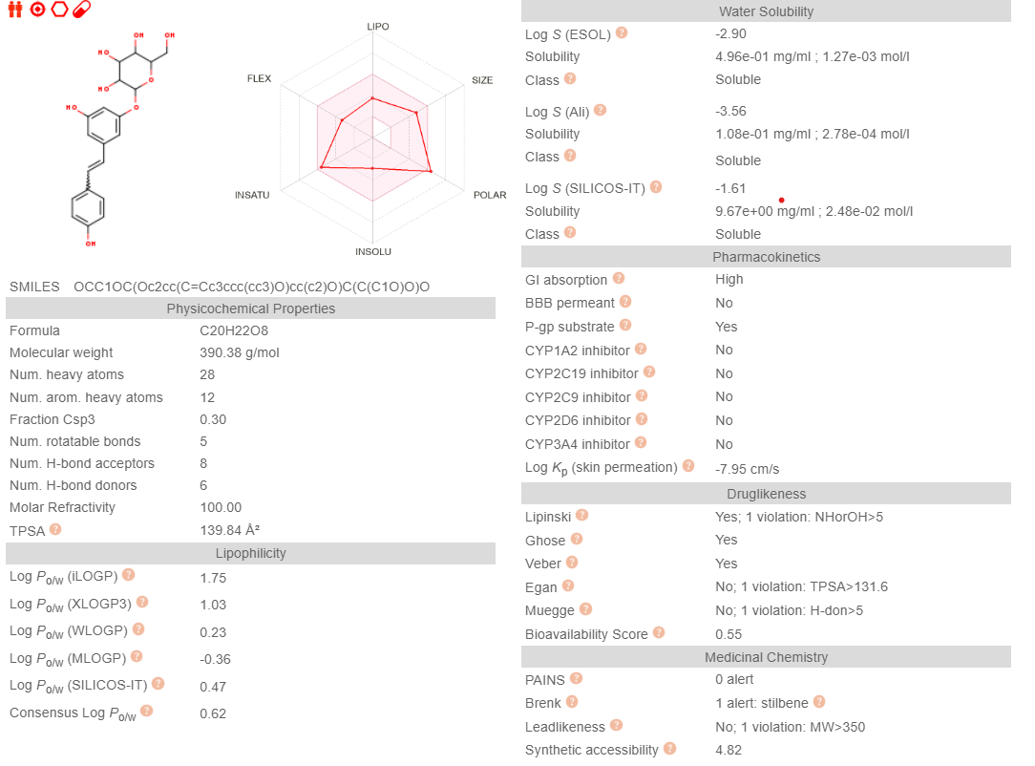

SP Fig.5 Comparison chemical-physical, biological properties of Polydatin were performed by Swiss ADME web tool

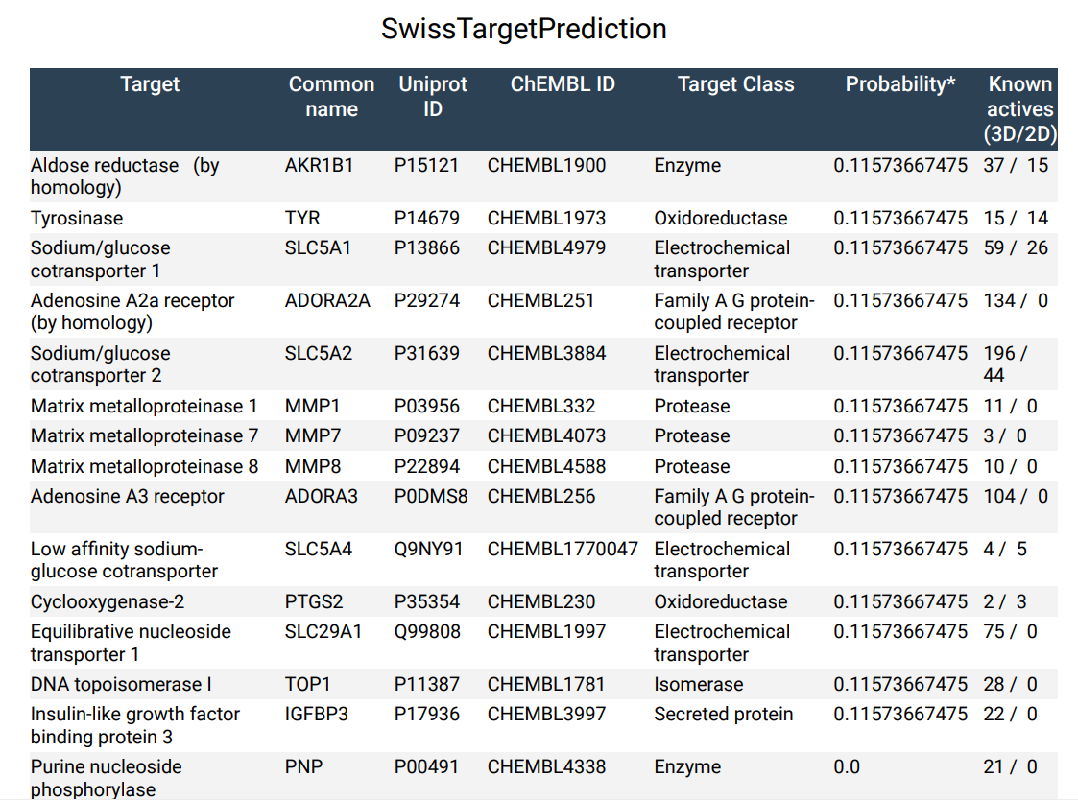
SP Fig.6 Comparison potential targets of Polydatin were performed by Swiss Target prediction web tool

