Grapevine trunk diseases in Greece: Disease incidence and fungi involved in discrete geographical zones and varieties

Stefanos I. Testempasis¹, Emmanouil A. Markakis^{2,3*}, Georgia, I. Tavlaki², Stefanos K. Soultatos^{2,3}, Christos Tsoukas⁴, Danai Gkizi⁵, Aliki K. Tzima⁴, Epameinondas Paplomatas⁴, Georgios S. Karaoglanidis¹

¹ Laboratory of Plant Pathology, School of Agriculture, Faculty of Agriculture, Forestry and Natural Environment, Aristotle University of Thessaloniki, 54124 Thessaloniki, Greece
² Laboratory of Mycology, Department of Viticulture, Vegetable Crops, Floriculture and Plant Protection, Institute of Olive Tree, Subtropical Crops and Viticulture, Hellenic Agricultural Organization - DIMITRA, 32^{A} Kastorias street, Mesa Katsabas 71307, Heraklion, Crete, Greece
³ Laboratory of Plant Pathology, Department of Agriculture, School of Agricultural Sciences, Hellenic Mediterranean University‎, Stavromenos 71004, Heraklion, Crete, Greece
⁴ Laboratory of Plant Pathology, Department of Crop Science, School of Plant Sciences, Agricultural University of Athens, Iera Odos 75, Votanikos 11855, Athens, Greece
⁵ Department of Wine, Vine and Beverage Sciences, University of West Attica, Ag. Spyridonos 28, 12243, Athens, Greece

*Corresponding author: Emmanouil A. Markakis
E-mail: markakis@elgo.gr

Supplementary Figure S1. Map illustrating the geographical distribution of the surveyed regions across Greece (Northern, Central, and Southern), providing the number of vineyards of the study area's regional coverage.

Supplementary Table S1. Morphological and physiological features of the fungal isolates (mean ± standard error) analyzed in the present study, along with their geographic origin, the plant tissue they were isolated and the GenBank accession numbers determined by the analyses of internal transcribed spacer regions of ribosomal DNA (rDNA-ITS), rDNA large subunit (LSU), translation elongation factor 1-alpha (tef1-α), β-tubulin (tub2) and actin (act) gene sequences
Isolateª | Fungal species^{b} | Vine part^{c} | Location | Colony color | Growth rate^{d} (mm/day) | Conidial dimensions (μm)^{e} | Hyphae width (μm) | GenBank accession No.
 |  |  |  |  |  |  |  | ITS^{f}/Identity (%) | LSU^{g}/Identity (%) | tef1-α^{h}/Identity (%) | tub2^{i}/Identity (%) | act^{j}/Identity (%)
HOURD2.1AVR1 | Kalmusia variispora | Cordon | Harakas, Heraklion | White to olive-green, grey | 2.97 ± 0.05 | Nf | 3.10 ± 0.14 | OQ683907/100.00% | OQ704313/99.73% | OQ798214/99.67% | OQ784650/99.55% | OQ798208/n.e.
PEROG2.1YP2 | Kalmusia variispora | Trunk | Asites, Heraklion | White to olive-green, grey | 3.95 ± 0.04 | Nf | 1.99 ± 0.13 | OQ683913/100.00% | OQ704319/100.00% | OQ798218/90.46% | OQ784655/99.77% | OQ798213/n.e.
SAROG1.3AVR10 | Seimatosporium vitis | Cordon | Pretoria, Heraklion | Light brown-black | 3.07 ± 0.14 | 15.29 (±0.38) × 4.73 (±0.12) | 2.79 ± 0.18 | OQ683910/100.00% | OQ704316/99.39% | OQ798216/100.00% | OQ784653/100.00% | OQ798211/n.e.
SAROG1.3AVR13 | Seimatosporium vitis | Cordon | Pretoria, Heraklion | Light brown-black | 2.16 ± 0.05 | 17.76 (±0.47) × 5.06 (±0.02) | 2.93 ± 0.14 | OQ683911/100.00% | OQ704317/99.91% | OQ798217/100.00% | OQ784654/100.00% | OQ798212/n.e.
SAROG1.2AKO1 | Didymosphaeria variabile | Trunk | Pretoria, Heraklion | White to olive-green, grey | 5.61 ± 0.10 | Nf | 2.90 ± 0.29 | OQ683908/100.00% | OQ704314/n.e. | - | OQ784651/99.78% | OQ798209/100.00%
SAROG1.3AVR7 | Neosetophoma italica | Cordon | Pretoria, Heraklion | White to pale brown | 2.61 ± 0.15 | 7.83 (±0.34) × 3.40 (±0.15) | 2.49 ± 0.10 | OQ683909/100.00% | OQ704315/n.e. | OQ798215/n.e. | OQ784652/n.e. | OQ798210/n.e.
ª Codes of fungal isolates obtained from symptomatic grapevine wood.
^{b} Fungal species as determined by the analysis of rDNA-ITS, LSU, tef1-α, tub2 and act sequences along with their morphological and physiological features.
^{c} Part (cordon or trunk) of vine where fungal strains were isolated on acidified potato dextrose agar (PDA).
^{d} Isolates were grown on PDA at 24 ˚C in the dark and their colonies’ diameter was measured at day 3, 7, 10, 14, 17 and 21 or stopped earlier when plate was completely covered by the fungus.
^{e} ‘nf’ indicates that isolates did not form spores within the 21-day incubation period.
^{f} Accession numbers of fungal isolates rDNA-ITS sequences that yielded and deposited in GenBank.
^{g} Accession numbers of fungal isolates LSU sequences that yielded and deposited in GenBank. ‘n.e.’ indicates that no sequence of this fungal species exists in NCBI.
^{h} Accession numbers of fungal isolates tef1-α sequences that yielded and deposited in GenBank. ‘n.e.’ indicates that no sequence of this fungal species exists in NCBI.
^{i} Accession numbers of fungal isolates tub2 sequences that yielded and deposited in GenBank. ‘n.e.’ indicates that no sequence of this fungal species exists in NCBI.
^{j} Accession numbers of fungal isolates act sequences that yielded and deposited in GenBank. ‘n.e.’ indicates that no sequence of this fungal species exists in NCBI.
Supplementary Table S2. Sequences used in the phylogenetic analysis of Neosetophoma, Kalmusia, Seimatosporium, and Didymosphaeria species.
Species | Culture accession number | Source | Origin | GeneBank accession numbersª
 |  |  |  | ITS | LSU | tef1-a | tub2
Neosetophoma aseptata | CBS 145363 | Viburnum opulus | Germany | NR_164449 | MK540024 | NA¹ | NA
Neosetophoma clematidis | MFLUCC 13-0734 | Clematis vitalba | Italy | NR_154228 | KP684153 | NA | NA
Neosetophoma shoemakeri | MFLUCC 17-0780 | Malva sp. | United Kingdom | MG844346 | MG844348 | NA | NA
Neosetophoma lunariae | CPC 26671 | Lunaria annua | Germany | NR_154242 | KX306789 | NA | NA
Neosetophoma salicis | MFLU 17-0118 | Salix sp. | Uzbekistan | MK608025 | MK608026 | NA | NA
Neosetophoma poaceicola | MFLUCC 16-0886 | Dead grass | Thailand | NR_165861 | KY550382 | NA | NA
Neosetophoma poaceicola | IRAN 2429 C | Malus domestica | Iran | KT832078 | MT102742 | NA | NA
Neosetophoma guiyangensis | GZCC 18-0111 | Dead branch | China | MH018134 | MH018132 | NA | NA
Neosetophoma xingrensis | GZCC 18-0110 | Decaying wood | China | MH018135 | MH018133 | NA | NA
Neosetophoma italica | SAROG1.3AVR7 | Vitis vinifera | This study | OQ683909 | OQ704315 | NA | NA
Neosetophoma italica | MFLU 14-0809 | Iris germanica | Italy | KP711356 | KP711361 | NA | NA
Neosetophoma italica | 108 | Citrus limon | Iran | KY290229 | KY355076 | NA | NA
Neosetophoma garenthjonesii | MFLUCC:14-0528 | Forest soil | United Kingdom | KY496758 | KY496738 | NA | NA
Neosetophoma samarorum | CBS 138.96 | Phlox paniculata | Netherlands | NR_156263 | NG_057836 | NA | NA
Neosetophoma rosigena | MFLU 17-0626 | Rosa canina | United Kingdom | NR_157525 | NG_059870 | NA | NA
Neosetophoma phragmitis | CBS 145364 | Phragmites australis | Germany | NR_164450 | MK540025 | NA | NA
Didymella exigua | CBS 183.55 | - | France | MH857436 | MH868977 | NA | NA
Kalmusia variispora | HOURS2.1AVR1 | Vitis vinifera | This study | OQ683907 | OQ704313 | NA | NA
Kalmusia variispora | PEROG2.1YP2 | Vitis vinifera | This study | OQ683913 | OQ704319 | NA | NA
Kalmusia variispora | KV-9 | Malus domestica | Iran | OL711708 | OL711712 | NA | NA
Kalmusia variispora | CBS 121517 | - | Syria | JX496030 | JX496143 | NA | NA
Kalmusia variispora | KV-13 | Malus domestica | Iran | OL711709 | OL711713 | NA | NA
Kalmusia italica | MFLU 14-0620 | Spartium junceum | Italy | KP325440 | KP325441 | NA | NA
Kalmusia longispora | CBS 582.83 | Arceuthobium pusillum | Canada | JX496097 | JX496210 | NA | NA
Kalmusia longispora | T15142 | Vitis vinifera | Hungary | MN945157 | MN945151 | NA | NA
Kalmusia longispora | CBS 824.84 | Triticum aestivum | Germany | JX496115 | JX496228 | NA | NA
Kalmusia ebuli | CBS 123120 | - | - | KF796674 | JN644073 | NA | NA
Kalmusia cordylines | ZHKU 21-0003 | Cordyline fruticosa | China | NR_184482 | NG_088312 | NA | NA
Kalmusia araucariae | CPC 37475 | Araucaria bidwillii | USA | MT223805 | MT223900 | NA | NA
Kalmusia spartii | MFLU 14-0751 | Spartium junceum | Italy | KP744441 | KP744487 | NA | NA
Helminthosporium leucadendri | CBS 135133 | Carpentaria acuminata | Australia | KF251150 | KF251654 | NA | NA
Seimatosporium vitis | Napa764 | Vitis vinifera | USA | KY706273 | KY706298 | KY706323 | KY706248
Seimatosporium vitis | SAROG1.3AVR10 | Vitis vinifera | This study | OQ683910 | OQ704316 | OQ798216 | OQ784653
Seimatosporium vitis | SAROG1.3AVR13 | Vitis vinifera | This study | OQ683911 | OQ704317 | OQ798217 | OQ784654
Seimatosporium vitis-viniferae | L189 | Vitis vinifera | Cyprus | ON680685 | ON692401 | ON863781 | ON695845
Seimatosporium vitis-viniferae | CBS 123004 | Vitis vinifera | Spain | MH553992 | MH554211 | MH554418 | MH554660
Seimatosporium vitis-viniferae | P210 | Vitis vinifera | Cyprus | ON680688 | ON692398 | ON863780 | ON695842
Seimatosporium pistaciae | CBS 138865 | Pistacia vera | Iran | KP004463 | KP004491 | MH554432 | MH554674
Seimatosporium rosae | CBS 139823 | Rosa sp. | Russia | LT853105 | MH823070 | LT853203 | LT853253
Seimatosporium germanicum | CBS 437.87 | - | Germany | MH554047 | MH554259 | MH554482 | MH554723
Seimatosporium cyprium | CBS 149019 | Vitis vinifera | Cyprus | ON680684 | ON705769 | ON863790 | ON695856
Seimatosporium sp. | 2310C | Vitis vinifera | Iran | MW361952.1 | MW361960.1 | MW375358.1 | MW375352.1
Seimatosporium vitisfusiforme | Wint753 | Vitis vinifera | USA | KY706296.1 | KY706321.1 | KY706346 | KY706271.1
Beltrania rhombica | CBS 123.58 | Mangrove swamp | Mozambique | MH857718 | MH869260 | MH704606 | MH704631
Didympsphaeria variabile | CBS 120014 | Actinidia chinensis | Italy | JX496026 | JX496139.1 | NA | JX496365.1
Didymosphaeria variabile | SAROG1.2AKO1 | Vitis vinifera | This study | OQ683908 | OQ704314 | NA | OQ784651
Paraconiothyrium brasilliense | CBS 115.92 | Olea europaea | Italy | JX496022 | JX496135.1 | NA | JX496361.1
Paraconiothyrium brasilliense | CBS 587.84 | Vitis vinifera | Italy | JX496099 | JX496212.1 | NA | JX496438.1
Paraconiothyrium fuckelii | CBS 508.94 | Rosa sp. | Netherlands | JX496096 | JX496209.1 | NA | JX496435.1
Paraconiothyrium fuckelii | CBS 764.71B | Human | Netherlands | JX496112 | JX496225.1 | NA | JX496451.1
Stagonospora paludosa | CBS 135088 | Carex acutiformis | Netherlands | KF251257 | KF251760.1 | NA | KF252740.1
ª NA: Not Applicable
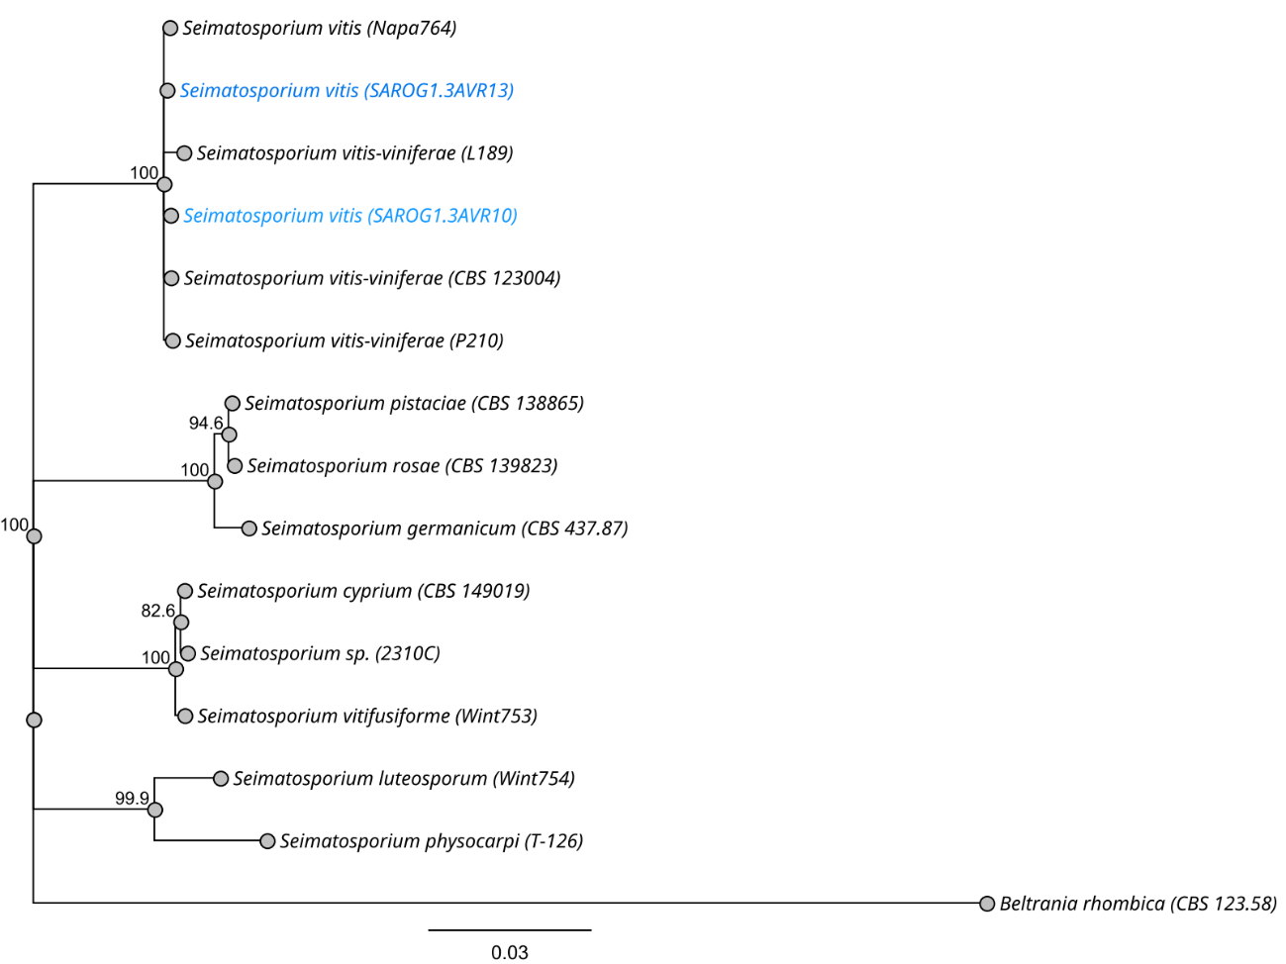
Supplementary Figure S2. Neighbor-joining (NJ) phylogram obtained from the combined rDNA-ITS, LSU, tub2, and tef1-a sequence alignment of Seimatosporium species. The tree was rooted to Beltrania rhombica CBS 123.58. Bootstrap values (1000 replicates) are indicated at the nodes. The scale bar indicated nucleotide substitution in NJ analysis, values ≥ 50% are presented above/below the branches.

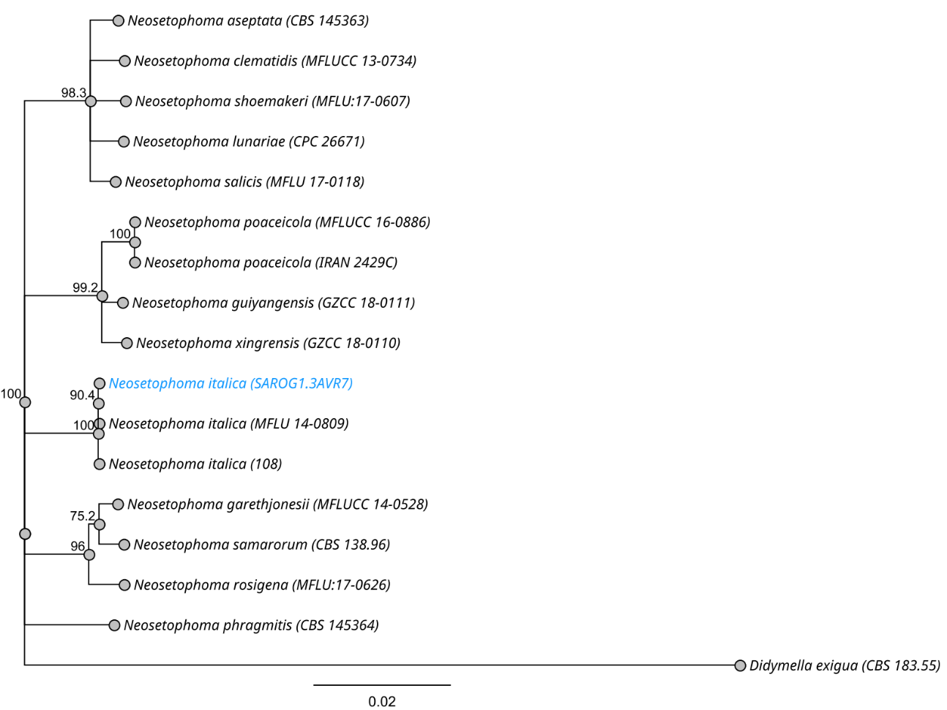
Supplementary Figure S3. Neighbor-joining (NJ) phylogram obtained from the combined rDNA-ITS, LSU sequence alignment of Neosetophoma species. The tree was rooted to Didymella exigua CBS 183.55. Bootstrap values (1000 replicates) are indicated at the nodes. The scale bar indicated nucleotide substitution in NJ analysis, values ≥ 50% are presented above/below the branches.

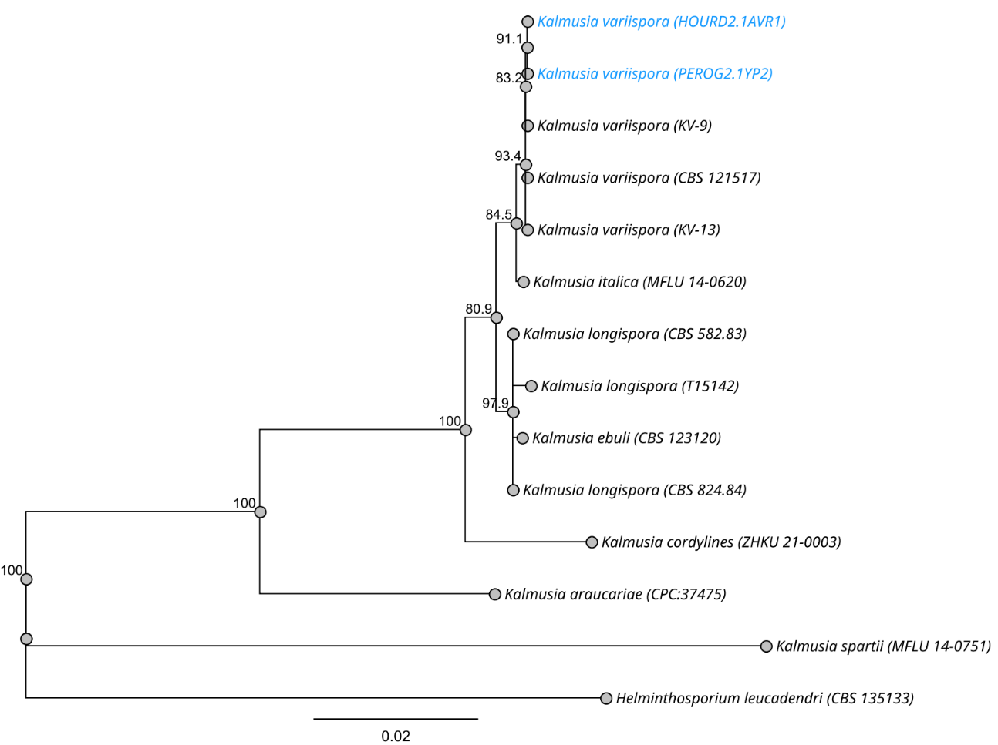
Supplementary Figure S4. Neighbor-joining (NJ) phylogram obtained from the combined rDNA-ITS, LSU sequence alignment of Kalmusia species. The tree was rooted to Helminthosporium leucadendri CBS 135133. Bootstrap values (1000 replicates) are indicated at the nodes. The scale bar indicated nucleotide substitution in NJ analysis, values ≥ 50% are presented above/below the branches.

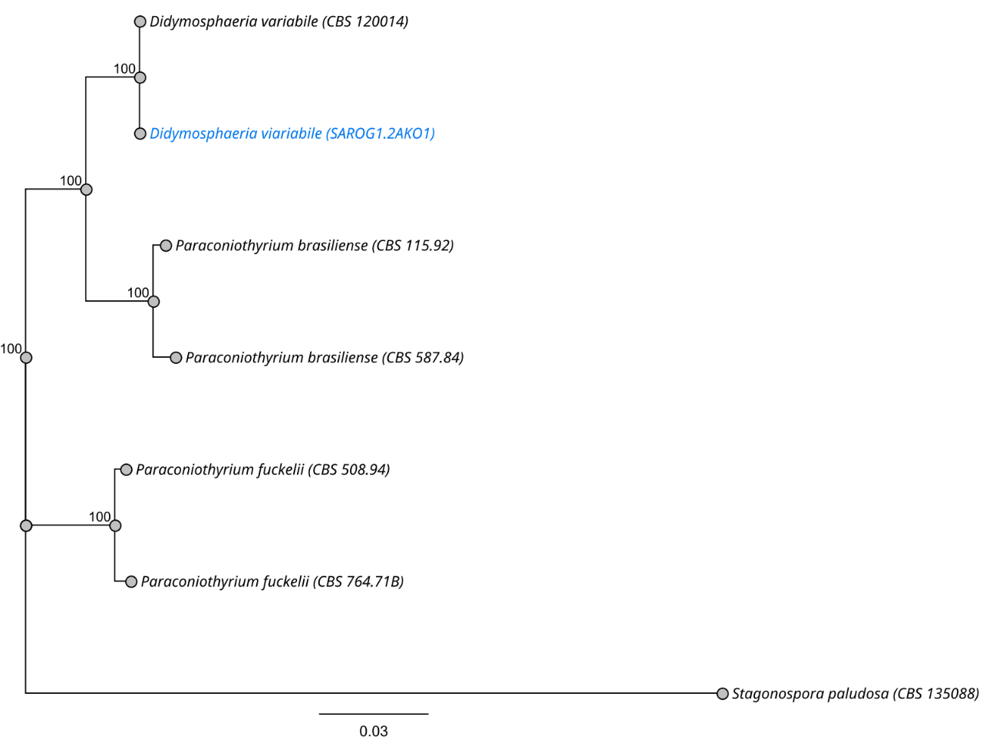
Supplementary Figure S5. Neighbor-joining (NJ) phylogram obtained from the combined rDNA-ITS, LSU, and tub2 sequence alignment of Didymosphaeria and Paraconiothiorum species. The tree was rooted to Stagonospora paludosa CBS 135088. Bootstrap values (1000 replicates) are indicated at the nodes. The scale bar indicated nucleotide substitution in NJ analysis, values ≥ 50% are presented above/below the branches.

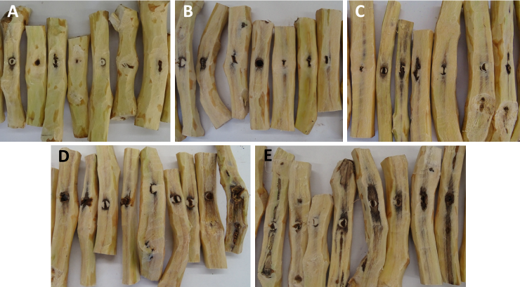
Supplementary Figure S6. Wood discoloration in 2-year-old canes of cv. Soultanina mock-inoculated with sterilized PDA (A) or artificially inoculated with Seimatosporium vitis (B), Didymosphaeria variabile (C), Kalmusia variispora (D) and Neosetophoma italica (E), six (6) months post the inoculation.

