Investigations on the Influence of Two Pyridyl-Mesoionic Carbene Constitutional Isomers on the Electrochemical and Spectroelectrochemical Properties of Group 6 Metal Carbonyl Complexes

T. Bens,^{a,b} Prof. Dr. B. Sarkar^{a,b,*}

ª Institut für Anorganische Chemie, Universität Stuttgart, Pfaffenwaldring 55, D-70569 Stuttgart, Germany, Email: biprajit.sarkar@iac.uni-stuttgart.de
^{b} Institut für Chemie und Biochemie, Freie Universität Berlin, Fabeckstraße 34-36, 14195, Berlin, Germany.

Keywords: mesoionic carbenes, (spectro)electrochemistry, carbonyl ligands, group 6 carbonyls, CO₂ reduction

1. Experimental Section 4
1.10 General Procedures, Materials and Instrumentation 4
1.30 Electrochemistry 5
1.40 Spectroelectrochemistry 5
1.50 DFT 6
2. Cyclic Voltammetry 8
2.10 Cyclic Voltammetry of [Cr(C−C)(CO)₄] 8
2.20 Cyclic Voltammetry of [Cr(C−N)(CO)₄] 9
2.30 Cyclic Voltammetry of [Mo(C−C)(CO)₄] 10
2.40 Cyclic Voltammetry of [Mo(C−N)(CO)₄] 12
2.60 Cyclic Voltammetry of [W(C−N)(CO)₄] 14
3. EPR-Spectroelectrochemistry and Spin Density Calculations 16
3.10 EPR-Spectroeletrochemistry and Spin Density Calculations of [Cr(C−C)(CO)₄] 16
2.20 EPR-Spectroeletrochemistry and Spin Density Calculations of [Mo(C−C)(CO)₄] 17
3.30 EPR-Spectroeletrochemistry and Spin Density Calculations of [W(C−C)(CO)₄] 18
3.40 EPR-Spectroeletrochemistry and Spin Density Calculations of [W(C−N)(CO)₄] 20
4. IR-Spectroelectrochemistry and DFT Calculations 21
4.10 IR Spectra of [M(C−C)(CO)₄] and [M(C−N)(CO)₄] (M = Cr, Mo, W) 21
4.20 IR-Spectroelectrochemistry of [Cr(C−C)(CO)₄] 22
4.21 Calculated IR Spectra of [Cr(C−C)(CO)₄] and [Cr(C−C)(CO)₄]⁻ 23
4.30 IR-Spectroelectrochemistry of [Mo(C−C)(CO)₄] 24
4.31 Calculated IR Spectra of [Mo(C−C)(CO)₄] and [Mo(C−C)(CO)₄]⁻ 25
4.40 IR-Spectroelectrochemistry of [W(C−C)(CO)₄] 26
4.41 Calculated IR Spectra of [W(C−C)(CO)₄] and [W(C−C)(CO)₄]⁻ 27
4.50 IR-Spectroelectrochemistry of [W(C−N)(CO)₄] 28
4.51 Calculated IR Spectra of [W(C−N)(CO)₄] and [W(C−N)(CO)₄]⁻ 29
5. UV/vis/NIR-Spectroelectrochemistry 30
5.10 UV/vis/NIR-Spectroelectrochemistry of [Cr(C−C)(CO)₄] 30
5.20 UV/vis/NIR-Spectroelectrochemistry of [Mo(C−C)] 30
5.30 UV/vis/NIR-Spectroelectrochemistry of [W(C−C)(CO)₄] 31
5.40 UV/vis/NIR-Spectroelectrochemistry of [W(C−N)(CO)₄] 31
6. TD-DFT Calculations 32
6.10 TD-DFT Calculations of [Cr(C−C)(CO)₄]⁻ 32
6.20 TD-DFT Calculations of [Mo(C−C)(CO)₄] and [Mo(C−C)(CO)₄]⁻ 38
6.30 TD-DFT Calculations of [W(C−C)(CO)₄] and [W(C−C)(CO)₄]⁻ 47
6.40 TD-DFT Calculations of [W(C−N)(CO)₄] and [W(C−N)(CO)₄]⁻ 56
7. Electrochemical CO₂ Reduction 65
7.10 Electrochemical CO₂ Reduction with [Cr(C−C)(CO)₄] 65
7.20 Electrochemical CO₂ Reduction with [Cr(C−N)(CO)₄] 66
7.30 Electrochemical CO₂ Reduction with [Mo(C−C)(CO)₄] 67
7.40 Electrochemical CO₂ Reduction with [Mo(C−N)(CO)₄] 68
7.50 Electrochemical CO₂ Reduction with [W(C−C)(CO)₄] 69
7.60 Electrochemical CO₂ Reduction with [W(C−N)(CO)₄] 70

1. Experimental Section

1.10 General Procedures, Materials and Instrumentation

Caution! Compounds containing azides are potentially explosive. Although we never experienced any problems during synthesis or analysis, all compounds should be synthesized only in small quantities and handled with great care!
Unless otherwise noted, all reactions were carried out using standard Schlenk-line-techniques under an inert atmosphere of argon (Linde Argon 4.8, purity 99.998%) or in a glovebox (Glovebox Systemtechnik, GS095218).
Commercially available chemicals were used without further purification. The solvents used for metal complex synthesis and catalysis were available from MBRAUN MB-SPS-800 solvent System and degassed by standard techniques prior to use. The identity and purity of compounds were established via ¹H and ¹³C NMR spectroscopy, elemental analysis and mass spectrometry.
Solvents for cyclic voltammetry and UV/vis- and EPR-spectroelectrochemical measurements were dried and distilled under argon and degassed by common techniques prior to use. Column chromatography was performed over silica 60 M (0.04 − 0.063 mm).
¹H and ¹³C{¹H} NMR spectra were recorded on a Bruker Avance 400 spectrometer at 19 – 22 °C. Chemical shifts are reported in ppm referenced to the residual solvent peaks.^{[1]}
The following abbreviations are used to represent the multiplicity of the signals: s (singlet), d (doublet), t (triplet), q (quartet), p (pentet), sept (septet).
Mass spectrometry was performed on an Agilent 6210 ESI-TOF.
Elemental analyses were performed with an Elementar Micro Cube elemental analyser.
The light-induced syntheses were performed with a LOT-QuantumDesign Arc Lamp (150 W, Xe OF).
[1] S. Budavari (Ed.) The Merck-index. An encyclopedia of chemicals, drugs, and biologicals, Rahway, NJ, 1991.

1.30 Electrochemistry
Cyclic voltammograms were recorded with a PalmSens4 potentiostat or PAR VersaStat (Ametek), respectively, with a conventional three-electrode configuration consisting of a glassy carbon working electrode or gold working electrode, a platinum auxiliary electrode, and a coiled silver wire as a pseudo reference electrode. The (decamethyl)ferrocene/(decamethyl)ferrocenium couple was used as internal reference. All measurements were performed at room temperature with a scan rate between 25 and 1000 mV$s^{-1}$. The experiments were carried out in absolute Acetonitrile containing 0.1 M Bu₄NPF₆ (Sigma Aldrich, ≥ 99.0%, electrochemical grade) as the supporting electrolyte.

1.40 Spectroelectrochemistry
UV/vis spectra were recorded with a Avantes spectrometer consisting of a light source (AvaLight-DH-S-Bal), a UV/vis detector (AvaSpec-ULS2048), and an NIR detector (AvaSpec-NIR256-TEC). IR spectra were recorded with a BRUKER Vertex 70 FT-IR or Nicolet 6700 FT-IR spectrometer, respectively. UV/vis-spectroelectrochemical measurements were carried out in an optically transparent thin-layer electrochemical (OTTLE)^{[2]} cell (CaF₂ windows) with a gold-mesh working electrode, a platinum-mesh counter electrode, and a silver-foil pseudo reference. EPR spectra at the X-band frequency (ca. 9.5 GHz) were obtained with a Magnettech MS-5000 benchtop EPR spectrometer equipped with a rectangular TE 102 cavity and a TC HO4 temperature controller. The measurements were carried out in synthetic quartz glass tubes. For EPR spectroelectrochemistry, a three-electrode setup was employed using two Teflon-coated platinum wires (0.005 in. bare and 0.008 in. coated) as the working and counter electrodes and a Teflon-coated silver wire (0.005 in. bare and 0.007 in coated) as the pseudo reference electrode. The experiments were carried out in absolute Acetonitrile containing 0.1 M Bu₄NPF₆ as the supporting electrolyte. The same solvents as for the CV measurements were used for each compound.

[2] a) J. Klein, A. Stuckmann, S. Sobottka, L. Suntrup, M. van der Meer, P. Hommes, H.-U. Reissig, B. Sarkar, Chem. Eur. J. 2017, 23, 12314; b) M. Krejčik, M. Daněk, M., F. Hartl, J. Electroanal. Chem. Interf. Electrochem. 1991, 317, 179.

1.50 DFT
The program package ORCA 4.1. was used for all DFT calculations.^{[3]} Starting from the molecular structure obtained from X-ray diffraction geometry optimizations were carried out using the B3LYP^{[4]} functional and no symmetry restrictions were imposed during the optimization. For tungsten relativistic effects in zero-order regular approximation (ZORA) were included.^{[5]} All calculations were performed with empirical Van der Waals correction (D3).^{[6]} The restricted and unrestricted DFT methods were employed for closed and open shell molecules respectively unless stated otherwise. Convergence criteria were set to default for geometry-optimization (OPT), and tight for SCF calculations (TIGHTSCF). Triple-ζ–valence basis sets (def2-TZVP)^{[7]} were employed for all atoms. Calculations were performed using resolution of the identity approximation^{[8]} with matching auxiliary basis sets^{[8]} for geometry optimizations and numerical frequency calculations and the RIJCOSX (combination of the resolution of the identity and chain of spheres algorithms) approximation for single point calculations using the B3LYP functional. Low-lying excitation energies were calculated with time-dependent DFT (TD-DFT). Solvent effects were taken into account with the conductor-like polarizable continuum model, CPCM.^{[9]} Spin densities were calculated according to the Mulliken population analysis.^{[10]} The absence of imaginary frequency Spin densities, molecular orbitals and difference densities were visualized with the modified Chemcraft 1.8 program.^{[11]} All molecular orbitals are illustrated with an iso value of 0.052. All calculated TD-DFT spectra are Gaussian broadened with a band width of 25 at half height unless otherwise noted.
[3] F. Neese, Wiley Interdiscip. Rev. Comput. Mol. Sci. 2012, 2, 73.
[4] a) S. Grimme, S. Ehrlich, L. Goerigk, J. Comput. Chem. 2011, 32, 1456; b) S. Grimme, J. Antony, S. Ehrlich, H. Krieg, J. Chem. Phys. 2010, 132, 154104; c) S. Grimme, J. Comput. Chem. 2004, 25, 1463; d) S. Grimme, J. Comput. Chem. 2006, 27, 1787.
[5] van Wüllen, C. J. Chem. Phys. 1998, 109, 392−399.
[6] a) S. Grimme, S. Ehrlich, L. Goerigk, J. Comput. Chem. 2011, 32, 1456; b) S. Grimme, J. Antony, S. Ehrlich, H. Krieg, J. Chem. Phys. 2010, 132, 154104; c) S. Grimme, J. Comput. Chem. 2004, 25, 1463; d) S. Grimme, J. Comput. Chem. 2006, 27, 1787.
[7] F. Weigend, R. Ahlrichs, Phys. Chem. Chem. Phys. 2005, 7, 3297.
[8] a) F. Neese, J. Comput. Chem. 2003, 24, 1740; b) F. Neese, F. Wenmohs, A. Hansen, U. Becker, Chem. Phys. 2009, 356, 98; c) O. Vahtras, J. Almloef, M. W. Feyereisen, Chem. Phys. Lett. 1993, 213, 514; d) J. L. Whitten, J. Chem. Phys. 1973, 58, 4496; e) R. Izsak; F. Neese, J. Chem. Phys. 2011, 135, 144105; f) F. Neese, G. Olbrich, Chem. Phys. Lett. 2002, 362, 170; g) T. Petrenko, S. Kossmann, F. Neese, J. Chem. Phys. 2011, 134, 054116.
[9] V. Barone, M. Cossi J. Phys. Chem. A 1998, 102, 1995.
[10] R. S. Mulliken, J. Chem. Phys. 1955, 23, 1833.
[11] a) M. D. Hanwell, D. E. Curtis, D. C. Lonie, T. Vandermeersch, E. Zurek and G. R. Hutchison, J. Cheminform. 2012, 4, 17; b) G. A. Zhurko, ChemCraft 1.8 http://www.chemcraftprog.com.

2. Cyclic Voltammetry

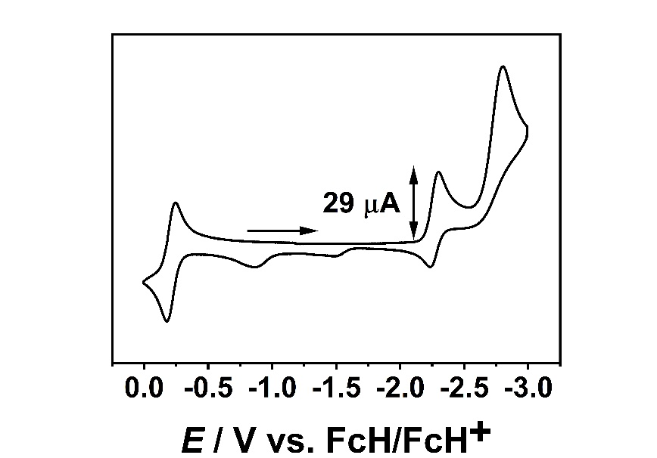
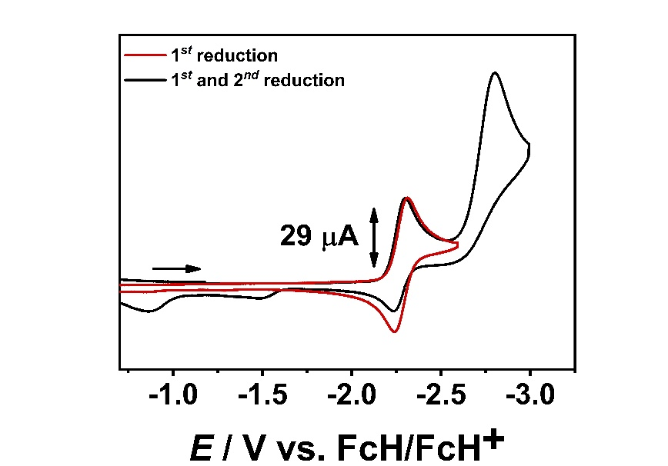
2.10 Cyclic Voltammetry of [Cr(C−C)(CO)₄]

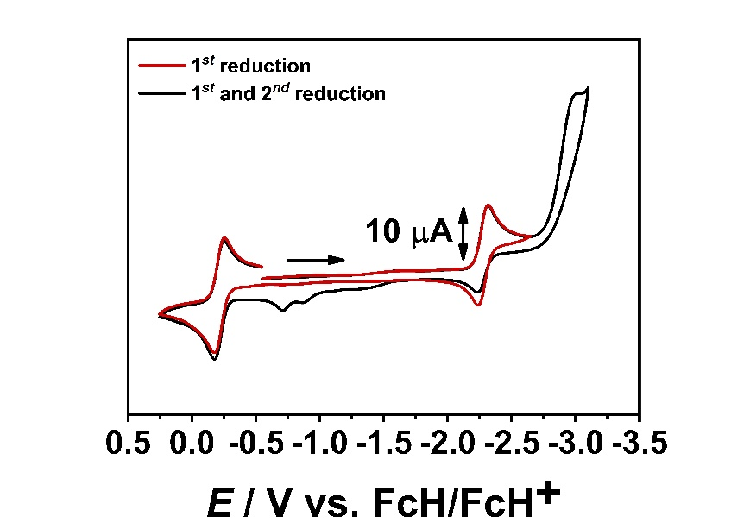
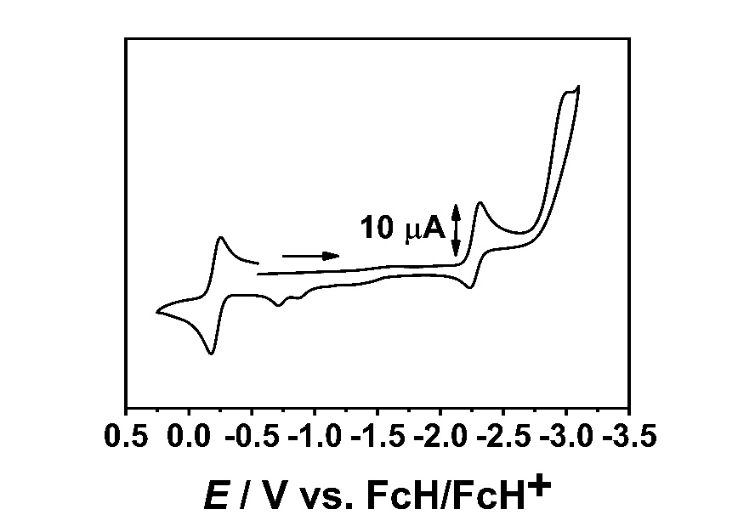
Figure S1. Cyclic voltammograms of [Cr(C−C)(CO)₄] in CH₃CN and 0.1 M Bu₄NPF₆ at a scan rate of 100 mV/s and a glassy carbon working electrode.

Figure S2. Cyclic voltammograms of [Cr(C−C)(CO)₄] in CH₃CN and 0.1 M Bu₄NPF₆ at a scan rate of 100 mV/s and a gold working electrode.

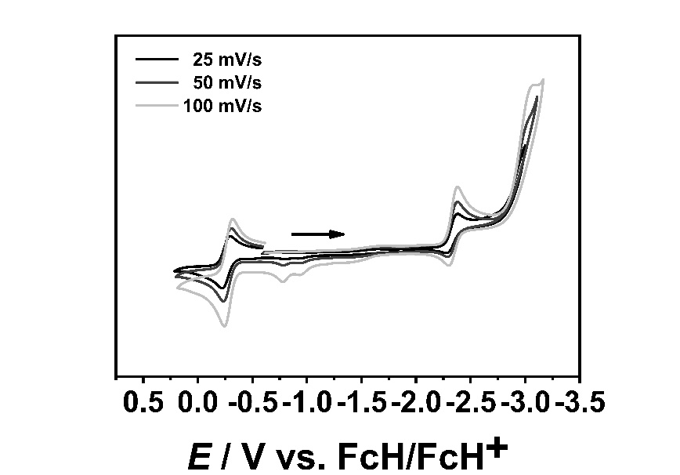
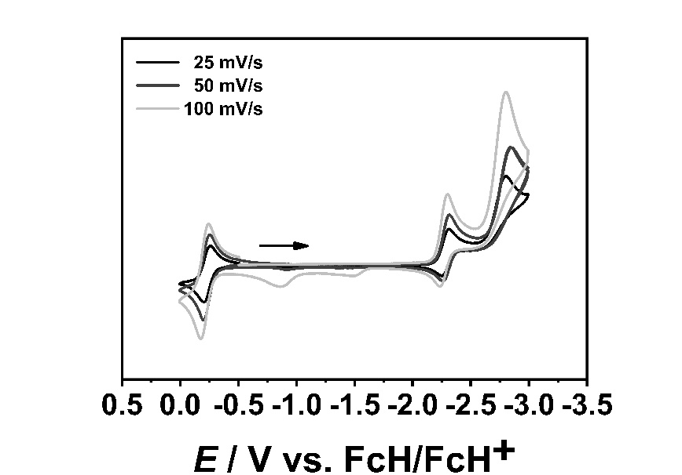
Figure S3. Scan rate dependency in cyclic voltammetry of complex [Cr(C−C)(CO)₄] in CH₃CN and 0.1 M NBu₄PF₆ (GC: left; Au: right).

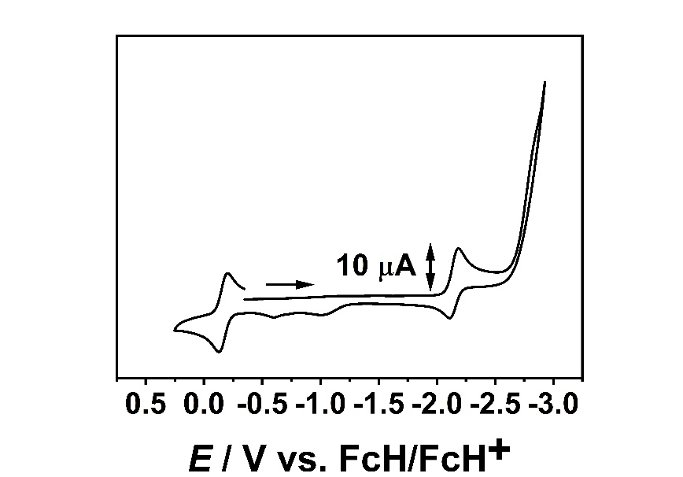
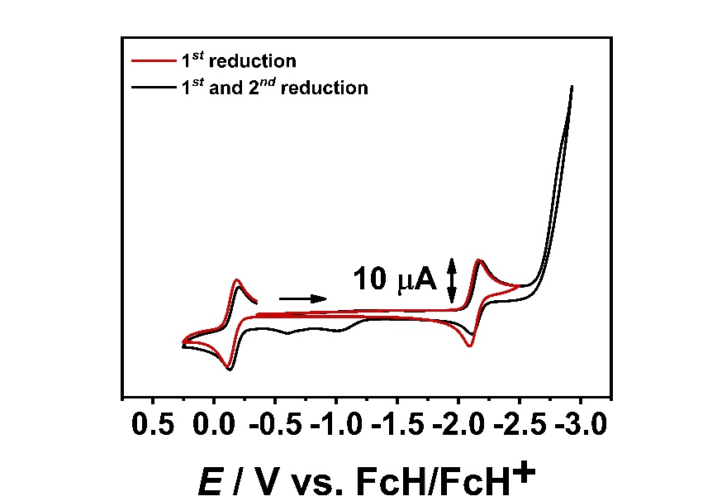
2.20 Cyclic Voltammetry of [Cr(C−N)(CO)₄]

Figure S4. Cyclic voltammograms of [Cr(C−N)(CO)₄] in CH₃CN and 0.1 M Bu₄NPF₆ with a scan rate of 100 mV/s and a gold working electrode.

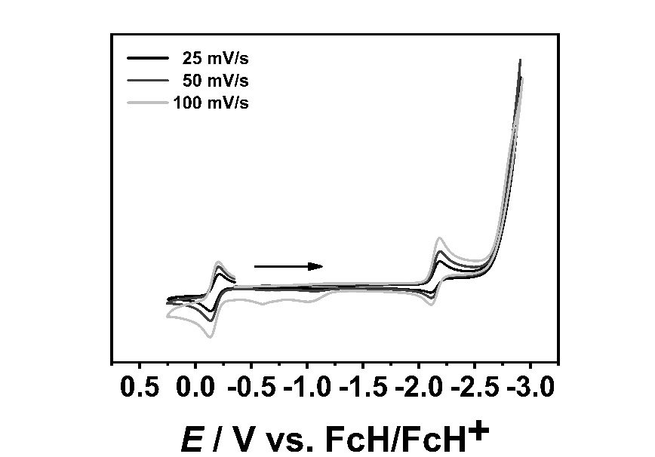

Figure S5. Scan rate dependency in cyclic voltammetry of complex [Cr(C−N)(CO)₄] in CH₃CN and 0.1 M NBu₄PF₆ and a Au working electrode.

2.30 Cyclic Voltammetry of [Mo(C−C)(CO)₄]
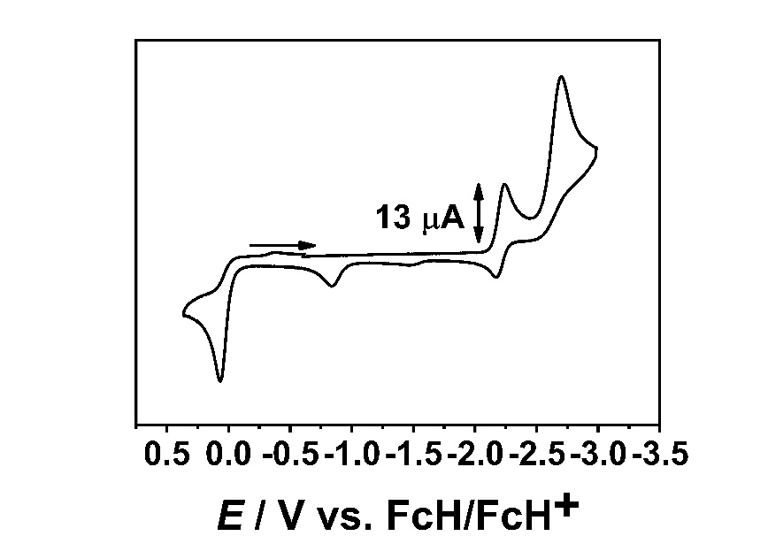
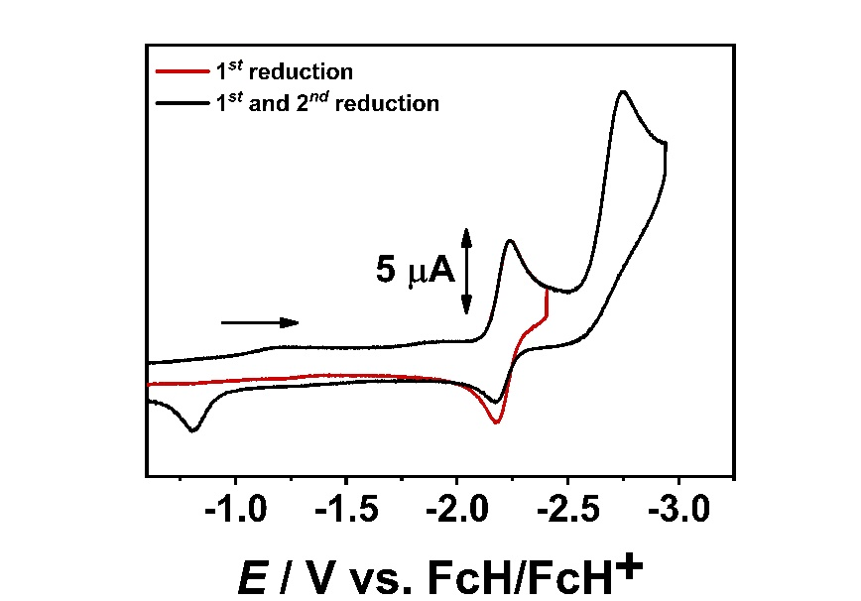

Figure S6. Cyclic voltammograms of [Mo(C−C)(CO)₄] in CH₃CN and 0.1 M Bu₄NPF₆ at a scan rate of 100 mV/s and a glassy carbon working electrode.

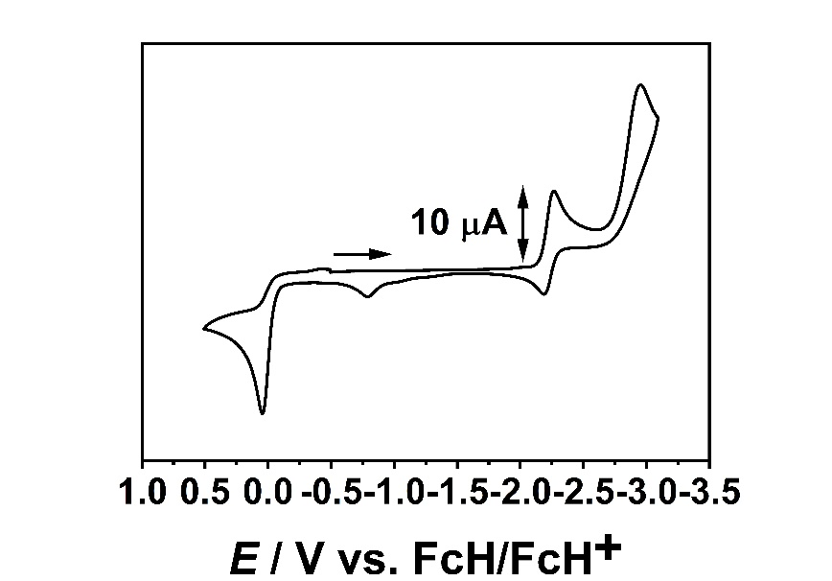
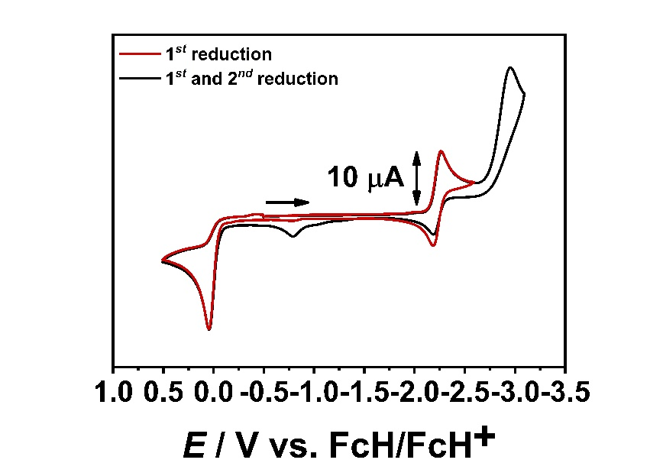
Figure S7. Cyclic voltammograms of [Mo(C−C)(CO)₄] in CH₃CN and 0.1 M Bu₄NPF₆ at a scan rate of 100 mV/s and a gold working electrode.
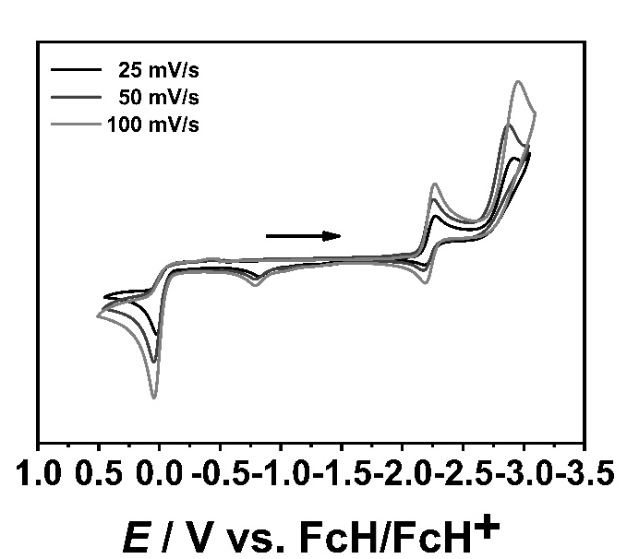
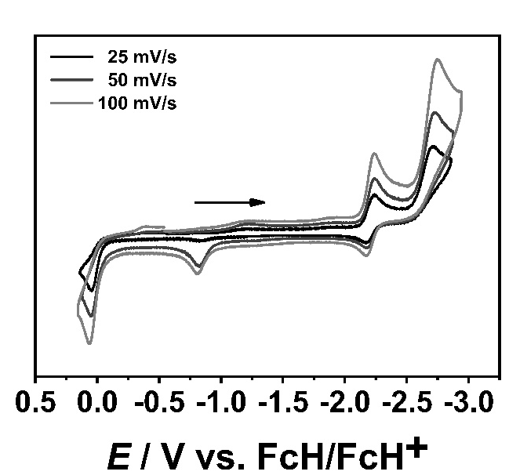
Figure S8. Scan rate dependency in cyclic voltammetry of complex [Mo(C−C)(CO)₄] in CH₃CN and 0.1 M NBu₄PF₆. (GC: left; Au: right).

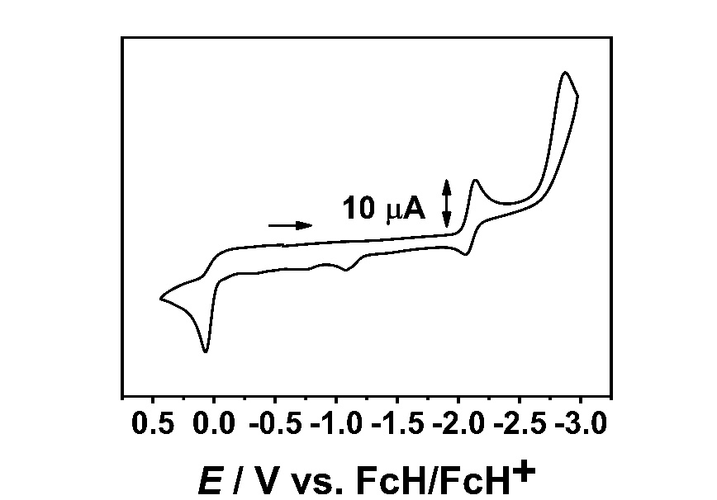
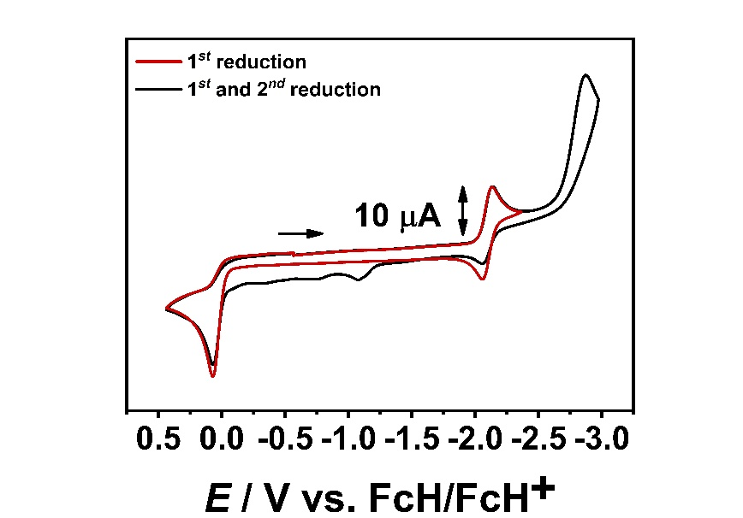
2.40 Cyclic Voltammetry of [Mo(C−N)(CO)₄]

Figure S9. Cyclic voltammograms of [Mo(C−N)(CO)₄] in CH₃CN and 0.1 M Bu₄NPF₆ at a scan rate of 100 mV/s and a gold working electrode.

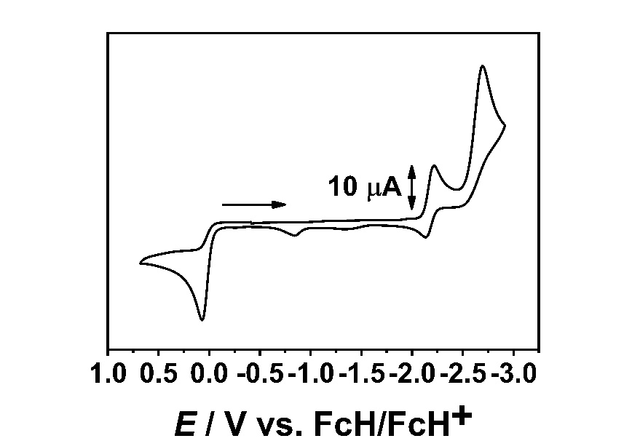
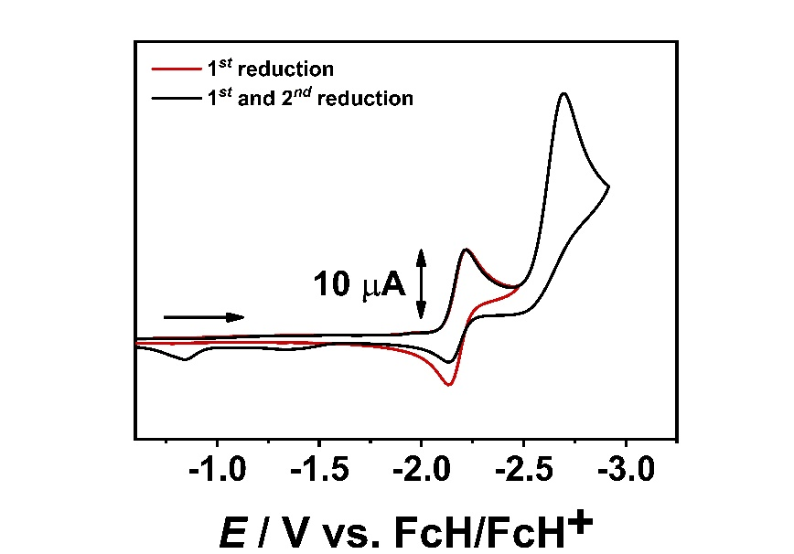
2.50 Cyclic Voltammetry of [W(C−C)(CO)₄]

Figure S10. Cyclic voltammograms of [W(C−C)(CO)₄] in CH₃CN and 0.1 M Bu₄NPF₆ at a scan rate of 100 mV/s and a glassy carbon working electrode.

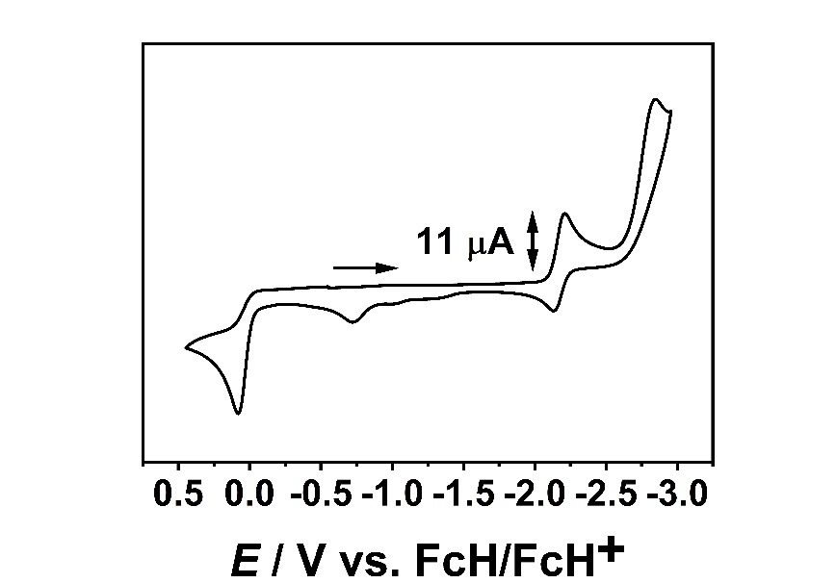
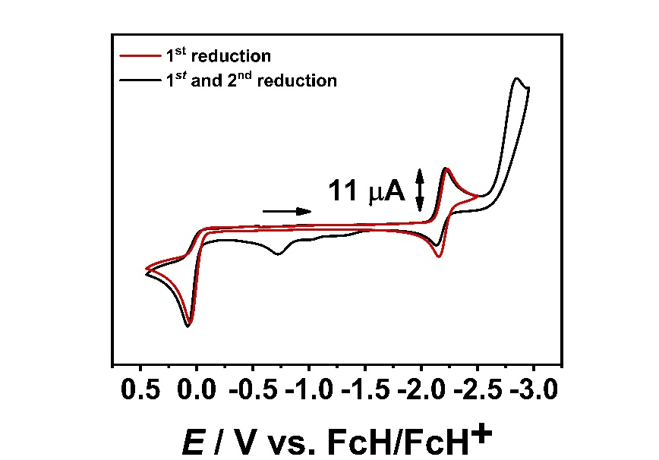
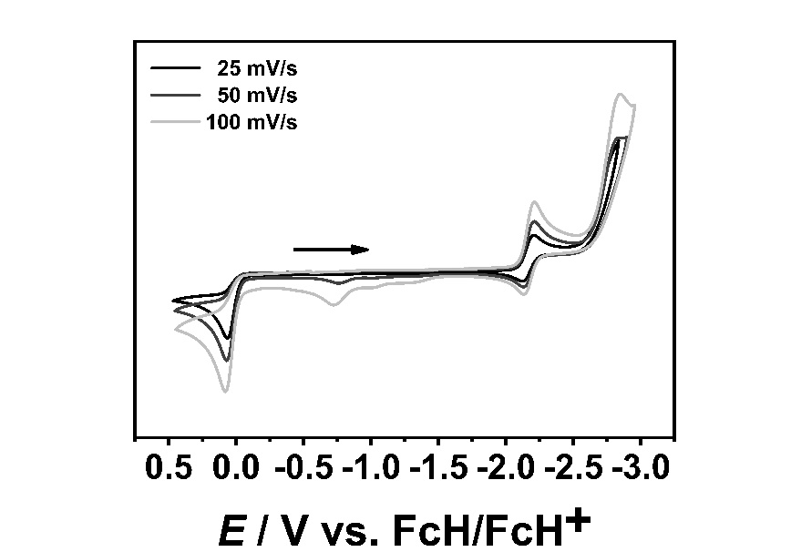
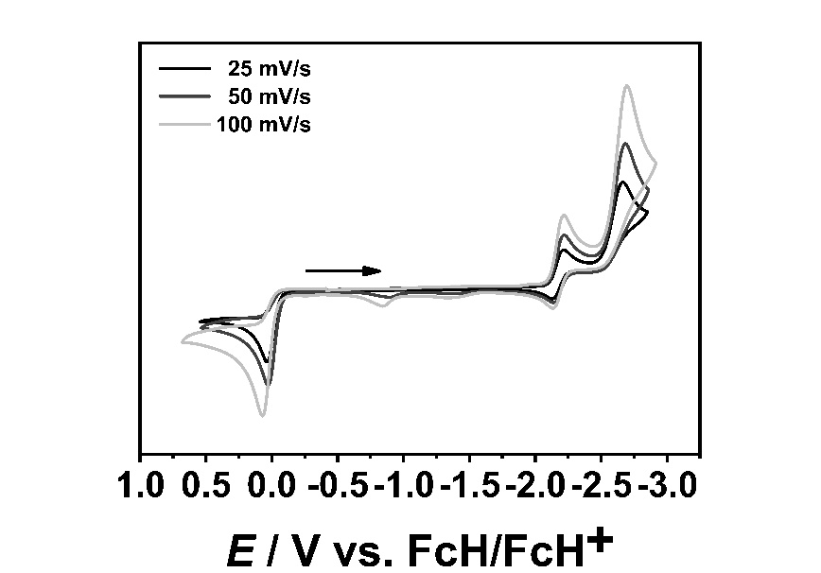
Figure S11. Cyclic voltammograms of [W(C−C)(CO)₄] in CH₃CN and 0.1 M Bu₄NPF₆ with a scan rate of 100 mV/s and a gold working electrode.

Figure S12. Scan rate dependency in cyclic voltammetry of complex [W(C−C)(CO)₄] in CH₃CN and 0.1 M NBu₄PF₆. (GC: left; Au: right).

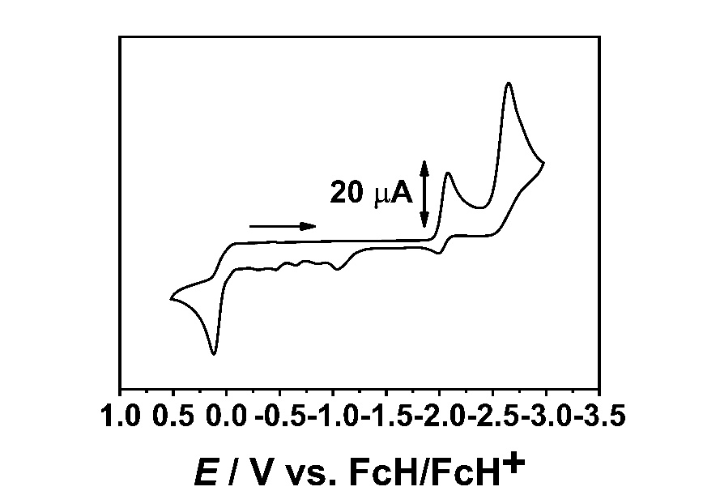
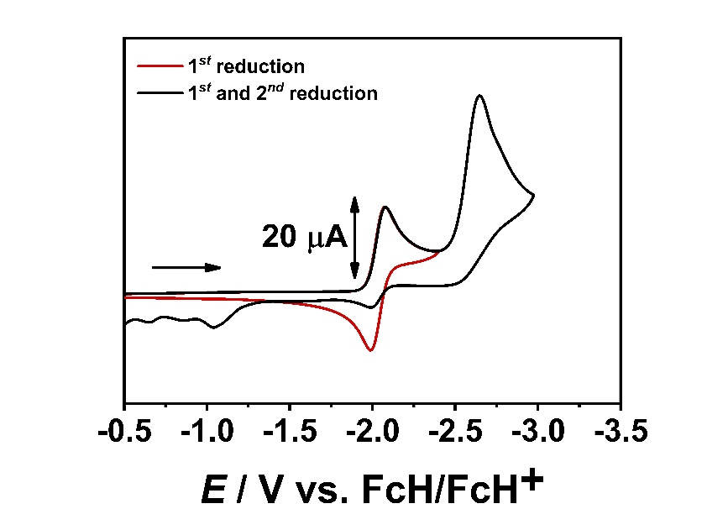
2.60 Cyclic Voltammetry of [W(C−N)(CO)₄]

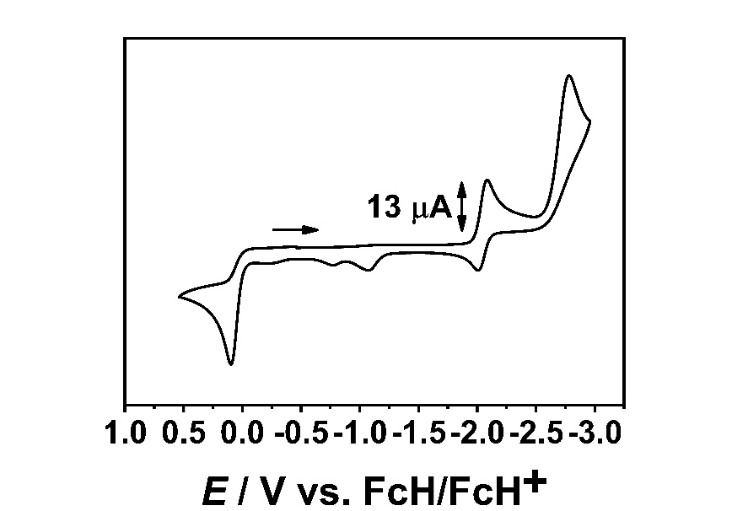
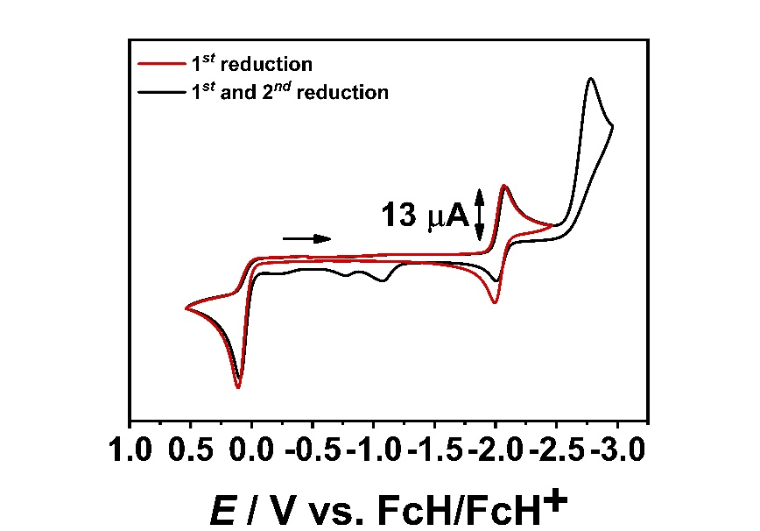
Figure S13. Cyclic voltammograms of [W(C−N)(CO)₄] in CH₃CN and 0.1 M Bu₄NPF₆ at a scan rate of 100 mV/s and a glassy carbon working electrode.

Figure S14. Cyclic voltammograms of [W(C−N)(CO)₄] in CH₃CN and 0.1 M Bu₄NPF₆ at a scan rate of 100 mV/s and a gold working electrode.

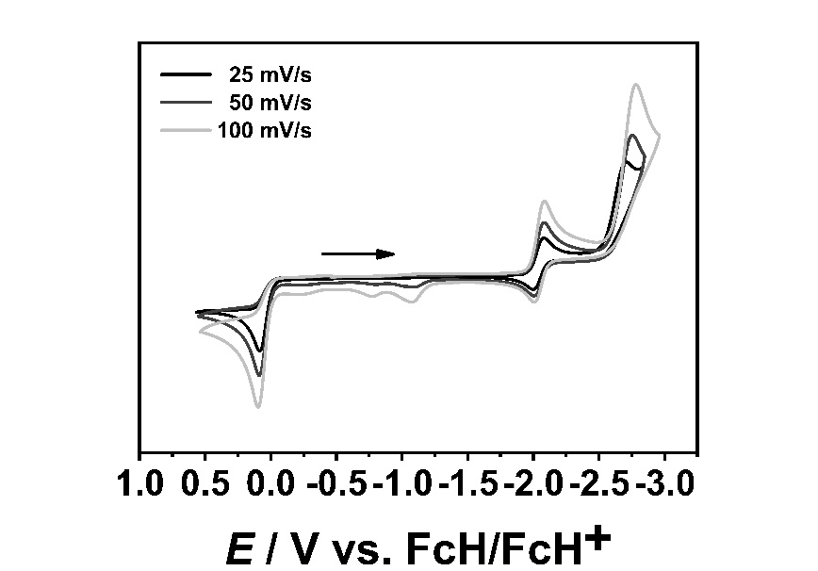
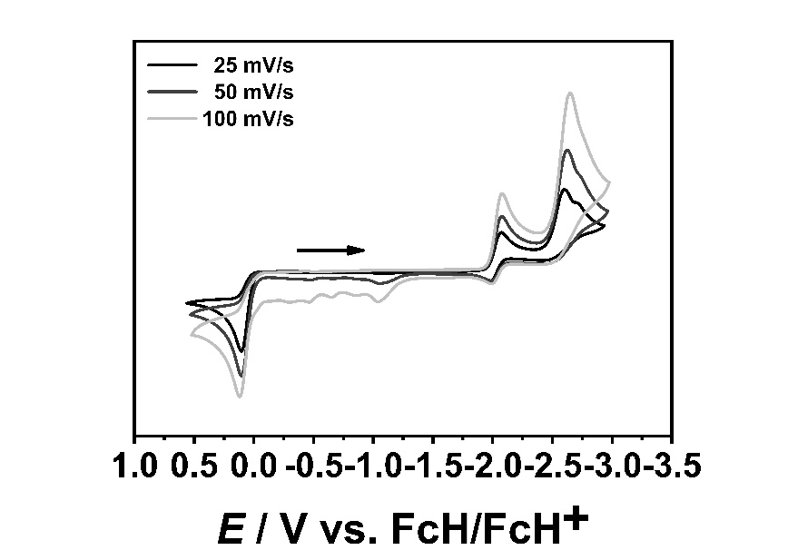

Figure S15. Scan rate dependency in cyclic voltammetry of complex [W(C−N)(CO)₄] in CH₃CN and 0.1 M NBu₄PF₆. (GC: left; Au: right).

Table S1. Redox potentials of [M(C−C)(CO)₄] and [M(C−N)(CO)₄] (M = Cr, Mo, W) in CH₃CN and 0.1 M NBu₄PF₆ at 100 mV/s with a glassy carbon working electrode.
 | 1. Red. / V  $E_{1/2}^{red1}$ ΔE_{p} |  | 2. Red. / V  $E_{p}^{red2}$ | 1. Ox. / V  $E_{1/2}^{ox1}$ ΔE_{p}
[Cr(C−C)(CO)₄]^{[X]} | $-$2.26 | 0.07 | $-$2.80 | $-$0.21 | 0.07
[Cr(C−N)(CO)₄]^{[12]} | $-$2.16 | 0.07 | $-$2.79 | $-$0.17 | 0.07
[Mo(C−C)(CO)₄] | $-$2.21 | 0.07 | $-$2.70 | 0.07ª
[Mo(C−N)(CO)₄]^{[12]} | $-$2.10 | 0.08 | $-$2.68 | 0.08ª
[W(C−C)(CO)₄] | $-$2.19 | 0.08 | $-$2.69 | 0.07ª
[W(C−N)(CO)₄] | $-$2.05 | 0.06 | $-$2.65 | 0.12ª
ª ${=E}_{p}^{ox}$
[12] T. Bens, P. Bode, P. Di Martino-Fumo, J. Beerheus, U. Abold, S. Sobottka, N. I. Neumann, M. Gerhards, B. Sarkar, Inorg. Chem. 2020, 59, 20, 15504.

Table S2. Redox potentials of [M(C−C)(CO)₄]and [M(C−N)(CO)₄] (M = Cr, Mo, W) in CH₃CN and 0.1 M NBu₄PF₆ at 100 mV/s with a gold working electrode.
 | 1. Red. / V  $E_{1/2}^{red1}$ΔE_{p} |  | 2. Red. / V  $E_{p}^{red2}$ | 1. Ox. / V  $E_{1/2}^{ox1}$ ΔE_{p}
[Cr(C−C)(CO)₄] | $-$2.28 | 0.08 | $-$3.08 | $-$0.21 | 0.07
[Cr(C−N)(CO)₄] | $-$2.13 | 0.08 | $-$2.89 | $-$0.16 | 0.08
[Mo(C−C)(CO)₄] | $-$2.22 | 0.08 | $-$2.96 | 0.05ª
[Mo(C−N)(CO)₄] | $-$2.10 | 0.08 | $-$2.88 | 0.07ª
[W(C−C)(CO)₄] | $-$2.19 | 0.07 | $-$2.85 | 0.07ª
[W(C−N)(CO)₄] | $-$2.04 | 0.08 | $-$2.78 | 0.10ª
ª ${=E}_{p}^{ox}$

3. EPR-Spectroelectrochemistry and Spin Density Calculations

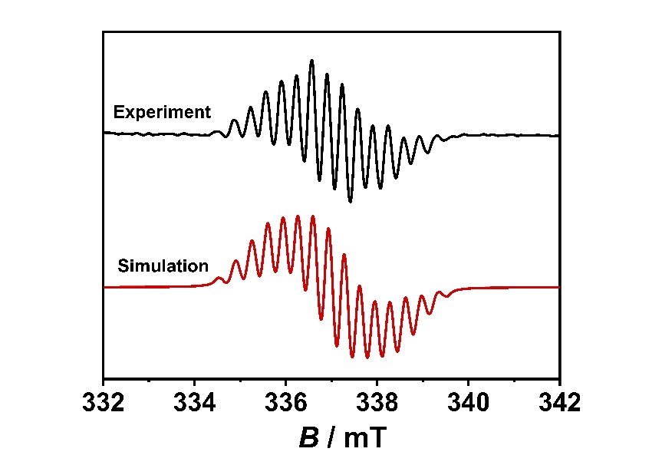
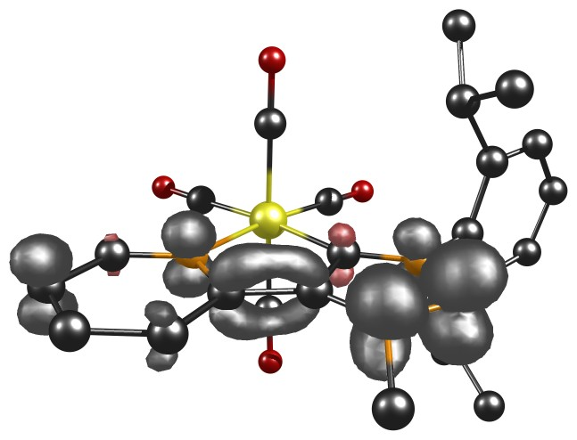
3.10 EPR-Spectroeletrochemistry and Spin Density Calculations of [Cr(C−C)(CO)₄]

Figure S16. EPR spectrum of [Cr(C−C)(CO)₄]⁻ (left, room temperature) in 0.1 M NBu₄PF₆/MeCN with a Au working electrode and spin density plot (right, B3LYP/RIJCOSX/D3BJ/def2-TZVP, iso value = 0.006).

Table S3. EPR simulation data of complex [Cr(C−C)(CO)₄]⁻.
[Cr(C−C)(CO)₄]⁻
g | 2.00295
ACr | 5.90
AN1 | 17.90
AN2 | 17.80
AN3 | 11.00
AN4 | 9.60
AH1 | 11.70
AH2 | 9.50
AH3 | 3.00
AH4 | 2.00
Line width for isotropic broadening / mT | [0 0.123]

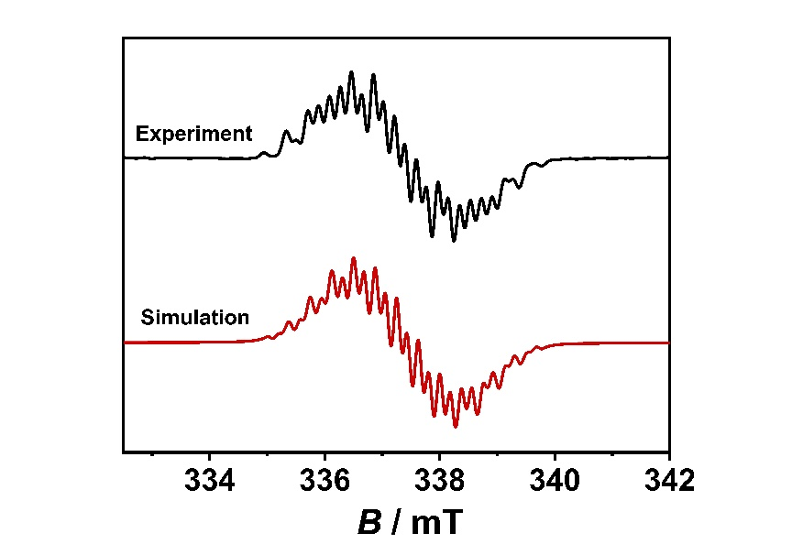
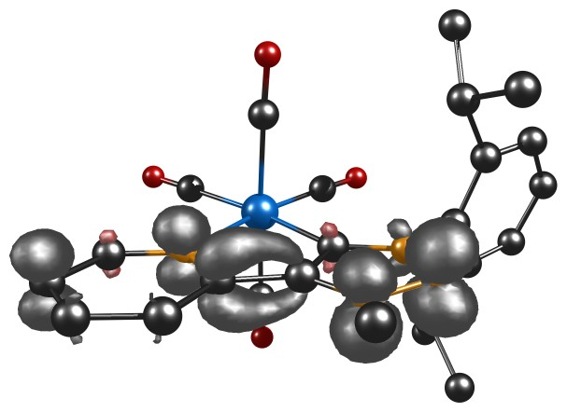
2.20 EPR-Spectroeletrochemistry and Spin Density Calculations of [Mo(C−C)(CO)₄]

Figure S17. EPR spectrum of [Mo(C−C)(CO)₄]⁻ (left, room temperature) in 0.1 M NBu₄PF₆/MeCN with a Au working electrode and spin density plot (right, B3LYP/RIJCOSX/D3BJ/def2-TZVP, iso value = 0.006).

Table S4. EPR simulation data of complex [Mo(C−C)(CO)₄]⁻.
[Mo(C−C)(CO)₄]⁻
g | 2.00327
AMo | 1.97
AN1 | 10.37
AN2 | 4.95
AN3 | 16.10
AN4 | 9.60
AH1 | 12.00
AH2 | 11.90
AH3 | 10.50
AH4 | 14.45
Line width for isotropic broadening / mT | [0 0.121]

3.30 EPR-Spectroeletrochemistry and Spin Density Calculations of [W(C−C)(CO)₄]
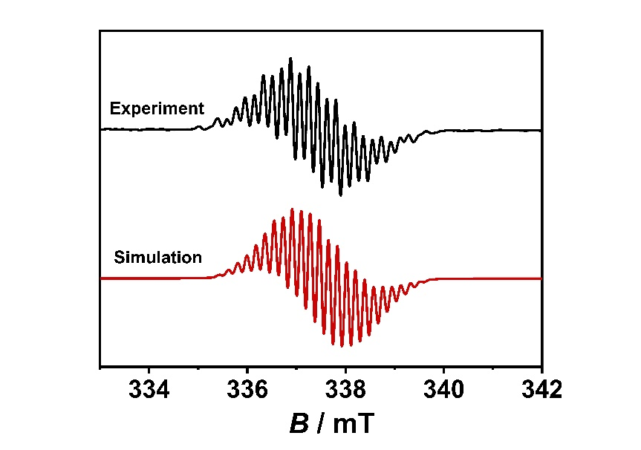
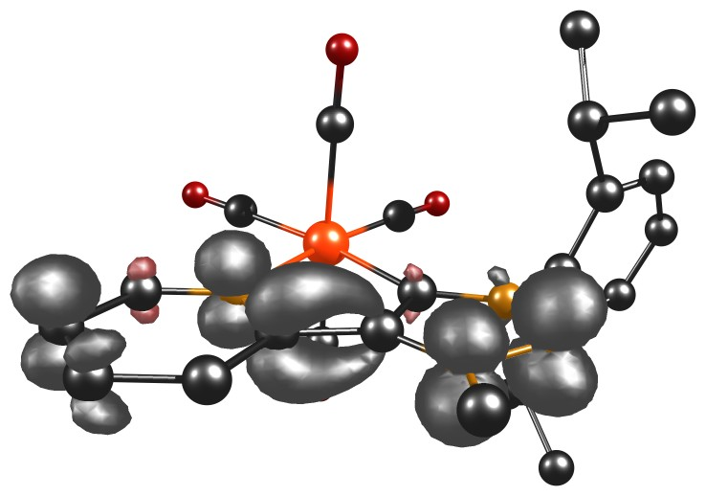

Figure S18. EPR spectrum of [W(C−C)(CO)₄]⁻ (left, room temperature) in 0.1 M NBu₄PF₆/MeCN with a Au working electrode and spin density plot (right, B3LYP/RIJCOSX/D3BJ/def2-TZVP, iso value = 0.006).

Table S5. EPR simulation data of complex [W(C−C)(CO)₄]⁻.
[W(C−C)(CO)₄]⁻
g | 2.00275
AW | 13.10
AN1 | 10.39
AN2 | 5.60
AN3 | 5.60
AN4 | 4.53
AH1 | 4.16
AH2 | 20.27
AH3 | 20.27
AH4 | 15.36
AH5 | 1.01
AH6 | 1.01
AH7 | 0.63
AH8 | 1.81
AH9 | 0.49
AH10 | 0.50
Line width for isotropic broadening / mT | [0 0.054]

3.40 EPR-Spectroeletrochemistry and Spin Density Calculations of [W(C−N)(CO)₄]
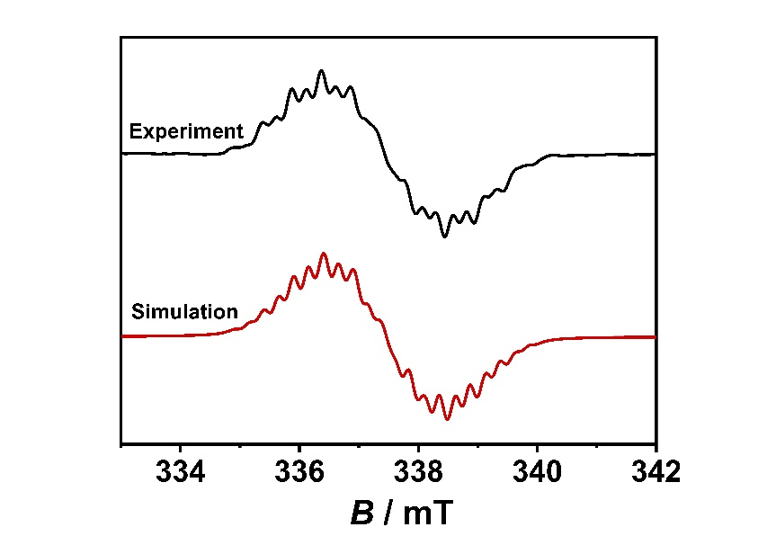
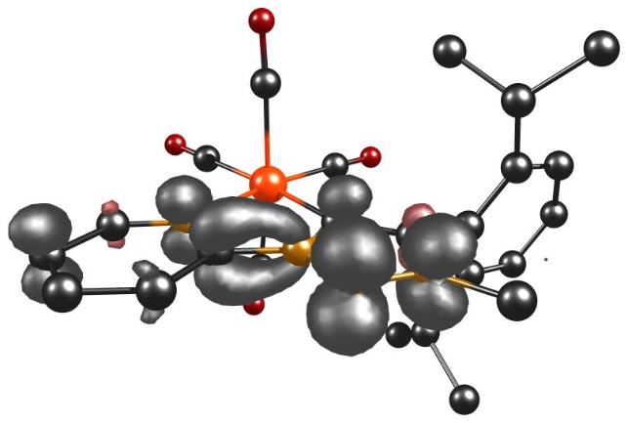

Figure S19. EPR spectrum of [W(C−N)(CO)₄]⁻ (left, room temperature) in 0.1 M NBu₄PF₆/MeCN with a Au working electrode and spin density plot (right, B3LYP/RIJCOSX/D3BJ/def2-TZVP, iso value = 0.006).

Table S5. EPR simulation data of complex [W(C−N)(CO)₄]⁻.
[W(C−N)(CO)₄]⁻
g | 2.00316
AW | 2.65
AN1 | 16.92
AN2 | 14.22
AN3 | 6.47
AN4 | 5.82
AH1 | 16.20
AH2 | 13.77
AH3 | 13.22
AH4 | 7.19
AH5 | 3.19
AH6 | 3.19
Line width for isotropic broadening / mT |  | [0 0.161]

Table S6. Composition of [M(C−C)(CO)₄]⁻ and [M(C−N)(CO)₄]⁻ (M = Cr, Mo, W) in Loewdin spin density.
MO | Composition (%)
 | M | L $+ | -$ | CO_{ax} $+ | -$ | CO_{eq} $+ | -$
[Cr(C−C) (CO)₄]⁻ | $-$0.8 | 103.8 | $-$3.4 | 0.4 | $-$0.3 | 0.3 | 0.0
[Cr(C−N) (CO)₄]^{− [12]} | $-$0.4 | 99.3 | $-$1.0 | 0.9 | 0.0 | 1.2 | 0.0
[Mo(C−C)(CO)₄]⁻ | $-$0.5 | 103.0 | $-$2.7 | 0.3 | $-$0.1 | 0.5 | $-$0.5
[Mo(C−N)(CO)₄]^{− [12]} | $-$0.7 | 98.5 | $-$1.0 | 1.1 | 0.0 | 2.1 | 0.0
[W(C−C)(CO)₄]⁻ | 0.0 | 100.4 | $-$0.0 | 0.0 | 0.0 | 0.0 | $0.0$
[W(C−N)(CO)₄]⁻ | 0.0 | 77.5 | $-$15.2 | 0.0 | 0.0 | 0.0 | 0.0

4. IR-Spectroelectrochemistry and DFT Calculations

4.10 IR Spectra of [M(C−C)(CO)₄] and [M(C−N)(CO)₄] (M = Cr, Mo, W)
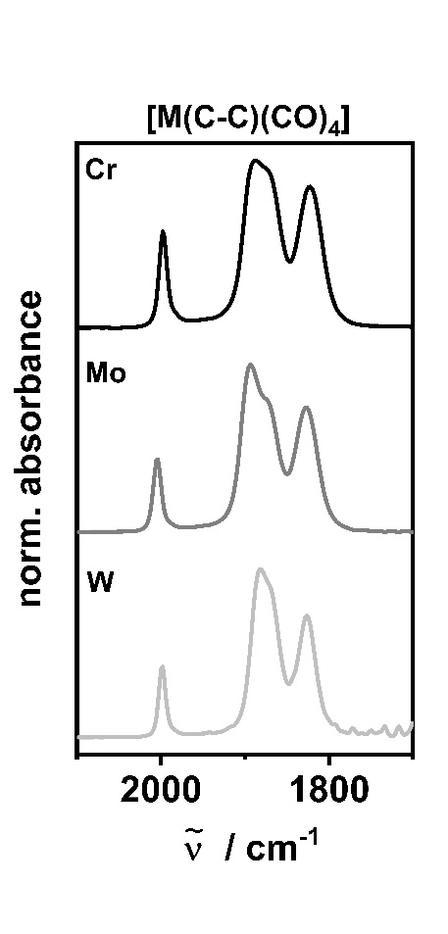
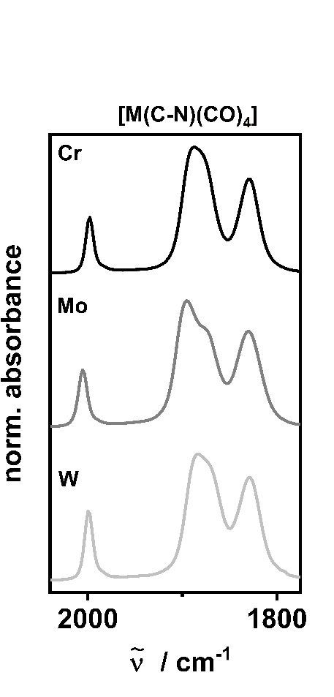

Figure S20. IR spectra of [M(C−C)(CO)₄] (left) and [M(C−N)(CO)₄] (right) in CH₂Cl₂ (M = Cr: black, Mo: grey, W: light grey).

Table S7. CO frequencies of [M(C−C)(CO)₄] and [M(C−N)(CO)₄] (M = Cr, Mo, W) in CH₂Cl₂.
 | $ῦ$ (CO) / ${cm}^{-1}$ |  |  |  | $ῦ_{average}$ (CO) / ${cm}^{-1}$
[Cr(C−C)(CO)₄]^{[X]} | 1998 | 1890 | 1875 (sh) | 1822 | 1896
[Cr(C−N)(CO)₄]^{[12]} | 1998 | 1890 | 1878 (sh) | 1830 | 1899
[Mo(C−C)(CO)₄] | 2004 | 1894 | 1876 (sh) | 1827 | 1900
[Mo(C−N)(CO)₄]^{[12]} | 2006 | 1896 | 1876 (sh) | 1830 | 1902
[W(C−C)(CO)₄] | 1998 | 1882 | 1870 (sh) | 1826 | 1894
[W(C−N)(CO)₄] | 2000 | 1884 | 1873 (sh) | 1830 | 1897

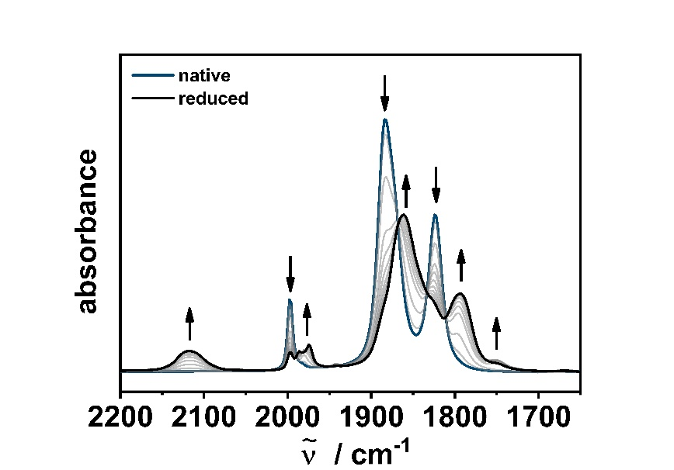
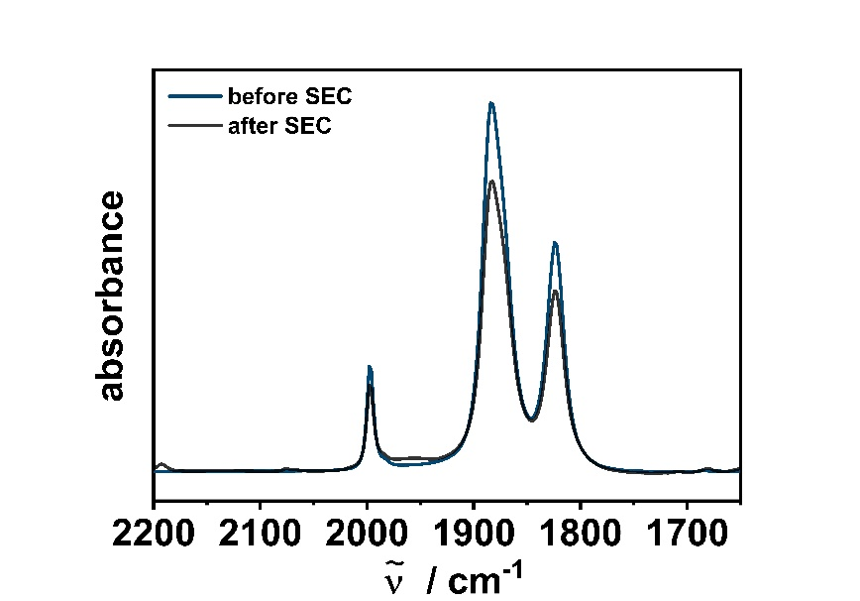
4.20 IR-Spectroelectrochemistry of [Cr(C−C)(CO)₄]

Figure S20. Changes in the IR spectra of [Cr(C−C)(CO)₄] in CH₃CN/0.1 M Bu₄NPF₆ with a Au working electrode during the first reduction (left) and after IR-SEC (right).
 |  | $ῦ$ (CO) / ${cm}^{-1}$
exp. | [Cr(C−C)(CO)₄] | 1998 | 1882 | 1874 (sh) | 1824
exp. | [Cr(C−C)(CO)₄]⁻ | 2118ª | 1986 | 1975 | 1861 | 1845 (sh) | 1794 | 1751
calc. | [Cr(C−C)(CO)₄] | 2045 | 1906 | 1903 | 1853
calc. | [Cr(C−C)(CO)₄]⁻ | 2029 | 1884 | 1876 | 1820
Table S8. Experimental and calculated changes (B3LYP/RIJCOSX/D3BJ/def2-TZVP) in the CO frequencies of [Cr(C−C)(CO)₄] in CH₃CN/0.1 M Bu₄NPF₆ with a Au working electrode during the first reduction.
ª free CO

4.21 Calculated IR Spectra of [Cr(C−C)(CO)₄] and [Cr(C−C)(CO)₄]⁻
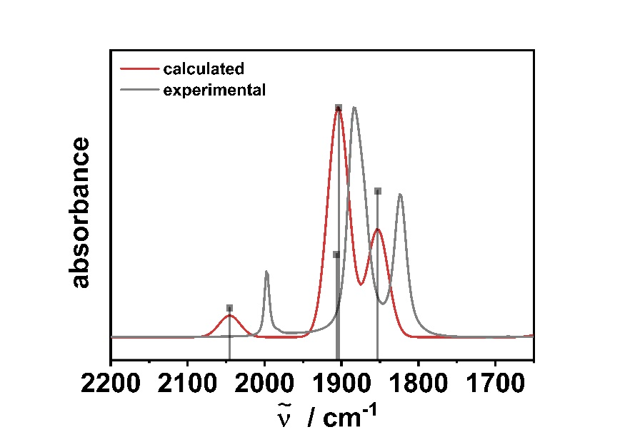
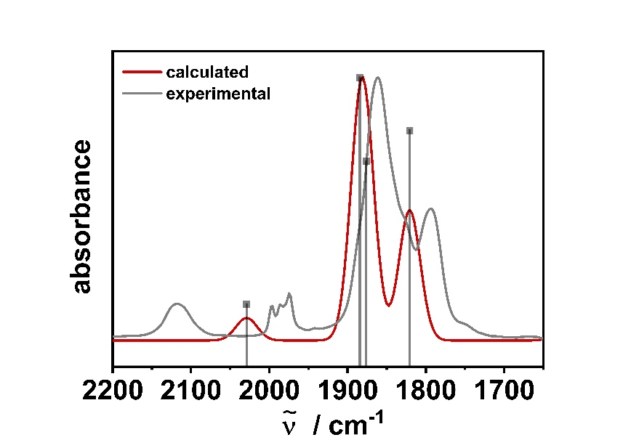
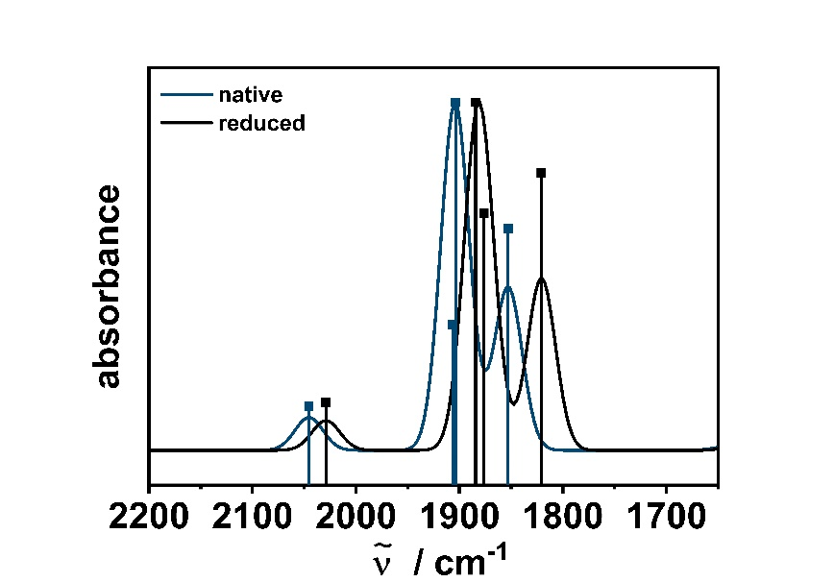

Figure S21. Top left: Calculated (red) and experimental (grey) IR spectra of [Cr(C−C)(CO)₄], Top right: Calculated (red) and experimental (grey) IR spectra of [Cr(C−C)(CO)₄]⁻ and bottom centered: Overlay of calculated [Cr(C−C)(CO)₄] (blue) and [Cr(C−C)(CO)₄]⁻ (black) (B3LYP/RIJCOSX/D3BJ/def2-TZVP, FWHM = 32).

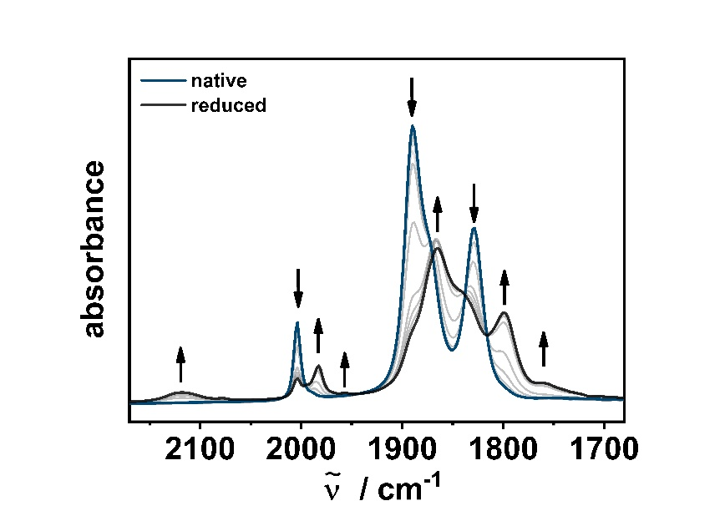
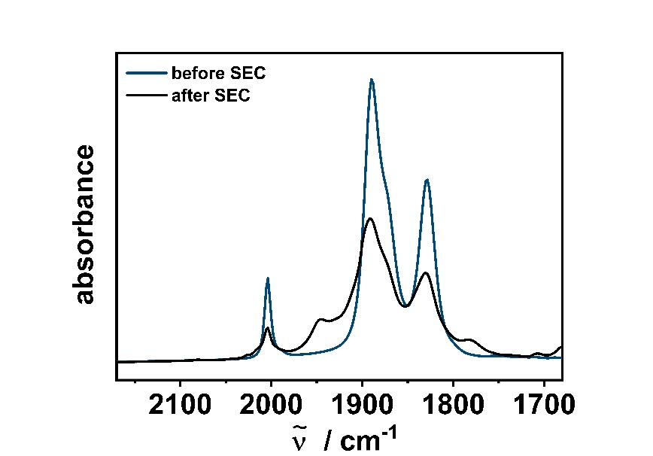
4.30 IR-Spectroelectrochemistry of [Mo(C−C)(CO)₄]

Figure S22. Changes in the IR spectra of [Mo(C−C)(CO)₄] in CH₃CN/0.1 M Bu₄NPF₆ with a Au working electrode during the first reduction (left) and after IR-SEC (right).
 |  | $ῦ$ (CO) / ${cm}^{-1}$
exp. | [Mo(C−C)(CO)₄] | 2004 | 1890 | 1876 (sh) | 1828
exp. | [Mo(C−C)(CO)₄]⁻ | 2119ª | 1982 | 1957 | 1865 | 1842 | 1799 | 1759
calc. | [Mo(C−C)(CO)₄] | 2051 | 1904 | 1894 | 1830
calc. | [Mo(C−C)(CO)₄]⁻ | 2036 | 1881 | 1869 | 1807
Table S9. Experimental and calculated changes (B3LYP/RIJCOSX/D3BJ/def2-TZVP) in the CO frequencies of [Mo(C−C)(CO)₄] in CH₃CN/0.1 M Bu₄NPF₆ with a Au working electrode during the first reduction.
ª free CO

4.31 Calculated IR Spectra of [Mo(C−C)(CO)₄] and [Mo(C−C)(CO)₄]⁻
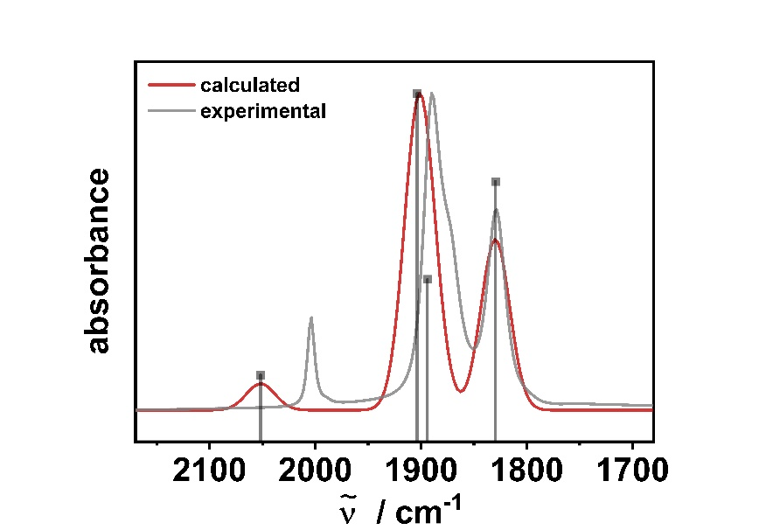
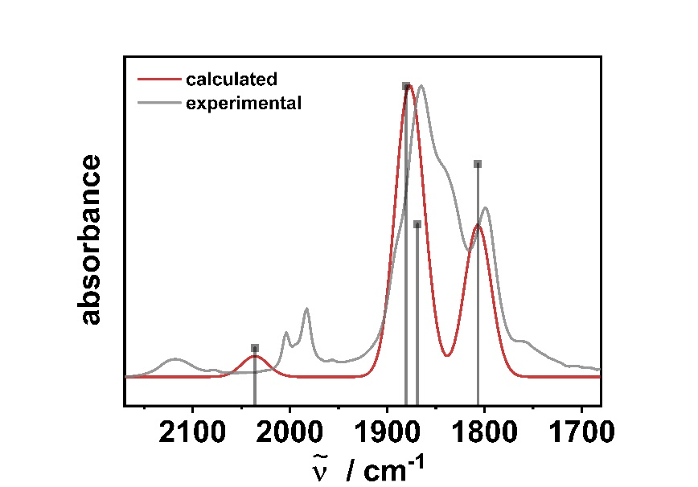
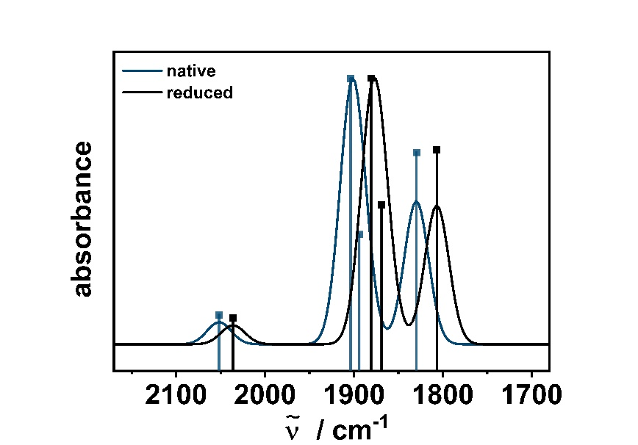

Figure S23. Top left: Calculated (red) and experimental (grey) IR spectra of [Mo(C−C)(CO)₄], Top right: Calculated (red) and experimental (grey) IR spectra of [Mo(C−C)(CO)₄]⁻ and bottom centered: Overlay of calculated [Mo(C−C)(CO)₄] (blue) and [Mo(C−C)(CO)₄]⁻ (black) (B3LYP/RIJCOSX/D3BJ/def2-TZVP, FWHM = 32).

4.40 IR-Spectroelectrochemistry of [W(C−C)(CO)₄]
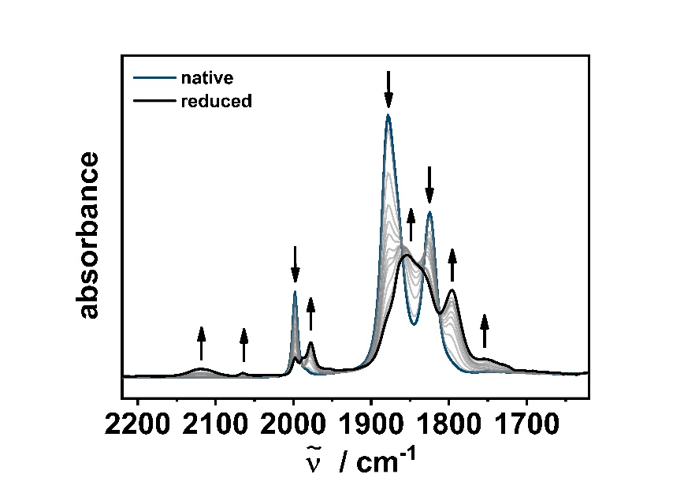
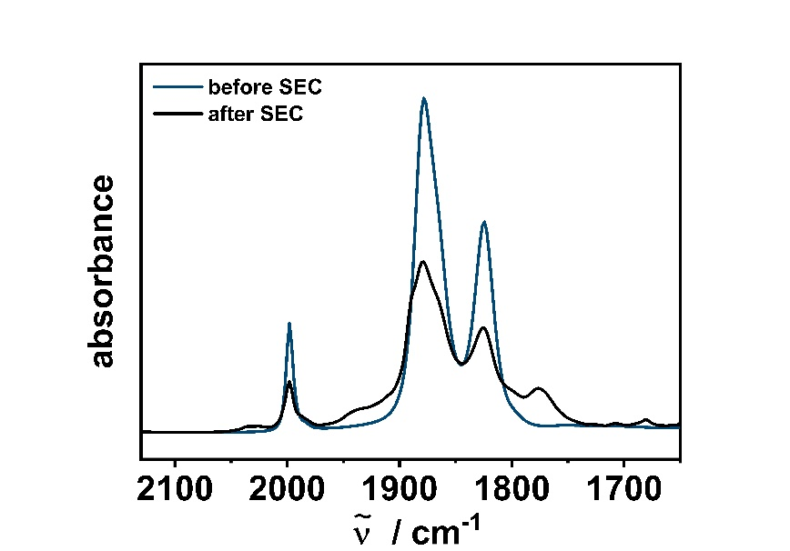
Figure S24. Changes in the IR spectra of [W(C−C)(CO)₄] in CH₃CN/0.1 M Bu₄NPF₆ with a Au working electrode during the first reduction (left) and after IR-SEC (right).
 |  | $ῦ$ (CO) / ${cm}^{-1}$
exp. | [W(C−C)(CO)₄] | 1998 | 1878 | 1871 | 1824
exp. | [W(C−C)(CO)₄]⁻ | 2119ª | 2065 | 1986 | 1877 | 1853 | 1795 | 1783 | 1754 | 1730
calc. | [W(C−C)(CO)₄] | 2047 | 1893 | 1889 | 1822
calc. | [W(C−C)(CO)₄]⁻ | 2027 | 1864 | 1856 | 1790
Table S10. Experimental and calculated changes (B3LYP/RIJCOSX/D3BJ/def2-TZVP) in the CO frequencies of [W(C−C)(CO)₄] in CH₃CN/0.1 M Bu₄NPF₆ with a Au working electrode during the first reduction.
ª free CO

4.41 Calculated IR Spectra of [W(C−C)(CO)₄] and [W(C−C)(CO)₄]⁻
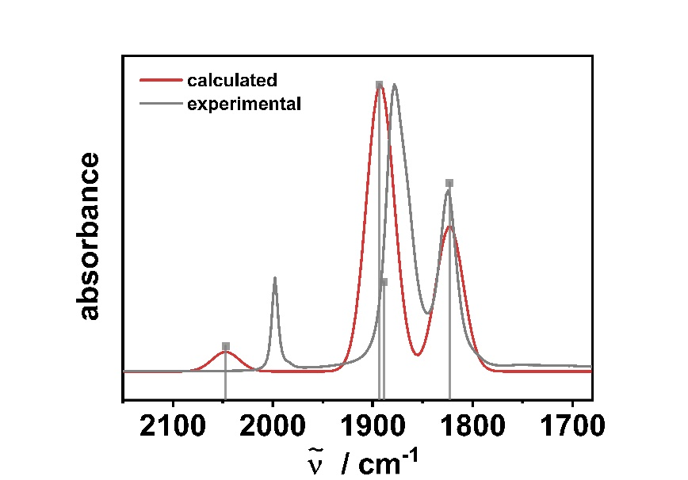
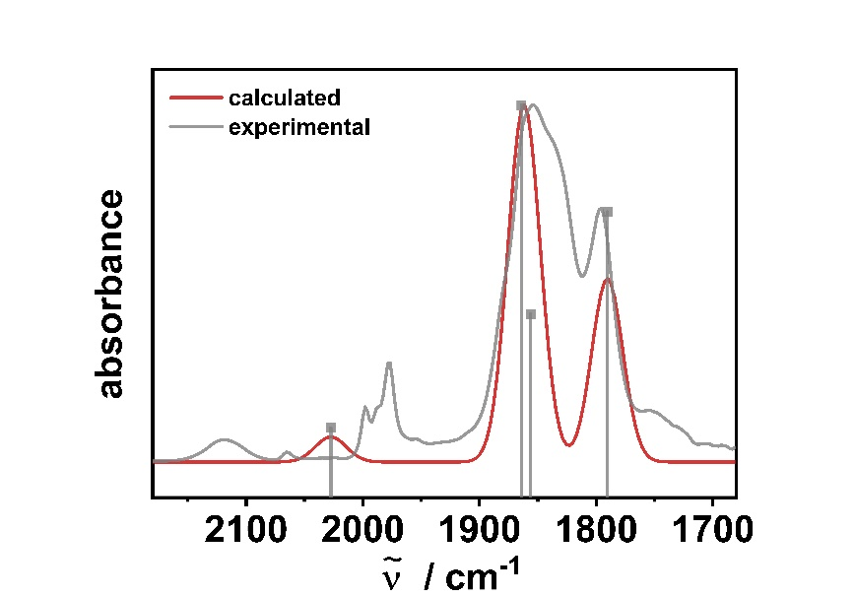
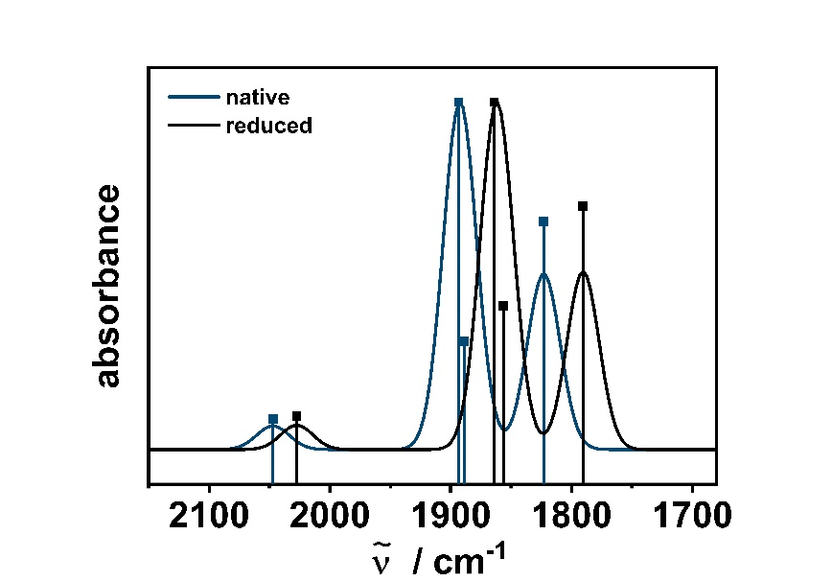

Figure S25. Top left: Calculated (red) and experimental (grey) IR spectra of [W(C−C)(CO)₄], Top right: Calculated (red) and experimental (grey) IR spectra of [W(C−C)(CO)₄]⁻ and bottom centered: Overlay of calculated [W(C−C)] (blue) and [W(C−C)(CO)₄]⁻ (black) (B3LYP/RIJCOSX/D3BJ/ZORA/def2-TZVP, FWHM = 32).

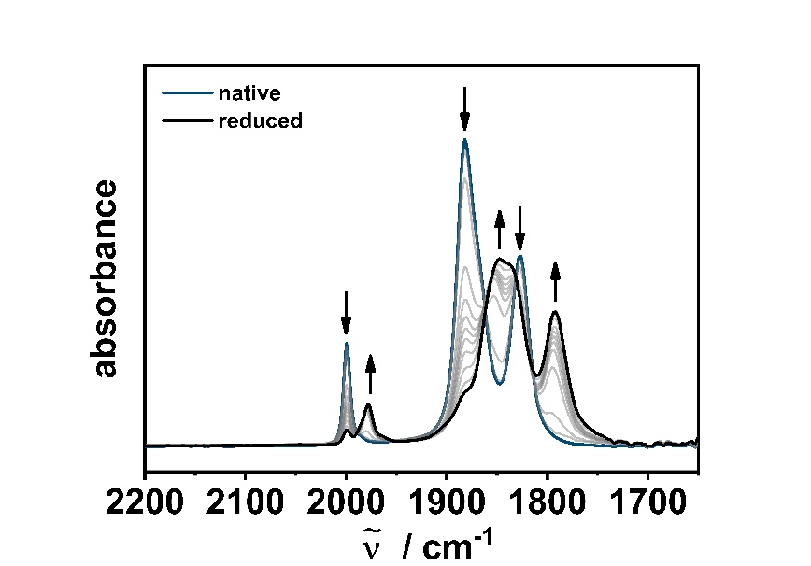
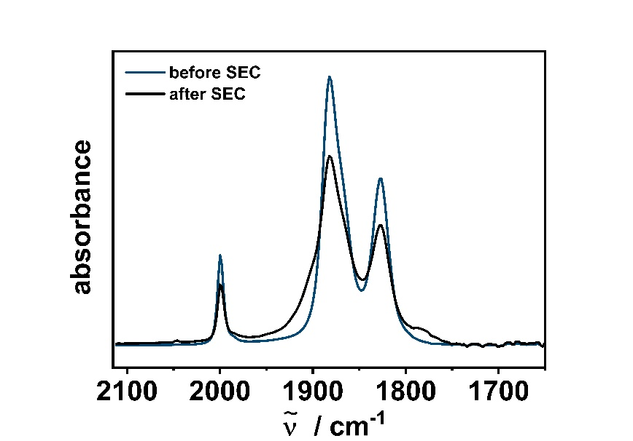
4.50 IR-Spectroelectrochemistry of [W(C−N)(CO)₄]

Figure S26. Changes in the IR spectra of [W(C−N)(CO)₄] in CH₃CN/0.1 M Bu₄NPF₆ with a Au working electrode during the first reduction (left) and after IR-SEC (right).
 |  | $ῦ$ (CO) / ${cm}^{-1}$
exp. | [W(C−N)(CO)₄] | 2000 | 1882 | 1873 (sh) | 1826
exp. | [W(C− N)(CO)₄]⁻ | 1979 | 1878 | 1838 | 1792
calc. | [W(C−N)(CO)₄] | 2039 | 1892 | 1881 | 1830
calc. | [W(C−N)(CO)₄]⁻ | 2018 | 1853 | 1843 | 1790
Table S11. Experimental and calculated changes (B3LYP/RIJCOSX/D3BJ/def2-TZVP) in the CO frequencies of [W(C−N)(CO)₄] in CH₃CN/0.1 M Bu₄NPF₆ with a Au working electrode during the first reduction.

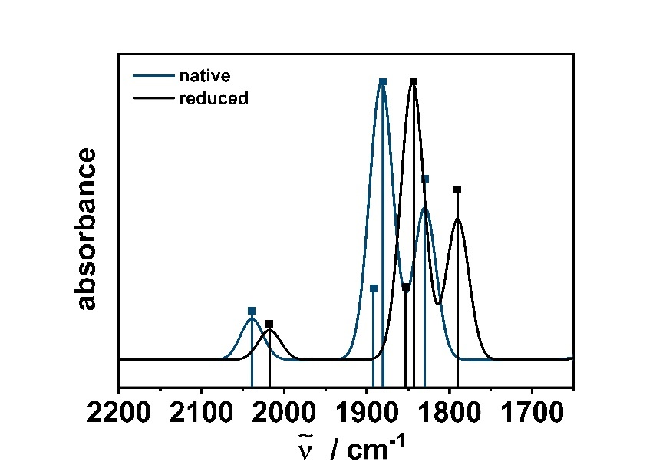
4.51 Calculated IR Spectra of [W(C−N)(CO)₄] and [W(C−N)(CO)₄]⁻
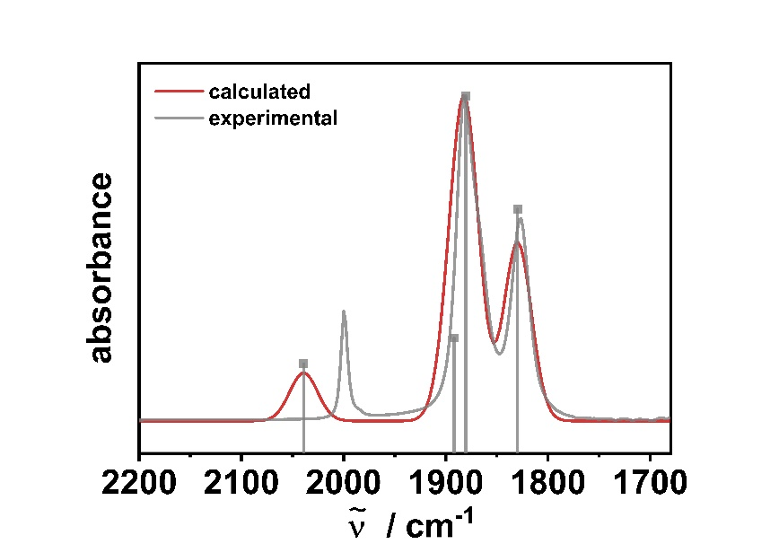
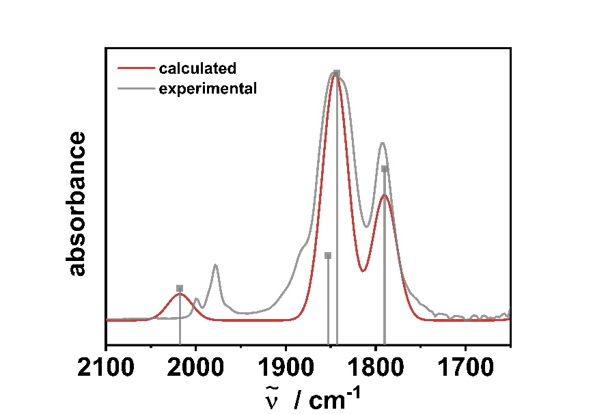

Figure S27. Top left: Calculated (red) and experimental (grey) IR spectra of [W(C−N)(CO)₄], Top right: Calculated (red) and experimental (grey) IR spectra of [W(C−N)(CO)₄]⁻ and bottom centered: Overlay of calculated [W(C−N)(CO)₄] (blue) and [W(C−N)(CO)₄]⁻ (black) (B3LYP/RIJCOSX/D3BJ/ZORA/def2-TZVP, FWHM = 32).

5. UV/vis/NIR-Spectroelectrochemistry

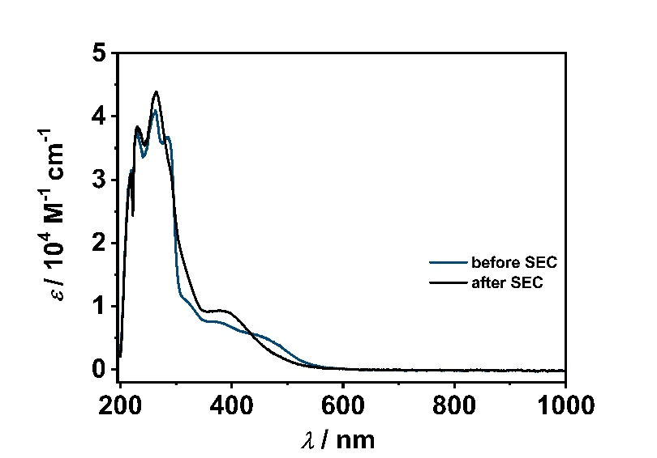
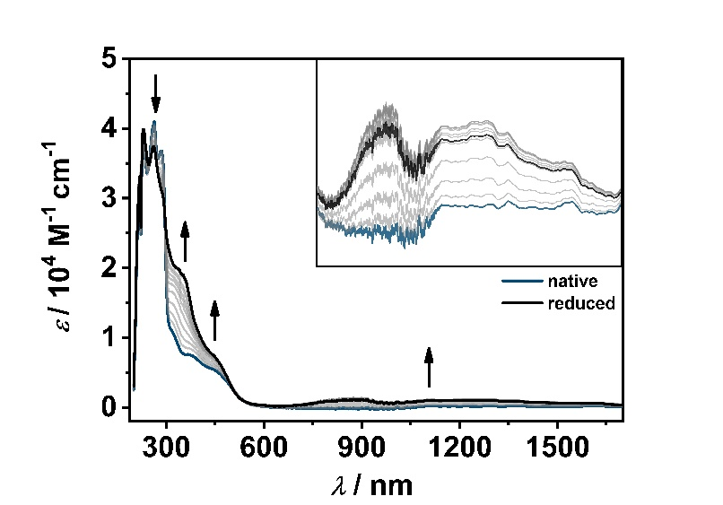
5.10 UV/vis/NIR-Spectroelectrochemistry of [Cr(C−C)(CO)₄]
Figure S28. Changes in the UV/VIS spectra of [Cr(C−C)(CO)₄] (left, Inset: 600−1800 nm) in CH₃CN/0.1 M Bu₄NPF₆ during the first reduction with a Au working electrode and after UV/vis/NIR-SEC (right).

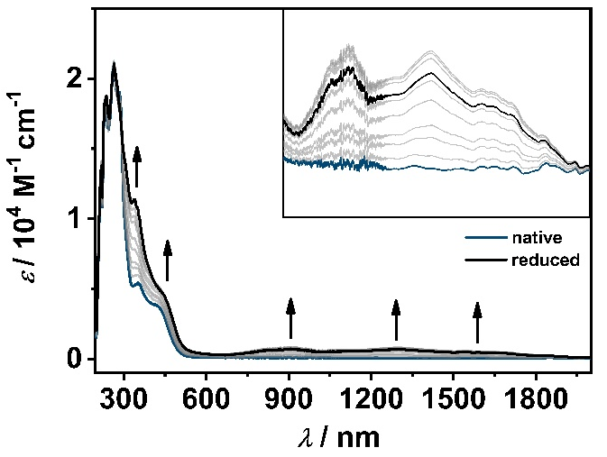
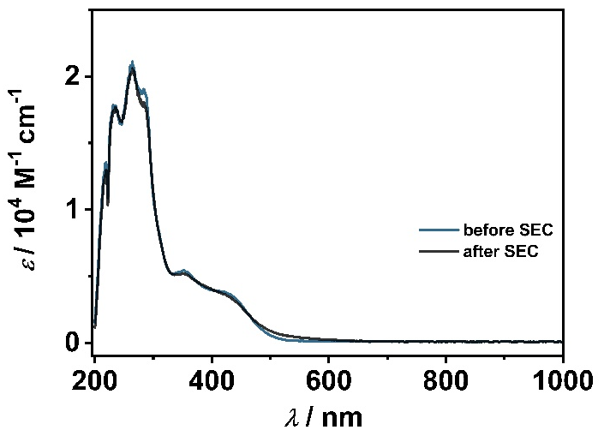
5.20 UV/vis/NIR-Spectroelectrochemistry of [Mo(C−C)]
Figure S29. Changes in the UV/VIS spectra of [Mo(C−C)(CO)₄] (left, Inset: 600−2000 nm) in CH₃CN/0.1 M Bu₄NPF₆ during the first reduction with a Au working electrode and after UV/vis/NIR-SEC (right).

5.30 UV/vis/NIR-Spectroelectrochemistry of [W(C−C)(CO)₄]
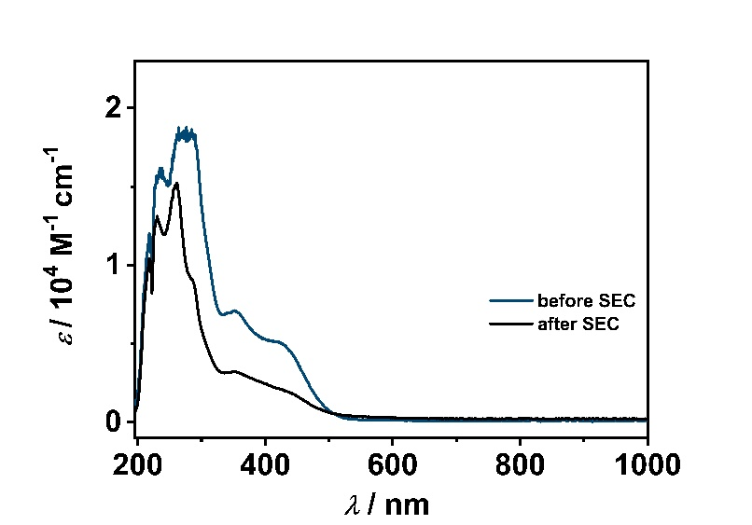
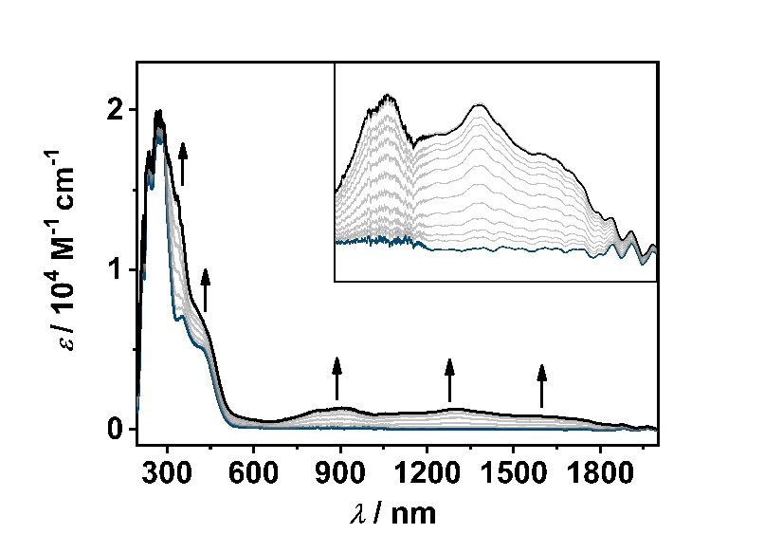

Figure S30. Changes in the UV/VIS spectra of [W(C−C)(CO)₄] (left, Inset: 650−2050 nm) in CH₃CN/0.1 M Bu₄NPF₆ during the first reduction with a Au working electrode and after UV/vis/NIR-SEC (right).

5.40 UV/vis/NIR-Spectroelectrochemistry of [W(C−N)(CO)₄]
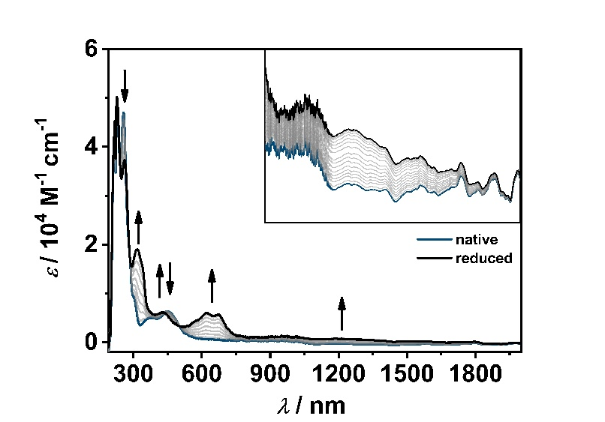
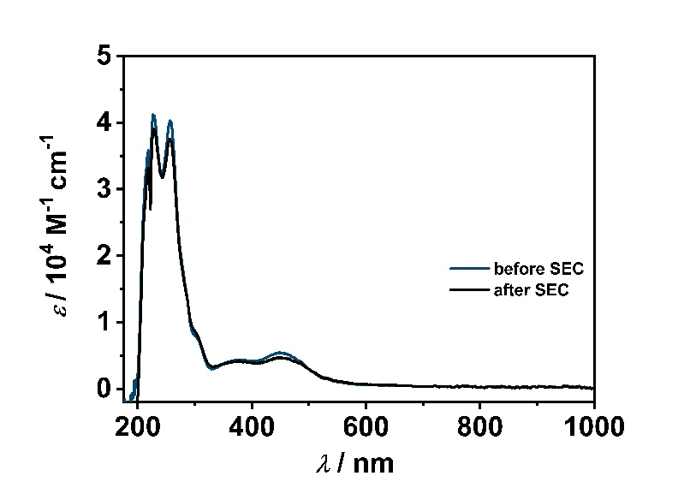
Figure S31. Changes in the UV/VIS spectra of [W(C−N)(CO)₄] (left, Inset: 750−2090 nm) in CH₃CN/0.1 M Bu₄NPF₆ during the first reduction with a Au working electrode and after UV/vis/NIR-SEC (right).

6. TD-DFT Calculations

6.10 TD-DFT Calculations of [Cr(C−C)(CO)₄]⁻
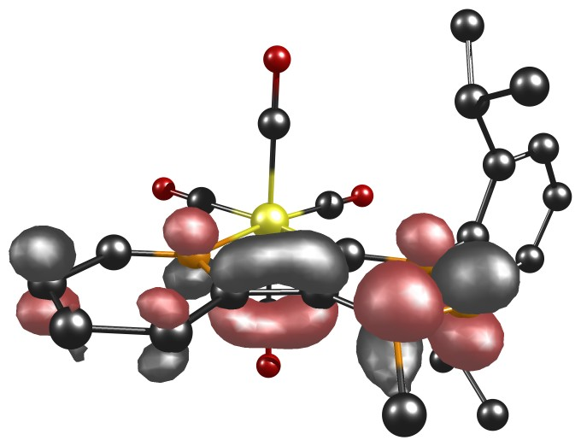
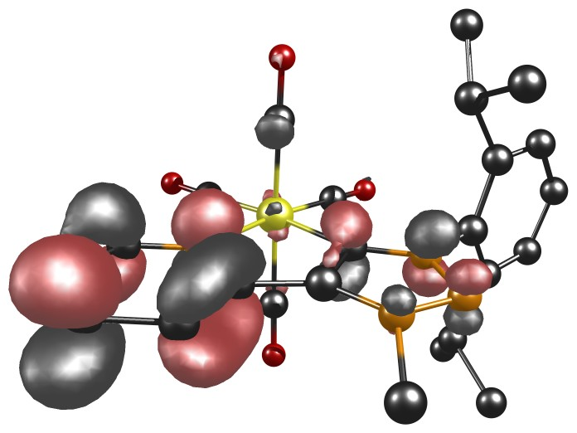

Figure S33. α-HOMO (left) and α-LUMO (right) of complex [Cr(C−C)(CO)₄]⁻.
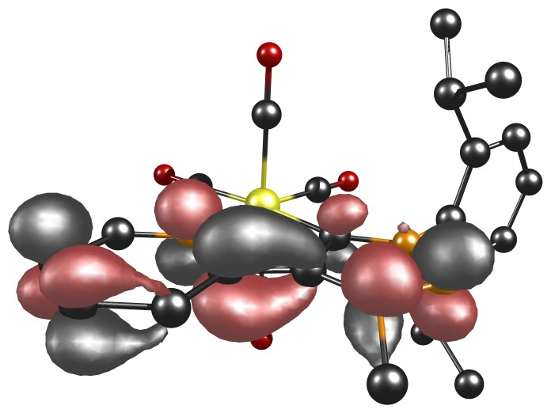
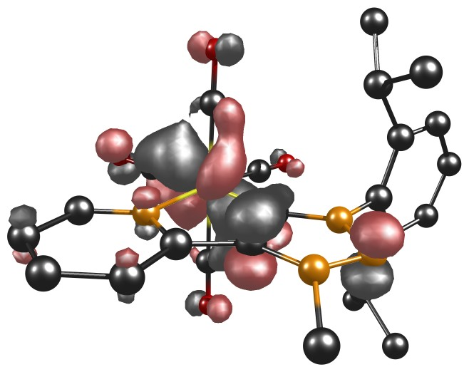

Figure S34. β-HOMO (left) and β-LUMO (right) of complex [Cr(C−C)(CO)₄]⁻.
Table S12. Energies of selected orbitals.
MO | Energy / eV
$${[Cr(C-C){(CO)}_{4}]}_{α-HOMO}^{-}$$ | $-$2.9139
$${[Cr(C-C){(CO)}_{4}]}_{α-LUMO}^{-}$$ | $-$0.7303
$${[Cr(C-C){(CO)}_{4}]}_{β-HOMO}^{-}$$ | $-$4.7504
$${[Cr(C-C){(CO)}_{4}]}_{β-LUMO}^{-}$$ | $-$1.0098

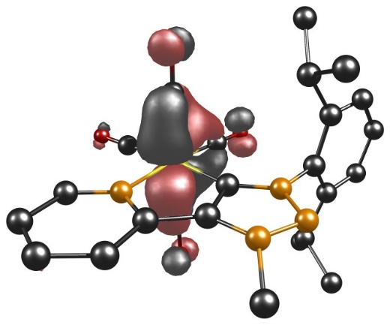
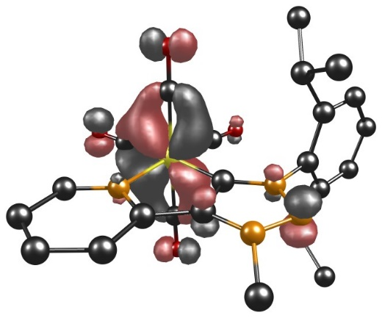
Table S12. Selected experimental UV/vis data of [Cr(C−C)(CO)₄]⁻ together with selected TD-DFT calculations.
State | $λ_{exp}$($λ_{DFT}$) / nm | $ε$ / 10⁴ M⁻¹ cm⁻¹(f) | Main contributing excitation (%)
1 | 1233 (1042) | 0.09 (0.021) | α-HOMO $→$ α-LUMO (92)
2 | 1233 (908) | 0.09 (0.004) | α-HOMO $→$ α-LUMO+1 (99)
5 | 874 (767) | 0.10 (0.008) | α-HOMO $→$ α-LUMO+3 (21)  α-HOMO $→$ α-LUMO+4 (77)
3 | 874 (712) | 0.10 (0.028) | α-HOMO $→$ α-LUMO+2 (71)  α-HOMO $→$ α-LUMO+3 (17)
4 | 874 (690) | 0.10 (0.013) | α-HOMO $→$ α-LUMO+2 (27)  α-HOMO $→$ α-LUMO+3 (55)  α-HOMO $→$ α-LUMO+4 (13)
6 | 874 (661) | 0.10 (0.005) | α-HOMO $→$ α-LUMO+5 (95)
12 | 444 (420) | 0.74 (0.052) | α-HOMO $→$ α-LUMO+6 (20)  β-HOMO−1 $→$ β-LUMO (23)  β-HOMO $→$ β-LUMO (39)
19 | 347 (386) | 1.90 (0.014) | α-HOMO−2 $→$ α-LUMO (55)  α-HOMO $→$ α-LUMO+8 (12)
23 | 289 (362) | 3.07 (0.040) | α-HOMO−3 $→$ α-LUMO (31)  α-HOMO $→$ α-LUMO+10 (10)  β-HOMO−2 $→$ β-LUMO (95)

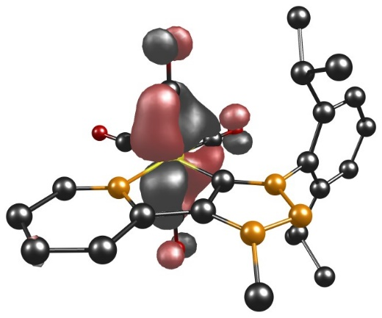
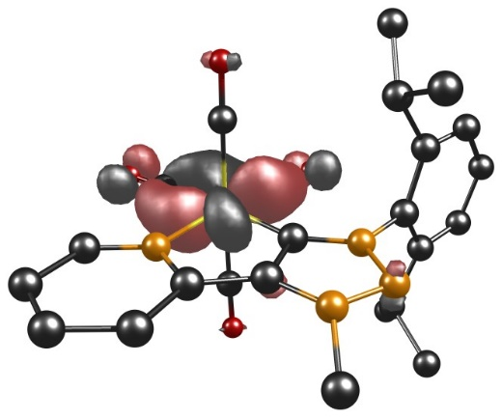
α-HOMO−3 α-HOMO−2

β-HOMO−2 β-HOMO−1
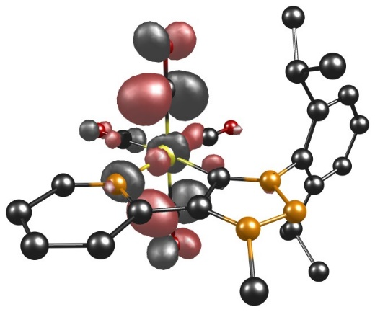
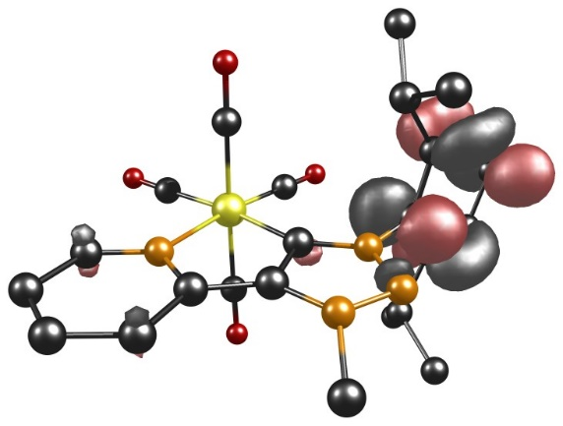
α-LUMO+1 α-LUMO+2
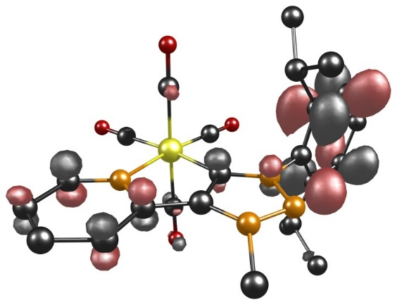
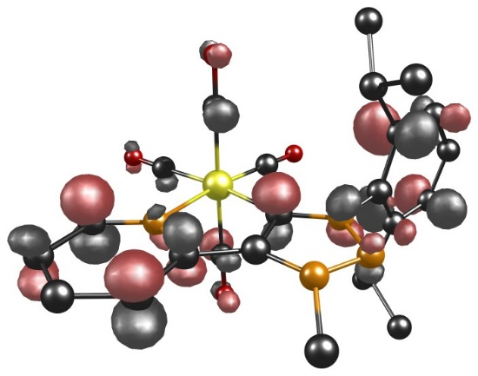

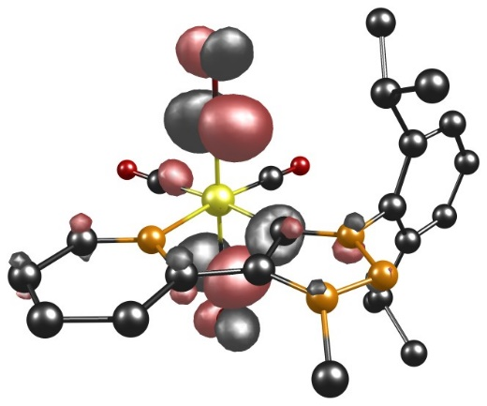
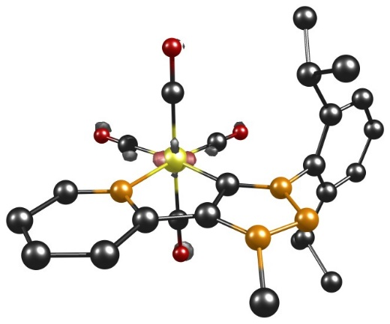
α-LUMO+3 α-LUMO+4

α-LUMO+5 α-LUMO+6

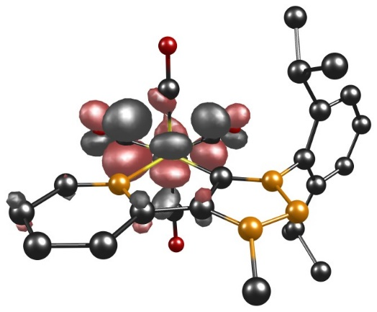
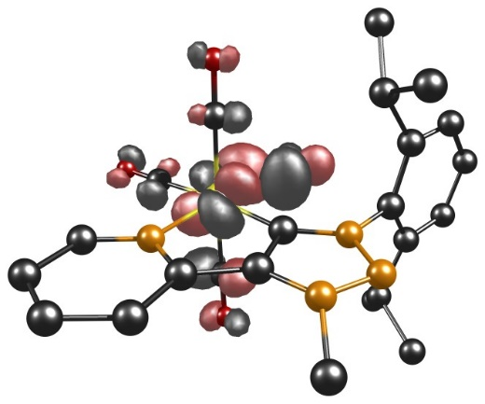

α-LUMO+8 α-LUMO+10

Figure S35. Involved TD-DFT orbitals of complex [Cr(C−C)(CO)₄]⁻.
Figure S36. Calculated TD-DFT spectrum with discrete transitions of [Cr(C−C)(CO)₄]⁻.

Table S13. Selected MO energies of [Cr(C−C)(CO)₄]⁻.
[Cr(C−C)(CO)₄]
MO | Energy / eV
α-HOMO−3 | $-$5.0233
α-HOMO−2 | $-$4.9339
β-HOMO−2 | $-$5.0087
β-HOMO−1 | $-$4.7884
α-LUMO+1 | $-$0.4520
α-LUMO+2 | $-$0.2976
α-LUMO+3 | $-$0.1509
α-LUMO+4 | $-$0.1018
α-LUMO+5 | 0.0296
α-LUMO+6 | 0.7195
α-LUMO+8 | 0.9970
α-LUMO+10 | 1.3273

Table S14. XYZ coordinates of optimized [Cr(C−C)(CO)₄]⁻.
 | x | y | z
Cr | 1.003091865399 | 10.144308109284 | 4.920620955770
N | -0.327529613304 | 11.225048571129 | 3.556597075598
C | 2.304260792897 | 11.157578850925 | 3.660889243339
C | 2.300027319261 | 9.396995879807 | 5.968236897578
C | -0.364731194992 | 9.394525104065 | 5.895184777627
C | 1.036980981727 | 8.588233261823 | 3.857503224277
C | 1.022708211846 | 11.703966211450 | 5.989811553496
C | 0.295958421057 | 12.073713175478 | 2.652694018438
C | -1.659205523688 | 11.179635670584 | 3.580707084696
C | 1.703000946840 | 12.027859460950 | 2.747089960653
N | 3.620330589328 | 11.346991047963 | 3.481090056778
O | 3.123885089854 | 8.918171908384 | 6.638880517296
O | -1.212475404048 | 8.889015251422 | 6.518466812216
O | 1.066078887157 | 7.592487662849 | 3.271722327061
O | 1.050292661236 | 12.659830542034 | 6.635347014676
C | -0.490466987621 | 12.854463965926 | 1.768009516708
C | -2.478828931017 | 11.927592514150 | 2.749422737846
H | -2.093967690411 | 10.505914848922 | 4.307849677130
N | 2.724170654548 | 12.669470884089 | 2.032572408242
N | 3.954690278002 | 12.286059105824 | 2.525111858559
C | 4.707546870760 | 10.657915295331 | 4.108296786689
H | -0.009393636320 | 13.508594022799 | 1.056758953974
C | -1.862569036132 | 12.781823124953 | 1.818984565904
H | -3.553282620709 | 11.841686424139 | 2.827347214182
C | 2.667145160162 | 14.009141791203 | 1.480040107077
C | 5.126706771478 | 9.439322300204 | 3.557527579024
C | 5.310442692325 | 11.221073247086 | 5.240728960465
H | -2.460990166273 | 13.382418909927 | 1.145117848779
H | 3.633630841160 | 14.236057282542 | 1.035288658247
H | 2.447745900655 | 14.748756438091 | 2.259162216749
H | 1.906200551001 | 14.069370185083 | 0.706030217281
C | 6.256619703008 | 8.835848146394 | 4.108490210903
C | 4.335745899669 | 8.768455060597 | 2.448855757613
C | 4.710228895259 | 12.436002825361 | 5.927808482522
C | 6.437379277906 | 10.580944381017 | 5.756019126606
H | 6.613771265882 | 7.898076612775 | 3.704977147245
C | 6.921021899080 | 9.414074760809 | 5.181307457013
H | 3.296769147441 | 9.056634710685 | 2.600443842596
C | 4.742399702485 | 9.250507472730 | 1.048308264630
C | 4.397384375359 | 7.241944490694 | 2.523087684508
H | 3.636211725899 | 12.386644482679 | 5.749124553782
C | 5.213370240599 | 13.762549407850 | 5.342981379669
C | 4.923123382583 | 12.420948340955 | 7.443912235763
H | 6.932463045209 | 10.986651054147 | 6.627426521221
H | 7.798111999138 | 8.931635479419 | 5.595696167752
H | 4.140486996235 | 8.742109223441 | 0.291554334159
H | 5.793576962160 | 9.022564125236 | 0.851400090421
H | 4.589006412587 | 10.324974654000 | 0.944829020697
H | 3.667755185932 | 6.814650707018 | 1.833535552300
H | 4.166585182340 | 6.879723256398 | 3.526079132096
H | 5.380544248422 | 6.860917449993 | 2.237783551776
H | 4.986462945283 | 13.828981270830 | 4.278929496535
H | 6.293691966507 | 13.857493536625 | 5.484932206895
H | 4.731532285160 | 14.599516481732 | 5.853806569160
H | 4.629356460343 | 11.464666923525 | 7.879966768611
H | 4.319770125660 | 13.204817569911 | 7.904645122493
H | 5.965277987676 | 12.613826526761 | 7.708989496680

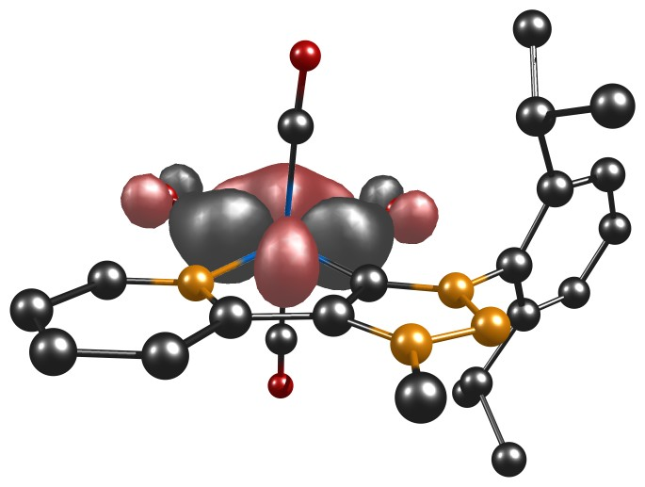
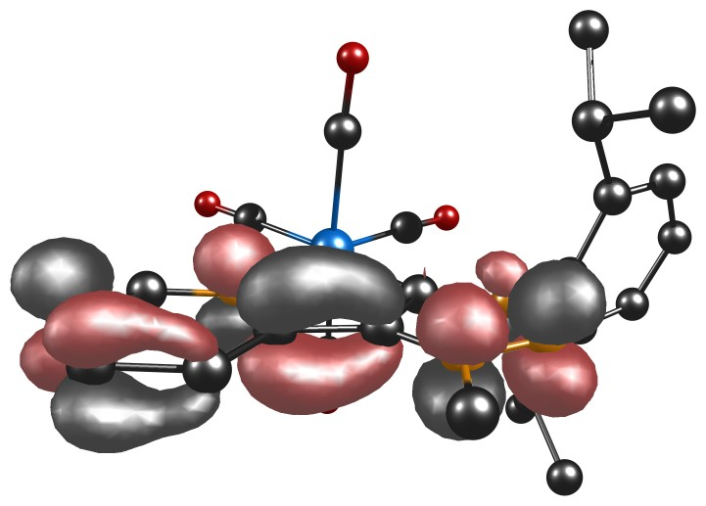
6.20 TD-DFT Calculations of [Mo(C−C)(CO)₄] and [Mo(C−C)(CO)₄]⁻

Figure S37. HOMO (left) and LUMO (right) of complex [Mo(C−C)(CO)₄].
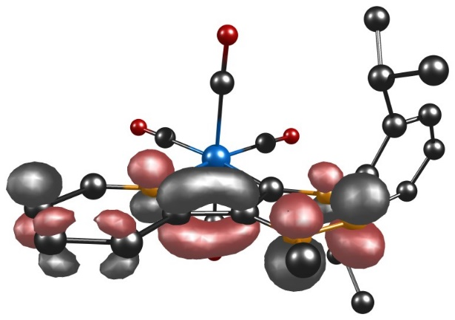
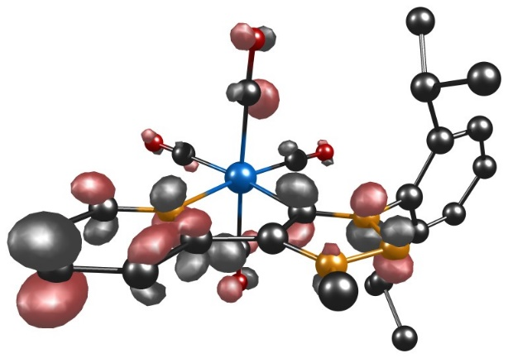

Figure S38. α-HOMO (left) and α-LUMO (right) of complex [Mo(C−C)(CO)₄]⁻.
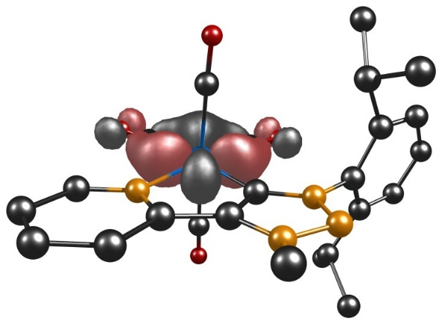
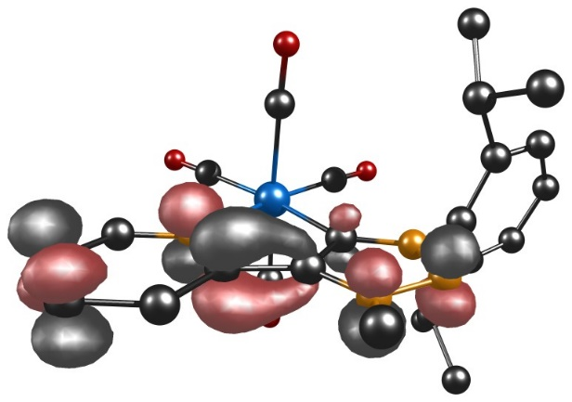
Figure S38. β-HOMO (left) and β-LUMO (right) of complex [Mo(C−C)(CO)₄]⁻.

Table S15. Energies and compositions of selected orbitals.
MO | Energy / eV
$${[Mo(C-C){(CO)}_{4}]}_{HOMO}^{}$$ | $-$5.1001
$${[Mo(C-C){(CO)}_{4}]}_{LUMO}^{}$$ | $-$2.0257
$${[Mo(C-C){(CO)}_{4}]}_{α-HOMO}^{-}$$ | $-$2.3462
$${[Mo(C-C){(CO)}_{4}]}_{α-LUMO}^{-}$$ | $-$0.7250
$${[Mo(C-C){(CO)}_{4}]}_{β-HOMO}^{-}$$ | $-$4.6769
$${[Mo(C-C){(CO)}_{4}]}_{β-LUMO}^{-}$$ | $-$0.6866

Table S16. Selected experimental UV/vis data of [Mo(C−C)] together with selected TD-DFT calculations.
State | $λ_{exp}$($λ_{DFT}$) / nm | $ε$ / 10⁴ M⁻¹ cm⁻¹(f) | Main contributing excitation (%)
3 | 422 (507) | 0.38 (0.048) | HOMO−2 $→$ LUMO (78)  HOMO−1 $→$ LUMO (18)
4 | 354 (373) | 0.54 (0.032) | HOMO $→$ LUMO+1 (33)  HOMO $→$ LUMO+2 (58)
10 | 305 (330) | 0.94 (0.070) | HOMO−2 $→$ LUMO+1 (45)  HOMO−2 $→$ LUMO+4 (16)  HOMO−1 $→$ LUMO+1 (15)

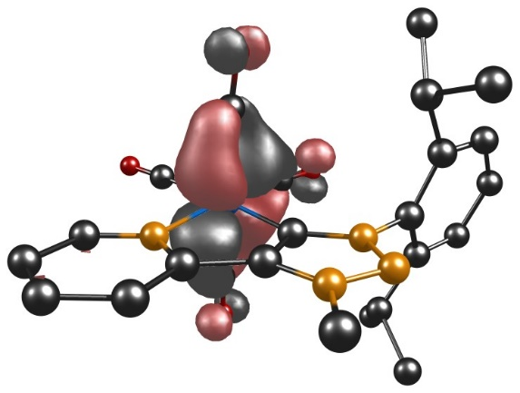
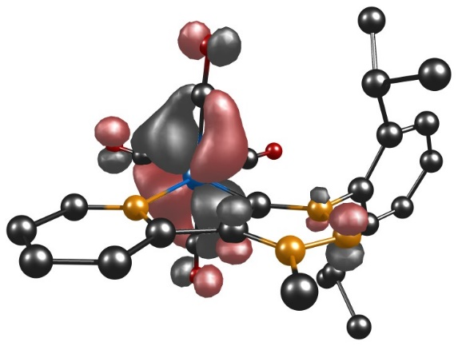

HOMO−2 HOMO−1

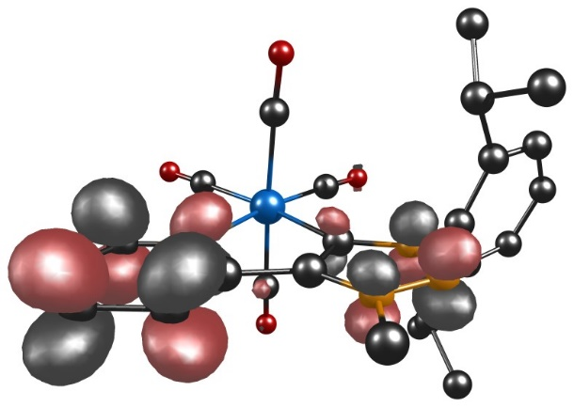
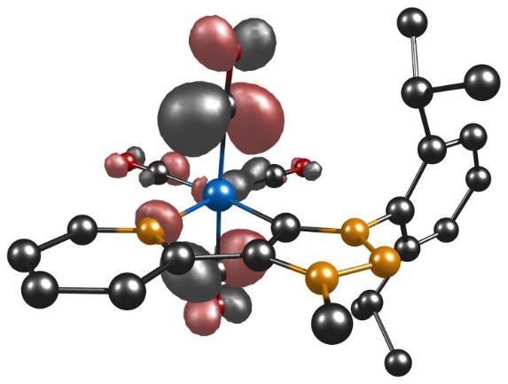
LUMO+1 LUMO+2
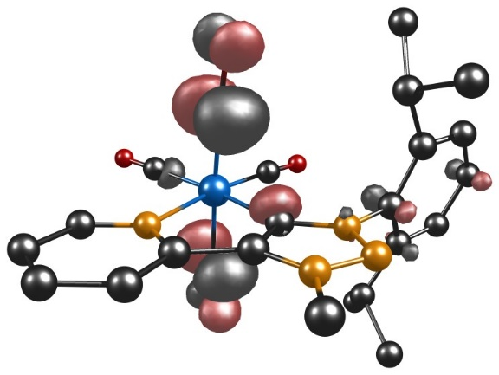

LUMO+4

Figure S39. Involved TD-DFT orbitals of complex [Mo(C−C)(CO)₄].
FigureS40. Calculated TD-DFT spectrum with discrete transitions of [Mo(C−C)(CO)₄].
Table S17. Selected experimental UV/vis data of [Mo(C−C)(CO)₄]⁻ together with selected TD-DFT calculations.
State | $λ_{exp}$($λ_{DFT}$) / nm | $ε$ / M⁻¹ cm⁻¹(f) | Main contributing excitation (%)
2 | 1300 (1262) | 0.07 (0.003) | α-HOMO $→$ α-LUMO+1 (86)
1 | 1300 (1096) | 0.07 (0.029) | α-HOMO $→$ α-LUMO+1 (93)
3 | 911 (950) | 0.07 (0.002) | α-HOMO $→$ α-LUMO+2 (86)
5 | 911 (852) | 0.07 (0.006) | α-HOMO $→$ α-LUMO+3 (22)  α-HOMO $→$ α-LUMO+5 (71)
4 | 911 (761) | 0.07 (0.032) | α-HOMO $→$ α-LUMO+2 (13)  α-HOMO $→$ α-LUMO+3 (22)
10 | 435 (457) | 0.49 (0.008) | α-HOMO $→$ α-LUMO+7 (70)
15 | 435 (408) | 0.49 (0.016) | α-HOMO−2 $→$ α-LUMO+2 (14)  β-HOMO−1 $→$ β-LUMO (22)  β-HOMO−1 $→$ β-LUMO+2 (29)
18 | 340 (402) | 1.14 (0.037) | β-HOMO−2 $→$ β-LUMO (14)  β-HOMO−1 $→$ β-LUMO (39)
30 | 340 (367) | 1.14 (0.053) | α-HOMO−3 $→$ α-LUMO (22)  α-HOMO−3 $→$ α-LUMO+1 (22)  α-HOMO−3 $→$ α-LUMO+3 (22)  α-HOMO−3 $→$ α-LUMO+3 (22)
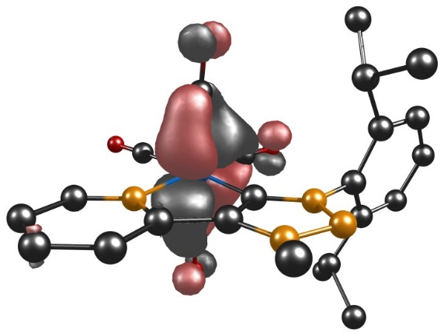
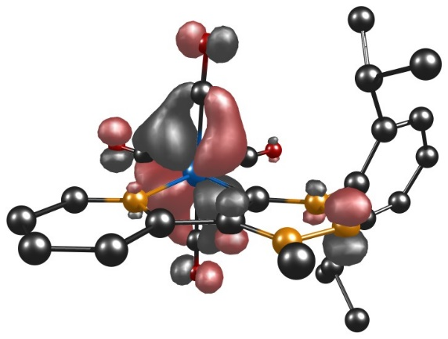

α-HOMO−3 α-HOMO−2

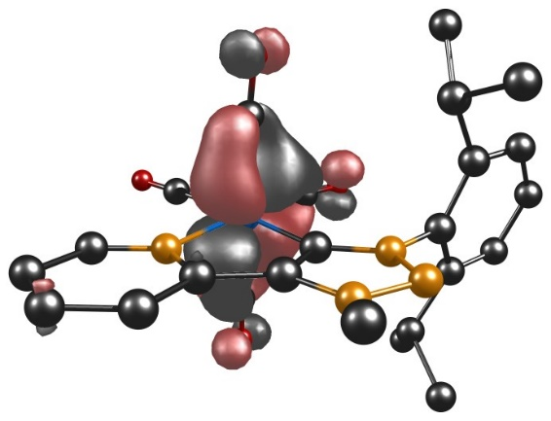
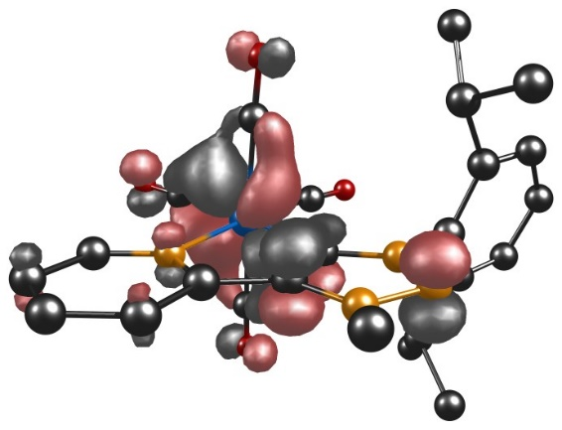
β-HOMO−2 β-HOMO−1
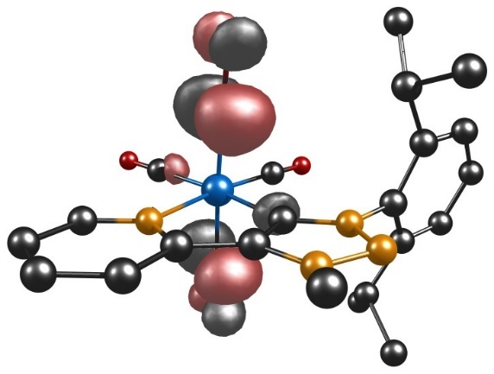
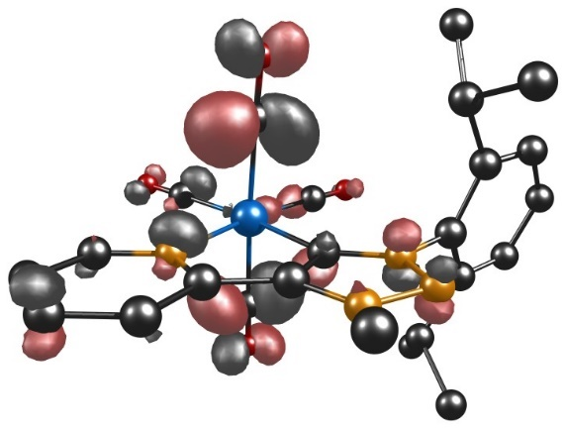

α-LUMO+1 α-LUMO+2
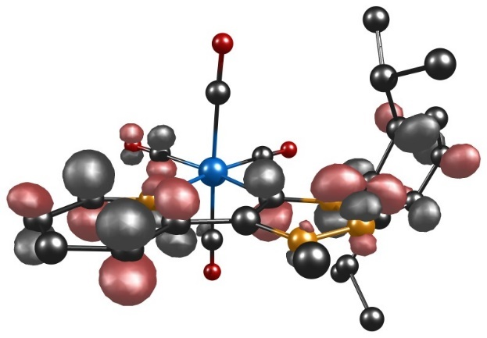
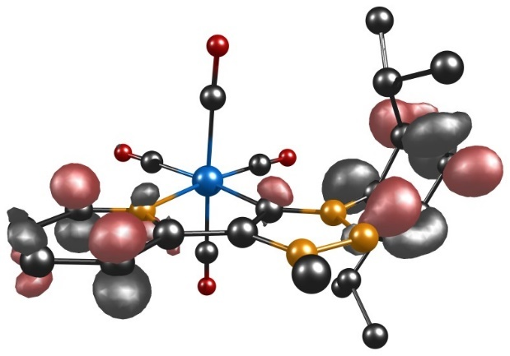

α-LUMO+3 α-LUMO+5

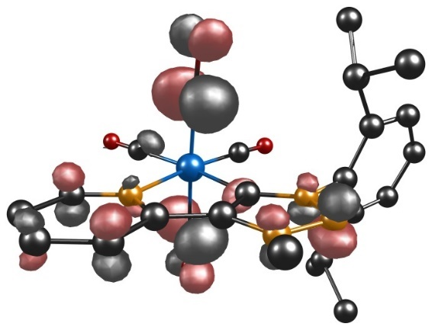
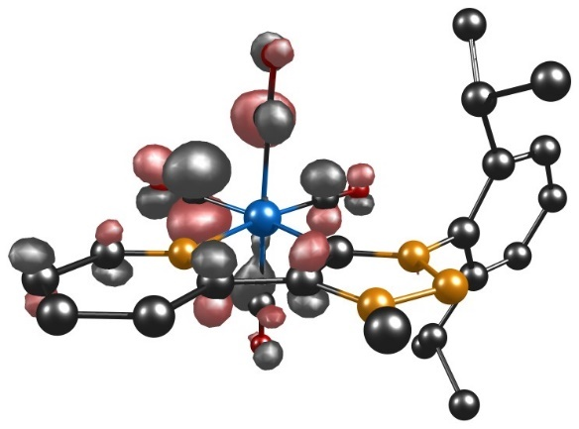

α-LUMO+7 β-LUMO+2
Figure S41. Involved TD-DFT orbitals of complex [Mo(C−C)(CO)₄]⁻.

Figure S42. Calculated TD-DFT spectrum with discrete transitions of [Mo(C−C)(CO)₄]⁻.

Table S18. Selected MO energies of [Mo(C−C)(CO)₄] and [Mo(C−C)(CO)₄]⁻.
[Mo(C−C)(CO)₄] |  | [Mo(C−C)(CO)₄]⁻
MO | Energy / eV | MO | Energy / eV
HOMO−2 | $-$5.3710 | α-HOMO−3 | $-$4.8700
HOMO−1 | $-$5.3161 | α-HOMO−2 | $-$4.6771
LUMO+1 | $-$1.3513 | β-HOMO−2 | $-$4.9296
LUMO+2 | $-$1.0433 | β-HOMO−1 | $-$4.7613
LUMO+4 | $-$0.6818 | α-LUMO+1 | $-$0.6687
 |  | α-LUMO+2 | $-$0.3627
 |  | α-LUMO+3 | $-$0.2927
 |  | α-LUMO+5 | $-$0.0365
 |  | α-LUMO+7 | 0.7661
 |  | β-LUMO+2 | $-$0.3680

Table S19. XYZ coordinates of optimized [Mo(C−C)(CO)₄].
 | x | y | z
Mo | 5.668613958431 | 4.650569521145 | 10.617888820018
N | 6.901830430287 | 3.130103905852 | 11.894751730907
C | 4.245216226792 | 3.466603015282 | 11.807589734835
C | 7.227292556468 | 5.470029527646 | 9.673809841092
C | 4.381286167989 | 5.818767111593 | 9.716868051357
C | 5.828432400970 | 6.139498068707 | 12.004413652109
C | 5.413751519780 | 3.265370575462 | 9.131765563486
C | 6.219714151011 | 2.265020065428 | 12.695622508639
C | 8.235960732089 | 3.049566363961 | 11.863826684594
C | 4.787517757654 | 2.474066358776 | 12.623496700356
N | 2.911233189420 | 3.297462786678 | 11.997712402623
O | 8.139597428533 | 5.952035275930 | 9.138008765925
O | 3.587006686751 | 6.512365556998 | 9.223304263589
O | 5.901873824219 | 7.052489454306 | 12.703000621655
O | 5.222095058848 | 2.502489557293 | 8.292947186463
C | 6.879235880261 | 1.310552100515 | 13.466044402173
C | 8.956811362364 | 2.125882816812 | 12.605488517058
H | 8.739915444187 | 3.752598838666 | 11.216529509699
N | 3.749136227340 | 1.822178613032 | 13.218719753779
N | 2.593466720460 | 2.317433153420 | 12.850945122019
C | 1.827128317848 | 3.988281218921 | 11.349373890874
H | 6.325670416683 | 0.631466478262 | 14.093750060572
C | 8.263559644013 | 1.240678591348 | 13.419761107281
H | 10.034907741996 | 2.104733301435 | 12.534614531645
C | 3.756060140114 | 0.688541559132 | 14.135257786899
C | 1.454642918027 | 5.246869461835 | 11.830545528929
C | 1.206781751130 | 3.355050340446 | 10.267614171866
H | 8.789107400494 | 0.504171881657 | 14.012260146749
H | 2.724544222174 | 0.457664197806 | 14.380353398778
H | 4.302799959251 | 0.957573571930 | 15.036179674690
H | 4.224938956038 | -0.162233063672 | 13.645382335067
C | 0.340855560938 | 5.842007298500 | 11.241081735879
C | 2.258533092474 | 5.942953573559 | 12.913063768631
C | 0.096146926376 | 3.992642871542 | 9.713541258751
C | 1.749967307816 | 2.062445155923 | 9.683767924848
H | 0.007066250449 | 6.810944020296 | 11.585067402743
C | -0.343865673493 | 5.210821131244 | 10.210421728503
H | 3.297256261827 | 5.649129611574 | 12.762184364496
C | 1.851876097642 | 5.496037119326 | 14.325586309310
C | 2.206553099173 | 7.466502975142 | 12.799199064672
H | -0.421176056340 | 3.538594990354 | 8.879775253163
C | 1.681381818492 | 2.049234170690 | 8.155052388361
H | 2.805298785138 | 2.004285256538 | 9.954938518679
C | 1.058275141373 | 0.818656745098 | 10.258331397842
H | -1.209424347438 | 5.689707947957 | 9.769532363938
H | 0.799563910067 | 5.723387454444 | 14.513682942111
H | 2.450567369181 | 6.026401614254 | 15.068621093844
H | 2.006978211570 | 4.425969978628 | 14.470888909791
H | 2.445486834578 | 7.798429851497 | 11.787791768808
H | 2.934815099314 | 7.905765030943 | 13.482450415577
H | 1.224348598099 | 7.859836862432 | 13.069388721006
H | 2.212898875312 | 1.176578899348 | 7.773005913636
H | 2.141077738229 | 2.941940114590 | 7.728768233950
H | 0.651276937612 | 1.990143946531 | 7.798651720501
H | -0.010572590795 | 0.832925903267 | 10.030199244263
H | 1.183634553852 | 0.760246176843 | 11.339376749811
H | 1.488241006930 | -0.080978907123 | 9.812864341160

Table S20. XYZ coordinates of optimized [Mo(C−C)(CO)₄]⁻.
 | x | y | z
Mo | 5.645743103638 | 4.641522907645 | 10.642365229029
N | 6.898350211141 | 3.157502644334 | 11.893496614530
C | 4.224696385226 | 3.459659255204 | 11.862661263279
C | 7.186916065898 | 5.460048528618 | 9.684676430772
C | 4.344801571738 | 5.795993150927 | 9.740303529494
C | 5.813696810313 | 6.139595353416 | 12.010820049962
C | 5.391506043808 | 3.241147929012 | 9.173979589424
C | 6.193553498842 | 2.279666254158 | 12.719965328765
C | 8.231344625259 | 3.069793148280 | 11.860551265593
C | 4.794661953848 | 2.466584842233 | 12.677491507957
N | 2.904770818675 | 3.311882980912 | 12.048057736577
O | 8.093786430535 | 5.950131487818 | 9.136611006650
O | 3.550941711075 | 6.488641773892 | 9.237100661146
O | 5.898267690258 | 7.064981002884 | 12.697107284937
O | 5.214021352481 | 2.472078769728 | 8.334418952232
C | 6.906442371117 | 1.329391799294 | 13.497085238908
C | 8.974439331869 | 2.163617185455 | 12.595770970785
H | 8.727428511021 | 3.771192724227 | 11.201489302997
N | 3.743649776120 | 1.822970630071 | 13.328298518205
N | 2.536321521298 | 2.318938657151 | 12.916402037719
C | 1.838338378213 | 3.996974761598 | 11.380832504443
H | 6.366263072889 | 0.649505694931 | 14.138352852003
C | 8.275925277090 | 1.270828811048 | 13.437455095534
H | 10.051470541797 | 2.146664342973 | 12.510498024792
C | 3.734190134000 | 0.537760727635 | 13.990342716485
C | 1.457852567261 | 5.267574956151 | 11.829023830105
C | 1.209599420310 | 3.350342918052 | 10.309382348368
H | 8.812734694650 | 0.543267559518 | 14.033324775268
H | 2.722959599660 | 0.348781200766 | 14.342698932363
H | 4.408126243340 | 0.539462121577 | 14.844880303580
H | 4.028749219247 | -0.259115626236 | 13.299770852917
C | 0.342520908363 | 5.851701037333 | 11.230137059880
C | 2.264207015177 | 5.992686737940 | 12.890573611405
C | 0.095214421792 | 3.972595988979 | 9.744782550663
C | 1.760666573948 | 2.057210923681 | 9.735156702296
H | 0.010589987398 | 6.828512251141 | 11.554518958623
C | -0.348143581922 | 5.199744048779 | 10.216659606676
H | 3.300367695573 | 5.691703779895 | 12.742167432893
C | 1.864728601058 | 5.576728408315 | 14.314066506562
C | 2.212721383580 | 7.513220199654 | 12.739704962032
H | -0.422211954030 | 3.500011293397 | 8.920643879256
C | 1.741640808957 | 2.061564815888 | 8.204676732962
H | 2.804351457275 | 1.992960797565 | 10.044180378977
C | 1.046468014985 | 0.812697596438 | 10.277583100169
H | -1.216525158274 | 5.668176084707 | 9.769211723284
H | 0.815494167059 | 5.816899429472 | 14.506999829048
H | 2.472892488816 | 6.114877279351 | 15.044496080175
H | 2.013475503411 | 4.507066338925 | 14.468401854047
H | 2.448351436444 | 7.818952584208 | 11.719059500059
H | 2.944389673951 | 7.969914328773 | 13.408199109642
H | 1.232059856016 | 7.916072261703 | 13.003227557422
H | 2.271503529483 | 1.185445026279 | 7.827297323601
H | 2.229386326332 | 2.951885030955 | 7.805358252320
H | 0.722845858729 | 2.025445964490 | 7.813593425514
H | -0.017588577319 | 0.834394471918 | 10.025795361002
H | 1.156532316674 | 0.751332735167 | 11.359990197246
H | 1.479702313909 | -0.086697908223 | 9.833363549428

6.30 TD-DFT Calculations of [W(C−C)(CO)₄] and [W(C−C)(CO)₄]⁻
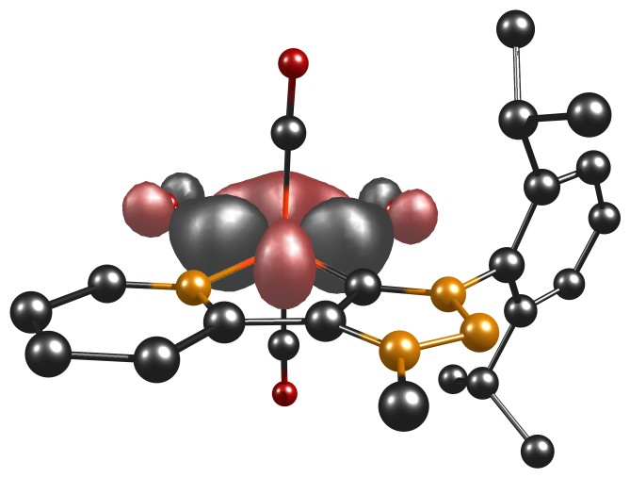
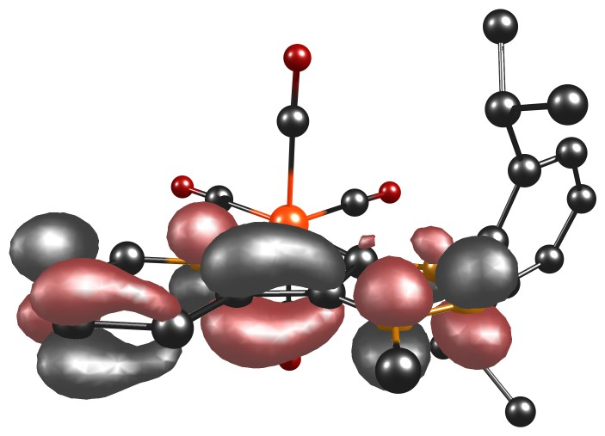

Figure S43. HOMO (left) and LUMO (right) of complex [W(C−C)(CO)₄].
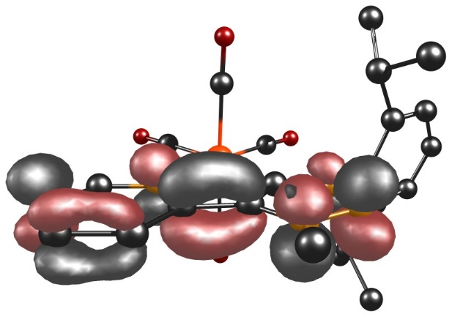
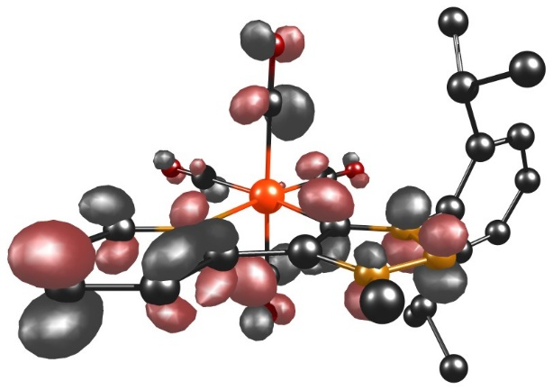

Figure S44. α-HOMO (left) and α-LUMO (right) of complex [W(C−C)(CO)₄]⁻.
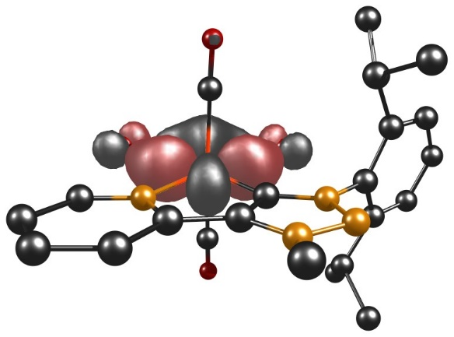
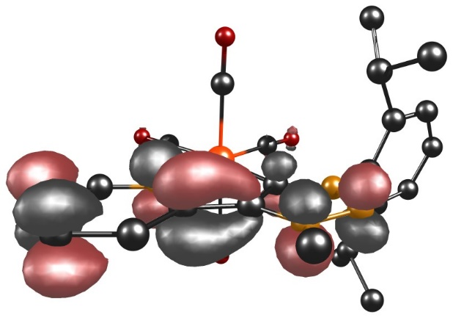

Figure S45. β-HOMO (left) and β-LUMO (right) of complex [W(C−C)(CO)₄]⁻.
Table S21. Energies and compositions of selected orbitals.
MO | Energy / eV
$${[W(C-C){(CO)}_{4}]}_{HOMO}^{}$$ | $-$5.0503
$${[W(C-C){(CO)}_{4}]}_{LUMO}^{}$$ | $-$2.0464
$${[W(C-C){(CO)}_{4}]}_{α-HOMO}^{-}$$ | $-$2.8466
$${[W(C-C){(CO)}_{4}]}_{α-LUMO}^{-}$$ | $-$0.9164
$${[W(C-C){(CO)}_{4}]}_{β-HOMO}^{-}$$ | $-$4.7190
$${[W(C-C){(CO)}_{4}]}_{β-LUMO}^{-}$$ | $-$1.0525

Table S22. Selected experimental UV/vis data of [W(C−C)(CO)₄] together with selected TD-DFT calculations.
State | $λ_{exp}$($λ_{DFT}$) / nm | $ε$ / 10⁴ M⁻¹ cm⁻¹(f) | Main contributing excitation (%)
3 | 421 (524) | 0.51 (0.054) | HOMO−2 $→$ LUMO (86)  HOMO−1 $→$ LUMO (8)
9 | 349 (407) | 0.71 (0.013) | HOMO−1$→$ LUMO+1 (64)  HOMO $→$ LUMO+4 (8)
11 | 349 (398) | 0.71 (0.018) | HOMO−2$→$ LUMO+1 (32)  HOMO$→$ LUMO+3 (36)  HOMO$→$ LUMO+4 (20)
14 | 304 (336) | 1.23 (0.076) | HOMO−2 $→$ LUMO+3 (23)  HOMO−1 $→$ LUMO+3 (35)  HOMO−1 $→$ LUMO+4 (12)
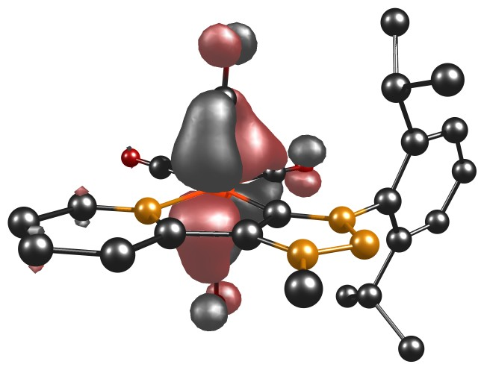
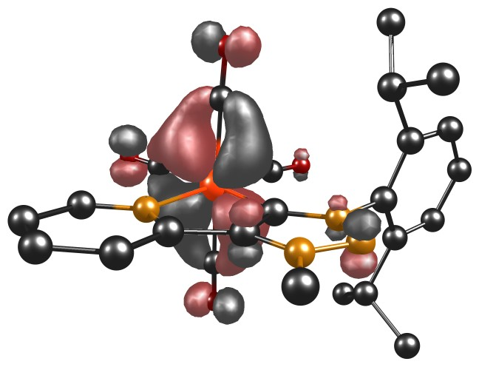

HOMO$-$2 HOMO$-$1

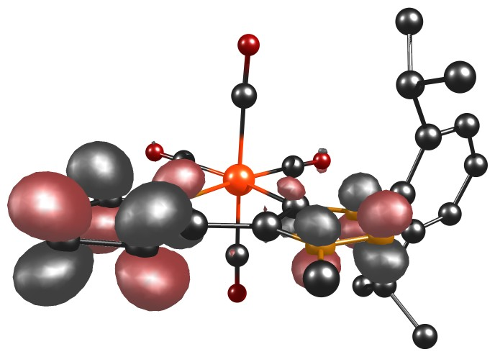
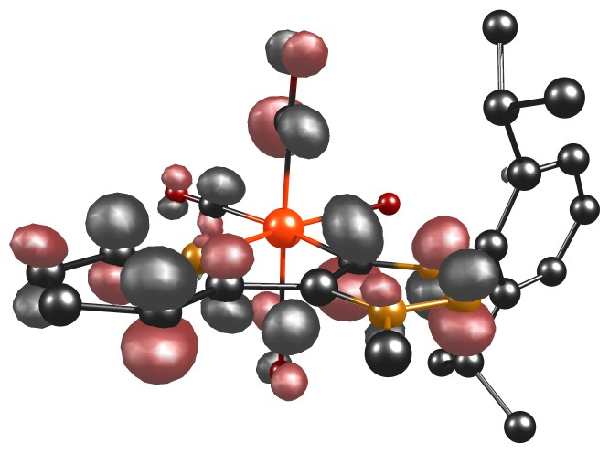
LUMO+1 LUMO+3
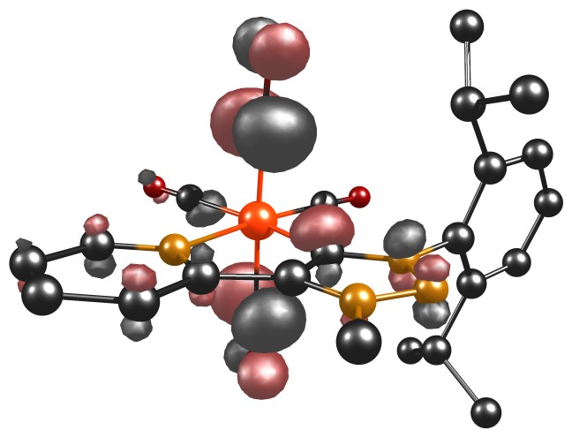

LUMO+4

Figure 46. Involved TD-DFT orbitals of complex [W(C−C)(CO)₄].
Figure S47. Calculated TD-DFT spectrum with discrete transitions of [W(C−C)(CO)₄].
Table S23. Selected experimental UV/vis data of [W(C−C)(CO)₄]⁻ together with selected TD-DFT calculations.
State | $λ_{exp}$($λ_{DFT}$) / nm | $ε$ / M⁻¹ cm⁻¹(f) | Main contributing excitation (%)
1 | 1583 (1105) | 0.08 (0.029) | α-HOMO $→$ α-LUMO (85)
6 | 1307 (861) | 0.13 (0.007) | α-HOMO $→$ α-LUMO+3 (82)
 |  |  | α-HOMO $→$ α-LUMO+4 (17)
4 | 905 (761) | 0.14 (0.029) | α-HOMO $→$ α-LUMO+2 (59)
 |  |  | α-HOMO $→$ α-LUMO+4 (21)
12 | 401 (450) | 0.64 (0.005) | α-HOMO$-$1 $→$ α-LUMO+1 (23)
 |  |  | α-HOMO$-$1 $→$ α-LUMO+2 (12)
 |  |  | β-HOMO $→$ β-LUMO (28)
 |  |  | β-HOMO $→$ β-LUMO+1 (26)
17 | 401 (420) | 0.64 (0.031) | β-HOMO$-$2 $→$ β-LUMO (19)  β-HOMO$-$1 $→$ β-LUMO (48)
21 | 401 (399) | 0.64 (0.010) | α-HOMO$-$3 $→$ α-LUMO (24)
 |  |  | α-HOMO$-$3 $→$ α-LUMO+1 (13)
 |  |  | β-HOMO$-$1 $→$ β-LUMO+2 (17)
26 | 351 (382) | 1.28 (0.011) | α-HOMO$-$3 $→$ α-LUMO+2 (27)  α-HOMO$-$2 $→$ α-LUMO+2 (26)
 |  |  | β-HOMO$-$2 $→$ β-LUMO+2 (17)
28 | 335 (380) | 1.45 (0.062) | α-HOMO$-$3 $→$ α-LUMO (35)  α-HOMO$-$2 $→$ α-LUMO+1 (18)  β-HOMO$-$2 $→$ β-LUMO (17)
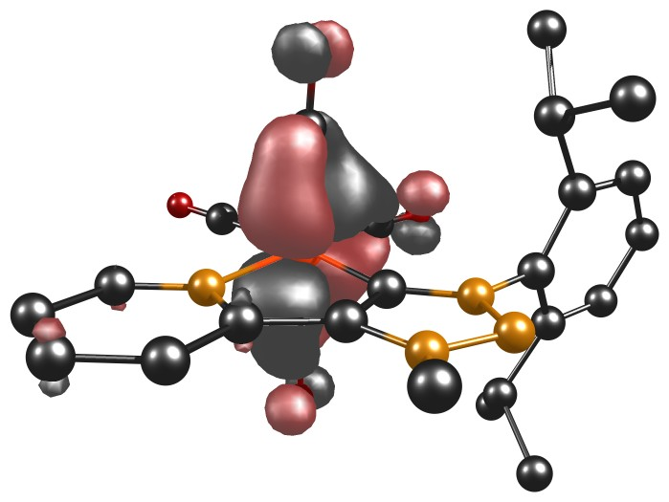
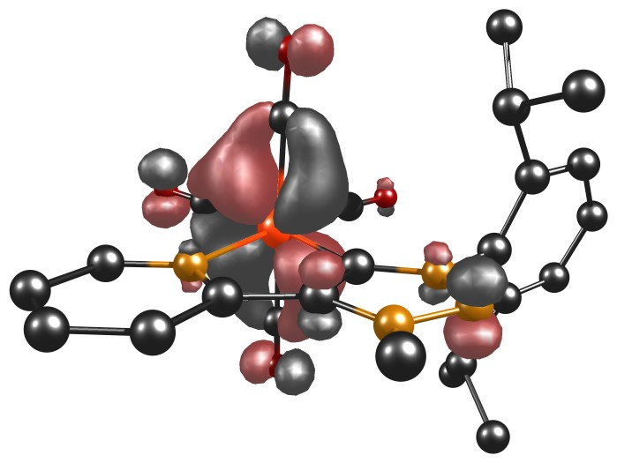

α-HOMO−3 α-HOMO−2

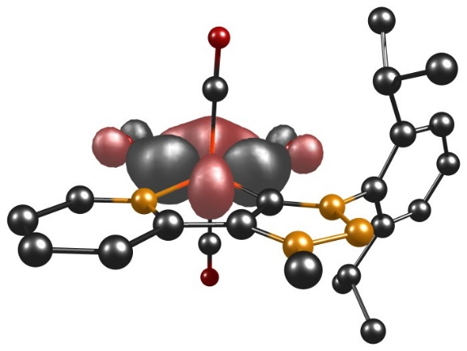
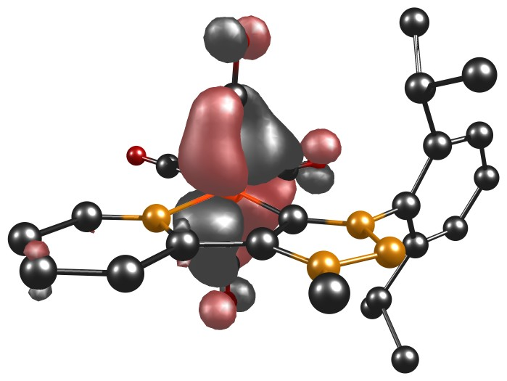

α-HOMO−1 $β$-HOMO−2
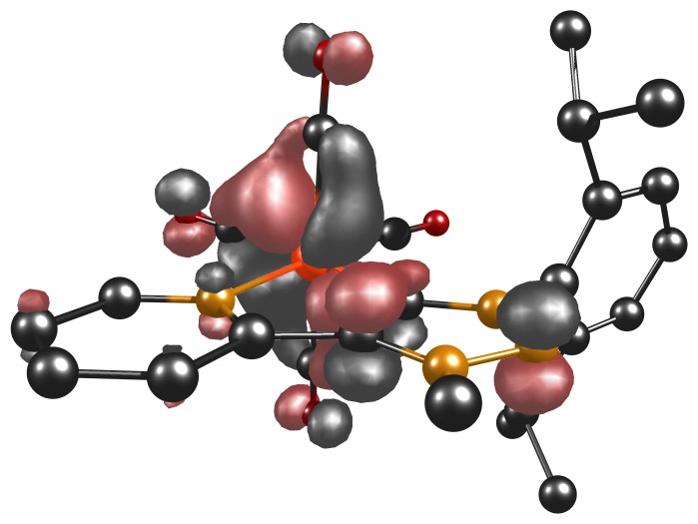
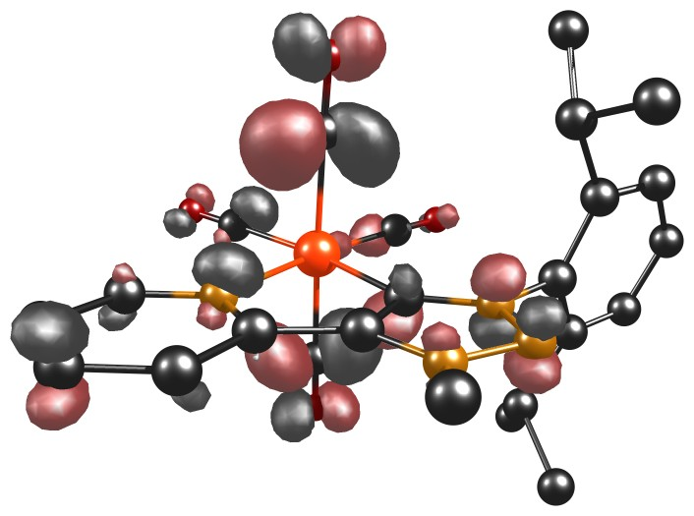

$β$-HOMO−1 α-LUMO+1
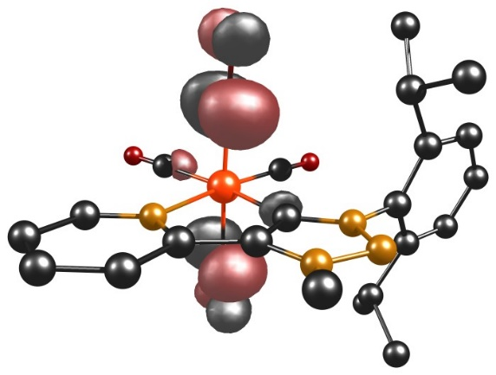
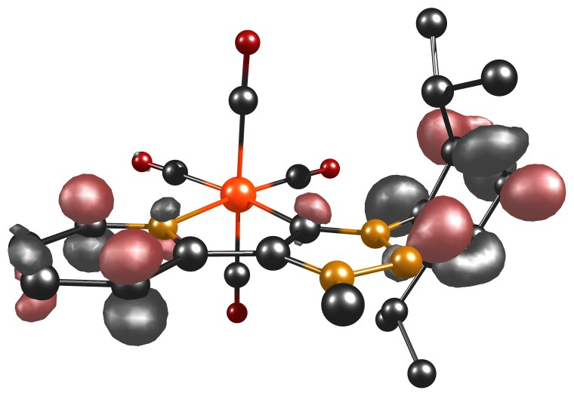

α-LUMO+2 α-LUMO+3

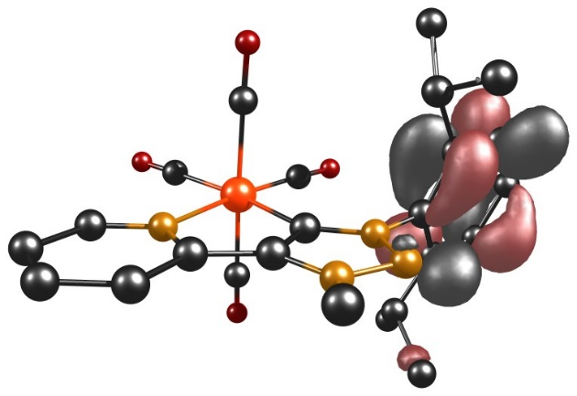
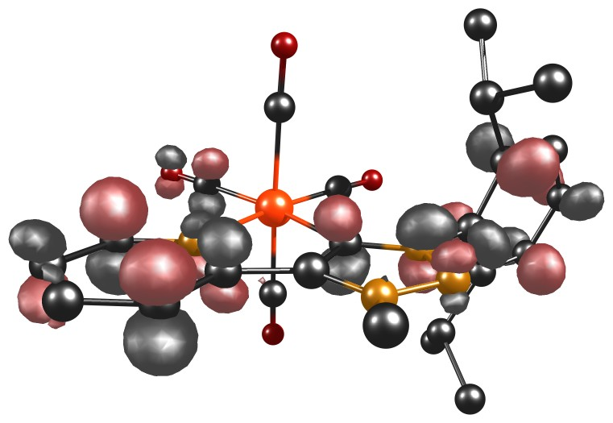

α-LUMO+4 α-LUMO+5
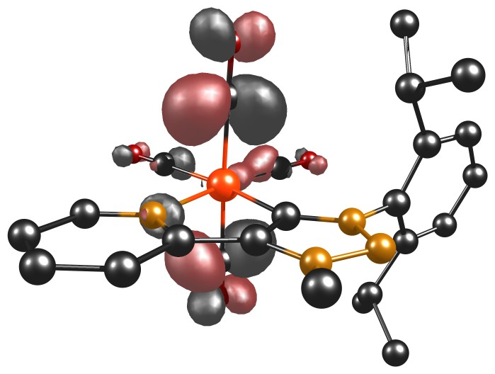
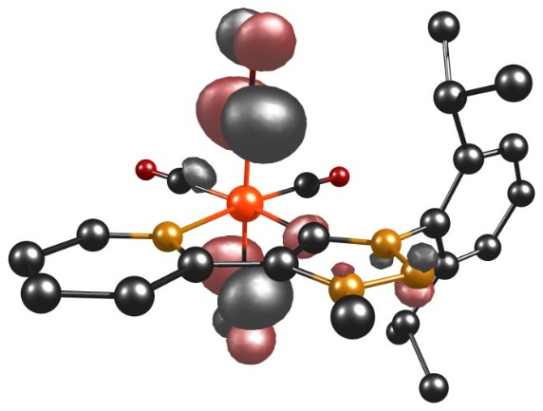

$β$-LUMO+1 $β$-LUMO+2

Figure S48. Involved TD-DFT orbitals of complex [W(C−C)(CO)₄]⁻.
Figure S49. Calculated TD-DFT spectrum with discrete transitions of [W(C−C)(CO)₄]⁻.
Table S24. Selected MO energies of [W(C−C)(CO)₄] and [W(C−C)(CO)₄]⁻.
[W(C−C)(CO)₄] |  | [W(C−C)(CO)₄]⁻
MO | Energy / eV | MO | Energy / eV
HOMO−2 | $-$5.3384 | α-HOMO−3 | $-$5.0850
HOMO−1 | $-$5.2955 | α-HOMO−2 | $-$5.0334
LUMO+1 | $-$1.0686 | α-HOMO−1 | $-$4.8048
LUMO+3 | $-$0.8123 | β-HOMO−2 | $-$5.0437
LUMO+4 | $-$0.7633 | β-HOMO−1 | $-$4.8739
 |  | α-LUMO+1 | $-$0.9098
 |  | α-LUMO+2 | $-$0.6169
 |  | α-LUMO+3 | $-$0.3078
 |  | α-LUMO+4 | $-$0.2644
 |  | β-LUMO+1 | $-$0.9032
 |  | β-LUMO+2 | $-$0.6160

Table S25. XYZ coordinates of optimized [W(C−C)(CO)₄].
 | x | y | z
W | 0.93332 | 4.68088 | 4.90794
N | -0.35288 | 3.12918 | 3.73599
C | 2.29383 | 3.43006 | 3.71159
C | -0.60342 | 5.55951 | 5.84979
C | 2.25177 | 5.86958 | 5.76133
C | 0.76953 | 6.08591 | 3.4228
C | 1.16495 | 3.35401 | 6.45453
C | 0.28155 | 2.23324 | 2.92699
C | -1.68528 | 3.05705 | 3.8414
N | 3.6195 | 3.25206 | 3.4755
C | 1.71557 | 2.43278 | 2.9284
O | -1.50776 | 6.06203 | 6.38782
O | 3.05628 | 6.56881 | 6.2367
O | 0.69554 | 6.92453 | 2.63473
O | 1.32595 | 2.62118 | 7.32894
C | -0.42303 | 1.26006 | 2.22379
C | -2.44662 | 2.11308 | 3.17138
H | -2.1511 | 3.78288 | 4.49179
N | 3.89862 | 2.26555 | 2.61765
C | 4.7147 | 3.92498 | 4.12501
N | 2.72628 | 1.77279 | 2.29883
H | 0.09398 | 0.55774 | 1.59025
C | -1.80291 | 1.19889 | 2.34806
H | -3.51905 | 2.09917 | 3.30479
C | 5.12393 | 5.16957 | 3.64505
C | 5.29619 | 3.29105 | 5.23221
C | 2.6718 | 0.62785 | 1.39841
H | -2.36351 | 0.44684 | 1.8095
C | 6.21875 | 5.76269 | 4.27477
C | 4.42875 | 5.86567 | 2.49159
C | 6.38835 | 3.92454 | 5.82182
C | 4.73533 | 1.99556 | 5.79384
H | 2.08111 | 0.88664 | 0.52244
H | 2.2246 | -0.2142 | 1.92289
H | 3.68904 | 0.38914 | 1.10587
H | 6.5757 | 6.72405 | 3.93026
C | 6.8545 | 5.13966 | 5.33754
H | 3.4963 | 5.339 | 2.29098
C | 4.06656 | 7.31595 | 2.83654
C | 5.28337 | 5.79691 | 1.21852
H | 6.87347 | 3.4715 | 6.67507
H | 3.67292 | 1.97005 | 5.54421
C | 4.83891 | 1.92545 | 7.31881
C | 5.38908 | 0.7541 | 5.16828
H | 7.7051 | 5.61584 | 5.8096
H | 4.95923 | 7.91824 | 3.01601
H | 3.44341 | 7.3668 | 3.72747
H | 3.51544 | 7.76586 | 2.00879
H | 4.75216 | 6.25888 | 0.38329
H | 5.51606 | 4.76399 | 0.95174
H | 6.22642 | 6.33031 | 1.35924
H | 4.42942 | 2.82038 | 7.78935
H | 5.87384 | 1.80636 | 7.6463
H | 4.27856 | 1.06288 | 7.68219
H | 5.24733 | 0.72865 | 4.0884
H | 4.94686 | -0.14899 | 5.5946
H | 6.46139 | 0.74011 | 5.37961

Table S26. XYZ coordinates of optimized [W(C−C)(CO)₄]⁻.
 | x | y | z
W | 0.917 | 4.60166 | 4.94718
N | -0.34296 | 3.13651 | 3.69144
C | 2.32321 | 3.41771 | 3.7062
C | -0.63944 | 5.4186 | 5.90097
C | 2.22488 | 5.74849 | 5.87516
C | 0.76007 | 6.13548 | 3.60407
C | 1.1327 | 3.20752 | 6.43631
C | 0.34733 | 2.25308 | 2.85166
C | -1.67996 | 3.05963 | 3.72821
N | 3.64147 | 3.2736 | 3.5022
C | 1.74608 | 2.43061 | 2.88723
O | -1.55852 | 5.90152 | 6.44162
O | 3.01945 | 6.43343 | 6.39525
O | 0.6793 | 7.08169 | 2.94197
O | 1.27647 | 2.45429 | 7.29999
C | -0.37882 | 1.31453 | 2.074
C | -2.43234 | 2.16718 | 2.99085
H | -2.16732 | 3.76052 | 4.39388
N | 3.9984 | 2.29046 | 2.62421
C | 4.71616 | 3.96248 | 4.15334
N | 2.79052 | 1.78982 | 2.23478
H | 0.15369 | 0.63345 | 1.42697
C | -1.74753 | 1.26887 | 2.13856
H | -3.50921 | 2.1621 | 3.08086
C | 5.09367 | 5.22727 | 3.68818
C | 5.35455 | 3.32259 | 5.22235
C | 2.78162 | 0.54771 | 1.49706
H | -2.29534 | 0.55071 | 1.54139
C | 6.21655 | 5.81437 | 4.26983
C | 4.28002 | 5.94254 | 2.62561
C | 6.47565 | 3.9477 | 5.76979
C | 4.81064 | 2.03139 | 5.80728
H | 2.14033 | 0.6256 | 0.61995
H | 2.43084 | -0.27343 | 2.12894
H | 3.79867 | 0.34133 | 1.17275
H | 6.54801 | 6.78691 | 3.93203
C | 6.91576 | 5.16995 | 5.28221
H | 3.24608 | 5.63416 | 2.77442
C | 4.3199 | 7.46365 | 2.7746
C | 4.68343 | 5.52708 | 1.20295
H | 7.00236 | 3.48057 | 6.59117
H | 3.76273 | 1.96575 | 5.51227
C | 4.84956 | 2.04006 | 7.33713
C | 5.51992 | 0.78721 | 5.25732
H | 7.79018 | 5.64026 | 5.7159
H | 5.29727 | 7.87336 | 2.50945
H | 4.08345 | 7.76852 | 3.79538
H | 3.58393 | 7.91405 | 2.10656
H | 4.07444 | 6.06224 | 0.47095
H | 4.539 | 4.45666 | 1.04912
H | 5.73209 | 5.77095 | 1.0114
H | 4.36134 | 2.92886 | 7.73954
H | 5.87352 | 2.01177 | 7.71531
H | 4.33035 | 1.16161 | 7.72404
H | 5.40015 | 0.72572 | 4.17578
H | 5.09192 | -0.11286 | 5.70528
H | 6.58648 | 0.80979 | 5.49832

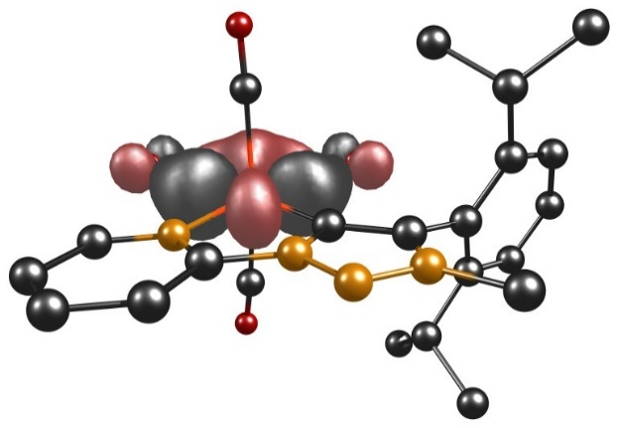
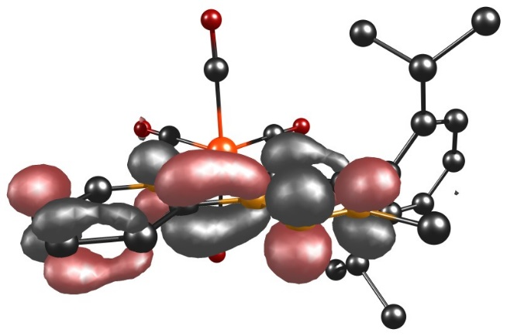
6.40 TD-DFT Calculations of [W(C−N)(CO)₄] and [W(C−N)(CO)₄]⁻

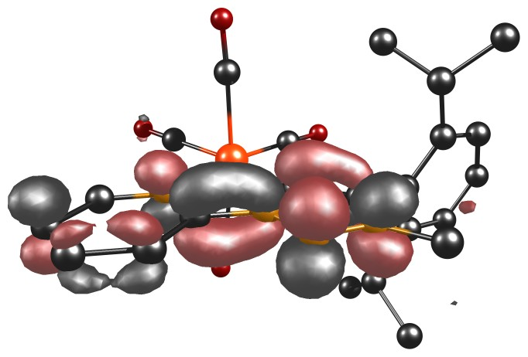
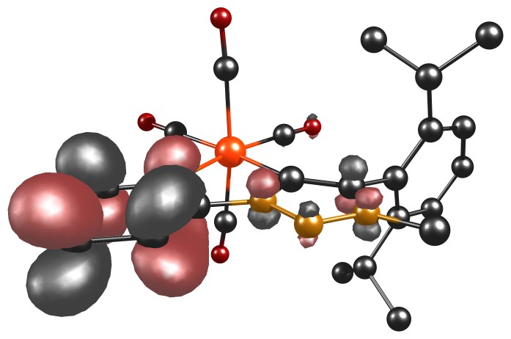
Figure S50. HOMO (left) and LUMO (right) of complex [W(C−N)(CO)₄].

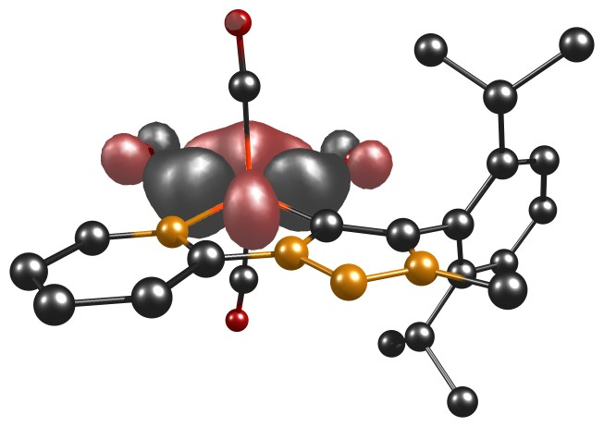
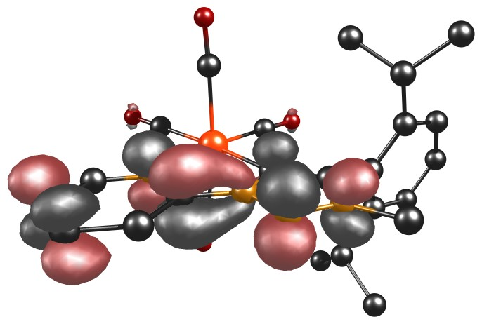
Figure S51. α-HOMO (left) and α-LUMO (right) of complex [W(C−N)(CO)₄]⁻.

Figure S52. β-HOMO (left) and β-LUMO (right) of complex [W(C−N)(CO)₄]⁻.

Table S27. Energies and compositions of selected orbitals.
MO | Energy / eV
$${[W(C-N){(CO)}_{4}]}_{HOMO}^{}$$ | $-$5.3143
$${[W(C-N){(CO)}_{4}]}_{LUMO}^{}$$ | $-$2.6455
$${[W(C-N){(CO)}_{4}]}_{α-HOMO}^{-}$$ | $-$2.9966
$${[W(C-N){(CO)}_{4}]}_{α-LUMO}^{-}$$ | $-$0.9720
$${[W(C-N){(CO)}_{4}]}_{β-HOMO}^{-}$$ | $-$4.8301
$${[W(C-N){(CO)}_{4}]}_{β-LUMO}^{-}$$ | $-$1.2443

Table S28. Selected experimental UV/vis data of [W(C−N)(CO)₄] together with selected TD-DFT calculations.
State | $λ_{exp}$($λ_{DFT}$) / nm | $ε$ / 10⁴ M⁻¹ cm⁻¹(f) | Main contributing excitation (%)
3 | 447 (534) | 0.64 (0.079) | HOMO−2 $→$ LUMO (20)
 |  |  | HOMO−1 $→$ LUMO (74)
10 | 374 (395) | 0.51 (0.056) | HOMO−2 $→$ LUMO+1 (47)  HOMO $→$ LUMO+3 (43)
9 | 374 (393) | 0.51 (0.035) | HOMO−2 $→$ LUMO+1 (36)  HOMO $→$LUMO+3 (55)
15 | 301 (318) | 0.93 (0.012) | HOMO−1 $→$LUMO+4 (65)

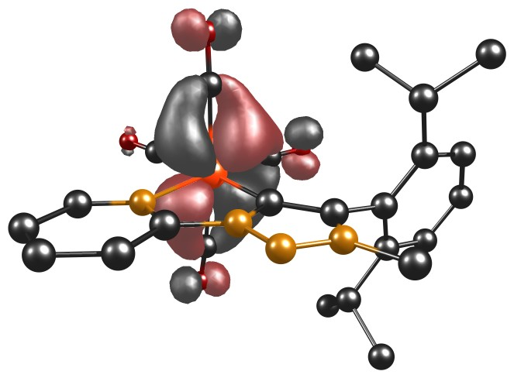
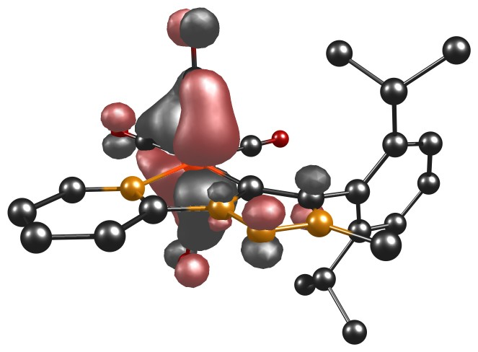

HOMO−2 HOMO−1

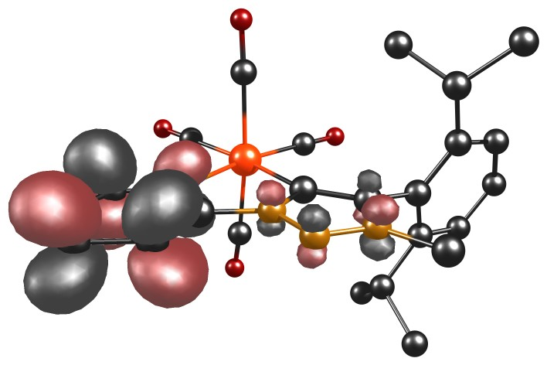
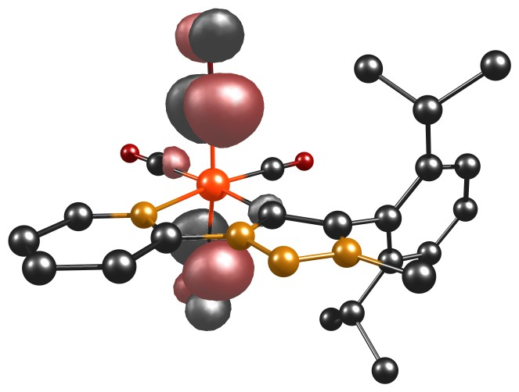
LUMO+1 LUMO+3
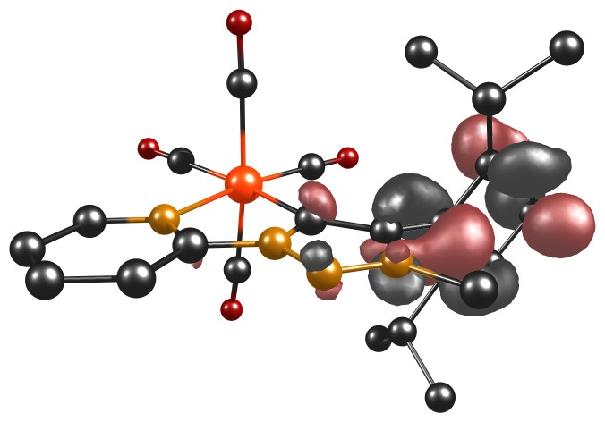

LUMO+4

Figure S53. Involved TD-DFT orbitals of complex [W(C−N)(CO)₄].
Figure S54. Calculated TD-DFT spectrum with discrete transitions of [W(C−N)(CO)₄].
Table S29. Selected experimental UV/vis data of [W(C−N)(CO)₄]⁻ together with selected TD-DFT calculations.
State | $λ_{exp}$($λ_{DFT}$) / nm | $ε$ / 10⁴ M⁻¹ cm⁻¹(f) | Main contributing excitation (%)
1 | 1570 (1242) | 0.02 (0.014) | α-HOMO $→$ α-LUMO (96)
3 | 1185 (927) | 0.07 (0.001) | α-HOMO $→$ α-LUMO+1 (99)
4 | 947 (1022) | 0.14 (0.012) | α-HOMO−1 $→$ α-LUMO+2 (98)
5 | 947 (817) | 0.14 (0.006) | α-HOMO $→$ α-LUMO+3 (99)
6 | 674 (515) | 0.56 (0.108) | α-HOMO $→$ α-LUMO+4 (86)
11 | 622 (454) | 0.60 (0.016) | α-HOMO $→$ α-LUMO+6 (47)
 |  |  | β-HOMO−1 $→$ β-LUMO+1 (29)
13 | 575 (448) | 0.44 (0.032) | β-HOMO−1 $→$ β-LUMO (68)
17 | 430 (431) | 0.62 (0.015) | β-HOMO−2 $→$ β-LUMO (66)
15 | 340 (423) | 1.55 (0.028) | α-HOMO−1 $→$ α-LUMO+1 (30)  β-HOMO $→$ β-LUMO+1 (32)
31 | 316 (380) | 1.90 (0.058) | α-HOMO−3 $→$ α-LUMO (22)  β-HOMO−2 $→$ β-LUMO+1 (63)
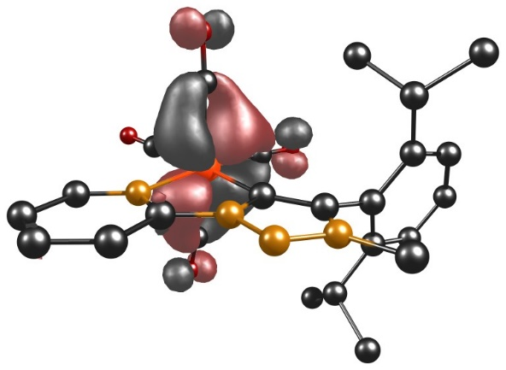
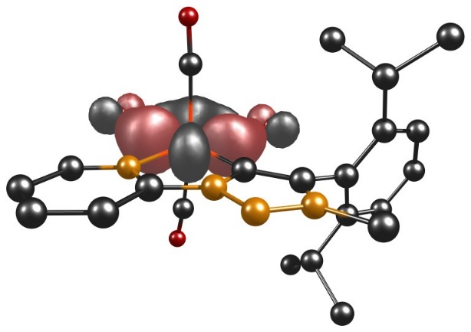

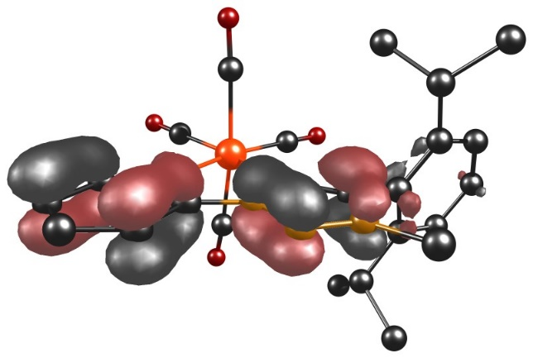
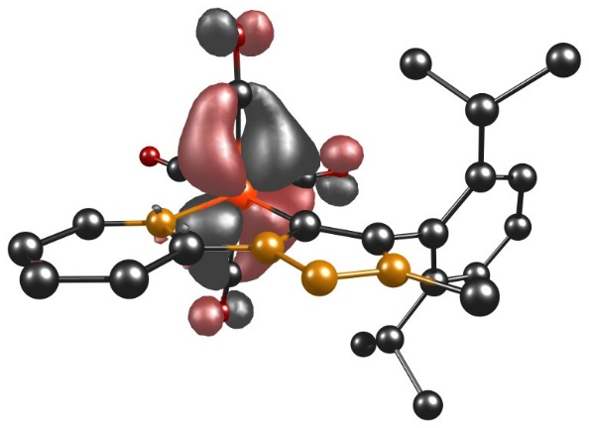
α-HOMO−3 α-HOMO−1

β-HOMO−2 β-HOMO−1

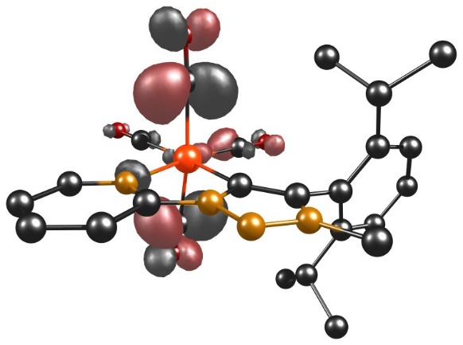
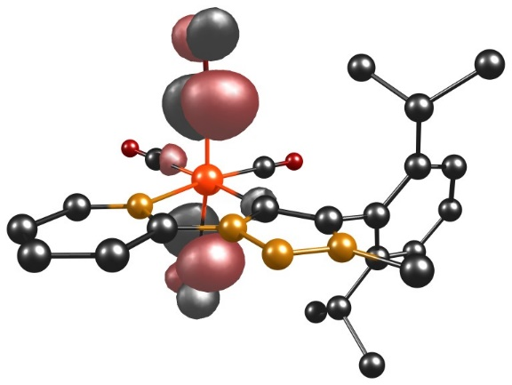
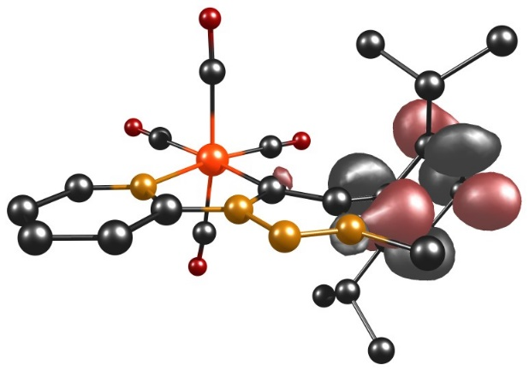
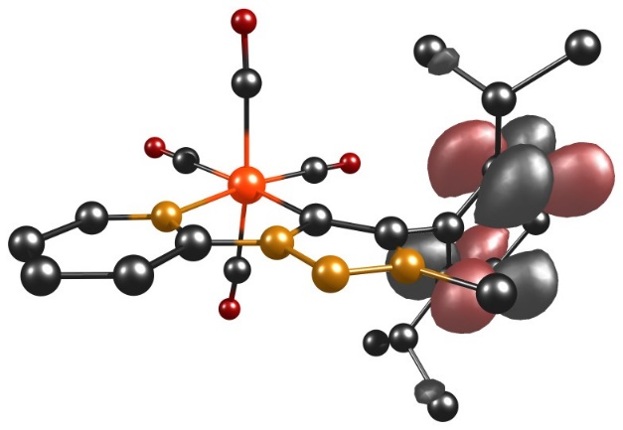
α-LUMO+1 α-LUMO+2

α-LUMO+3 α-LUMO+4
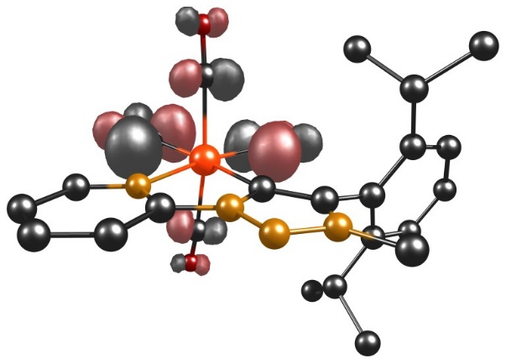
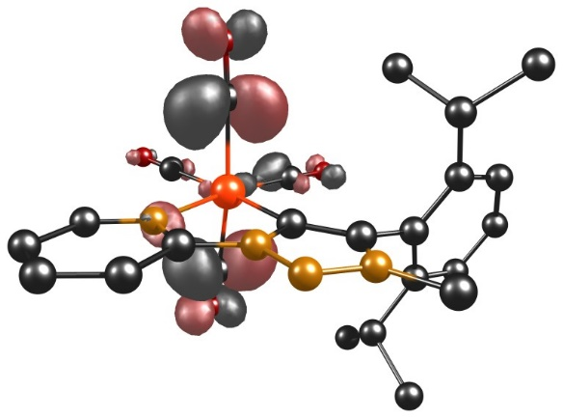

α-LUMO+6 β-LUMO+1

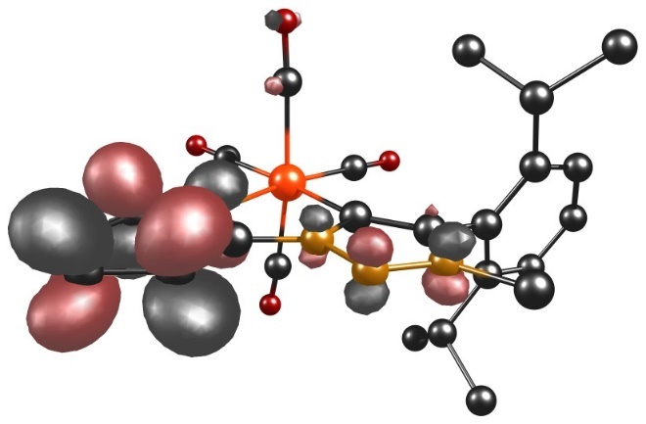
β-LUMO+2

Figure 55. Involved TD-DFT orbitals of complex [W(C−N)(CO)₄]⁻.
Figure S56. Calculated TD-DFT spectrum with discrete transitions of [W(C−N)(CO)₄]⁻.

Table S30. Selected MO energies of [W(C−N)(CO)₄] and [W(C−N)(CO)₄]⁻.
[W(C−N)(CO)₄] |  | [W(C−N)(CO)₄]⁻
MO | Energy / eV | MO | Energy / eV
HOMO−2 | $-$5.4114 | α-HOMO−3 | $-$ 5.1212
HOMO−1 | $-$5.3226 | α-HOMO−1 | $-$4.8312
LUMO+1 | $-$1.5436 | β-HOMO−2 | $-$5.0951
LUMO+3 | $-$0.8234 | β-HOMO−1 | $-$4.8841
LUMO+4 | $-$0.6371 | α-LUMO+1 | $-$0.9098
 |  | α-LUMO+2 | $-$0.6299
 |  | α-LUMO+3 | $-$0.3915
 |  | α-LUMO+4 | $-$0.1097
 |  | α-LUMO+6 | 0.2604
 |  | β-LUMO+1 | $-$0.9035
 |  | β-LUMO+2 | $-$0.7963

Table S31. XYZ coordinates of optimized [W(C−N)(CO)₄].
 | x | y | z
W | -2.07759 | 9.73554 | 9.61697
N | -2.96761 | 7.65608 | 10.04448
C | -0.50307 | 8.2197 | 9.22942
C | -3.67879 | 10.84371 | 10.06891
C | -1.01579 | 11.32229 | 9.11795
C | -2.87022 | 9.7527 | 7.73163
C | -1.5265 | 10.04743 | 11.56671
C | -2.16693 | 6.58764 | 9.90972
C | -4.24562 | 7.43058 | 10.39694
C | 0.80693 | 8.06144 | 8.78333
N | -0.86599 | 6.92263 | 9.4941
O | -4.61537 | 11.48775 | 10.32662
O | -0.36745 | 12.2394 | 8.80839
O | -3.39567 | 9.88172 | 6.71223
O | -1.28255 | 10.33587 | 12.65699
C | -2.57092 | 5.28107 | 10.1267
C | -4.74347 | 6.1598 | 10.6166
H | -4.86981 | 8.30563 | 10.4977
N | 1.07888 | 6.72162 | 8.8307
C | 1.73233 | 9.07169 | 8.2307
N | 0.0719 | 6.00309 | 9.26531
H | -1.87158 | 4.46832 | 10.00309
C | -3.89129 | 5.06731 | 10.48763
H | -5.78114 | 6.03457 | 10.89117
C | 2.32432 | 6.051 | 8.47017
C | 2.79535 | 9.57707 | 9.00607
C | 1.50774 | 9.52366 | 6.91752
H | -4.25204 | 4.06282 | 10.66178
H | 2.10445 | 5.24863 | 7.77093
H | 2.78762 | 5.64725 | 9.36801
H | 2.97747 | 6.7847 | 8.0094
C | 3.62014 | 10.54744 | 8.44257
C | 3.00999 | 9.10062 | 10.43458
C | 2.36207 | 10.49259 | 6.39344
C | 0.40982 | 8.93538 | 6.05046
H | 4.44153 | 10.95367 | 9.0149
C | 3.40765 | 11.0012 | 7.14635
H | 2.8103 | 8.02583 | 10.45686
C | 2.00226 | 9.76379 | 11.38238
C | 4.43763 | 9.30153 | 10.9483
H | 2.21181 | 10.84743 | 5.3825
H | -0.30392 | 8.43384 | 6.70358
C | 0.99207 | 7.87157 | 5.10882
C | -0.36411 | 9.99906 | 5.26801
H | 4.06438 | 11.75135 | 6.72312
H | 2.16235 | 10.84424 | 11.41442
H | 2.11407 | 9.36649 | 12.39356
H | 0.98043 | 9.58626 | 11.05581
H | 5.17605 | 8.86949 | 10.27082
H | 4.5453 | 8.82094 | 11.92218
H | 4.67254 | 10.36024 | 11.0773
H | 0.1962 | 7.39736 | 4.52941
H | 1.51846 | 7.09405 | 5.66658
H | 1.70213 | 8.32369 | 4.41236
H | 0.26267 | 10.48049 | 4.51497
H | -0.75154 | 10.77088 | 5.93338
H | -1.20875 | 9.53797 | 4.75346

Table S32. XYZ coordinates of optimized [W(C−N)(CO)₄]⁻.
 | x | y | z
W | -2.06786 | 9.72788 | 9.63463
N | -2.97596 | 7.67083 | 10.04528
C | -0.48365 | 8.21092 | 9.23315
C | -3.64508 | 10.84533 | 10.11098
C | -0.99324 | 11.30386 | 9.13403
C | -2.88509 | 9.76388 | 7.76288
C | -1.53083 | 10.02029 | 11.58842
C | -2.14669 | 6.58813 | 9.9007
C | -4.25432 | 7.43495 | 10.38142
C | 0.79969 | 8.0526 | 8.78569
N | -0.88101 | 6.89132 | 9.50839
O | -4.56877 | 11.5093 | 10.3946
O | -0.33876 | 12.22052 | 8.81907
O | -3.43778 | 9.91139 | 6.75557
O | -1.31435 | 10.31458 | 12.6876
C | -2.59346 | 5.26842 | 10.11902
C | -4.77164 | 6.17214 | 10.58956
H | -4.87674 | 8.31371 | 10.48207
N | 1.10927 | 6.70498 | 8.80651
C | 1.72091 | 9.06841 | 8.22967
N | 0.08353 | 5.94564 | 9.27448
H | -1.90044 | 4.4488 | 10.00145
C | -3.90743 | 5.06597 | 10.46101
H | -5.812 | 6.05176 | 10.85551
C | 2.35543 | 6.05673 | 8.4784
C | 2.78051 | 9.58273 | 9.00405
C | 1.51676 | 9.50926 | 6.90949
H | -4.27689 | 4.06202 | 10.6277
H | 2.19057 | 5.27244 | 7.73759
H | 2.80791 | 5.61295 | 9.36883
H | 3.03014 | 6.80188 | 8.06607
C | 3.61523 | 10.54578 | 8.44067
C | 2.98035 | 9.1201 | 10.43898
C | 2.37823 | 10.47111 | 6.38143
C | 0.42104 | 8.92096 | 6.03996
H | 4.43227 | 10.95543 | 9.01778
C | 3.41849 | 10.98705 | 7.13726
H | 2.7373 | 8.05512 | 10.47279
C | 1.99589 | 9.83107 | 11.37616
C | 4.41474 | 9.27649 | 10.94915
H | 2.23786 | 10.81517 | 5.36469
H | -0.27242 | 8.39879 | 6.6979
C | 1.00689 | 7.88611 | 5.0694
C | -0.37824 | 9.99061 | 5.29175
H | 4.08171 | 11.73077 | 6.71199
H | 2.19646 | 10.90551 | 11.39812
H | 2.08994 | 9.44178 | 12.39298
H | 0.97196 | 9.683 | 11.04179
H | 5.1366 | 8.80672 | 10.27835
H | 4.50764 | 8.80798 | 11.93088
H | 4.69024 | 10.32752 | 11.06085
H | 0.21223 | 7.41289 | 4.48661
H | 1.54693 | 7.10518 | 5.60924
H | 1.70484 | 8.35998 | 4.37434
H | 0.23309 | 10.50368 | 4.54598
H | -0.77143 | 10.7368 | 5.98239
H | -1.22143 | 9.5309 | 4.77275

7. Electrochemical CO₂ Reduction

7.10 Electrochemical CO₂ Reduction with [Cr(C−C)(CO)₄]
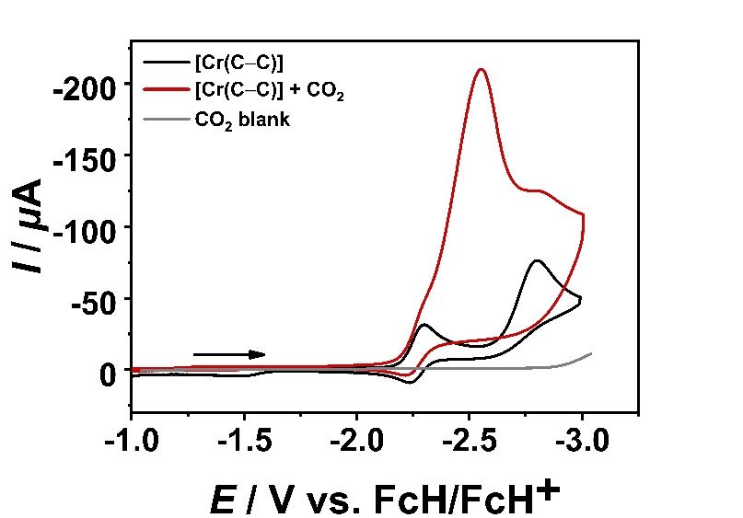
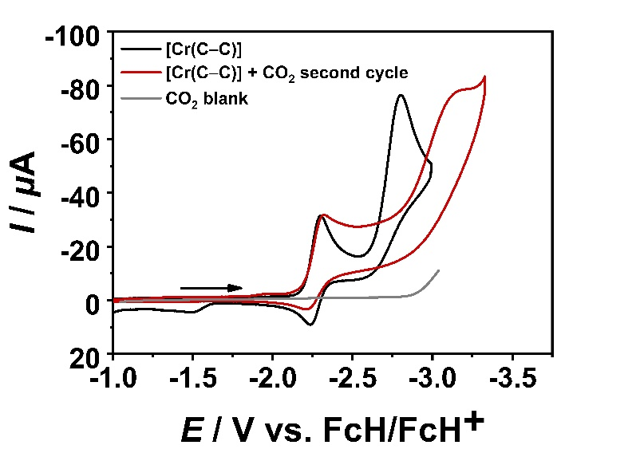

Figure S57. Cyclic voltammograms of [Cr(C−C)(CO)₄] (1 mM, black) and in the presence of CO₂ (red) at 100 mV/s in CH₃CN/0.1 M Bu₄NPF₆ with a GC working electrode (left: first cycle, right: second cycle).
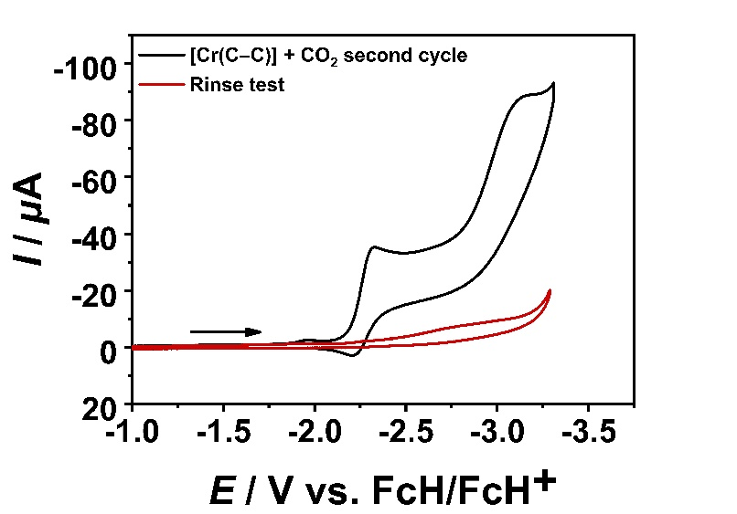

Figure S58. Rinse test of [Cr(C−C)(CO)₄] (1 mM, black, second cycle) and freshly prepared saturated CO₂ solution (red) at 100 mV/s in CH₃CN/0.1 M Bu₄NPF₆ with a GC working electrode.

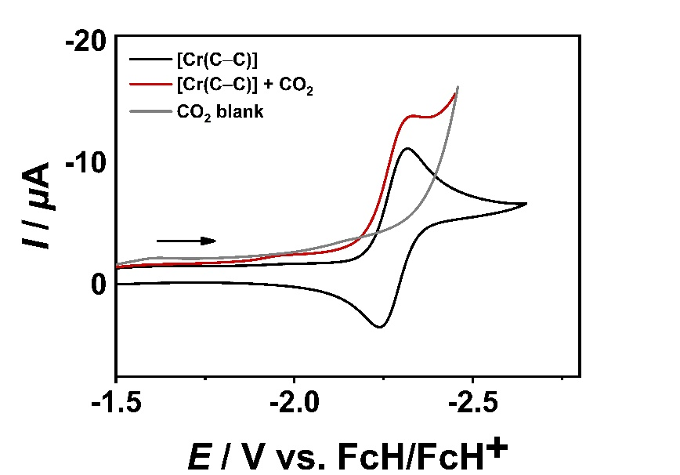

Figure S59. Cyclic voltammograms of [Cr(C−C)(CO)₄] (1 mM, black) and in the presence of CO₂ (red) at 100 mV/s in CH₃CN/0.1 M Bu₄NPF₆ with a Au working electrode.

7.20 Electrochemical CO₂ Reduction with [Cr(C−N)(CO)₄]
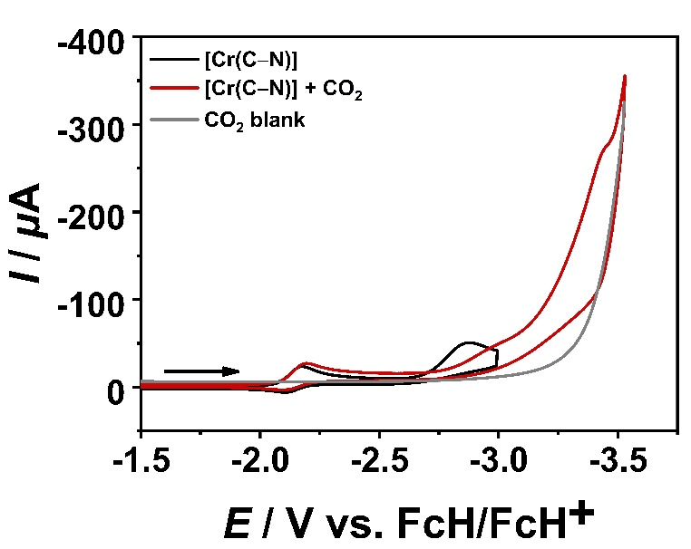

Figure S60. Cyclic voltammograms of [Cr(C−N)(CO)₄] (1 mM, black) and in the presence of CO₂ (red) at 100 mV/s in CH₃CN/0.1 M Bu₄NPF₆ with a GC working.

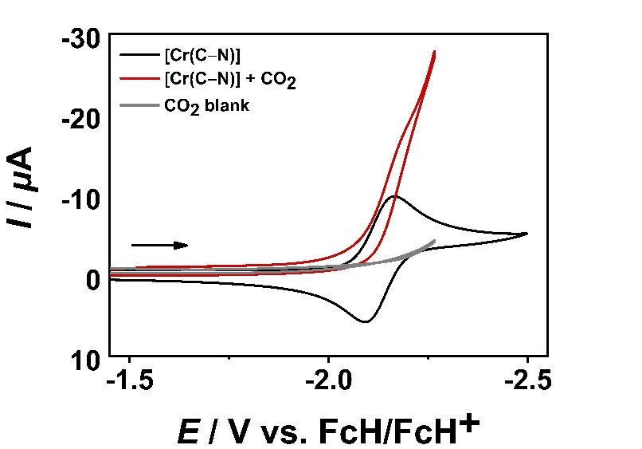
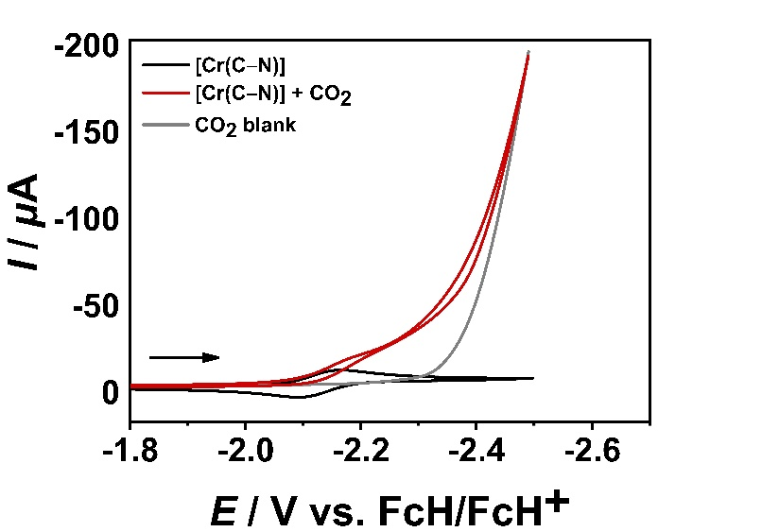
Figure S61. Cyclic voltammograms of [Cr(C−N)(CO)₄] (1 mM, black) and in the presence of CO₂ (red) at 100 mV/s in CH₃CN/0.1 M Bu₄NPF₆ with a Au working electrode.

7.30 Electrochemical CO₂ Reduction with [Mo(C−C)(CO)₄]
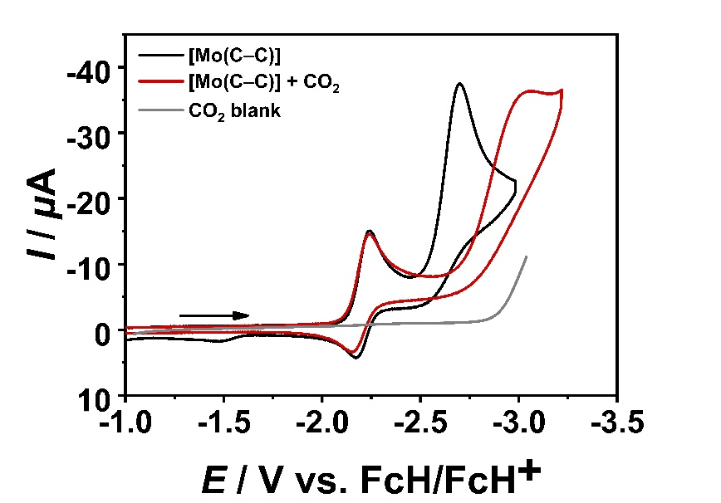

Figure S62. Cyclic voltammograms of [Mo(C−C)(CO)₄] (1 mM, black) and in the presence of CO₂ (red) at 100 mV/s in CH₃CN/0.1 M Bu₄NPF₆ with a GC working.

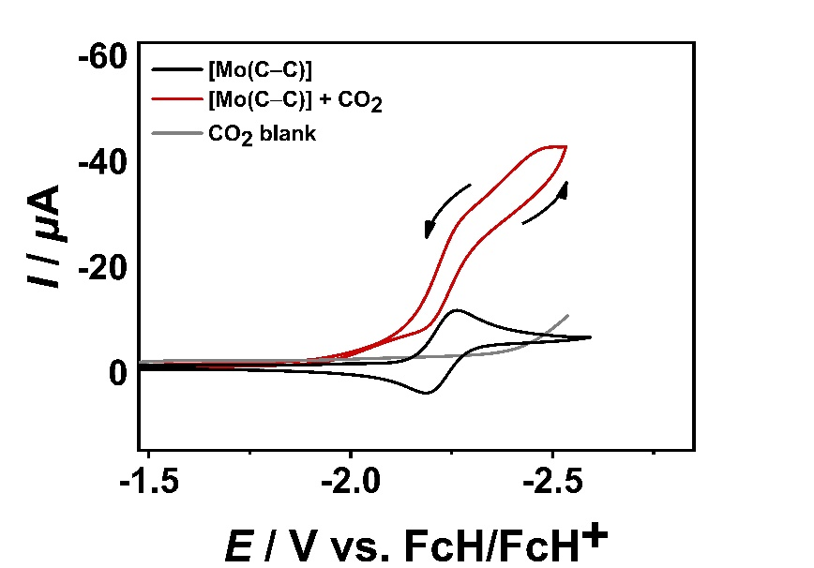

Figure S63. Cyclic voltammograms of [Mo(C−C)(CO)₄] (1 mM, black) and in the presence of CO₂ (red) at 100 mV/s in CH₃CN/0.1 M Bu₄NPF₆ with a Au working electrode.

7.40 Electrochemical CO₂ Reduction with [Mo(C−N)(CO)₄]
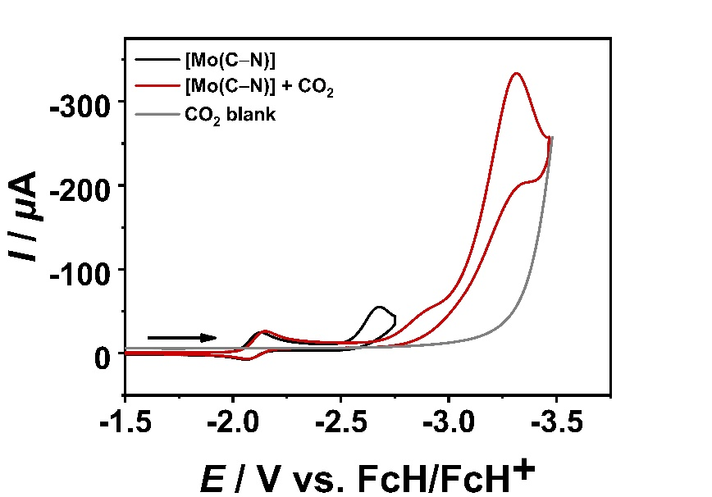

Figure S64. Cyclic voltammograms of [Mo(C−N)(CO)₄] (1 mM, black) and in the presence of CO₂ (red) at 100 mV/s in CH₃CN/0.1 M Bu₄NPF₆ with a GC working.

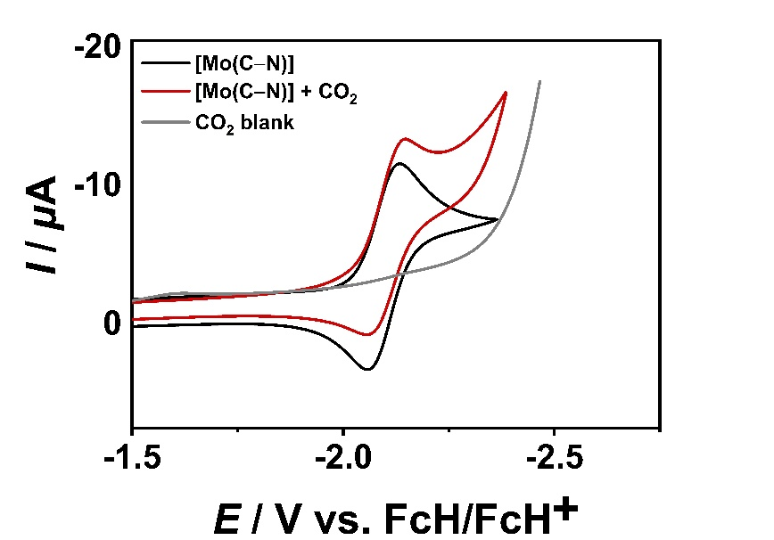

Figure S65. Cyclic voltammograms of [Mo(C−N)(CO)₄] (1 mM, black) and in the presence of CO₂ (red) at 100 mV/s in CH₃CN/0.1 M Bu₄NPF₆ with a Au working electrode.

7.50 Electrochemical CO₂ Reduction with [W(C−C)(CO)₄]
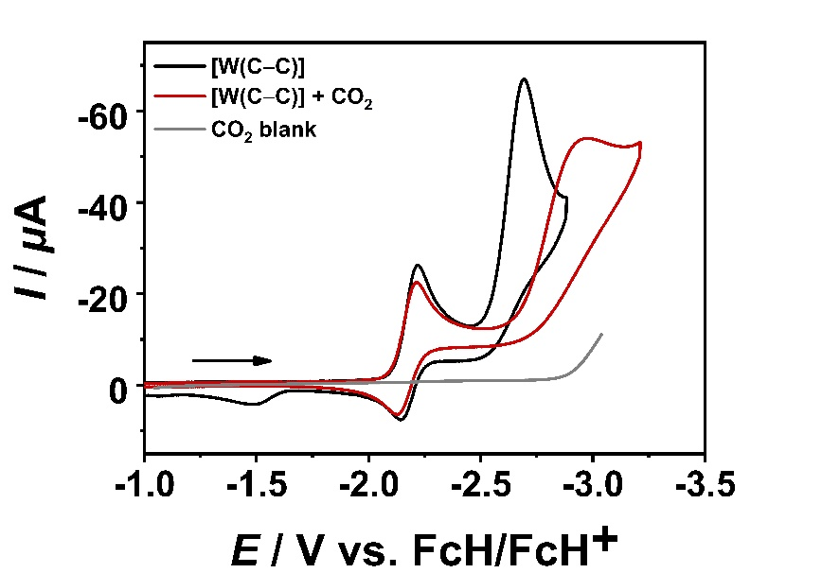

Figure S66. Cyclic voltammograms of [W(C−C)(CO)₄] (1 mM, black) and in the presence of CO₂ (red) at 100 mV/s in CH₃CN/0.1 M Bu₄NPF₆ with a GC working.

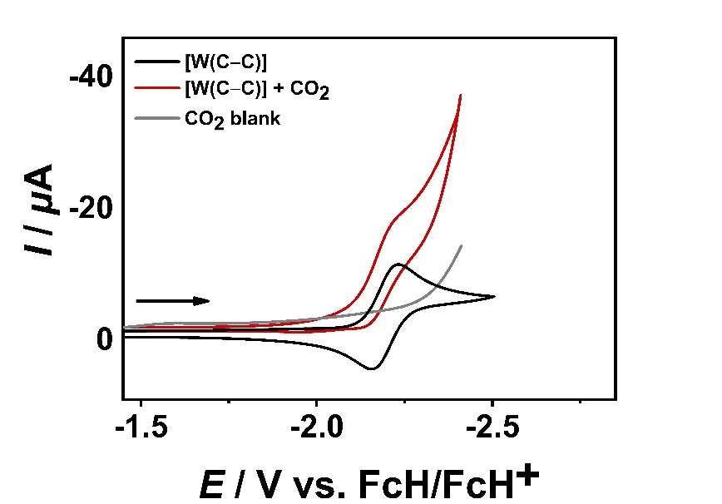

Figure S67. Cyclic voltammograms of [W(C−C)(CO)₄] (1 mM, black) and in the presence of CO₂ (red) at 100 mV/s in CH₃CN/0.1 M Bu₄NPF₆ with a Au working electrode.

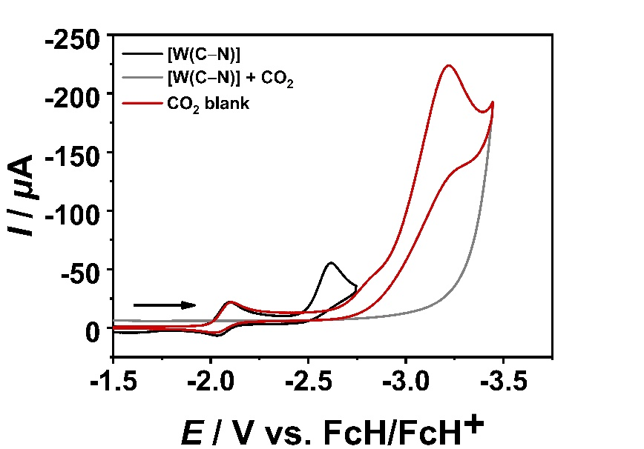
7.60 Electrochemical CO₂ Reduction with [W(C−N)(CO)₄]

Figure S68. Cyclic voltammograms of [W(C−N)(CO)₄] (1 mM, black) and in the presence of CO₂ (red) at 100 mV/s in CH₃CN/0.1 M Bu₄NPF₆ with a GC working.

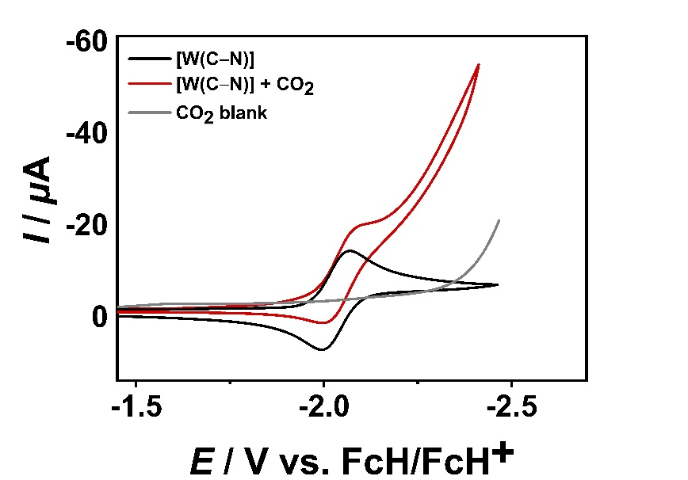

Figure S69. Cyclic voltammograms of [W(C−N)(CO)₄] (1 mM, black) and in the presence of CO₂ (red) at 100 mV/s in CH₃CN/0.1 M Bu₄NPF₆ with a Au working electrode.

