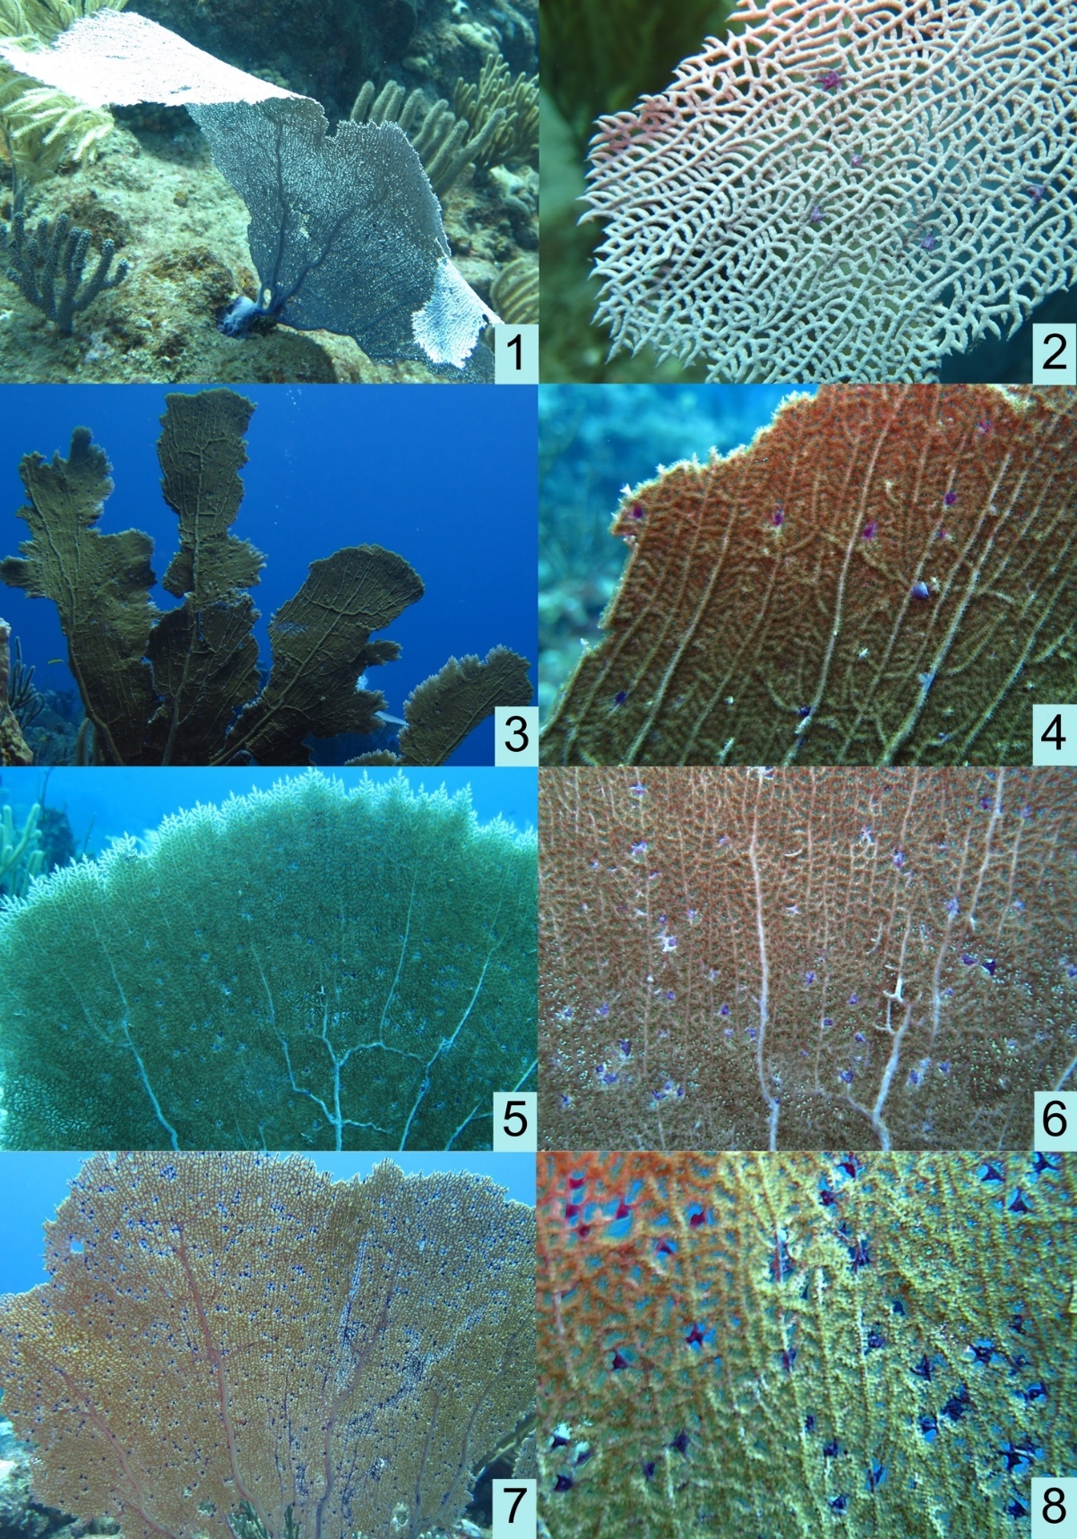
Figure S1. Specimens of Gorgonia ventalina (Linnaeus 1758) labeled as follows: Statia15-99 – 1, 2; Statia15-134 – 3, 4; Statia15-135 – 5, 6; Statia15-141 – 7, 8.

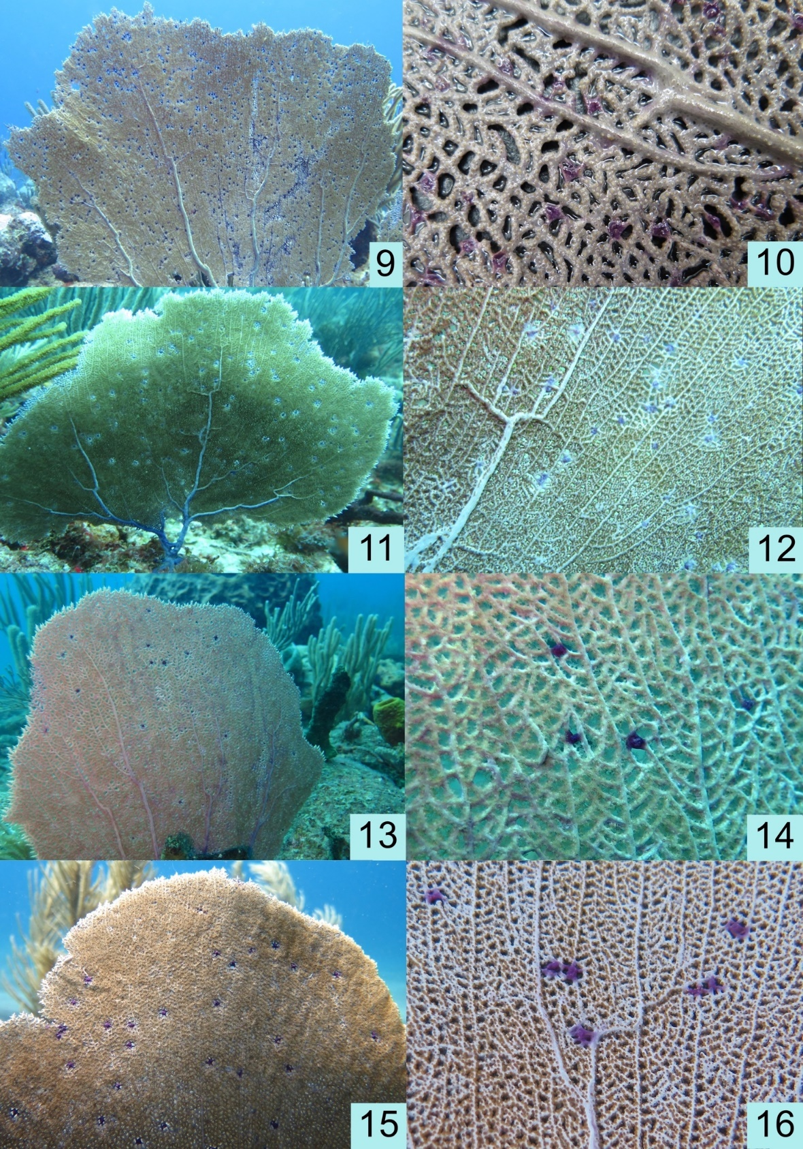
Figure S2. Specimens of Gorgonia ventalina (Linnaeus 1758) labeled as follows: Statia15-142 – 9, 10; Statia15-146 – 11, 12; Statia15-163 – 13, 14; Statia15-170 – 15, 16.

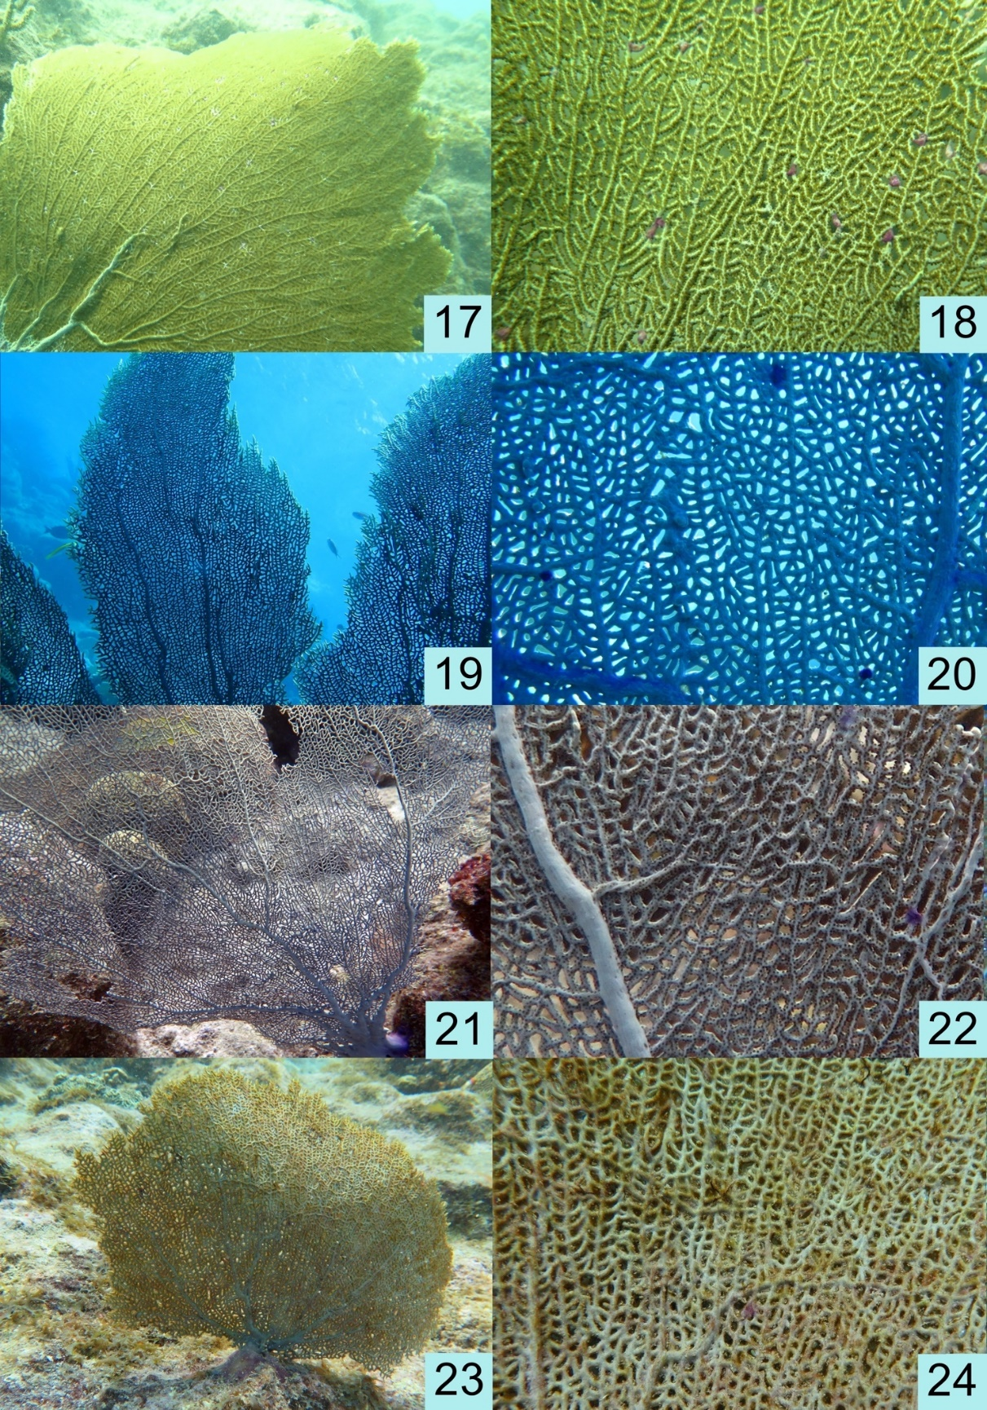
Figure S3. Specimens of Gorgonia ventalina (Linnaeus 1758) labeled as follows: Statia15-174 – 17, 18; CUR17-39 – 19, 20; CUR17-81 – 21, 22; CUR17-88 – 23, 24.

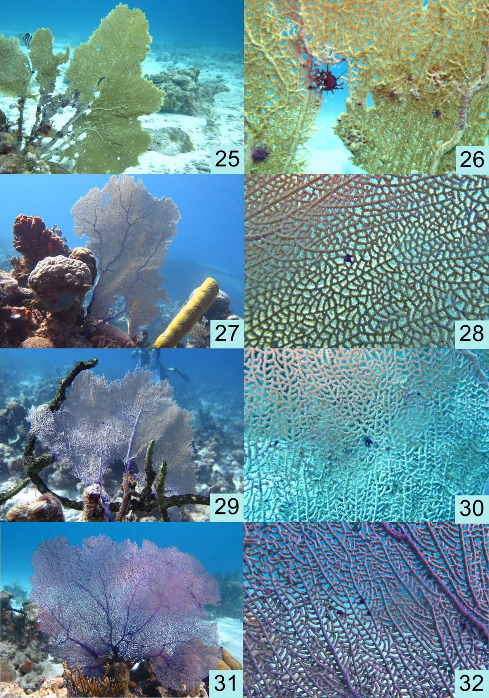
Figure S4. Specimens of Gorgonia ventalina (Linnaeus 1758) labeled as follows: CUR17-96 – 25, 26; Cuba19-1 – 27, 28; Cuba19-2 – 29, 30; Cuba19-3 – 31, 32.

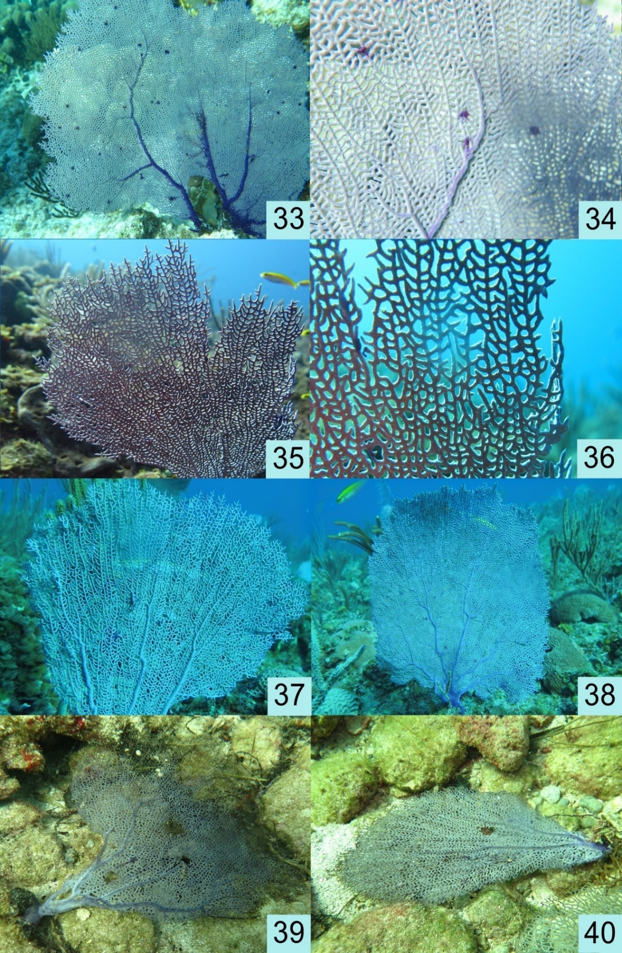
Figure S5. Specimens of Gorgonia ventalina (Linnaeus 1758) labeled as follows: Cuba19-5 – 33, 34; Cuba19-21 – 35, 36; Cuba19-22 – 37; Cuba19-25 – 38, no; Cuba19-32 – 39, no; Cuba19-33 – 40.

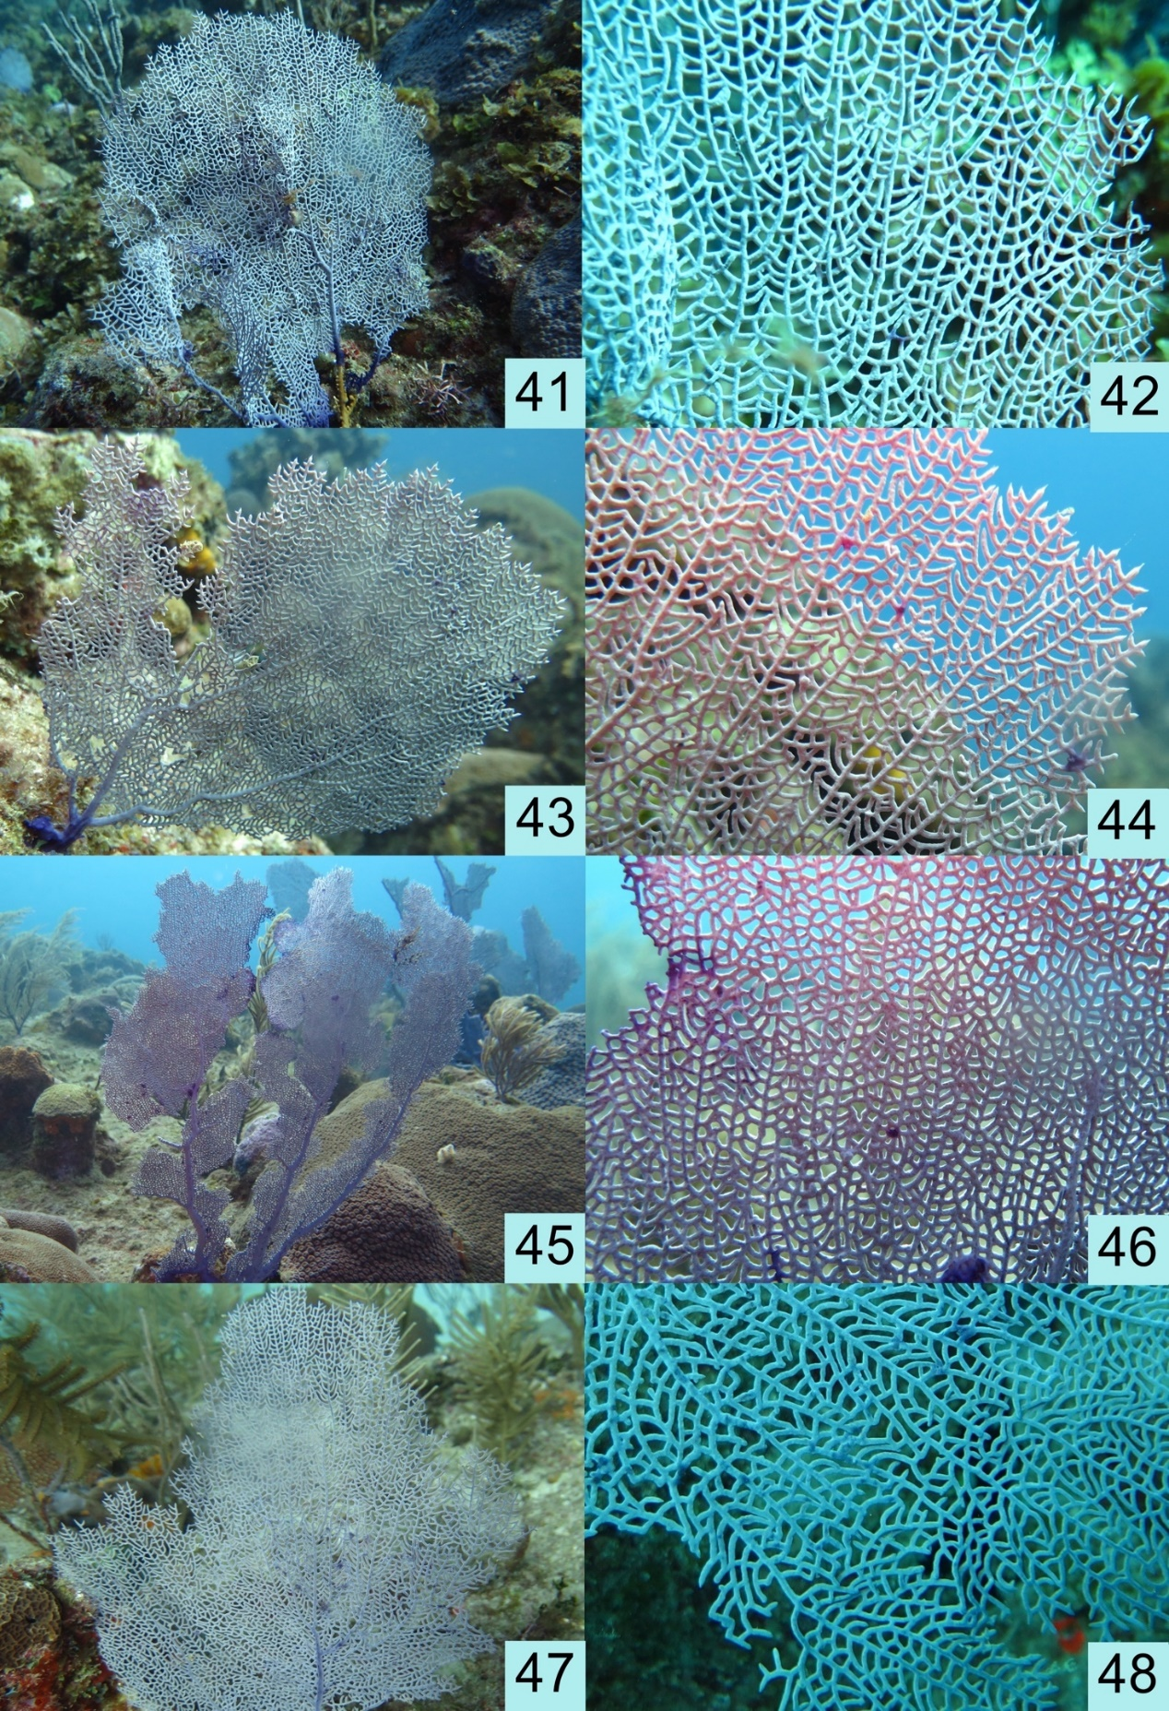
Figure S6. Specimens of Gorgonia ventalina (Linnaeus 1758) labeled as follows: Cuba19-23 – 41, 42; Cuba19-27 – 43, 44; Cuba19-28 – 45, 46; Cuba19-30 – 47, 48.

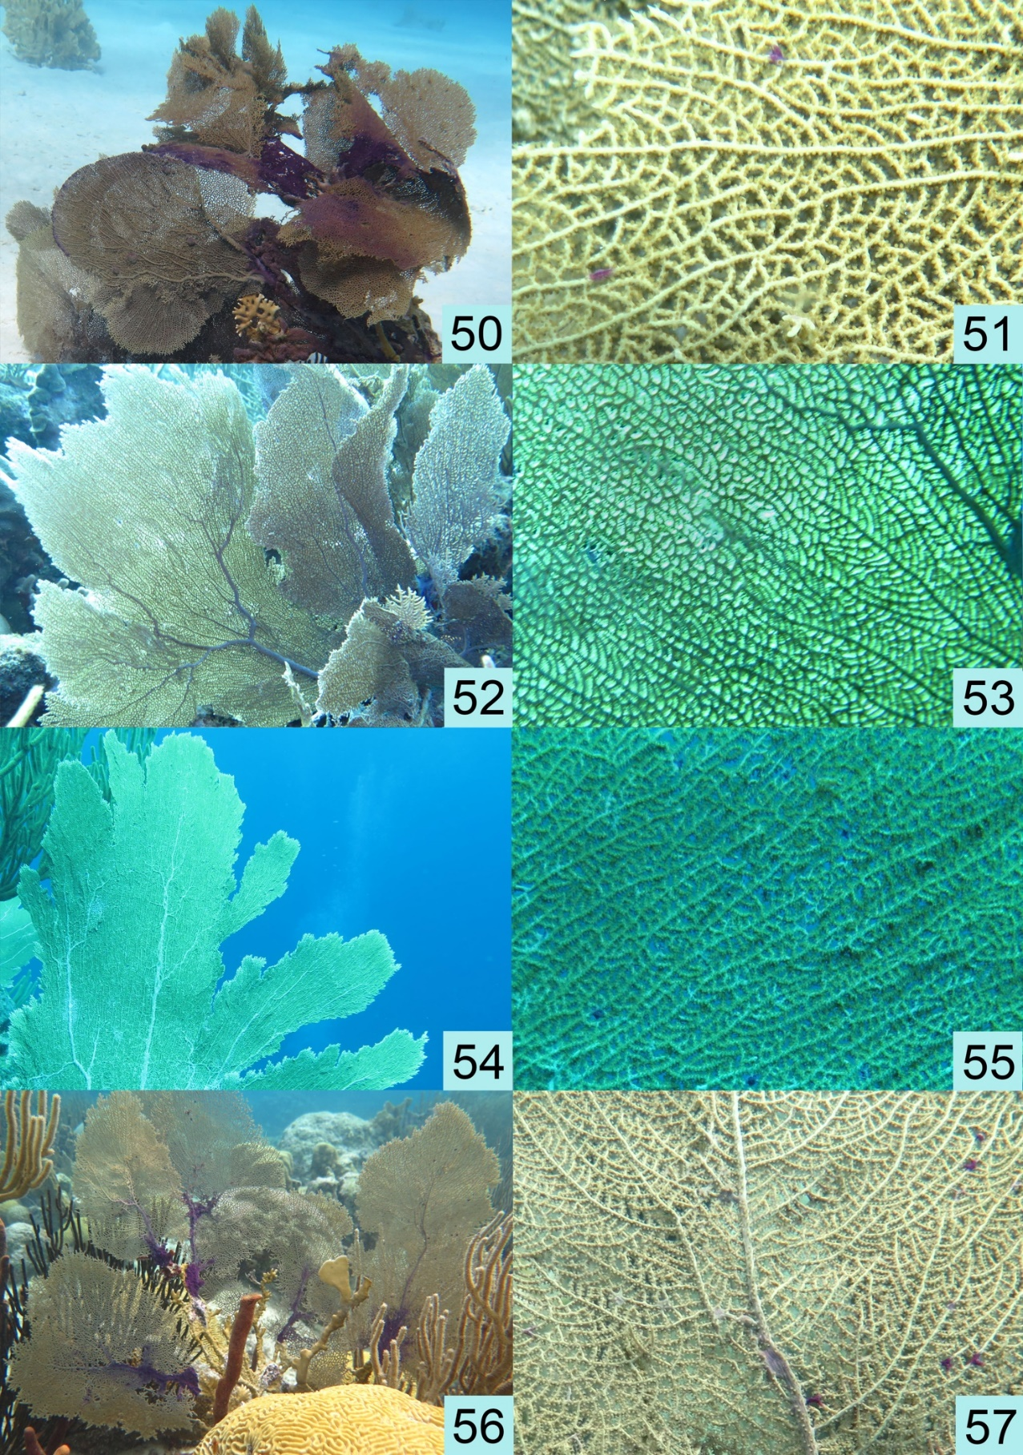
Figure S7. Specimens of Gorgonia ventalina (Linnaeus 1758) labeled as follows: Bonaire19-28 – 50, 51; Bonaire19-31 – 52, 53; Bonaire19-47 – 54, 55; Bonaire19-91 – 56, 57.

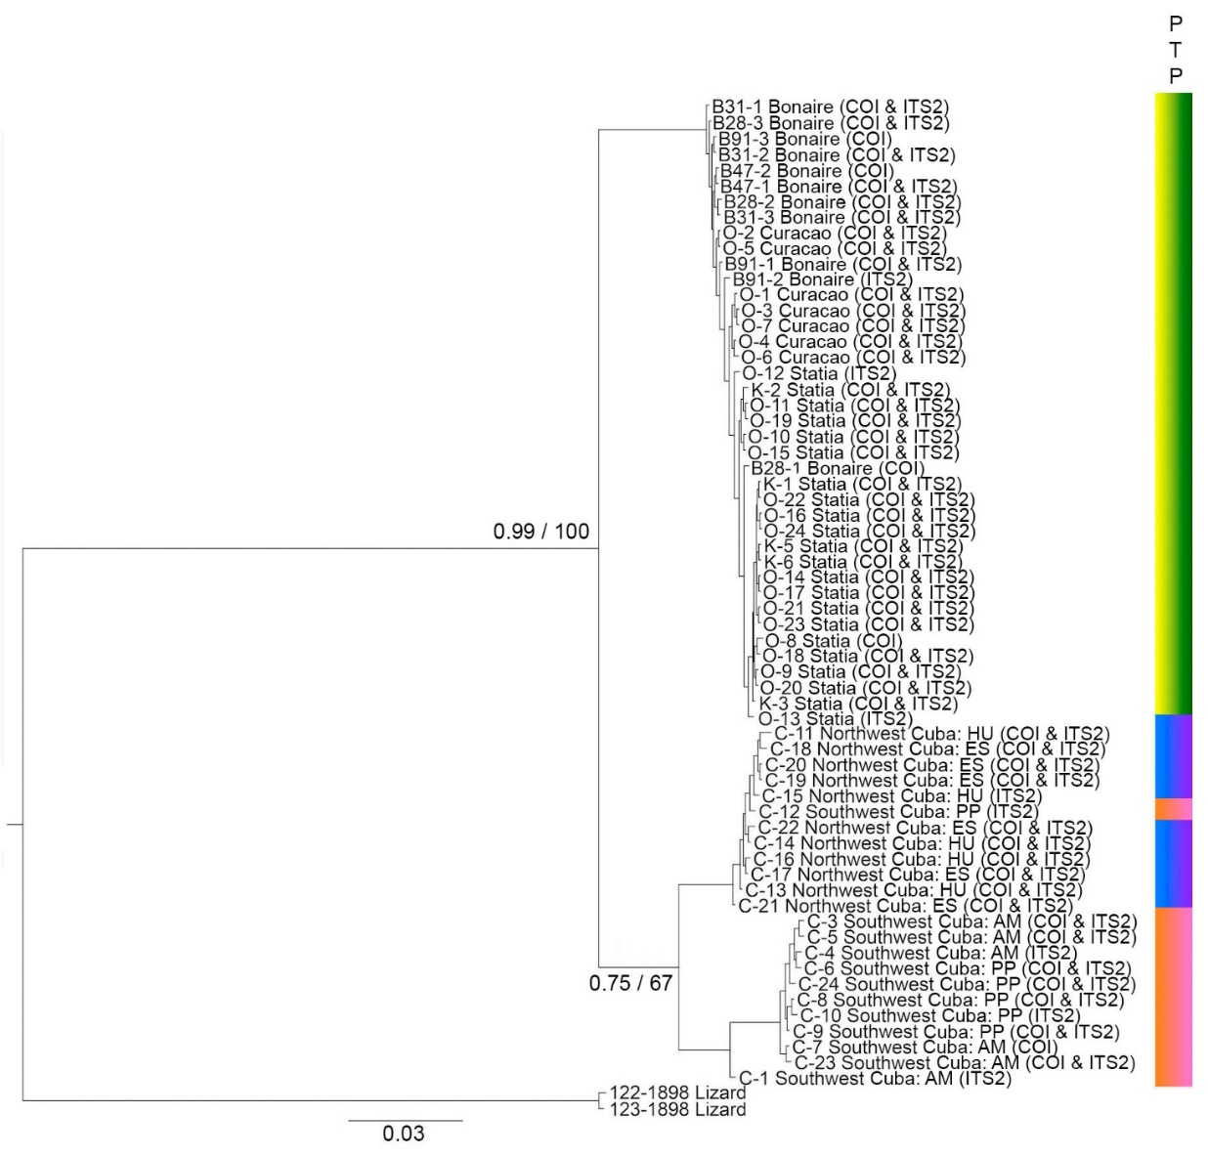

Figure S8. The phylogenetic tree was constructed based on the concatenated alignment of COI (Cytochrome c oxidase subunit I) and ITS2 (Internal Transcribed Spacer 2) sequences of Lamippidae copepods, including Sphaerippe spp. Model of nucleotide evolution is HKY+G for COI_pos1, K81UF+I for ITS and COI_pos2, HKY+I for COI_pos3. Numbers in the nodes is posterior probabilities / bootstrap supports. Color bars on the right denote the species delimitation results. For additional details, including geographic coordinates, please refer to Table 1 and Table S4.
Figure S9. In the Bayesian (BA) phylogenetic tree based on the alignment of 18S sequences of crustacean copepods, as indicated in Table S6, the nucleotide evolution model applied was GTR + G + I. The numbers associated with the nodes represent Bayesian (BA) posterior probabilities. For additional information, refer to Figure 6 and Supplementary Figure 10 (Figure 6 and Figure S10).
Figure S10. Maximum Likelihood phylogenetic tree based on the 18S alignment of copepod crustaceans indicated in Table S6. The nucleotide evolution model applied is GTR + G + I. The numbers associated with the nodes represent bootstrap support values. For additional information, refer to Figure 6 and Supplementary Figure 9 (Figure 6 and Figure S9).

