Supplemental Figures
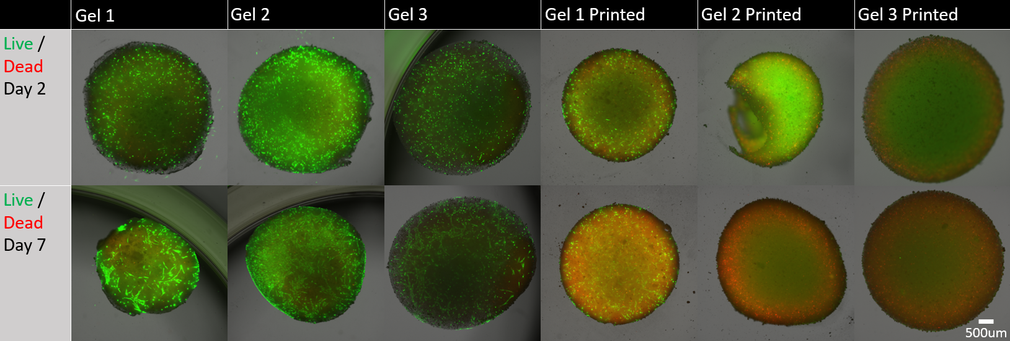
Supplemental Figure 1. – Cell viability in GelMA/HA bioinks: Live hMSC cells stained green and dead hMSC cells stained red, composite images are shown. Printed gel 2 and 3 were not quantifiable and were not analyzed for cell viability.

