Intrauterine growth restriction affects colonic barrier function via regulating the Nrf2/Keap1 and TLR4-NFκB/ERK pathways and altering colonic microbiota and metabolome homeostasis in growing-finishing pig model
Liang Xiong ^{1, 2}, Md. Abul Kalam Azad ¹, Yang Liu ¹, Wanghong Zhang ^{1,} Qian Zhu ¹, Chengjun Hu ¹, Jinming You ^{2, *}, and Xiangfeng Kong ^{1, *}
¹ Key Laboratory of Agro-ecological Processes in Subtropical Region, Hunan Provincial Key Laboratory of Animal Nutritional Physiology and Metabolic Process, National Engineering Laboratory for Pollution Control and Waste Utilization in Livestock and Poultry Production, Institute of Subtropical Agriculture, Chinese Academy of Sciences, Changsha, Hunan 410125, China
² Key Laboratory of Animal Nutrition in Jiangxi Province, College of Animal Science and Technology, Jiangxi Agricultural University, Nanchang, Jiangxi 440000, China
* Correspondence: J.M. You, E-mail: youjinm@163.com; X.F. Kong, E-mail: nnkxf@isa.ac.cn.

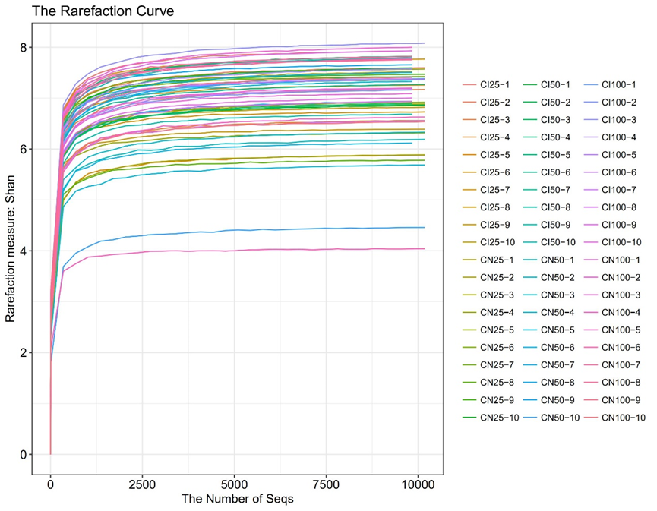

Figure S1. Rarefaction curve analysis was used to evaluate whether further sequencing would likely detect additional taxa. CI and CN represent samples obtained from the colon contents of intrauterine growth restriction (IUGR) pigs and normal birth weight (NBW) pigs, respectively; 25, 50, and 100 represent 25, 50, and 100 kg body weight stages of NBW pigs, respectively.

Table S1 Ingredients and chemical composition of the experimental diets (as-fed basis).
Items | Nursery pig feed  (28-69 day-old) | Growing pig feed  (70-103 day-old) | Finishing pig feed  (104-165 day-old)
Ingredients (%)
Corn | 60.00 | 61.00 | 61.17
Soybean meal | 27.50 | 25.00 | 25.50
Barley | 6.00 | 8.00 | 8.00
Soybean oil | 2.00 | 1.50 | 1.00
Lysine | 0.16 | 0.18 | 0.13
CaHPO₄ | 0.10 | 0.10 | 0.00
Threonine | 0.10 | 0.07 | 0.08
Methionine | 0.02 | 0.03 | 0.00
Anti-mildew agent | 0.10 | 0.10 | 0.10
Anti-oxidant | 0.02 | 0.02 | 0.02
Nursery pigs premix¹⁾ | 4.00 | 0.00 | 0.00
Growing-finishing pigs premix²⁾ | 0.00 | 4.00 | 4.00
Total | 100.00 | 100.00 | 100.00
Nutrient levels³⁾
Digestible energy (MJ/kg) | 13.91 | 13.77 | 13.64
Crude protein | 17.20 | 16.40 | 16.50
Crude fat | 4.70 | 4.30 | 3.80
Crude fiber | 2.70 | 2.70 | 2.80
Digestible lysine | 1.17 | 1.08 | 1.05
Digestible methionine | 0.33 | 0.30 | 0.28
Digestible threonine | 0.77 | 0.71 | 0.73
Total calcium | 0.77 | 0.74 | 0.66
Total phosphorus | 0.56 | 0.52 | 0.45
¹⁾ The nursery pig premix supplied for per kg diet: vitamin A 8 000 IU, vitamin D₃ 228 IU, vitamin E 15 IU; vitamin K₃ 3.00 mg, vitamin B₁ 1.30 mg, vitamin B₂ 3.10 mg, vitamin B₆ 1.20 mg, vitamin B₁₂ 0.03 mg, calcium pantothenate 13.40 mg, choline chloride 500 mg, iron 120 mg, copper 10 mg, zinc 130 mg, manganese 100 mg, iodine 0.30 mg, and selenium 0.30 mg.
²⁾ The growing-finishing pig premix supplied for per kg diet: vitamin A 15 000 IU, vitamin D₃ 200 IU, vitamin E 50 IU, vitamin K₃ 4.00 mg, vitamin B₁ 4.00 mg, vitamin B₂ 10 mg, vitamin B₆ 3.00 mg, vitamin B₁₂ 0.04 mg, calcium pantothenate 20.00 mg, choline chloride 800 mg, iron 120 mg, copper 20 mg, zinc 112 mg, manganese 124 mg, iodine 0.50 mg, and selenium 0.40 mg.
³⁾ Nutrient levels were calculated values.
Table S2 Primer sequences used in the RT-PCR.
Target genes | Primers | Sequences (5′-3′) | Product size (bp)
β-actin | Forward | GATCTGGCACCACACCTTCTACAAC | 107
 | Reverse | TCATCTTCTCACGGTTGGCTTTGG
GPX1 | Forward | TGGGGAGATCCTGAATT | 184
 | Reverse | GATAAACTTGGGGTCGG
GPX4 | Forward | GATTCTGGCCTTCCCTTGC | 173
 | Reverse | TCCCCTTGGGCTGGACTTT
SOD1 | Forward | GAGACCTGGGCAATGTGACT | 189
 | Reverse | CCAAACGACTTCCAGCATTT
SOD2 | Forward | TGTATCCGTCGGCGTCCAAGG | 93
 | Reverse | TCCTGGTTAGAACAAGCGGCAATC
IL-1β | Forward  Reverse | ACCTGGACCTTGGTTCTC  GGATTCTTCATCGGCTTC | 124
IL-10 | Forward  Reverse | CACTGCTCTATTGCCTGATCTTCC  AAACTCTTCACTGGGCCGAAG | 136
TNF-α | Forward  Reverse | ACGCTCTTCTGCCTACTGC | 162
 |  | TCCCTCGGCTTTGACATT
GPX, glutathione peroxidase; SOD, superoxide dismutase; IL, interleukin; TNF-α, tumor necrosis factor α.

