Supplemental Information
An Method for Separation of Delta 9 THC from Delta 8 THC
Giovanni A. Ramirez^, Monica K. Pittiglio^, Tesfay T. Tesfatsion, Kyle P. Ray, Westley Cruces*
Colorado Chromatography Labs, 10505 S Progress Way Unit 105, Parker, CO 80134
*Corresponding Author: wes@coloradochromatography.com, 303-856-3244
^Both Authors contributed equally.

Table of Contents:
- Figure S1: ¹H NMR D8THC S2
- Figure S2: ¹³C NMR D8THC S3
- Figure S3: HPLC of the mixture of THC isomers from CRM S4
- Figure S4: HPLC of the synthesized THC mixture of isomers S4
- Figure S5: HPLC of synthesized THC following the removal of D9 THC. S5

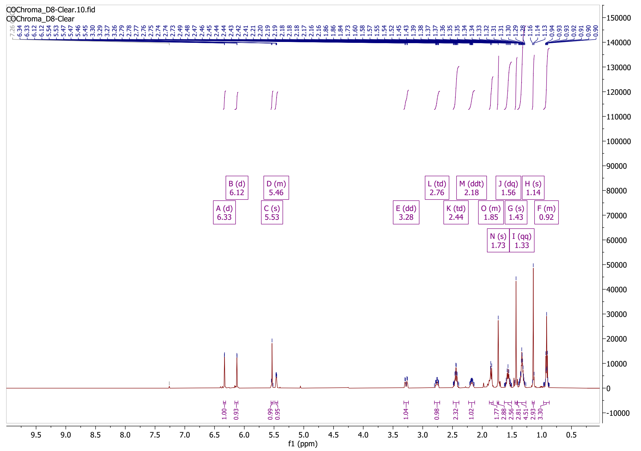
Figure S1: ¹H NMR D8THC
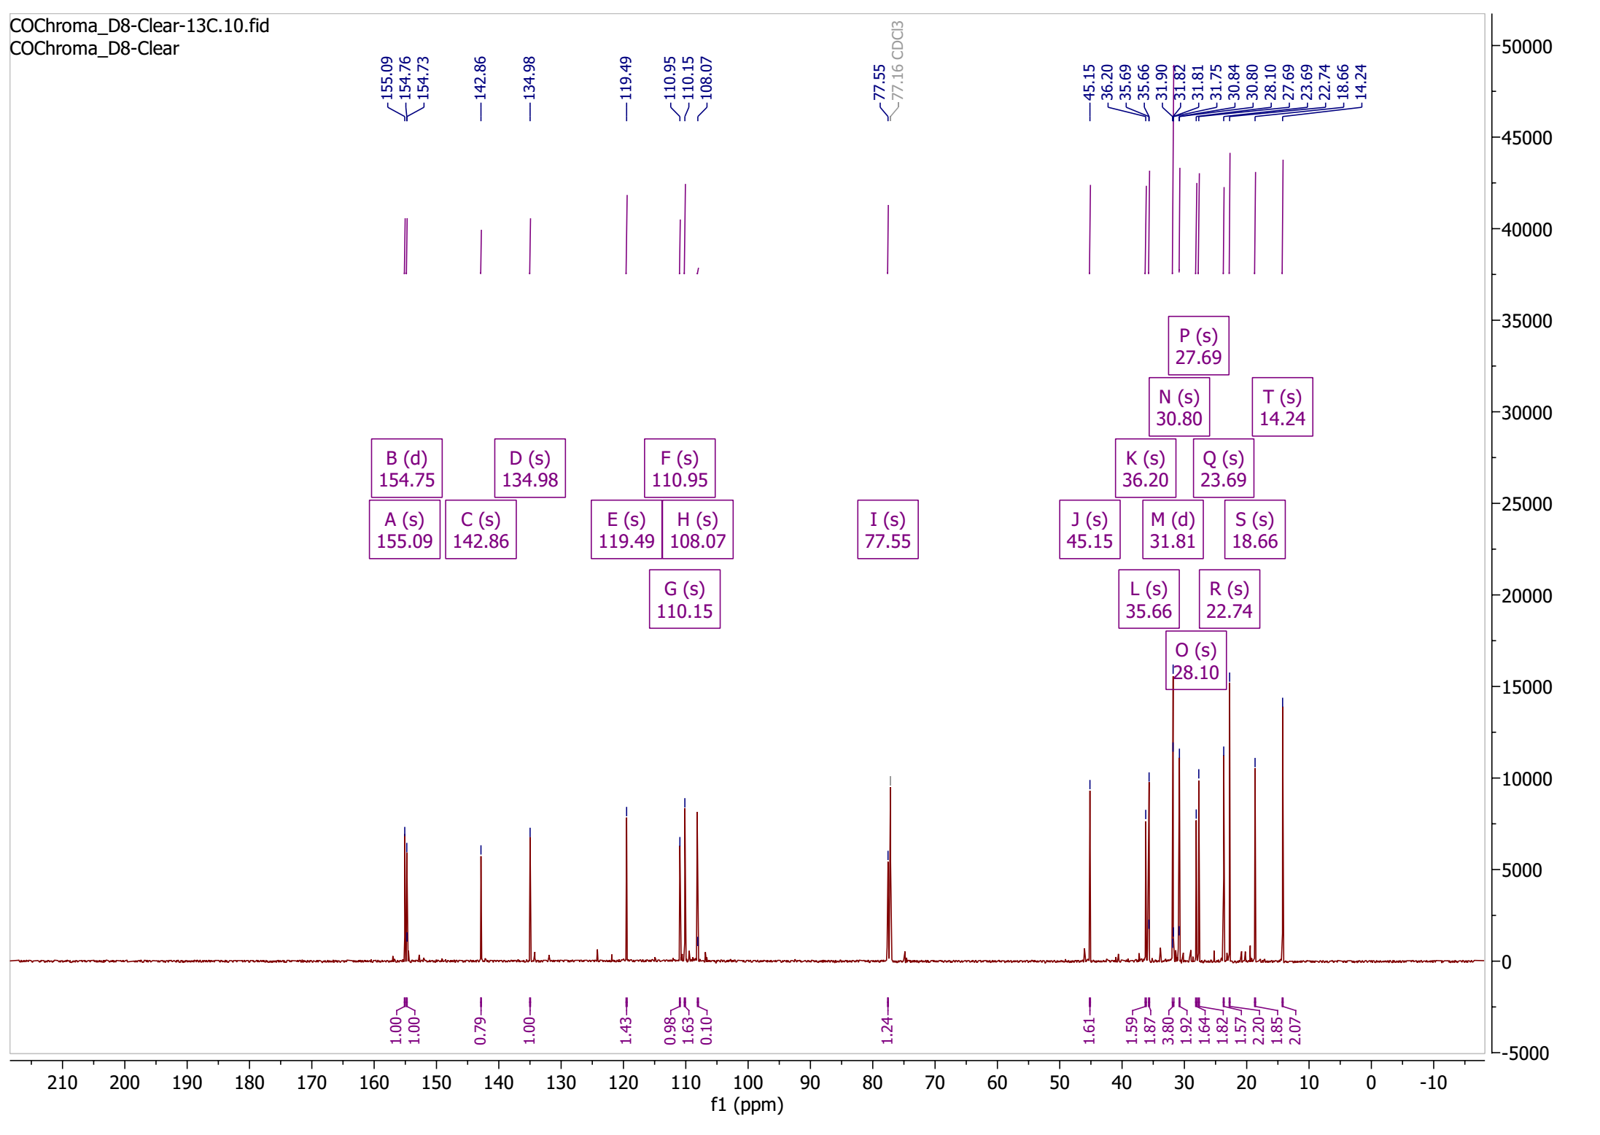
Figure S2: ¹³C NMR D8THC
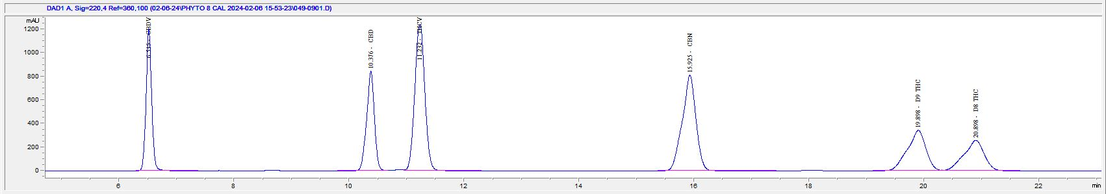
Figure S3: HPLC of the mixture of THC isomers from CRM standards.

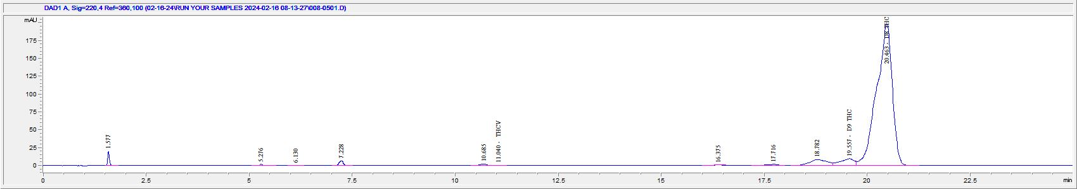
Figure S4: HPLC of the synthesized THC mixture of isomers.

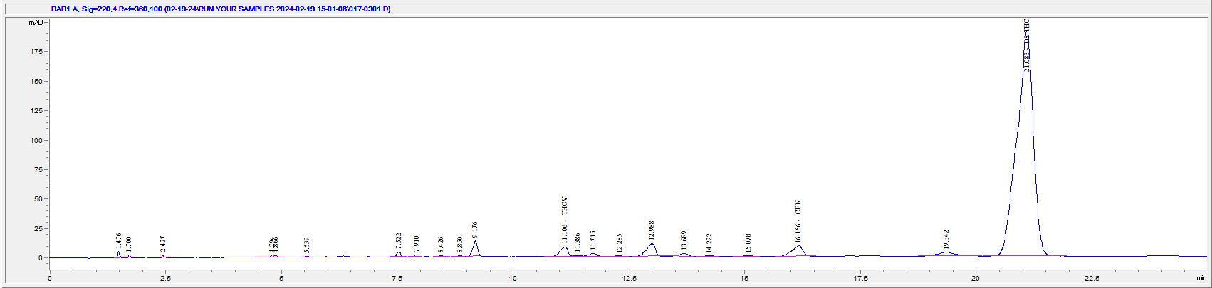
Figure S5: HPLC of synthesized THC following the removal of D9 THC.

