Supplementary Material

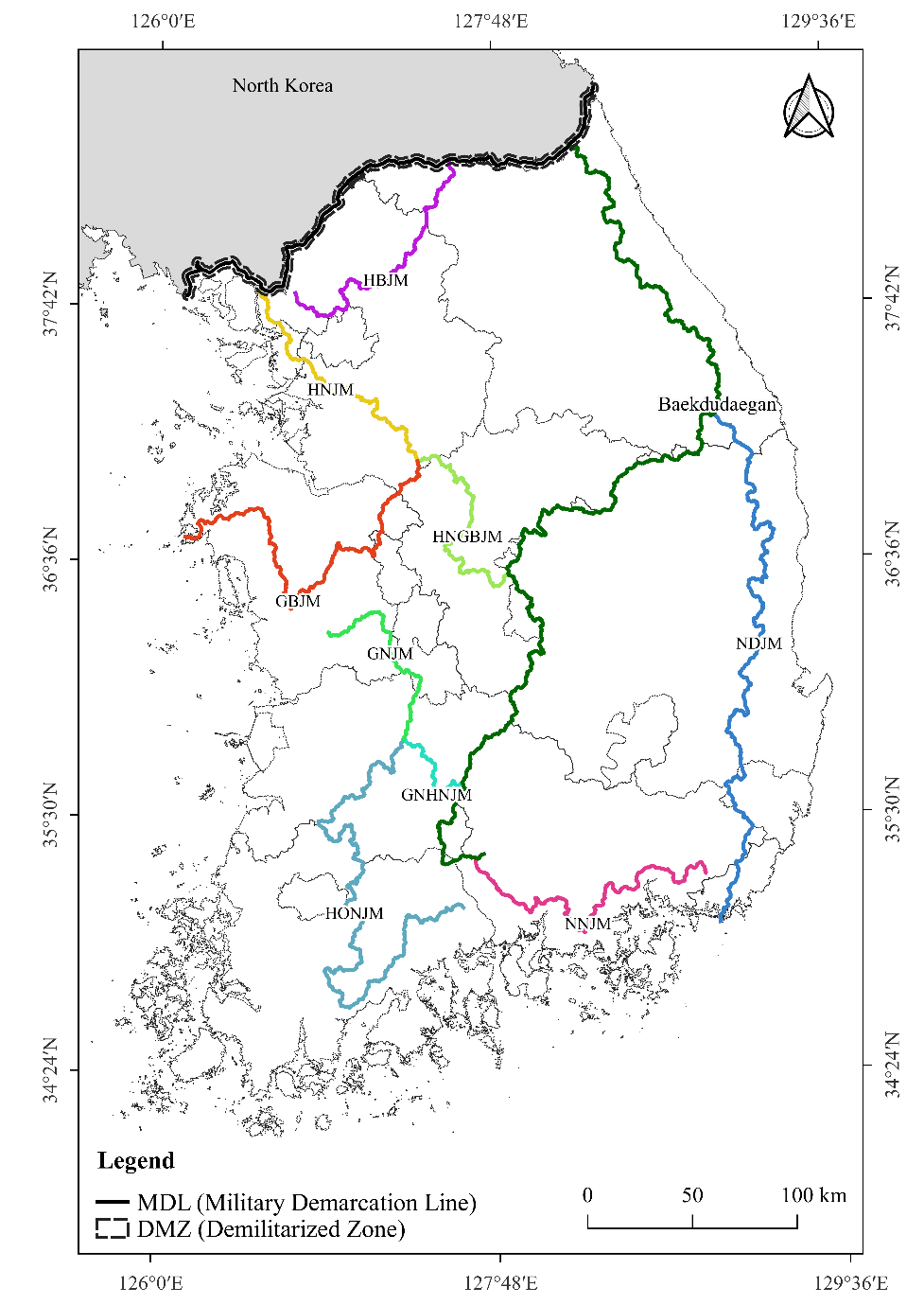

Figure S1. Geographical distribution of the Korean mountain ranges comprising the Baekdudaegan Mountain Range (Baekdugaegan), an elongated ridge that runs from Mt. Baekdu-san in North Korea to Jirisan National Park in South Korea, and the nine mountain ranges (Jeongmaeks) that branch off from the Baekdudaegan (NGII, 2023). Civilian Control Line (CCL), which lies 100 m south along the Military Demarcation Line (MDL), and is intended to control citizen access. The area between MDL and CCL is called the Civilian Control Area (CCA).

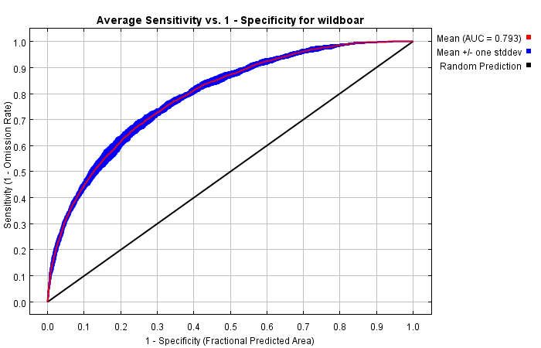
Figure S2. Area Under the ROC Curve (AUC) value, which is calculated from the area under the Receiver Operating Characteristic Curve obtained through 10 bootstrap replicates.

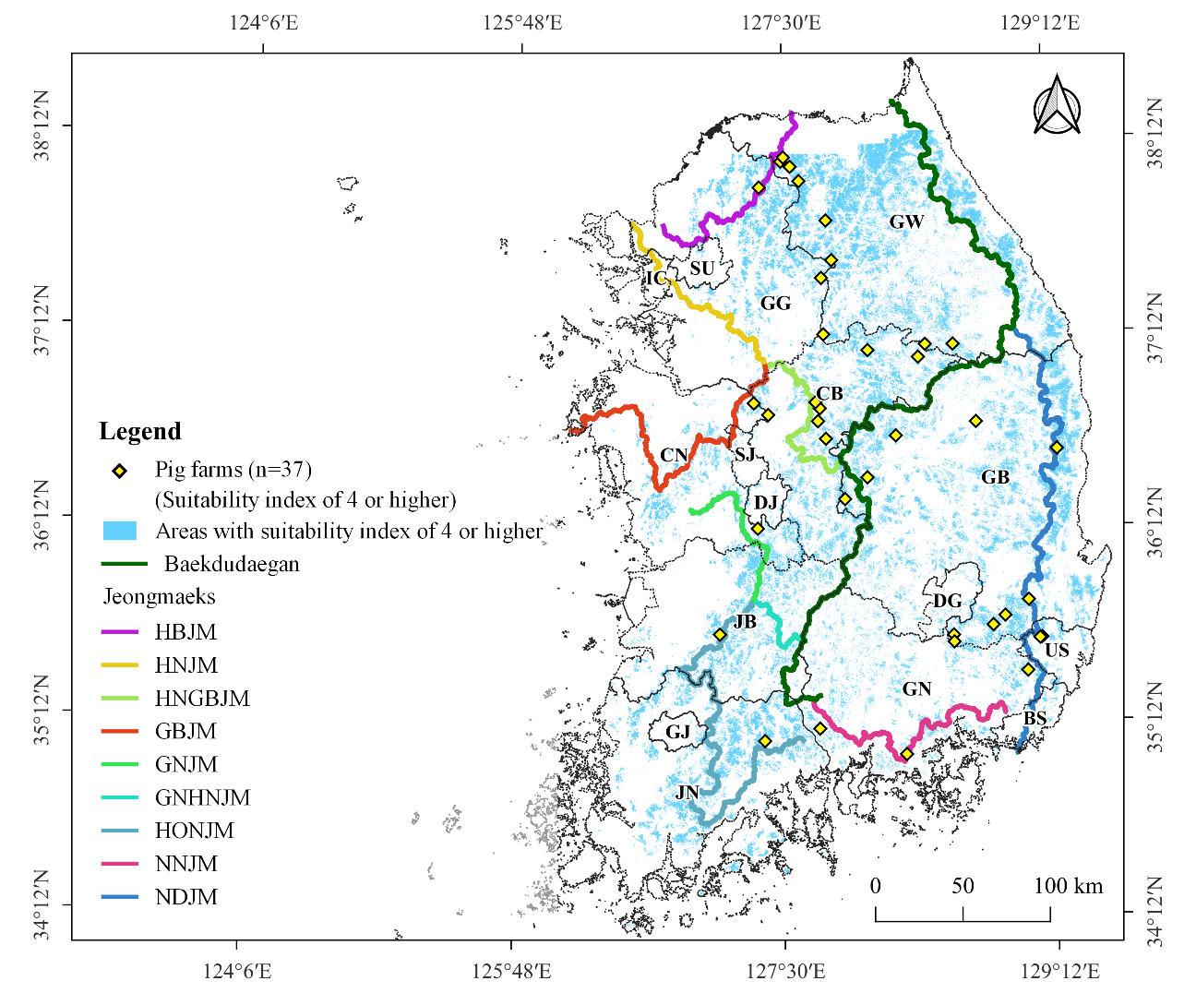
Figure S3. Geographical distribution of 37 individual pig farms located in an area with a suitability value of 0.4 or higher.

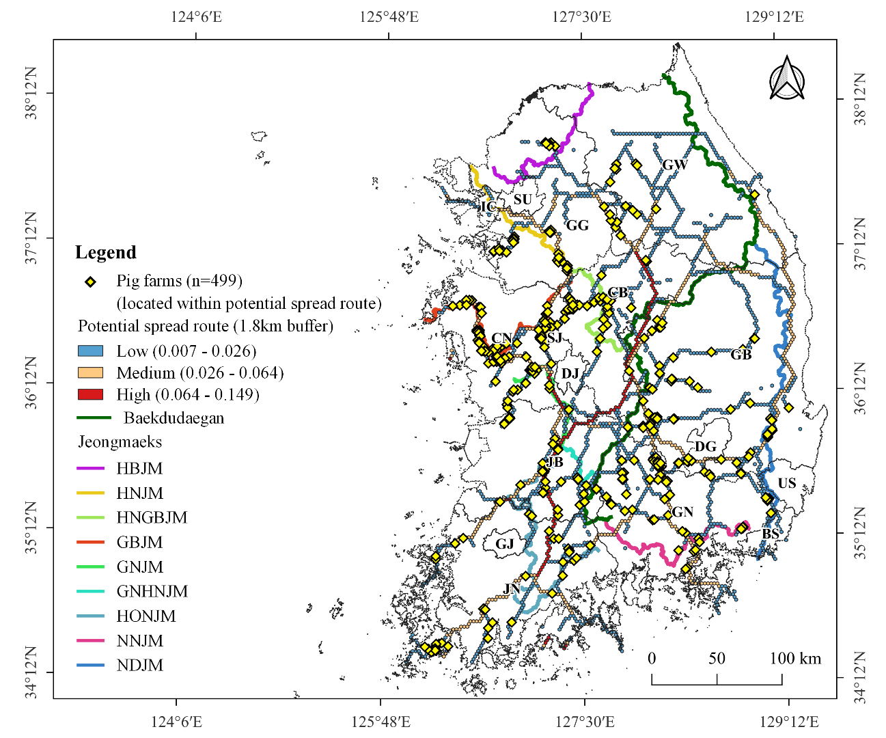
Figure S4. Geographical distribution of 499 pig farms within a 1.8-km range of the shortest-path.
Table S1. Relative importance of variables used in the MaxEnt model.

