Supplemental

Long-term and seasonal changes in emission sources of atmospheric particulate-bound pyrene and 1-nitropyrene in selected four cities in the Western Pacific

Kazuichi Hayakawa

Institute of Nature and Environmental Technology, Kanazawa University, Nomi City, Ishikawa Prefecture, 923-1224, Japan

E-mail address: hayakawa@p.kanazawa-u.ac.jp; Phone number: +81-761-51-4440

Figure 1: Fig. S1.
Table 2: Table S1, Table S2.

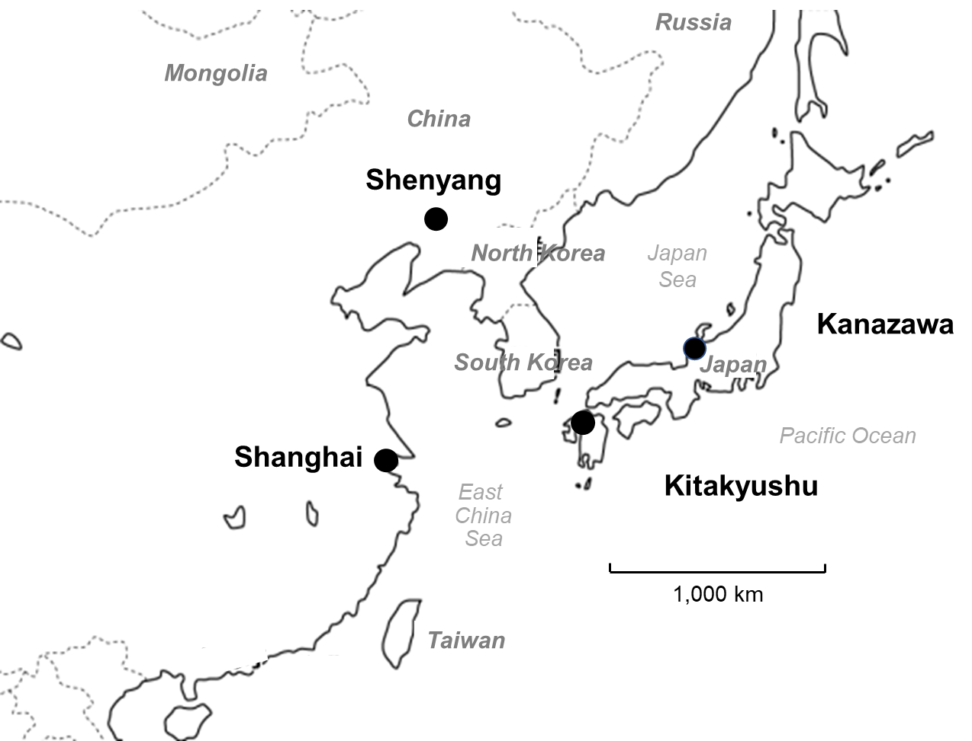
Fig. S1. Sampling cities in Western Pacific Region

Table S1. Characteristics of the sampled cities
City | Location | Population  (×10³) | Avg. temp. (°C) |  | Characteristics
 | Latitude, Longitude |  | Summer | Winter
Kanazawa  (Japan) | 36°33′N, 136°40′E | 450 | 27.0 | 3.8 | Capital of Ishikawa prefecture; Commercial city; Covered with sow in winter
Kitakyushu  (Japan) | 33°53′N, 130°53′E | 920 | 27.4 | 5.8 | Industrial city including iron manufacturing; Coke oven plants consume coal
Shenyang  (China) | 41°37′N, 123°25′E | 8,320 | 24.6 | −12.0 | Capital of Liaoning province; Agricultural and industrial city; Coal heating in winter
Shanghai  (China) | 31°13′N, 116°24′E | 24,760 | 27.8 | 3.5 | Business and commercial city; Economic and financial center

Text S2. Values of a and b with atmospheric concentrations of Pyr and 1-NP in four cities from 1997 to 2021
Year/Season | [Pyr]  ng m⁻³ | [1-NP]  pg m⁻³ | a | b
Kanazawa
1997S | 0.202 | 44.5 | 0.996 | 0.422
1997W | 0.587 | 119 | 0.995 | 0.391
1999S | 0.587 | 44.5 | 0.995 | 0.351
1999W | 0.506 | 119 | 0.996 | 0.450
2004S | 0.166 | 22.5 | 0.998 | 0.258
2005W | 0.202 | 24.0 | 0.990 | 0.226
2007S | 0.107 | 10.4 | 0.986 | 0.181
2008W | 0.344 | 12.6 | 0.960 | 0.068
2010S | 0.081 | 3.7 | 0.969 | 0.087
2010W | 0.303 | 10.6 | 0.958 | 0.065
2013S | 0.109 | 4.5 | 0.964 | 0.075
2014W | 0.405 | 6.4 | 0.903 | 0.028
2017S | 0.080 | 1.1 | 0.917 | 0.033
2018W | 0.220 | 2.9 | 0.935 | 0.042
2020W | 0.067 | 1.8 | 0.941 | 0.045
2020S | 0.017 | 0.84 | 0.970 | 0.091
2021W | 0.103 | 1.6 | 0.924 | 0.027
Kitakyushu
1997S | 0.303 | 4.0 | 0.646 | 0.017
1997W | 0.566 | 13.6 | 0.938 | 0.045
2004S | 0.607 | 5.4 | 0.825 | 0.014
2005W | 0.607 | 17.3 | 0.963 | 0.079
2007S | 0.045 | 1.3 | 0.949 | 0.053
2008W | 0.607 | 7.2 | 0.916 | 0.032
2010S | 0.178 | 3.2 | 0.916 | 0.032
2010W | 0.445 | 9.2 | 0.926 | 0.037
2013S | 0.061 | 0.50 | 0.796 | 0.012
2014W | 1.76 | 7.7 | 0.641 | 0.005
Shenyang
2001S | 0.607 | 37.1 | 0.976 | 0.115
2002W | 50.6 | 178 | 0.553 | 0.004
2007S | 1.52 | 42.0 | 0.946 | 0.051
2008W | 15.0 | 95.4 | 0.885 | 0.023
2010S | 0.546 | 23.7 | 0.966 | 0.082
2010W | 7.49 | 181 | 0.938 | 0.044
2013S | 1.21 | 22.3 | 0.916 | 0.032
2014W | 22.3 | 188 | 0.814 | 0.013
2018A | 3.42 | 26.0 | 0.793 | 0.012
2019Sp | 2.79 | 10.3 | 0.568 | 0.004
Shanghai
2007S | 0.223 | 371 | 0.994 | 0.318
2007W | 0.587 | 37.1 | 0.978 | 0.120
2010S | 0.152 | 8.4 | 0.973 | 0.103
2010W | 1.13 | 49.4 | 0.967 | 0.082
2013S | 0.150 | 4.7 | 0.953 | 0.057
2014W | 2.63 | 42.0 | 0.903 | 0.028
2015S | 2.20 | 1.9 | 0.819 | 0.014
2015W | 1.09 | 11.7 | 0.855 | 0.018
2017S | 0.110 | 4.3 | 0.956 | 0.072
2018W | 0.850 | 8.9 | 0.851 | 0.017
Season: S, summer; W, winter. Sp, spring; A, autumn. Values a and b were calculated by the NP method.

