Supplementary Information

Supplementary Figure S1: Raw sequence data of high-throughput sequencing.

Supplementary Figure S2: Coastal sewage treatment facilities, locations and major pollutants.

Supplementary Figure S3: Water samples collected from twenty-two stations used for the screening of type I and type II polyketide synthase genes.

Supplementary Figure S4: (a) Map of the 19 sampling stations in the coastal region of Bohai Bay. (b) Plateau map of the wastewater treatment plants by Bohai Bay (Nandaihe wastewater treatment plant). These sites contain the sampling stations of Bohai Gulf near Nandai River wastewater treatment facility (c) The Hudson Bay, upper bay (several wastewater treatment plants are located nearby).

Supplementary Figure S5: (a) Statistical chart of OUT(Operational Taxonomic Unit) classification (Blaxter et al., 2005) and classification status identification results. The abscissa is arranged according to the sample name, and the coordinate is the number of OTUs in each sample that can be classified to each classification level of phylum, class, order, family, genus and species (C11, C12, C13, C14, C15 are #8, #9, #11, #12, #13 in Fig. 1a respectively). (b) The sample population classification tree based on GraPhlAn (Asnicar et al., 2015).

Supplementary Figure S6: Community taxonomic composition and abundance distribution diagram at all levels. Class, Genus, Order, and family (a-d, where C11-C15 corresponds to #8-#13 respectively).

Supplementary Figure S7: Proposed enrichment mechanism of Pseudomonad in organic rich environment and the sequential spread of resistance gene and pathogenicity factors.
Supplementary Figure S8: Proposed evolutionary association between Proteobacteria phylum and Pseudomonadale order. HGT, horizontal gene transfer.

Supplementary Table S1. The copy numbers of the ampicillin resistance gene and kanamycin resistance gene vs. relative abundance of Pseudomonadale species in total bacteria from the examined stations (#8-#13).
Site | Copy number (AmpR) | Cpoy number (KanR) | Relative abundance of Pseudomonad (%)
#8 | 6.399972 | 5.376488 | 75.3
#9 | 5.120853 | 4.25424 | 21.8
#11 | 6.570171 | 4.73345 | 50.3
#12 | 6.044575 | 4.479393 | 40.6
#13 | 4.913966 | 3.639037 | 23.4

Supplementary Table S2. the comparison of the percent abundance of the Proteobacteria and the Pseudomonas in total bacteria in the examined stations (#8-#13) and average (Avg(#)) of Bohai Bay with that at several globally sites (§13, §30, §33, §36).

Site | Percent abundance of Proteobacteria | Percent abundance of Pseudomonas
#8 | 88.3 | 63.5
#9 | 22.3 | 2.4
#11 | 51.2 | 14.1
#12 | 41.0 | 1.2
#13 | 27.3 | 15.5
Avg(#) | 46.0 | 19.3
§13 | 78 | 40
§30 | 72.7 | 22.7
§33 | 55 | 30
§36 | 38 | 13

Supplementary Figure S1: Standard curves and melting curves of three antibiotic resistance genes. Melting curves and standard calibration curve for the quantitative determination of three antibiotic resistance genes: Figure S1a, S1b, S1c are melting curves for ampicillin resistance gene, kanamycin resistance gene and gentamycin resistance gene; Figure S1a1, S1b1, S1c1 are standard calibration curves for ampicillin resistance gene, kanamycin resistance gene and gentamycin resistance gene.

Supplementary Figure S2. Global distribution of the coastal wastewater treatment facilities and the locations with potential threat of Pseudomonadale enrichment. (Supplementary Data S2)

Supplementary Figure S3: Water samples collected from twenty-two stations used for the screening of type I and type II polyketide synthase genes (#1, efflux point 1 (agriculture); #2, efflux point 2 (municiple)).

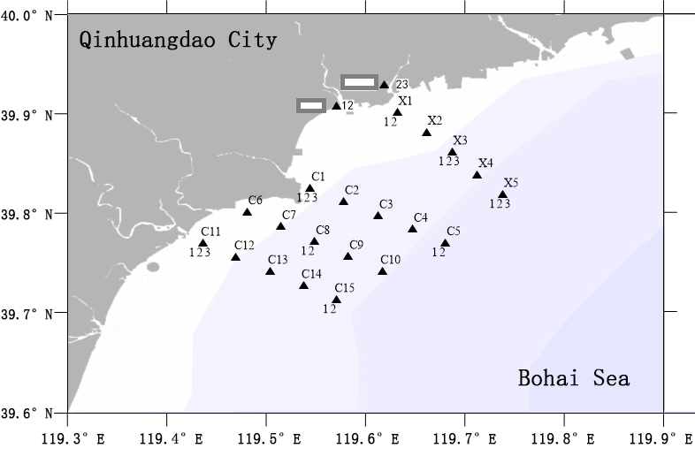
#2
#1

Supplementary Figure S4. (a) Map of the 19 sampling stations in the coastal region of Bohai Bay. (b) Plateau map of the wastewater treatment plants by Bohai Bay (Nandaihe wastewater treatment plant). These sites contain the sampling stations of Bohai Gulf near Nandai River wastewater treatment facility (c) The Hudson Bay, upper bay (several wastewater treatment plants are located nearby).

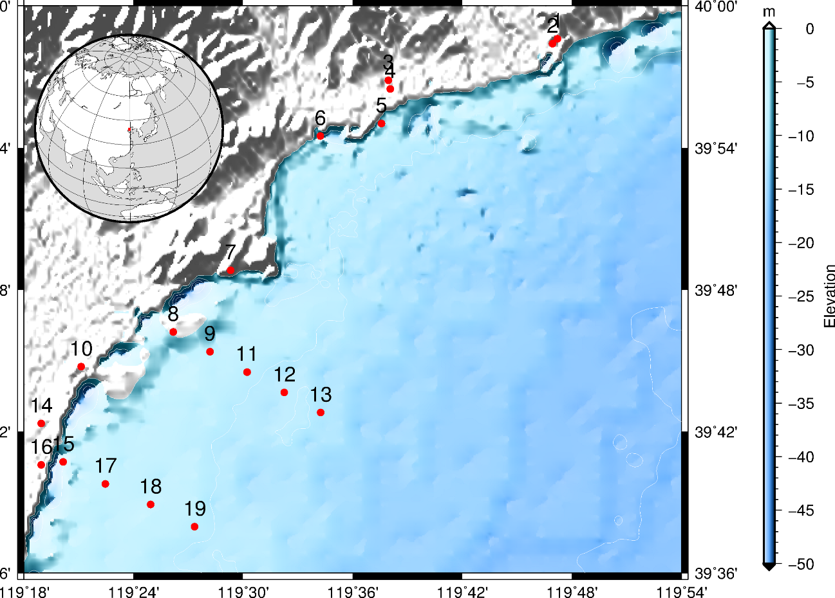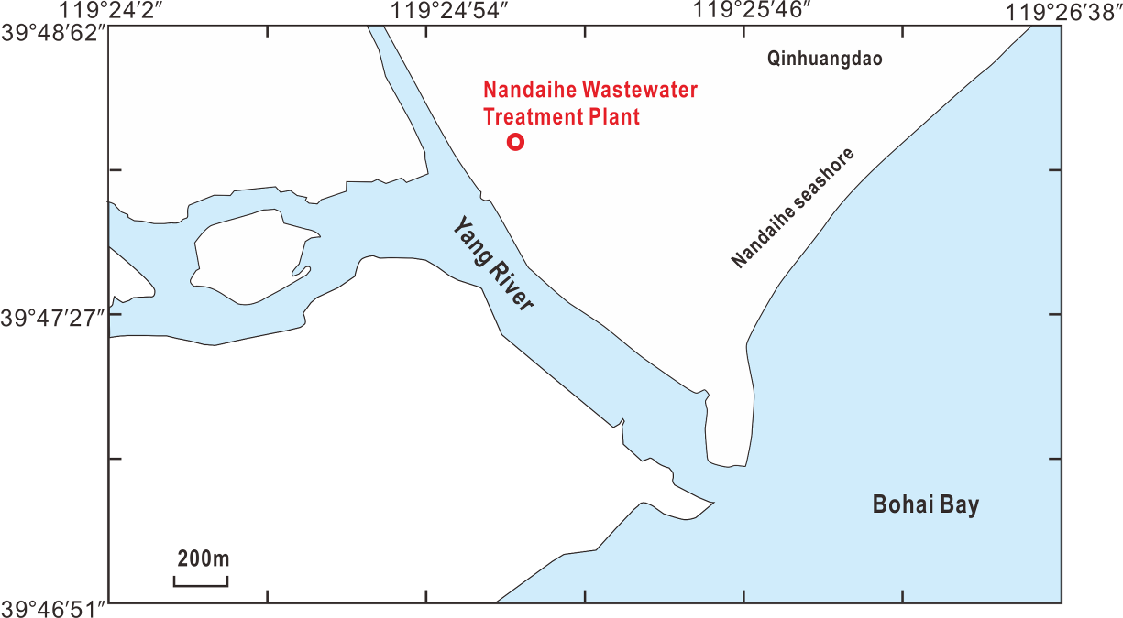
- (b)
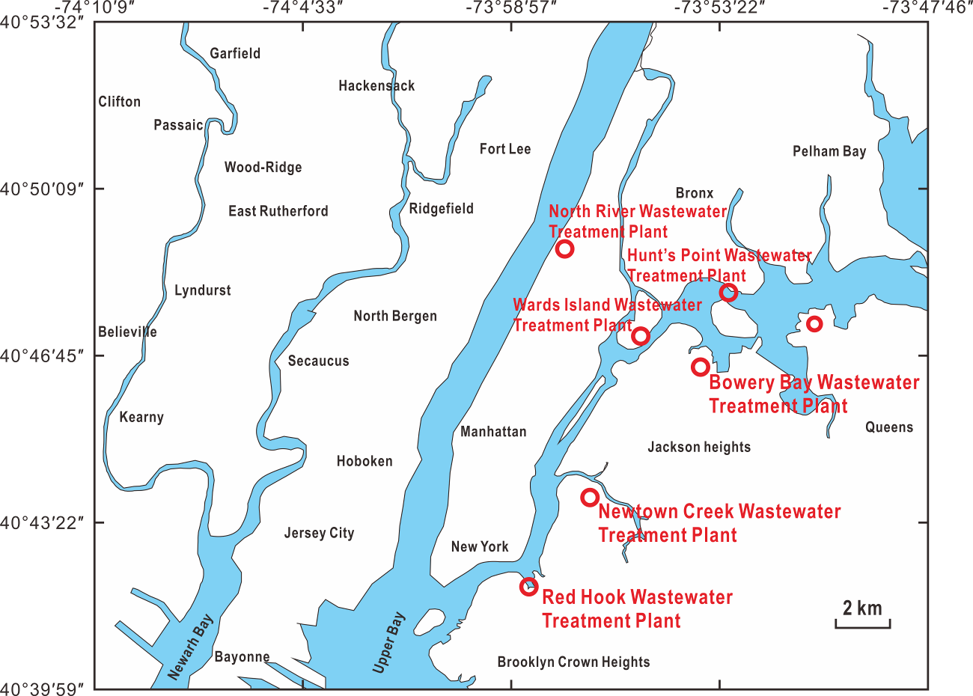
(c)

Supplementary Figure S5. (a) Statistical chart of OUT(Operational Taxonomic Unit) classification (Blaxter et al., 2005) and classification status identification results. The abscissa is arranged according to the sample name, and the coordinate is the number of OTUs in each sample that can be classified to each classification level of phylum, class, order, family, genus and species (C11, C12, C13, C14, C15 are #8, #9, #11, #12, #13 in Fig. 1a respectively). (b) The sample population classification tree based on GraPhlAn (Asnicar et al., 2015). The classification hierarchy tree shows the hierarchical relationship of all taxons (represented by nodes) from phylum to genus (arranged from inner circle to outer circle in turn). The node size corresponds to the average relative abundance of the taxon. The top 20 taxons of relative abundance is also identified by letters (arranged from phylum to genus in order from outer layer to inner layer in order) in the figure. The shadow on the letters is the same as the corresponding node color.

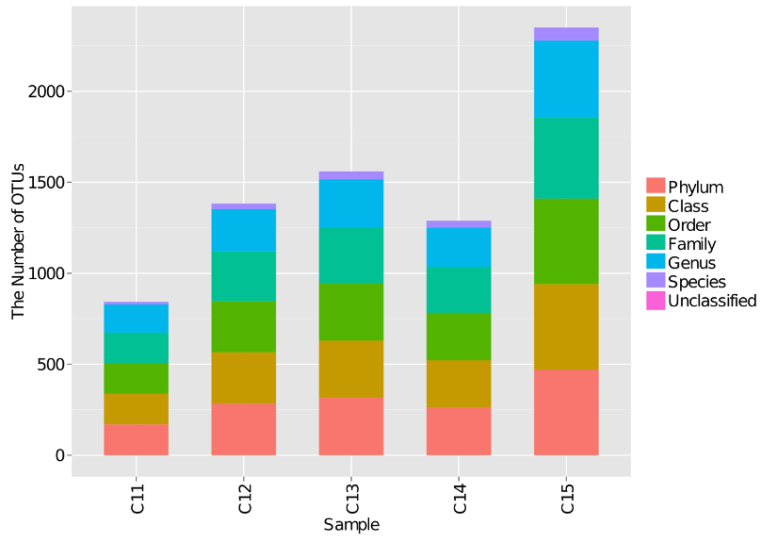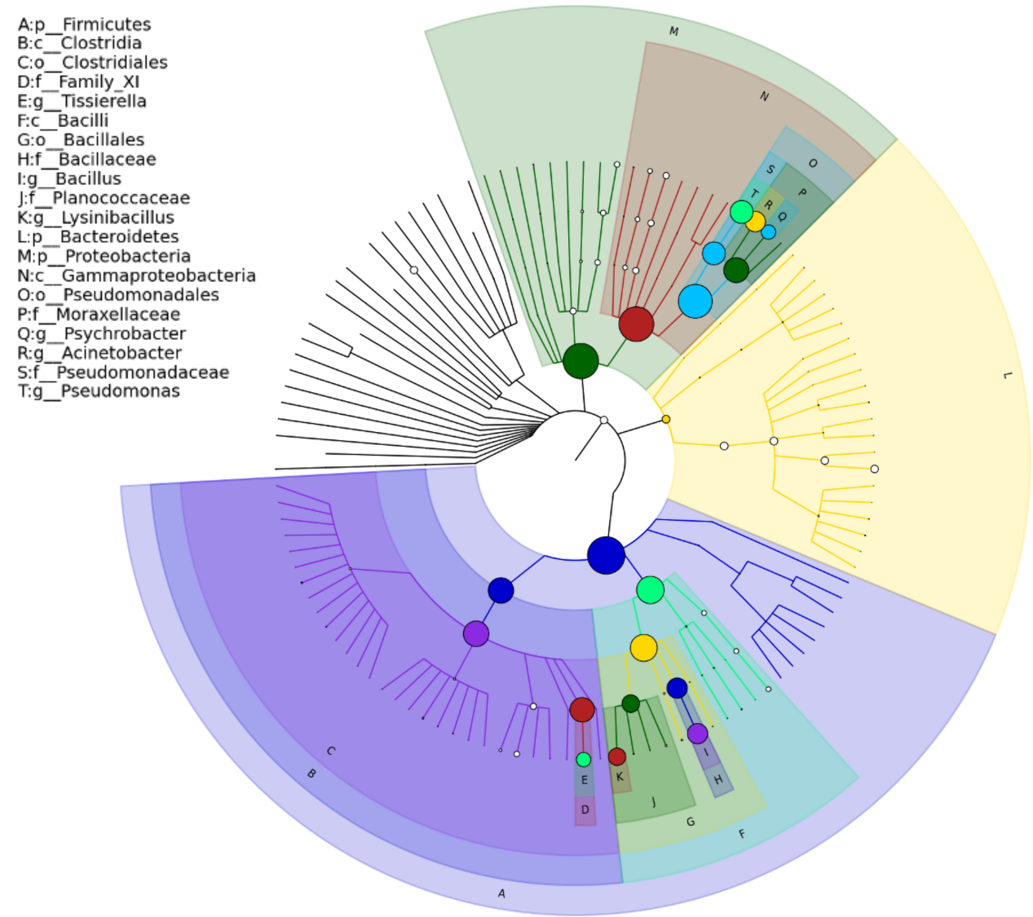
- (b)

Supplementary Figure S6. Community taxonomic composition and abundance distribution diagram at all levels. Class, Genus, Order, and family (a-d, where C11-C15 corresponds to #8-#13 respectively). The abscissa is arranged according to the sample name, each column chart represents a sample, and each classification unit is distinguished by color, and the coordinate represents the relative abundance of each classification unit. The longer column length indicates higher abundance of the classification unit in the corresponding sample.

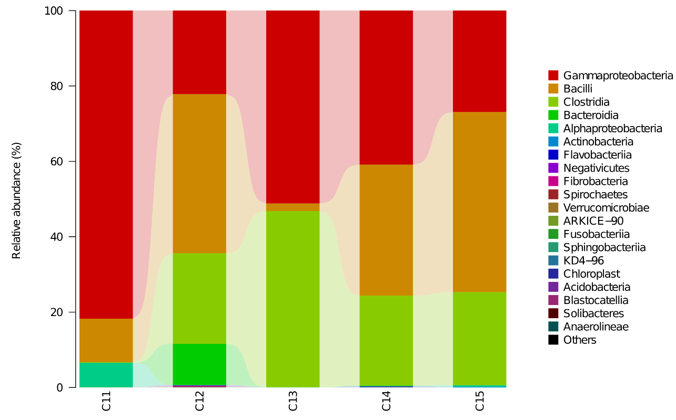

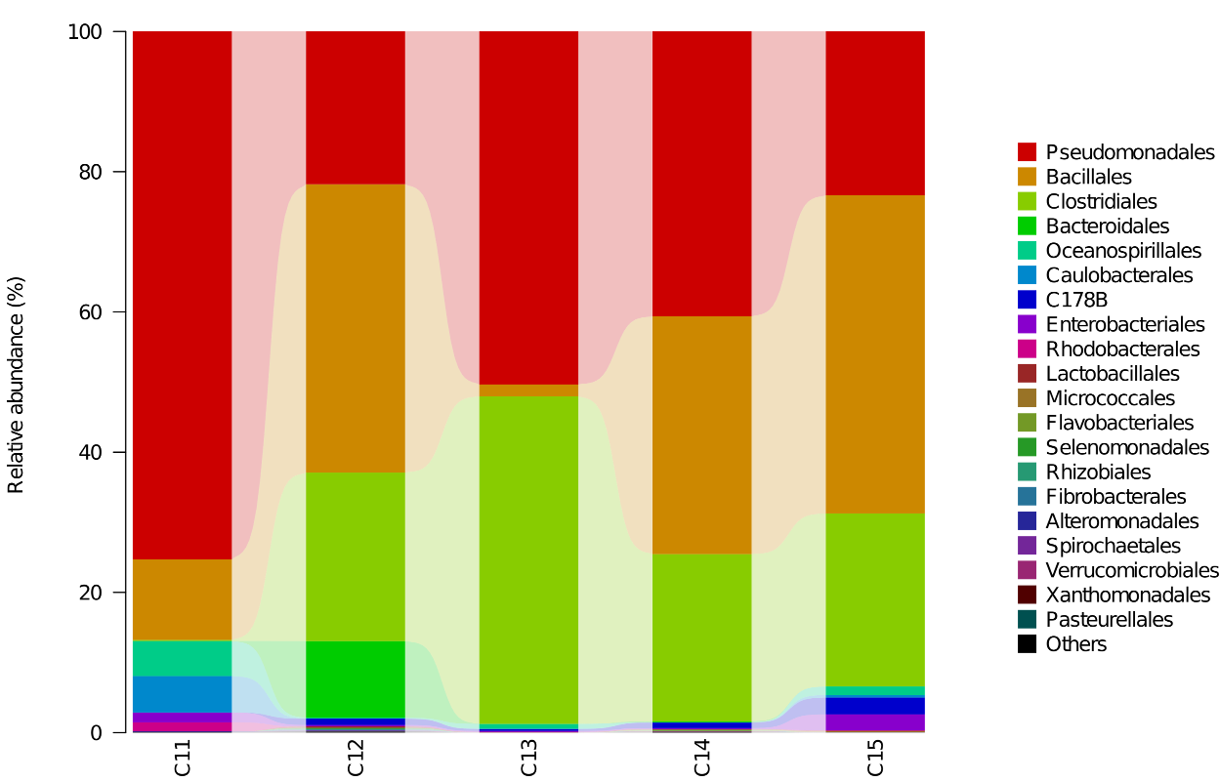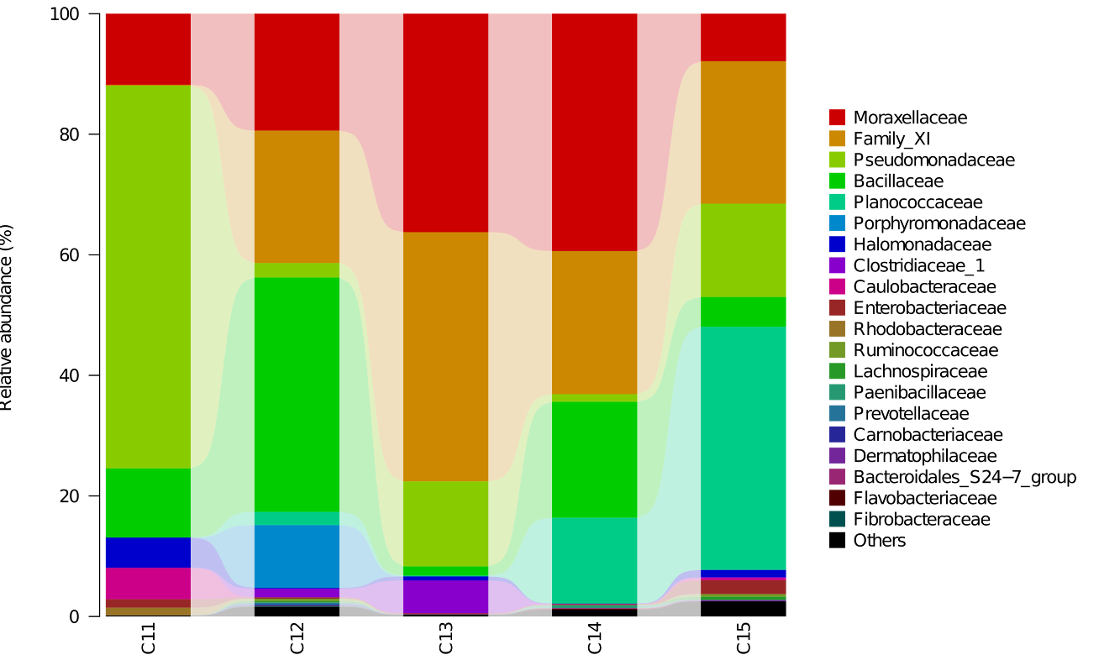

Supplementary Figure S7. Proposed enrichment mechanism of Pseudomonad in organic rich environment and the sequential spread of resistance gene and pathogenicity factors.
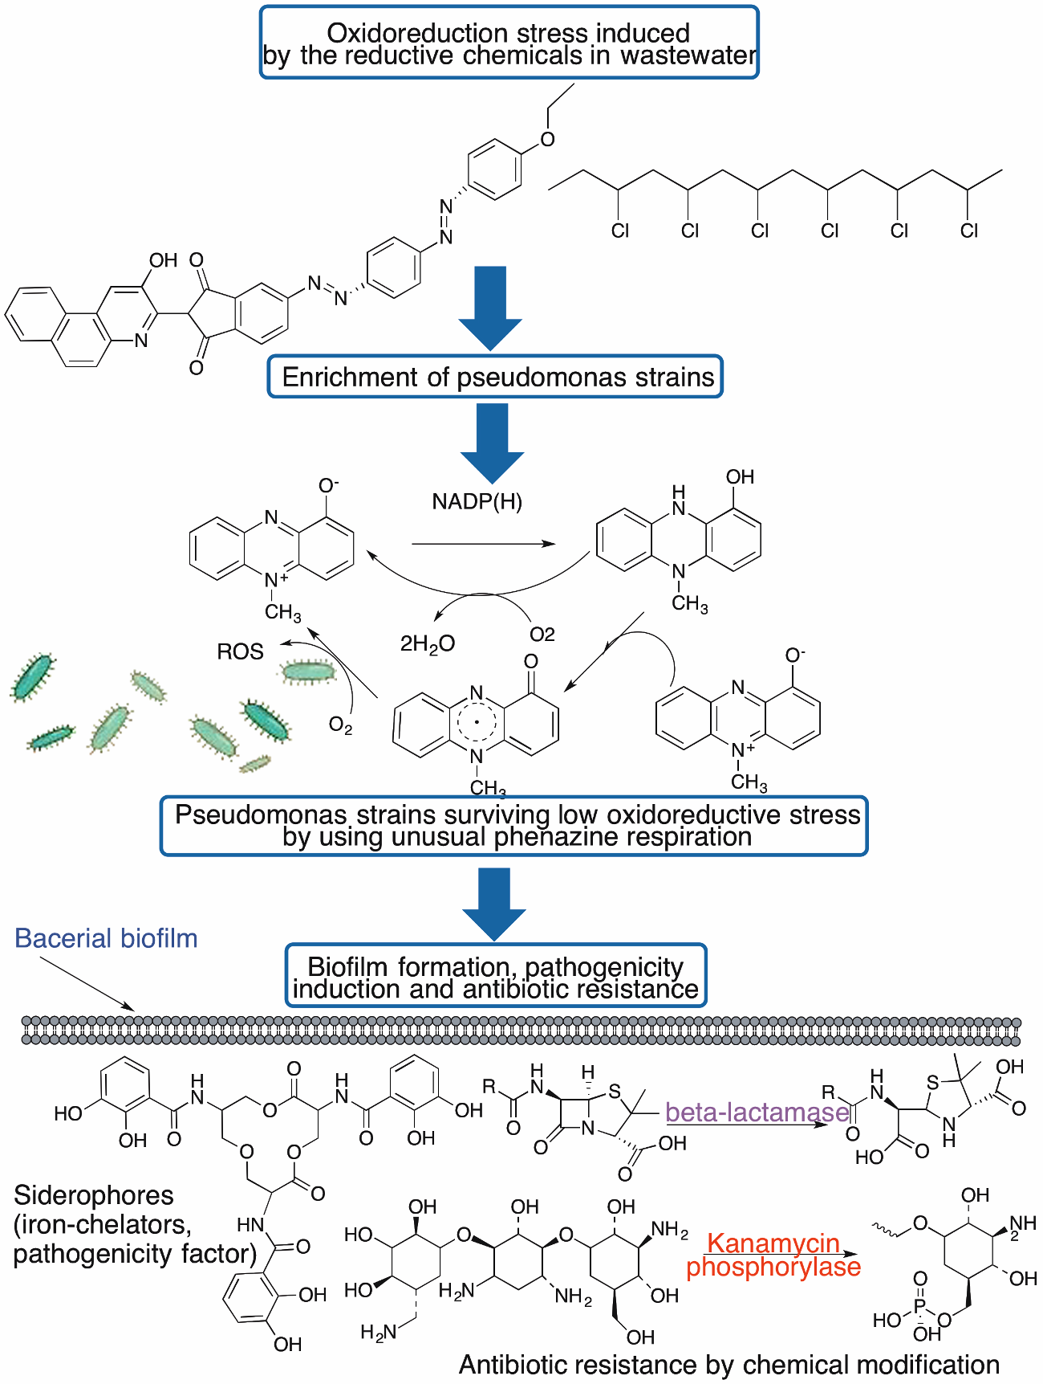

Figure S8: Proposed evolutionary association between Proteobacteria phylum and Pseudomonadale order. HGT, horizontal gene transfer.

Actinomycete Firmecutes Phylum Phylum

Proteobacteria Phylum

HGT
Drug-efflux
A-Proteobacteria

G-Proteobacteria Class
Pseudomonadale Order
B-Proteobacteria
Other

Supplementary Material and Methods

Diagnostic polymerase chain reaction (PCR) and qPRC analyses of resistance genes
To examine the presence of clinically significant antibiotic-resistance genes in water samples, three pairs of primers were devised to magnify the full-length genes responsible for their resistance against ampicillin, kanamycin, and gentamycin in the testing water samples. Genomic DNA was abstracted from all water filters using an E.N.Z.A. TM Water DNA tool (Omega, Environmental Technologies). For all PCR reactions, a uniform reaction system was prepared consisting of 8 μL sterile distilled water, 10 μL Taq polymerase mix, forward/reverse primers (100 mol/L; 0.5 μL each), and 1 μL of DNA template in a total capacity of 20 μL. The thermal cycling procedure (S1000 Thermal Cycler) was as below: initial denature at 95℃ for 5 min; 34 cycles of in-cycle amplification with denaturation at 95℃ for 30 sec, annealing at 62℃ for 30 s (ampicillin resistance gene), 70℃ for 30 s (kanamycin resistance gene) or 65℃ for 30 s (gentamycin resistance gene); extension at 72℃ for 1 min; and final prolongation at 72℃ for 5 min. The ampicillin resistance gene was amplified using the primer pair ampR-F (GCTCTAGAATGAGTATTCAACATTTCCG) and ampR-R (AACTGCAG TTACCAATGCTTAATCAGTG). The kanamycin resistance gene was magnified using the primer pair kanR-F (GACCAGAATCGGCAACTAGC) and kanR-R (TCAGAAGAACTCGTCAAGAAGG). The gentamycin resistance gene was magnified using the primer pair genR-F (GCTCTAGATACGTGCAAGCAGATTACGG), and genR-R (AACTGCAGCCTCACTACGTAGAAGATAA). Positive controls for all three genes were included by using a plasmid template that carries individual resistance genes. The expected sizes of each amplicon were 911 bp (for the ampicillin resistance gene), 879 bp (for the kanamycin resistance gene) and 989 bp (for the gentamycin resistance gene). The PCR products were probed by agarose gel electrophoresis (DYY-60, Beijing Liuyi Instrument Factory) and analyzed by a gel imaging analyzer (WD-9413B).
To quantify the resistance genes in the five stations along the coast, quantitative PCR (qPCR) reactions was performed. The standard template concentration of each resistance gene was measured by the spectrophotometer (ThermoScientific, NanoDrop 2000) to calculate the nucleic acid copy number. The standard plasmid template containing each resistance gene was diluted (51-55) and used as a template for qPCR detection. Each standard plasmid template sample was created in triplicate. The reaction mixture consisted of 1 μL of plasmid template, 10 μL of SYBR qPCR Master Mix, 0.5 μL of the forward primer (10 nmol/L), 0.5 μL of reverse primer (10 nmol/L), and sterile ddH2O was added to the mixture to a total volume of 20 μL. The nucleotide sequences of each primer used to amplify the partial ampicillin resistance gene, kanamycin resistance gene and gentamycin resistance gene were as follows: AmpR-RT-F (GGTCGCCGCATACACTATTC) / AmpR-RT-R (GTCCTCCGATCGTTGTCAGA), KanR-RT-F (ATGGTTACTCACCACTGCGA) / KanR-RT-R (GCCTGAGCGAGACGAAATAC) and GenR-RT-F(CCGCGGAGTTGTTCGGTAAA) / GenR-RT-R (CGCCAAGCTTCCTGCTGAAC). The amplification program (CFX, Connect, Real-Time, System, BIO-RAD) involves a pre-denaturation at 95℃ for 3 min, then 40 cycles of denaturation at 95℃ for 20 sec, annealing at 60℃ for 30 s, prolongation at 72℃ for 1 min and a final extension for 7 min at 72℃.
To quantify the proliferation rate, fluorescence signals were scanned at the end of the extension creating a dissolution curve from 65℃ to 95℃ with a reading frequency of 0.5 sec and a total length of 5 seconds. The standard curve was constructed by using the logarithm value of the standard copy number as the independent variable and the corresponding CT value as the dependent variable. The sample DNA was also subject to quantitative analysis with three duplicates for each sample. The reaction scheme and thermal cycling program were the same as those described above. The copy number of each resistance gene was calculated according to the CT value of the ARGs in each sample. Total DNA collected from samples at all five stations was used as a template for quantitative analysis.
To examine the abundance of individual heterotrophic bacterial species, total genomic DNA samples were prepared and sequenced using the Illumina MiSeq 2500 platform. Paired-end sequence reads were established using cyclic reversible chain termination chemistry. The base call of each successive read was tested and screened for quality objectives. Sequences that fell below the quality threshold or that were < 200 bp in length were removed. The successive read pairs were combined using QIIME and condensed on account of 97% similarity. (Magoc and Salzberg, 2011) Chimeric clusters were removed using the de novo function in USEARCH, and unique clusters were liable to BLAST analyses. The taxonomy was first assigned to operational taxonomic units (OTUs) applying the BLAST method in QIIME and in the light of specialist UNITE bacterial databases. The results were compared to set up the correct annotation to be consistent across the individual databases. To identify individual bacterial strains accurately and confirm their taxonomic designation, the dataset was BLASTed according to the full National Center for Biotechnology Information (NCBI) nucleotide reference database. After the taxonomy task, the singletons were dislodged using the program filter_otus_from_otu_table.py.

