Genes | Primer sequences (5'-3')
 | Forward primer | Reverse Primer
B2M  Cyt B  ND1  ND2  ND3  ND4L  ND4  ND5  ND6  COX1  COX2  COX3  ATP6  ATP8  Cyt B  12s | CAGCGTACTCCAAAGATTCA CATCCGACACAACAACAGCA  GGATCCTTCACCCTCTCCACA  CCCAATCATCTTTTTTATTATTCTATC  TCAGAAAAAACAAGCCCATATGAG  GATCCCACCTAATATCCTCC  GGCCTCACATCCTCTATAC  GGCGACATCGGGTTTATC  CCAGTAACAAACGCCCCTAAG  CCCGACATAGCATTCCCCC  TACTACACTCATGGGCCG  GAGTGTACGGCTCAACTTTC  TCGGAGGAGCTACACTTG  CACAACTAGACACATCAACATGAC  CAAATCCTCACCGGCCTA  GGTCAACGAAACTAAGAGGAG | GAATGCTCCACTTTTTCAAT ATAAGCCTCGTCCTACGTGC GTTCTGATTCTCCTTCGGTGA  GCCCGTGGGTTGTGATT  GTGGAAGGAGGAGTGCAATTTCT  CTGCGAAGACCAGTAAGATG  AGGGCTAGGTTGGTTAGG  TCCTGTTGCGGCTAGTA  ATTGTGTTAAATTTTGGTGGGTC  AGGTTACCTGCTAAAGGGG  ATTCAAGGACAATAGGTATAAAG  GCCGAAATGGTGGTTAGAG  GCTGACTAGGAGGGTGAATA  CAAATAAATTTTCGTTCATTTTGTTTCTC  CTCGTCCTACGTGTATATATAAG  GGCTGGCACGAGATTTAC
Table S1 Genes and primer pairs used for mtDNA copy number and mitochondrial protein coding gene expression analysis

B2M Amplification curves:
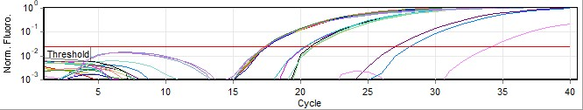
B2M Met Curve:
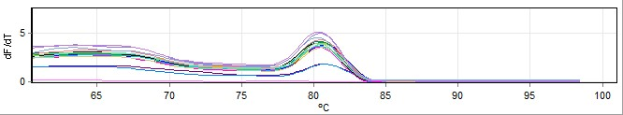
Cyt B Amplification Curve:
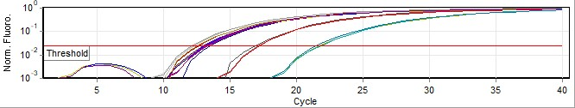
Cyt B Melt Curve:
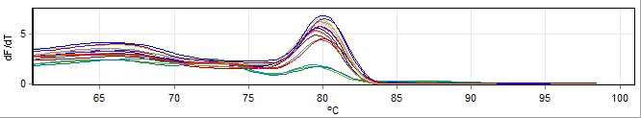

Figure S1: Amplification plots and Melt Curve of Different Analysed Genesfor mt-DNA copy number analysis

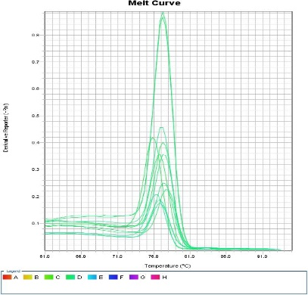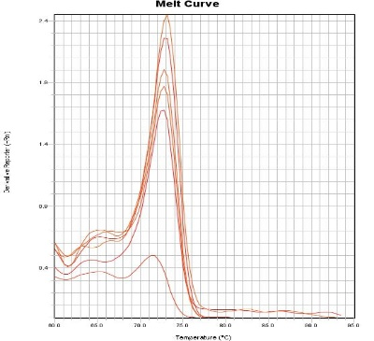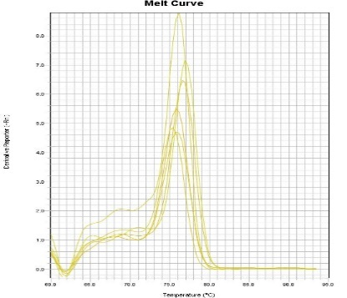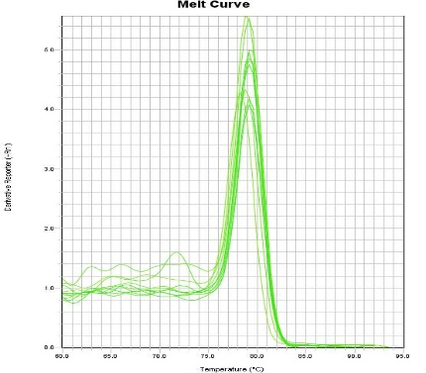
ND4
ND3
ND2
ND1
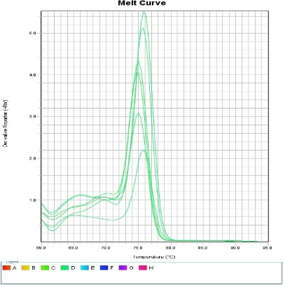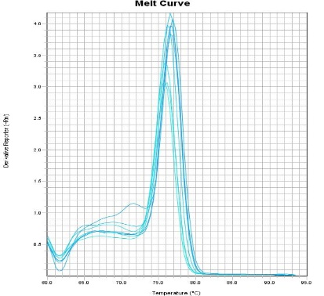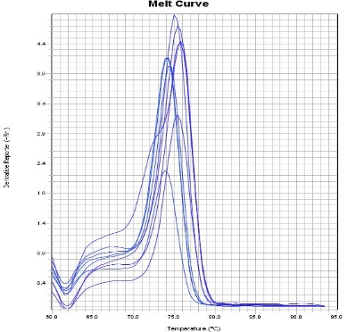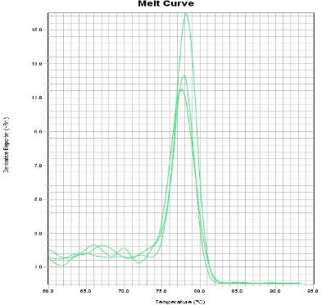
Cyt B
ND6
ND5
ND4L
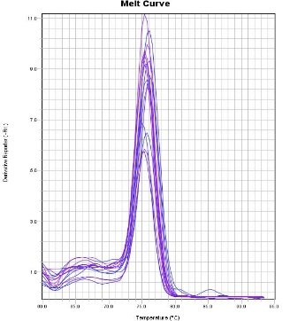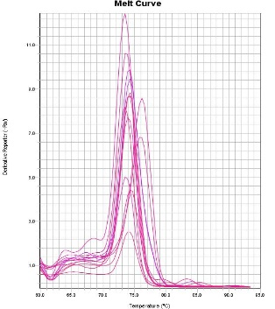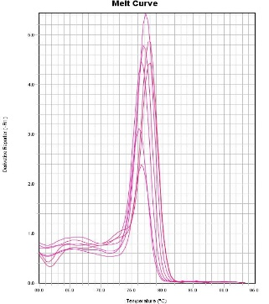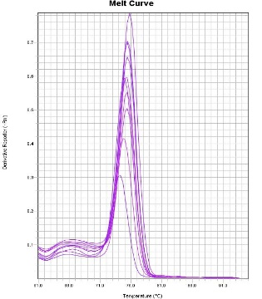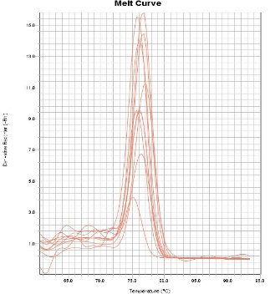
ATP8
ATP6
COX3
COX2
COX1

Figure S2: Melt Curve of 13 mitochondrial protein coding genes for relative gene expression analysis.

