Supplementary Materials
Multi-Scale Digital Pathology Patch Level Prostate Cancer Grading Using Deep Learning: Use Case Evaluation of DiagSet Dataset
Tanaya Kondejkar ¹, Salah Mohammed Awad Al-Heejawi ², Anne Breggia ³, Bilal Ahmad ⁴, Robert Christman ⁵, Ryan Stephen T ⁶ and Saeed Amal ^{7,}*
¹ Northeastern University, College of Engineering, United States; kondejkar.t@northeastern.edu
² Northeastern University, College of Engineering, United States; s.al-heejawi@northeastern.edu
³ Maine Health Institute for Research, United States; anne.breggia@mainehealth.org
⁴ Maine Medical Center, United States; bilal.ahmad@spectrumhcp.com
⁵ Maine Medical Center, United States; robert.christman@spectrumhcp.com
⁶ Maine Medical Center, United States; stephen.ryan@mainehealth.org
⁷ The Roux Institute, Department of Bioengineering, College of Engineering at Northeastern University, United States; s.amal@northeastern.edu
* Correspondence: Saeed Amal email: s.amal@northeastern.edu

Resnet34 on all magnifications:
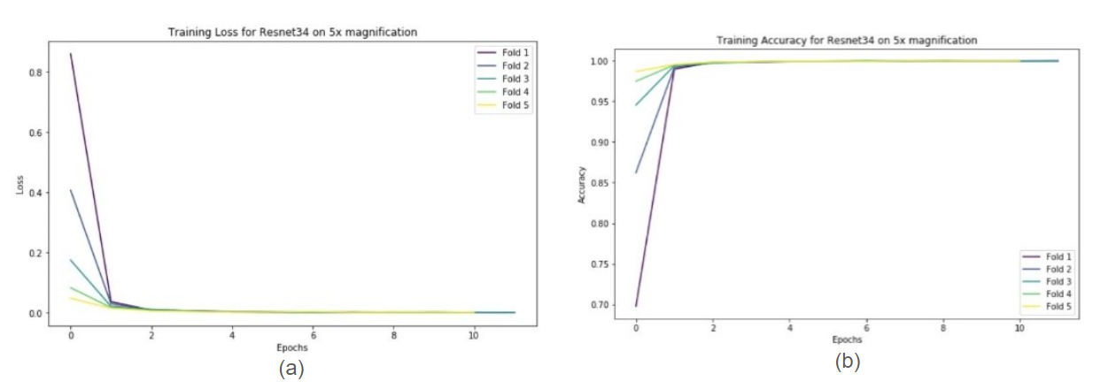
Figure S1. Training Loss (a) and Training Accuracy (b) for Resnet34 on 5× magnification. 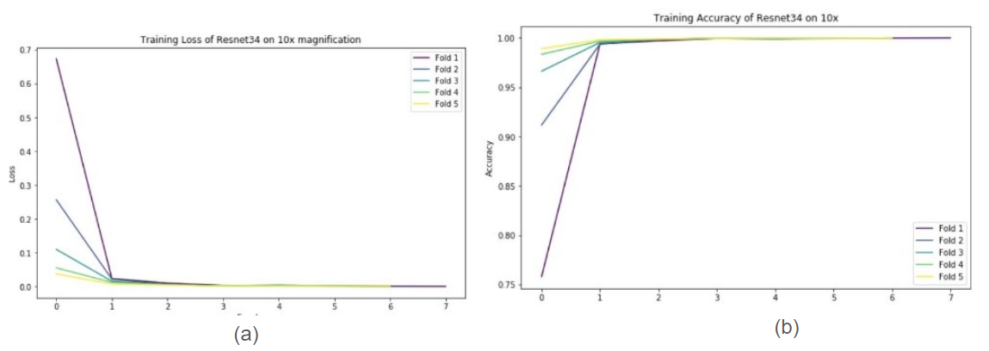
Figure S2. Training Loss (a) and Training Accuracy (b) for Resnet34 on 10× magnification.
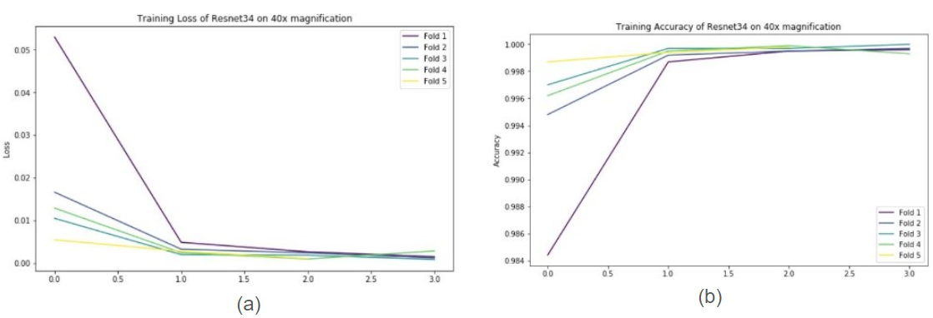
Figure S3. Training Loss (a) and Training Accuracy (b) for Resnet34 on 40× magnification.

Resnet18 on all magnifications:
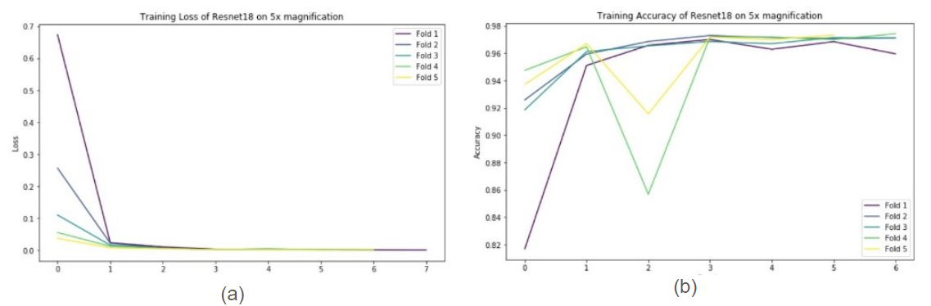
Figure S4. Training Loss (a) and Training Accuracy (b) for Resnet18 on 5× magnification.
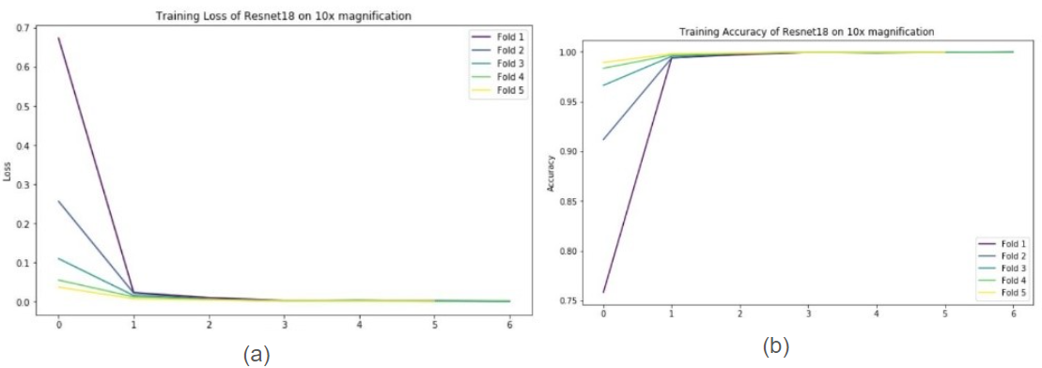
Figure S5. Training Loss (a) and Training Accuracy (b) for Resnet18 on 10× magnification.
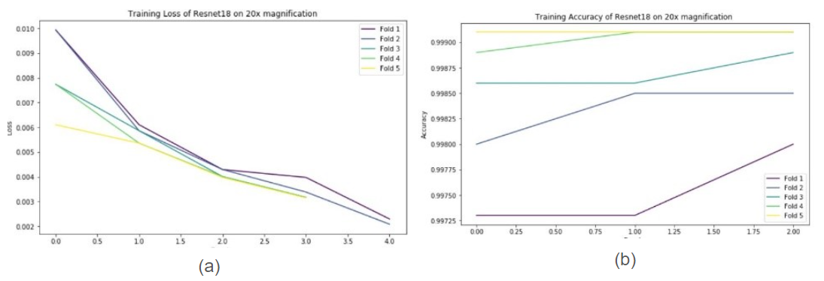
Figure S6. Training Loss (a) and Training Accuracy (b) for Resnet18 on 20× magnification.
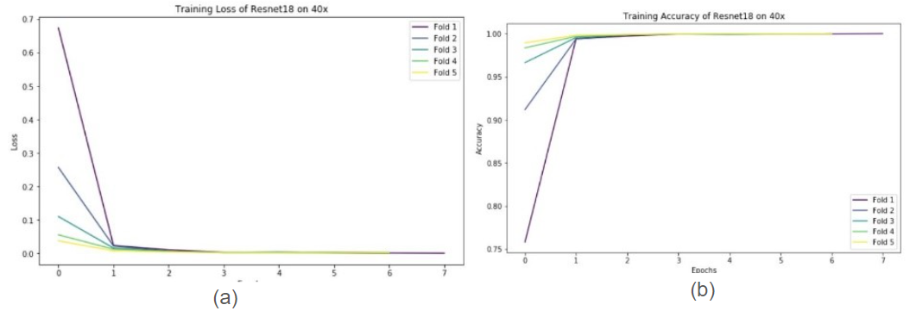
Figure S7. Training Loss (a) and Training Accuracy (b) for Resnet18 on 40× magnificatin.

Resnet50 Training Loss and Accuracy across all magnifications:
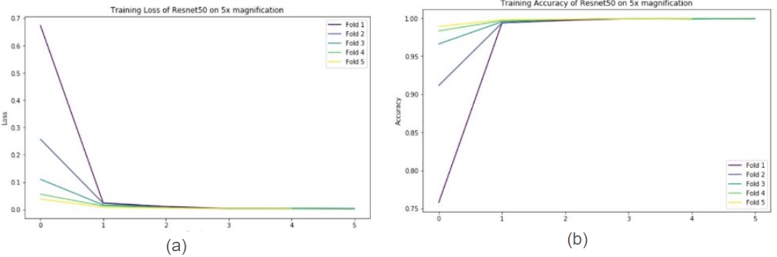
Figure S8. Training Loss (a) and Training Accuracy (b) for Resnet50 on 5× magnification.
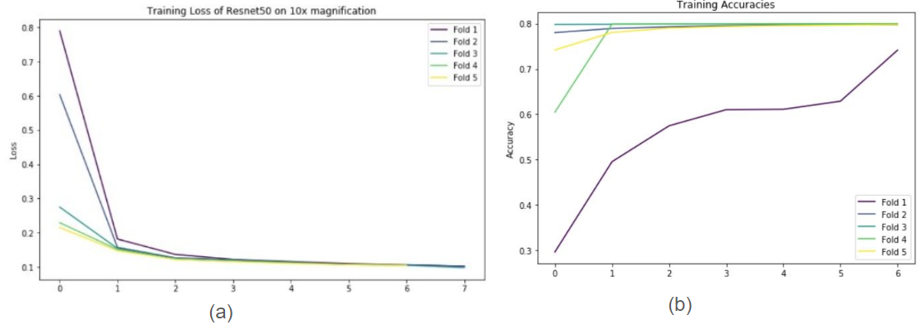
Figure S9. Training Loss (a) and Training Accuracy (b) for Resnet50 on 10× magnification.
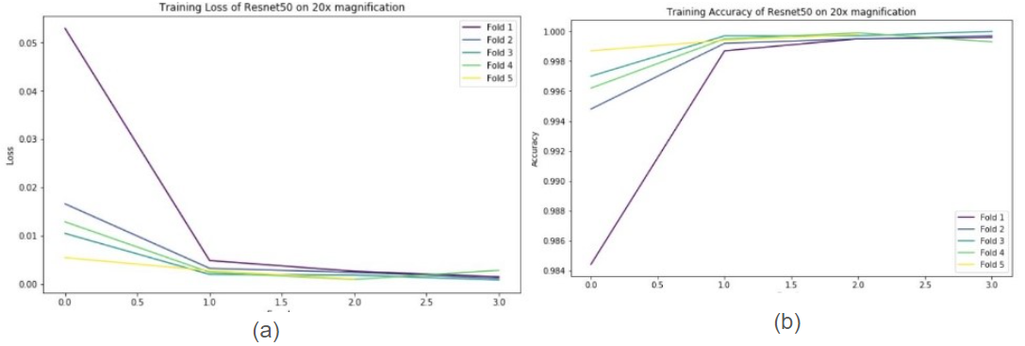
Figure S10. Training Loss (a) and Training Accuracy (b) for Resnet50 on 20× magnification.

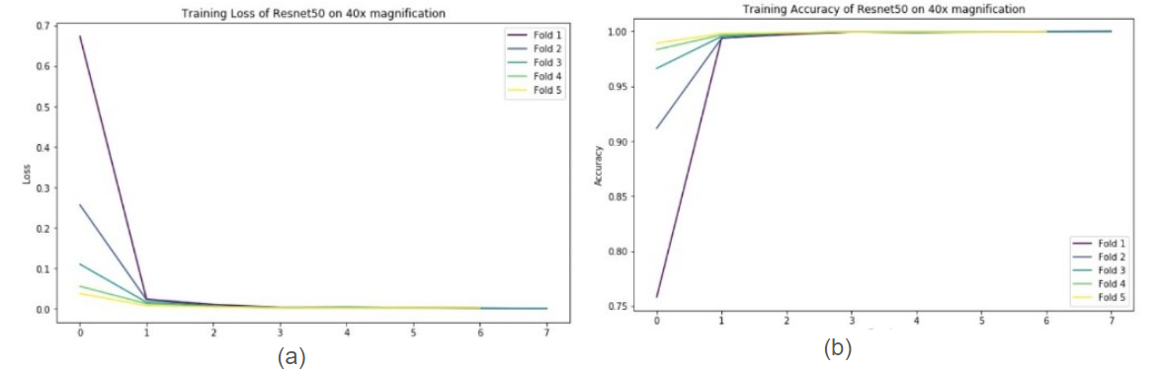
Figure S11. Training Loss (a) and Training Accuracy (b) for Resnet50 on 40× magnification.

