Fused Filament Fabrication of WC-10Co Hardmetals: A Study on Binder Formulations, and printing variables.

Supplementary Material

M1  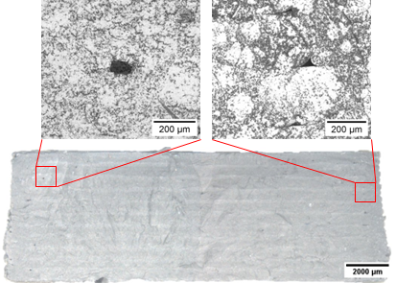 | M2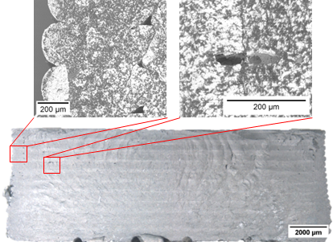
M3  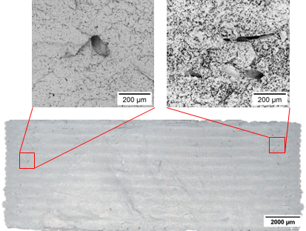 | M4  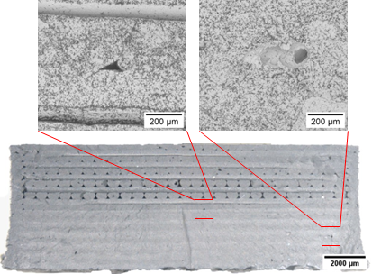
Fig 1. SEM-BSE details and Optical Microscopy of the Green Samples printed at 10 mm/s after cryogenic fracture for the different feedstocks printed at 210 °C a), M1-P b) M2-P c) M3-Pd) M4-P.

